Project

Probability:

Exercise 1

1. Information:

* About 1/125 of births are non-identical twins
* About 1/300 of births are identical twins.
* The probability of having a son and a daughter is equal to 1/2
* The probability of birth of twins=

By this information, the probability that Elvis had an identical twin brother is:

1. Information:

* Eric got chocolate cookie.
* There are two bowls:
* Bowl 1 : 40 cookies. 10 almond cookies, 30 chocolate cookies:

* Bowl 2 : 40 cookies . 20 almond cookie, 20 chocolate cookies:

From that:

* The probability of choose chocolate cookie from bowl 1:
* The probability of choose chocolate cookie from bowl 2:
* The probability of choose chocolate cookie:

By this information, the probability that Eric choose the first bowl:

Exercise 2:

We need that the yellow candy come from the package before 1995( i.e 1994), and the green from the package after 1995 (i.e 1996)

Information:

* There is two option of date:
* In 1994 the colors distribution was:

30% Brown, 20% Yellow, 20% Red, 10% Green, 10% Orange, 10% Tan.

So:

The probability to choose a yellow candy from 1994:

The probability to choose a green candy from 1994:

* In 1996 the colors distribution was:

24% Blue , 20% Green, 16% Orange, 14% Yellow, 13% Red, 13% Brown.

The probability to choose a yellow candy from 1996:

The probability to choose a green candy from 1996:

From that:

* The probability to choose a yellow candy
* The probability to choose a green candy

By this information, the probability to choose yellow candy from 1996 and green candy from 1996:

Exercise 3:

Information:

* The probability of having a flue:
* The probability of not having a flue:
* Return true when healthy:
* Return false when sick =0
* Return true when sick =100%
* The probability of having a flue and the exam return true:
* The probability of not having a flue and the exam return true:
* The probability that the exam return true:

1. By this information , the probability of having a flue when the exam return true:
2. Information:

* The probability of having flue -Thailand:

* The probability of not having a flue after Thailand:
* The probability of having a flue and the exam return true:
* The probability of not having a flue and the exam return true:
* The probability that the exam return true:

By this information, the probability of having a flue after Thailand when the exam return true:

**Random Variables:**

1. Roi is playing a dice game with Yael.  
   Roi will roll 2 six-sided dice, and if the sum of the dice is divisible by 3, he will win 6$. If the sum is not divisible by 3, he will lose 3$.  
   **What is Roi’s expected value of playing this game?**

Answer:

We will look at the sum of the numbers and check which are divided into three and which are not:

The numbers: 3,6,9,12 is divided by 3, and the probability of getting them:

|  |  |  |  |  |  |  |
| --- | --- | --- | --- | --- | --- | --- |
| 6 | 5 | 4 | 3 | 2 | 1 |  |
| 7 | 6 | 5 | 4 | 3 | 2 | 1 |
| 8 | 7 | 6 | 5 | 4 | 3 | 2 |
| 9 | 8 | 7 | 6 | 5 | 4 | 3 |
| 10 | 9 | 8 | 7 | 6 | 5 | 4 |
| 11 | 10 | 9 | 8 | 7 | 6 | 5 |
| 12 | 11 | 10 | 9 | 8 | 7 | 6 |

* The probability of get number that divided by 3:
* The probability of get number that not divided by 3:

By this information about of the games Roi will win, which means that he will gain 6$ for win, and about of the games Roi will lose, which means that he will lose 6$ for two lost.

from that, Roi will not gain or lose any value because it will even out.

1. Sharon has challenged Alex to a round of Marker Mixup. Marker Mixup is a game where there is a bag of 5 red markers numbered 1 through 5, and another bag with 5 green Markers numbered 6 through 10. Alex will grab 1 marker from each bag, and if the 2 markers add up to more than 12, he will win 5 $, If the sum is exactly 12, he will break even, and If the sum is less than 12, he will lose $ 6.

**What is Alex's expected value of playing Marker Mixup?**

Answer:

|  |  |  |  |  |  |
| --- | --- | --- | --- | --- | --- |
| 5 | 4 | 3 | 2 | 1 | + |
| 11 | 10 | 9 | 8 | 7 | 6 |
| 12 | 11 | 10 | 9 | 8 | 7 |
| 13 | 12 | 11 | 10 | 9 | 8 |
| 14 | 13 | 12 | 11 | 10 | 9 |
| 15 | 14 | 13 | 12 | 11 | 10 |

* The probability of get number above 12:
* The probability of get number below 12:
* The probability of get number equal to 12:

From that information we got for every 25 games, 6 of the games he will gain 5$, (30$ total), and 15 of the game he will lose (90$ total)

By that, after 25 games he will lose 60$.

Exercise 3:

A division of a company has 200 employees, 40%, percent of which are male. Each month,

the company randomly selects 8 of these employees to have lunch with the CEO.

What are the mean and standard deviation of the number of males selected each

month?

Answer:

Information:

* There is: 80 male, 120 female.

Note that 40% of the employs is male, so 40% from all the cases, man will be in the 8 people who was at lunch:

So the mean is:

.

Std:

There is 9 option of male been in the lunch: 0,1,2,3,4,5,6,7,8

So, by the formula:

Exercise 4:

Different dealers may sell the same car for different prices. The sale prices for a particular car are normally distributed with a mean and standard deviation of 26,000$ and 2,000$, respectively. Suppose we select one of these cars at random. Let X = the sale price (in thousands of dollars) for the selected car. Find P(26<X<30).

Answer:

By the normal distribution, in order to get a price between 26 and 30, we look at the 2 std’s to the right of the mean.

By that, and by the rule of “68%, 95%, 99.72%”, we need to look at 95% area, and divide it by 2, because we don’t want the price to be below the average.

So, the probability of a sale price between 26 and 30 is 47.5%.

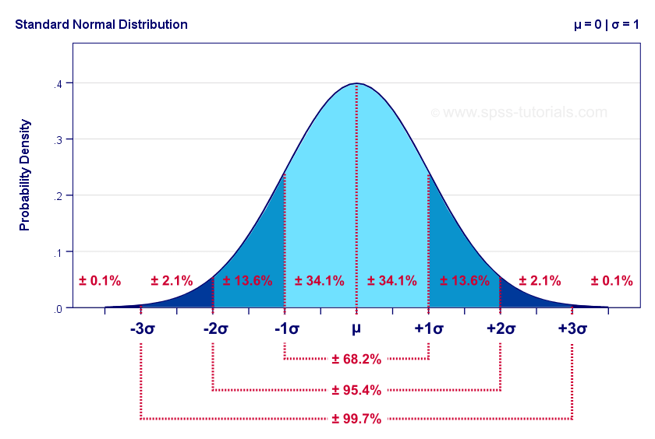

Exercise 5:

Given the following distribution, what is P(x>3)?

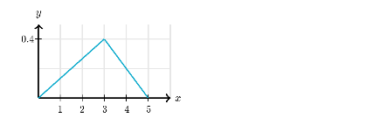

Answer:

In order to calculate the probability, lets note that all the area in the triangle is 100% of the total probability.

So, the probability to is:

Exercise 6:

A company has 500 employees, and 60% of them have children. Suppose that we randomly

select 4 of these employees.

What is the probability that exactly 3 of the 4 employees selected have children?

Answer:

Information:

* The number of employs that have children:
* Note that the number of employs that not have children:

By that, the probability of that exactly 3 of the 4 employees selected have children (Note that the order of the selection is not important, so we multiply the answer by 4):

Exercise 7:

Look at the next Graph. What is the expected value of X?

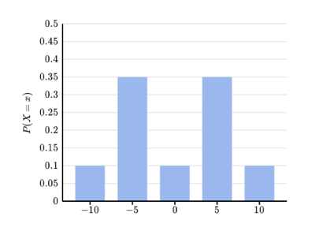

Answer:

We use the formula of random variable:

So the calculation is: