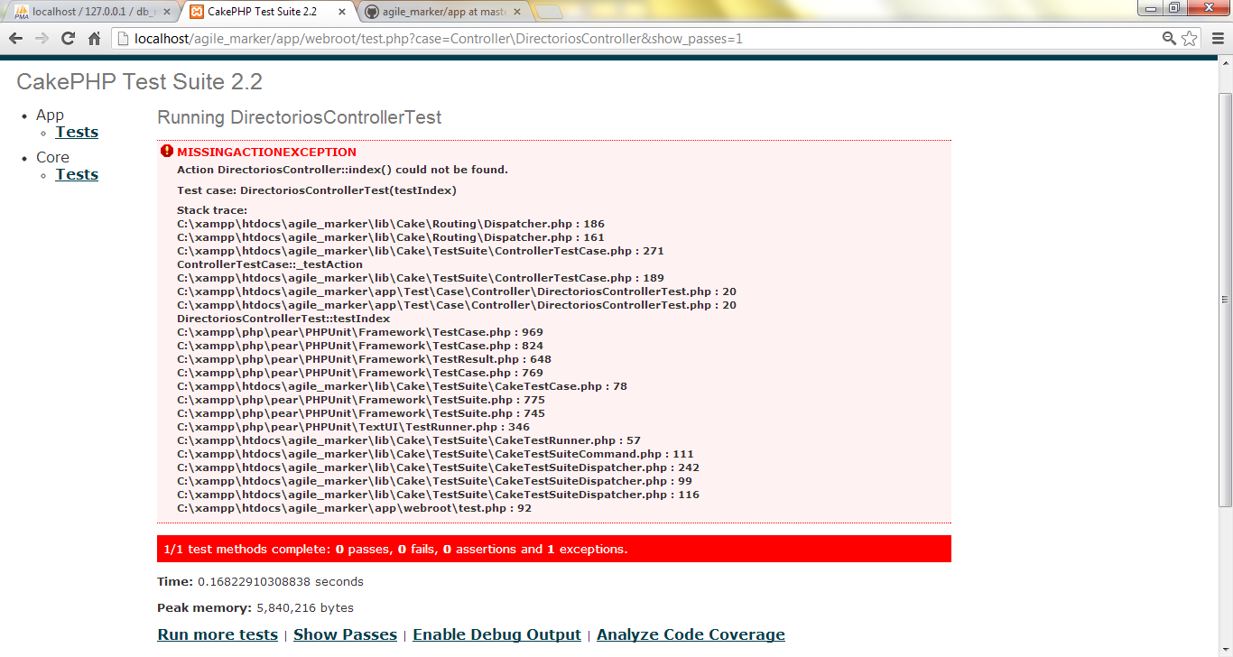

class DirectoriosControllerTest extends ControllerTestCase{

public $fixtures = array('app.directorio', 'app.enlace');

public function setup(){

parent::setUp();

$this->Directorio = ClassRegistry::init('Directorio');

}

public function testIndex()

{

$records = array(

array('id'=>1, 'nombre'=>'Red Social', 'created' => '2007-03-18 10:39:23', 'modified' => '2007-03-18 10:41:31'),

array('id'=>2, 'nombre'=>'Buscador', 'created' => '2007-03-18 10:39:23', 'modified' => '2007-03-18 10:41:31'),

array('id'=>3, 'nombre'=>'Videos', 'created' => '2007-03-18 10:39:23', 'modified' => '2007-03-18 10:41:31'),

array('id'=>4, 'nombre'=>'Educativo', 'created' => '2007-03-18 10:39:23', 'modified' => '2007-03-18 10:41:31'),

);

$this->testAction('/directorios/index');

$this->assertInternalType('array', $this->vars['directorios']);

}

}

