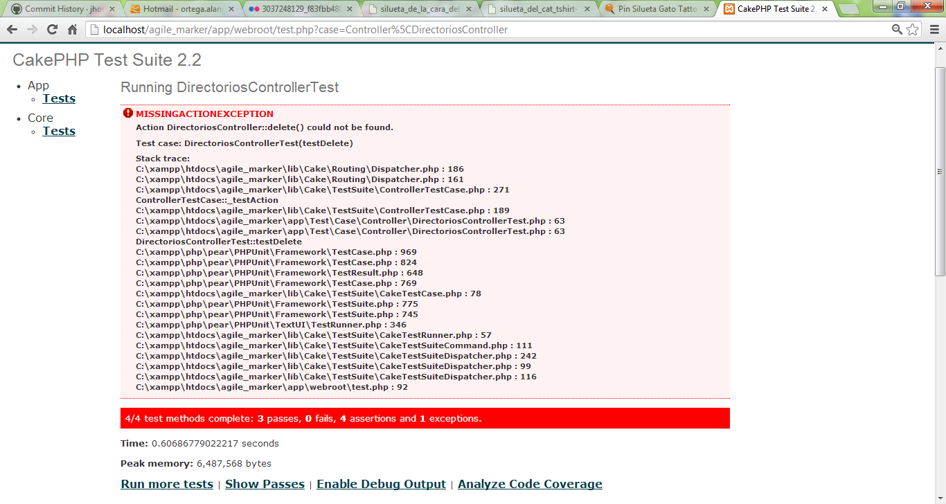

function testDelete(){

$before = $this->Directorio->find('count');

$this->testAction('/directorios/delete/1', array('method' => 'get'));

$after = $this->Directorio->find('count');

$this->assertEquals($before-1, $after);

}

