**Deliverable 0**

**System Overview**

Simplified-Scheduler (SS) is a web-based application that is designed to generate a valid multi-year schedule for a student. The purpose of SS is to facilitate students’ task to create, and organize their own multi-year schedule using the Concordia Registration system.

On the website the user will be prompted to log in to their account using a username and a password. Once authenticated, the students can then build their schedule, and modify it as they choose (assuming modifications are within rules). The student’s record contains a list of completed classes such that the application will verify if the student has taken the required prerequisites for the class the student intends to register for.

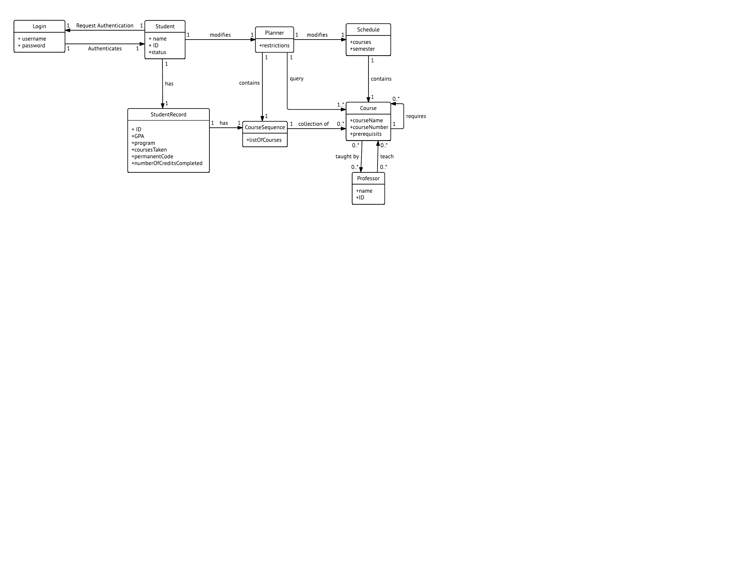**Domain Model Diagram**

**Doman Model Overview**The Domain Model diagram consists of a total of eight domain level objects (DLO). It represents the liaison between the student and the aspects to build their multi-year schedule.  
  
**Login**  
Login has two attributes: Username and Password. Login authenticates Student with a one to one relationship.   
 **Student Record**  
 Student Record has six attributes, they being the student Identification number (ID), the GPA, the program to which the student is registered, courses taken , permanent code, number of credits completed over total number of credits.   
Student record has a one to one relationship with Student and Course Sequence.  
  
**Student/User**  
Student has three attributes: Student Identification number (ID), Name, Status (Part-time student, Full-time student). Student is associated to student record, login and planner. Student needs to request from Login in order to be authenticated. Each student has a Student Record. Student/User has a one-to-one relationship with Student Record, Planner and Login.

**Course Sequence**  
Course Sequence has one attribute: List of Courses. Sequence has a one-to-one relationship with Course, Planner and Student Record.  
  
**Planner**Planner has one attribute: Restrictions. Planner has a one-to-one relationship with Student/User, Schedule, Course Sequence and a one-to-many relationship with Courses.

**Course**   
Course has three attributes: Course name, Course number, Prerequisites. Course has a one-to-many and many-to-one relationship with professor and to itself.

**Professor**  
Professor has two attributes: Name and Identification Number (ID). Professor has a one-to-many relationship with Course.

**Schedule**  
Schedule has two attributes: Courses and Semester. Schedule has a one-to-many relationship with Course and one-to-one relationship with Planner.

**Team Details**

Team name: Polinemarwa

Team Captain: Lance Lafontaine

List of team members and tentative roles

* Jason Tsalikis(25892120) , Documentation and Back End
* Bruce Choi (..) Documentation and Back End
* Hannah Ortiz (26939414), Documentation and Front End
* Ahmad Hyjaz Loudin (27179294), Documentation, Design and Front End Programming
* Nassim El Sayed (27010419), Documentation, Database and Back End
* Benny Zhao (27205104), Database, Backend, Documentation
* Nimrat Cheema (27035845), Documentation and Design
* Feken Baboyan (27754507) Documentation, Front End and Back End
* Lance Lafontaine Documentation and Back End
* Armine Iradian (27197144) Documentation, Front End and Tester
* Andrew Laranee (27050925) Documentation and Back End