# **EX3 - VAE, GAN, WGAN**

* **General**

This readme file describes how to run the code in the notebook of exercise 3.

The code is written such that we train all the cases and show the required graphs on a *Tensorboard* or and standard matplotlib plots.

* **Run the code**  
  The notebook structured to run first the code of question 3, and then question 4.  
    
  Accordingly, we will first modify the following cell in order to choose if we want to run pre-trained model or we want to train the VAE model from scratch.

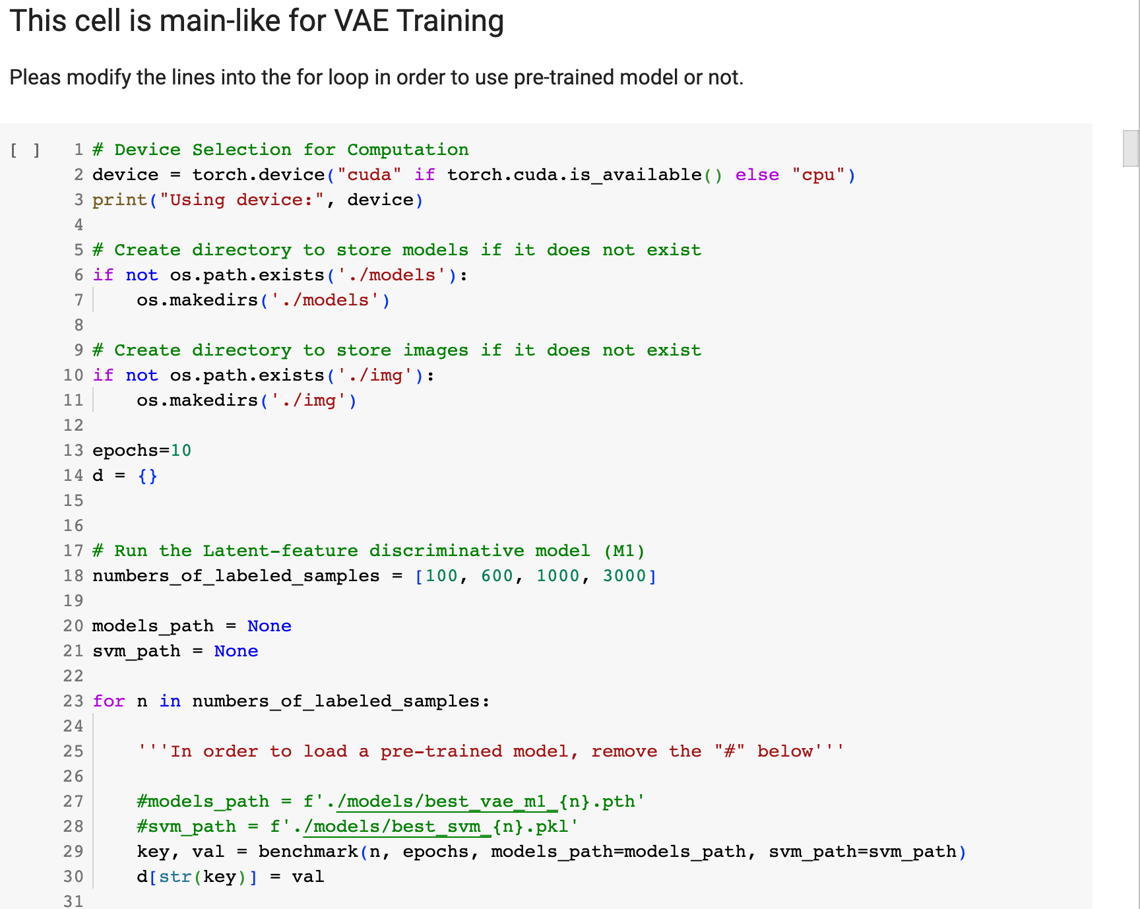

Then we will do the same for the GANs of question 4

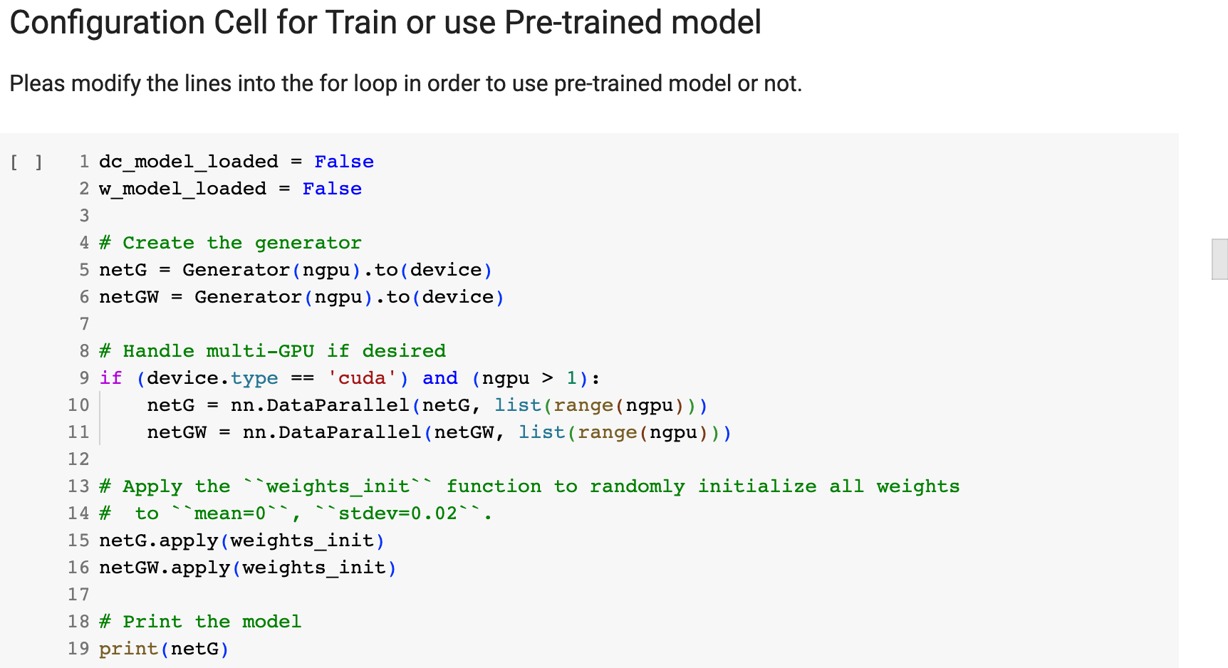

* **How to train**Modify the cells above according to the table below.

|  |  |
| --- | --- |
|  | **Modification** |
| Question 3 | #models_path = f'./models/best_vae_m1_{n}.pth'  #svm_path = f'./models/best_svm_{n}.pkl' |
| Question 4 | dc_model_loaded = False  w_model_loaded = False |

* **How to test with saved weights (Default in the notebook)**Modify the cells above according to the table below.

|  |  |
| --- | --- |
|  | **Modification** |
| Question 3 | models_path = f'./models/best_vae_m1_{n}.pth'  svm_path = f'./models/best_svm_{n}.pkl' |
| Question 4 | dc_model_loaded = True  w_model_loaded = True |

* **How to generate DC-GAN and WGAN images with saved weights**After you modified the code to use pretrained generator networks,   
  please run the next cell to generate 2 images from each GAN type + 2 Real images.

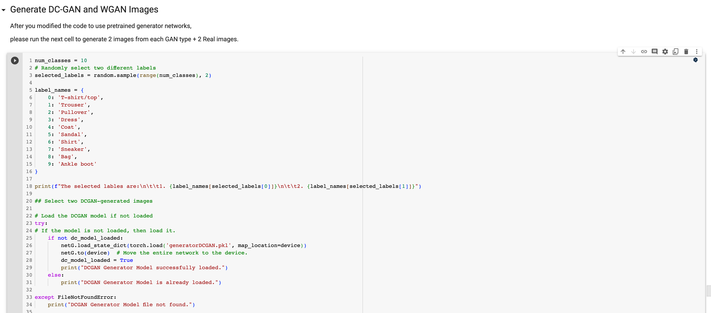

So finally, you we get plot like this:

