Image Processing Lab

2022-2023
Group #8

Experiment #4 Final Report

Pair No. 43
ID1: 301613501
ID2: 208560086

Lab 4 – Image Filtering
Student IDs: 301613501, 208560086
Mount to Google Drive
from google.colab import drive
drive.mount('/content/drive/')
Mounted at /content/drive/
Change working directory to lab folder
%cd '/content/drive/My Drive/IP Labs/4'
import os
path = os.getcwd()
print('path: ' + path)
/content/drive/My Drive/IP Labs/4
path: /content/drive/My Drive/IP Labs/4
Import the necessary libraries for Lab 4:
%matplotlib inline
import numpy as np
from numpy import fft
import cv2
import matplotlib.pylab as plt
from skimage import transform,io,filters
from skimage.filters import unsharp_mask
from scipy import signal,ndimage
Load and display an image of your choice as a grayscale image:
import matplotlib.pyplot as plt
from skimage import img_as_ubyte
from skimage import transform,io,color
img = color.rgb2gray(io.imread('stopsign.jpeg'))
img = img_as_ubyte(img)
print ('Image shape: {}\nImage data type: {}'.format(img.shape,img.dtype))
plt.imshow(img, cmap = 'gray')
plt.xticks([]), plt.yticks([]) # to hide tick values on X & Y axis
plt.show()
Image shape: (360, 540)
Image data type: uint8
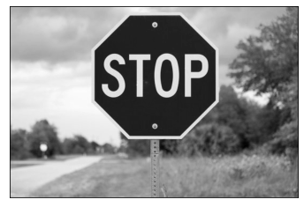

Follow the instructions in each section:

Part 1 – DFT Properties

Use the supplied function dft_demo() :
def dft_demo():
# Demonstration of effect of the "fftshift" command on the amplitude and on the spectrum of the image.
#-----------------------------------------------------------------------------------------------------#
N1 = 100; N2=100; M1=20; M2=20
A = np.zeros([N1,N2])
A[(N1-M1)//2:(N1+M1)//2,(N2-M2)//2:(N2+M2)//2]=255
B = np.fft.fft2(A)
log_magnitude_B= 20*np.log(np.abs(B)+1) # add 1 - in order to prevent log(0)
B_fftshift=np.fft.fftshift(B)
log_magnitude_B_fftshift= 20*np.log(np.abs(B_fftshift)+1)
fig, axes = plt.subplots(nrows=1, ncols=3, figsize=(8, 8))
ax = axes.ravel()
ax[0].imshow(A, cmap='gray')
ax[0].set_title('The original image'), ax[0].axis('off')
ax[1].imshow(log_magnitude_B, cmap='gray')
ax[1].set_title('|DFT(a)| [dB]')
ax[2].imshow(log_magnitude_B_fftshift, cmap='gray')
ax[2].set_title('|DFT(a)| [dB] + fftshift')
plt.tight_layout()
# Linearity - 3 demonstrations (two horizontal boxes, two vertical boxes and four boxes)
#----------------------------------------------------------------------------------------------------#
# Two horizontal boxes
delta=40
A2_hor=np.zeros([N1,N2])
A2_hor[(N1-M1)//2:(N1+M1)//2,(N2-delta-M2)//2:(N2-delta+M2)//2]=255
A2_hor[(N1-M1)//2:(N1+M1)//2,(N2+delta-M2)//2:(N2+delta+M2)//2]=255
B2_hor=np.fft.fft2(A2_hor)
B2_hor_magnitude = 20*np.log(np.abs(np.fft.fftshift(B2_hor))+1)
fig, axes = plt.subplots(nrows=2, ncols=2, figsize=(6, 6))
ax = axes.ravel()
ax[0].imshow(A, cmap='gray')
ax[0].set_title('One box'), ax[0].axis('off')
ax[1].imshow(log_magnitude_B_fftshift, cmap='gray')
ax[1].set_title('|DFT{One box}| [dB]')
ax[2].imshow(A2_hor, cmap='gray')
ax[2].set_title('Two horizontal boxes'), ax[2].axis('off')
ax[3].imshow(B2_hor_magnitude, cmap='gray')
ax[3].set_title('|DFT{Two horizontal boxes}|[dB]')
plt.tight_layout()
# Two vertical boxes
A2_ver=np.zeros([N1,N2])
A2_ver[(N1-delta-M1)//2:(N1-delta+M1)//2,(N2-M2)//2:(N2+M2)//2]=255
A2_ver[(N1+delta-M1)//2:(N1+delta+M1)//2,(N2-M2)//2:(N2+M2)//2]=255
B2_ver=np.fft.fft2(A2_ver)
B2_ver_magnitude = 20*np.log(np.abs(np.fft.fftshift(B2_ver))+1)
fig, axes = plt.subplots(nrows=1, ncols=2, figsize=(6, 6))
ax = axes.ravel()
ax[0].imshow(A2_ver, cmap='gray')
ax[0].set_title('Two vertical boxes'), ax[0].axis('off')
ax[1].imshow(B2_ver_magnitude, cmap='gray')
ax[1].set_title('|DFT{Two vertical boxes}|[dB]')
plt.tight_layout()
# Four boxes
A4=np.zeros([N1,N2])
A4[(N1-delta-M1)//2:(N1-delta+M1)//2,(N2-delta-M2)//2:(N2-delta+M2)//2]=255
A4[(N1+delta-M1)//2:(N1+delta+M1)//2,(N2-delta-M2)//2:(N2-delta+M2)//2]=255
A4[(N1-delta-M1)//2:(N1-delta+M1)//2,(N2+delta-M2)//2:(N2+delta+M2)//2]=255
A4[(N1+delta-M1)//2:(N1+delta+M1)//2,(N2+delta-M2)//2:(N2+delta+M2)//2]=255
B4=np.fft.fft2(A4)
B4_magnitude = 20*np.log(np.abs(np.fft.fftshift(B4))+1)
fig, axes = plt.subplots(nrows=1, ncols=2, figsize=(6, 6))
ax = axes.ravel()
ax[0].imshow(A4, cmap='gray')
ax[0].set_title('Four boxes'), ax[0].axis('off')
ax[1].imshow(B4_magnitude, cmap='gray')
ax[1].set_title('|DFT{Four boxes}|[dB]')
plt.tight_layout()
# Scaling (reduction and enlargement)
#----------------------------------------------------------------------------------------------------#
# Reduction
M1_small=10; M2_small=10
A_small = np.zeros([N1,N2])
A_small[(N1-M1_small)//2:(N1+M1_small)//2,(N2-M2_small)//2:(N2+M2_small)//2]=255
B_small = np.fft.fft2(A_small)
log_magnitude_B_small= 20*np.log(np.abs(np.fft.fftshift(B_small))+1)
# Enlargement
M1_large=40; M2_large=40
A_large = np.zeros([N1,N2])
A_large[(N1-M1_large)//2:(N1+M1_large)//2,(N2-M2_large)//2:(N2+M2_large)//2]=255
B_large = np.fft.fft2(A_large)
log_magnitude_B_large= 20*np.log(np.abs(np.fft.fftshift(B_large))+1)
fig, axes = plt.subplots(nrows=2, ncols=2, figsize=(6, 6))
ax = axes.ravel()
ax[0].imshow(A_small, cmap='gray')
ax[0].set_title('Reduced image'), ax[0].axis('off')
ax[1].imshow(log_magnitude_B_small, cmap='gray')
ax[1].set_title('|DFT{Reduced A}| [dB]')
ax[2].imshow(A_large, cmap='gray')
ax[2].set_title('Enlarged image'), ax[2].axis('off')
ax[3].imshow(log_magnitude_B_large, cmap='gray')
ax[3].set_title('|DFT{Enlarged A}|[dB]')
plt.tight_layout()
# Rotation
#----------------------------------------------------------------------------------------------------#
theta = 45 #in degrees
A_rotate = transform.rotate(A, angle=theta)
B_rotate = np.fft.fft2(A_rotate)
log_magnitude_B_rotate= 20*np.log(np.abs(np.fft.fftshift(B_rotate))+1)
fig, axes = plt.subplots(nrows=1, ncols=2, figsize=(6, 6))
ax = axes.ravel()
ax[0].imshow(A_rotate, cmap='gray')
ax[0].set_title('Rotated image'), ax[0].axis('off')
ax[1].imshow(log_magnitude_B_rotate, cmap='gray')
ax[1].set_title('|DFT{Rotated A}|[dB]')
plt.tight_layout()
dft_demo()
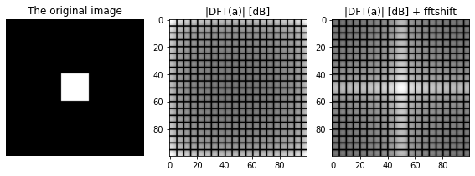
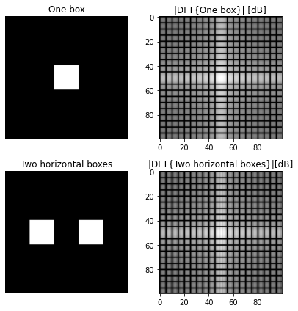
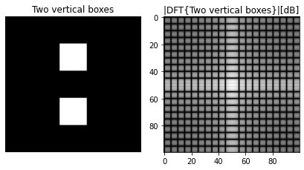
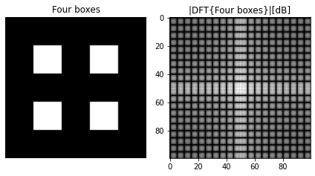
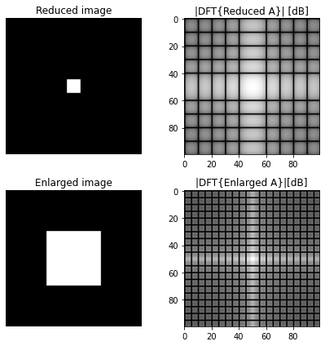
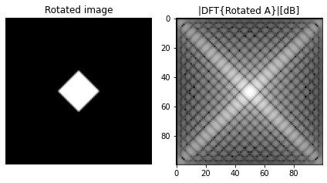
- Observe the following properties and demonstrations from the dft_demo():
  - fftshift command.
  - Linearity.
  - Scaling.
  - Rotation.
1. Add a short explanation of each of the observations above.
Insert your explanation here

Answer 1
fftshift - The fftshift function is a utility function that rearranges the frequency components of a discrete Fourier transform (DFT) so that the zero-frequency component is at the center of the spectrum. In the demo above we can see easily how this function shifts the "DC" components from the margins to the center. One more thing that stands out is the duplication and the conjugate properties of the DFT.
Linearity - Here, we can see from the center of the spectrum that the basis image of the lower frequencies is divided by the number of rectangular.
Scaling - We can see the DFT (inverse ration) scaling property by this demo. when the original image scaled up, the DFT reduced. and the same for the other direction.
Rotation - As we learned in the class, the DFT rotated by the same angle of the original image.

2. Generate the DFT transform of the image of your choice. \ Show the 3 following plots: Your image, the regular transformation without fftshift and transformation with the fftshift function.
ft = fft.fft2(img)
log_mag_ft = 20*np.log(np.abs(ft)+1) # add 1 - in order to prevent log(0)
ft_shift = fft.fftshift(ft)
log_mag_ft_shift = 20*np.log(np.abs(ft_shift)+1)
fig, ax = plt.subplots(nrows=1, ncols=3, figsize=(10, 10))
ax = ax.ravel()
ax[0].imshow(img, cmap='gray')
ax[0].set_title('The original image'), ax[0].axis('on')
ax[1].imshow(log_mag_ft, cmap='gray')
ax[1].set_title('|DFT(img)| [dB]')
ax[2].imshow(log_mag_ft_shift, cmap='gray')
ax[2].set_title('|DFT(img)| [dB] + fftshift')
plt.tight_layout()
plt.show()
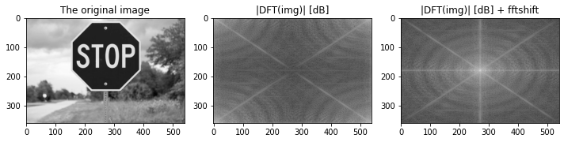
3. Test the following properties on your image and show the effects on its DFT:
- Scaling: factors - ½ and 2
- Rotation: by 30 and 45 degrees
Notes:
- for your image the scaling property should be implemented differently than in the demo (you can use the function *transform.rescale*).
- Use zero padding as needed prior to DFT computations.
img_width = img.shape[0]
img_height = img.shape[1]
img_fact2x0 = np.pad(transform.resize(img, (2*img_width, 2*img_height)), pad_width=1)
img_fact0x5 = np.pad(transform.resize(img, (0.5*img_width, 0.5*img_height)), pad_width=1)
img_rot30 = np.pad(transform.rotate(img, 30), pad_width=1)
img_rot45 = np.pad(transform.rotate(img, 45), pad_width=1)
img_fact2x0_ft = fft.fft2(img_fact2x0)
img_fact0x5_ft = fft.fft2(img_fact0x5)
img_rot30_ft = fft.fft2(img_rot30)
img_rot45_ft = fft.fft2(img_rot45)
log_magnitude_img_fact2x0_ft = 20*np.log(np.abs(img_fact2x0_ft)+1)
log_magnitude_img_fact0x5_ft = 20*np.log(np.abs(img_fact0x5_ft)+1)
log_magnitude_img_rot30_ft = 20*np.log(np.abs(img_rot30_ft)+1)
log_magnitude_img_rot45_ft = 20*np.log(np.abs(img_rot45_ft)+1)
img_fact2x0_ft_shift = 20*np.log(np.abs(fft.fftshift(img_fact2x0_ft))+1)
img_fact0x5_ft_shift = 20*np.log(np.abs(fft.fftshift(img_fact0x5_ft))+1)
img_rot30_ft_shift = 20*np.log(np.abs(fft.fftshift(img_rot30_ft))+1)
img_rot45_ft_shift = 20*np.log(np.abs(fft.fftshift(img_rot45_ft))+1)
fig1, ax1 = plt.subplots(nrows=3, ncols=5, figsize=(20, 10))
ax1 = ax1.ravel()
ax1[0].imshow(img, cmap='gray')
ax1[0].set_title('Original Size'), ax[0].axis('on')
ax1[1].imshow(img_fact0x5, cmap='gray')
ax1[1].set_title('Scaling x0.5')
ax1[2].imshow(img_fact2x0, cmap='gray')
ax1[2].set_title('Scaling x2')
ax1[3].imshow(img_rot30, cmap='gray')
ax1[3].set_title('Rotation 30')
ax1[4].imshow(img_rot45, cmap='gray')
ax1[4].set_title('Rotation 45')
ax1[5].imshow(log_mag_ft, cmap='gray')
ax1[5].set_title('|DFT(img)| [dB]'), ax[0].axis('on')
ax1[6].imshow(log_magnitude_img_fact0x5_ft, cmap='gray')
ax1[6].set_title('|DFT(img_x0.5)| [dB]')
ax1[7].imshow(log_magnitude_img_fact2x0_ft, cmap='gray')
ax1[7].set_title('|DFT(img_x2)| [dB]')
ax1[8].imshow(log_magnitude_img_rot30_ft, cmap='gray')
ax1[8].set_title('|DFT(img_30)| [dB]')
ax1[9].imshow(log_magnitude_img_rot45_ft, cmap='gray')
ax1[9].set_title('|DFT(img_45)| [dB]')
ax1[10].imshow(log_mag_ft_shift, cmap='gray')
ax1[10].set_title('|DFT(img)| [dB] + fftshift'), ax[0].axis('on')
ax1[11].imshow(img_fact0x5_ft_shift, cmap='gray')
ax1[11].set_title('|DFT(img_x0.5)| [dB] + fftshift')
ax1[12].imshow(img_fact2x0_ft_shift, cmap='gray')
ax1[12].set_title('|DFT(img_x2)| [dB] + fftshift')
ax1[13].imshow(img_rot30_ft_shift, cmap='gray')
ax1[13].set_title('|DFT(img_40)| [dB] + fftshift')
ax1[14].imshow(img_rot45_ft_shift, cmap='gray')
ax1[14].set_title('|DFT(img_45)| [dB] + fftshift')
plt.tight_layout()
plt.show()
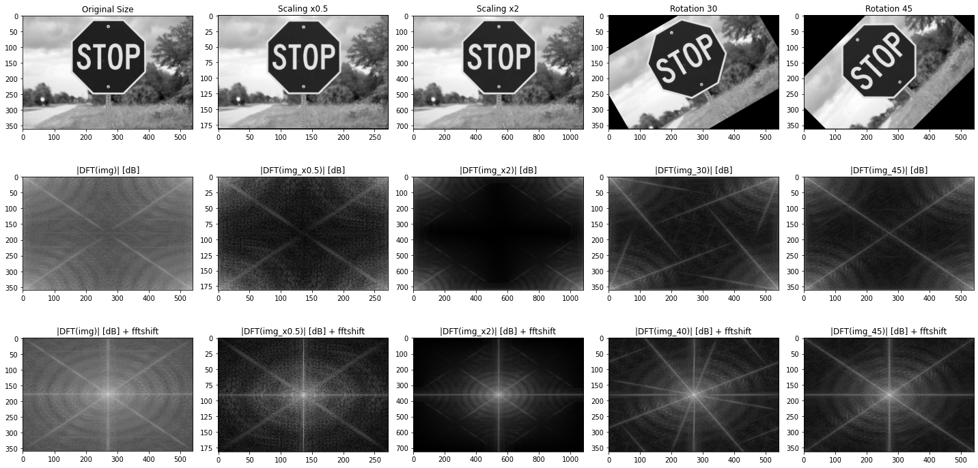
Explain your results here.

Answer 2
First, we'd like to notice that it is much easy to analyze the results after the fft shifting.
Our original image have a symmetric octagon in the center, so the 2 major things that stand out from this demonstration are
- We have 8 rays that represent the main shape.
- The DFT is also symmetric like the shape in the original image.
We can also say that the scaling property of the DFT is conspicuous, compared to the original image.
As a result of our unique shape in the image, we can se that it is not very easy to recognize the 45 degrees rotation, while in the 30 degrees the symmetricity of the DFT is broken (because the angle doesn't match the shape angle).

4. Write a function called mag_phase_exchange(img1,img2).
- Your function should compute the 2D DFTs of both inpute images, and reconstruct new images img1_ex, img2_ex, through exchanging the computed DFT magnitudes and phases.
- Specifically:
Retrieve the magnitudes and phases of the DFTs of the inputs images. \ Generate DFT representations of the modified images, through exchanging their magnitudes and phases \ (i.e., img1_ex <- mag1 + phase2, img2_ex <- mag2 + phase1). \ Reconstruct img1_ex, img2_ex using IDFT. \
Notes:
- Both of the images need to be with the same shape. Resize or crop one of the images if it is necessary.
- You may need the functions numpy.abs and numpy.angle
def mag_phase_exchange(img1,img2):
img1r = transform.resize(img1, (500, 500))
img2r = transform.resize(img2, (500, 500))
ft1 = fft.fft2(img1r)
ft2 = fft.fft2(img2r)
mag1 = np.abs(ft1)
phase1 = np.angle(ft1)
mag2 = np.abs(ft2)
phase2 = np.angle(ft2)
img1_ex = np.abs(fft.ifft2(mag1 * np.exp(1j * phase2)))
img2_ex = np.abs(fft.ifft2(mag2 * np.exp(1j * phase1)))
return img1_ex, img2_ex
- Test your function on 2 images of your choice - display both original and manipulated images. What can be said about the importance of both magnitude and phase of natural images?
img1 = color.rgb2gray(io.imread('cat.jpg'))
img1 = img_as_ubyte(img1)
print ('Image 1\n shape: {}\n dtype: {}'.format(img1.shape,img1.dtype))
img2 = color.rgb2gray(io.imread('wall.jpg'))
img2 = img_as_ubyte(img2)
print ('\nImage 2\n shape: {}\n dtype: {}'.format(img2.shape,img2.dtype))
Image 1
shape: (2720, 4106)
dtype: uint8
Image 2
shape: (797, 1205)
dtype: uint8
img1_ex, img2_ex = mag_phase_exchange(img1,img2)
fig, ax = plt.subplots(nrows=2, ncols=2, figsize=(7, 7))
ax = ax.ravel()
ax[0].imshow(img1, cmap='gray')
ax[0].set_title('img1 original'), ax[0].axis('on')
ax[1].imshow(img2, cmap='gray')
ax[1].set_title('img2 original')
ax[2].imshow(img1_ex, cmap='gray')
ax[2].set_title('img1_ex <- mag1 + phase2')
ax[3].imshow(img2_ex, cmap='gray')
ax[3].set_title('img2_ex <- mag2 + phase1')
plt.tight_layout()
plt.show()
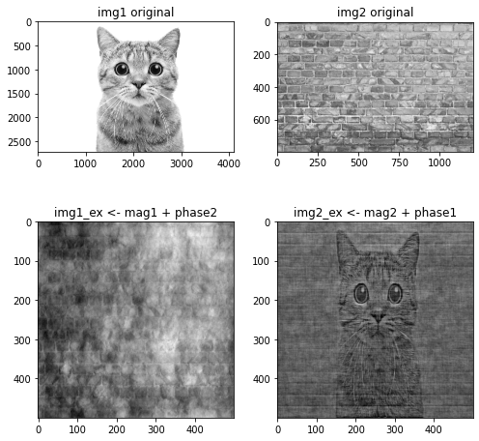
img1 = img_as_ubyte(io.imread('cat.jpg'))
print ('Image 1\n shape: {}\n dtype: {}'.format(img1.shape,img1.dtype))
img2 = img_as_ubyte(io.imread('wall.jpg'))
print ('\nImage 2\n shape: {}\n dtype: {}'.format(img2.shape,img2.dtype))
Image 1
shape: (2720, 4106, 3)
dtype: uint8
Image 2
shape: (797, 1205, 3)
dtype: uint8
_, img2_ex = mag_phase_exchange(img1,img2)
plt.imshow(img2_ex)
plt.title('cool bonus!!')
plt.show()
WARNING:matplotlib.image:Clipping input data to the valid range for imshow with RGB data ([0..1] for floats or [0..255] for integers).
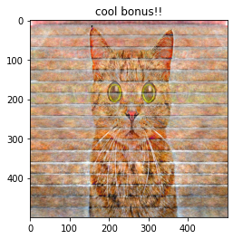
Write your answers here.

Answer 3
In a similar way to the material we learned in class, the phase is much more dominant.
We can see that in our demonstration above, while we took the phase of image 2 and put it on the magnitude of image 1. There is no visual signs of the stop sign from the original image 1.

Part 2 – Convolution and Image Filtering

1. In this section you will implement an efficient convolution compution using vecorization.
- Write a function called unfold_image(img, kernel_shape). \ Assume a 2D convolution kernel of size K x K. The function tranforms an H x W image into a matrix M of dimensions: K^2 x (H-K+1)(W-K+1), \ such that every colum in M is a column stacked image patch corresponding to each one of the kernel positions during convolution. \
For example, assume a 16x16 image, to be filtered using a 3x3 kernel. \ The resulting matrix is of size 3^2 x (16-3+1)(16-3+1) = 9 x 196, as there are 196 kernel positions during the convolution.
def unfold_image(img, kernel_shape):
k_w, k_h = kernel_shape
w, h = img.shape
#create the wanted unfolded image shape
unfolded_image = np.empty((k_h * k_w, (h - k_h + 1) * (w - k_w + 1)))
for i in range(k_h):
for j in range(k_w):
unfolded_image[i * k_w + j, :] = img[i:i + w - k_w + 1, j:j + h - k_h + 1].flatten()
return unfolded_image
- Write a function called my_convolve2d(img,kernel). \ Your function should compute the convolution through the following steps:
Generate a corresponding image matrix M (the unfolded image) using the function from the previous section. \ Transform the K x K convolution kernel to a K^2 x 1 row vector kernel_row. \ Perform matrix multilplication: img_filtered_flattened = kernel_row M. \ Acquire the resulting image img_filtered* through reshaping.
def my_convolve2d(img,kernel):
h,w = img.shape
k = kernel.shape[0]
k_r = kernel.reshape(1, kernel.size)
img_filtered_flattened = k_r @ unfold_image(img, kernel.shape)
img_filtered = img_filtered_flattened.reshape(h-k+1,w-k+1)
return img_filtered
- Test your function! \ Use the following blur kernel and the reference convolve2d function. \ Make sure your function produces the same results, both numerically and qualitatively.
def calc_RMS(f, f_hat):
# Insert your code:
RMS = np.sqrt(np.mean((f-f_hat)**2))
return RMS
blur_kernel = (1.0/36)*np.ones((6,6))
img_filtered_ref = signal.convolve2d(img,blur_kernel,mode='valid')
img_filtered_our = my_convolve2d(img, blur_kernel)
print("The RMS error between the reference convolve2d to my_convovle2d: {}\n".format(calc_RMS(img_filtered_ref,img_filtered_our)))
fig, ax = plt.subplots(nrows=1, ncols=2, figsize=(7, 7))
ax = ax.ravel()
ax[0].imshow(img_filtered_ref, cmap='gray')
ax[0].set_title('reference filter'), ax[0].axis('on')
ax[1].imshow(img_filtered_our, cmap='gray')
ax[1].set_title('our filter')
plt.tight_layout()
plt.show()
The RMS error between the reference convolve2d to my_convovle2d: 4.570400595722915e-14
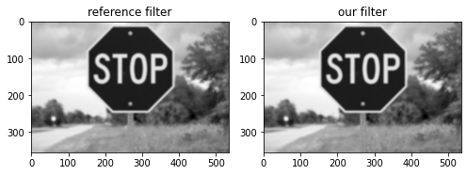
Explain your results here.

Answer 4
It is possible to see by the image comparison above that the we got a similar visual results as the reference function shows. both of the images have the same size. We also compared our results numerically as mentioned above - RMS error between our function and the built-in function is ~ 0 (e-14).

2. You will now investigate two methods for image filtering:
- Direct method (using convolution, in spatial domain) - which you have already implemented.
- Indirect method (using DFT, in frequency domain).
- Write a function called my_fft_filter2d(img,kernel). \ Your function should compute the filtered image through the following steps:
Pad with zeros both image and kernel to desired dimensions (what should they be?) \ Compute 2D DFT of padded image and kernel. \ Perform pointwise multiplication. \ Retrieve filtered image through computing IDFT.
def my_fft_filter2d(img,kernel,mode = 'valid'):
# Insert your implementaion here
if kernel.shape[0]%2 == 0 :
s1,s2 = int(kernel.shape[0]/2)-1,int(kernel.shape[1]/2)-1 # kernel shape is even in example 6x6
if kernel.shape[0]%2 != 0 :
s1,s2 = int(kernel.shape[0]/2),int(kernel.shape[1]/2) # kernel shape is odd in example 5x5
sz = tuple([img.shape[0]+kernel.shape[0]-1,img.shape[1]+kernel.shape[1]-1])
H = np.fft.fft2(kernel, s = sz)
F = np.fft.fft2(img, s = sz)
G = F * H
g = np.abs(np.fft.ifft2(G))
if mode == 'valid':
img_filtered = g[kernel.shape[0]-1:img.shape[0],kernel.shape[1]-1:img.shape[1]]
if mode == 'same':
img_filtered = g[s1:(img.shape[0]+s1),s2:(img.shape[1]+s2)]
if mode == 'full':
img_filtered = g[0:(img.shape[0]+kernel.shape[0]-1), 0:(img.shape[1]+kernel.shape[1]-1)]
return img_filtered
- Test your function!
Use the previously given blur kernel and the reference convolve2d function. \ Make sure both methods produce the same results, both numerically and qualitatively.
- What is purpose of the 'mode' argument in calling signal.convolve2d?
m = 'full'
img_filtered_ref = signal.convolve2d(img, blur_kernel,mode = m)
img_filtered_dft = my_fft_filter2d(img,blur_kernel,mode = m)
print("The RMS error between convolve2d to my_fft_filter2d {}\n".format(calc_RMS(img_filtered_ref,img_filtered_dft)))
fig, ax = plt.subplots(nrows=1, ncols=2, figsize=(7, 7))
ax = ax.ravel()
ax[0].imshow(img_filtered_ref, cmap='gray')
ax[0].set_title('reference filter'), ax[0].axis('on')
ax[1].imshow(img_filtered_dft, cmap='gray')
ax[1].set_title('our DFT filter')
plt.tight_layout()
plt.show()
The RMS error between convolve2d to my_fft_filter2d 8.627036774327608e-14
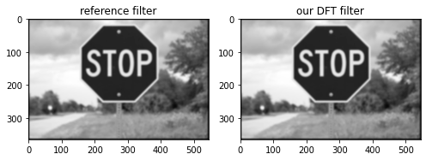
Explain your results here.

Answer 5
In the Direct method (using convolution in the spatial domain) we implemented a linear convolution. Now, we want to do the same in the frequency domain. We learned in class that the multiplication between the fft of the image and the fft of the kernel is equal to circular convolution in the spatial domain (and not a linear convolution as we implemented). In order to make that the linear and the circular convolutions will converge, we need to pad the kernel and the image to the size: [image_size + kernel_size - 1] in each axis.
The mode argument defines the output size and shape of the 2D convolution. There are 3 options to choose in this mode - full, same and valid. We implemented the my_fft_filter2d such that it will support all the mode options and we can see by the result that the MSE error is ~ 0 and the images are the same.
3. Observe the following filters. \ Apply all the filters on your image (you may choose which method to use). \ Determine which filters are high pass filters and which are low pass filters.
# simple averaging filter without scaling parameter
mean_filter = np.ones((3,3))
# creating a guassian filter
x = cv2.getGaussianKernel(5,0.5)
gaussian = x*x.T
# different edge detecting filters
# scharr in x-direction
scharr = np.array([[-3, 0, 3],
[-10,0,10],
[-3, 0, 3]])
# sobel in x direction
sobel_x= np.array([[-1, 0, 1],
[-2, 0, 2],
[-1, 0, 1]])
# sobel in y direction
sobel_y= np.array([[-1,-2,-1],
[0, 0, 0],
[1, 2, 1]])
# laplacian
laplacian=np.array([[0, 1, 0],
[1,-4, 1],
[0, 1, 0]])
filters = [mean_filter, gaussian, laplacian, sobel_x, sobel_y, scharr]
filter_name = ['mean_filter', 'gaussian','laplacian', 'sobel_x', \
'sobel_y', 'scharr_x']
img_arr = []
fig, ax = plt.subplots(nrows=3, ncols=2, figsize=(10, 15))
ax = ax.ravel()
for f in range(len(filters)):
ax[f].imshow(my_fft_filter2d(img,filters[f]), cmap='gray')
ax[f].set_title(filter_name[f])
plt.tight_layout()
plt.show()
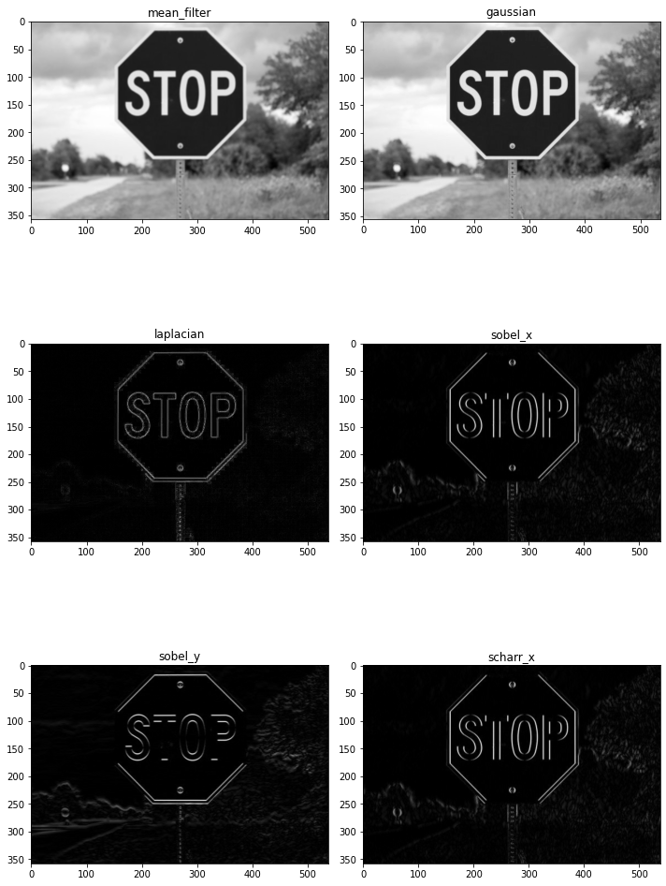
Insert your answers here

Answer 6
We know that edges are characterized by high frequencies in the image domain. So according to that in our case we can say that:
- mean_filter - this filter is bluring the edges --> low pass
- gaussian - this filter is bluring the edges --> low pass (as we expect to see according to the 1-D case)
- laplacian - this filter passes almost only the edges --> (strong) high pass
- sobel_x - it seems like this filter passes high frequencies in the x direction (horizontal) and low frequencies in the y directions (vertical)
- sobel_y - similar to sobel_x but in the oposite directions. --> low pass horizontal and high pass verticaly
- scharr_x - the filtered image seems very similar to sobel_x filter but a little bit sharper. --> high pass horizontal and low pass verticaly
In order to confirm our explanation, we also attached polts of the filters' DFT below.

fig, ax = plt.subplots(nrows=3, ncols=2, figsize=(5, 7.5))
ax = ax.ravel()
for f in range(len(filters)):
B = np.fft.fft2(filters[f])
log_magnitude_B= 20*np.log(np.abs(B)+1) # add 1 - in order to prevent log(0)
B_fftshift=np.fft.fftshift(B)
log_magnitude_B_fftshift= 20*np.log(np.abs(B_fftshift)+1)
ax[f].imshow(log_magnitude_B_fftshift, cmap='gray')
ax[f].set_title(filter_name[f])
plt.tight_layout()
plt.show()
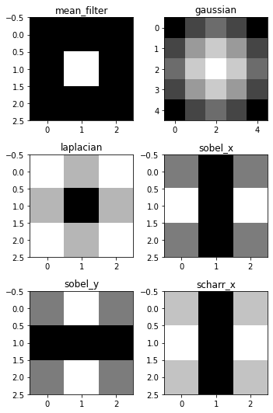

Part 3 – Unsharp Masking (USM)

1. Use the supplied function unsharp_masking_demo.
- Test the function with the image of your choice. Optimize lambda1 and lambda2 for your image.
- Explain the two different sharpening techniques used in the demo and your results.
- Specifically, note that a LPF is used for sharpenning images (Unsharp).
def unsharp_masking_demo(img):
# Obtain blurred image using convolution in spatial domain
blur_kernel = (1.0/36)*np.ones((6,6))
img_blurred = transform.resize(signal.convolve2d(img,blur_kernel),(img.shape[0],img.shape[1]))
# Perform unsharp masking using Laplacian filter
lambda1=1.2; lambda2=1.2
img_laplace = cv2.Laplacian(img,cv2.CV_64F)
img_enhanced_edges = img-lambda1*img_laplace
# Perform unsharp masking using the low pass filtered image with parameter lambda2.
img_unsharp = img+lambda2*(img-img_blurred)
# Display the results
fig, axes = plt.subplots(nrows=2, ncols=2, figsize=(8, 8))
ax = axes.ravel()
ax[0].imshow(img, vmin=0,vmax=255,cmap='gray')
ax[0].set_title('Original image'), ax[0].axis('off')
ax[1].imshow(img_blurred,vmin=0,vmax=255, cmap='gray')
ax[1].set_title('Blurred image'), ax[1].axis('off')
ax[2].imshow(img_enhanced_edges, vmin=0,vmax=255, cmap='gray')
ax[2].set_title('Image after laplacian edge enhancement'), ax[2].axis('off')
ax[3].imshow(img_unsharp, vmin=0,vmax=255,cmap='gray')
ax[3].set_title('Image after low pass based unsharp masking'), ax[3].axis('off')
plt.tight_layout()
Insert your explanation here

Answer 7
The unsharp_masking_demo function uses 2 different techniques to sharpening our image.
The first method takes an image and applies strong high pass filter on it, then it subtracts this filtered image (multiplied by a factor) from the original images. In bottom line, it takes an image and subtract the high frequencies from it.
The other method takes an image and applies average low pas filter on it, then it subtracts this filtered image from the original images and finally add it (multiplied by a factor) to the original image. Which means that it takes the original image and add to it the also the high frequency component that was generated by subtract the low frequencies from the original image on the first step.
Since both of the functions actually to the same, the lambdas factors give similar results when they are on the same size.

unsharp_masking_demo(img)
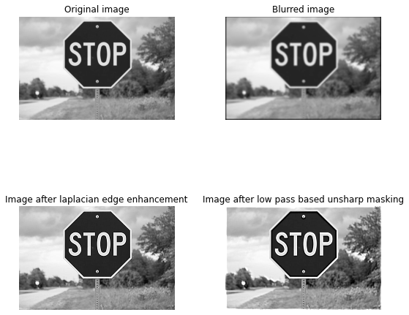
2. Implement unsharp masking using python’s function skimage.filters.unsharp_mask
enhanced image = original + amount * (original - blurred)
from skimage.filters import unsharp_mask
result_1 = unsharp_mask(img, radius=1, amount=1)
result_2 = unsharp_mask(img, radius=5, amount=2)
result_3 = unsharp_mask(img, radius=20, amount=1)
fig, axes = plt.subplots(nrows=2, ncols=2,
sharex=True, sharey=True, figsize=(10, 10))
ax = axes.ravel()
ax[0].imshow(img, cmap=plt.cm.gray)
ax[0].set_title('Original image')
ax[1].imshow(result_1, cmap=plt.cm.gray)
ax[1].set_title('Enhanced image, radius=1, amount=1.0')
ax[2].imshow(result_2, cmap=plt.cm.gray)
ax[2].set_title('Enhanced image, radius=5, amount=2.0')
ax[3].imshow(result_3, cmap=plt.cm.gray)
ax[3].set_title('Enhanced image, radius=20, amount=1.0')
for a in ax:
a.axis('off')
fig.tight_layout()
plt.show()
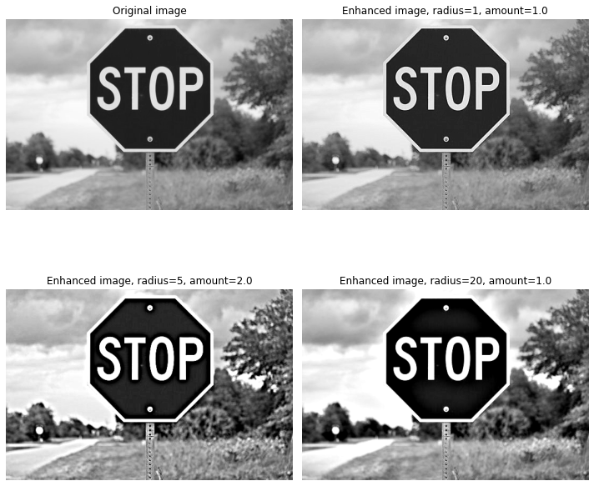
Provide a short explanation
Insert your explanation here

#### Answer 8
Unsharp masking is a linear image processing technique which sharpens the image. The sharp details are identified as a difference between the original image and its blurred version. These details are then scaled, and added back to the original image by the following formula:
enhanced image = original + amount * (original - blurred)
we can see that amount parameter is used as the weight of the difference between the original image and the blurred one. Since this function uses Gaussian filter to bluer the image, the radius input is refer to the sigma of the filter.
In our experiment we can see that as greater the radius (sigma) as sharper the image. But when we increased the amount, we also got well performance even though the radius was smaller than the latest image.

