Image Processing Lab

2022-2023
Group #8

Experiment #5 Final Report

Pair No. 43
ID1: 301613501
ID2: 208560086

Lab 5 - Image Restoration

Goal: Introduction to image restoration
--- Make sure you are using GPU accelerator in Colab Runtime ---
Mount Google drive
from google.colab import drive
drive.mount('/content/drive/')
%cd '/content/drive/My Drive/IP Labs/5/'
%ls
import os
path = os.getcwd()
print('path: ' + path)
Mounted at /content/drive/
/content/drive/My Drive/IP Labs/5
BoatsColor.jpg ex5_pre_code.ipynb Lab5.ipynb 'Lab 5 Manual.pdf' net.pth
path: /content/drive/My Drive/IP Labs/5
Import the necessary libraries
%matplotlib inline
import numpy as np
from skimage.util import random_noise
import matplotlib.pyplot as plt
from skimage import transform,io,util,img_as_float, img_as_ubyte
from skimage.color import rgb2gray
from skimage import restoration
import cv2
import random
from scipy import signal,ndimage
class Images():
def __init__(self, image, title):
self.image = image
self.title = title
def plotImages(images,dim, size=(20, 15)):
fig, ax = plt.subplots(dim[0],dim[1],figsize=size)
ax = ax.ravel()
for i,image in enumerate(images):
ax[i].imshow(image.image, cmap='gray',vmin = 0,vmax = 255)
ax[i].set_title(image.title)
ax[i].set_xlabel('Width [px]')
ax[i].set_ylabel('Height [px]')
plt.tight_layout()
plt.show()

Part 1 - Median Filter

- Insert your implementaion from the preliminary report to add salt and pepper noise to an image:
# Insert your answer here
def sp_noise(image,p):
'''
Add salt and pepper noise to image
prob: Probability of the noise
'''
p = p/2
noisy = image.copy()
rnd = np.random.rand(image.shape[0], image.shape[1])
noisy[rnd < p] = 0
noisy[rnd > 1 - p] = 255
return noisy
- Load a grayscale uint8 image
# Insert your answer here
img = rgb2gray(io.imread('BoatsColor.jpg'))
img = img_as_ubyte(img)
print ('Image shape:{}, Image data type:{}'.format(img.shape,img.dtype))
plt.imshow(img, cmap = 'gray')
plt.xticks([]), plt.yticks([]) # to hide tick values on X & Y axis
plt.show()
Image shape:(576, 787), Image data type:uint8
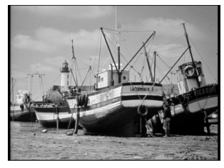

- Add to image salt and pepper noise with different p values - 1%, 5%, 10%. Show the outputs. Print a small patch from every image such that the noise can be seen clearly (total 6 images).

# Insert your answer here
noisy_img = []
P = [0.01,0.05,0.1]
for p in P :
noisy_img.append(Images(sp_noise(img,p)," Noisy Image with Probability = " + str(p) ))
for p in P :
noisy_img.append(Images(sp_noise(img,p)[100:200,300:400]," Noisy Image with Probability = " + str(p) ))
plotImages(noisy_img, [2,3], (15, 10))
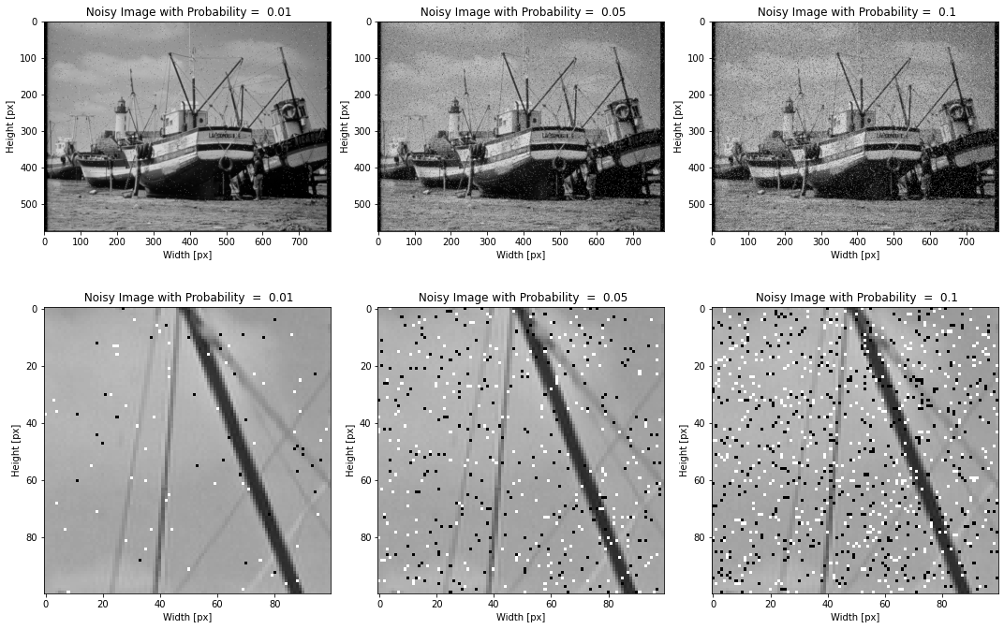
- Apply a median filter on the 3 noisy images to reduce the noise. You may choose different values for the kernel_size parameter. Print the results. Print 3 pairs of patches with same indexing, where the first patch is from the noisy image and the second is from filtered image. Did the filter work? Explain the edge conservation property of the median filter in relation to your results.

# Insert your answer here
filtered_img = [] # append the noisy img
K = [5,5,9]
for i in range(0,3) :
iltered_img.append(Images(cv2.medianBlur(noisy_img[i].image,K[i])[100:200,300:400]," Filtered Image with K = " + str(K[i]) + " and P = " + str(P[i]) ))
plotImages(noisy_img[3:6], [1,3], (12, 12))
plotImages(filtered_img, [1,3], (12, 12))
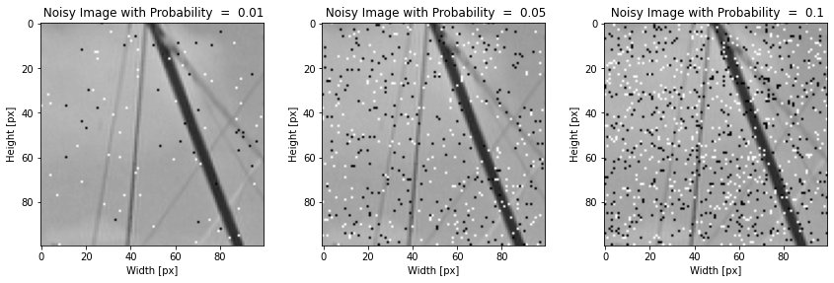
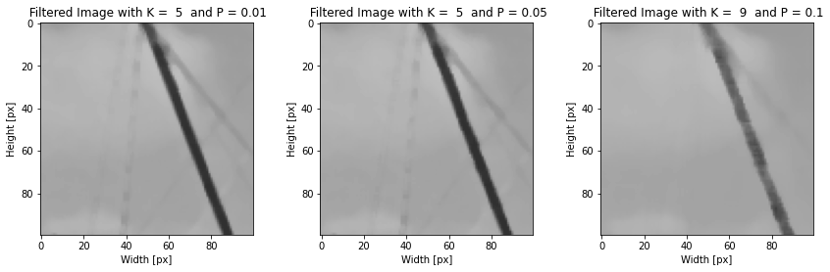

Answer 1
Like the mean filter, the median filter considers each pixel in the image in turn and looks at its nearby neighbors to decide whether or not it is representative of its surroundings. it replaces it with the median of those values. In general, the median filter allows a great deal of removing noise on images where less than half of the pixels in a smoothing neighborhood have been affected. let’s demonstrate a 3x3 kernel - first
we sort all the 9 pixels, then in the case of paper noise (pixel that changed to 0) the median filter fails if the fifth pixel equal 0, but the fifth pixel will be 0 if at least 5 out of 9 pixels are also 0 (because the 9 pixels are sorted) that’s mean that the probability to fail its (p/2) ^5. of course, same apply for the salt noise (255 instead of 0). In addition, since the median value must actually be the value of one of the pixels in the neighborhood, the median filter does not create new unrealistic pixel values when the filter straddles an edge. For this reason, the median filter is much better at preserving sharp edges than the mean filter. we can see in our result that the median filter preserving sharp edges. When the noise density is increased in order to completely remove the noise. we will need to increase the kernel size in that case serious blurring occurs at the edges.

Part 2 - Inverse Filter
- Insert your implementaion from preliminary report - add blurring and Gaussian noise to image:
# The function return two images: a blurred image
# and an image after blurring and noise adding
def AddBlurreAndNoise_TIME(img, filter_blur,v=0.01):
# Insert your implementaion here
img_blurre = cv2.filter2D(img, -1, filter_blur,borderType = 0)
img_blurre_noise = random_noise(img_blurre, mode='gaussian', var=v)
return img_blurre, img_blurre_noise
def my_fft_filter2d(img,kernel,mode = 'valid'):
sz = tuple([img.shape[0]+kernel.shape[0]-1,img.shape[1]+kernel.shape[1]-1])
H = np.fft.fft2(kernel, s = sz)
F = np.fft.fft2(img, s = sz)
G = F * H
g = np.abs(np.fft.ifft2(G))
if mode == 'valid':
img_filtered = g[kernel.shape[0]-1:img.shape[0],kernel.shape[1]-1:img.shape[1]]
if mode == 'same':
if kernel.shape[0]%2 == 0 :
s1,s2 = int(kernel.shape[0]/2)-1,int(kernel.shape[1]/2)-1 # kernel shape is even in example 6x6
if kernel.shape[0]%2 != 0 :
s1,s2 = int(kernel.shape[0]/2),int(kernel.shape[1]/2) # kernel shape is odd in example 5x5
img_filtered = g[s1:(img.shape[0]+s1),s2:(img.shape[1]+s2)]
if mode == 'full':
img_filtered = g[0:(img.shape[0]+kernel.shape[0]-1), 0:(img.shape[1]+kernel.shape[1]-1)]
return img_filtered

Note
for better understanding we will implement also blurring and noise in the frequency domain because in this exercise all the filters are in the frequency domain
def AddBlurreAndNoise_FREQUENCY(img, filter_blur,v=0.01):
# Insert your implementaion here
img_blurre = my_fft_filter2d(img,filter_blur,'same')
img_blurre_noise = random_noise(img_blurre, mode='gaussian', var=v)
return img_blurre, img_blurre_noise
- Load image as float64:
img = io.imread('BoatsColor.jpg', as_gray = True)
img = img_as_float(img) #keep this line!
print ("Image shape:{}, Image data type:{}".format(img.shape,img.dtype))
# Use gaussian kernel for burring the image
# gaussian kernel is separable function
filter_blur = cv2.getGaussianKernel(ksize=5,sigma=1.85)*cv2.getGaussianKernel(ksize=5,sigma=1.85).T
blurred, noise = AddBlurreAndNoise_TIME(img,filter_blur)
blurred_F, noise_F = AddBlurreAndNoise_FREQUENCY(img,filter_blur)
plt.figure(figsize=(20,10))
plt.subplot(131),plt.imshow(img, cmap='gray'),plt.title('Original')
plt.xticks([]), plt.yticks([])
plt.subplot(132),plt.imshow(blurred, cmap='gray'),plt.title('Blurred')
plt.xticks([]), plt.yticks([])
plt.subplot(133),plt.imshow(noise, cmap='gray'),plt.title('Blurred + Noised')
plt.xticks([]), plt.yticks([])
plt.show()
Image shape:(576, 787), Image data type:float64
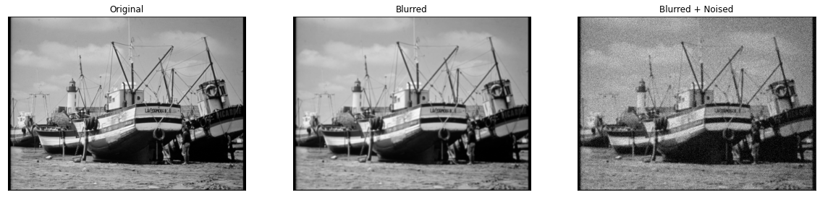
def calc_RMS(f, f_hat):
# Insert your code:
RMS = np.sqrt(np.mean((f-f_hat)**2))
return RMS
print("rms error between blurred to blurred_fft {}".format(calc_RMS(blurred,blurred_F)))
print("rms error between noise to noise_fft {}".format(calc_RMS(noise,noise_F)))
rms error between blurred to blurred_fft 1.8699135262791524e-16
rms error between noise to noise_fft 0.1359234879160902

Note
we can see that both the time domain filter and the frequency domain gave the same result: rms between the blurred images are e^-16
- Test the restoration with the Inverse Filter for deblurring and denoising
def InverseFilter(img,kernel,mode = 'valid'): #same as regular filter in frequency domain only need to add H_I = 1/H
sz = tuple([img.shape[0]+kernel.shape[0]-1,img.shape[1]+kernel.shape[1]-1])
H = np.fft.fft2(kernel, s = sz)
F = np.fft.fft2(img, s = sz)
H_I = 1/H
G = F*H_I
g = np.abs(np.fft.ifft2(G))
if mode == 'valid':
img_filtered = g[kernel.shape[0]-1:img.shape[0],kernel.shape[1]-1:img.shape[1]]
if mode == 'same':
if kernel.shape[0]%2 == 0 :
s1,s2 = int(kernel.shape[0]/2)-1,int(kernel.shape[1]/2)-1 # kernel shape is even in example 6x6
if kernel.shape[0]%2 != 0 :
s1,s2 = int(kernel.shape[0]/2),int(kernel.shape[1]/2) # kernel shape is odd in example 5x5
img_filtered = g[s1:(img.shape[0]+s1),s2:(img.shape[1]+s2)]
if mode == 'full':
img_filtered = g[0:(img.shape[0]+kernel.shape[0]-1), 0:(img.shape[1]+kernel.shape[1]-1)]
return img_filtered
denoise_Invert_img = InverseFilter(noise,filter_blur,'same')
plt.figure(figsize=(20,10))
plt.subplot(131),plt.imshow(img, cmap='gray'),plt.title('Original')
plt.xticks([]), plt.yticks([])
plt.subplot(132),plt.imshow(noise, cmap='gray'),plt.title('Blurred + Noised')
plt.xticks([]), plt.yticks([])
plt.subplot(133),plt.imshow(denoise_Invert_img, cmap='gray'),plt.title('After Invert Filter')
plt.xticks([]), plt.yticks([])
plt.show()

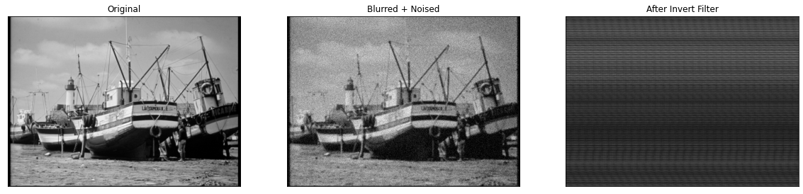
- What is the problem with the Inverse Filter? How can this be solved?
Insert your answer here

Answer 2
Let us call the fft of the kernel H and the fft of the original and noise images F and G respectively. We know that the noised image in the frequency domain G = FH + N (N is the fft of the noise) in the time domain g = f * h + n (* is convolution) H may have values that equal to zero (or close to zero), s.t. when we are using the inverse filter we are dividing the noise image's fft by H and we get: G/H = (FH + N) / H = F+N/H . In the values that close to zero the noise will explode to very large values. We can solve this problem by setting some threshold condition s.t every value under this TH in the H matrix will remain zero after the dividing operation. This solution called pseudo inverse.

Part 3 - Pseudo Inverse Filter
- Test the restoration with the Pseudo Inverse Filter for deblurring and denoising.

def PseudoInverseFilter(img, kernel, epsilon=0.5,mode = 'valid'):
sz = tuple([img.shape[0]+kernel.shape[0]-1,img.shape[1]+kernel.shape[1]-1])
H = np.fft.fft2(kernel, s = sz)
F = np.fft.fft2(img, s = sz)
H_I = 1/H
H_I[H<epsilon] = 0
G = F*H_I
g = np.abs(np.fft.ifft2(G))
if mode == 'valid':
img_filtered = g[kernel.shape[0]-1:img.shape[0],kernel.shape[1]-1:img.shape[1]]
if mode == 'same':
if kernel.shape[0]%2 == 0 :
s1,s2 = int(kernel.shape[0]/2)-1,int(kernel.shape[1]/2)-1 # kernel shape is even in example 6x6
if kernel.shape[0]%2 != 0 :
s1,s2 = int(kernel.shape[0]/2),int(kernel.shape[1]/2) # kernel shape is odd in example 5x5
img_filtered = g[s1:(img.shape[0]+s1),s2:(img.shape[1]+s2)]
if mode == 'full':
img_filtered = g[0:(img.shape[0]+kernel.shape[0]-1), 0:(img.shape[1]+kernel.shape[1]-1)]
return img_filtered
epsilon = 0.5
denoise_pseudo_img = PseudoInverseFilter(noise,filter_blur,epsilon,'same')
plt.figure(figsize=(20,10))
plt.subplot(131),plt.imshow(img, cmap='gray'),plt.title('Original')
plt.xticks([]), plt.yticks([])
plt.subplot(132),plt.imshow(noise, cmap='gray'),plt.title('Blurred + Noised')
plt.xticks([]), plt.yticks([])
plt.subplot(133),plt.imshow(denoise_pseudo_img, cmap='gray'),plt.title('After Pseudo Invert Filter, eps = {}'.format(epsilon))
plt.xticks([]), plt.yticks([])
plt.show()
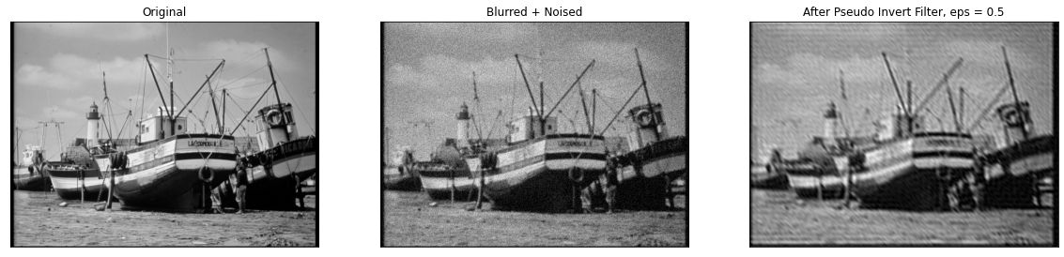
The Root Mean Square (RMS) error of restoration is defined in the following way: \begin{equation} RMS = \left( \frac{1}{MN} \sum_{k=0}^{M-1} \sum_{k=0}^{N-1} (\hat{f}(i,j)-f(i,j))^2 \right)^{0.5} \end{equation}
where 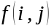 is the original image, 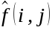 is the restored image and 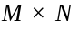 is the size of both images.
def calc_RMS(f, f_hat):
# Insert your code:
RMS = np.sqrt(np.mean((f-f_hat)**2))
return RMS
- Plot the graph of the RMS error (Y axis) versus the parameter (X axis) . Use several values in the range 0-1
(the variance of the noise is fixed to the default value in the supplied program).
# Insert your code here
blurred, noise = AddBlurreAndNoise_TIME(img,filter_blur)
epsilons = np.arange(0.1, 1.1, 0.01).tolist()
rms = []
for e in epsilons :
denoise_pseudo_img = PseudoInverseFilter(noise,filter_blur,e,'same')
rms.append(calc_RMS(img,denoise_pseudo_img))
plt.plot(epsilons,rms)
plt.title('Root Mean Square error')
plt.xlabel(r'$\epsilon$')
plt.ylabel('RMS')
plt.show()
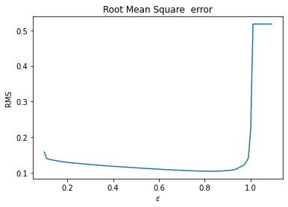
Show the result of the best restoration by the best epsilon value. (if it different than the previous shown result)

Note
This is the same epsilon value, so we don't show the image again.

3.Now fix the parameter 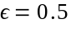. Plot the graph of the Root Mean Square (RMS) error of restoration (Y axis) versus the variance of the noise (X axis). And Show the result of the best restoration (Use several values in the range 0-1)
# Insert your code here
VARS = np.arange(0, 1, 0.01).tolist()
rms = []
for v in VARS :
blurred,noise = AddBlurreAndNoise_TIME(img,filter_blur,v)
denoise_pseudo_img = PseudoInverseFilter(noise,filter_blur,mode ='same')
rms.append(calc_RMS(img,denoise_pseudo_img))
# Insert your code here
plt.plot(VARS,rms)
plt.title('Root Mean Square error')
plt.xlabel('Variance')
plt.ylabel('RMS')
plt.show()
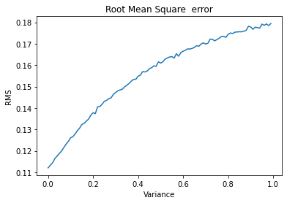
var=0
blurred , noise = AddBlurreAndNoise_TIME(img,filter_blur,var)
denoise_pseudo_img = PseudoInverseFilter(noise,filter_blur)
plt.figure(figsize=(20,10))
plt.subplot(131),plt.imshow(img, cmap='gray'),plt.title('Original')
plt.xticks([]), plt.yticks([])
plt.subplot(132),plt.imshow(noise, cmap='gray'),plt.title('Blurred + Noised')
plt.xticks([]), plt.yticks([])
plt.subplot(133),plt.imshow(denoise_pseudo_img, cmap='gray'),plt.title('Best Restoration for var = {}'.format(var))
plt.xticks([]), plt.yticks([])
plt.show()
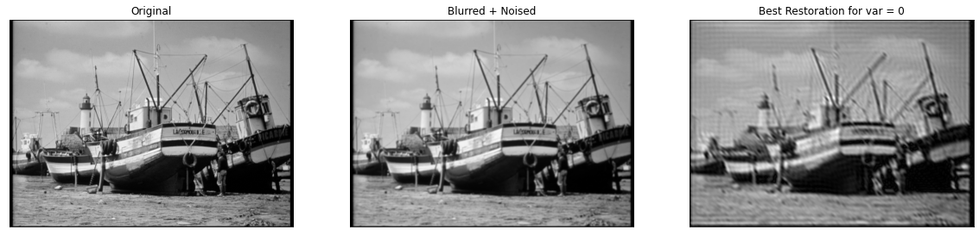
3.1. For what maximal value of the variance of the noise you still get an acceptable restoration? show the noisy and result plots
var = 0.05
blurred , noise = AddBlurreAndNoise_TIME(img,filter_blur,var)
denoise_pseudo_img = PseudoInverseFilter(noise,filter_blur)
plt.figure(figsize=(20,10))
plt.subplot(131),plt.imshow(img, cmap='gray'),plt.title('Original')
plt.xticks([]), plt.yticks([])
plt.subplot(132),plt.imshow(noise, cmap='gray'),plt.title('Blurred + Noised v = 0.1')
plt.xticks([]), plt.yticks([])
plt.subplot(133),plt.imshow(denoise_pseudo_img, cmap='gray'),plt.title('Acceptable restoration for var = {}'.format(var))
plt.xticks([]), plt.yticks([])
plt.show()
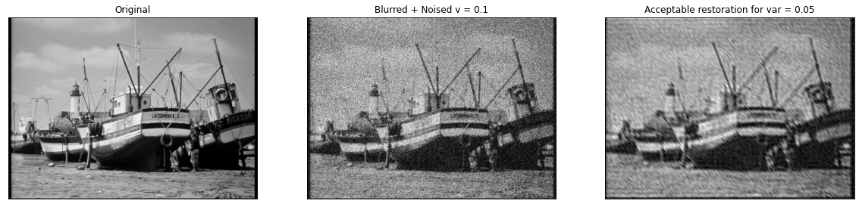

Answer 3
The maximal value of the variance of the noise we still get an acceptable restoration is 0.05.

Part 4 - Wiener Filter
- Test the restoration with the Wiener Filter for deblurring and denoising
Assume that the variance used in the Wiener filter formula is equal to the variance of the noise , and both of them are equal to 0.01 (for image in a range of 0-1) or 0.01 ∗ 255 (for image in a range of 0-255).
sigma_noise=0.01
blurred , noise = AddBlurreAndNoise_TIME(img,filter_blur,sigma_noise)
def WienerFilter(noise_img, kernel, sigma=0.01, alpha=0.095):
sz = tuple([noise_img.shape[0]+kernel.shape[0]-1,noise_img.shape[1]+kernel.shape[1]-1])
H = np.fft.fft2(kernel, s = sz)
G = np.fft.fft2(noise_img, s = sz)
K = np.conj(H) / (np.abs(H)**2 + sigma / alpha)
F = G * K
f_hat = np.real(np.fft.ifft2(F))
return f_hat[:noise_img.shape[0], :noise_img.shape[1]]
sigma = sigma_noise
alpha = 0.095
denoise_wiener_img = WienerFilter(noise,filter_blur,sigma, alpha)
plt.figure(figsize=(20,10))
plt.subplot(131),plt.imshow(img, cmap='gray'),plt.title('Original')
plt.xticks([]), plt.yticks([])
plt.subplot(132),plt.imshow(noise, cmap='gray'),plt.title('Blurre + Noise')
plt.xticks([]), plt.yticks([])
plt.subplot(133),plt.imshow(denoise_wiener_img, cmap='gray'),plt.title('After Wiener Filter: sigma = {}, alpha = {}'.format(sigma, alpha))
plt.xticks([]), plt.yticks([])
plt.show()
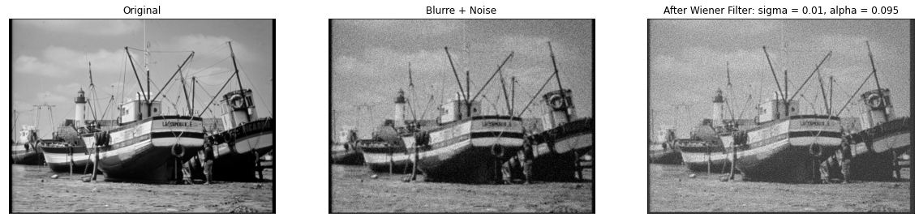
- Plot the graph of the Root Mean Square (RMS) error of restoration (Y axis) versus the parameter (X axis) (change only in the filter, the noise image stay the same, also no need to change alpha). Show the result of the best restoration.
# Insert your code here
sigmas = np.arange(0.0001, 0.5, 0.005).tolist()
a = 0.095
rms = []
for s in sigmas:
denoise_wiener_img = WienerFilter(noise,filter_blur,s, a)
rms.append(calc_RMS(img,denoise_wiener_img))
plt.plot(sigmas,rms)
plt.title('Root Mean Square error')
plt.xlabel('Sigma')
plt.ylabel('RMS')
plt.show()
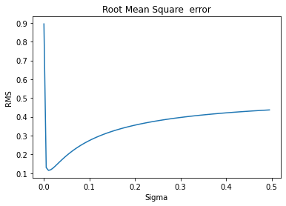

Note 2
We can see that the error graph behaves like a function f=1/x, as expected from the Winer filter form. Such that the optimal value we be given at variance = sigma = 0.01 as expected. Exactly where the variance of the noise.

sigma = 12
alpha = 0.095
denoise_wiener_img = WienerFilter(noise,filter_blur,sigma)
plt.figure(figsize=(20,10))
plt.subplot(131),plt.imshow(img, cmap='gray'),plt.title('Original')
plt.xticks([]), plt.yticks([])
plt.subplot(132),plt.imshow(noise, cmap='gray'),plt.title('Blurre + Noise')
plt.xticks([]), plt.yticks([])
plt.subplot(133),plt.imshow(denoise_wiener_img, cmap='gray'),plt.title('After Wiener Filter sigma = {}, alpha = {}'.format(sigma, alpha))
plt.xticks([]), plt.yticks([])
plt.show()
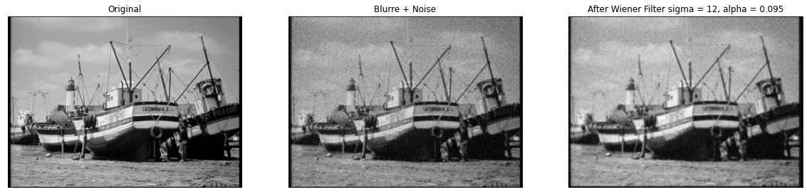

Part 5 - Deep learning (DnCNN)
- After using a few filters to restoration the image, Lets try with the new Deep learning approach and compare the results
For building the neural network we will use the PyTorch framwork
Because of a lack of time we aren't going to train the network here. We will use a pretrained model
First, a few more imports for using pytorch:
# run this
!pip3 install torch torchvision torchaudio
Looking in indexes: https://pypi.org/simple, https://us-python.pkg.dev/colab-wheels/public/simple/
Requirement already satisfied: torch in /usr/local/lib/python3.8/dist-packages (1.13.0+cu116)
Requirement already satisfied: torchvision in /usr/local/lib/python3.8/dist-packages (0.14.0+cu116)
Requirement already satisfied: torchaudio in /usr/local/lib/python3.8/dist-packages (0.13.0+cu116)
Requirement already satisfied: typing-extensions in /usr/local/lib/python3.8/dist-packages (from torch) (4.4.0)
Requirement already satisfied: pillow!=8.3.*,>=5.3.0 in /usr/local/lib/python3.8/dist-packages (from torchvision) (7.1.2)
Requirement already satisfied: requests in /usr/local/lib/python3.8/dist-packages (from torchvision) (2.25.1)
Requirement already satisfied: numpy in /usr/local/lib/python3.8/dist-packages (from torchvision) (1.21.6)
Requirement already satisfied: idna<3,>=2.5 in /usr/local/lib/python3.8/dist-packages (from requests->torchvision) (2.10)
Requirement already satisfied: certifi>=2017.4.17 in /usr/local/lib/python3.8/dist-packages (from requests->torchvision) (2022.12.7)
Requirement already satisfied: urllib3<1.27,>=1.21.1 in /usr/local/lib/python3.8/dist-packages (from requests->torchvision) (1.24.3)
Requirement already satisfied: chardet<5,>=3.0.2 in /usr/local/lib/python3.8/dist-packages (from requests->torchvision) (4.0.0)
import torch
import torch.nn as nn
from torch.autograd import Variable
Now we will define the architecture of the neural network.
We will implement the DnCNN architecture:
Here you can see the architecture is a class that inherits from nn.Module (pytorch module)
class DnCNN(nn.Module):
def __init__(self, channels, num_of_layers=17):
super(DnCNN, self).__init__()
kernel_size = 3
padding = 1
features = 64
layers = []
# first layer: conv2d -> Relu (for activation) :
layers.append(nn.Conv2d(in_channels=channels, out_channels=features, kernel_size=kernel_size, padding=padding, bias=False))
layers.append(nn.ReLU(inplace=True))
# then lets defined all the other hidden layer as: conv2d -> BatchNorm -> Relu
for _ in range(num_of_layers-2):
layers.append(nn.Conv2d(in_channels=features, out_channels=features, kernel_size=kernel_size, padding=padding, bias=False))
layers.append(nn.BatchNorm2d(features))
layers.append(nn.ReLU(inplace=True))
# and at the end: need to get back the image so conv2d with out_channels as in the original image:
layers.append(nn.Conv2d(in_channels=features, out_channels=channels, kernel_size=kernel_size, padding=padding, bias=False))
# insert all the layers in to Sequential that will pass the data in order
self.dncnn = nn.Sequential(*layers)
def forward(self, x):
# defined the forward pass of our network
out = self.dncnn(x)
return out
Note that we do not need to define the back propagation, as the Pytorch framework does that for us.
- What is the Conv in the network architecture? Give a brief explanation (up to 4 lines)

Answer 4
Specific Answer: The Conv in the code above is a 2D convolutional layer that applies a convolution operation over the input data using a set of 2D kernels.
General Answer: The convolutional layers use a set of learnable kernels (or filters) to extract features from input data by sliding the kernels over the input and performing element-wise multiplications and summations. The output of a convolutional layer is called a feature map and has a reduced spatial dimension compared to the input, since each output element is the result of a convolution of a local neighborhood in the input.

After building the network architecture, we need to load the pretrained model and feed it the noisy image:
def DnCNN_network(noise_img, num_of_layers=17, model_path='net.pth'):
print('Loading model ...')
# defined the network, use the class we create above
net = DnCNN(channels=1, num_of_layers=num_of_layers)
traind_model = nn.DataParallel(net)
# load pretrain model
pretraind = torch.load(model_path)
# get the state of the model (weights + baises ...)
traind_model.load_state_dict(pretraind)
traind_model.double()
# say to pytorch that we juist want to test the model (not tarin it)
traind_model.eval()
print('Loaded\n')
# Expend dim for using the network:
noise_img = np.expand_dims(noise_img, 0) # batch dim
noise_img = np.expand_dims(noise_img, 1) # channels dim
# cast to tensor variable
noise_img = torch.DoubleTensor(noise_img)
INoisy = Variable(noise_img)
with torch.no_grad(): # this can save much memory
print("Inserting the noisy image...\n")
the_noise_that_we_learned = traind_model(INoisy)
plt.imshow(the_noise_that_we_learned.cpu().squeeze(), cmap='gray'),plt.title('The noise that the network predict')
plt.show()
Out = torch.clamp(INoisy.cpu() - the_noise_that_we_learned.cpu(), 0., 1.)
return Out.squeeze()
- Explain the following line in the code. Why do we need this line?
Out = torch.clamp(INoisy.cpu() - the_noise_that_we_learned.cpu(), 0., 1.)

Answer 5
The model is predicting the noise. Therefore, this line is subtracting the noise prediction made by the trained model from the input noisy image, element-wise. The clamp function is then applied to the result to ensure that all elements are between 0 and 1 (the range of valid pixel values for a grayscale image). This is done to ensure that the output image is a valid image with pixel values in the expected range.
The clamp function limits the minimum and maximum values that an element in the input tensor can take. In this case, it is ensuring that the output image has pixel values between 0 and 1 by setting all values below 0 to 0 and all values above 1 to 1.

Now let's use the neural network and show the results:
denoise_dncnn_img = DnCNN_network(noise)
plt.figure(figsize=(20,10))
plt.subplot(131),plt.imshow(img, cmap='gray'),plt.title('Original')
plt.xticks([]), plt.yticks([])
plt.subplot(132),plt.imshow(noise, cmap='gray'),plt.title('Blurre + Noise')
plt.xticks([]), plt.yticks([])
plt.subplot(133),plt.imshow(denoise_dncnn_img, cmap='gray'),plt.title('After substract the noise that learned')
plt.xticks([]), plt.yticks([])
plt.show()
Loading model ...
Loaded
Inserting the noisy image...
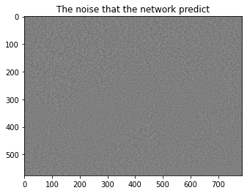
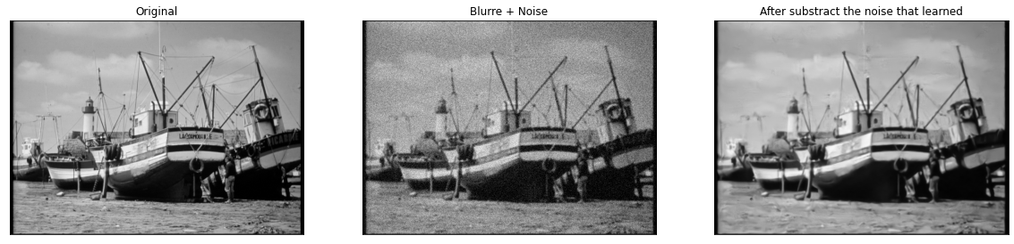

Part 6 - Comparison
- Lets compare the results from all the methods that we used in this lab:
Show the best image after restoration from all the methods (Pseudo Invers Filter, Wiener Filter, DnCNN). which one do you think is better?
# Insert your code here
blurred , noise = AddBlurreAndNoise_TIME(img,filter_blur,0.01)
denoise_pseudo_img = PseudoInverseFilter(noise,filter_blur,mode = 'same')
denoise_wiener_img = WienerFilter(noise,filter_blur,15)
denoise_dncnn_img = DnCNN_network(noise)
plt.figure(figsize=(20,10))
plt.subplot(131),plt.imshow(denoise_pseudo_img, cmap='gray'),plt.title('Pseudo Invers Filter')
plt.xticks([]), plt.yticks([])
plt.subplot(132),plt.imshow(denoise_wiener_img, cmap='gray'),plt.title('Wiener Filter')
plt.xticks([]), plt.yticks([])
plt.subplot(133),plt.imshow(denoise_dncnn_img, cmap='gray'),plt.title('DnCNN')
plt.xticks([]), plt.yticks([])
plt.show()
Loading model ...
Loaded
Inserting the noisy image...
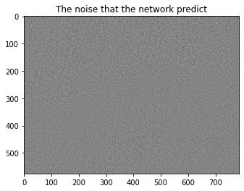
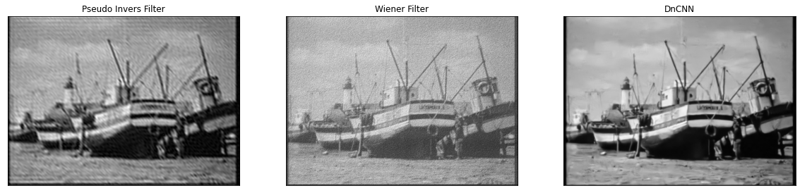

Answer 6
It easy clearly to see that the DnCNN give much better results :)

Now we will use a quantitive metric to examine the reconstruction. We will use Structural similarity index (ssim). You may read about it online. ssim 1 means exact reconstruction, ssim 0 means worst reconstruction.
from skimage.metrics import structural_similarity as ssim
def calc_ssim(original_image, reconstract_image):
original_image = img_as_float(original_image)
reconstract_image = img_as_float(reconstract_image)
ssim_metric = ssim(original_image, reconstract_image,
data_range=original_image.max() - original_image.min())
return ssim_metric
- Make a quantitive comparison of the reconstruction of all metheds (Pseudo Invers Filter, Wiener Filter, DnCNN). You may use the provided method. Print the ssim metric for each reconstruction method. Which one is the best?
# Insert your answer here
print("The ssim metric is:\n Pseudo Inverse Filter,: {}\n Wiener Filter: {}\n DnCNN: {}".format(calc_ssim(img,denoise_pseudo_img)
,calc_ssim(img,denoise_wiener_img), calc_ssim(img,denoise_dncnn_img)))
The ssim metric is:
Pseudo Inverse Filter,: 0.4203926130762024
Wiener Filter: 0.2694596830516761
DnCNN: 0.7512529844382666

Answer 7
The best restoration according to the SSIM metric:
- DnCNN
- Pseudo Inverse Filter
- Wiener Filter
The best result of the DnCNN is expected according to the comparison above, but the fact that the Pseudo Inverse filter is better then the Wiener was not expected since the image of the winner filter seen more acceptable than the Pseudo Inverse one.

