**COVID-19 PANDEMIC AND EDUCATION**

**ABSTRACT**

More than 1 billion children are at risk of falling behind due to school closures aimed at containing the spread of COVID-19. To keep the world’s children learning, countries have been implementing remote education programs. Yet many of the world’s children – particularly those in poorer households – do not have internet access, personal computers, TVs or even radio at home, amplifying the effects of existing learning inequalities. Students lacking access to the technologies needed for home-based learning have limited means to continue their education. As a result, many face the risk of never returning to school, undoing years of progress made in education around the world.

**SCHOOL CLOSURES**

With school closures across 188 countries (as of April 2020), many of them are exploring alternative ways to provide continuous education using technologies such as Internet, TV, and radio. However, access to these technologies is limited in many low- and middle-income countries, especially among poor households.

* While more than 90 per cent of the countries adopted digital and/or broadcast remote learning policies, only 60 per cent did so for pre-primary education. [[†]](https://data.unicef.org/resources/remote-learning-reachability-factsheet/)
* Policy measures taken by the governments to ensure learning continuity through broadcast or digital media allowed for potentially reaching 69 per cent of schoolchildren (at maximum) in pre-primary to secondary education globally.
* 31 per cent of schoolchildren worldwide (463 million) cannot be reached by the broadcast- and Internet-based remote learning policies either due to the lack of necessary technological assets at home, or because they were not targeted by the adopted policies.
* Online platforms were the most used means by the governments to deliver education while schools remain closed, with 83 per cent of countries using this method. However, this allowed for potentially reaching only about a quarter of schoolchildren worldwide.
* Television had the potential to reach the most students (62 per cent) globally.
* Only 16 per cent of schoolchildren could be reached by radio-based learning worldwide.
* Globally, 3 out of 4 students who cannot be reached by the remote learning policies come from rural areas and/or belong to the poorest households.

Considering these data, it is important that countries do not rely on any single remote learning channel to reach *all* children. Additionally, expanding access to Internet and other digital solutions for all children would be one key long-term priority to reduce learning vulnerabilities.

**COUNTRIES & CLOSES ENSUREMENT**

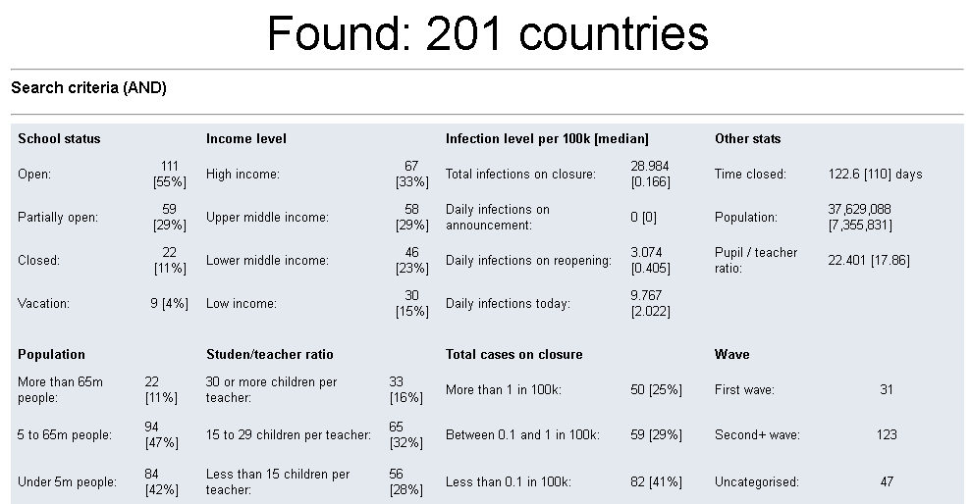

We observe that education activities are closed during the pandemic process in more than two hundred countries. Also, according to these data, we can deduce that they have switched to distance education.

**AFFECTED UNIVERSITY AND OTHER ALL STUDENTS**

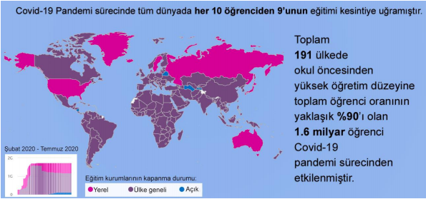

In this chart, we observe the number of students affected by the pandemic process worldwide .Also, The number of students affected by the interruption of education has reached approximately 25 million students in Turkey.