Impact of 6G Network Performance on Manufacturing Efficiency in Smart Factories
Research Paper
6G Smart Factory Dashboard – Simulation-Based Study

Abstract
Smart manufacturing requires fast and dependable communication between machines, sensors, robots, and industrial control systems. Sixth-generation (6G) wireless communication is expected to provide extremely low latency, high reliability, high throughput, intelligent network management, and integrated sensing capabilities. This paper presents a simulation-based framework for studying how 6G network performance can influence manufacturing efficiency in smart factories. A synthetic dataset is generated for network latency, reliability, throughput, production rate, machine utilization, overall equipment effectiveness (OEE), defect rate, downtime, and energy consumption. A Streamlit dashboard is developed to visualize these indicators and investigate relationships between communication performance and manufacturing outcomes. The results are illustrative simulation results rather than measurements from a real 6G factory.

1. Introduction
The development of smart factories has increased the need for fast, dependable, and intelligent wireless communication. Industrial robots, autonomous mobile robots, sensors, machine tools, digital twins, and automated inspection systems generate large volumes of time-sensitive data. Communication delays or interruptions can affect coordination, production continuity, and quality.
6G is being investigated as a future wireless technology for industrial automation because of its potential for ultra-reliable low-latency communication, high data rates, artificial intelligence-assisted network management, integrated sensing, and flexible connectivity. This study develops a dashboard-based prototype connecting 6G performance indicators with manufacturing KPIs.

2. Research Objectives
- Examine 6G latency, reliability, and throughput in smart-factory communication.
- Relate network indicators to production rate, OEE, utilization, quality, and downtime.
- Develop a visual analytics dashboard for network and manufacturing monitoring.
- Use correlation and scatter analysis to investigate relationships between 6G and manufacturing metrics.
- Provide a framework for future testing with real industrial and 6G measurements.

3. Literature Review

3.1 6G Wireless Communication
Recent 6G research describes future networks designed to support demanding applications through improved reliability, latency, capacity, intelligence, and sensing. Artificial intelligence, edge computing, network virtualization, and advanced spectrum technologies are important enabling technologies.

3.2 6G for Industrial Automation
Industrial automation places strict requirements on communication reliability and latency. 6G research identifies robotics, closed-loop control, collaborative machines, and industrial sensing as important use cases.

3.3 Wireless Communication in Smart Manufacturing
Smart manufacturing combines industrial communication, Industrial Internet of Things devices, sensors, automation systems, and analytics. Wireless technologies can support flexible production environments, while reliability and deterministic performance remain important challenges.

3.4 Latency and Digital Twins
Digital-twin systems require timely data exchange between physical equipment and digital representations. Latency across sensing, communication, processing, and application layers can influence smart-manufacturing responsiveness.

4. Proposed Methodology
The methodology consists of synthetic data generation, preprocessing, KPI calculation, visualization, relationship analysis, and automated insight generation. The prototype uses Python, Pandas, NumPy, Plotly, and Streamlit.
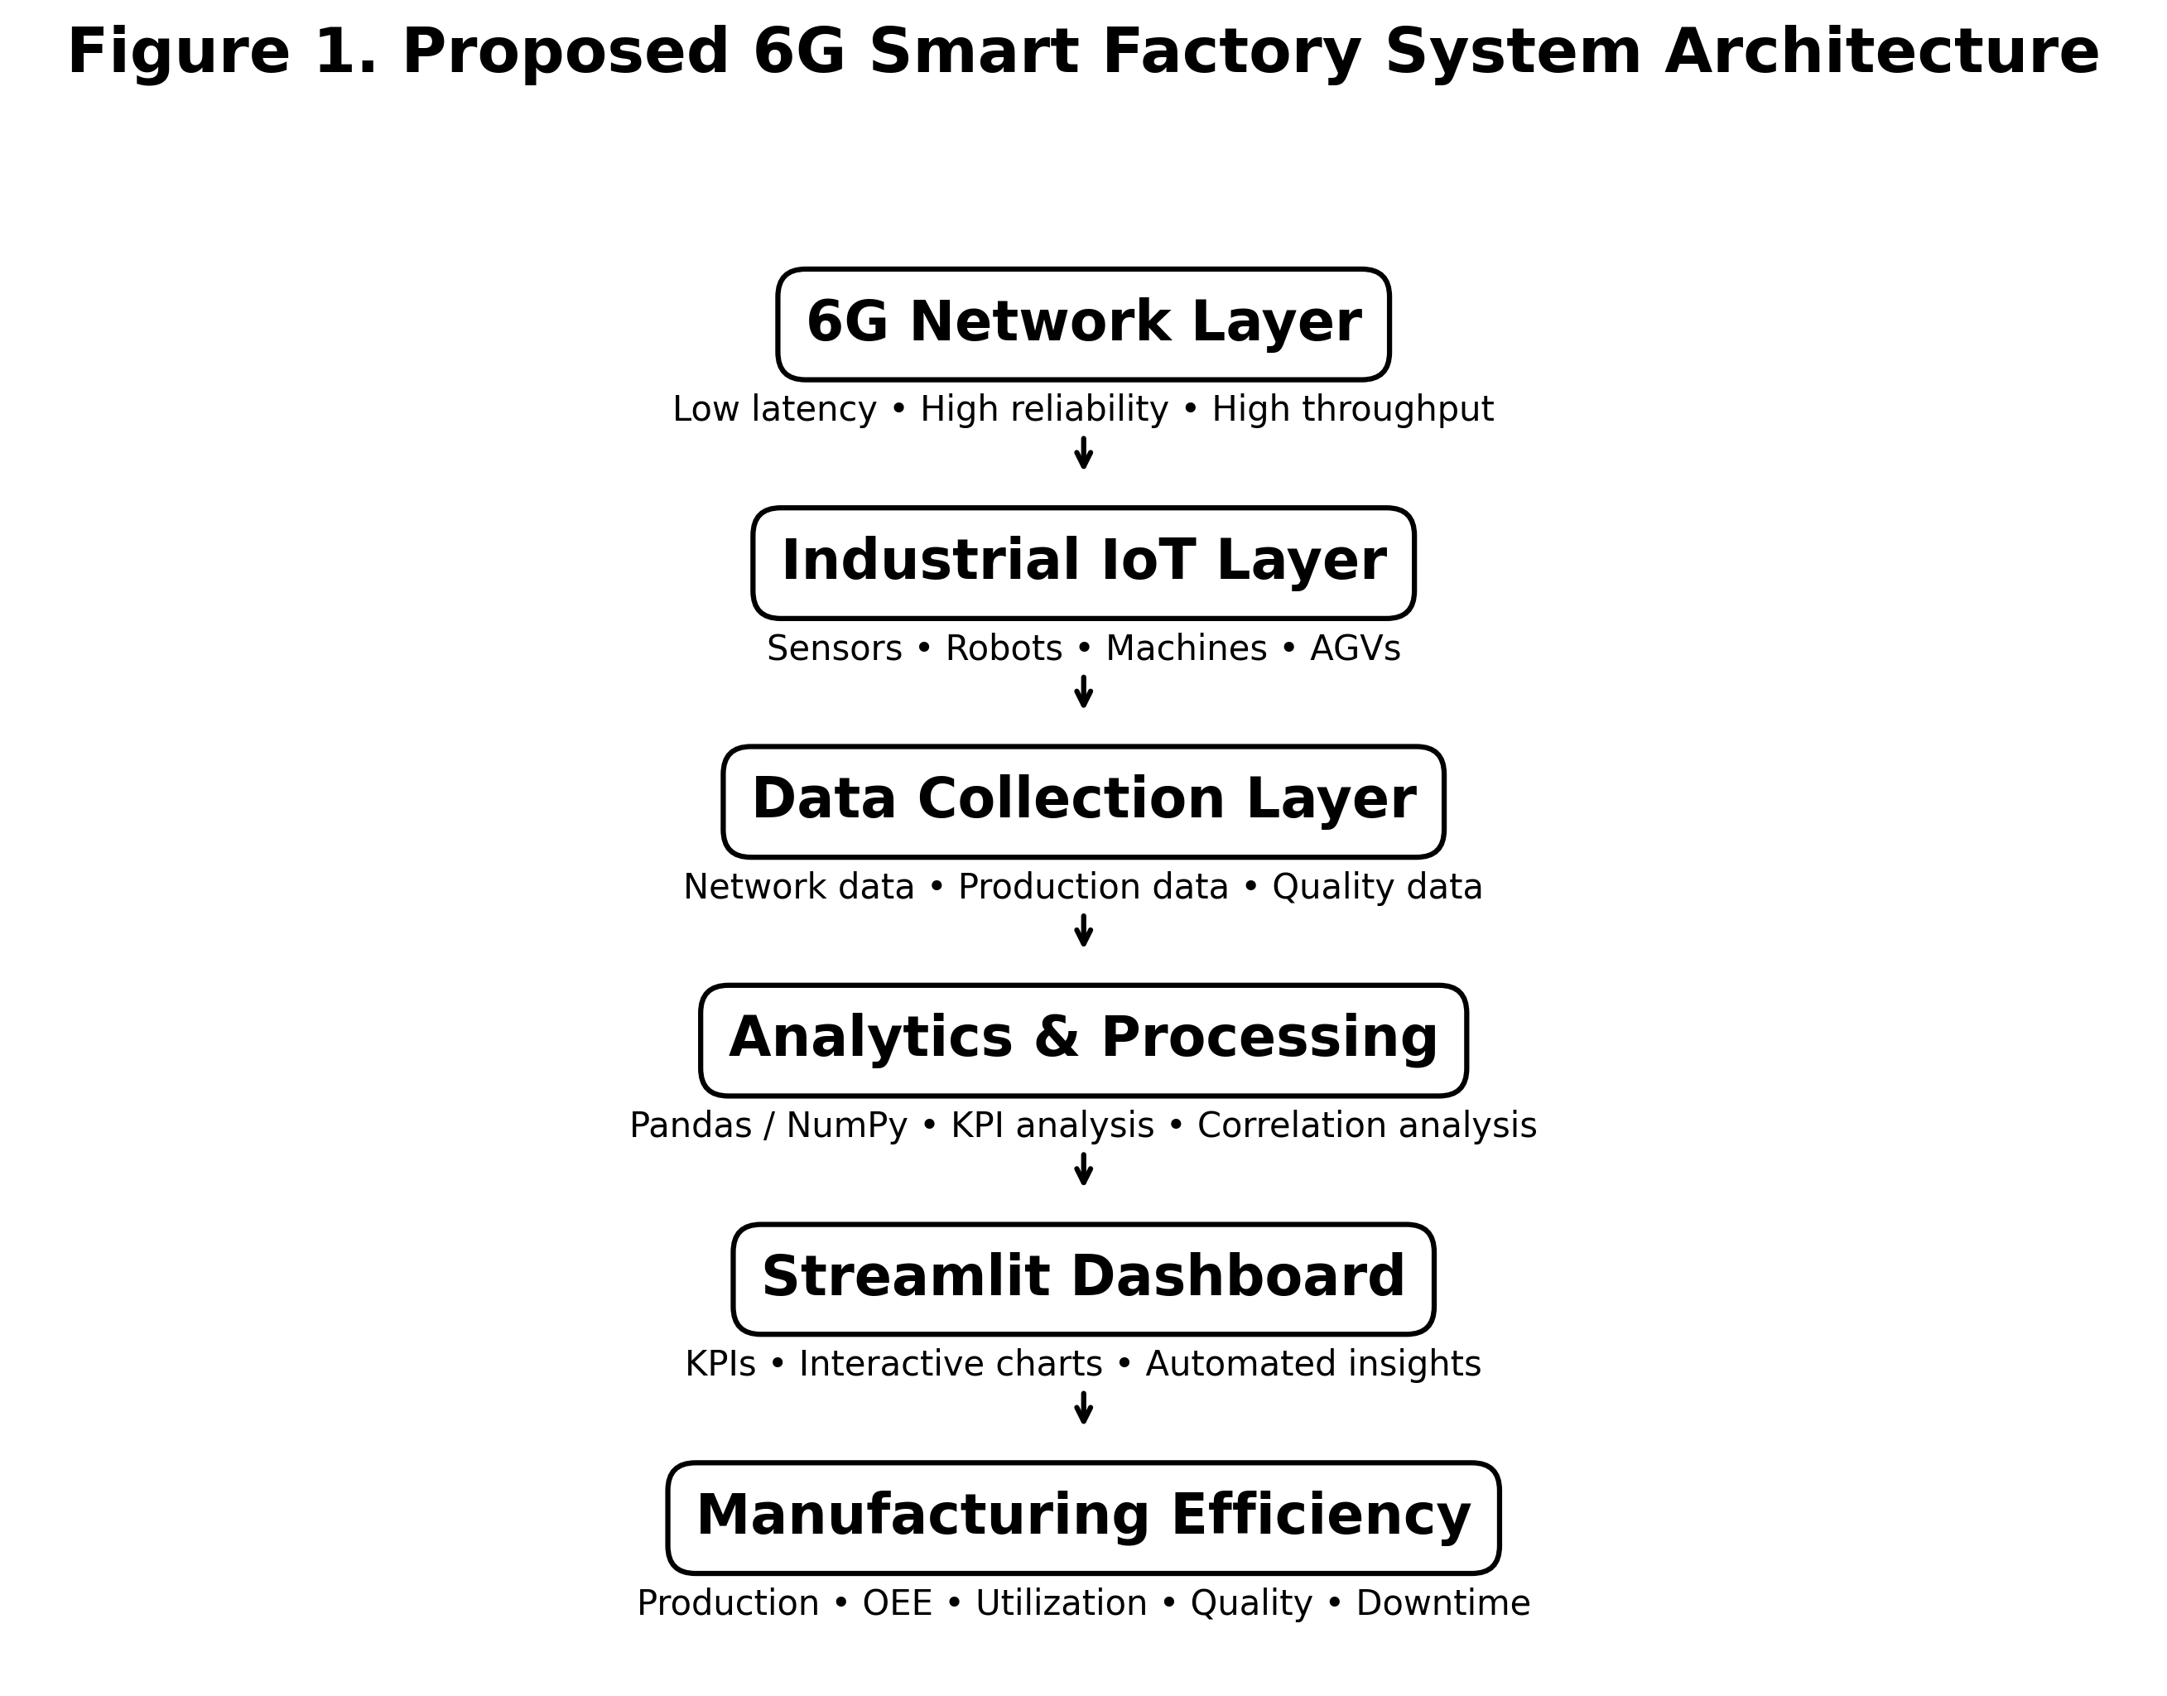
Figure 1. Proposed 6G Smart Factory System Architecture.

5. Dataset
A synthetic 24-hour factory dataset is generated for four production lines. The simulation includes network latency, reliability, throughput, production rate, machine utilization, OEE, defect rate, downtime, and energy per unit. The values are illustrative and are not measurements from an operational 6G factory.

6. Performance Indicators
- 6G Latency (ms) – communication delay.
- Network Reliability (%) – wireless connection reliability.
- 6G Throughput (Gbps) – data-transfer capacity.
- Production Rate (units/hr) – manufacturing output.
- Machine Utilization (%) – equipment utilization.
- OEE (%) – combined availability, performance, and quality indicator.
- Defect Rate (%) – defective production proportion.
- Downtime (minutes) – production time lost to interruptions.
- Energy per Unit (kWh) – energy consumed per manufactured unit.

7. Dashboard Development
The Streamlit dashboard provides production-line and time-window controls, KPI cards, interactive network charts, manufacturing charts, quality indicators, correlation analysis, automated insights, and downloadable CSV data. It is designed as a decision-support prototype.

8. Results and Analysis
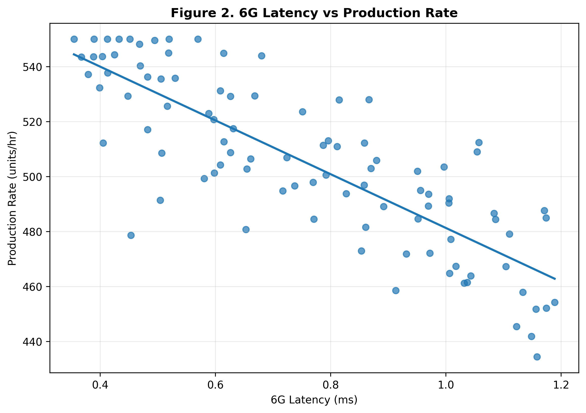
Figure 2. 6G Latency vs Production Rate.
The latency-versus-production plot illustrates the relationship between communication delay and manufacturing output. Lower latency can support faster coordination of connected industrial processes. The relationship shown is based on synthetic observations.
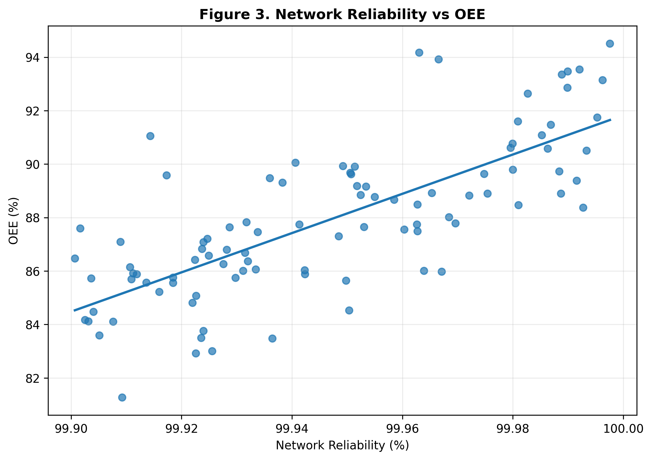
Figure 3. Network Reliability vs OEE.
The reliability-versus-OEE plot examines whether reliable connectivity is associated with stronger equipment effectiveness. The simulated relationship is illustrative and does not establish causation.
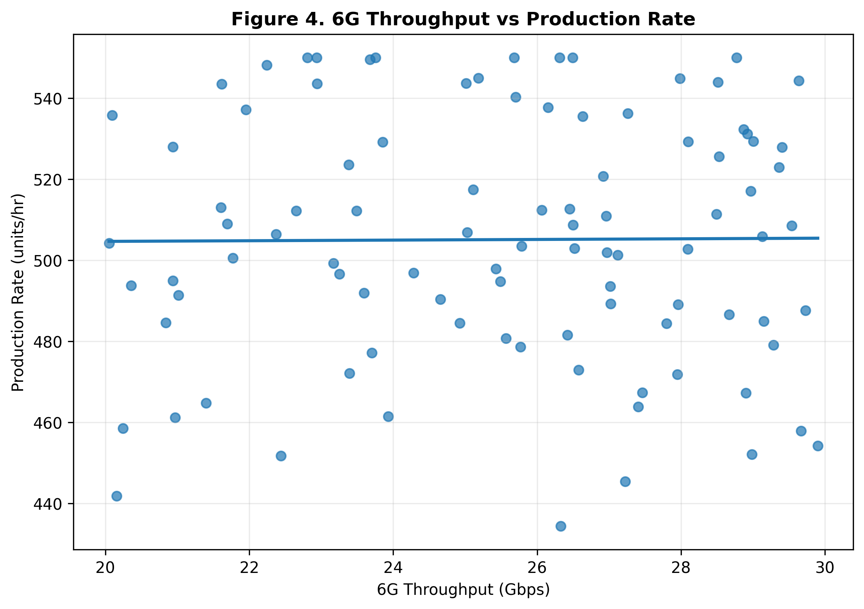
Figure 4. 6G Throughput vs Production Rate.
The throughput analysis compares communication capacity with production rate. Higher throughput can support large volumes of sensor, machine-vision, and digital-twin data.
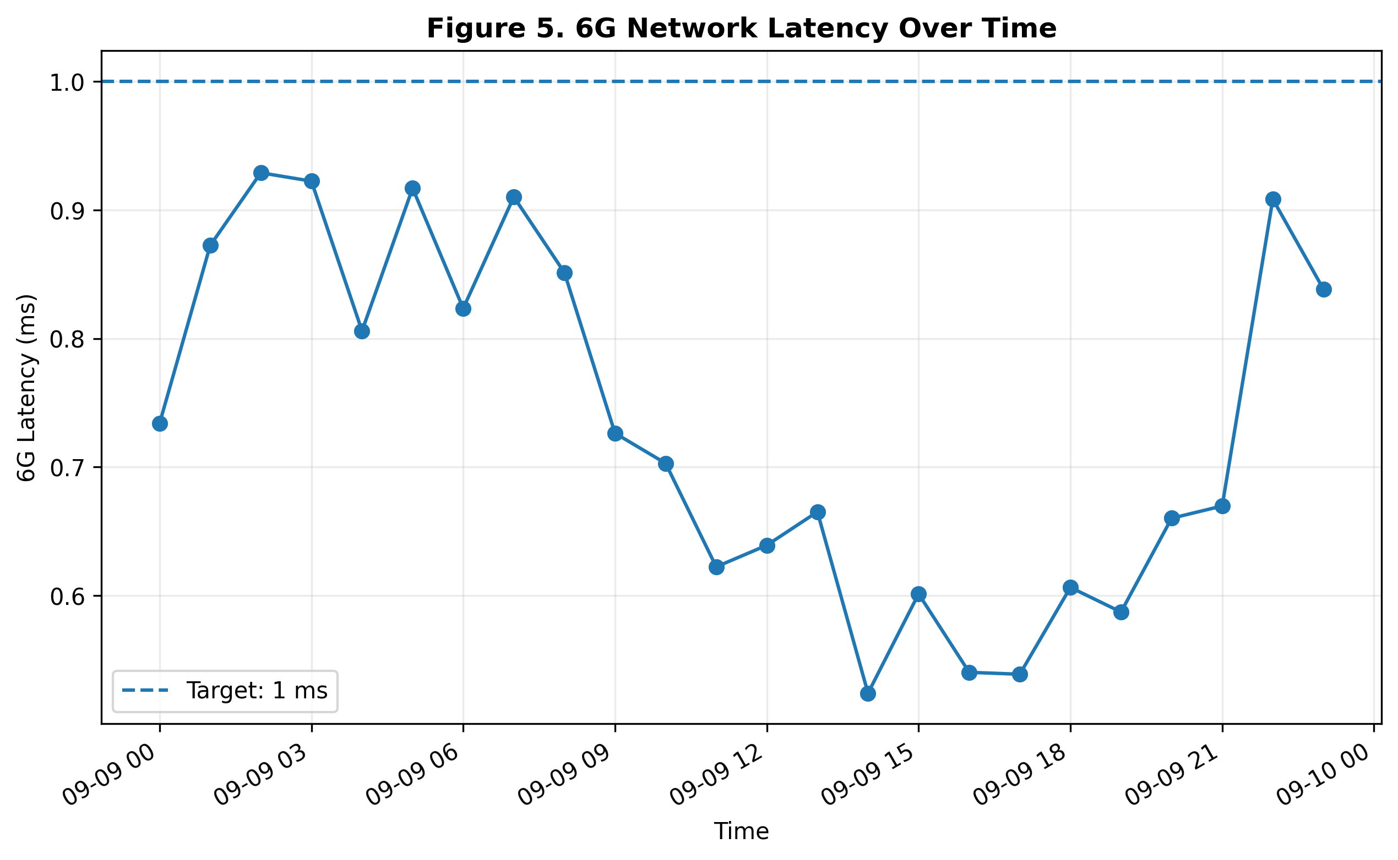
Figure 5. 6G Network Latency Over Time.
Latency is monitored over time against the illustrative 1 ms target.
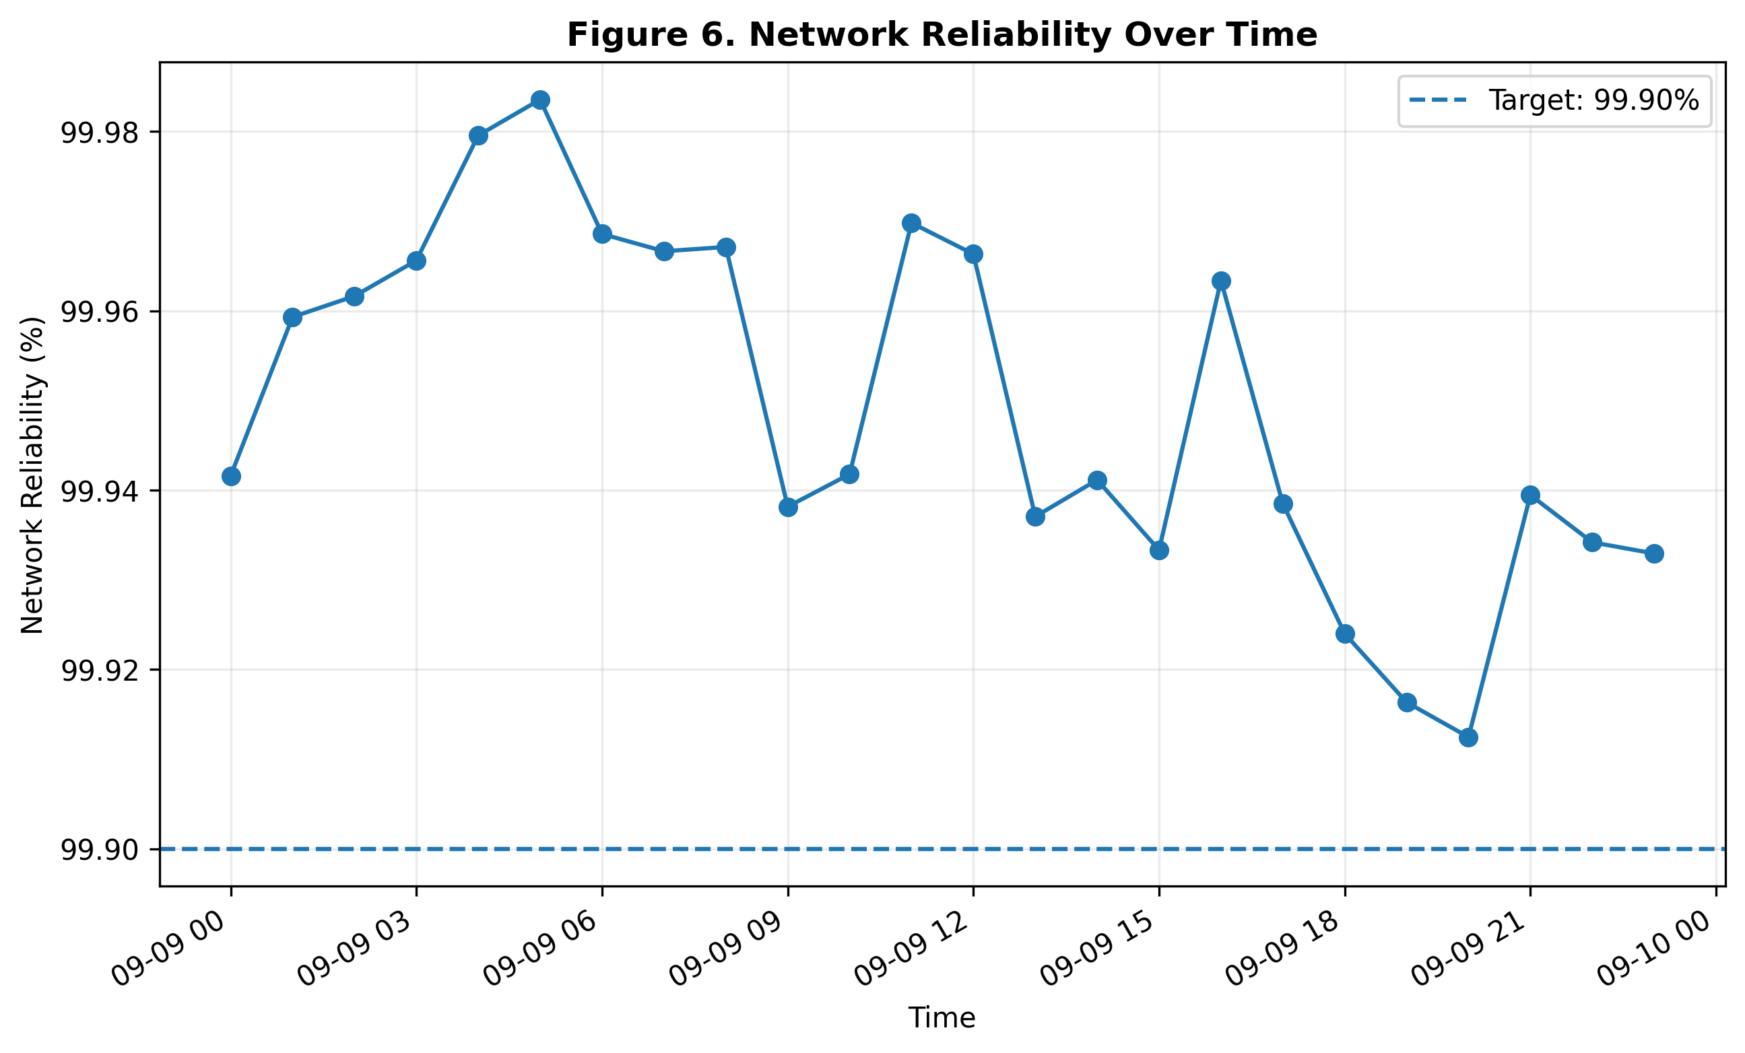
Figure 6. Network Reliability Over Time.
Reliability is monitored over time against the illustrative 99.90% target.
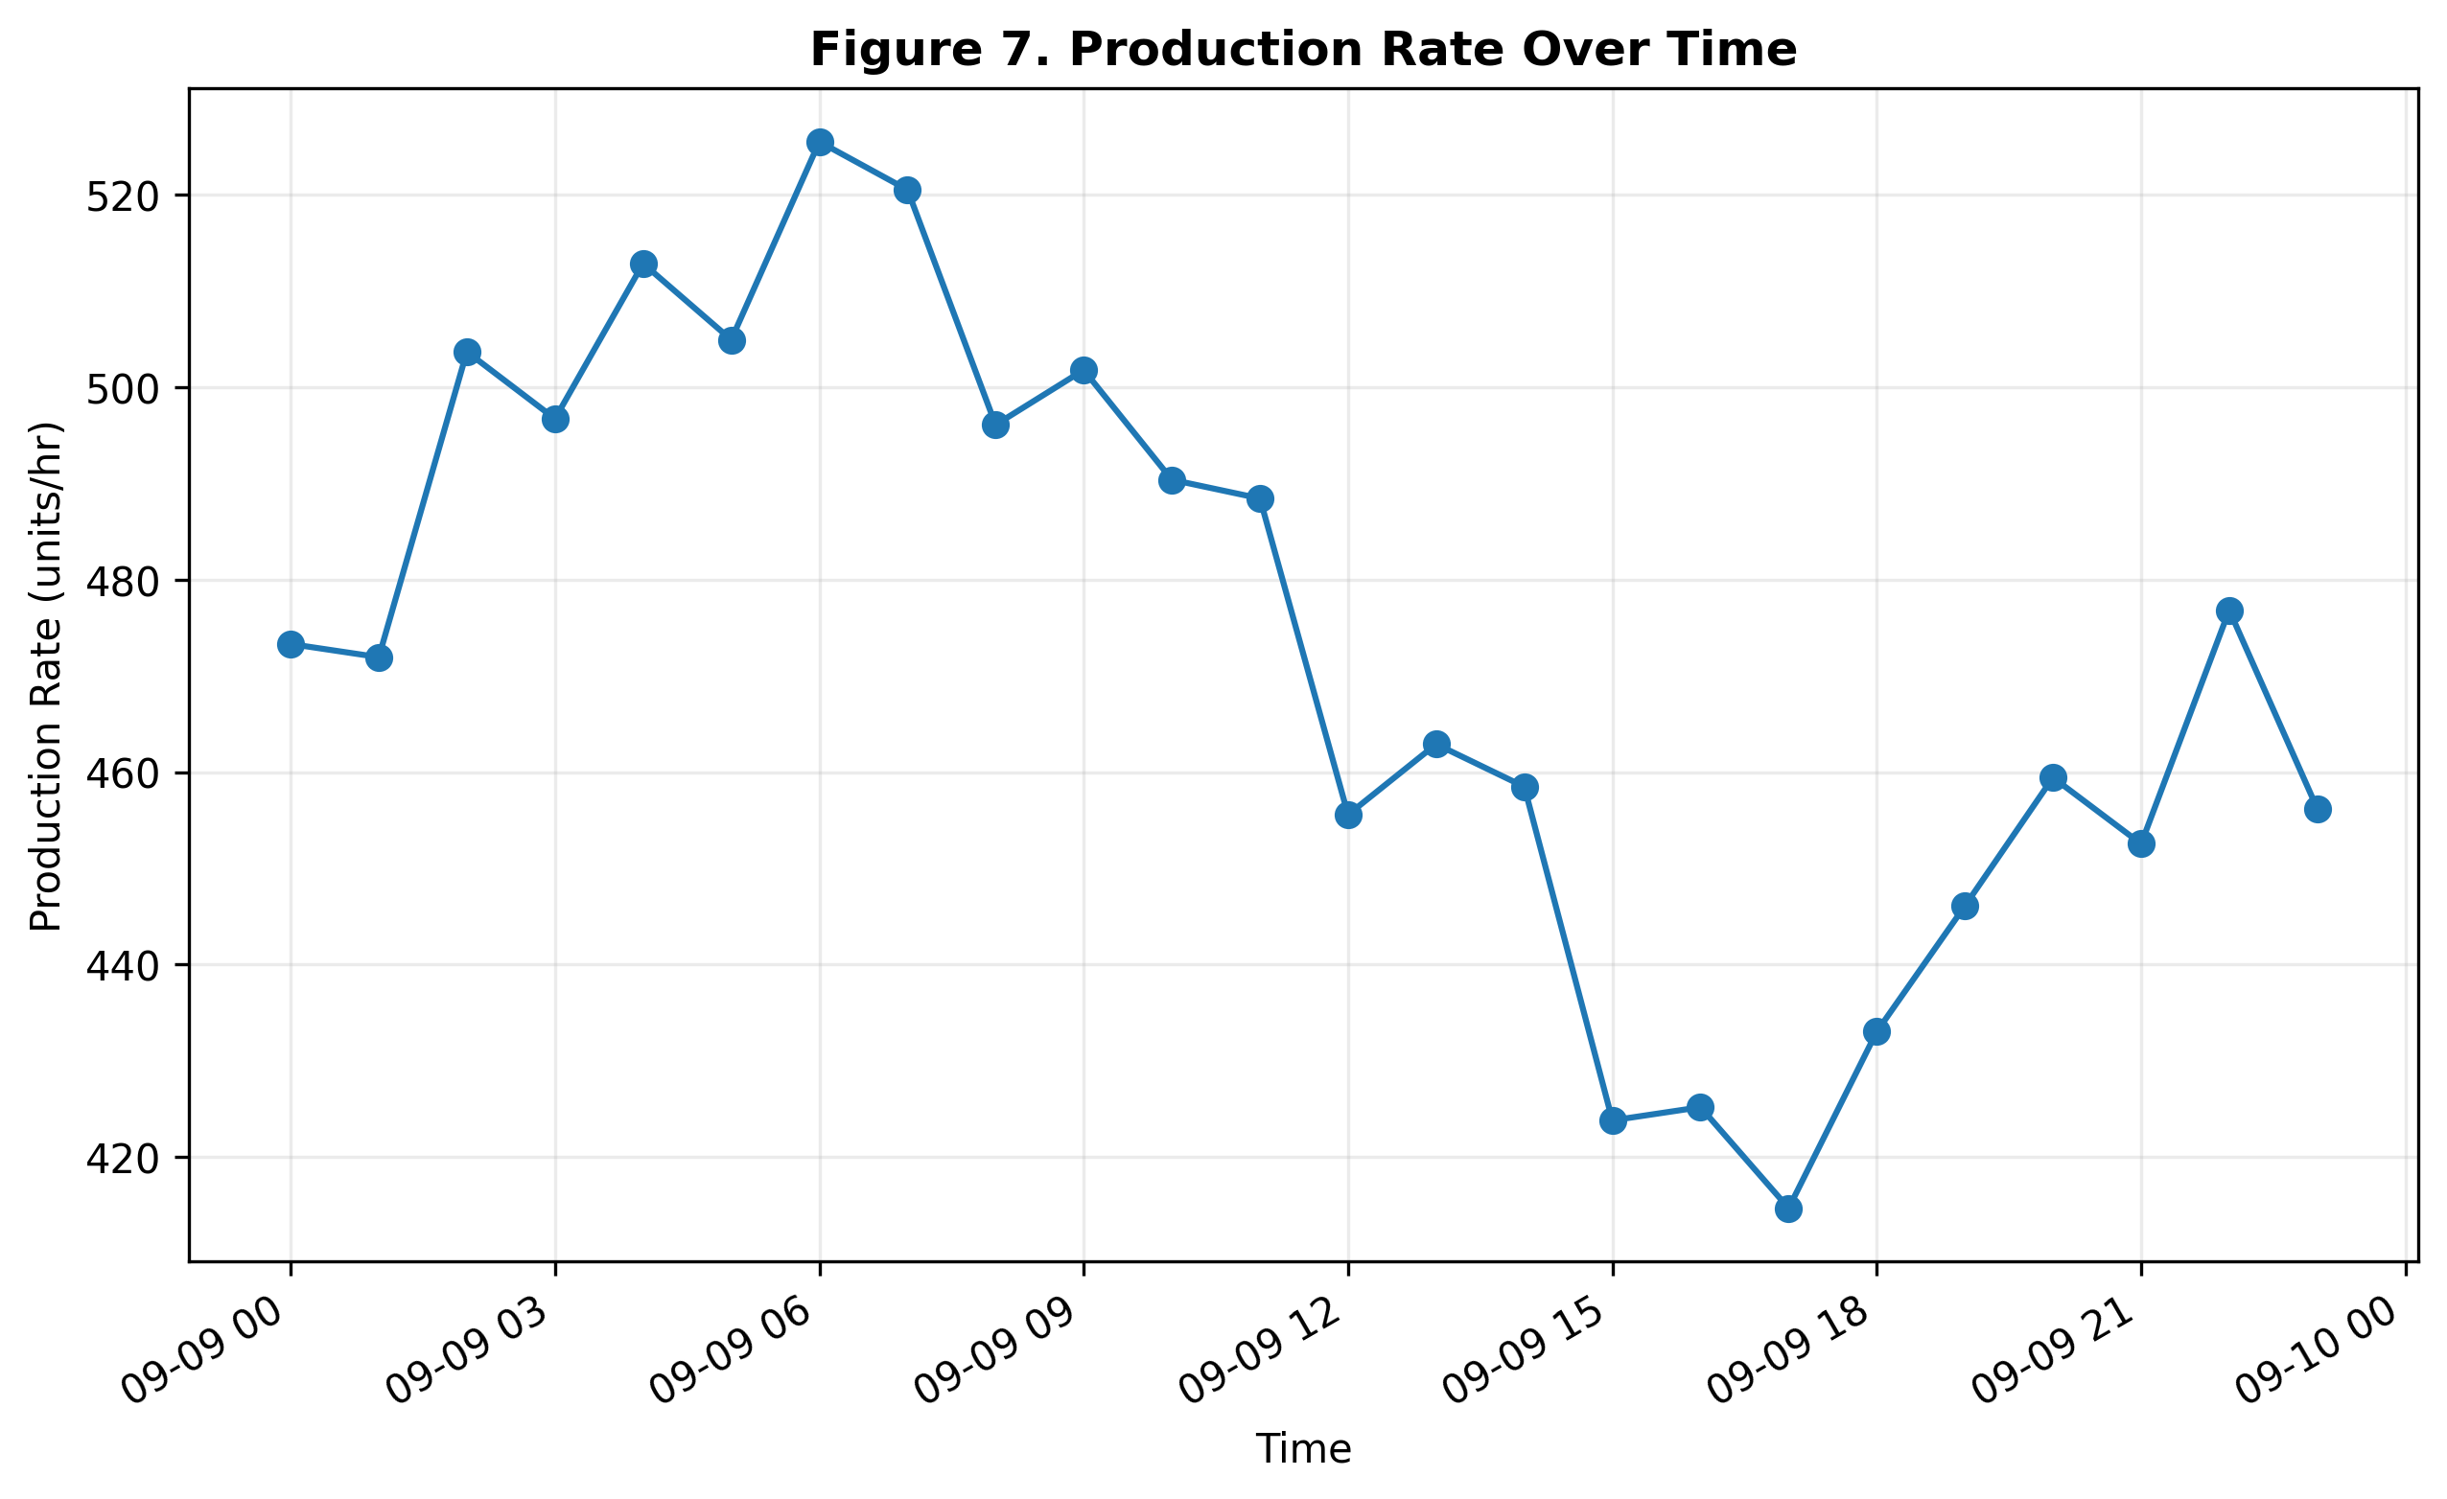
Figure 7. Production Rate Over Time.
Production rate is tracked across the simulated operating period to support comparison with network conditions.
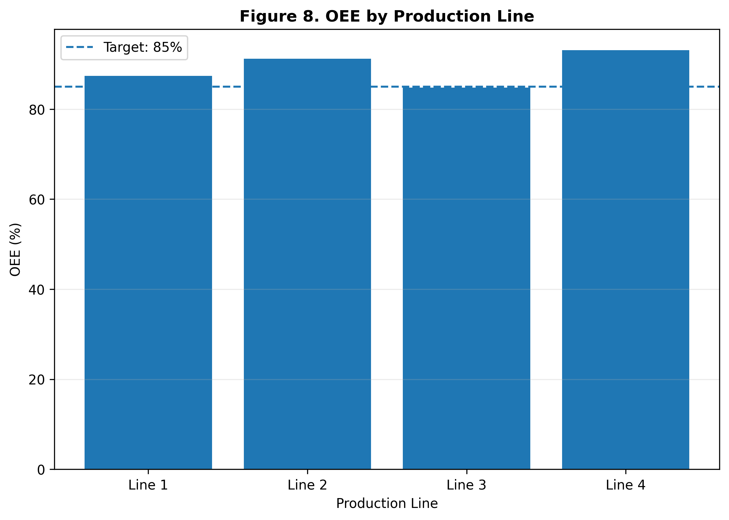
Figure 8. OEE by Production Line.
OEE is compared across four simulated production lines to identify lines that may require further operational investigation.

9. Correlation Analysis
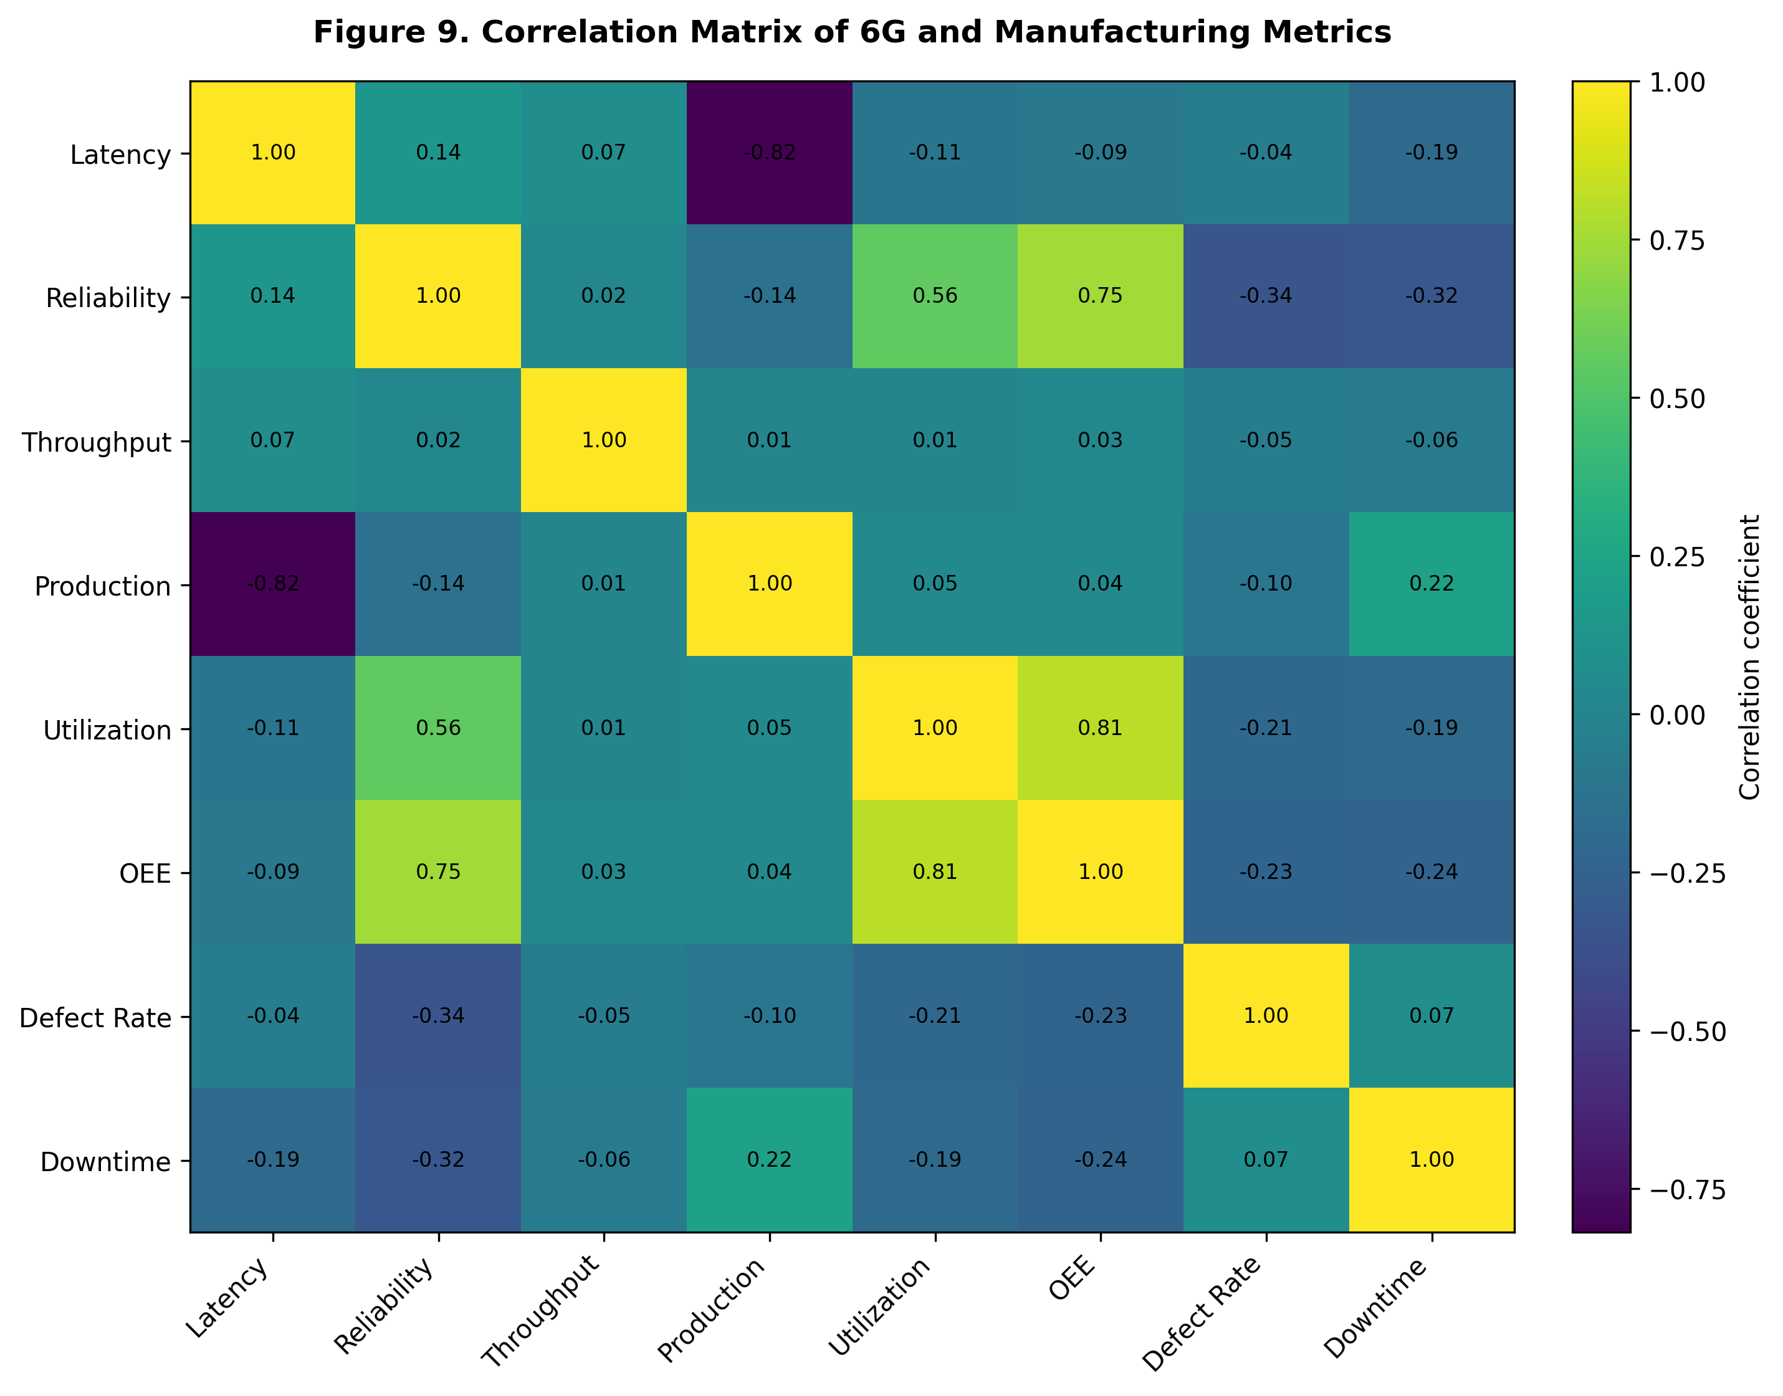
Figure 9. Correlation Matrix of 6G and Manufacturing Metrics.
The correlation matrix summarizes linear relationships among communication and manufacturing indicators. Correlation can identify variables that move together, but it does not prove causation.

10. Proposed 6G Smart Factory Framework
The framework connects the 6G network layer to industrial IoT devices, data collection, analytics, dashboard visualization, and manufacturing-efficiency indicators. Future versions can add edge computing, digital twins, predictive maintenance, AI optimization, and closed-loop control.

11. Advantages
- Unified view of network and manufacturing performance.
- Interactive Streamlit monitoring.
- Relationship analysis between communication and production KPIs.
- Can be extended with real industrial data.
- Low-cost research prototype.

12. Limitations
The principal limitation is the use of synthetic data rather than measurements from a deployed 6G manufacturing facility. Therefore, numerical relationships in the figures are illustrative. The prototype also does not model every industrial factor, including machine-specific control cycles, packet loss, jitter, electromagnetic interference, and detailed energy models.

13. Future Work
- Replace synthetic data with industrial testbed measurements.
- Evaluate real 5G-Advanced and future 6G networks under factory workloads.
- Add packet loss, jitter, and end-to-end latency.
- Integrate digital-twin and edge-computing platforms.
- Develop predictive models for downtime, defects, and production efficiency.
- Study closed-loop industrial control under different network conditions.

14. Conclusion
This research presents a simulation-based approach for examining the impact of 6G network performance on smart-factory manufacturing efficiency. The dashboard integrates latency, reliability, and throughput with production rate, OEE, utilization, defects, downtime, and energy consumption. The nine figures demonstrate how these indicators can be monitored and analyzed together. The prototype provides a foundation for future research using real industrial datasets and 6G testbeds.

References
- Zeydan, E., Arslan, S., & Turk, Y. (2024). 6G wireless communications for industrial automation: Scenarios, requirements and challenges. Journal of Industrial Information Integration, 42, 100732.
- Akbar, M. S., Hussain, Z., Ikram, M., Sheng, Q. Z., & Mukhopadhyay, S. C. (2025). On challenges of sixth-generation (6G) wireless networks: A comprehensive survey of requirements, applications, and security issues. Journal of Network and Computer Applications, 233, 104040.
- Zhao, Y., et al. (2020). A Comprehensive Survey of 6G Wireless Communications. arXiv:2101.03889.
- Lindenschmitt, D., et al. (2023). 6G Underlayer Network Concepts for Ultra Reliable and Low Latency Communication in Manufacturing. arXiv:2309.10624.
- Wireless Communications for Smart Manufacturing and Industrial IoT: Existing Technologies, 5G and Beyond. (2023).
- Lei, J., et al. (2025). Fusion of heterogeneous industrial wireless networks: A survey. Computer Networks, 257, 110929.
- Latency in IoT-Enabled Digital Twin Systems for Smart Manufacturing: A Review of the Taxonomy and Measurement. (2026). Applied Sciences, 16(12), 6060.
- The applications of joint communication and sensing in manufacturing: a 6G technology. (2025). Procedia CIRP, 132, 178–183.

