Name: Thasin abedin

ID: 160021139

Section: c

Group: c2

DIGITAL FILTER DESIGN LAB

EXP NO. : 3

**TASK 2:**

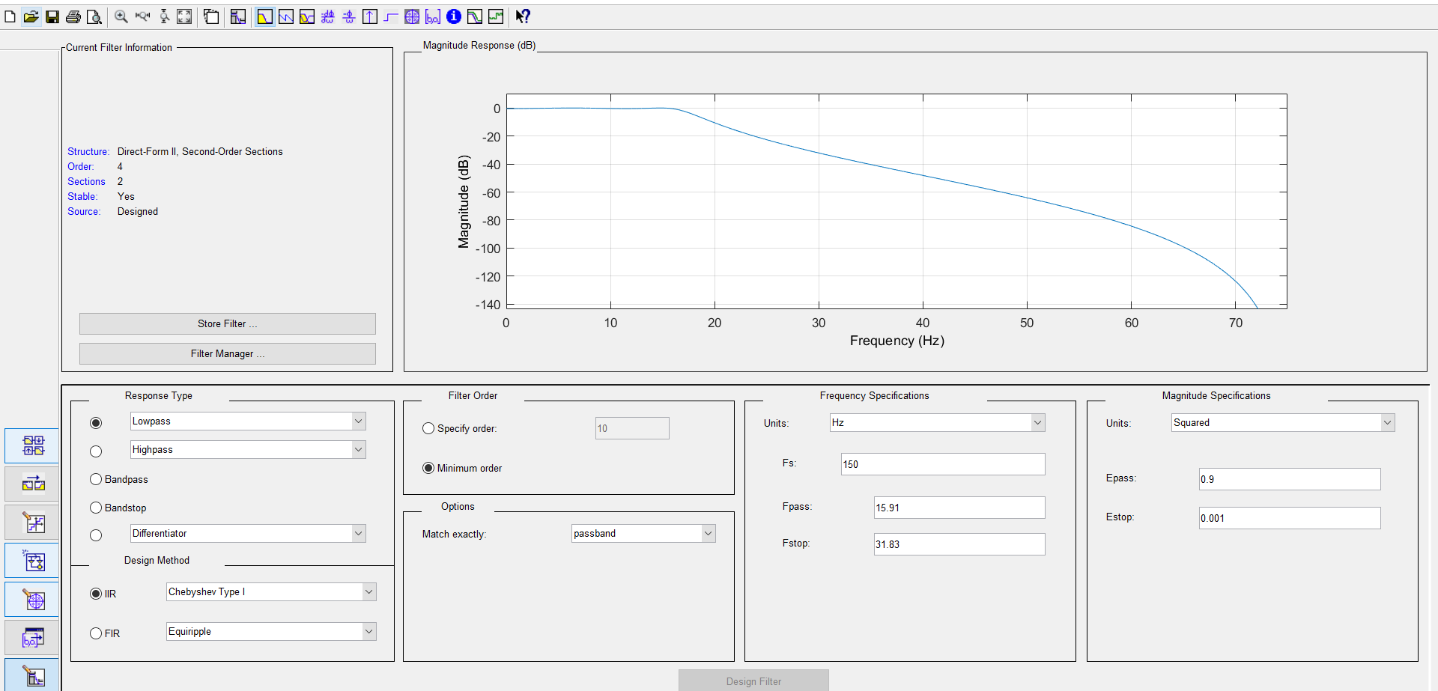

A)Pole-zero location:

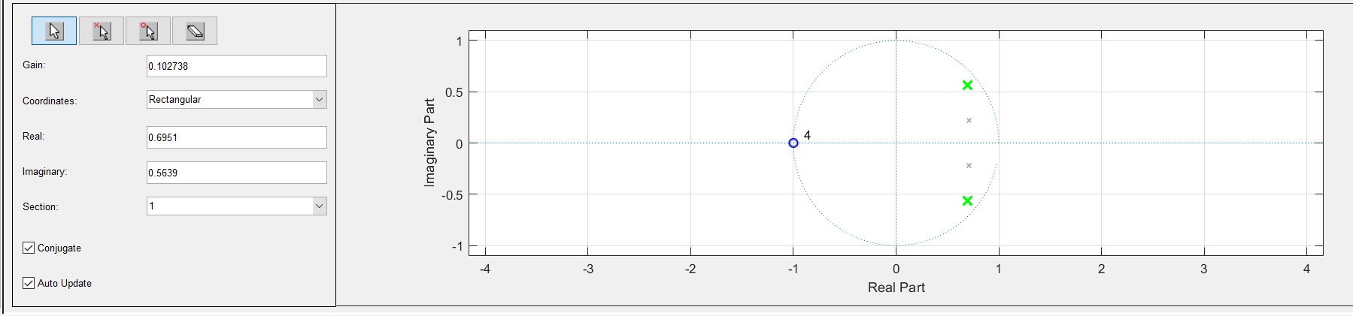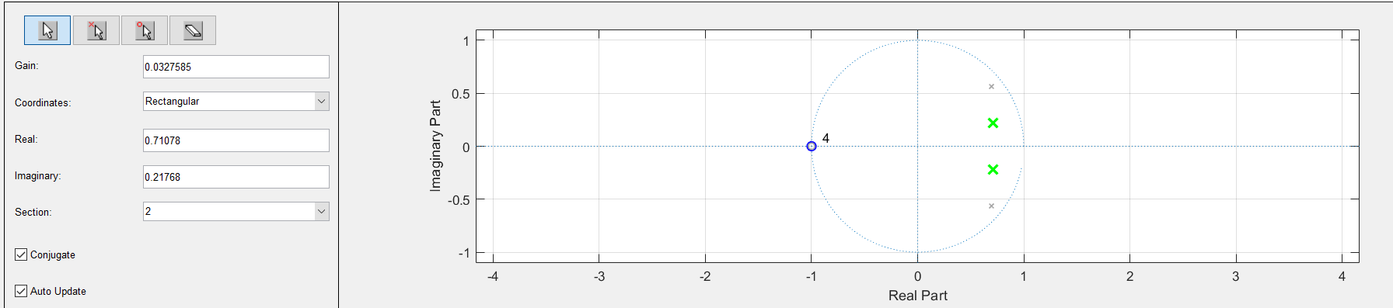

B & C) Calculated pole-zero & Designed Circuit:

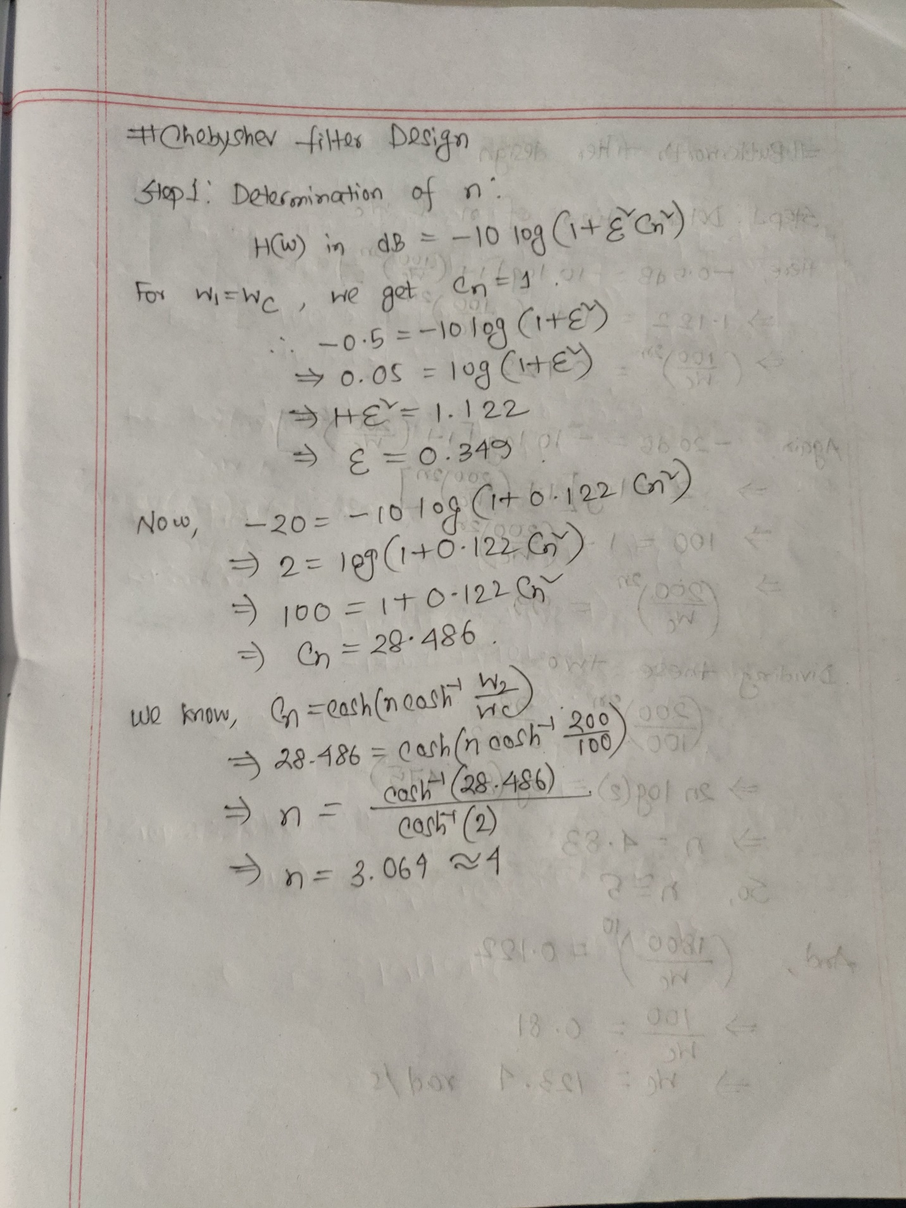

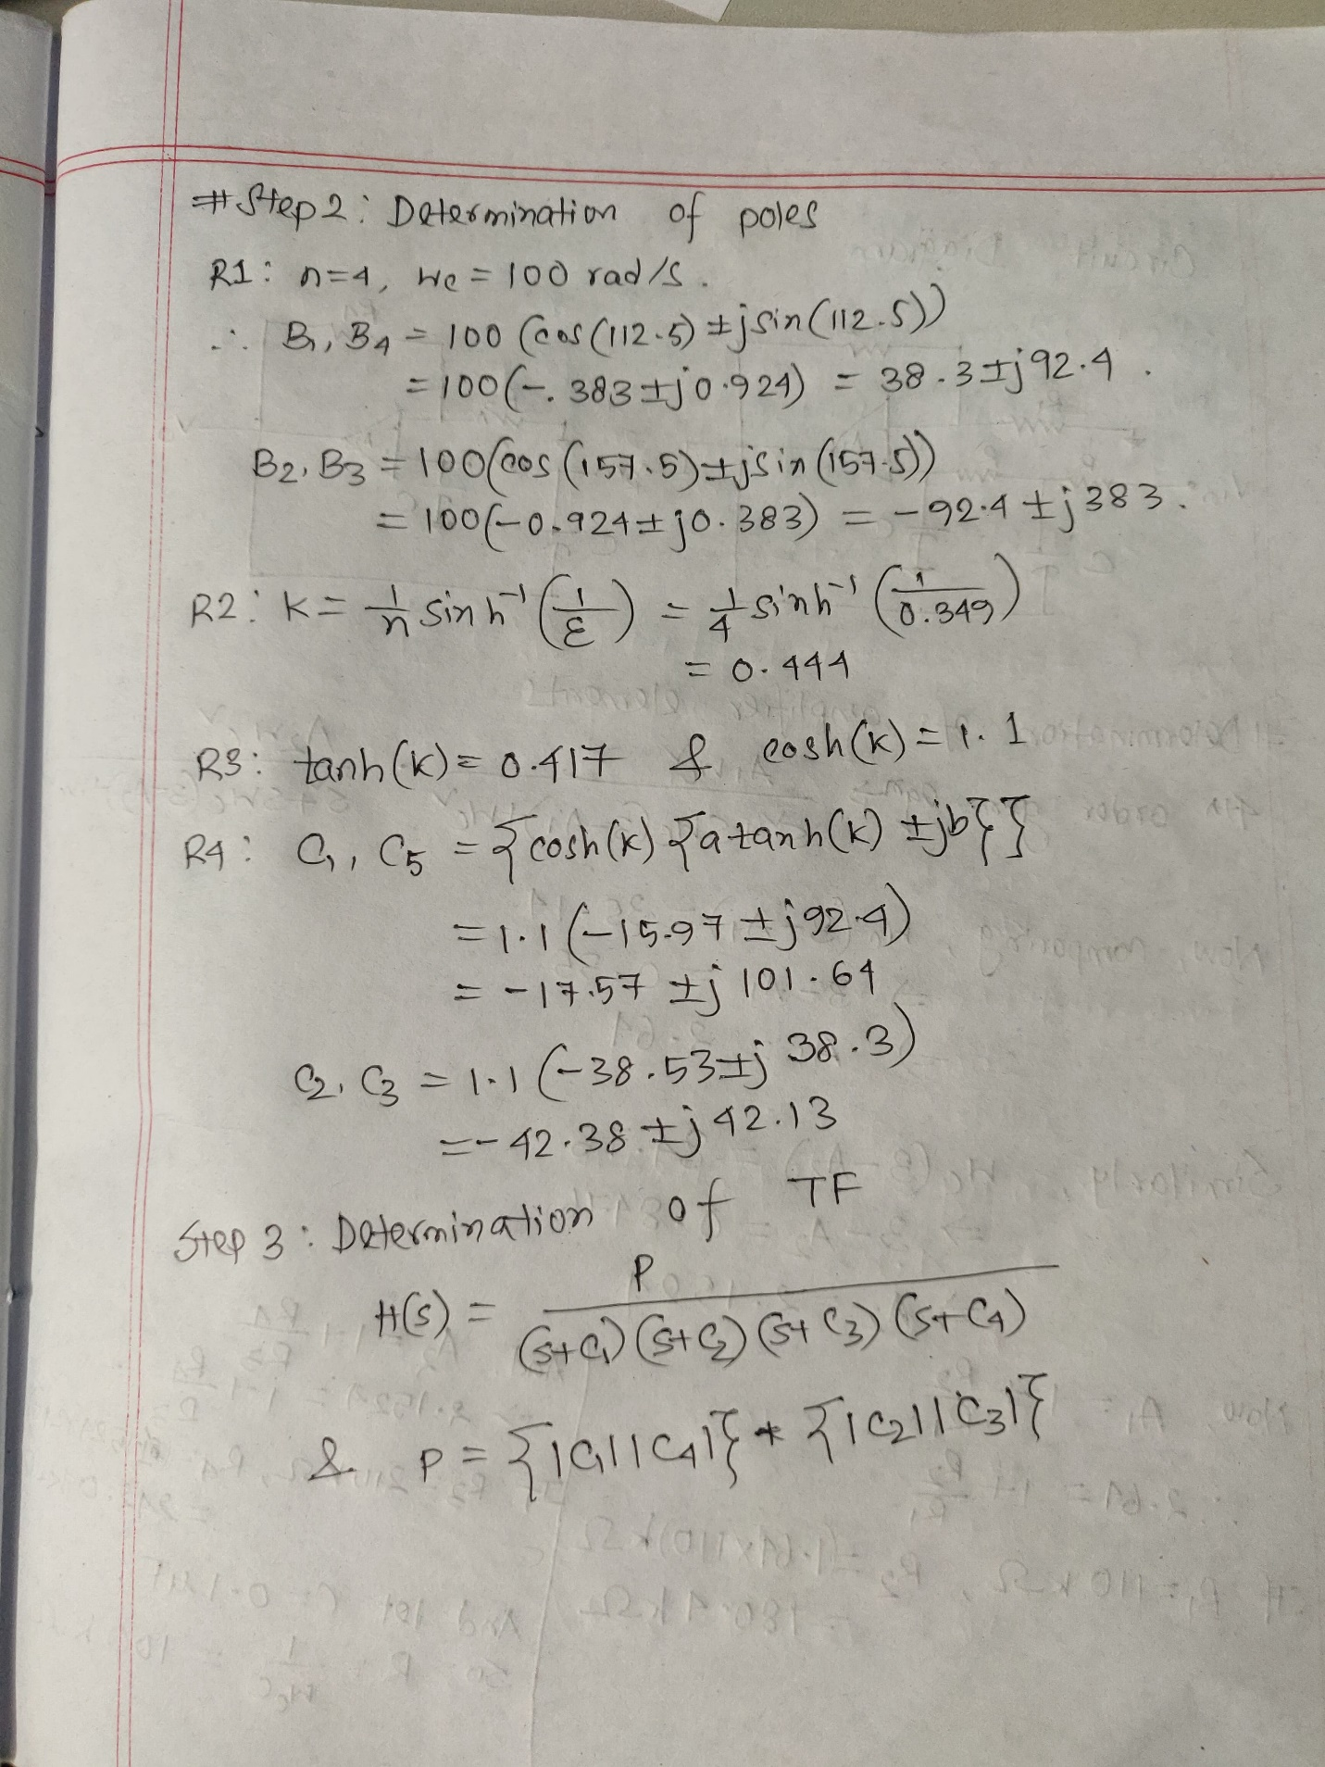

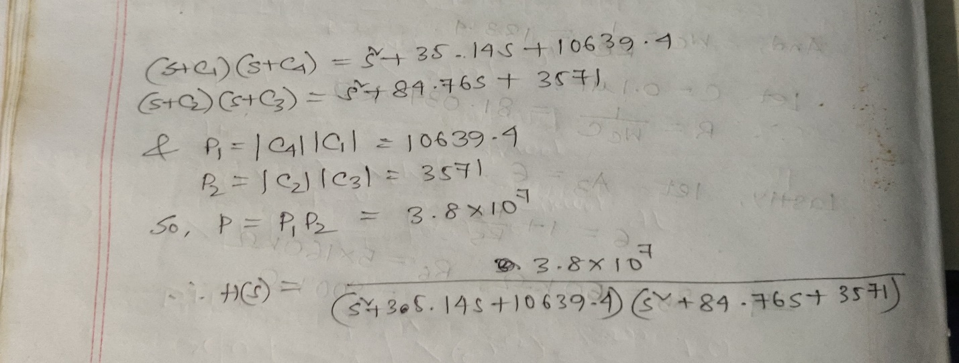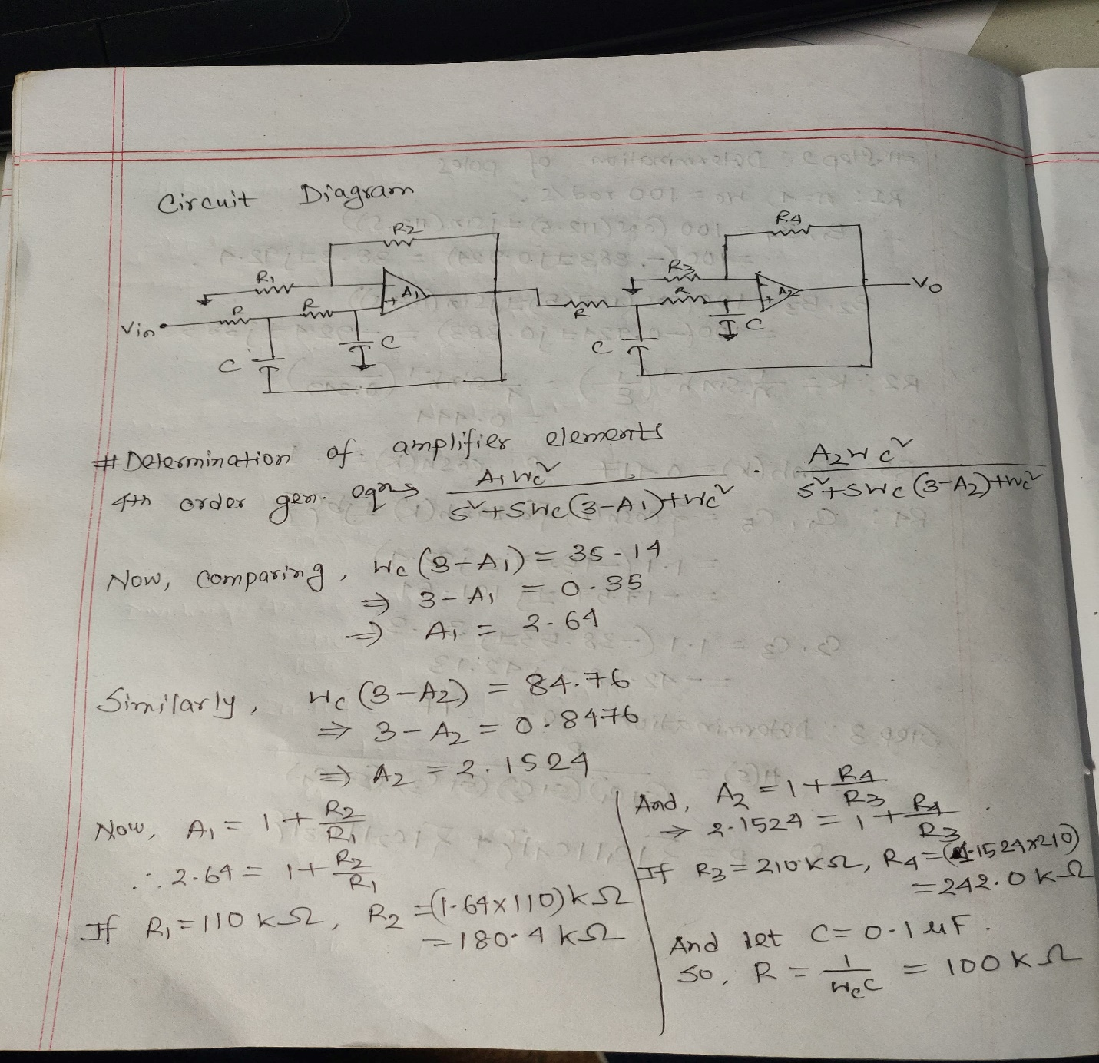

D)Frequency Response:

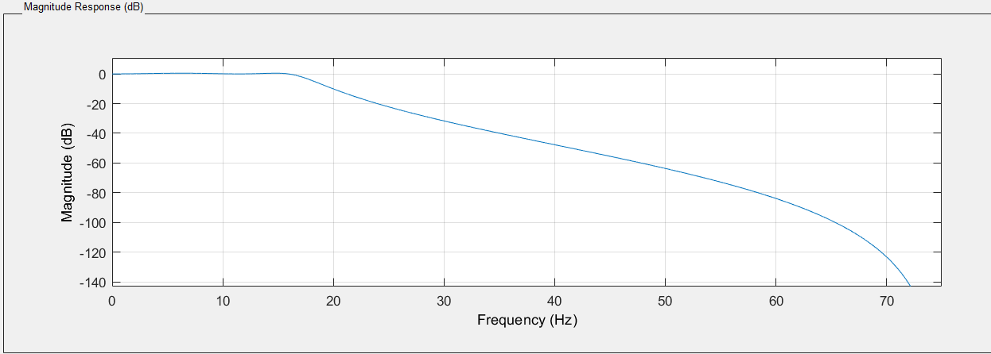

E) Generating given pulse in Proteus:

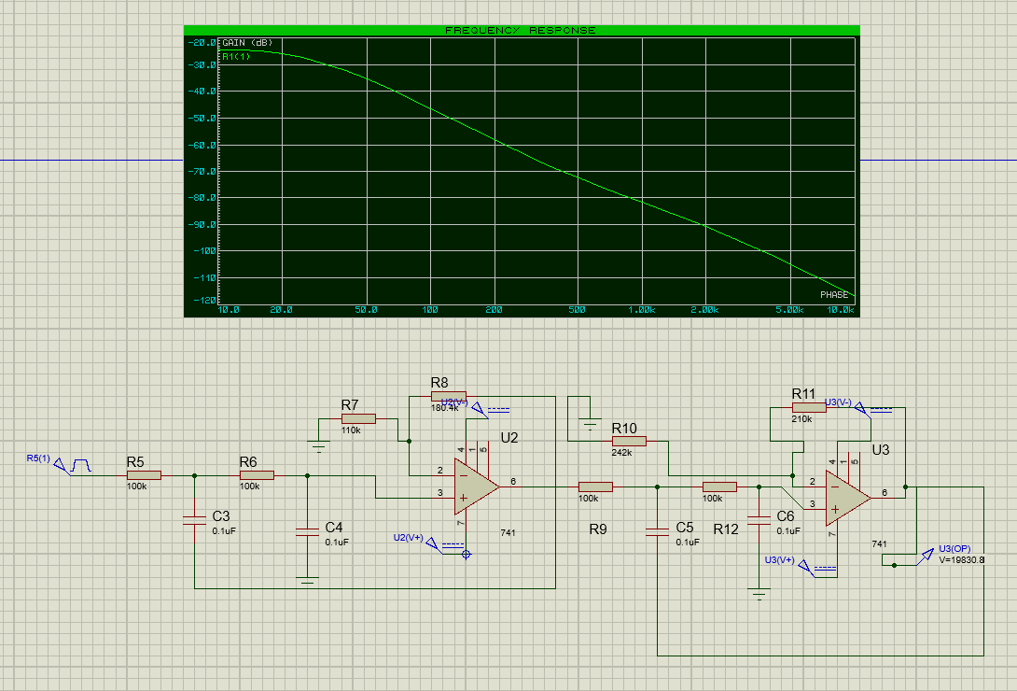

F) Generating given pulse in Simulink:

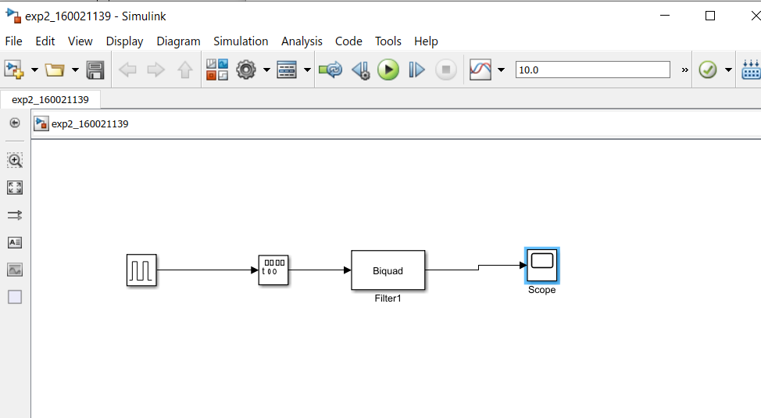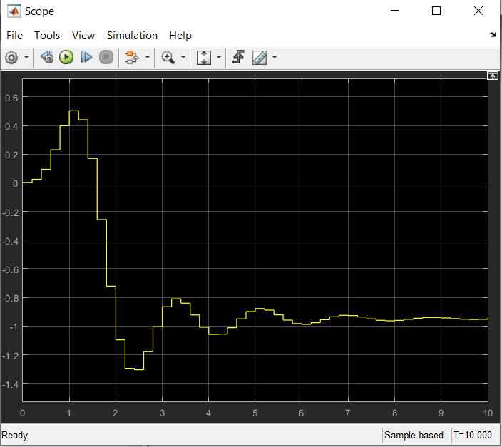

G) To improve the quality of the filter:

As in butterworth filter, we can improve the quality in Chebyshev Type 1 by increasing the order of the filter as well. Higher the order, higher the improvement in quality. But higher order Chebyshev are much more complex to implement. However, there is another option of improving the filter quality. We can use Chebyshev Type 2 filter instead since it has no existence of ripples in the pass band. Moreover, a lower order less costly filter can also be used then due to the existence of ripples in the attenuation band.