Name: thasin abedin

ID : 160021139

Section : c

Group: c2

DIGITAL FILTER DESIGN LAB

EXP NO. : 4

**Task 3:**

Comparison between SNR of Butterworth and Chebyshev Filter by MATLAB Code:

%Noise Signal Creation

x= cos(2*pi*20*[0:0.001:1.23]);

x(end) = [];

[b,a] = butter(2,[0.7 0.8],'bandpass');

filtered_noise = filter(b,a,randn(1, length(x)*2));

noise = (x + 0.6*filtered_noise(500:500+length(x)-1))/length(x)*2;

%Designing Butterworth & Chebyshev Filter

%Given specification

wp = (100/(2*pi))/100;

ws = (200/(2*pi))/100;

Apass = 0.5;

Astop = 20;

%Chose one between the fiters

%CHEBYSHEV

[N,wn] = cheb1ord(wp,ws,0.5,20);

[b,a] = cheby1(N,0.5,wn);

%BUTTERWORTH

%[N,wn] = buttord(wp,ws,0.5,20);

%[b,a] = butter(N,wn);

%Filter Signal

noise_filtered = filter(b,a,noise);

%Before doing the filter

snr_pre = mean(x.^2) / mean(filtered_noise.^2);

snr_before_db = 10 * log10(snr_pre) % in decibel

%After doing the filtering

residual_noise = x - noise_filtered;

snr_after = mean(x.^2) / mean(residual_noise.^2);

snr_after_db = 10 * log10(snr_after)% in decibel

Results:

For Butterworth Filter

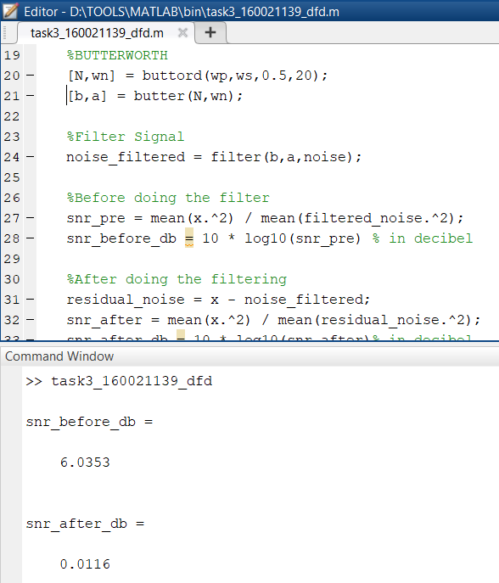

For Chebyshev Type 1 Filter:

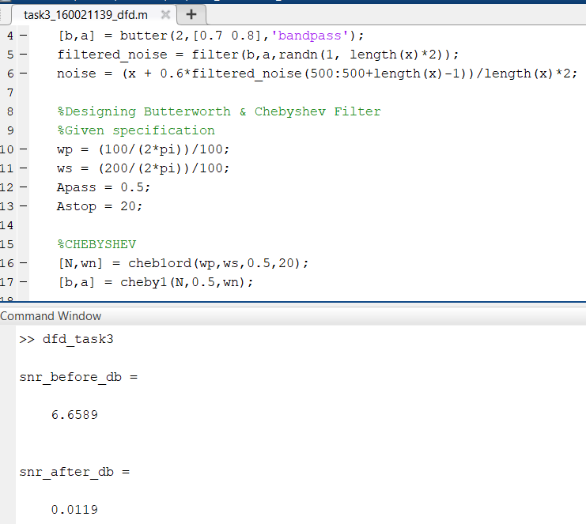

Observation:

Based on my simulation result, we can see that the SNR after the filtering is more or less same. It has not improved that much. One possible reason for such observation maybe due to the low order of the filters. In both the cases, the order does not exceed more than 5. However, increasing the order should bring changes in the SNR between them as we know the Chebyshev Type 1 filter outperforms the Butterworth filter of the same order. And it becomes more and more significant as the order of the filters are increased. So according to my observation, the Chebyshev Type 1 filter performs better than the Butterworth filter even though it adds more complexity to the system.