

BOX CONTENT

Version 1

The official version of this document is maintained in MetroShoe Warehouse SharePoint. Any printed copies are for reference only. Users are responsible for accessing the official version and verifying that any copies are accurate and complete.

TABLE OF CONTENTS

1 DOCUMENT INFORMATION 3
1.1 About this Document 3
1.2 Who Should Use This Document 3
1.3 Revision/ Approval History 3
1.4 References 3
2 ROLES AND RESPONSIBILITIES 4
3 PROCESS FLOW 4
1.5 Step Description 5
4 DEFINITIONS 19

DOCUMENT INFORMATION

About This Document

This document provides a comprehensive guide to preparing box contents and creating shipping labels for Amazon products. It outlines the step-by-step procedures to ensure that all items are accurately listed, packed, and labeled according to Amazon's guidelines.

Who Should Use This Document

All concerned employees belonging to MetroShoes Warehouse who are responsible for the Box Content and Shipping Labels processing and those tasked to create, update, review, and revise this document.

Revision/Approval History

Version Number | Effective Date | Summary of Changes | Author  <Name and Role> | Reviewer  <Name and Role> | Approved by:  <Name and Role>
1.0 | 08/24/2024 | Initial Version | Orville Barba – Amazon FBA Data Analyst | Matt Thompson  Zac Webb  Marquez Borjas | Matt Thompson

References

Box Content Template (to be uploaded to Nineyard)
Weights and Dimensions Update (to be uploaded to Nineyard)
Box Content Main Spreadsheet (vendor/brand dependent)

ROLES AND RESPONSIBILITIES

Role | Responsibility
Vendor | - Send box content requests via email routing fbarouting@metroshoewarehouse.com
Box Label and Shipping Details Process Owner | - Receive the email  - Upload box contents, weights, and shipping dimensions in Nineyard  or FEDEX.  - Print shipping labels  - Record/document in the master spreadsheet
MetroShoe Warehouse Employee | - Send the box contents to respective vendors

PROCESS FLOW

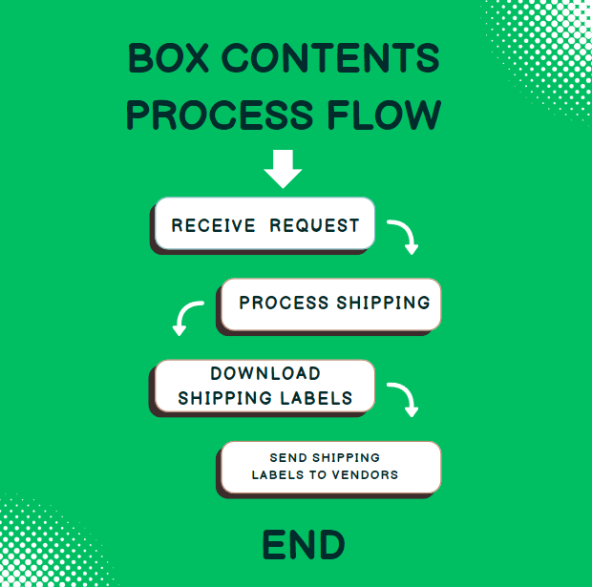

Step Description

Step 1: Sign in to www.nineyard.com.

Step 2: Click “Shipping.”
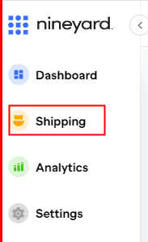

Step 3: Click “Shipments.”
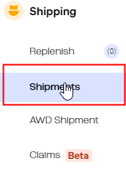

Step 4: Search for a shipment ID.
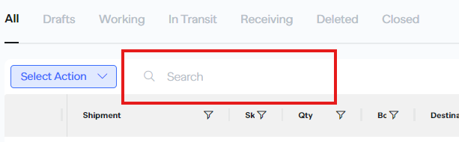

Step 5: Click the shipment ID in blue text.
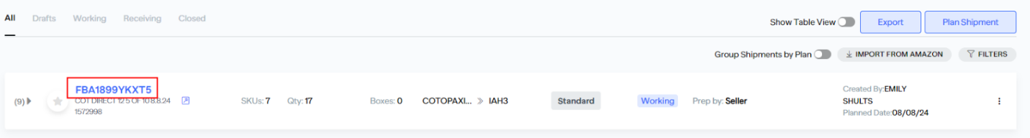

Step 6: Click the 3 dots on the upper right.

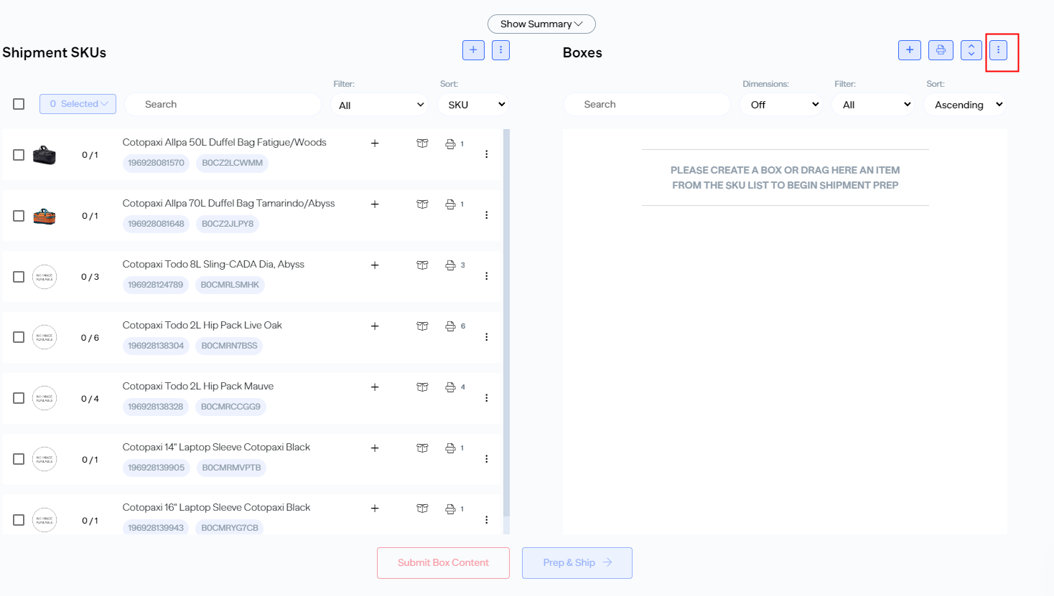

Step 7: Click Import Box Content and choose by SKU.
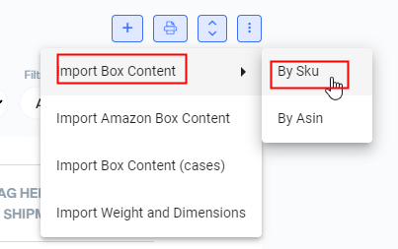

Step 8: Download a new template or upload an already accomplished one. You can also go to the References section of this document to download a template.
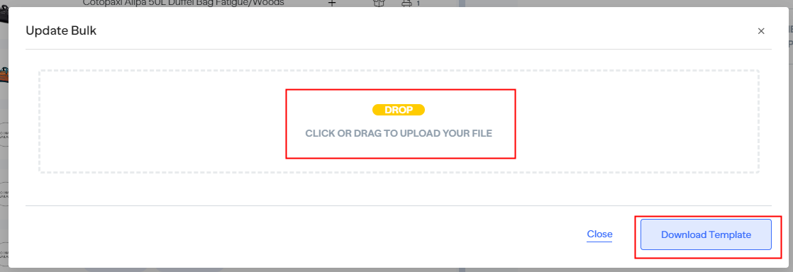

Step 9: After dragging or uploading a template, you will see the consolidated SKUs. Click Save.
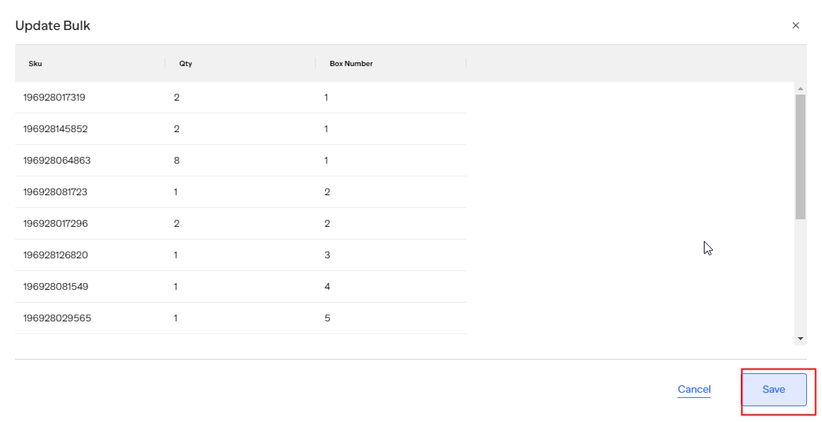

Step 10: Open the box content main spreadsheet and copy the weight and dimension details of the Pos you’re processing.
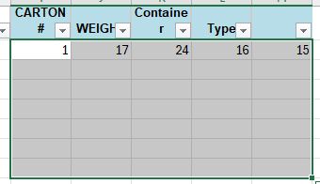

Step 11: Copy, paste, and save the details to the “WEIGHTS AND DIMS UPDATE NINEYARD” file.
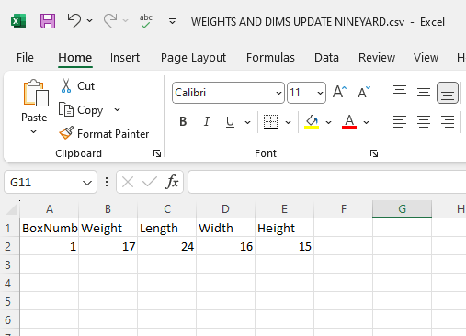

Step 12: Click the 3 dots again on the upper right and choose Import Weight and Dimensions.
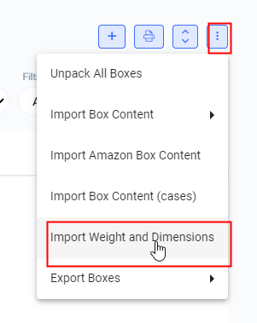

Step 15: Drag the “WEIGHTS AND DIMS UPDATE NINEYARD” file and save. A dialogue box “Updated Bulk” appears to confirm it’s saved. Click Save.

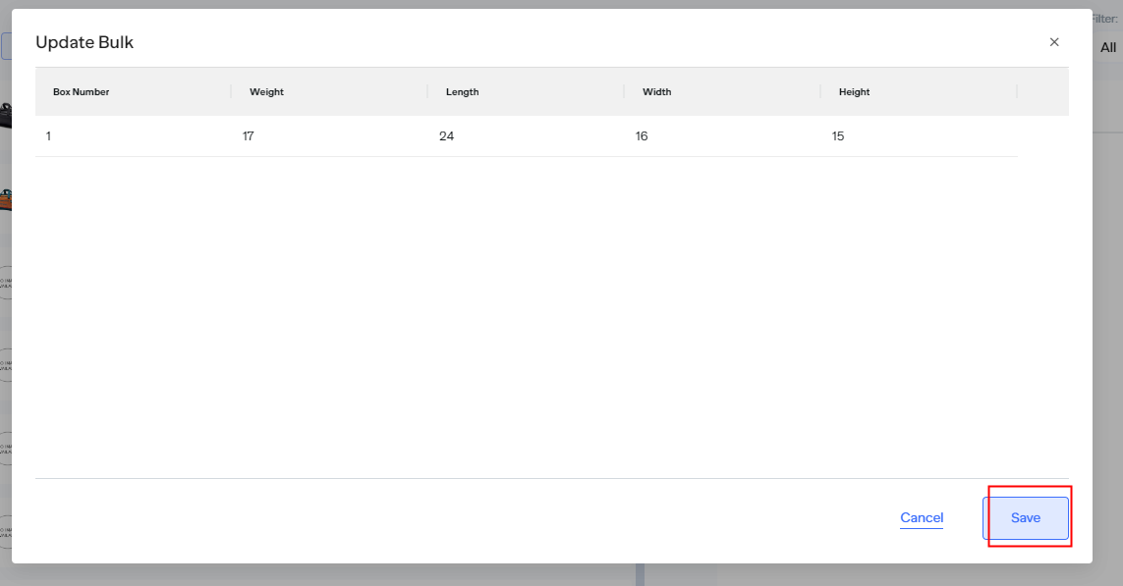
Step 13: Click Submit Box Content. Select Box Labels as Box Content Type and Save.
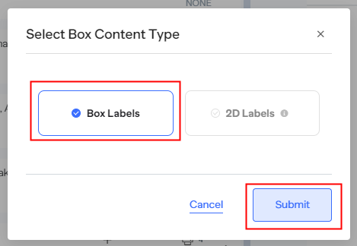

Step 14: A “Submit Box Content” turned green indicates that the submission was successful.
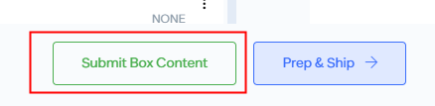

Step 15: You can submit again to ensure it’s submitted and click Prep & Ship then Submit Box Content.
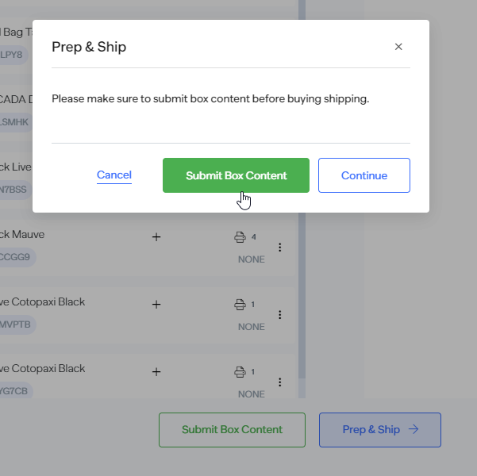

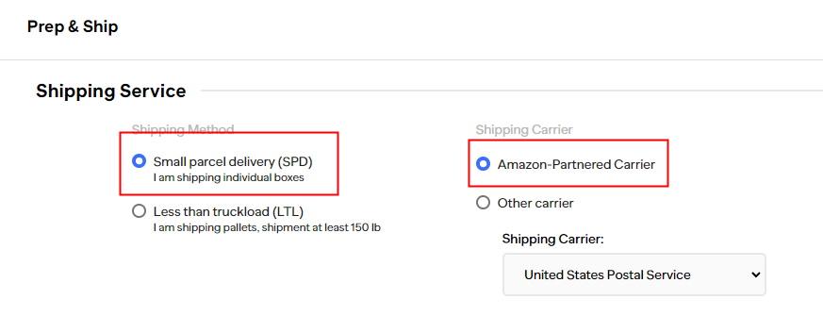
Step 16: Tick Small Parcel Delivery (SPD) and Amazon Partnered Carrier.

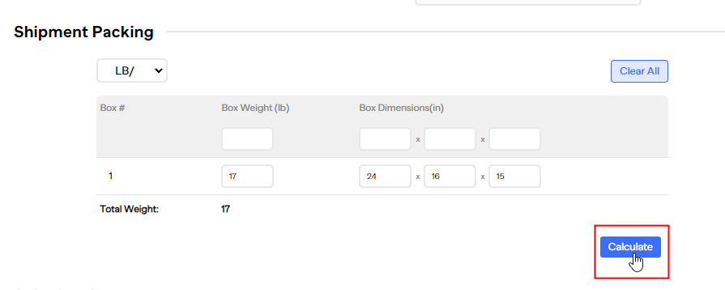
Step 17: In the Shipment Packing, click Calculate.

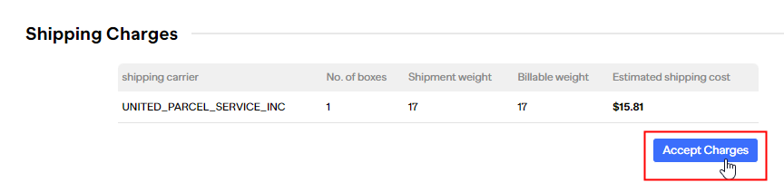
Step 18: In the Shipping Charges, click Accept Charges and Confirm.
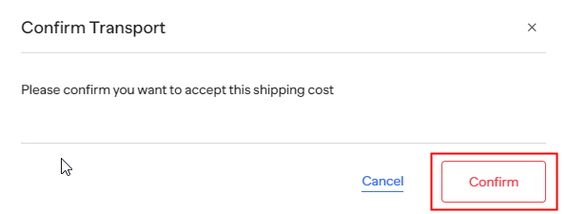

Step 19: The Void Label prompt gives us the option to cancel this within 24 hours.
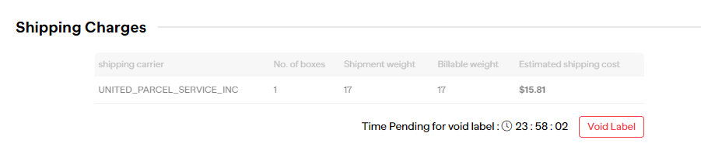

Step 20: Print Shipping Labels and Confirm number of boxes. Click Download and keep the PDF file in the Sharepoint.
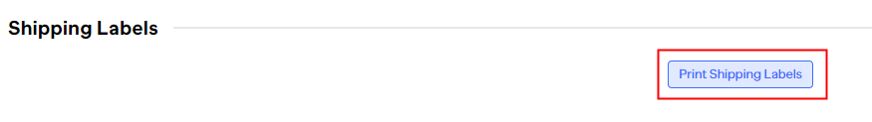
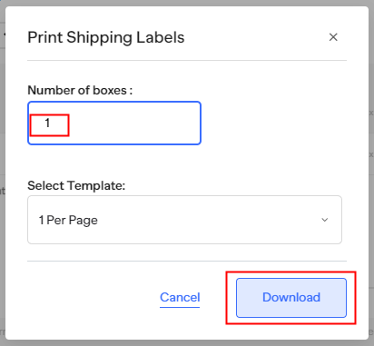
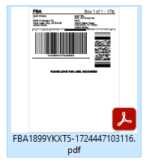

Step 21: Go back to the master spreadsheet and highlight the updated PO and UPC.
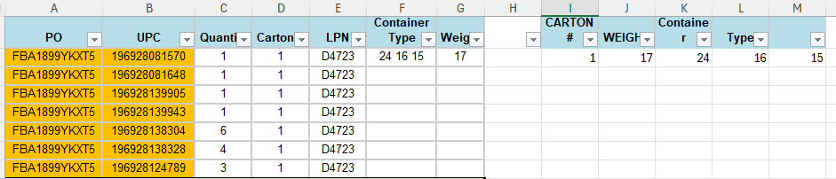

Step 25: Filter the UPC by color.
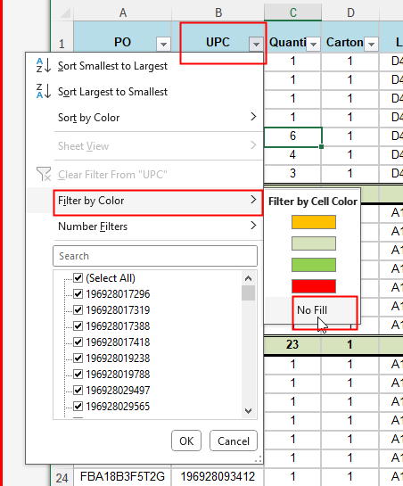

Step 22: Filter the PO. First, deselect all and choose only one. The purpose is to see only one PO while processing.
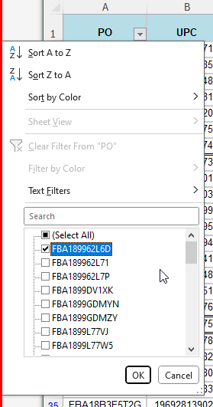

Step 23: Repeat the same process with the rest of the POs.

In case you encounter this, just click “Remove From Shipment.”
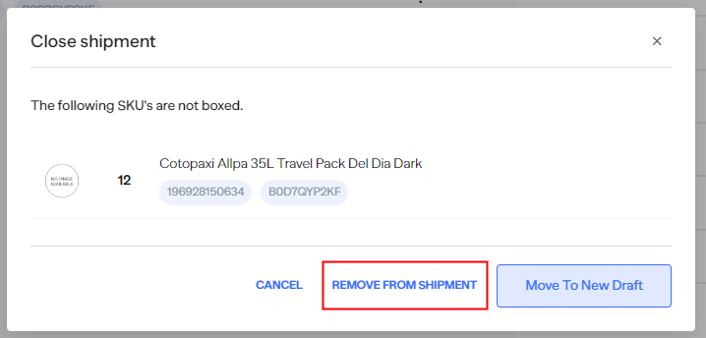

And continue shipping.

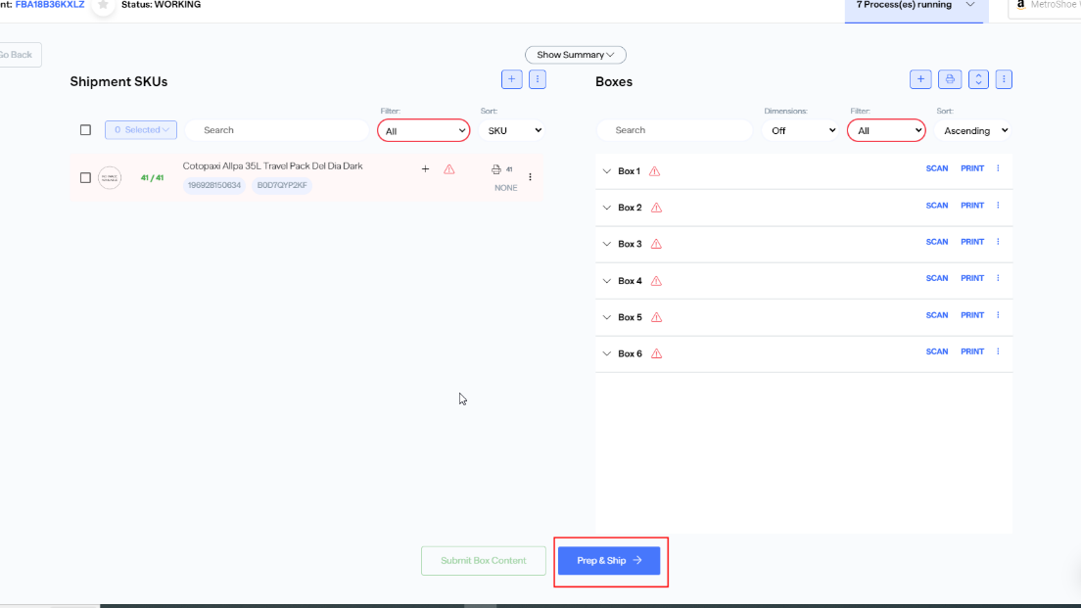

Highlight Column I and convert from General to Number. Remove the zeroes.
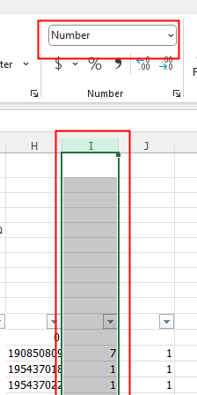

Right click on one tab and click Select All sheets.
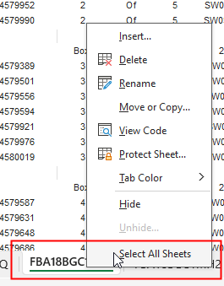

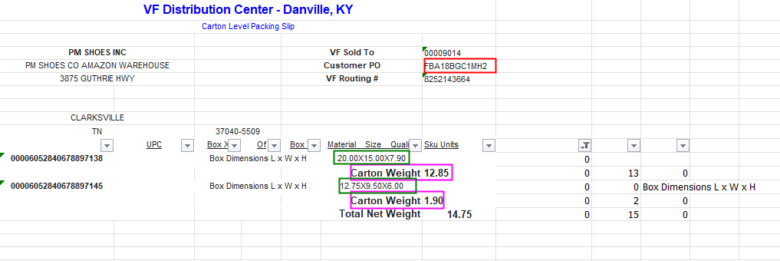

*Red – PO
* Pink – Weight
*Green – Length x Width X Height

DEFINITIONS

The following are definitions of some terms commonly used in Amazon Box Content and Shipping Labels processing.

TERM | DEFINITION
FBA | Fulfillment by Amazon
PO
UPC
LTL

END OF DOCUMENT

“Continuous improvement is better than delayed perfection.” – Mark Twain

