- Log in to FEDEX. https://www.fedex.com/secure-login/en-us/
- Click Shipping > Create Shipment
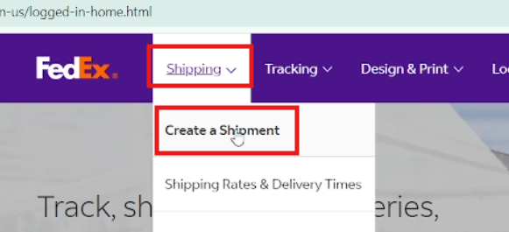

- Click “Select Shipment Profile.”
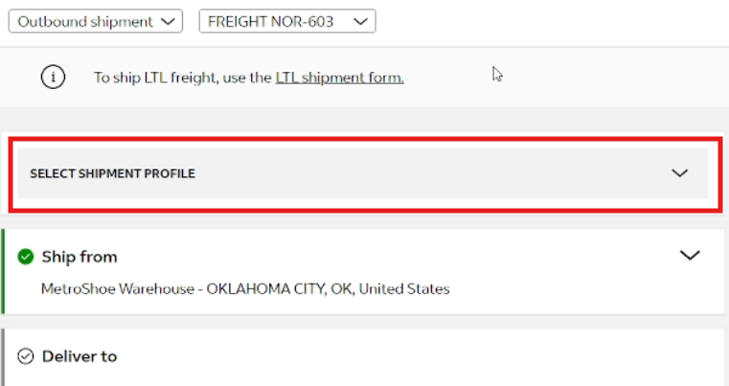

- Select the brand. For this one, it’s COTOPAXI.
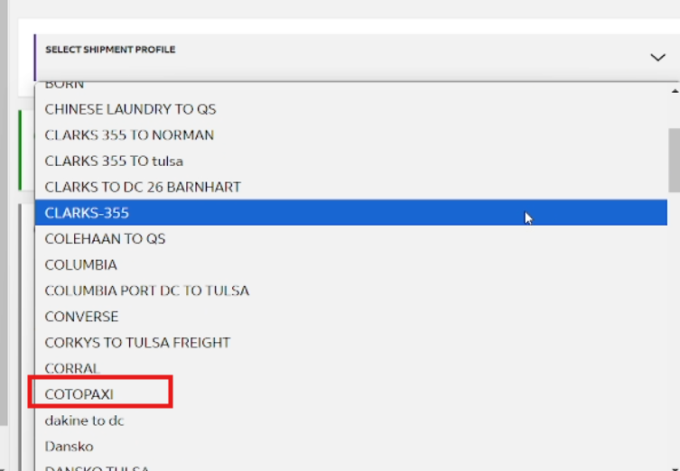

- Go back to Nineyard and click “Show Summary” and copy the code in “Ship To.”
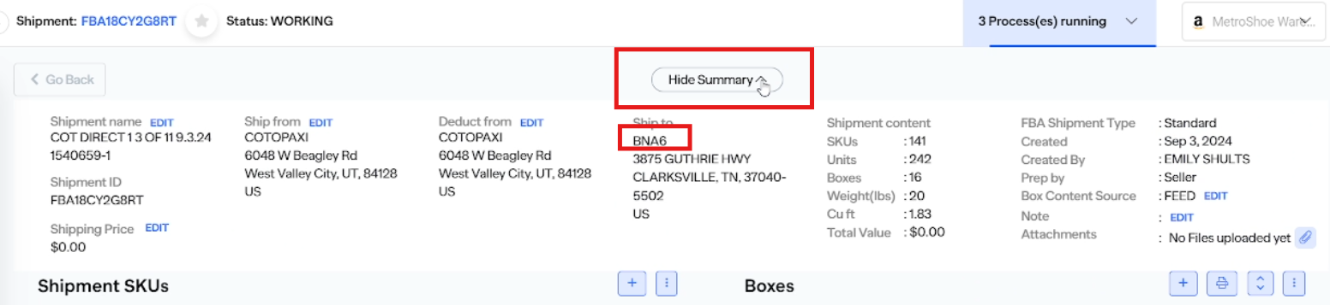

- Go back to FEDEX and in the Address Book, paste the code and select the address.
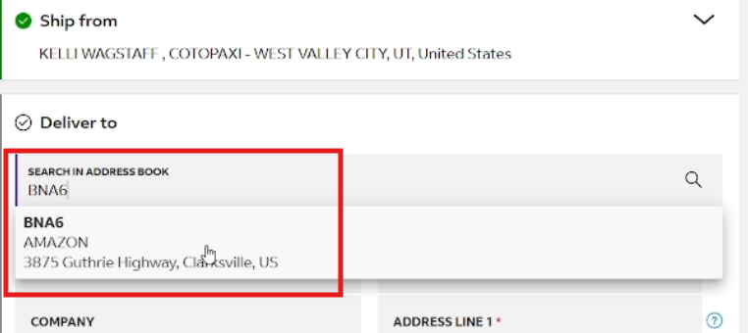

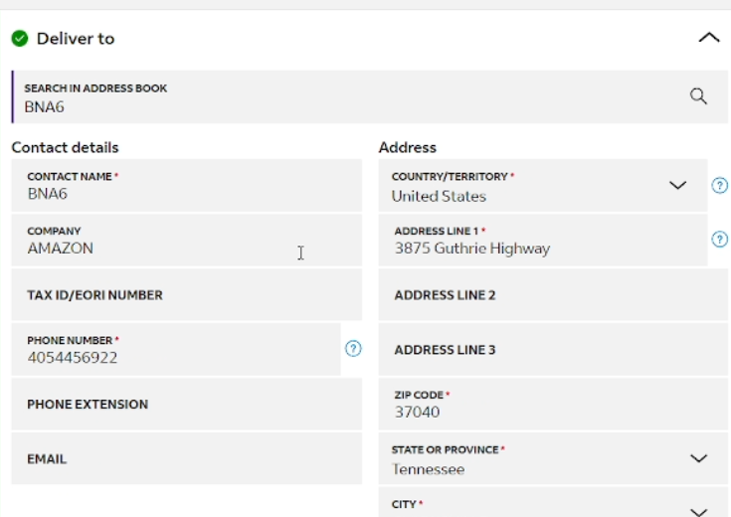

- Check on the right side and make sure the Service is ground.
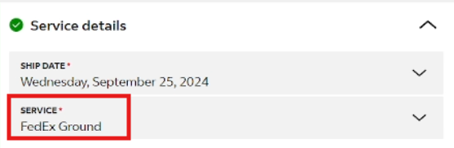

- Tick “Add shipment references” in the Additional Options.
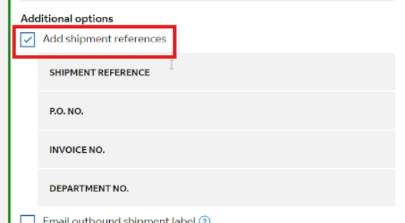

- Copy the Shipment ID and paste it to the Shipment Reference and P.O. NO.
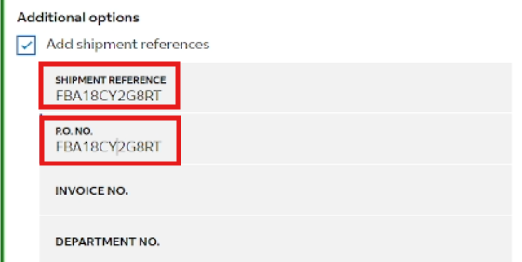

- Change the Pickup/drop-off to “I have already scheduled a pickup at my location.
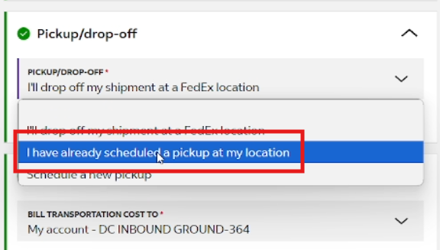
- Check the Billing Details, it should be 364 in the end.
BILLING DETAILS SHOULD CONTAIN THE VENDOR KEYWORD

- Unselect Add shipment notifications.
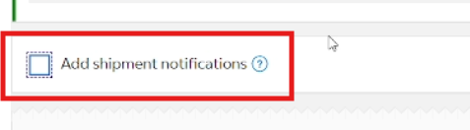

- Add package. It depends on the number of cartons/boxes in the request. For this request we have 16 packages so we will add 16.
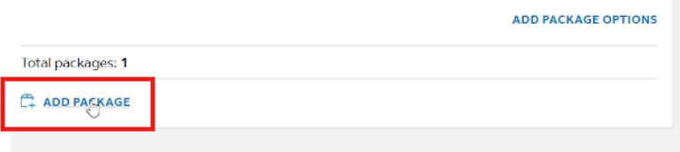

- Manually input the weight and dims.
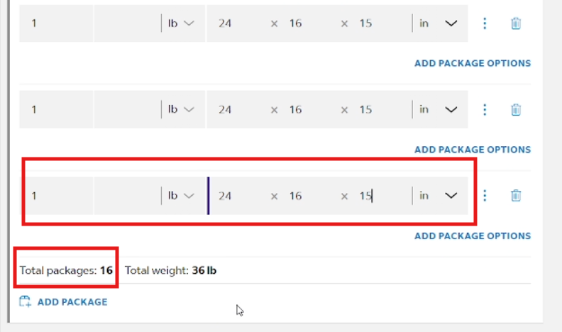

- Compare the shipping prices between Nineyard UPS and FEDEX. Whichever is the cheaper, we’ll go with that.

- Go back to Nineyard and print the box labels.
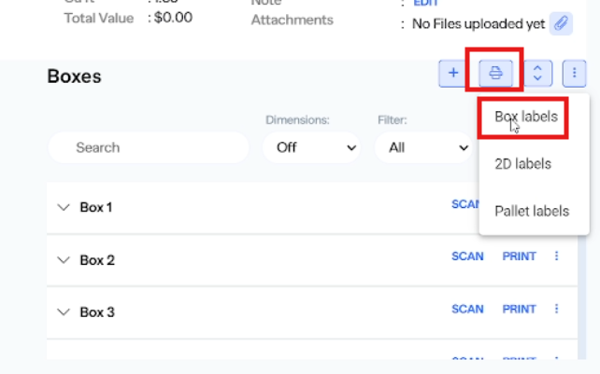

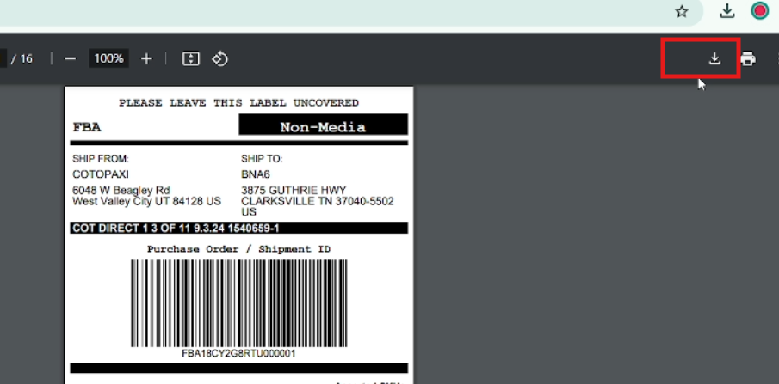

- Save using the FBA # + box labels filename.
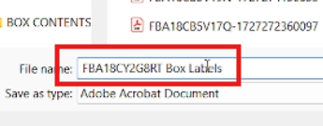

- Go back to Nineyard Prep & Ship. Choose “Other carrier” and select FEDEX EXPRESS CORP.
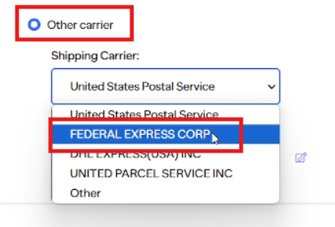

- Click the edit button next to shipping cost.
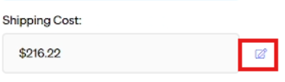

- Go back to FedEx, copy the Estimated total cost and add the price in Nineyard.
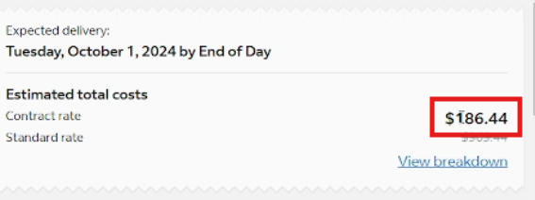

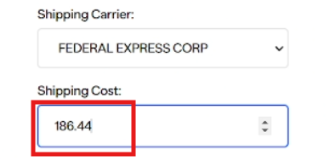

- Go back to FedEx and click FINALIZE.
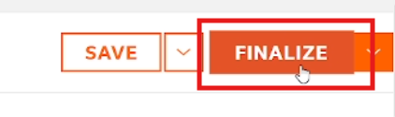

- Download shipping labels.
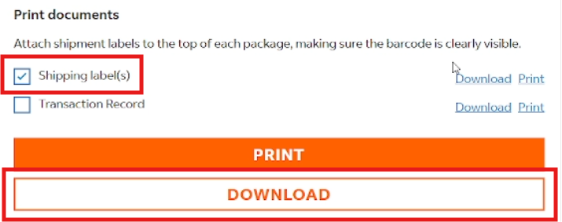

- Open the shipping labels pdf file and copy the tracking numbers.
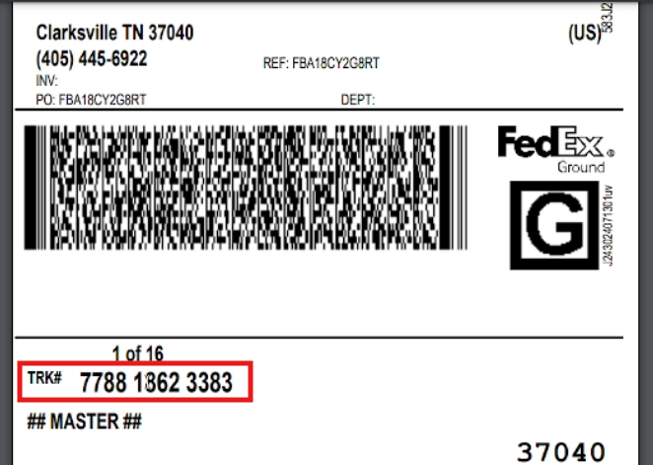

- Go back to Nineyard and fill each box.
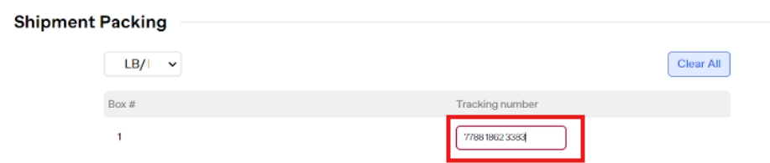

- Once done, click “Submit.”
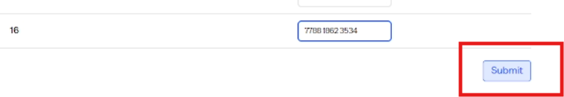

- Go back and click the Shipment ID. It should direct you to Amazon Seller Central.
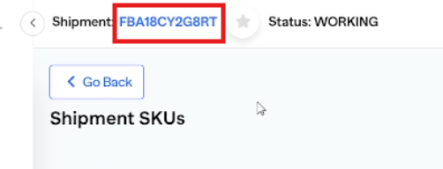

- It will direct you to the tracking page of the shipment.
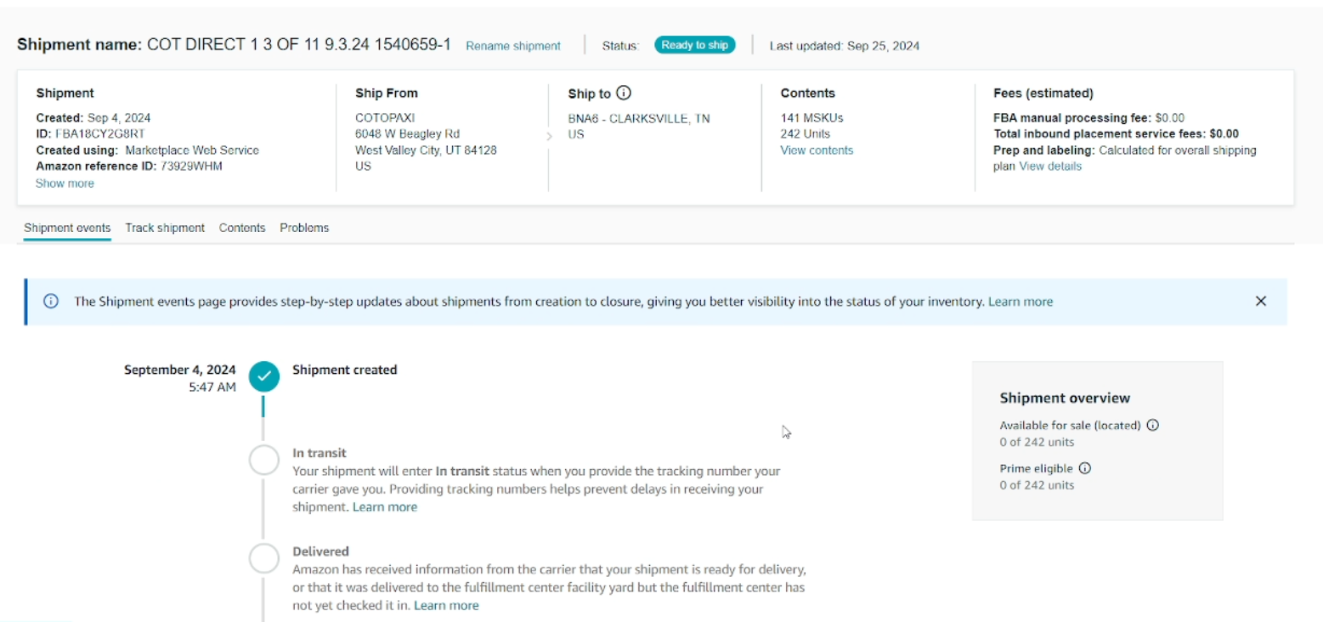

- Go back to the pdf file and change the filename by adding the shipment ID.
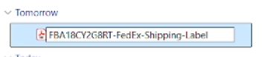
- Include that pdf file in your email.

