Advanced Trains
This mod aims to provide realistic, good-looking and functional trains by introducing a revolutionary rail placement system. It features several wagons that can be coupled together.
This mod is not finished. Don't expect everything to work. If you miss features, suggest them, but do not denounce this mod just because they are not yet implemented. They will be.

Placing Rails
Minetest's in-house rail system features rails that turn at an angle of 90 degrees – totally impractical for the use with realistic trains. Sod we have our own rails. Remember: Carts can't drive on the rails provided by this mod, as do trains not drive on minetest's default rails because of their different track widths.
First, craft some rails.

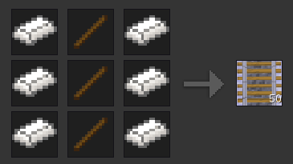
Now, place one at any position and another one right next to it: you have made your first railway track!
To learn how to make turns have a look at the following examples. A rail node has been placed only at the red-marked places.

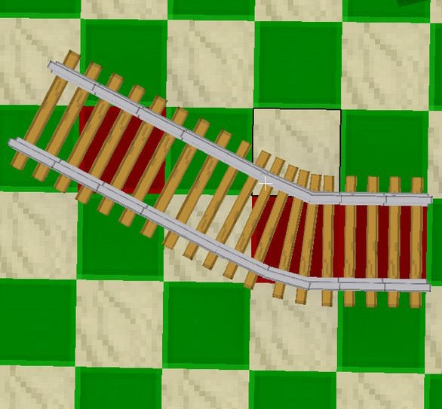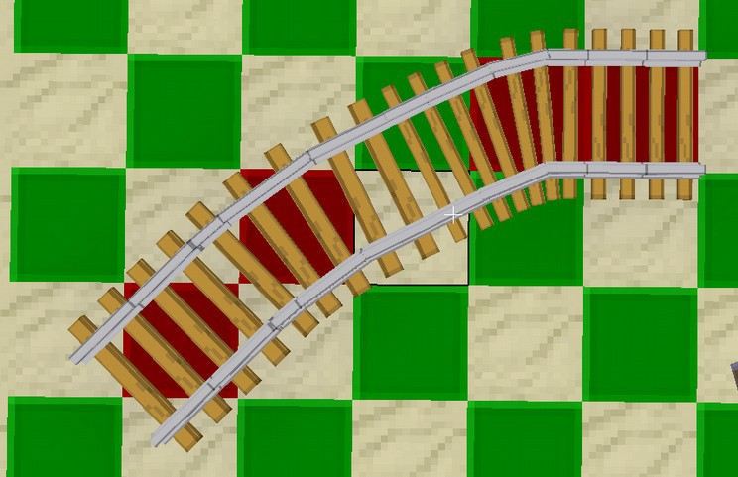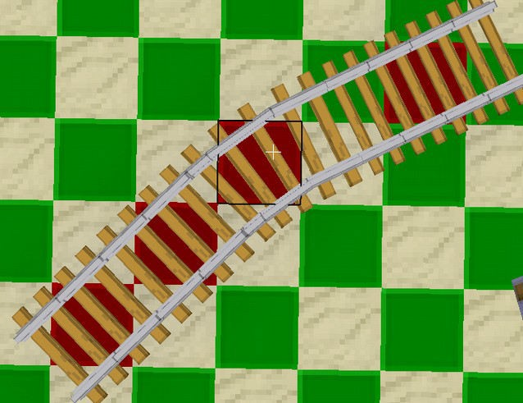
As shown in the illustrations above, the 30-degree angled rails use a knight's move (2 ahead, 1 aside) for placement.
For the rails to look realistic, I encourage you not to build turns that are too narrow. IMO the angles you can build with this are still way to narrow, but this is the best compromise I can find.

Switches
To create switches we need the trackworker tool. Aside from turning rails into switches, it is also capable of rotating everything (rails, bumpers, signals) in this mod in angles smaller than 90°. ATM it looks like a Sonic Screwdriver.

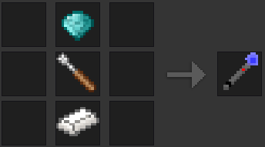
Place some rails. Then left-click 1-2 times on one of these rails, until you see a switch. Use right-click to rotate it how you need it. You can change the switch direction by right-clicking the switch or by powering it with mesecons.
Unfortunately tracks that are placed next to switches don't always automatically connect to them. You need to correct manually using the Trackworker. One day I will implement proper handling for these.
When you are finished it could look like this:

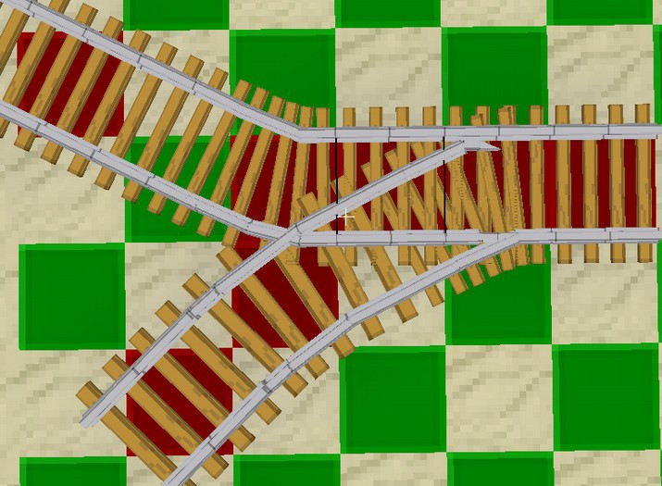

Rail crosses
There are no real cross-rail nodes. However you can create crossing rails by being creative and using the knight's move or by placing opposing 45-degree rails.

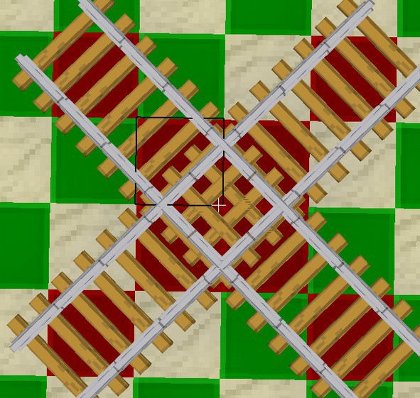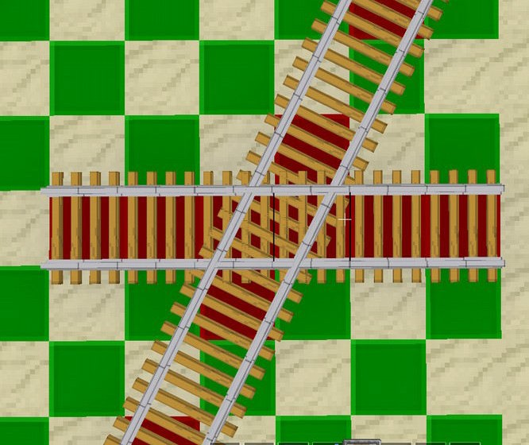

Height differences
To master height differences you can craft slope nodes:

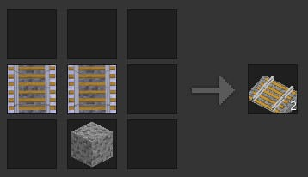

To place them, you have to prepare the base, then stand in the right direction and point to the slope start point, then place it. A slope will be constructed in the direction you are facing (45 degree steps) leaned against the next solid node. The right number of slopes is subtracted from the item stack if you are in survival.

Bumpers, platforms, signals and detector rails

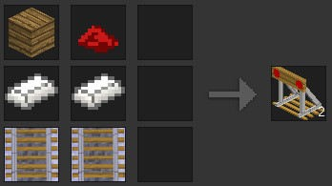
Bumpers are objects that are usually placed at the end of a track to prevent trains rolling off it. After placed, they can be rotated using the Trackworker.

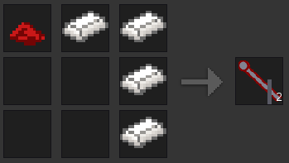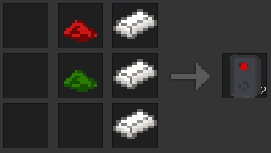

These are a regular analog signal and an electric signal. Like everything, you can rotate them using the Trackworker. Right-click or power with mesecons to signal trains that they can pass or have to stop.
The signals do not have any effect on trains, they can only signal the driver.
A more advanced signalling system (with distant signals/signal combinations) is planned.

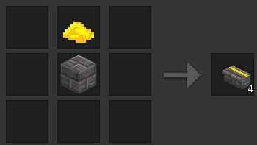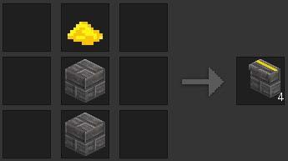

These are some platform nodes. I suggest using the left one, it's only half height and looks better. These nodes also have a sandstone variant, craft with sandstone bricks.
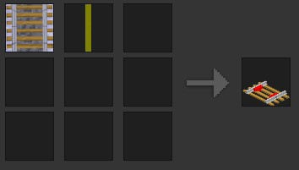

These detector rails turn adjacent mesecons on when a train is standing/driving over them.

Trains

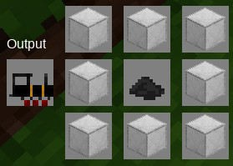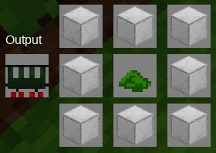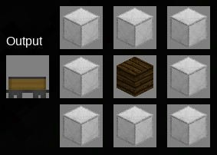
These are a steam engine and a passenger and a box wagon for it. The wagons are immovable if not pulled/pushed by an engine.

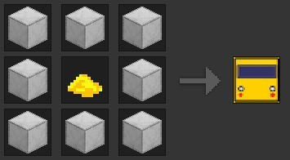
This is an underground train wagon. Hook some of them together to get an underground train.
There are also some wagons that can't be crafted yet:
- The 'Japanese Train' is a simple modern passenger train. IDS: advtrains:wagon_japan and advtrains:engine_japan
- There are industrial wagons: a red diesel engined a wood wagon and a tank wagon: advtrains:engine_industrial advtrains:wagon_wood advtrains:wagon_tank
To place wagons simply craft and click a track. In survival if you destroy trains you get only some of your steel back.

Driving trains
Right-click any wagon to get on. You will be presented with a list of 'seats' on this wagon. Select one by clicking it.
If yours or the servers minetest version is pre-0.4.15 there will probably be an empty formspec opening. Close it using Esc.
Always get off any wagon by right-clicking it.
Train controls
If you are inside a driver stand you are presented with a head-up display:

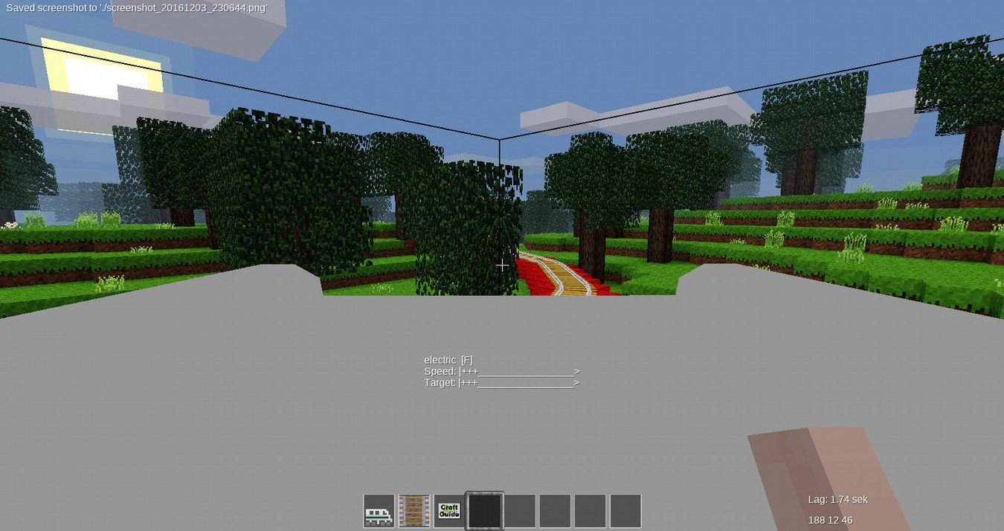
The upper bar shows your current speed and the lower bar shows what speed you ordered the train to hold. Assuming you have the default controls (WASD, Shift for sneak, Space for jump), the following key bindings apply:
W - faster
S - slower / change direction
A / D – open/close doors
Space: brake (shown by =B=d target speed will be decreased automatically) Shift+S: set speed to 0 (train rolls out, brake to stop!)
Shift+W: Set full speed
Shift+A: Set speed to 4 (~40km/h) Shift+D: Set speed to 8 (~100km/h)
Shift+Space: toggle brake (the brake will not release when releasing the keys, shown by =^B=) Shift+Use: get off (only works on driving stands)

Coupling wagons
You just learned how to drive an engine. Now place a wagon anywhere and drive your engine slowly towards that wagon. As soon as they collided your engine will stop. Now get off and right-click the green icon that appeared between the engine and the train. You have coupled the wagon to the engine.

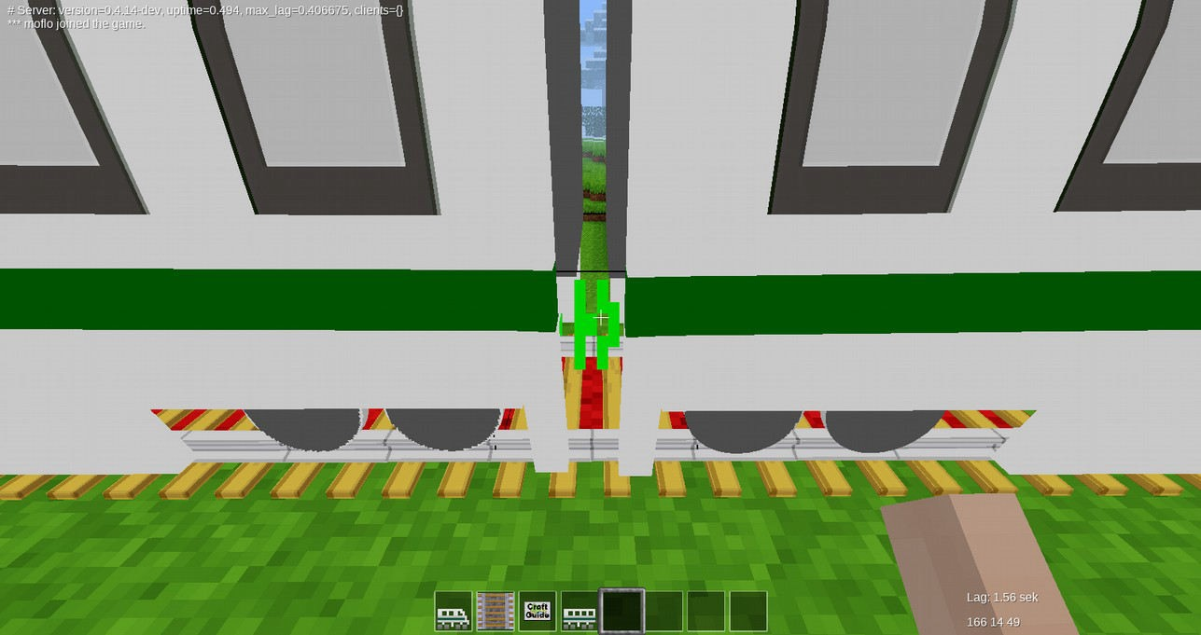
To discouple a wagon, punch the red icon between the wagons you want to discouple while the train is standing.

Automatic Train Control (ATC)
The ATC controller does not have a crafting recipe. When placed, you can set a command and it will be sent to any train driving over the controller. This allows you to implement limited train automation.
For the available commands and their syntax see the file atc_command.txt.
Another more powerful ATC interface with LUA Commands is planned.

And now have fun playing around with trains in minetest!

