|  |  |
| --- | --- |
| TRUSTED NEWS CODE  User Guide  Week 7 Assignment | ABSTRACT  This guide was created for UMUC Course, CMSC 495, Group 3 and describes the requirements and usage of the Trusted News Code (TNC) Software.  Group 3 Members  Name: Christiano, Andrew  Name: Fernandez, Yrume  Name: Orwick, Brian  Name: Sell, Julia  Class: CMSC 495 - Current Trends and Projects in Computer Science Professor: Dr. Hung Dao  Due: 07 October 2018 |

**Version Control**

|  |  |  |  |  |
| --- | --- | --- | --- | --- |
| Revision # | Date | Name | Descriptions | Contact Info |
| TNC_UG_0001 | 10/7/2018 | Yrume Fernandez | Created | yrume.fernandez@gmail.com |
| TNC_UG_0002 | 10/7/2018 | Brian Orwick | Modified | orwick12@outlook.com |
| TNC_UG_0003 | 10/7/2018 | Andrew Christiano | Modified | ajchristiano91@gmail.com |
| TNC_UG_0004 | 10/7/2018 | Julia Sell | Modified | selljm14@gmail.com |

Table of Contents

Introduction 4

a. Description 4

Requirements 4

a. System Requirements 4

Installation 5

Step 1: (Download Code) 5

Step 2: (Install Modules) 5

Operation 6

Step 1: (Run the Program) 6

Step 2: (Using Website) 7

# Introduction

Trusted News Code (TNC)

## Description

The Trusted News Code (TNC) software is a Python Web Application which searches the articles on the websites of provided news organizations to retrieve news articles, count the number of times an article is found, and provide the user a list of articles prioritized by their trustworthiness with a link to the main article. This guide is meant for the administrator of the TNC program, as regular users have no need to install the program as it is regularly accessed via the internet.

# Requirements

## System Requirements

The following are the minimum required system and software to support a Python based news indexing system, using Flask, Newspaper and SQLite modules:

* Processors:
  1. Intel® Core™ i5 processor 4300M at 2.60 GHz
* Memory:
  1. 8 GB of RAM
* Disk space:
  1. 3 GB
* Operating systems:
  1. Windows® 10, macOS (Sierra), or Linux (Ubuntu 16.04)
* Browsers: Microsoft Edge, Google Chrome, or Mozilla Firefox
* Applications:
  1. Python version 3.7.0
     1. Additional Python Modules (Install with pip):
        1. Flask
        2. Newspaper3k

The Trusted News Code is maintained on the Social Software Development Site GitHub and can be retrieved at https://github.com/Mercury-6-Solutions/CMS495/tree/master/src. Users are encouraged to periodically check the site for new updates, codes, or information pertaining to future enhancements. To install the TNC for initial use, please follow the below Installation guidelines.

(Note) This guide assumes that the user has already installed Python 3.7.0 (or greater).

# Installation

## Step 1: (Download Code)

Download the Source Code (src folder) from https://github.com/Mercury-6-Solutions/CMS495/tree/master/src.

The contents should be the following:

(Note) Your directory path (C:\xxxx\xxxx\src) may look different depending on where you install the src code.

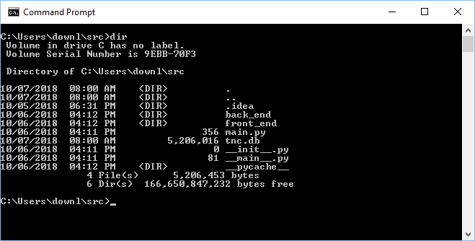

## Step 2: (Install Modules)

Install required python modules (flask, newspaper3k) by running the following commands from the command prompt (command line interface):

1. pip install flask
2. 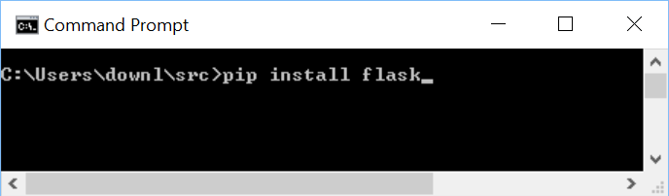pip install newspaper3k

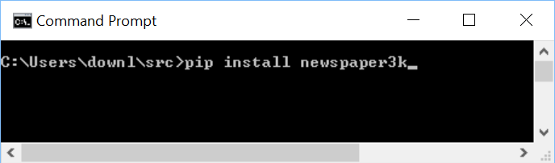

# Operation

## Step 1: (Run the Program)

To run the program user opens up a command prompt from within their operating system and performs the following steps:

1. Go to the src directory
2. 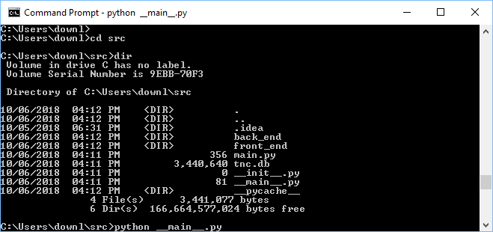From the src directory type: python __main__.py
3. Program will start retrieving articles, and displaying capture information on command prompt standard output (as shown below)

(Note) Please be patient as this will take some time as program retrieves articles from multiple sources and populates database. The errors you see below are not presented to normal users accessing the TNC program through the internet. These are only visible to the administrator of the TNC program. The errors are showing when articles cannot be downloaded, and therefore cannot be parsed.

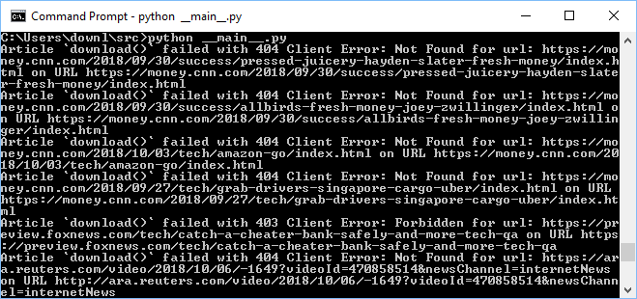

1. Website is running, and program is operating once the following page is displayed:

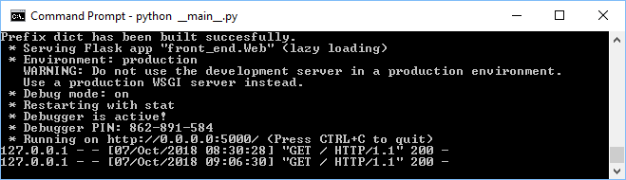

## Step 2: (Using Website)

To test that the website is available to any users who want to access it to retrieve trusted news articles simply enter <http://localhost:5000> on any web browser, and the website will provide a list of articles, sorted from most referenced on the internet to lowest referenced by trusted news sources.

