**The experimental procedures involving human subjects described in this work were approved under UTD IRB # 11-59 by the Institutional Review Board at the University of Texas at Dallas, Richardson, Texas, USA.**

**The Dataset consists of two experiments as explained below:**

* **Experiment 1:**

1. Data is collected using Vista Medical FSA SoftFlex 2048

2. Size of pressure mat is 32*64. This is the raw data collected reporting numbers in range of [0-1000] for each sensor.

3. Sampling rate is 1Hz.

4. Each file includes the data frames around 2-mins (around 120 frames).

* **Subject properties:**

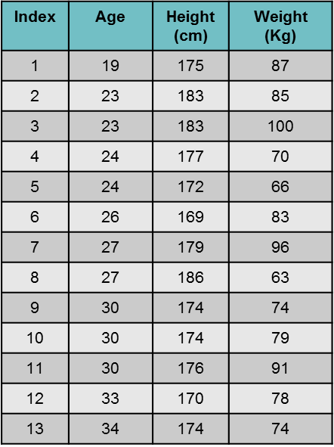

* **Data properties:**

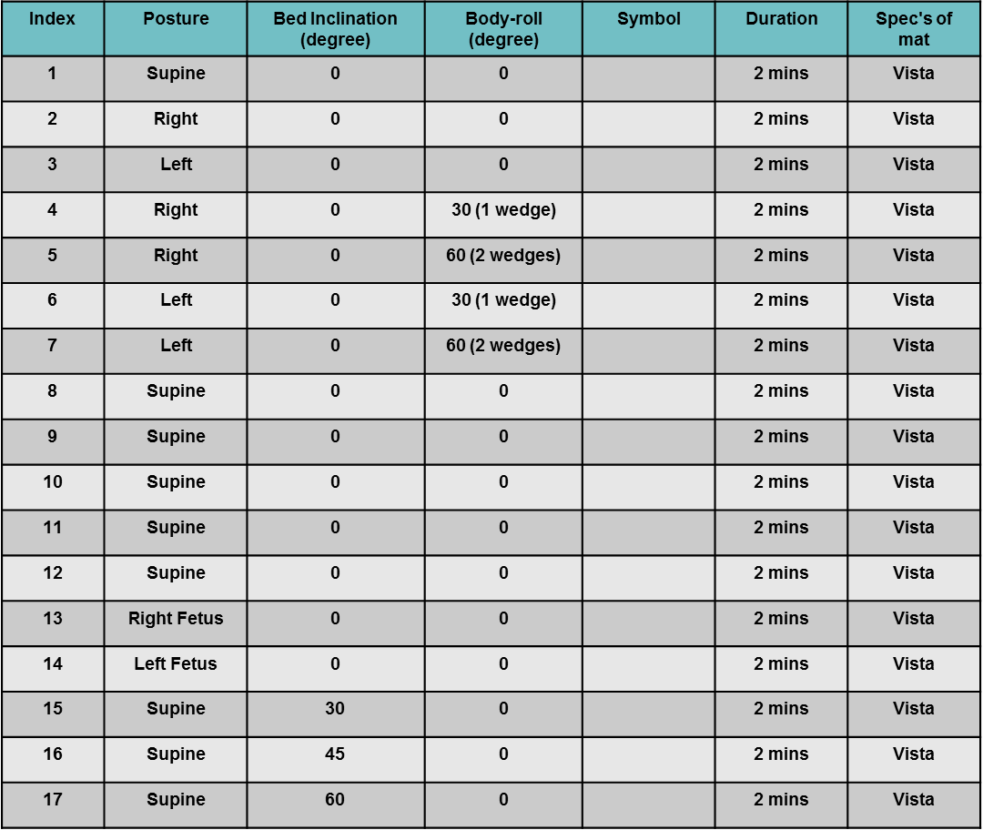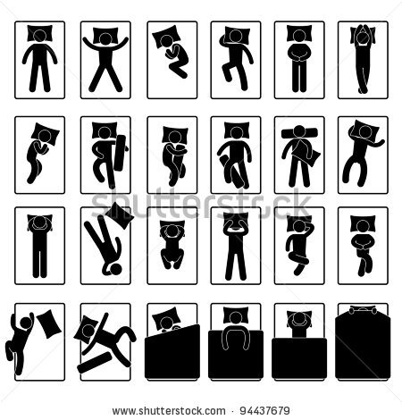

* **Experiment 2:**

1. Data is collected using Vista Medical BodiTrak BT3510

2. Size of pressure mat is 27*64. This is the raw data collected reporting numbers in range of [0-500] for each sensor.

3. Sampling rate is 1Hz.

4. Each file contains the average of around 20 frames

5. The data is collected for both sponge and air mattresses separately.

* **Subject properties:**

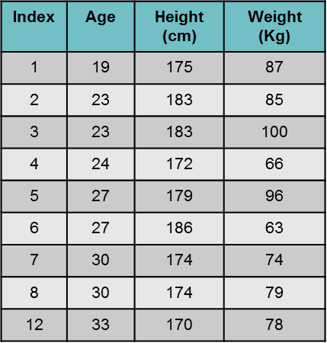

* **Data properties:**
  + **Part B:**

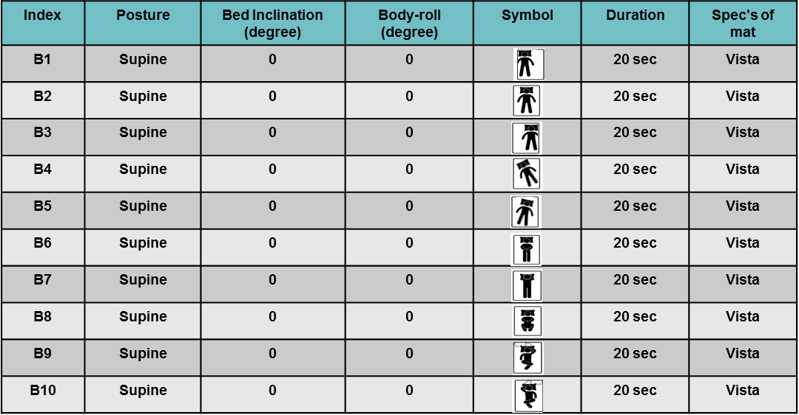

* + **Part C:**

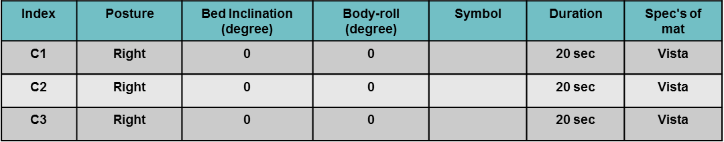

* + **Part D:**

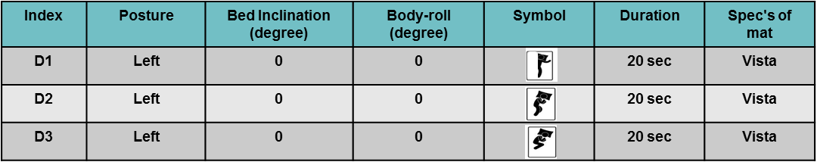

* + **Part E:**

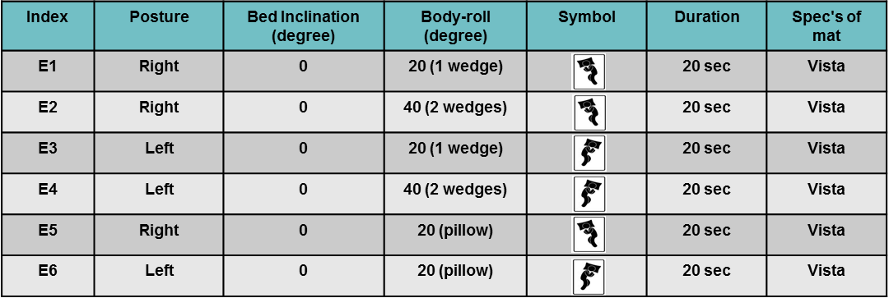

* + **Part F:**

