**顾家北词伙积累**

**教育**

（1）历史

history textbook 历史教科书

revise history books修改历史书

reflect territorial claims反映领土要求

deeply-held prejudices根深蒂固的偏见

emotionally-charged perceptions情绪化的看法

political bias政治偏见

suppress difficult topics in history回避历史上的难题

history knowledge 历史知识

an overview of world history 对世界历史的完整认识

the history curriculum 历史课程

face prejudice 遇到歧视

established a chronology 知道历史事件的先后顺序

form an overall narrative 将历史故事讲全

（2）管理类

display knowledge 展示知识

develop leadership and management skills培养领导能力和管理能力

develop a rapport 发展友好关系

build relationship with建立良好关系

prospective employers潜在雇主

low morale士气低落

business literate深谙商道

a degree in maths数学专业学位

（3）考试要求

sufficient language skills 足够的语言能力

an English language assessment 英语考查

pass a language test 通过语言考试

communicate effectively to a high standard of English 用高水平的英文交流

check writing and speaking fluency 检查写和说的流利程度

（4）科学实验

practical work 实践工作

science curriculum 科学课程

undertake/conduct practical experiments 做实验

follow the curriculum 遵照课程大纲

damage the economic future 影响经济

a chronological history 编年史

write simple computer programs写程序

geographic features 地貌

（5）课外活动

outdoor pastimes 室外活动

outdoor experiences 户外活动经历

experience nature 体验大自然

junior school children 中学生

get to grips with the natural environment 接触大自然

（6）分班上课

ability grouping 按能力分班

grouping pupils by ability 分班

harm self-esteem 伤害自尊

classroom management 教室管理

teach mixed ability classes 混合能力班级

in streamed schools 分班的学校

social adjustment 社会适应能力

low ability classes 低分班

（7）人工智能

achieve a landmark 获得里程碑的成功

an artificial intelligence programme 人工智能软件

beat the champion 战胜世界冠军

tougher challenge 更严峻的考验

beat its human rival 赢人的对手

advanced amateur 业余高手

a professional level player 专业选手

（8）留学申请

choose a course选择一门课程

take a course学习一门学科

make a daunting choice做出一个艰难的选择

grab imagination and attention引发想象力并吸引注意力

a sustainable source of stimulation and enjoyment一个持续性的激励和乐趣的源泉

a vocational course职业课程

academic course学术课程

options of work职业选择

identify passions, interests and ambitions发掘自己的热情、兴趣和抱负

match interests and abilities to courses available兴趣和能力和提供的课程相匹配

decide on a course选好课程

subject courses 专业课程

the course content课程内容

live at home住在家里

limit the range of courses限制课程的范围

independent living独立生活

go to a university上大学

get home for a hot meal回家吃顿热乎乎的饭

sample entirely different circumstances体验完全不同的环境

open days开放日

university life 大学生活

prospective students未来的学生

make better-informed choices做出更加明智的选择

fill in application form填写申请表

（9）电视的影响

delay child development延缓儿童发育

have the TV on开着电视

impair young children's development影响儿童的发展

reduce the amount of conversation减少谈话

delay in language development延缓语言发展

the fault of TV电视的过错

a host of other modern ills其他一系列的现代弊病

heavy TV viewing长时间看电视

at an early age在很小的时候

linguistic problems语言问题

family circumstances家庭环境

other social influences其他社会影响

lack of interaction缺乏互动

at a personal level在个人层面

monitor levels of age-appropriate programmes监测适龄水平的项目

foster language skills培养语言技能

improve attention提高注意力

discuss the contents讨论内容

watch high-quality, tailored programmes观看高质量，量身定制的节目

contain familiar words and scenarios包含熟悉的单词和场景

surf the internet上网

give them access to other worlds which present useful information让他们接触到其他能够提供有用信息的世界

exposure to TV and computer screens看电视和玩电脑

the permanent presence of the TV in the background长期以来一直存在着电视作为背景播放这一现象

have some high-quality children's programmes有一些高质量的儿童节目

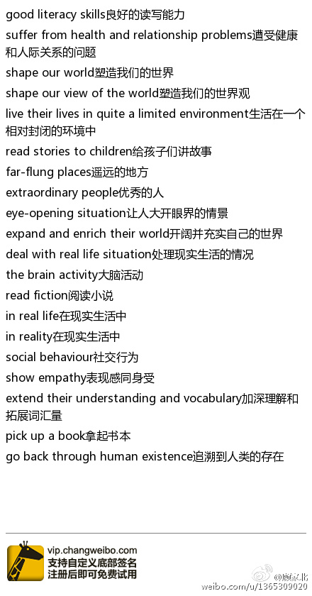

**关于阅读**

read on screen在电子屏幕上阅读

screen-based reading电子书

electronic editions电子书

electronic texts电子书

a digital copy 电子书

in digital marketplaces数字市场

in printed form纸质的

print books纸质书

a bound book装订本

literary fiction文学小说

reference works工具书

bestselling books畅销书

physical book 纸质书

property and copyright law产权和著作权法

read on e-book reader在电子屏幕上阅读

**关于音乐**

play an instrument演奏乐器

boost intelligence提高智力

boost general well-being提高总体幸福感

work as a team 团队合作

face an uphill battle面临一场攻坚战

incorporate music into the curriculum把音乐纳入到课程中

a well-rounded education全面的教育

in early years education学前教育

help concentration有助于集中注意力

aid relaxation有助于放松

influence moods and emotions影响心情

boost the immune system增强免疫系统

develop musical ability培养音乐能力

dedication to music对音乐的全身心投入

in the teenage years在青少年时期

develop potential开发潜力

**关于工作**

long, inflexible hours长时间，不灵活的工作

remain a rarity 很少见

flexible working 灵活的工作

work long hours长时间工作

strike a better balance between their job and their life outside work

在工作和工作之外的生活之间取得更好的平衡

balance work and life平衡工作和生活

better workplace performance更好的工作表现

the embedded culture of presenteeism根深蒂固的出勤主义文化

reduced absenteeism减少旷工

less staff turnover减少员工流动率

a more productive, highly committed workforce更加专注且高效的员工

a better work-life balance更好地平衡工作和生活

launch new guidelines 推出新的指导方针

take the time to pursue other interests花时间去追求其他兴趣

parental leave产假

have access to job-share schemes能够享受轮班方案

工作着装：

go out of fashion过时

suits and ties西装领带

turn up for work looking smart工作时看起来很有精气神

a formal business dress code正式的商务着装要求

wear casual clothes穿便装

in a suit穿正装

damage a company's image损害公司形象

affect work rates影响工作效率

mental capability心理素质

wear a collar穿着硬领衬衫

press the clothes熨衣服

**医疗条件**

greater participation of the private sector私营部门的大力参与

stimulate competition刺激竞争

healthcare provision提供医疗保健服务

private health providers提供私人医疗服务

private operators of hospitals私立医院

in the interest of patients为了患者的利益

**航空业**

aviation industry航空业

airline carriers航空公司

purchase carbon allowances 购买碳排放量

heavy carbon emitters大型碳排放者

power plants发电站

pass along to their customers转移到顾客身上

raise fares提高票价

cover the costs of compliance支付遵守法律的费用

increase fares提高票价

launch a trade war发动贸易战

reach space get into space 达到太空

reach orbit 进入轨道

launch a satellite 发射卫星

launch space rockets 发射火箭

space planes 太空飞机

space exploration missions 太空探索计划

space technologies 太空科技

scientific institutions 科学机构

economically viable 经济可行

**社会**

（1）风气

worship celebrities 崇拜名人

look up to individuals 崇拜人

receive attention 吸引注意

in prehistoric times 史前时期

qualities are revered 尊重素质

emulate fame 追赶名声

copy behavior 模仿行为

follow celebrities追求名人

receive wealth from society 从社会获得财富

名人隐私：

tabloid press 八卦新闻

hack one's phone 偷听电话

in the public eye 受到公众关注

reveal inner secrets 暴露自己的秘密

guard private lives 保护隐私

generate fame 获得名声

conduct one's life生活

have a private life有隐私

public property公共财产

（2）发展

agricultural and industrial goods农业和工业品

Insatiable demands无法满足的需求

massive appetite for goods对货物的巨大需求

a looming ecological crisis生态危机迫在眉睫

an emerging economic superpower一个正崛起的经济超级大国

（3）减肥

eating disorders 饮食不好

promote unhealthy body images 宣传不健康的体型

act responsibly 行为规矩一点

undermine self-esteem 伤害自尊

appear physically perfect 看上去身材很好

digitally manipulate images 处理过的照片

psychological and social factors 心理和社会因素

advertising agencies 广告中介

a powerful influence 很大的影响

adopt recommendations 接受推荐

an important step 重要的一步

diminish self-esteem 影响自尊

a positive influence 积极的影响

draw the line 分清界限

digital manipulation 美图

it's impractical 不现实

（4）城市发展

embrace building boom 接受房地产的快速发展

futuristic look 未来主义的外观

office complex 办公楼

property development company 房产开发商

world-renowned architect 世界著名建筑师

economy has boomed 经济腾飞

skyline has soared 天际线飙升

pour into cities 涌入城市

development and demolition of buildings建筑物的开发和拆除

divide opinion看法不一

staff cuts裁员

城市建筑：

architectural merit建筑价值

leave the building empty让建筑物闲置

an example of outstanding architecture著名建筑的范例

single occupancy commercial building独立的商业大厦

windows at the front 正面有很多窗

an office building办公大楼

encompass forms包含各种形式

reflect the sunlight反射阳光

住房成本：

rising housing costs 住房成本上升  
contain three generations of a family 包括一个家庭的三代人  
first time buyers 首次购房者  
a regular feature of life 生活的一个普遍特点  
rising levels of debt  债务增加  
high cost of property房价高企

（5）网络环境：烟酒文化过多

online music videos在线音乐视频

positive depictions of smoking and drinking alcohol 喝酒抽烟的正面描述

require regulatory control 需要法律监控

put age ratings 年龄收视指引

viewing percentage 收视率

contain alcohol-related content 包含酒的内容

微博：

post short messages 发短信息

character limit 字数限制

popular micro-blogging platform 流行的微博平台

in a single post 一个微博

increase pressure on 促使

during a pilot phase 实验阶段

use the extended facility 拓展功能

take screenshots of text 截屏

（6）青少年犯罪

youth reoffending rate 青少年再次犯罪率

young offenders 青少年罪犯

commit offences 犯法

first-time offenders 首犯者

the youth justice system has been reformed 青年

serious community sentence, tougher community sentences 更加严厉的社区监禁

（7）垃圾回收

recycle household rubbish 回收家庭垃圾

reduce household waste 减少家庭垃圾

cut waste 减少垃圾

give cash rewards 给奖金

free plastic shopping bags 免费的塑料袋

set higher recycling targets 设定更高的回收目标

introduce variable charges 不同的收费

use charges 使用收费

raise funds 筹款

**动物保护**

for the good of others为了他人的利益

welfare campaigners 动物权益活动人士

act disinterestedly 行为无私

exhibit signs of morality展现道德迹象

resemble human behaviour和人类行为相似

treated humanely 人道地对待

possess a level of conscious awareness拥有一定程度的意识水平

have some level of morality具有一定的道德水平

have some concern over other animals对其他动物有一定的关切

live within a groups生活在一个团体内

a moral code of behaviour行为道德规范

exhibit similar moral codes to humans向人类展示相似的道德规范

spend professional lives 用自己的职业生涯

by observation通过观察

by experiments通过实验

test their mental capacities测试他们的心智能力

feel sensation and emotion in the same way as humans和人类一样有感觉有情绪

destined for human consumption为人类食用

eat genetically engineered seafood吃转基因的海鲜

meet the regulatory requirements符合监管部门的要求

wild fish野生鱼

injected with a gene注射基因

healthy and nutritious food健康营养的食物

marine habitats海洋栖息地

**奥运会（运动）**

体育场馆

funding boost for sports center为建设体育中心拨款

sports facilities体育设施

receive a boost获得支持

build the on-campus development在校内建新的建筑物

be open to students and the local community对学生和当地社区开放

a four court sports hall一个四球场的体育馆

fitness gym健身房

changing rooms更衣室

regularly take part in sport定期参加运动

taking part in more regular sport定期参加运动

sustain local sports clubs保持当地体育俱乐部

support the health and fitness支持健康和健身

provide quality sports facilities提供高质量的体育设施

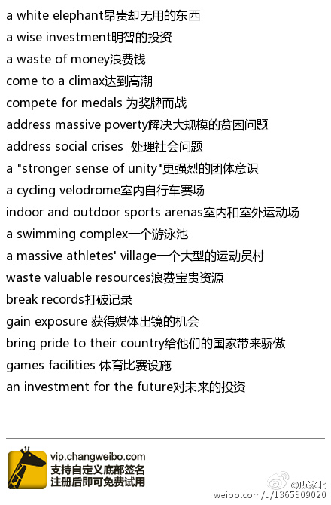

**文化专题：**

（1）节日风俗

the lunar new year春节

usher in the lantern festival迎来元宵节

the first lunar month元月

eat rice dumplings吃元宵

view lanterns赏花灯

riddle guessing games猜灯谜游戏

watch stilt walking看踩高跷表演

gather at a temple云集在寺庙里

pray for good luck 纳福求吉

Lunar New Year celebrations 农历新年庆祝

welcome in the new year迎接新年

travel home返乡

make passenger trips 旅行

a time to be with family 和家人团聚的时间

fireworks display 烟花表演

reunion dinner 团年饭

re-enactment of colorful ancient ceremonies 重新进行古代的庆祝活动

传统建筑：

historic homes 古屋

artefacts were looted 文物被抢走

old neighbourhoods are bulldozed 老社区被推倒

narrow alleyways 胡同

make way for apartment buildings 给住宅楼让路

have a ghostly feel 阴森森的感觉

during imperial times 封建时期

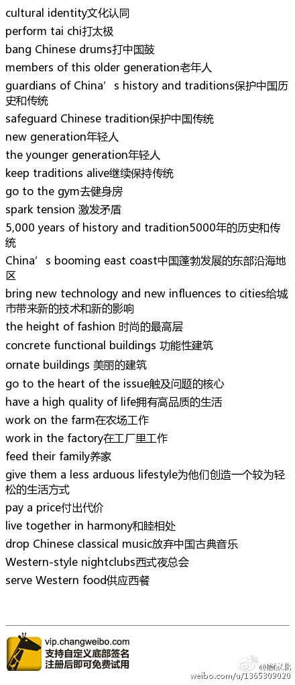

文化差异：

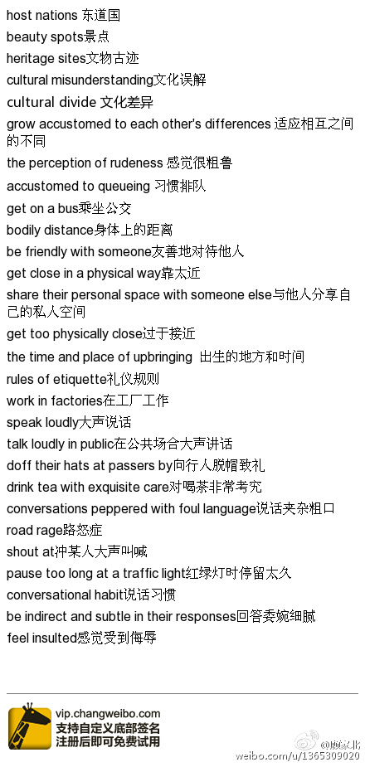

**旅游观光：**

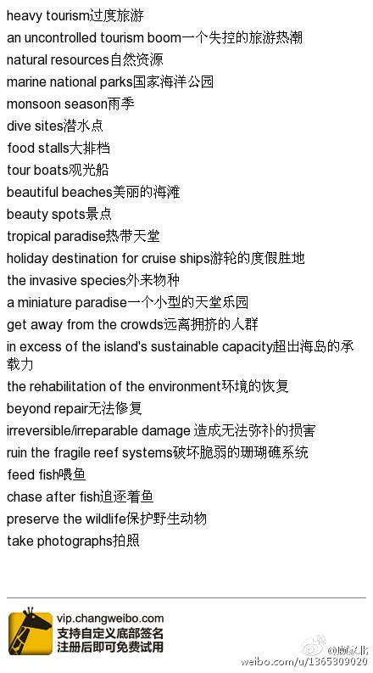

**生态环境：**

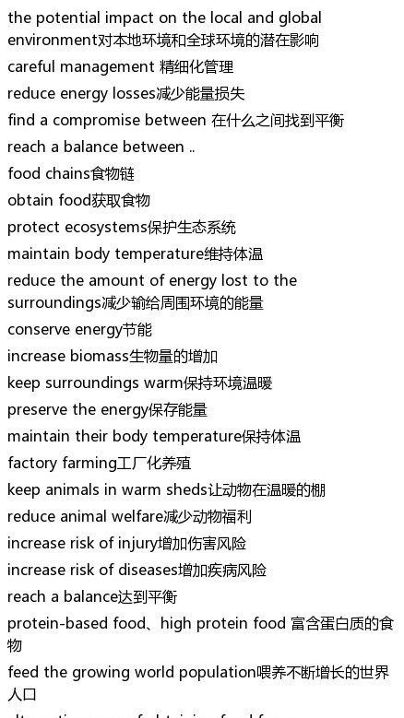

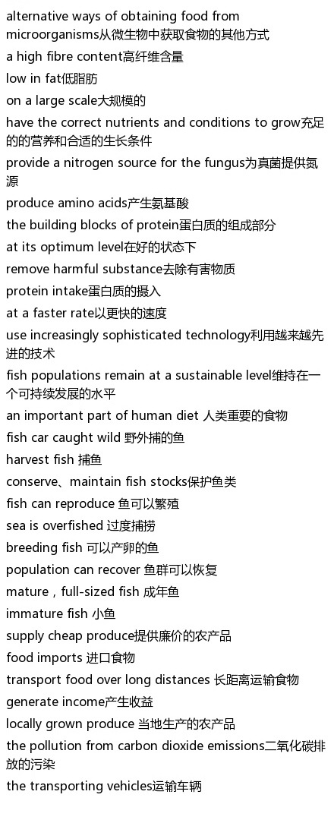

工作服，制服，校服

suits and ties西装领带

turn up for work looking smart工作时看起来很有精气神

a formal business dress code正式的商务着装要求

wear a collar穿着硬领衬衫

press the clothes熨衣服

Smart clothes for work 上班穿的很帅气

Wear formal dress 穿正式衣服

dress formally 穿衣正式

a tie and a shirt 穿西装打领带

wear casual clothes穿便装

in a suit穿正装

wear a suit 穿西装

wear uniforms 穿工作服

a work-based uniform 工作制服

快餐

Fast food restaurants 快餐店

a fast food outlet 快餐店

the fast food industry 快餐行业

tinned fruit  灌装水果

Contain fat, sugar  含有脂肪和糖分

ready meals  即食产品

ready-to-eat foods即食产品

A diet of convenience foods 快餐

Prepared meals 即食产品

An unhealthy diet 不健康的食品

Unhealthy junk food  不健康的垃圾食品

fed a diet of junk food 经常喂食垃圾食品

上网和虚拟世界

In the virtual world 在虚拟世界

An Internet connection/ access to Internet   可以上网

Get in the Internet age 网络时代

 use the Internet 使用网络

surf the web上网

have Internet access 可以上网

Go online /get online 上网

Connected to the Internet 连接网络

Access  the web 上网

looking at a computer screen 看电脑屏幕

犯罪和罪犯的种类

young offenders 少年犯

minor offences 轻度犯罪

first-time offenders 首犯者

Hardened criminals，persistent offender , habitual criminals 惯犯

serious offenders 重犯

Career criminal 职业罪犯

Youth/juvenile crime 青少年犯罪

Petty crime 轻微犯罪

Corporate crime 商业罪案

Computer crime 电脑犯罪

立法和违法犯罪

introduce guidelines 提供指引

Enact laws, enforce laws 实施法律

Make laws, introduce laws 实施法律

Pass laws 通过法律

strengthen enforcement 加强执法

take rigorous action against 采取严厉的措施打击

introduce tougher legislation 颁布严厉的法律

impose tighter restrictions on, 实施严厉的限制

subject to state regulation 受国家制度约束

tighten regulations 收紧法律

strict/tough/stringent regulations 严格的法律

环保行为的相关词伙

Go green 环保

Environmentally friendly 环保的

Live a sustainable life 过环保的生活

Environmental impacts 环境的影响

Launch massive campaigns 开始大规模的宣传活动

Environmental awareness 环境意识

Educate the public about 给大众提供教育

Impose heavy fines 大额罚款

Recycle waste 回收垃圾

Rubbish bins 垃圾箱

Household waste/rubbish 家庭垃圾

Energy conservation 节能

全球变暖

Warm up the planet     使地球变暖

global warming    全球变暖

The greenhouse effect     温室效应

Climate change     气候变化

extreme weather conditions    极端天气条件

extreme weather events 极端天气

fight climate change      应对气候变化

weather phenomenon 天气现象

Rising sea levels     上升的海平面

Global temperatures rise     全球气温升高

太空科技

reach space达到太空

get into space 达到太空

reach orbit 进入轨道

launch a satellite 发射卫星

launch space rockets 发射火箭

space planes 太空飞机

space exploration missions 太空探索计划

space technologies 太空科技

space science 太空科技

develop spacecrafts 发展太空飞船

垃圾的处理

recycle household rubbish 回收家庭垃圾

reduce household waste 减少家庭垃圾

cut waste 减少垃圾

Recycle waste 回收垃圾

give cash rewards 给奖金

free plastic shopping bags 免费的塑料袋

set higher recycling targets 设定更高的回收目标

introduce variable charges 不同的收费

use charges 使用收费

raise funds 筹款

Rubbish bins 垃圾桶

睡眠

ruin sleep 破坏睡眠

sleep deprived 缺乏睡眠

Disturb sleep 影响休息

Lack of sleep 缺乏睡眠

Sleep deprivation 缺乏睡眠

Combat sleep problems 解决睡眠问题

suffer from insomnia 失眠

have difficulty in staying asleep 很难保持睡眠

sleep like a log （i） 睡的很死

sleep soundly睡得很香

get back to sleep 再次入睡

feel awake 保持清醒

lie awake 躺着睡不着

Stay up late at night 很晚都不睡

sleep habits 睡眠习惯

职业的成功和成就，实现才华和梦想

Achieve career success 获得职业的成功

Successful people 成功人士

Have a fulfilling career 有一个成功的职业

Achieve fame 变得出名

Build/develop/establish a reputation 变得闻名

Earn/gain/acquire a reputation 变得有名

Become world famous 世界闻名

live out their dream, 实现梦想

realise dreams, 实现梦想

realise ambition, 实现野心

选课和上课

Study engineering subjects 学习工程

Business subjects 商科课程

Offer subjects 提供课程

University courses 大学课程

Take courses 上课

Art degrees 艺术学位

Study subjects 学习的专业

Study the course of their choice 学习自己喜欢的课程

Preferred area of study 喜欢的学习领域

Areas of knowledge 知识的领域

手机相关的表达

Mobile phones 手机

Mobile devices 移动工具

Mobile technology 移动科技

Hand-held devices 手拿的工具（就是电话的替换表达）

A portable phone 可移动的电话

portable devices 移动通讯工具

Ring tones 铃声

Send text messages 发手机信息

instant message 短信

text on their mobiles 发手机信息

talk on the phone 用手机交流

speak on the phone 手机上说话

switch off work phones 关手机

老建筑

Historic building 历史建筑

Historic sites 历史遗址

Historic monuments 历史建筑物

Places of historical interest 有历史意义的地方

Ancient buildings/heritage buildings 古老建筑

A built heritage 建筑的遗产

Preservation of historic sites 历史遗址的保存

Renovate/repair old buildings 翻新老房子

Restore old buildings 翻新房子

upgrade historic buildings 翻新历史建筑

工作繁忙、超时工作、工作时间

Flexible working hours 灵活的工作时间

shorten workweeks缩短工作天数

work fewer hours 减少工作时间

length of the average work week 平均一周工作时间

reduce work hours缩短工作时间

shorter work week较短的工作周

Work long hours 长时间工作

work extra hours 长时间工作

work excessive hours 长时间工作

Work overtime 加班

在家工作

Work from home 在家工作

Work at home

Remote work, telecommuting, teleworking , homeworking 远程工作

Telecommuters/teleworkers/homeworkers can easily be exploited 在家工作的人很容易被剥削

Remote workers, 远程工作的人

Remote working technology, 远程工作的科技

Video conferencing 视频会议

Virtual online offices 虚拟办公室

Change working habits 改变工作习惯

Work arrangement 工作安排

团队工作

Work in a team 在团队里工作

Work well in groups 在团队里很好工作

Work closely with others 紧密和别人工作

Collaborate with others 和别人合作

Collaborate with others 和别人合作

Play their part in 参与其中

Group assignments/projects 团队项目

Enjoy teamwork 享受团队活动

Team spirit 团队精神

a tremendous team effort 团队的劳动成果

电影制作

Box office is booming ， 票房上升

Screen beauties， 屏幕上的美女

blockbuster action movies 动作大片

Top grossing films 高票房收入的电影

Big budget movies, 大制作的电影

A low-budget film 小预算小制作的电影

Main character, 主角

Central character, 主角

Male/female lead 男女主角

play supporting roles 扮演配角

贫穷和贫富差距的词伙

Live in poverty 生活在贫困中

Live below the poverty line 贫困线下

Struggle financially 有经济问题

The gap between haves and have-nots贫富差距变大

the gap between rich and poor贫富差距，

reduce inequality减少贫富差距

lifted out of poverty 摆脱贫困

fight poverty, 解决贫困

economic inequality贫富差距，

Live on a tight budget 生活拮据

快乐

Bring enjoyment 带来快乐

Find enjoyment 找到快乐

improve the mood 让心情愉悦

lift the mood 让心情更好

Lighten my mood 让心情更好

put you in a good mood 让你心情好

Find contentment in 找到快乐

Live a happy and rewarding life 过满足的生活

Lead a pleasant life 过快乐的生活

Derive a sense of satisfaction from 获得满足感

食品生产和饥荒的词伙

Food shortage 食品短缺

The acute food shortage， 食品紧缺

Food price rises 食品价格上涨

Soaring food prices食品价格上涨

increased demand for food 对食品的需求增加

meet the world's growing demand for food 满足食品的需求

Tackle famine 解决饥荒

Chronic food shortages 长期食品不够

fight world hunger 解决粮食不够

tackle global hunger 解决粮食不够

电脑的相关词伙

Computer technology 电脑科技

Computer literacy 电脑技能

learn computer skills 学习电脑技能

Enhance troubleshooting skills 提高修电脑的能力

Data technology 数字科技

Harness the power of big data 利用大数据的力量

Design a website/create a website 设计网站

The latest computer software 最新的电脑软件

In the computer industry 在电脑业

A computer expert 电脑专家