Scenario Anaysis: Impact on mental disorder prevalence due to COVID-19 Systemic Shock

May 27, 2020

diff_tb <-purrr::map2_dfr(sk_res_ls,  
 bc_res_ls,  
 ~ {  
 abc <- .x[[1]] %>% dplyr::select_if(is.numeric)   
 def <- .y[[1]] %>% dplyr::select_if(is.numeric)  
abc-def  
})

Not for citation or public dissemination.

# Introduction

This document explores the potential impact of the significant social and economic disruption arising from COVID-19 on annual prevalence of any common mental disorder amongst 4 to 84 year olds resident in Victoria State and Territory between 14 May 2020 and 14 May 2025.

# Modelling Steps and Outputs

## Demographic Projections

We first predicted the population of 4 to 84 year olds resident in Victoria State and Territory. These predictions do not account for any potential COVID-19 disruptions to migration or mortality.

### Predicted Change in Resident Population Between 14 May 2020 and 14 May 2025

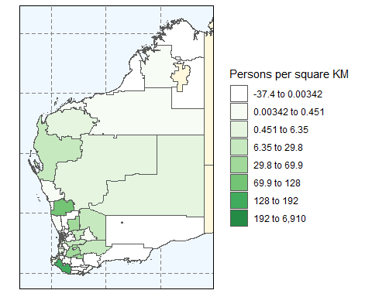

Predicted Change in Total Resident Population of 4 to 84 Year Olds in Victoria State and Territory Between 14 May 2020 and 14 May 2025

## Annual Prevalence of Any Common Mental Disorder Base Case

We next applied age and sex prevalence rates estimated from the most recent Australian surveys to predicted annual prevalence of any common mental disorder amongst 4 to 84 year olds resident in Victoria State and Territory. These rates neither account for any potential change in the background prevalence of mental disorder since these surveys were undertaken, not for the potential impacts of the systemic shock arising from COVID-19.

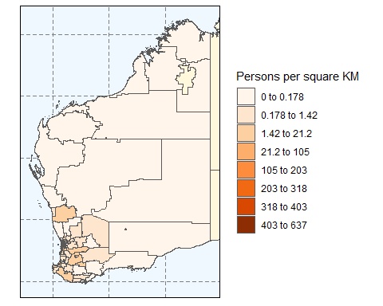

Predicted 14 May 2020 Total Annual Prevalence of Any Common Mental Disorder in 4 to 84 Year Olds in Victoria State and Territory

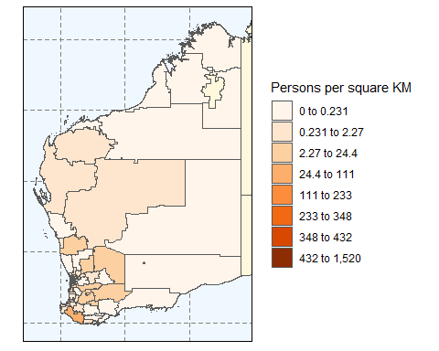

Predicted 14 May 2025 Total Annual Prevalence of Any Common Mental Disorder in 4 to 84 Year Olds in Victoria State and Territory

### Predicted Change in Annual Prevalence of Any Common Mental Disorder Between 14 May 2020 and 14 May 2025

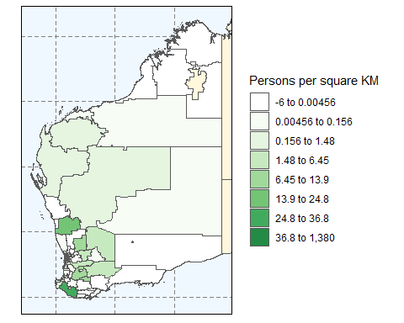

Predicted Change in Total Annual Prevalence of Any Common Mental Disorder in 4 to 84 Year Olds in Victoria State and Territory Between 14 May 2020 and 14 May 2025

## COVID-19 Counterfactual

Finally, we modelled one counterfactual scenario - that of an increase in prevalence rates due to the COVID-19 systemic shock. This scenario did not explore any potential change in background prevalence between the conduct of national Australian epidemiological surveys that are the source of our base case prevalence rate data nor any demographic change (population size and composition) arising from the COVID-19 systemic shock.

## # A tibble: 5 x 3  
## Statistic `Base case` `COVID shock`  
## <chr> <chr> <chr>   
## 1 Prevalent population counts in 2024/2025 2,189,322 2,706,425   
## 2 Prevalent population proportion in 2024/25 20% 25%   
## 3 Change in prevalent population from 2020 Base case 1,529,997 2,047,101   
## 4 COVID-19 excess prevalent counts in 2024/25 NA 517,103   
## 5 Health utility impact (in QALYs) of excess prevalen~ NA 35,974.23

To explore the cost of mitigating the population health utility loss under this scenario, we multiplied the projected Quality Adjusted Life Years (QALYs) lost by an empirical estimate of the marginal productivity of Australian healthcare expenditure in dollars per QALY. The estimated healthcare financing requirement to completely offset the projected health loss due to the COVID-19 systemic shock modelled under this scenario is $1,175,870,853.

# bc<-input_params_ls$sim_results_ls_path_chr %>% readRDS()  
# bc[[1]][[1]]$t0_20200506_p_tl