Laboratory work 5
Full name: Galym Orynbay

Task 1
Add a CHECK constraint to the new_passengers table: passengers must be at least 10 years old.
ALTER TABLE new_passengers
ADD CONSTRAINT chk_pass_age10
CHECK (date_of_birth <= CURRENT_DATE - INTERVAL '10 years');

SELECT * FROM new_passengers;

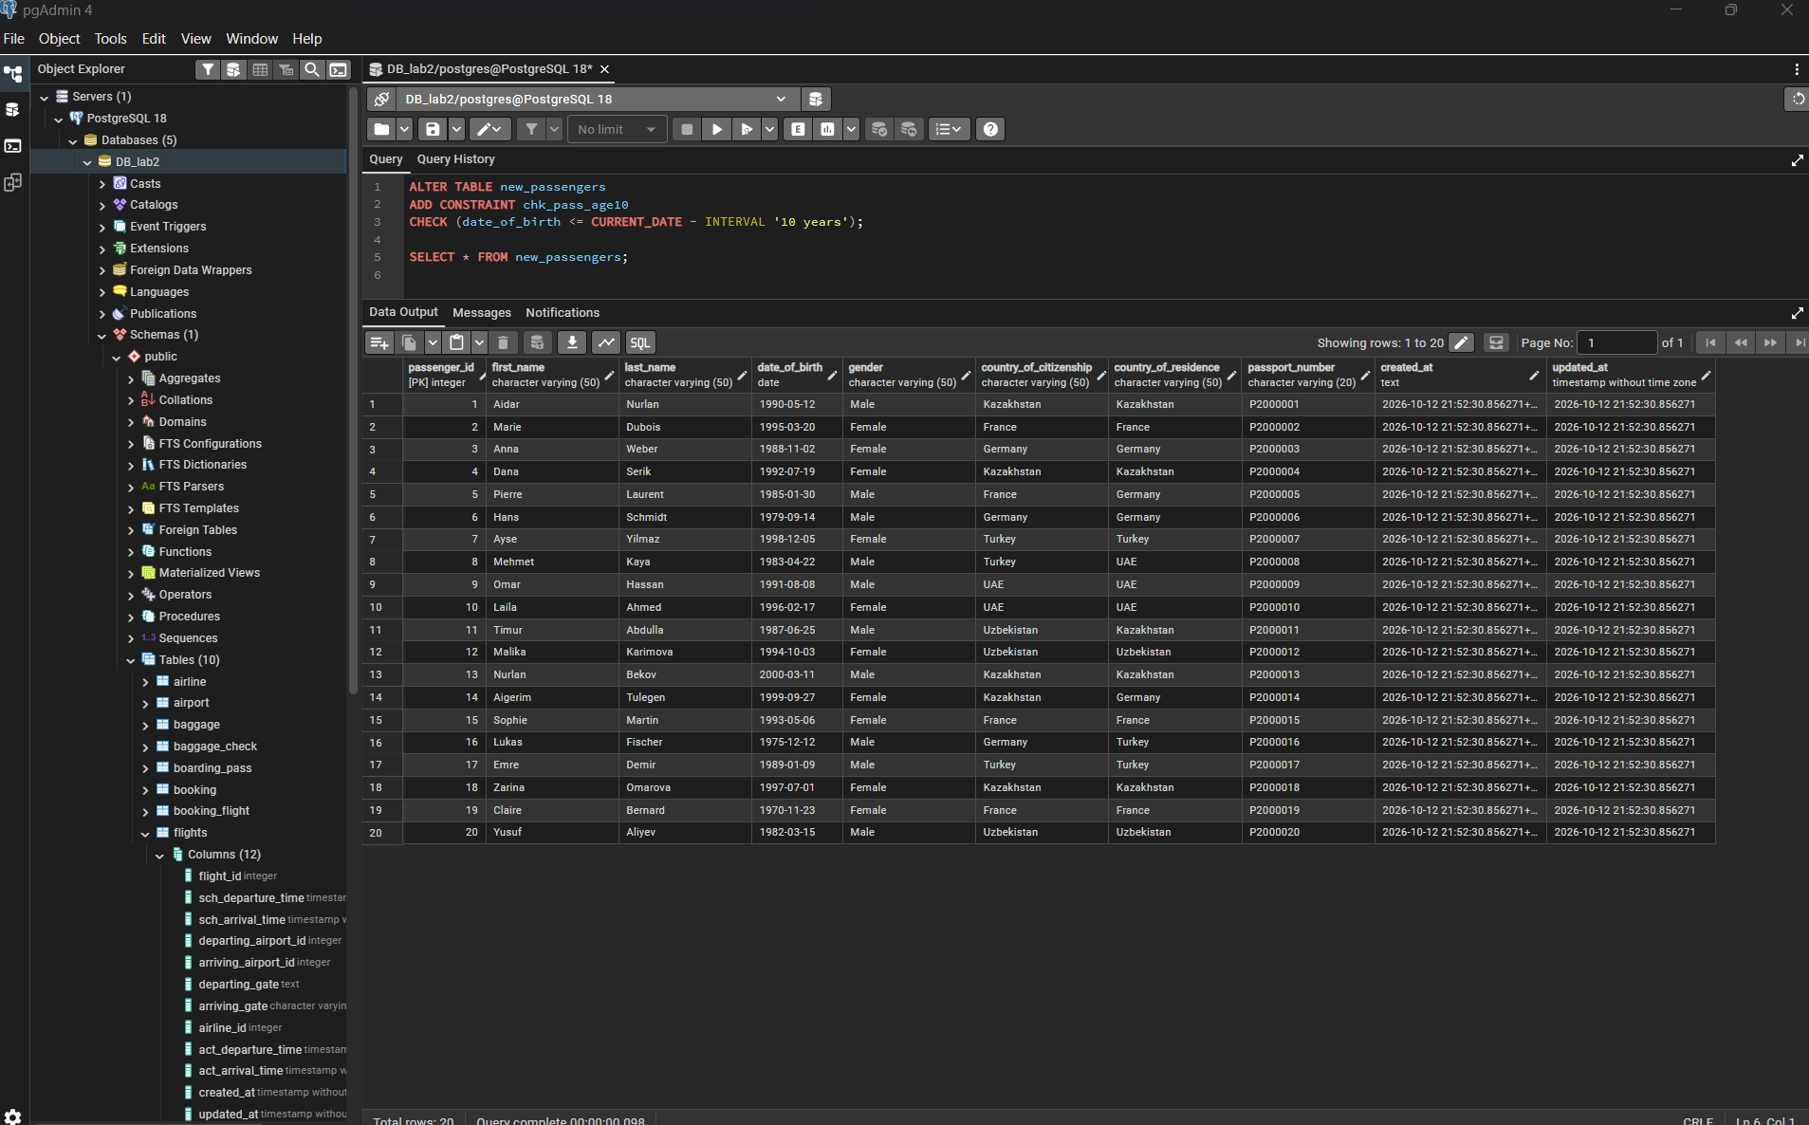

Task 2
Add a CHECK constraint: booking price must be between 0 and 50000 tg.
ALTER TABLE booking
ADD CONSTRAINT chk_price_range
CHECK (ticket_price >= 0 AND ticket_price <= 50000);

SELECT * FROM booking;

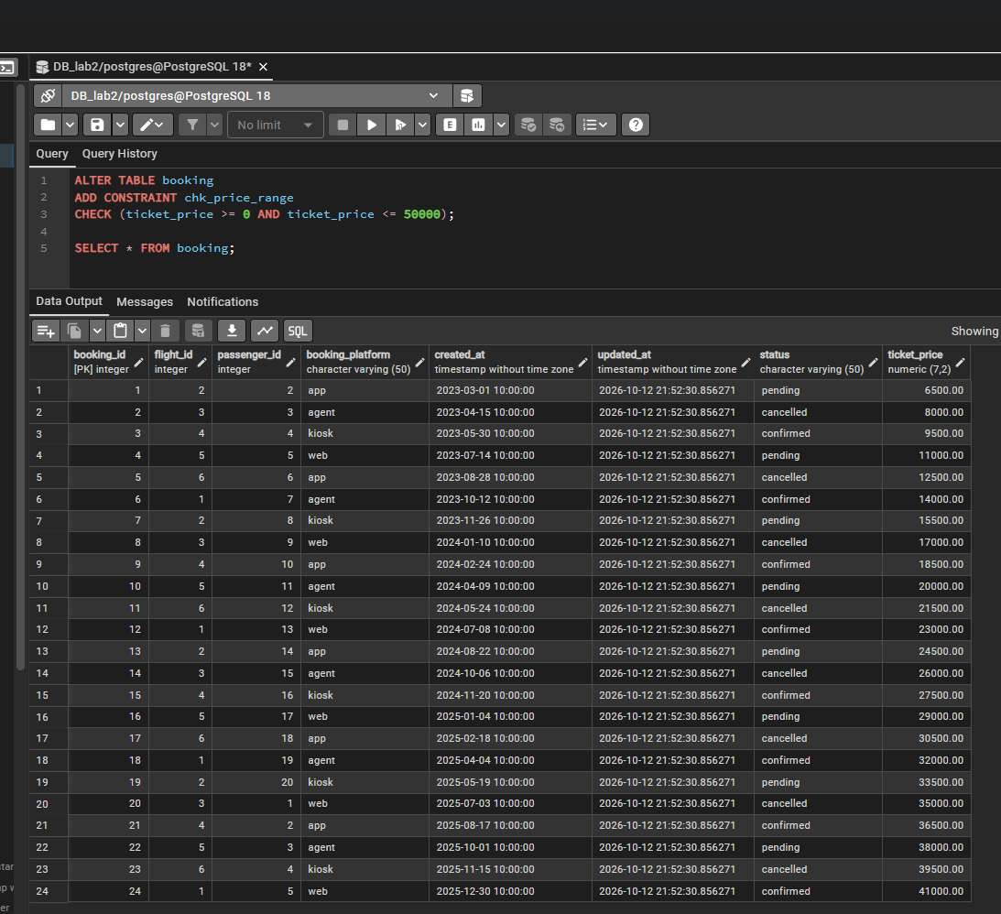

Task 3
Add a CHECK constraint: luggage weight between 1 and 23 kg.
ALTER TABLE baggage
ADD CONSTRAINT chk_weight_1_23
CHECK (weight_in_kg BETWEEN 1 AND 23);

SELECT * FROM baggage;

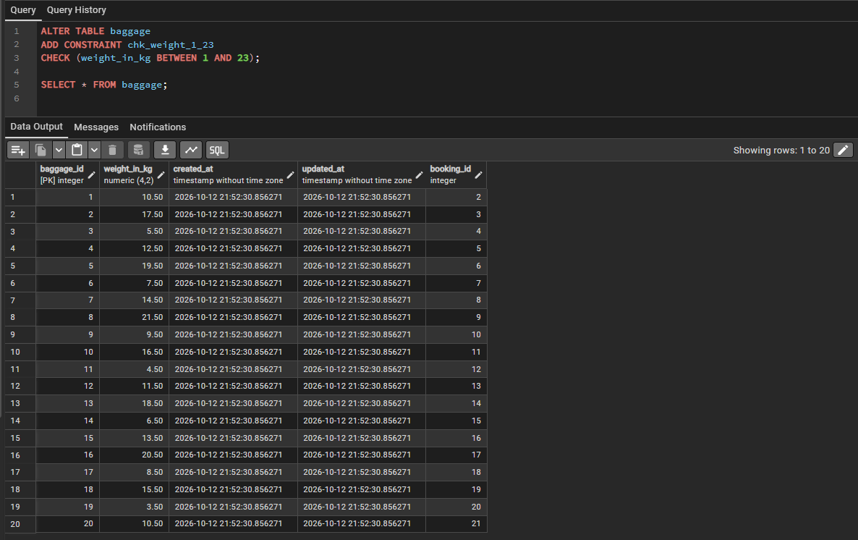

Task 4
Add a CHECK constraint: airport_name must have at least 10 characters.
ALTER TABLE airport
ADD CONSTRAINT chk_airport_name_len
CHECK (LENGTH(airport_name) >= 10);

SELECT * FROM airport;

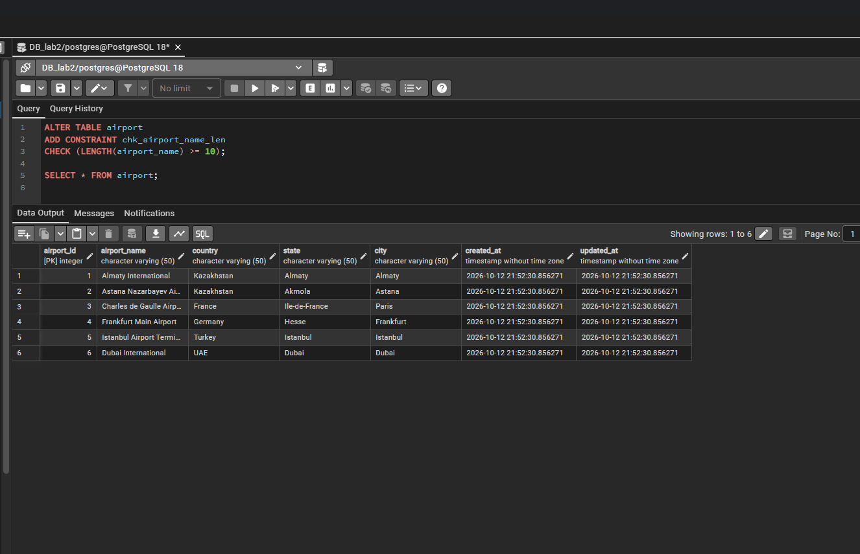

Task 5
Add UNIQUE constraints to some columns in each table.
ALTER TABLE new_passengers ADD CONSTRAINT uq_passenger_passport UNIQUE (passport_number);
ALTER TABLE airport ADD CONSTRAINT uq_airport_name UNIQUE (airport_name);
ALTER TABLE booking ADD CONSTRAINT uq_booking_id UNIQUE (booking_id);
ALTER TABLE flights ADD CONSTRAINT uq_flights_id UNIQUE (flight_id);
ALTER TABLE baggage ADD CONSTRAINT uq_baggage_id UNIQUE (baggage_id);
ALTER TABLE airline ADD CONSTRAINT uq_airline_code UNIQUE (airline_code);
ALTER TABLE boarding_pass ADD CONSTRAINT uq_boarding_pass_id UNIQUE (boarding_pass_id);
ALTER TABLE booking_flight ADD CONSTRAINT uq_booking_flight_id UNIQUE (booking_flight_id);
ALTER TABLE baggage_check ADD CONSTRAINT uq_baggage_check_id UNIQUE (baggage_check_id);
ALTER TABLE security_check ADD CONSTRAINT uq_security_check_id UNIQUE (security_check_id);

SELECT conname, conrelid::regclass FROM pg_constraint WHERE contype = 'u';

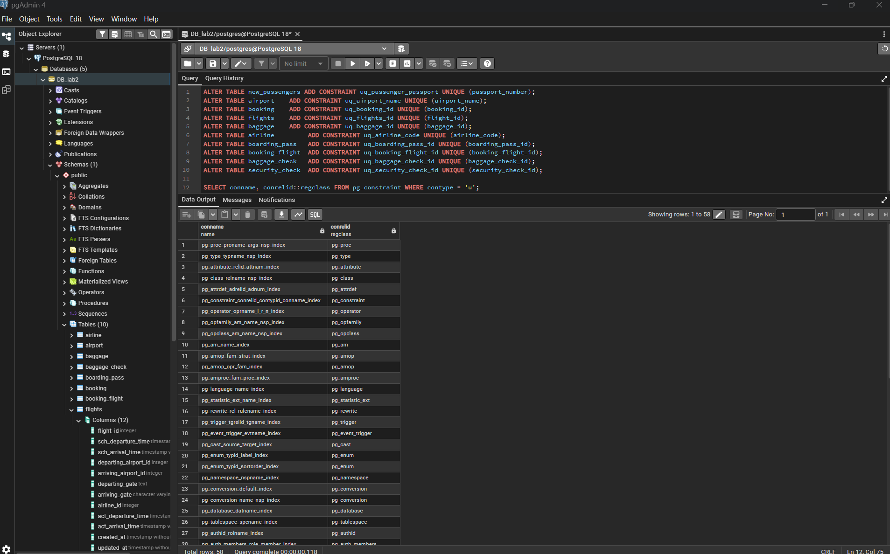

Task 6
Male passengers must be at least 18 years old, female passengers at least 19.
ALTER TABLE new_passengers
ADD CONSTRAINT chk_gender_age
CHECK (
(LOWER(gender) = 'male' AND date_of_birth <= CURRENT_DATE - INTERVAL '18 years') OR
(LOWER(gender) = 'female' AND date_of_birth <= CURRENT_DATE - INTERVAL '19 years')
);

SELECT * FROM new_passengers;

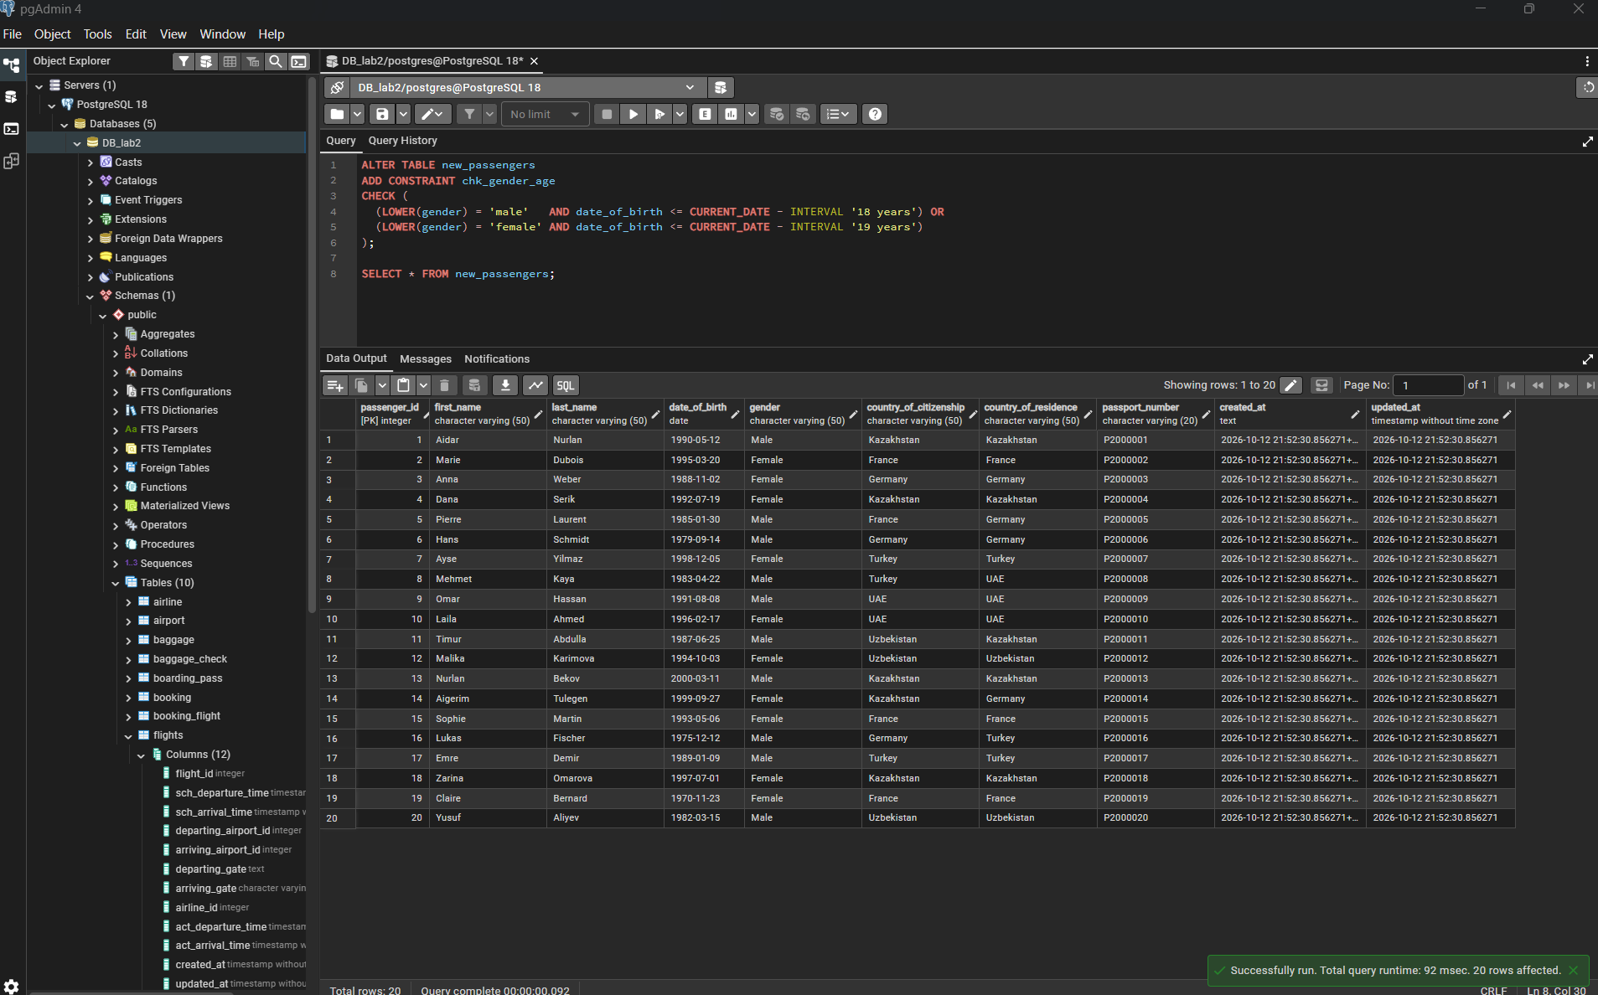

Task 7
Age rule by country_of_citizenship: Kazakhstan 18+, France 17+, other countries 19+.
ALTER TABLE new_passengers
ADD CONSTRAINT chk_citizenship_age
CHECK (
(country_of_citizenship = 'Kazakhstan' AND date_of_birth <= CURRENT_DATE - INTERVAL '18 years') OR
(country_of_citizenship = 'France' AND date_of_birth <= CURRENT_DATE - INTERVAL '17 years') OR
(country_of_citizenship NOT IN ('Kazakhstan','France') AND date_of_birth <= CURRENT_DATE - INTERVAL '19 years')
);

SELECT * FROM new_passengers;

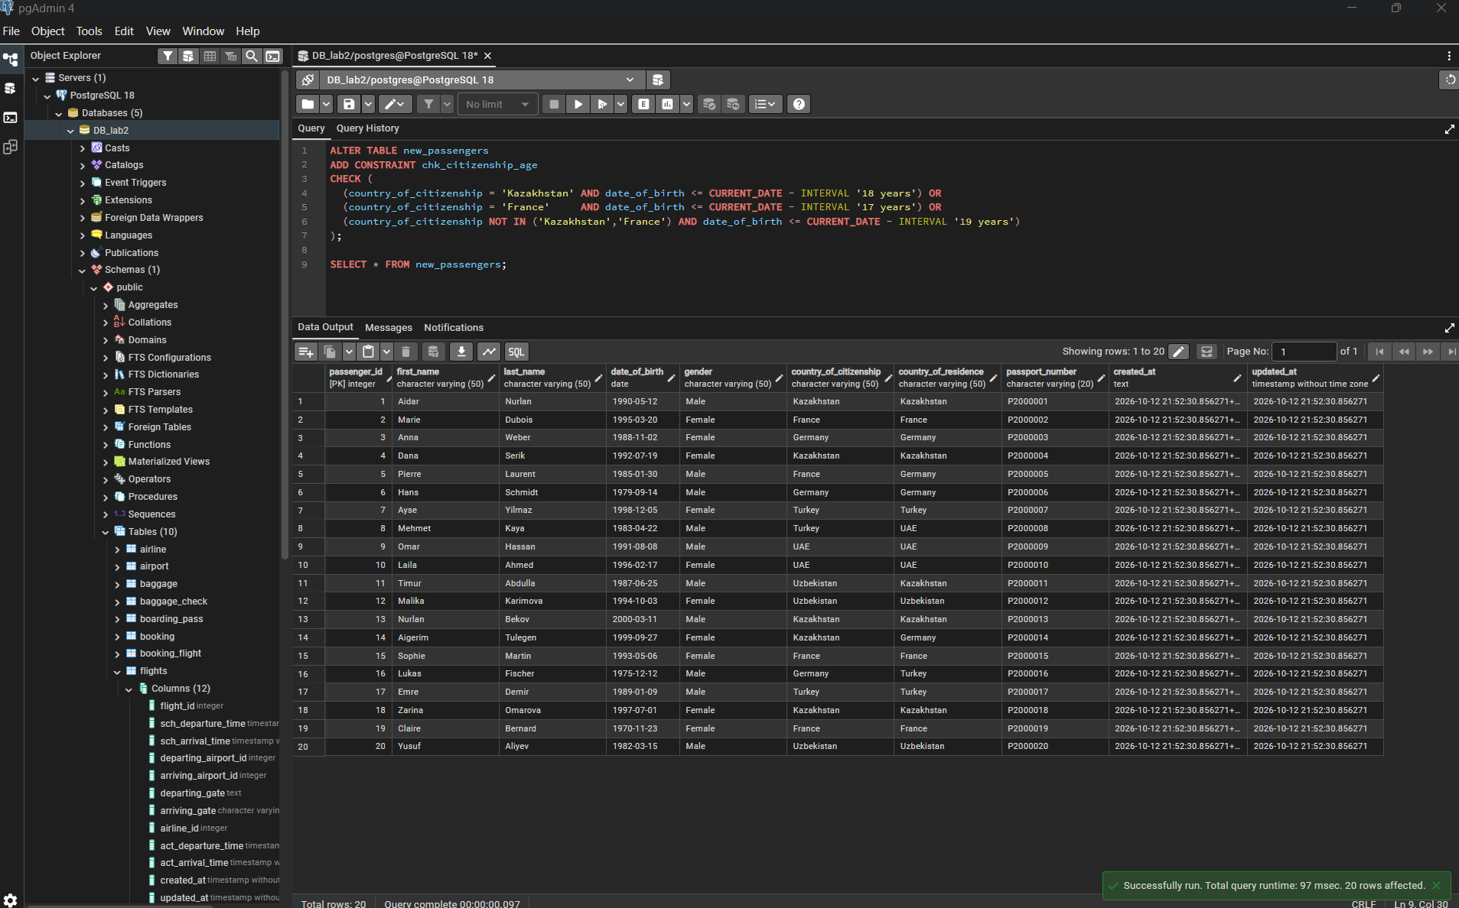

Task 8
Add ticket_discount column to booking and a CHECK: 5% for tickets created after 2024-01-01, 10% before.
ALTER TABLE booking ADD COLUMN ticket_discount numeric(5,2);

UPDATE booking
SET ticket_discount = CASE WHEN created_at > TIMESTAMP '2024-01-01' THEN 5 ELSE 10 END;

ALTER TABLE booking
ADD CONSTRAINT chk_ticket_discount
CHECK (
(created_at > TIMESTAMP '2024-01-01' AND ticket_discount = 5) OR
(created_at <= TIMESTAMP '2024-01-01' AND ticket_discount = 10)
);

SELECT * FROM booking;

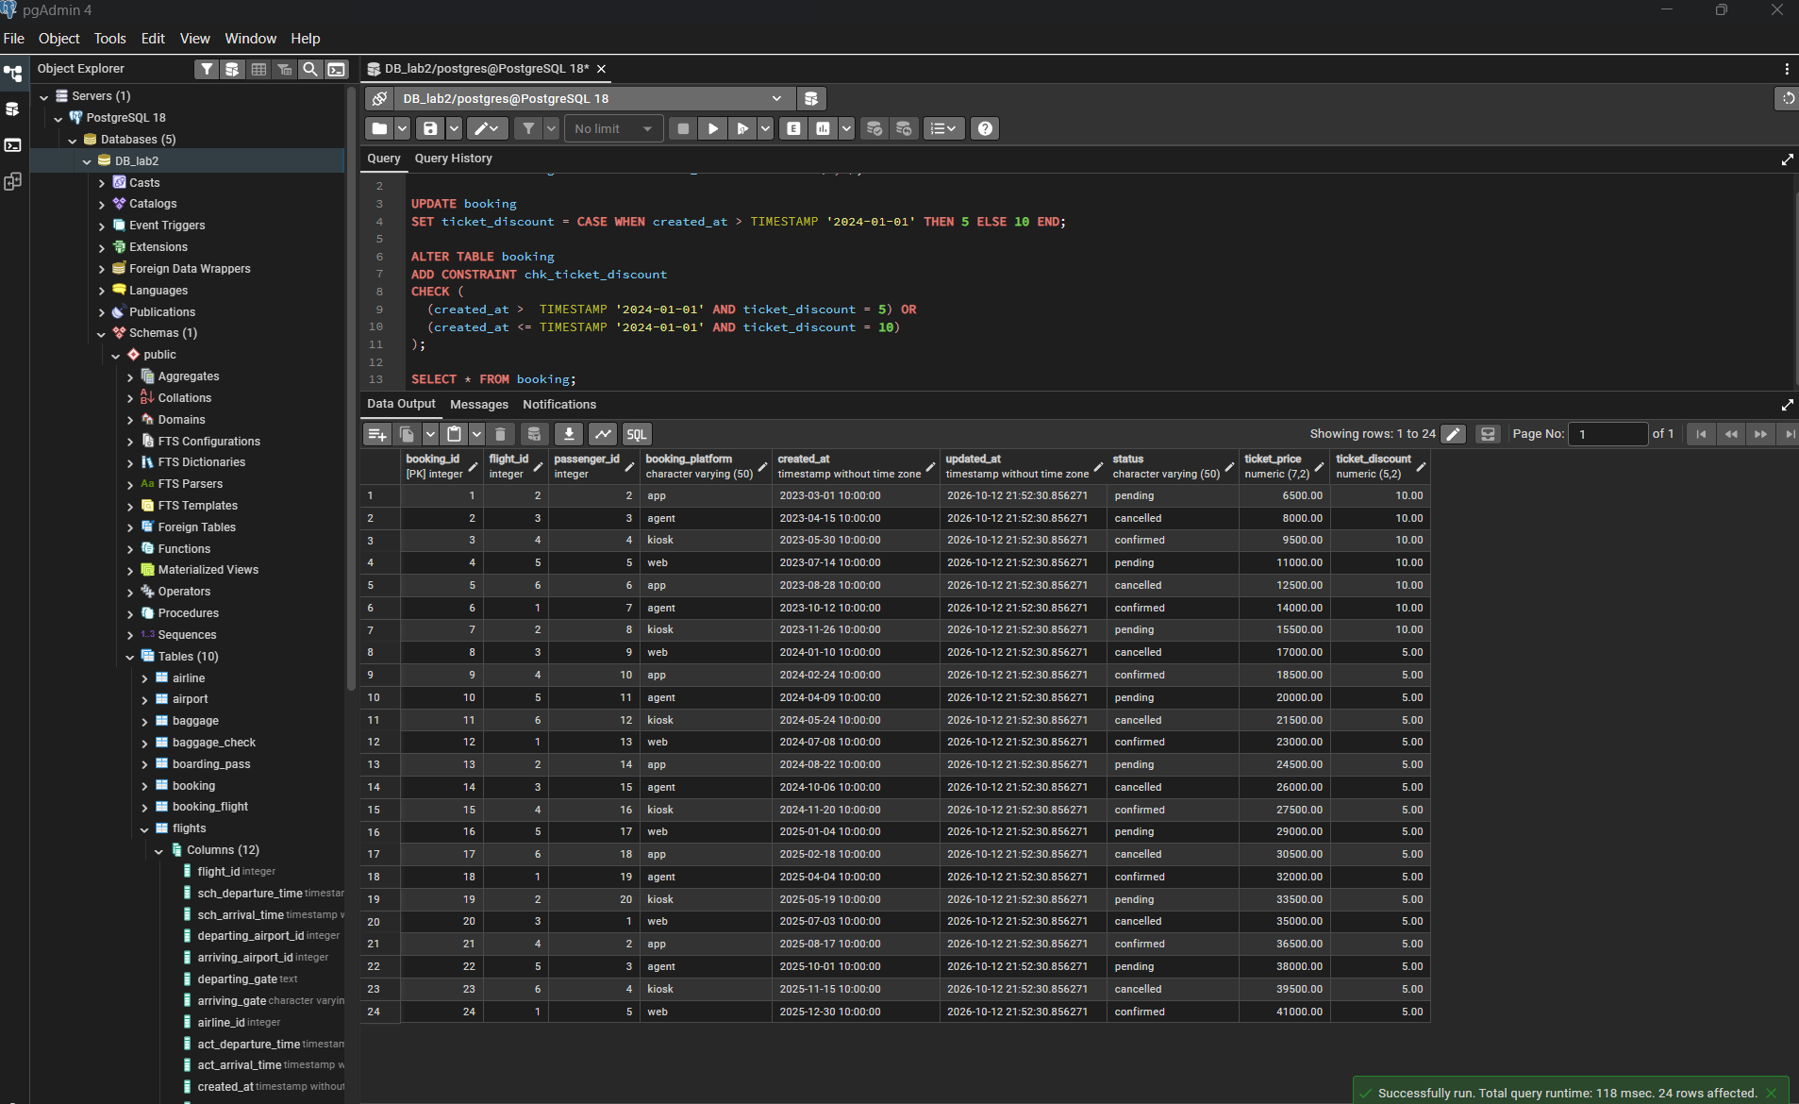

Task 9
Set default value 'Confirmed' for booking status, then insert a booking without specifying status.
ALTER TABLE booking ALTER COLUMN status SET DEFAULT 'Confirmed';

INSERT INTO booking (booking_id, flight_id, passenger_id, booking_platform, ticket_price, ticket_discount, created_at, updated_at)
VALUES (25, 1, 1, 'app', 20000, 5, NOW(), NOW());

SELECT * FROM booking ORDER BY booking_id DESC LIMIT 5;

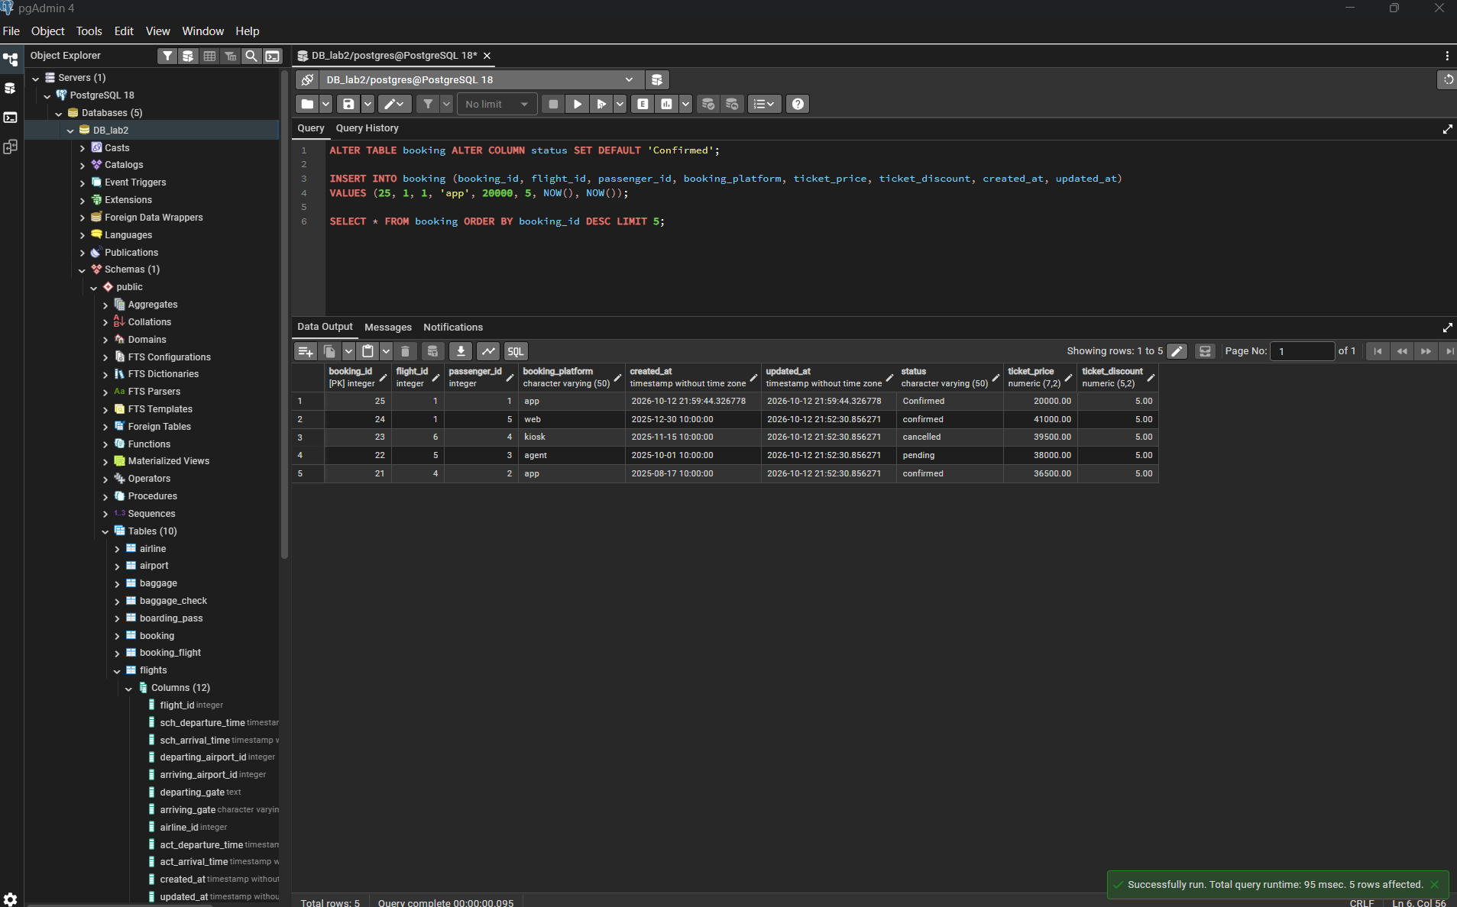

Task 10
Make the date column set automatically to the current date on insert.
ALTER TABLE booking ALTER COLUMN created_at SET DEFAULT CURRENT_DATE;

INSERT INTO booking (booking_id, flight_id, passenger_id, booking_platform, ticket_price, ticket_discount, updated_at)
VALUES (26, 1, 2, 'web', 10000, 5, NOW());

SELECT * FROM booking ORDER BY booking_id DESC LIMIT 3;



