Laboratory work #2
Galym Orunby 25B031451
Normalization
Consider the following unnormalized table used for printing booking receipts: Booking_receipt(booking_id, passenger_full_name, passenger_passport_number, flight_number, departure_airport_name, departure_city, arrival_airport_name, arrival_city, airline_name, seat_numbers, ticket_price). The seat_numbers column stores a comma-separated list (e.g. "12A, 12B") when a booking covers several passengers on the same reservation. Identify which normal form (1NF, 2NF, 3NF) this table violates and explain why, referring to the specific columns responsible.
Answer:
This table violates 1NF.
The column "seat_numbers" stores multiple values in a single cell, so one booking can have many seats. It creates problems with filtering and searching, and it breaks the connection of one passenger to one seat, which is not good for the business. Finally, multiple values in one cell violate the rule of atomicity.
Normalize Booking_receipt step by step: first bring it to 1NF, then to 2NF, then to 3NF. For each step draw/describe the resulting table(s), underline the primary key of each table, and mark the foreign keys.
Answer:
To 1NF:
Booking_receipt(
booking_id, ==> composite key
passenger_full_name,
passenger_passport_number,
flight_number,
departure_airport_name,
departure_city,
arrival_airport_name,
arrival_city,
airline_name,
seat_number, <----- only one value, for example "12C" or "12B"
ticket_price
)
We need to change seat_numbers. Now we can store only one seat in each row. For this, we need to multiply the number of rows. For example, if we have 12C and 12B in one cell, we create two rows with the same data, but in the seat_number column the first row will have 12B and the second row will have 12C.
However, in this case, our booking_id cannot be the primary key because we copy rows. So, we need to make a composite primary key that consists of booking_id and seat_number. Now every record is unique, every column has atomic data that cannot be divided into smaller values, and there are no multiple values in one cell. So, it is in 1NF.
To 2NF:
A table is in 2NF if every non-key column depends on the whole primary key. But we have a composite key, and the seat_number does not have a direct connection with the other booking columns. So, we need to create another table where the connection between seat_number and booking_id will be stored.
Booking(
booking_id, PK
passenger_full_name,
passenger_passport_number,
flight_number,
departure_airport_name,
departure_city,
arrival_airport_name,
arrival_city,
airline_name,
ticket_price
)
BookingSeat(
booking_id, PK, FK from Booking
seat_number PK
)
PK: (booking_id, seat_number)
FK: booking_id ---> Booking.booking_id
To 3NF:
Here we need to delete all transitive dependencies. In Booking, we have the following columns:
flight_number,
departure_airport_name,
departure_city,
arrival_airport_name,
arrival_city,
airline_name,
ticket_price
All of them do not have a direct connection to booking_id. Most of these attributes are descriptions of the flight_number, so we create another table, Flights, with flight_number as the primary key.
But here we have departure_city and arrival_city. They also do not have a direct connection with flight_number. They depend on departure_airport and arrival_airport. So, we also need to create a new table for airports and cities.
Booking(
booking_id PK
passenger_full_name,
passenger_passport_number,
flight_number FK Flight.flight_number
ticket_price
)
Flight(
flight_number PK
departure_airport_name FK Airport.airport_name
arrival_airport_name FK Airport.airport_name
airline_name
)
Airport(
airport_name PK,
city
)
BookingSeat(
booking_id PK, FK Booking.booking_id
seat_number PK
)
List the functional dependencies you used to justify each normalization step in task 2 (e.g. booking_id -> flight_number, flight_number -> airline_name).
booking_id -> passenger_full_name
booking_id -> passenger_passport_number
booking_id -> flight_number
booking_id -> ticket_price
flight_number -> departure_airport_name
flight_number -> arrival_airport_name
flight_number -> airline_name
departure_airport_name -> departure_city
arrival_airport_name -> arrival_city
For the airport database you created in the DDL section, check whether the Flights table is in 3NF. State the current primary key and functional dependencies and explain whether any transitive dependency exists between non-key attributes (for example, via departing_airport_id or airline_id).
Answer:
Primary Key: flight_id
Functional dependency:
flight_id -> sch_departure_time, sch_arrival_time, departing_airport_id, arriving_airport_id, departing_gate, arriving_gate, airline_id, act_departure_time, act_arrival_time, created_at, updated_at
Transitive dependency check: No transitive dependency exists between non-key attributes. The table stores only foreign keys (departing_airport_id, arriving_airport_id, airline_id) referencing the Airport and Airline tables, rather than descriptive attributes like airport name or city directly. Since those descriptive details are stored in separate tables, there is no attribute within Flights itself that could transitively depend on another non-key attribute of Flights.
Conclusion: The Flights table is already in 3NF.
- Using CREATE TABLE statements, implement the 3NF tables you designed in task 2, then write INSERT statements that populate them with at least 5 rows of sample data split out from a denormalized dataset of your choice.
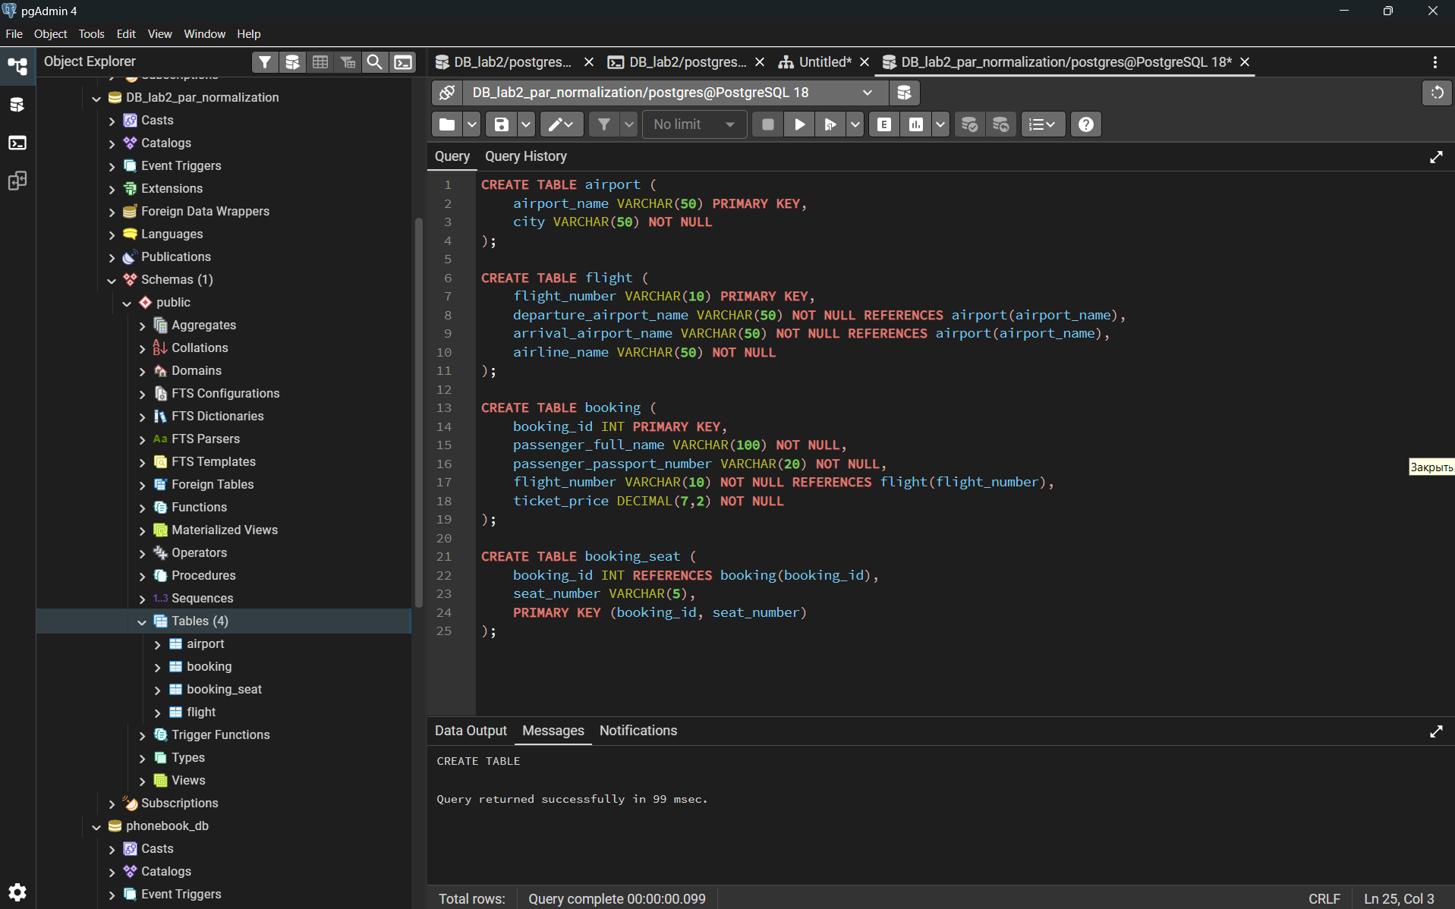
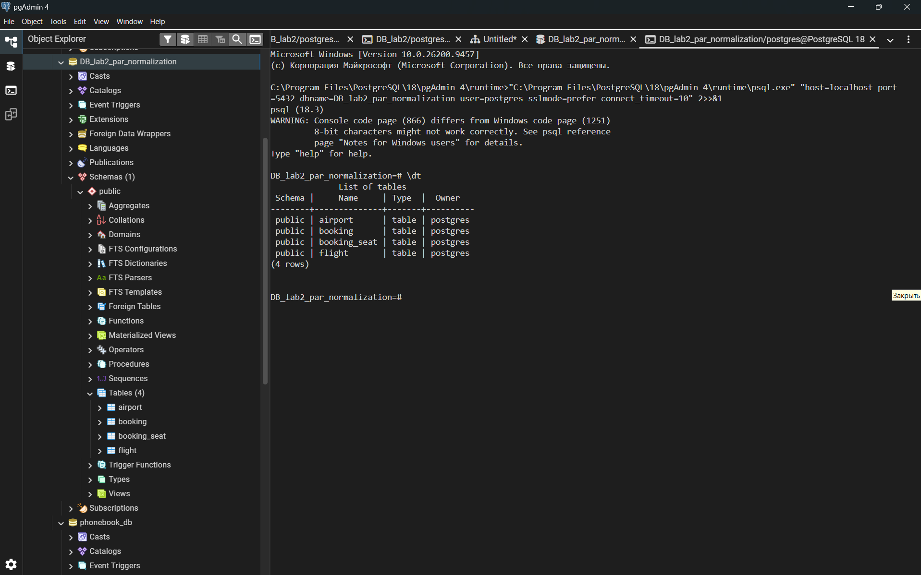

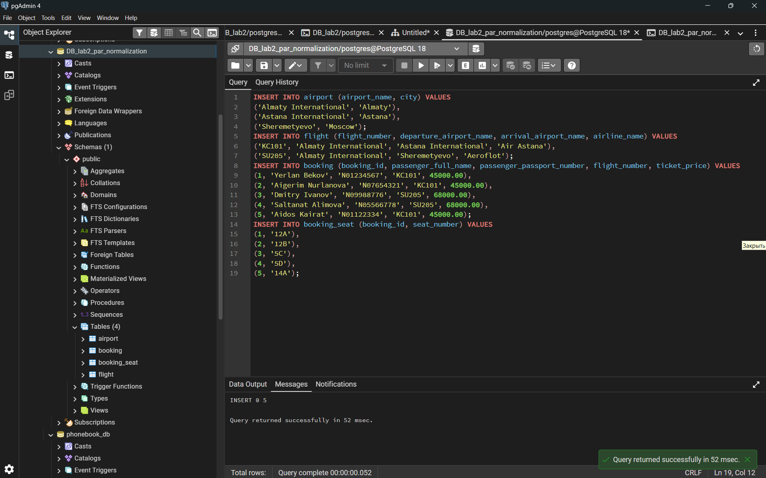
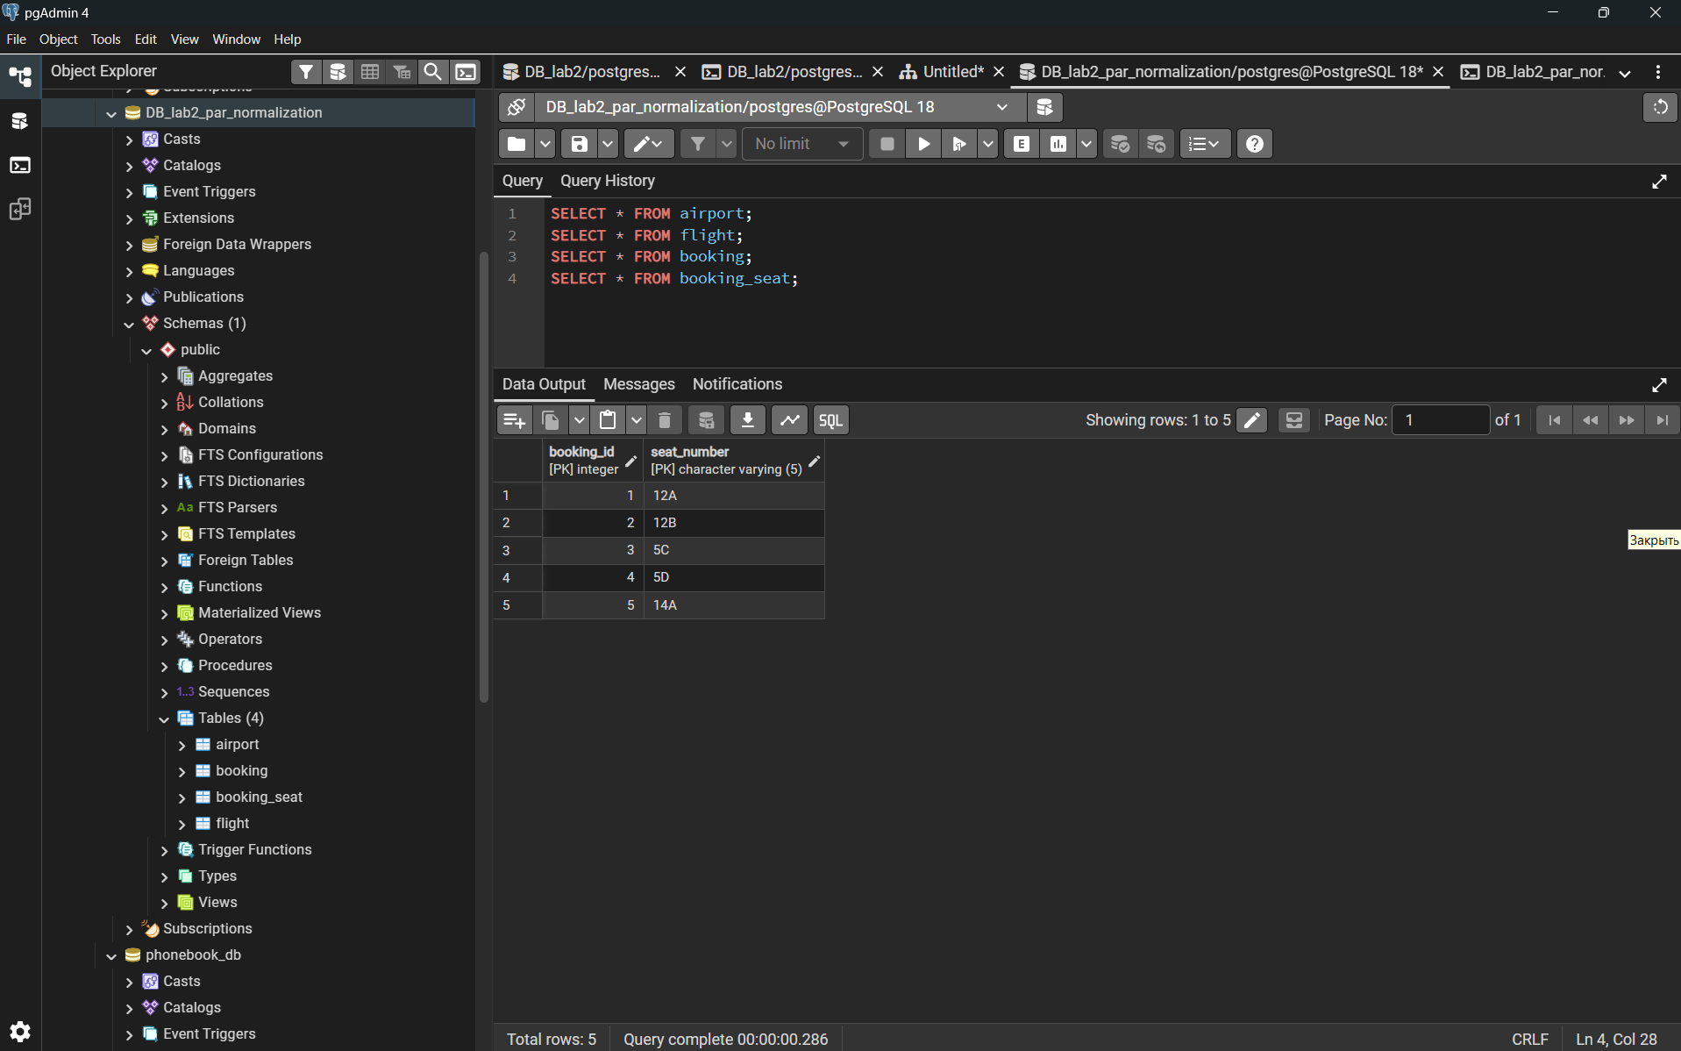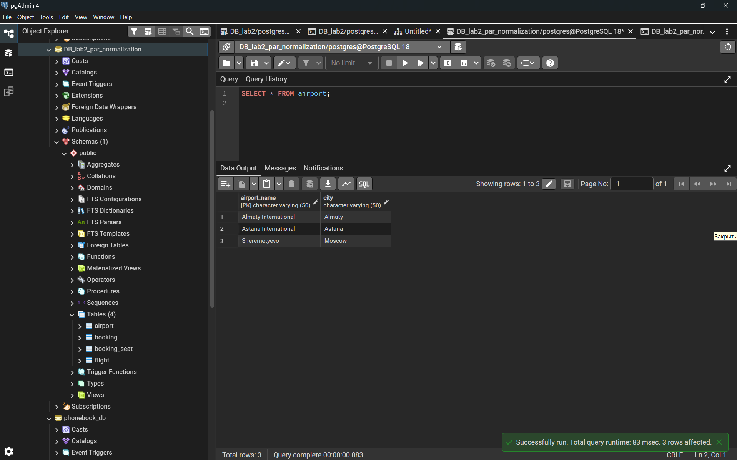
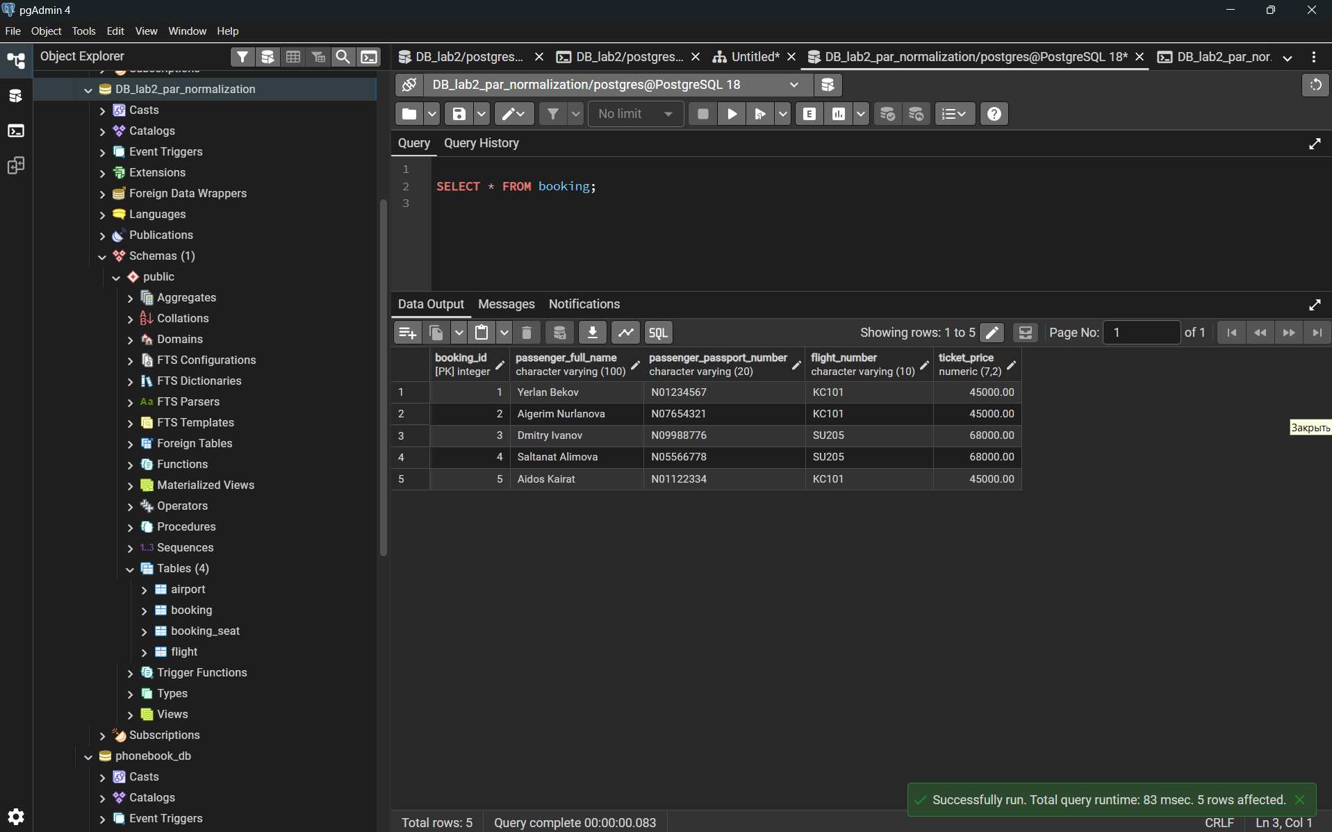
DDL
1.1 Creating tables and defining Primary Keys
Airline_info
airline_id (int, PK), airline_code (varchar(30)), airline_name (varchar(50)), airline_country (varchar(50)), created_at (timestamp), updated_at (timestamp), info (varchar(50))
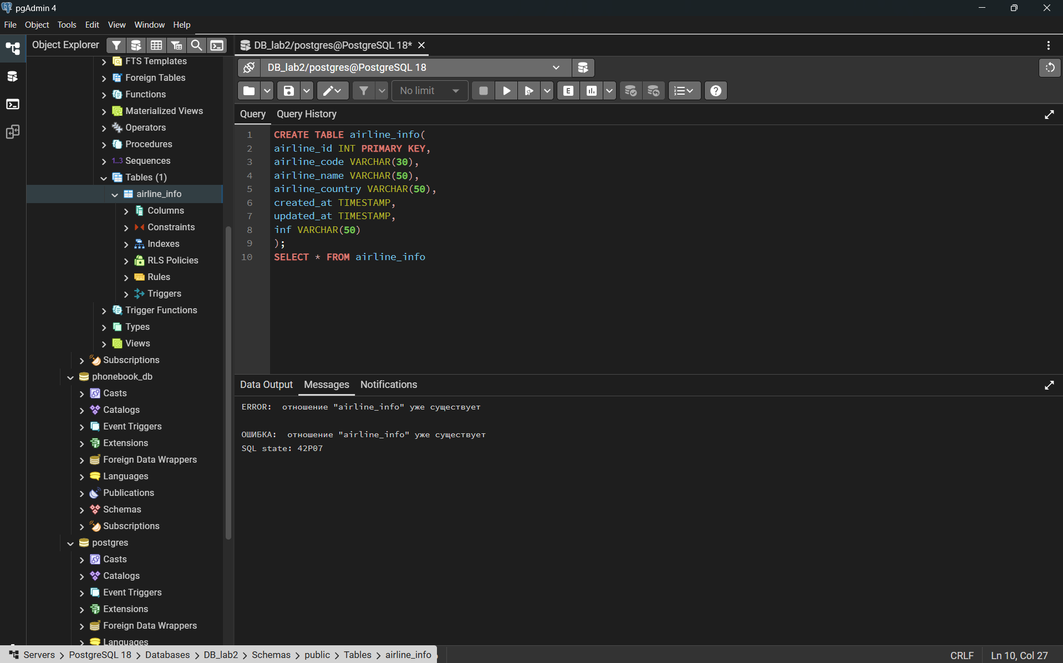
Airport
airport_id (int, PK), airport_name (varchar(50)), country (varchar(50)), state (varchar(50)), city (varchar(50)), created_at (timestamp), updated_at (timestamp)
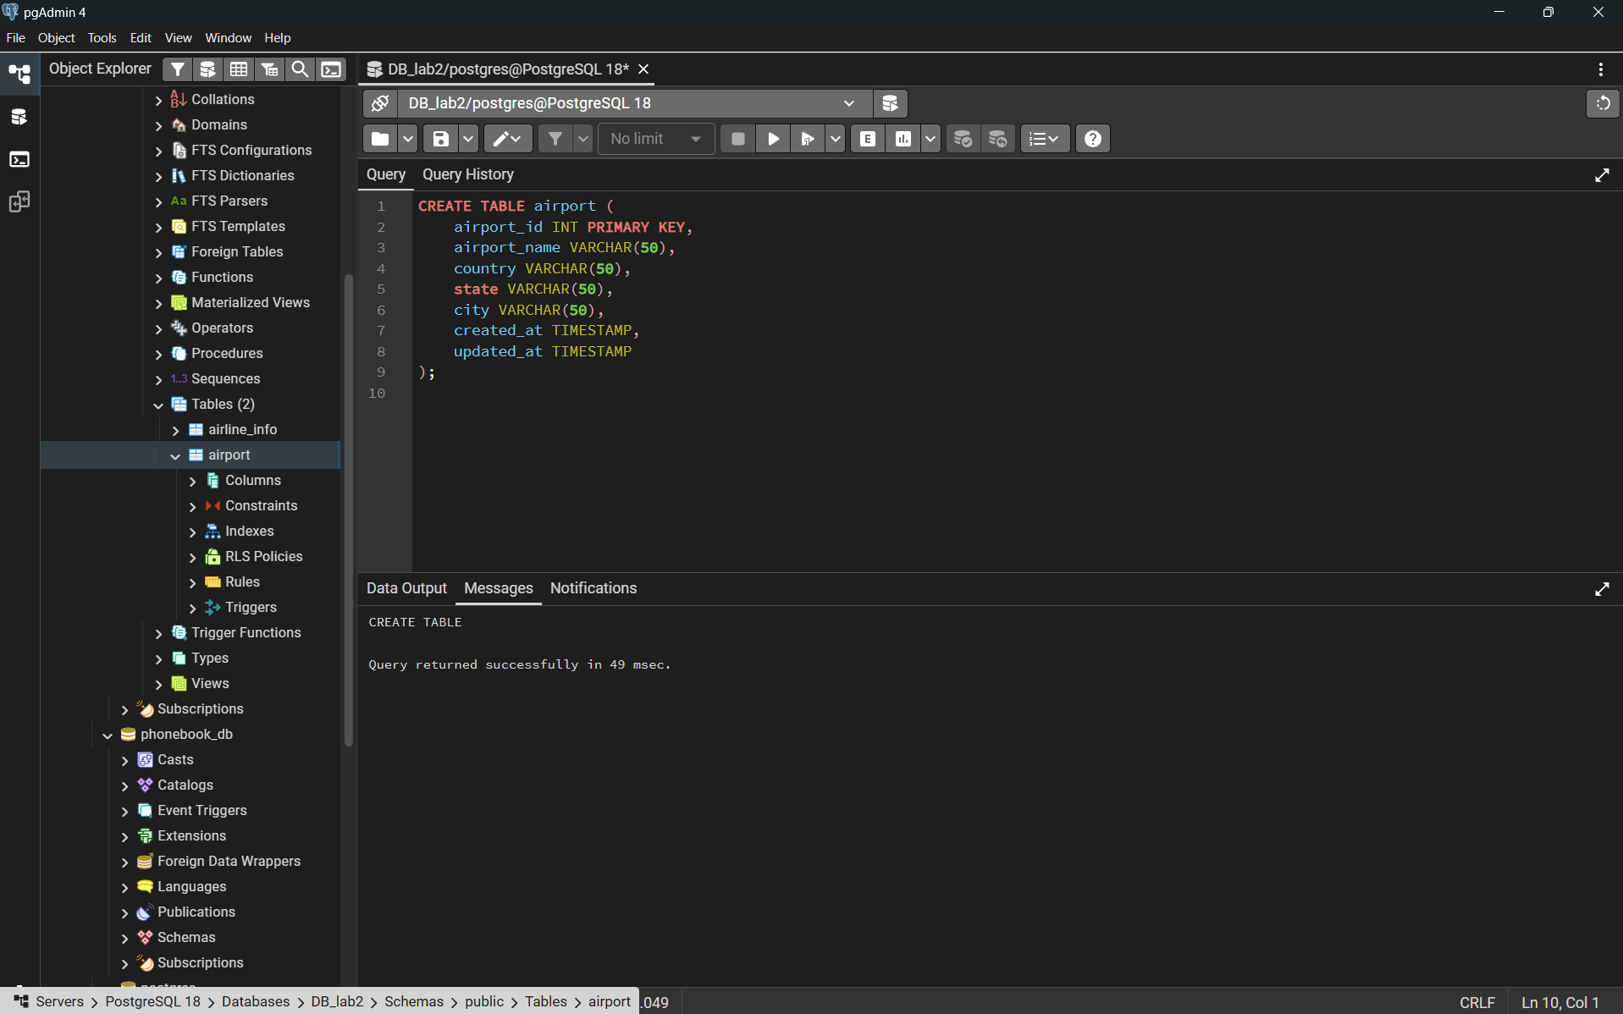

Baggage_check
baggage_check_id (int, PK), check_result (varchar(50)), created_at (timestamp), updated_at (timestamp), booking_id (int), passenger_id (int)
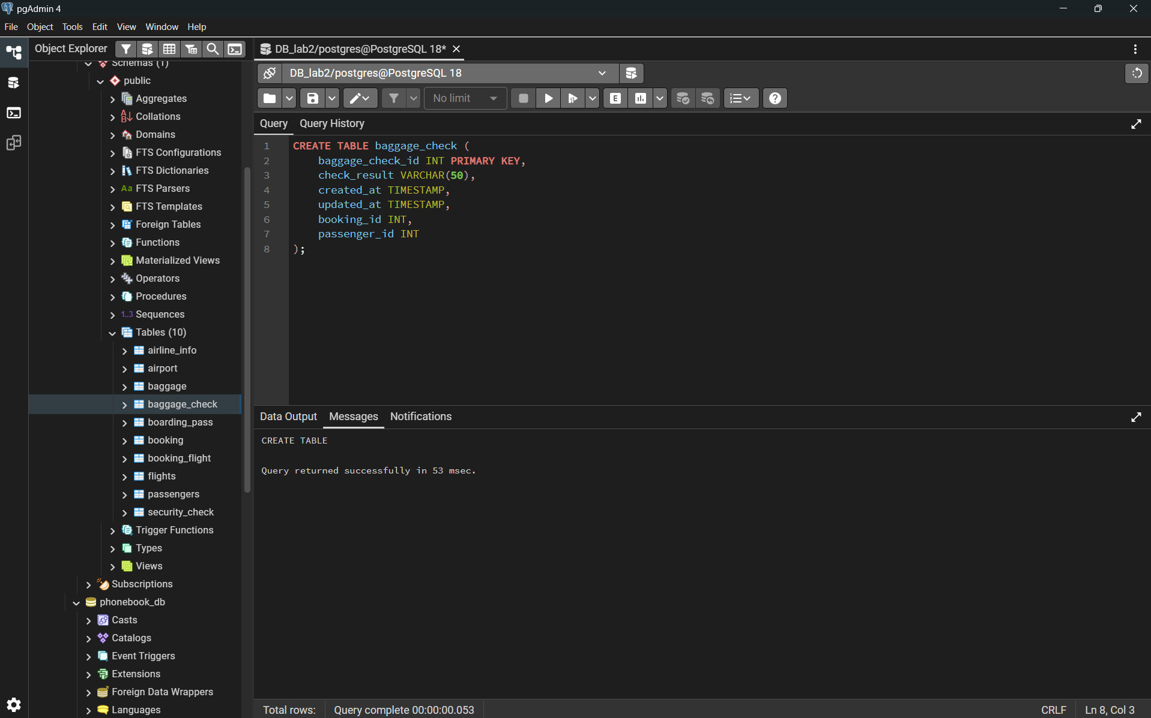
Baggage
baggage_id (int, PK), weight_in_kg (decimal(4,2)), created_at (timestamp), updated_at (timestamp), booking_id (int)
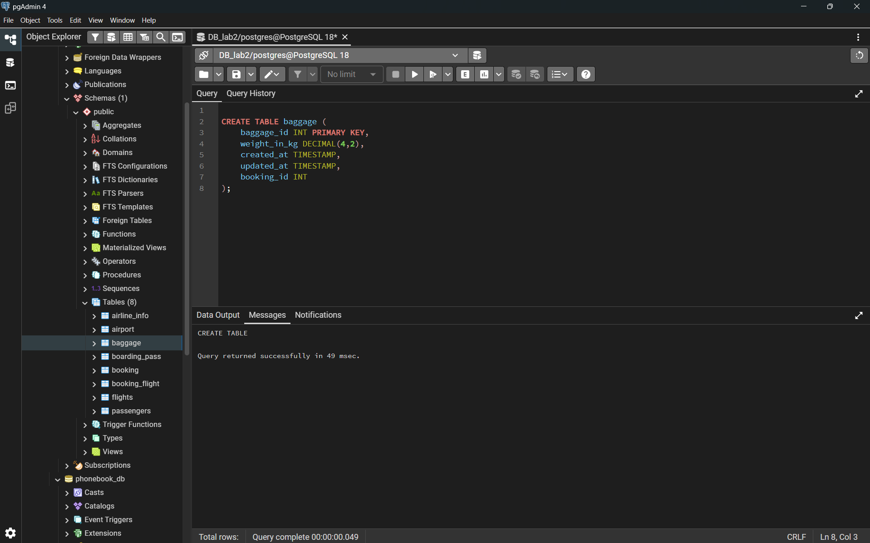
Boarding_pass
boarding_pass_id (int, PK), booking_id (int), seat (varchar(50)), boarding_time (timestamp), created_at (timestamp), updated_at (timestamp)
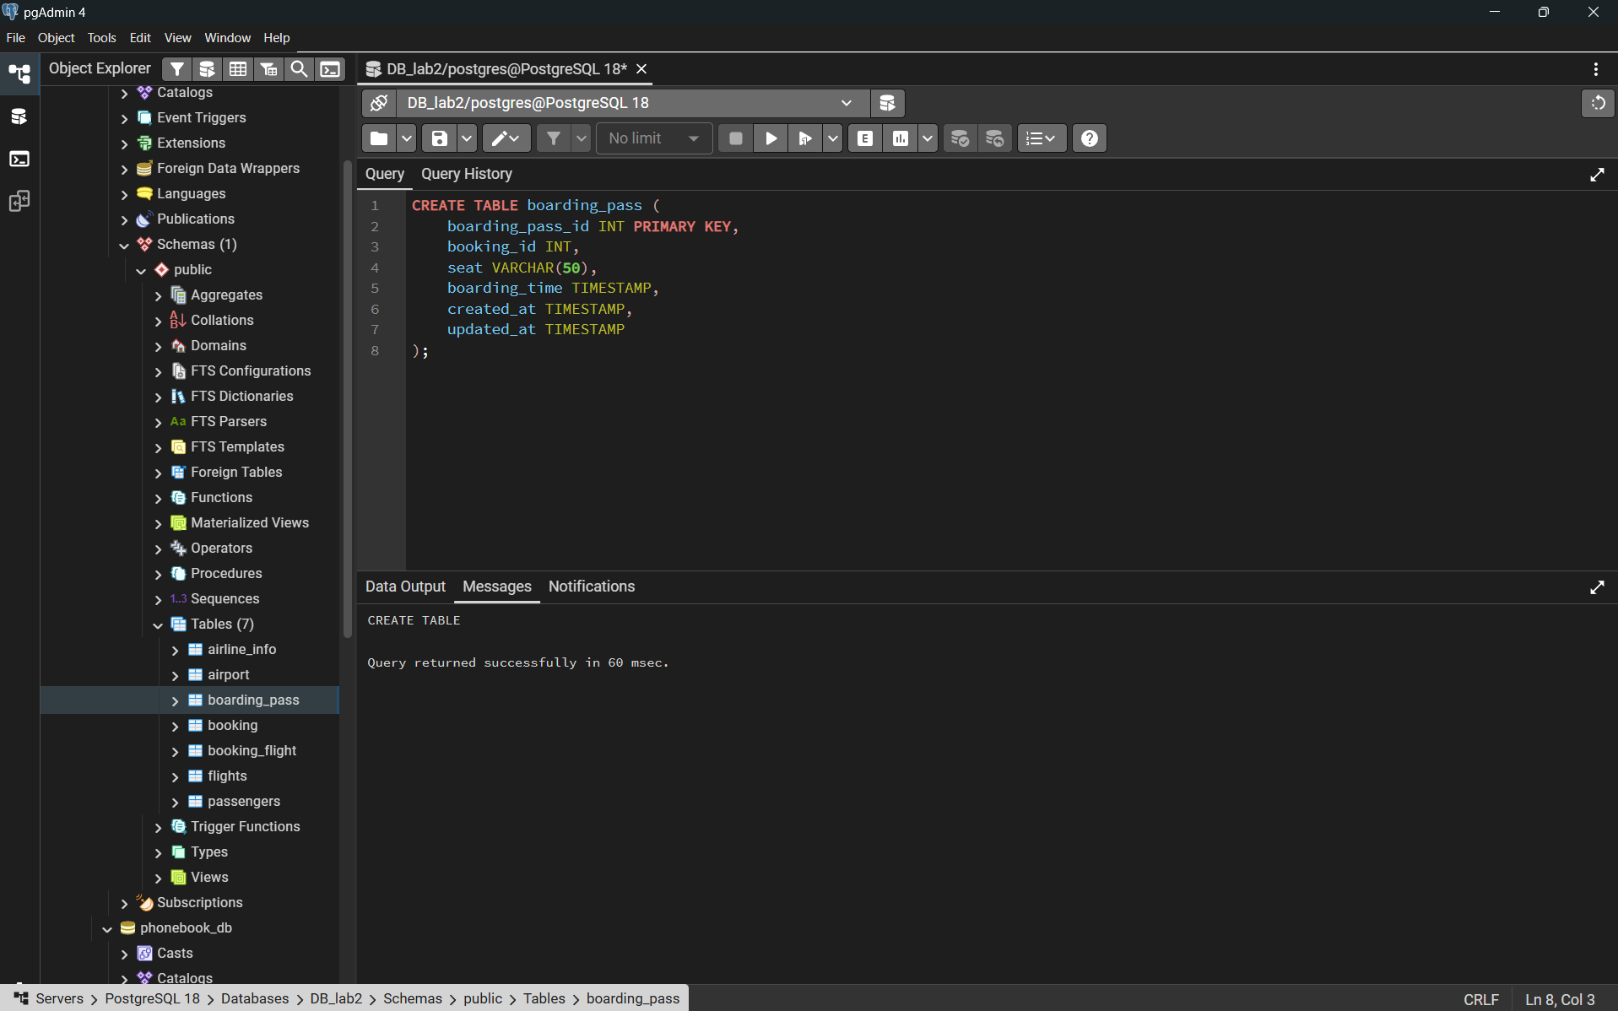
Booking_flight
booking_flight_id (int, PK), booking_id (int), flight_id (int), created_at (timestamp), updated_at (timestamp)
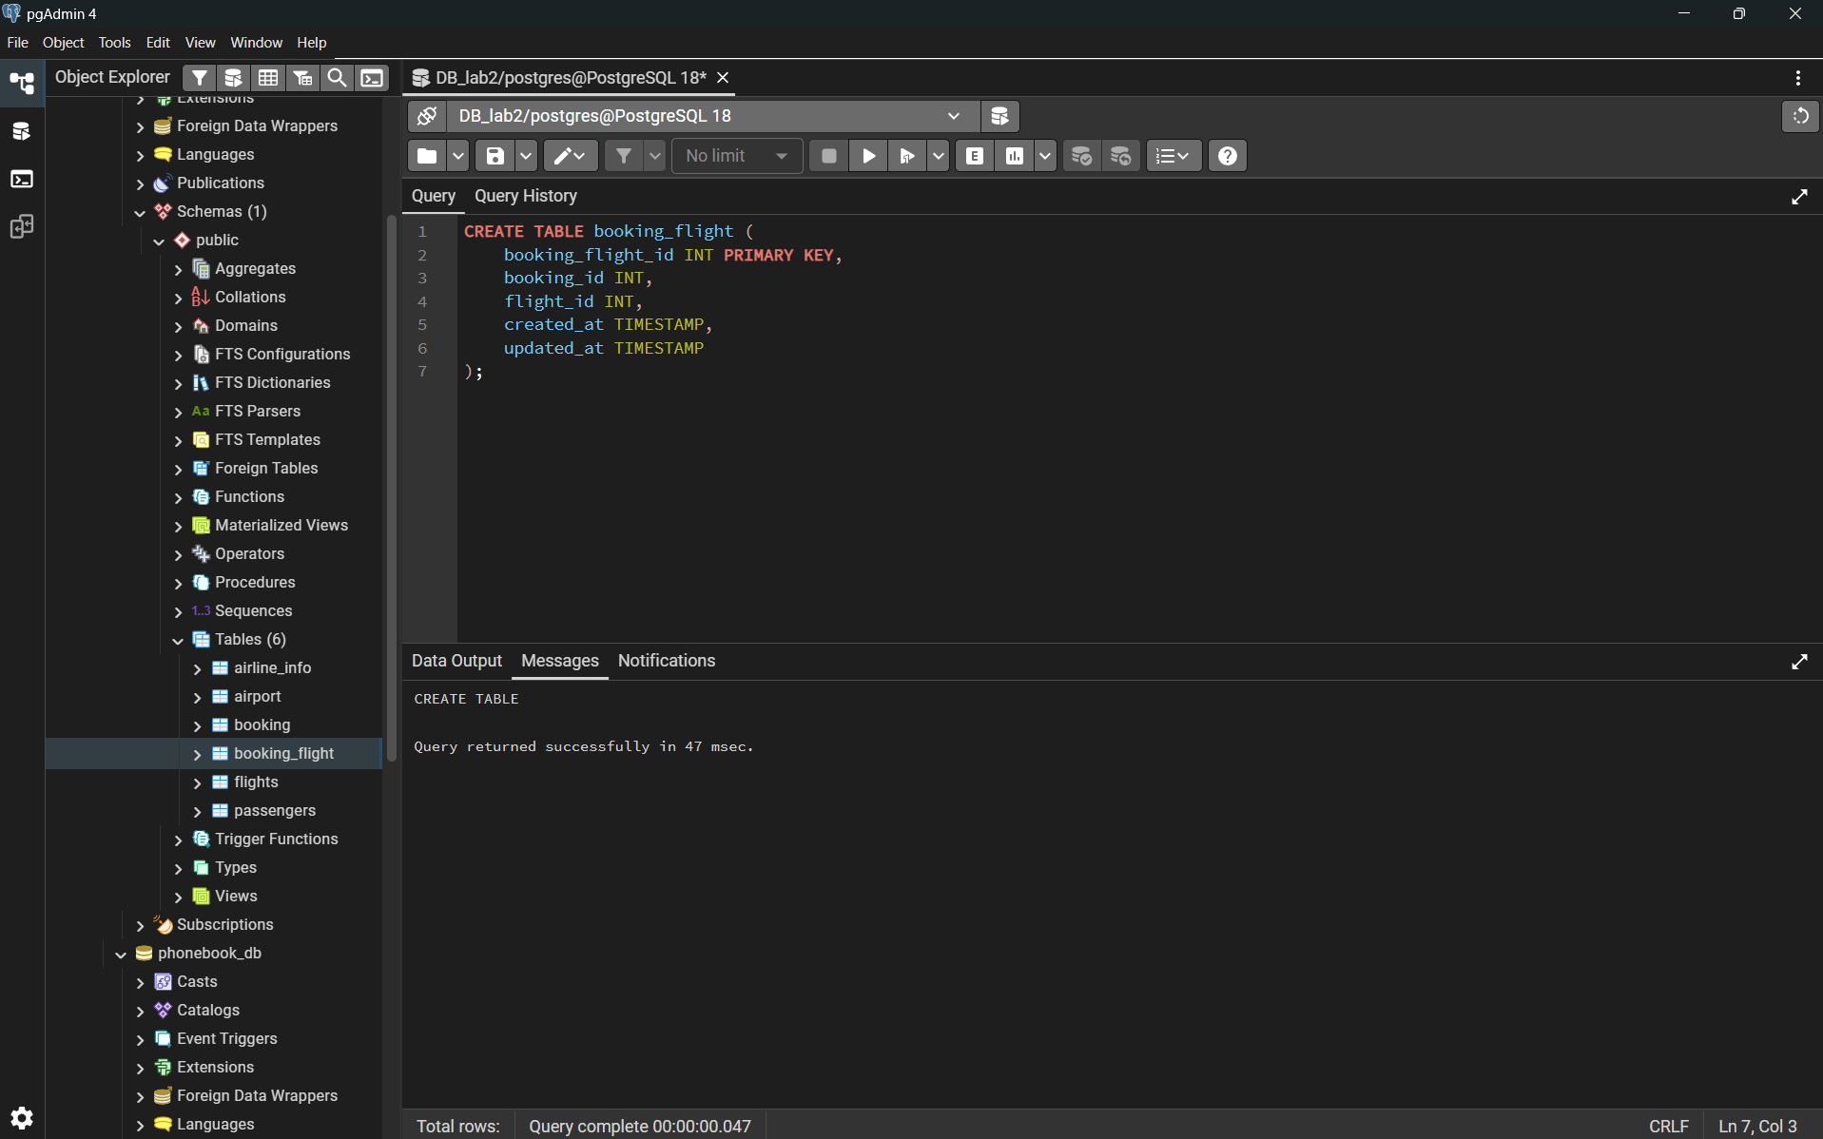Booking
booking_id (int, PK), flight_id (int), passenger_id (int), booking_platform (varchar(50)), created_at (timestamp), updated_at (timestamp), status (varchar(50)), price (decimal(7,2))
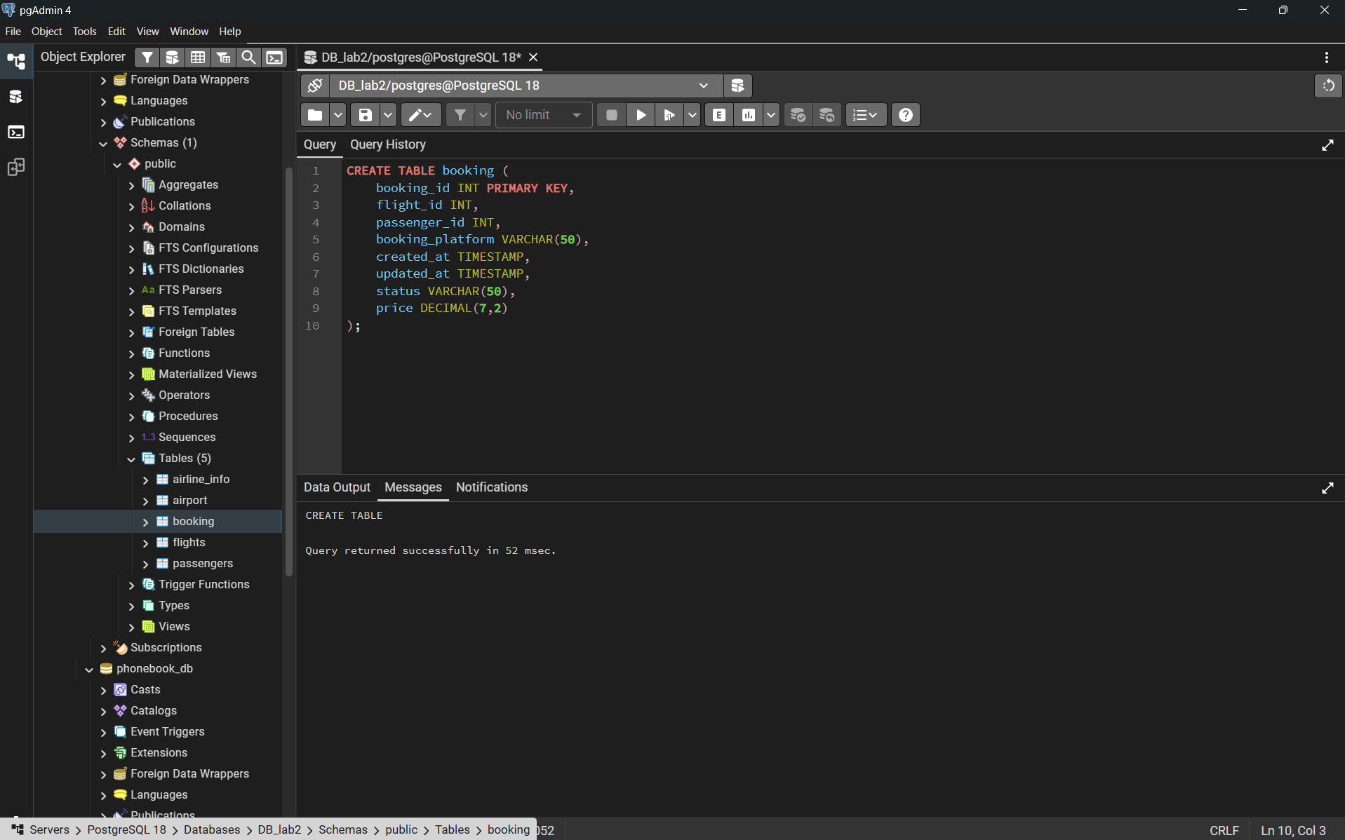
Flights
flight_id (int, PK), sch_departure_time (timestamp), sch_arrival_time (timestamp), departing_airport_id (int), arriving_airport_id (int), departing_gate (varchar(50)), arriving_gate (varchar(50)), airline_id (int), act_departure_time (timestamp), act_arrival_time (timestamp), created_at (timestamp), updated_at (timestamp)
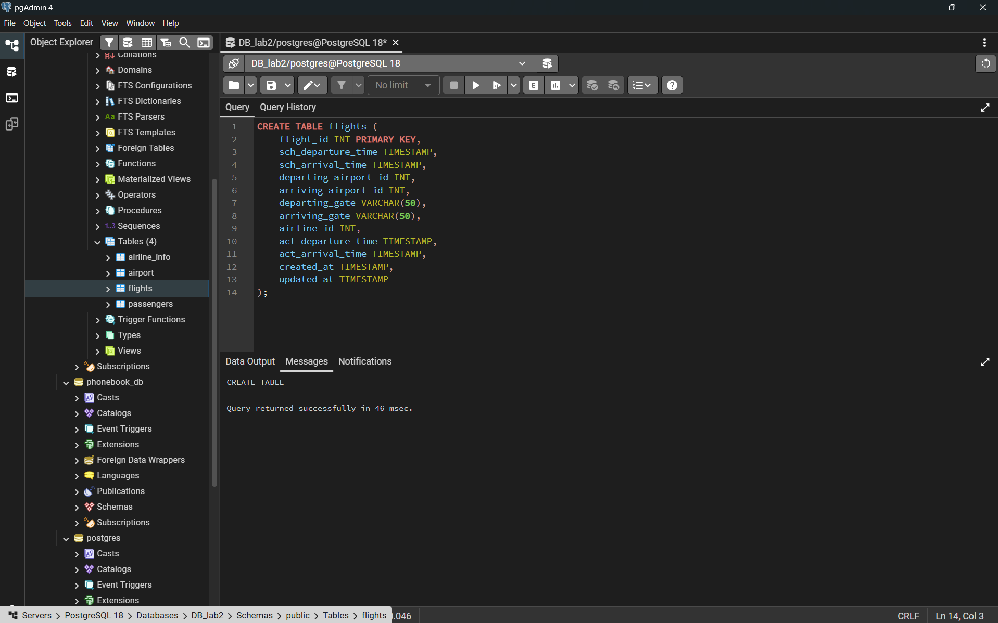

Passengers
passenger_id (int, PK), first_name (varchar(50)), last_name (varchar(50)), date_of_birth (date), gender (varchar(50)), country_of_citizenship (varchar(50)), country_of_residence (varchar(50)), passport_number (varchar(20)), created_at (timestamp), updated_at (timestamp)
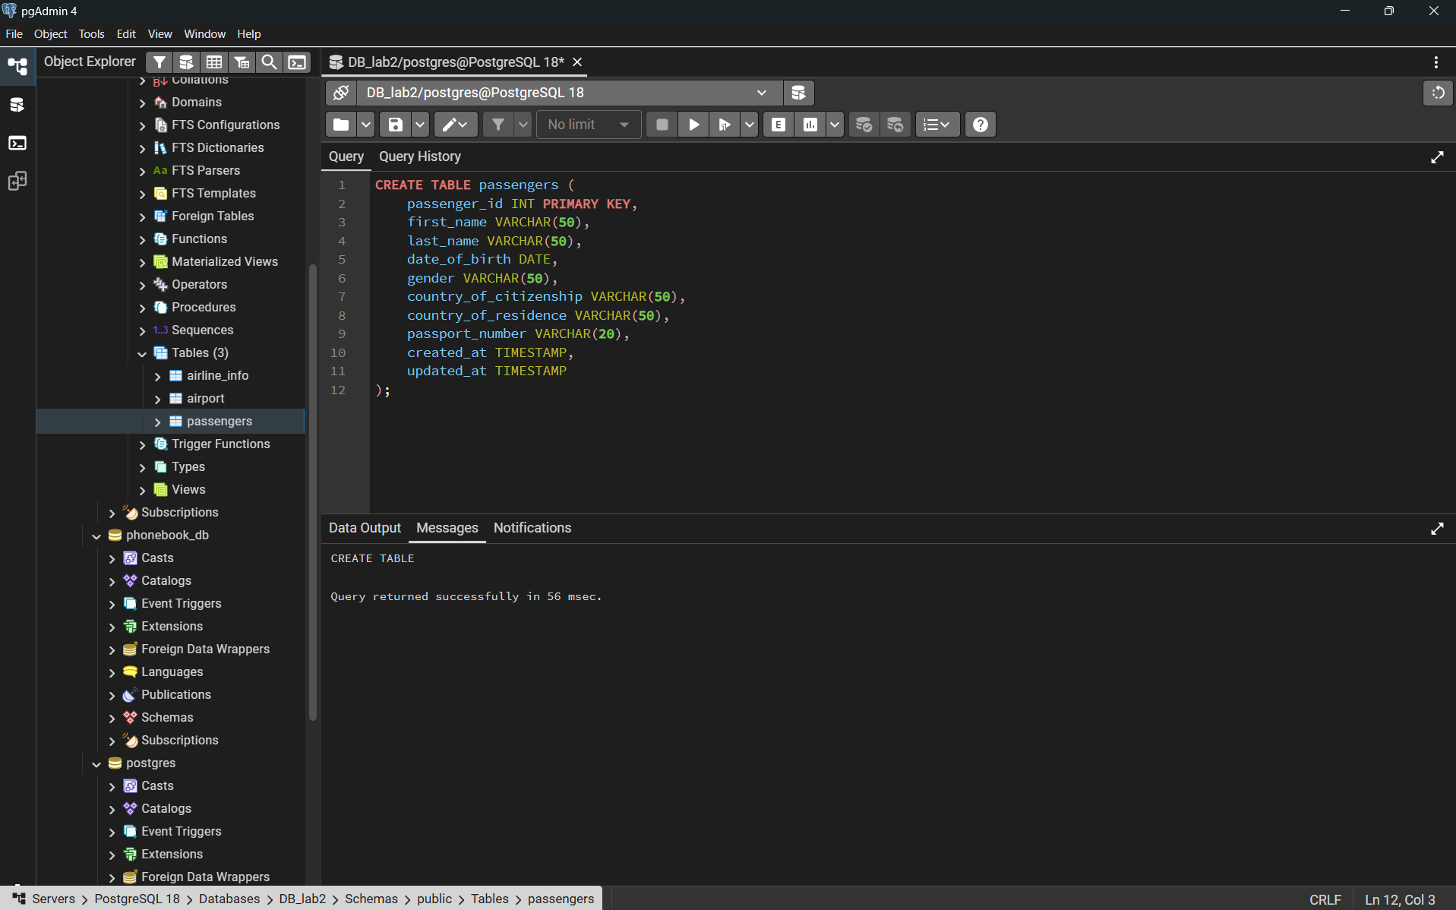
Security_check
security_check_id (int, PK), check_result (varchar(20)), created_at (timestamp), updated_at (timestamp), passenger_id (int)
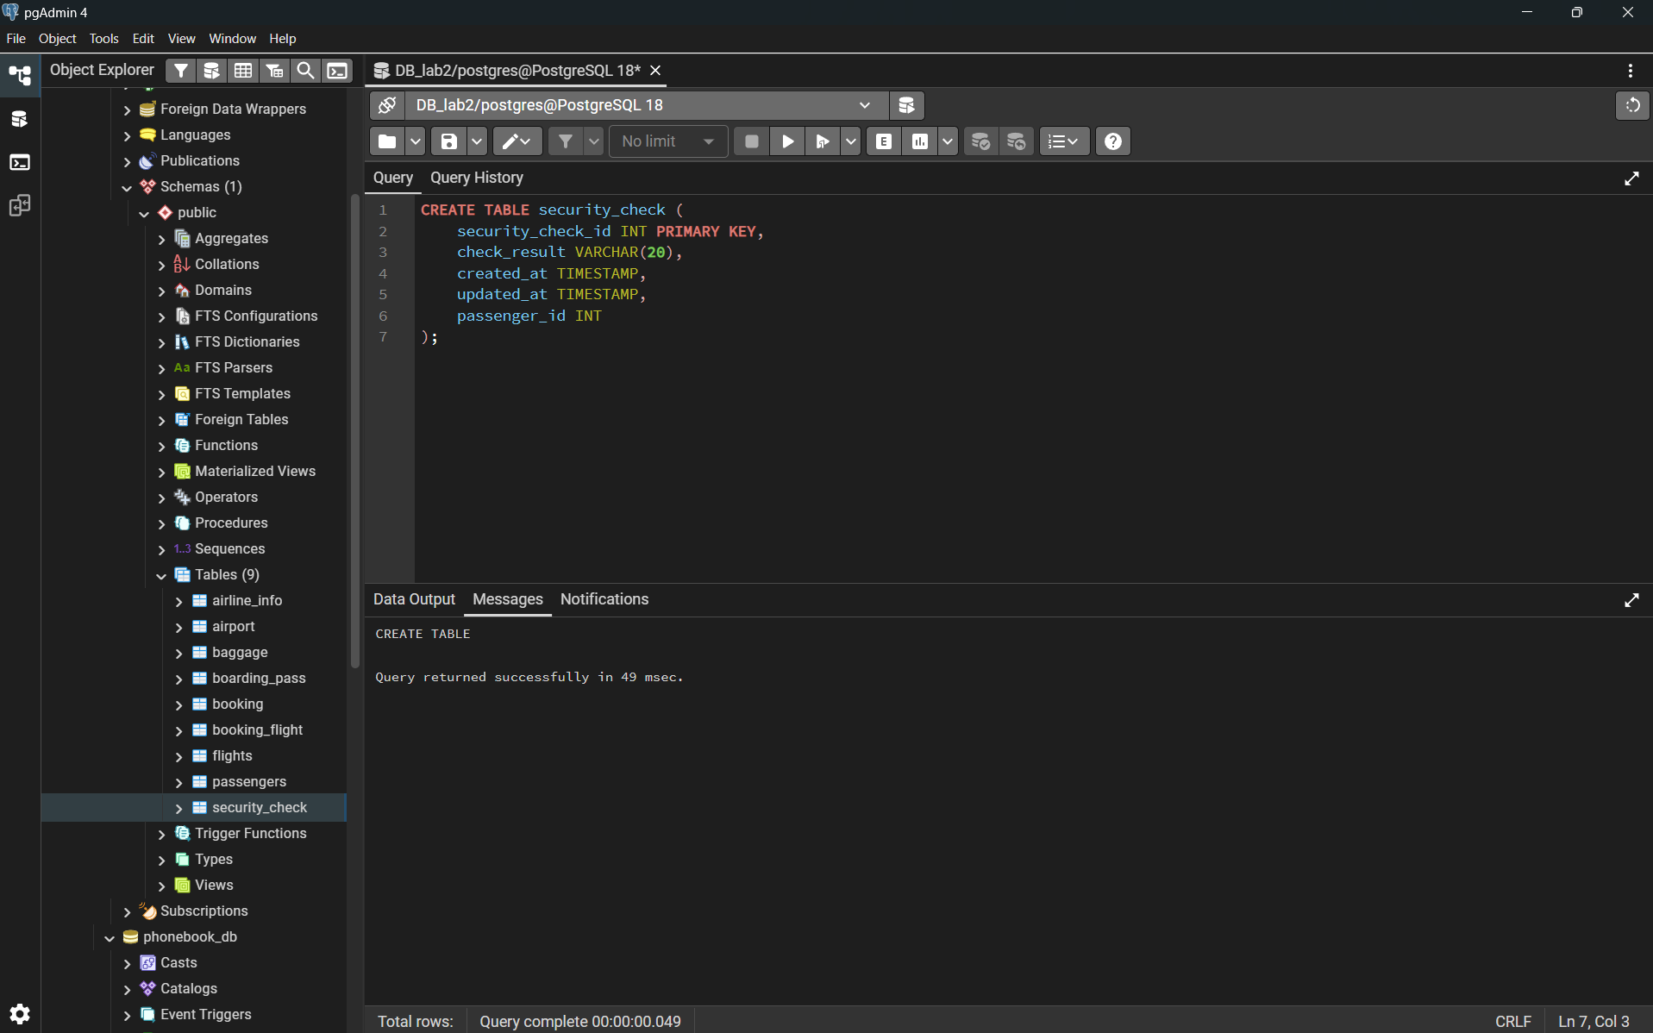
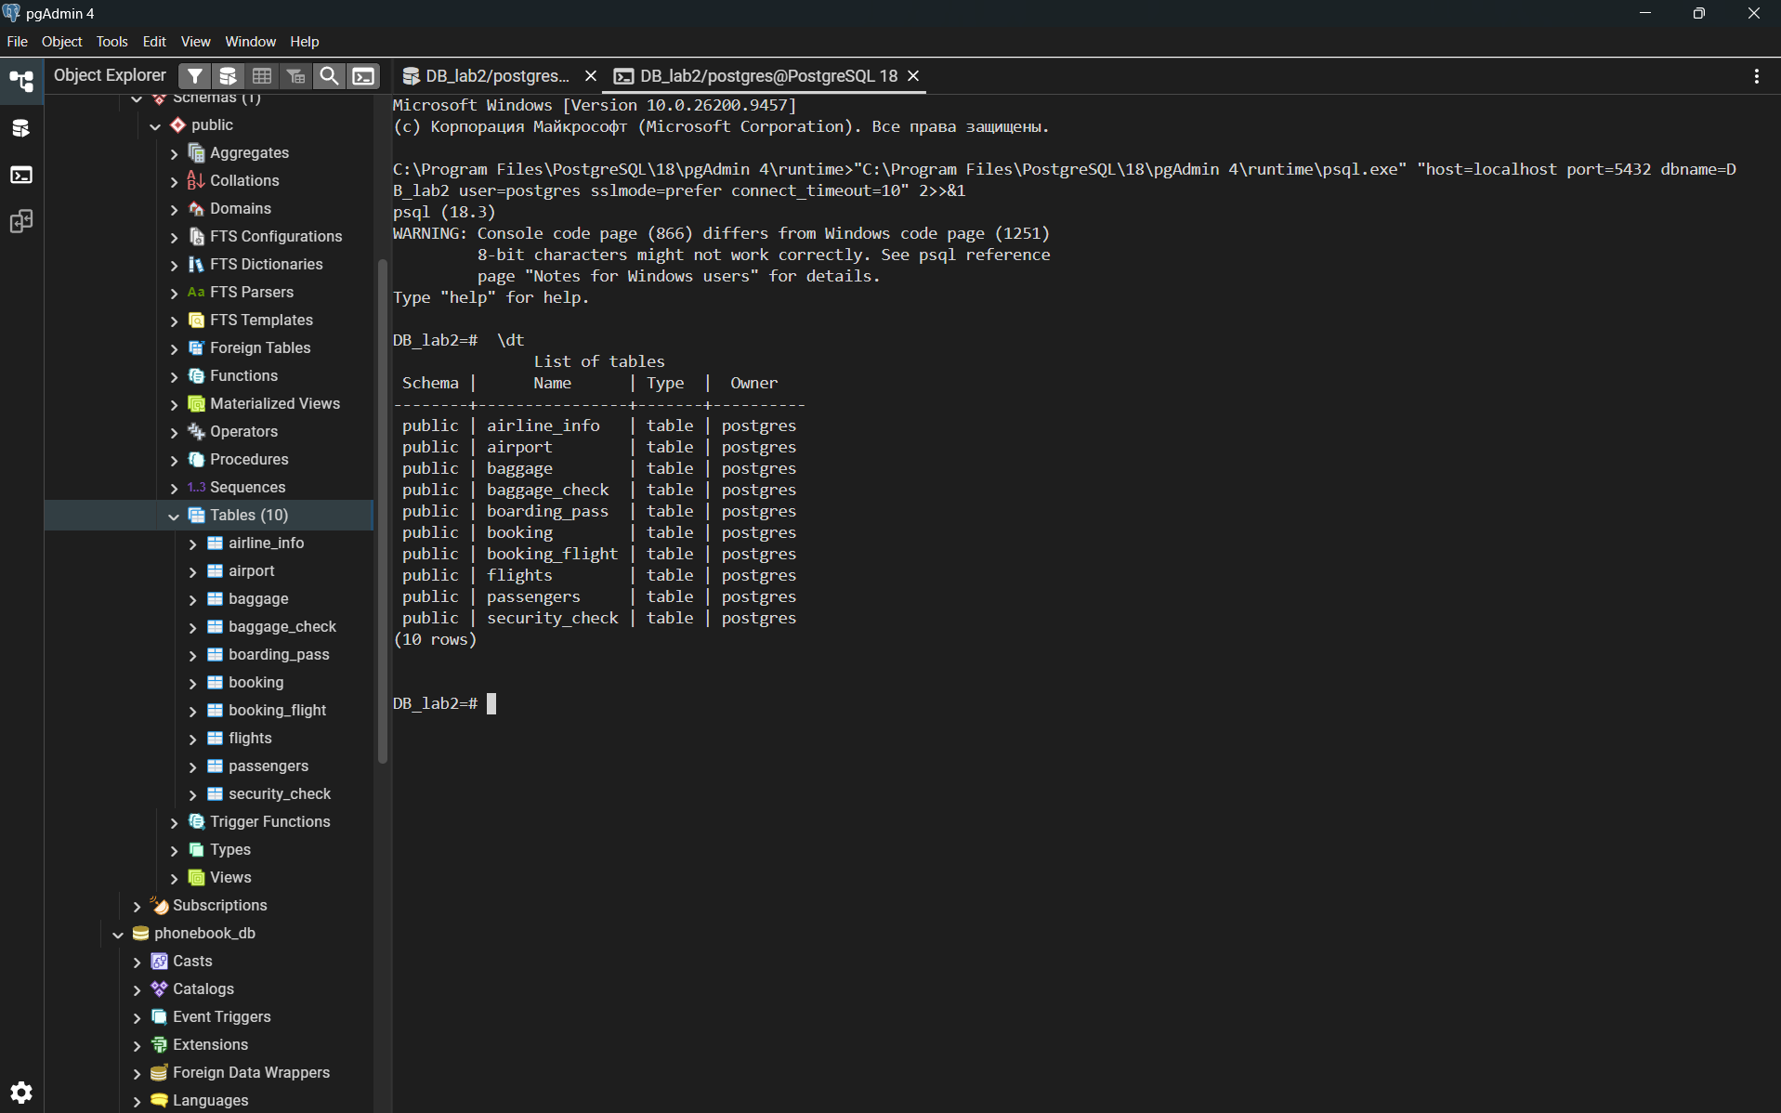

1.2 Adding NOT NULL constraints to all attributes
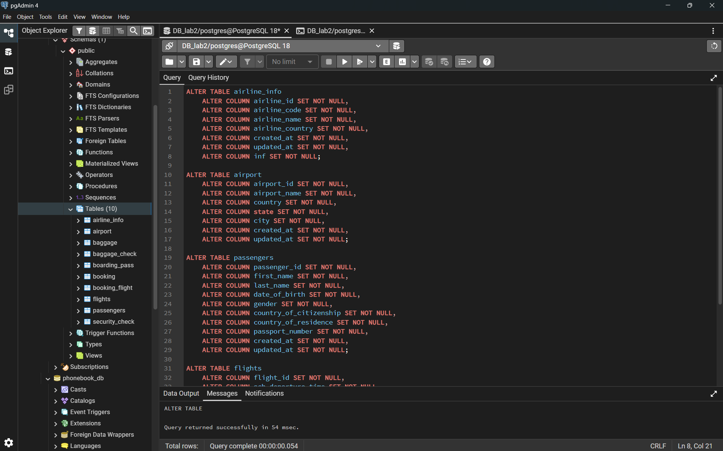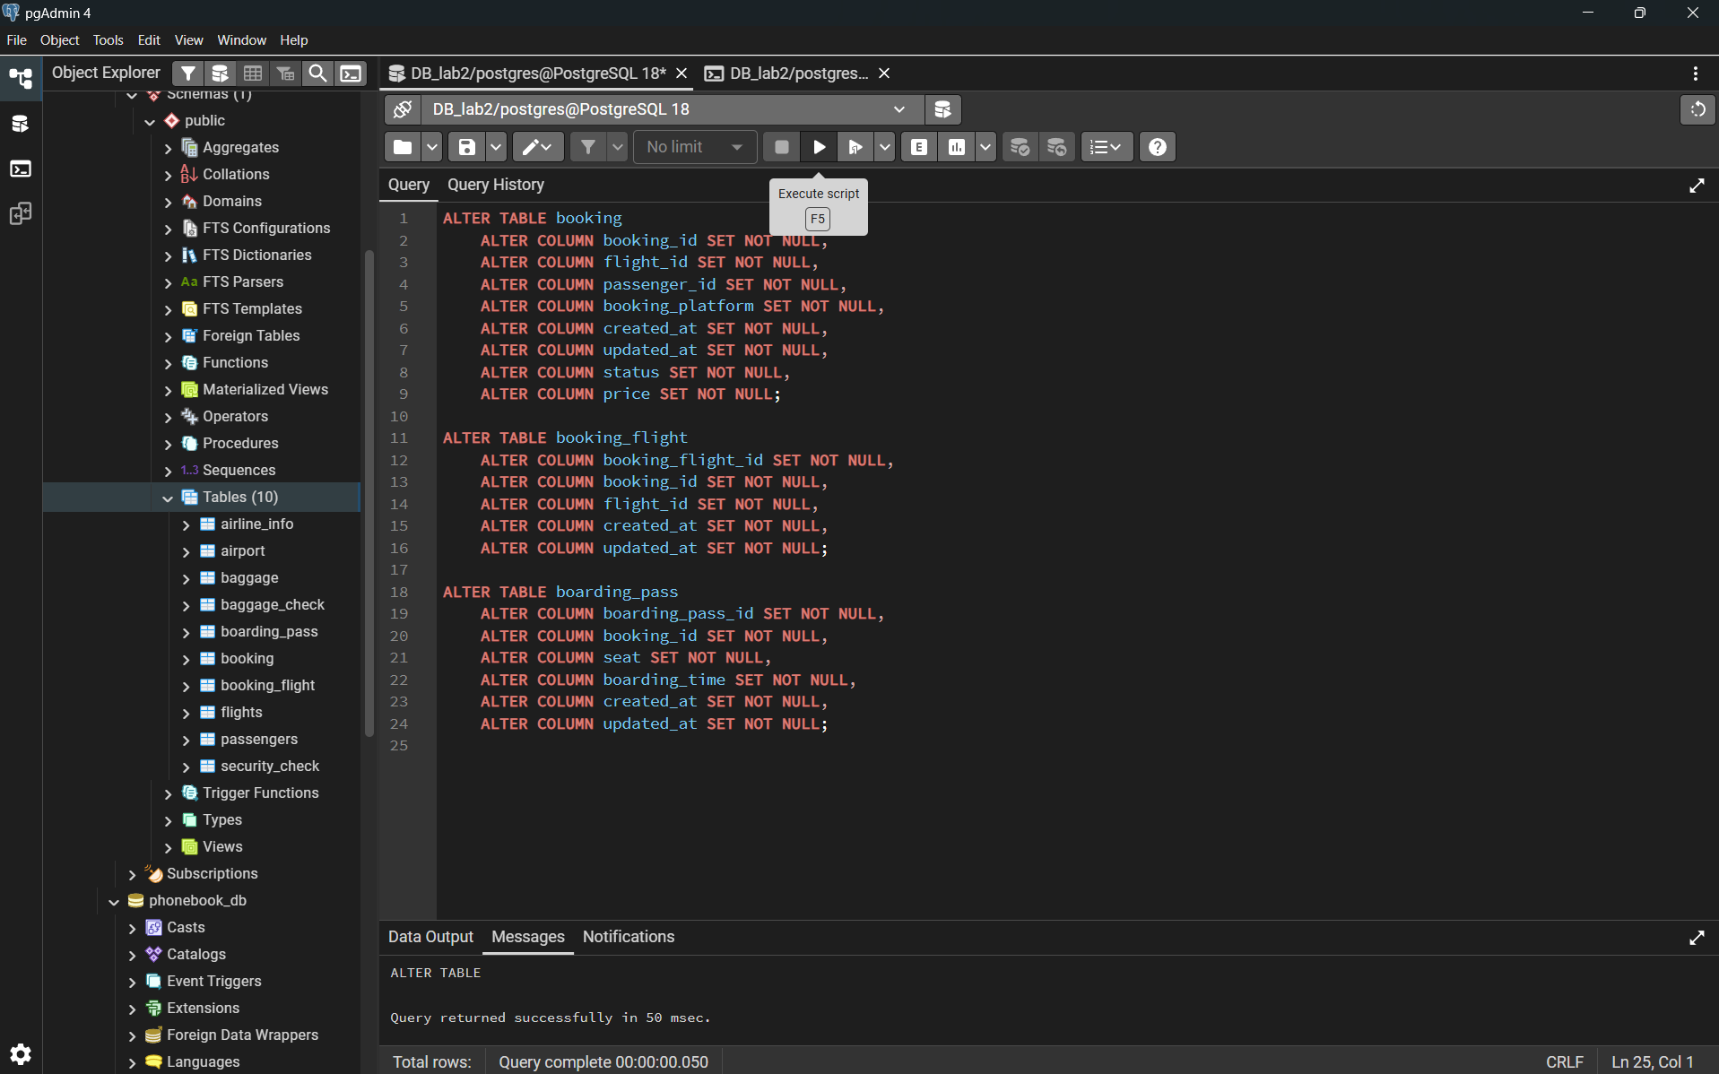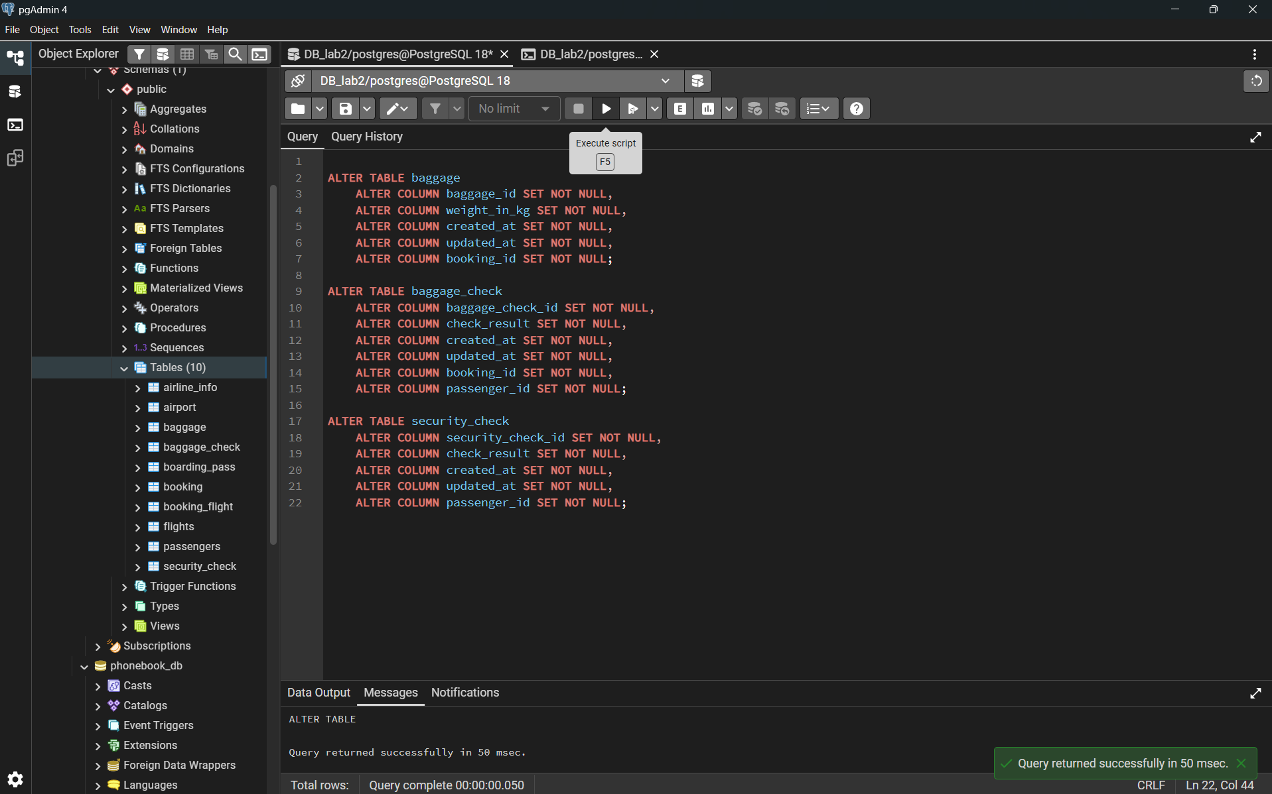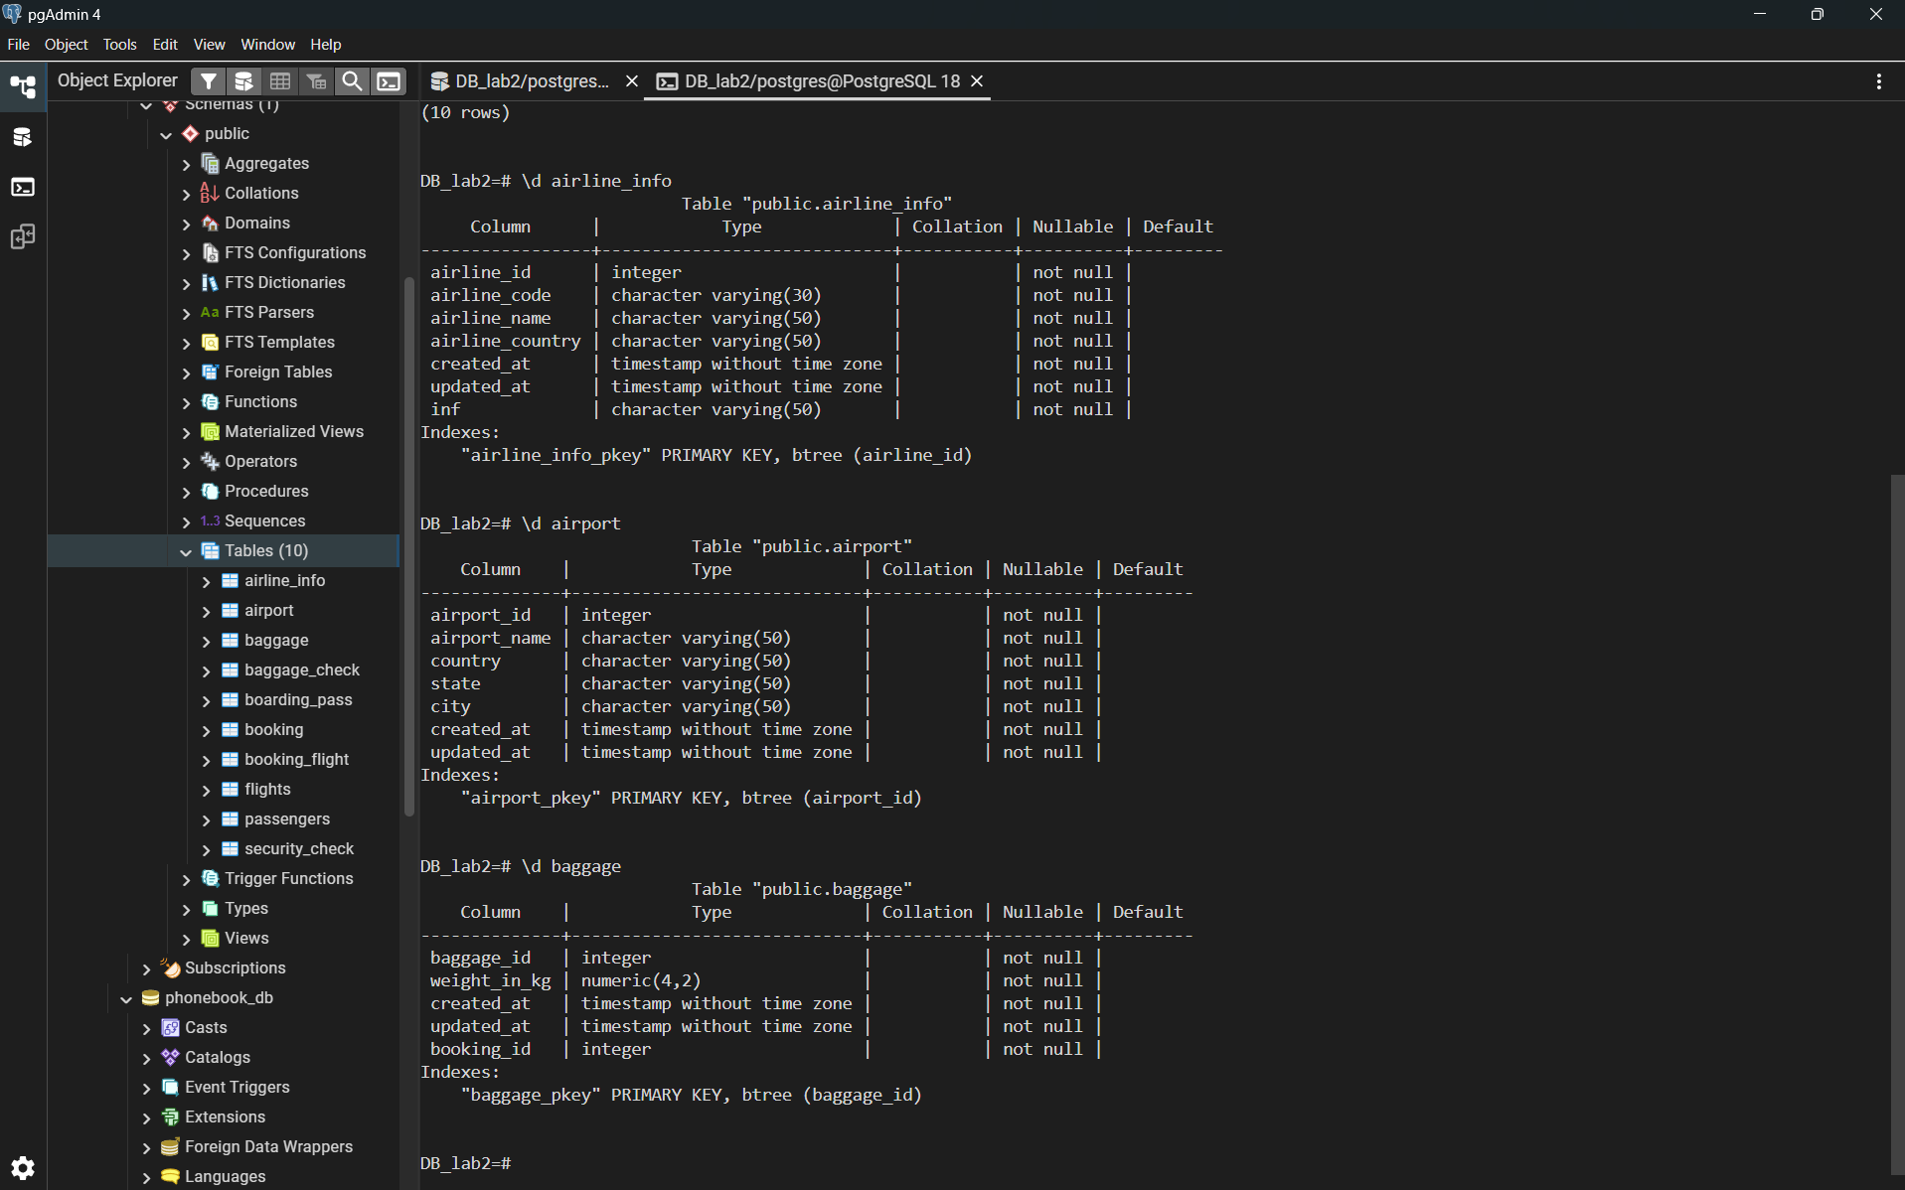

1.3 Renaming the table airline_info to airline
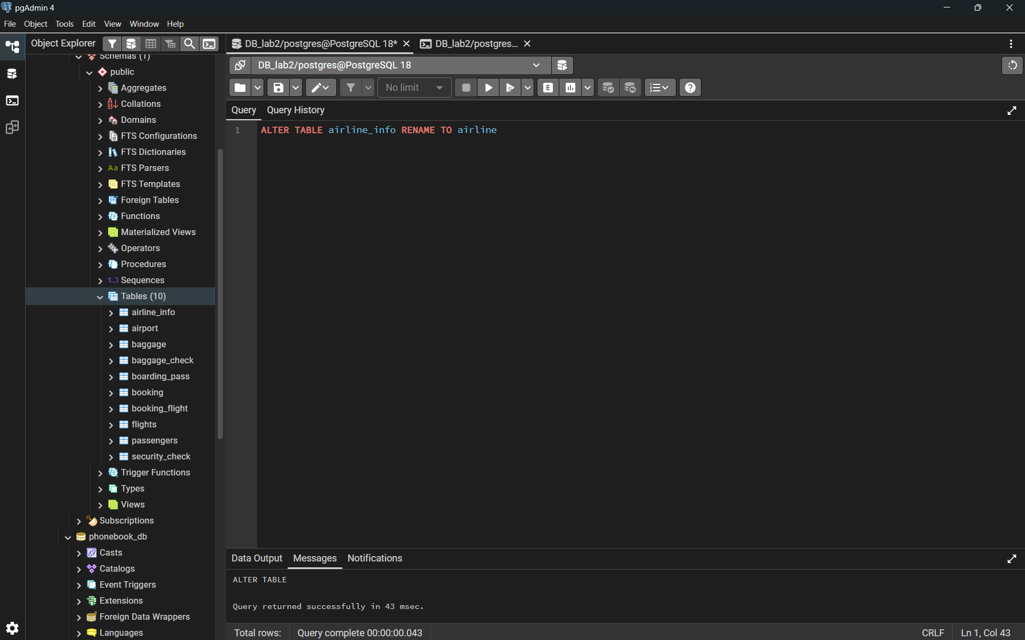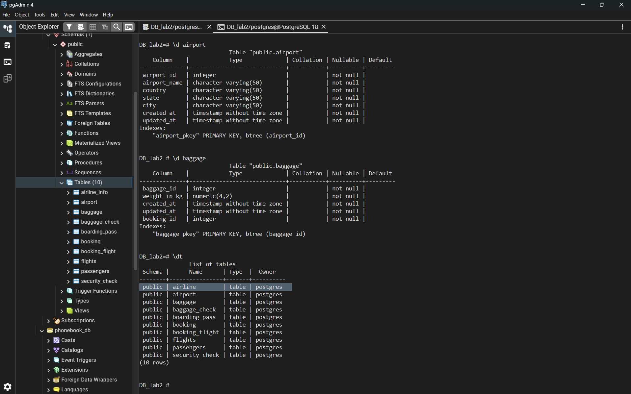

1.4 Renaming the column price to ticket_price in the booking table
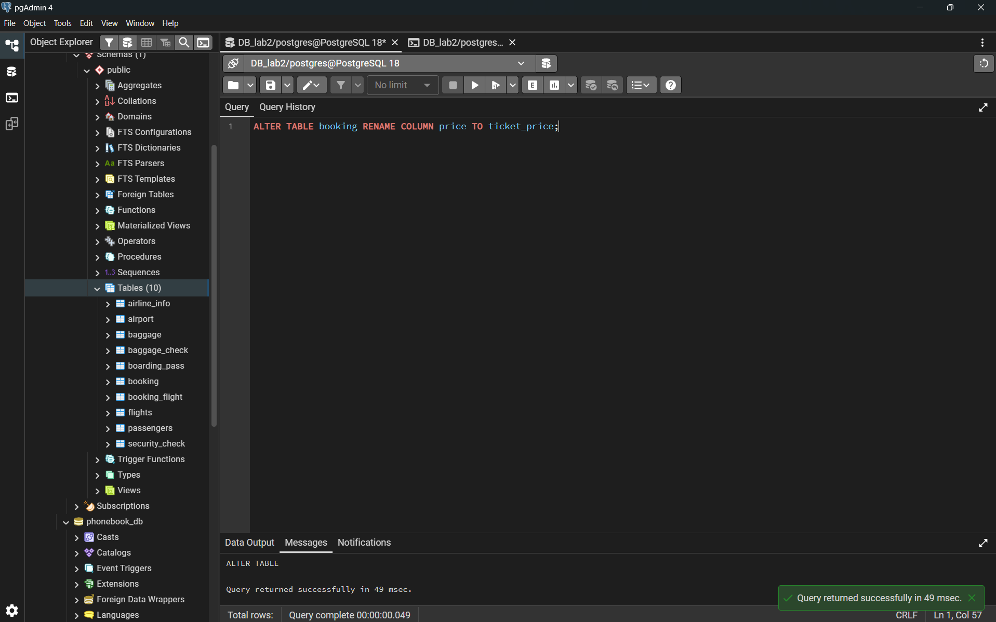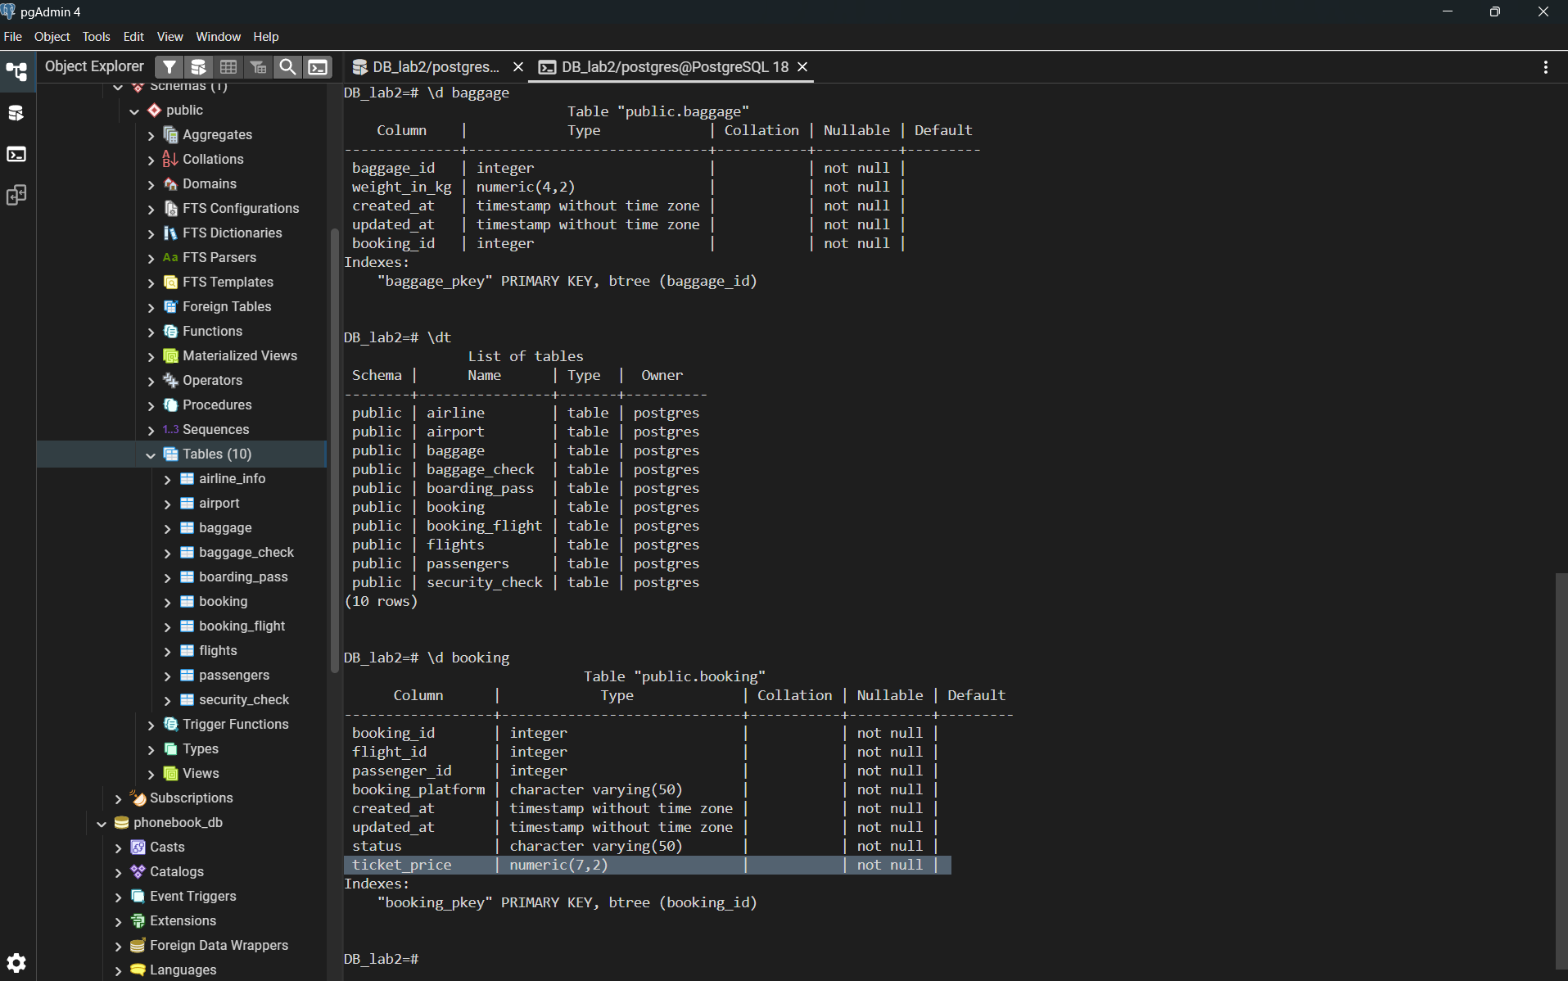

1.5 Changing the data type of departing_gate from varchar(50) to text
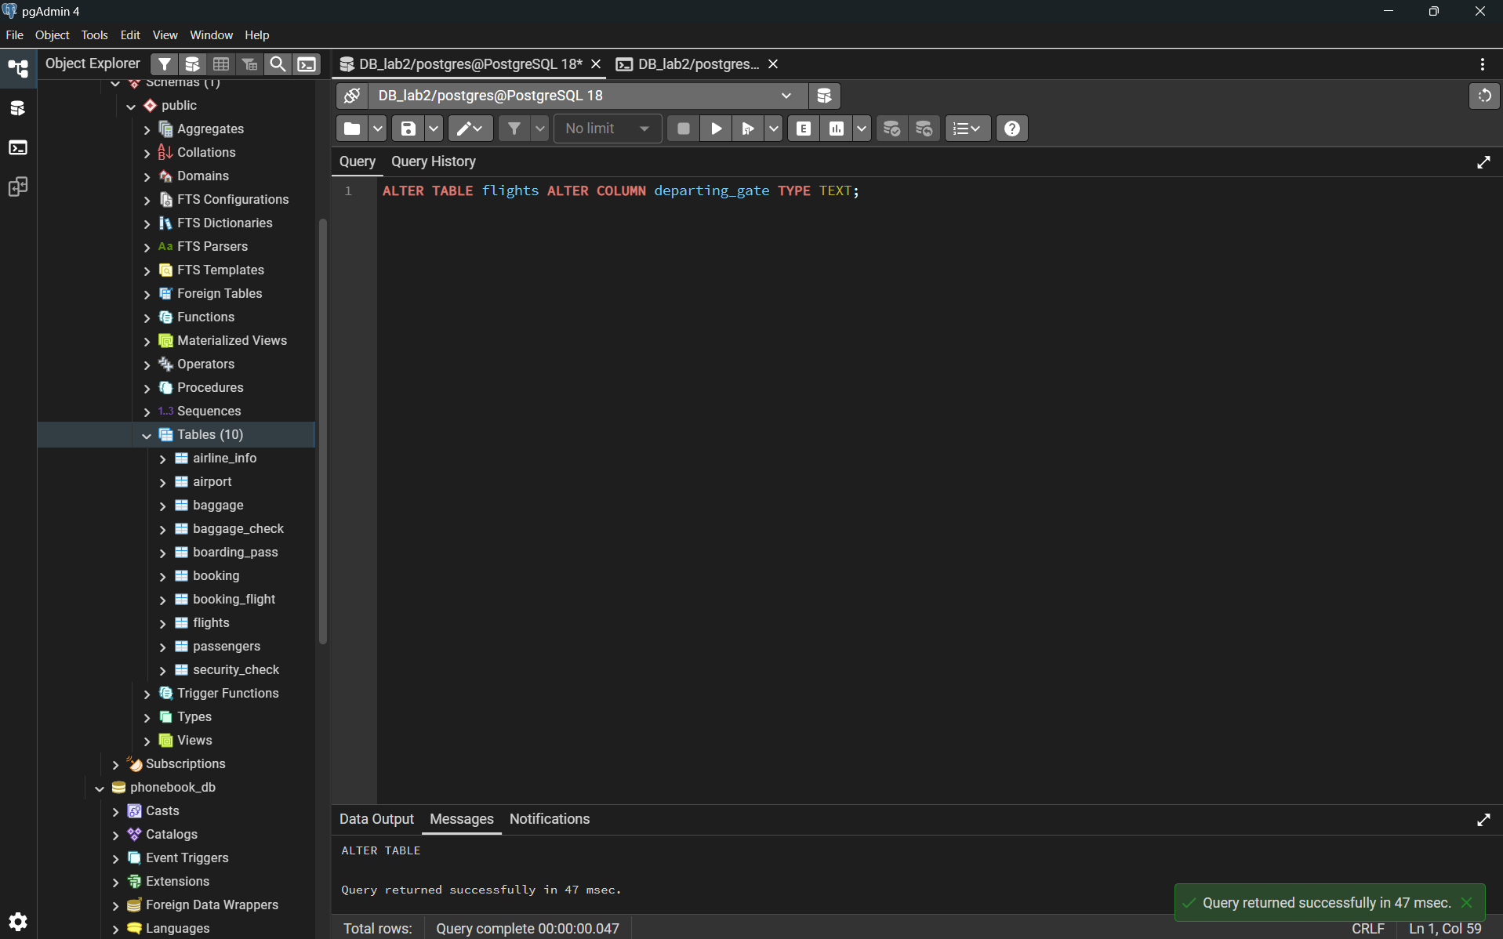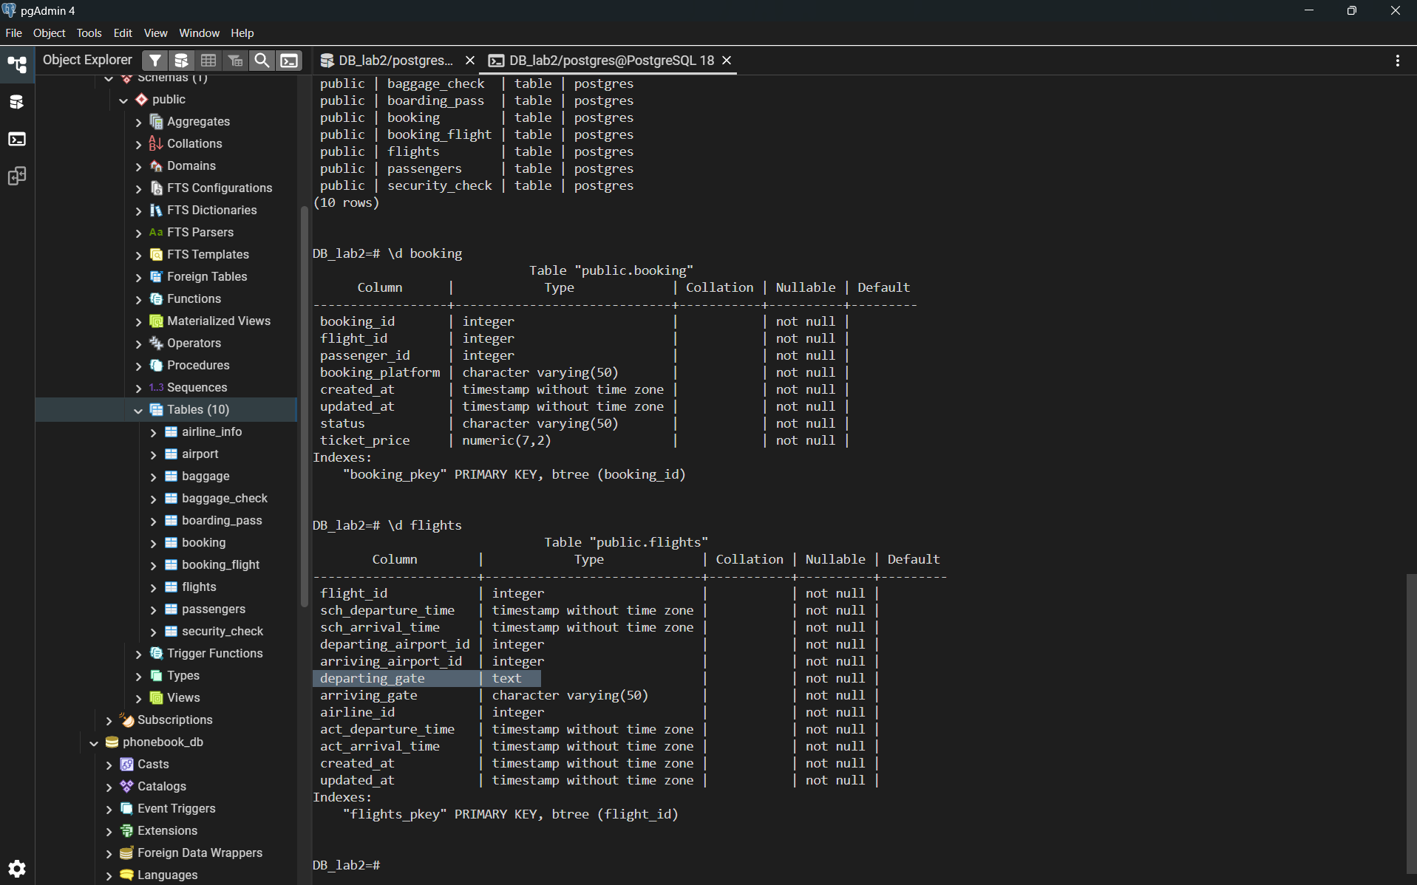

1.6 Dropping the column info from the airline table
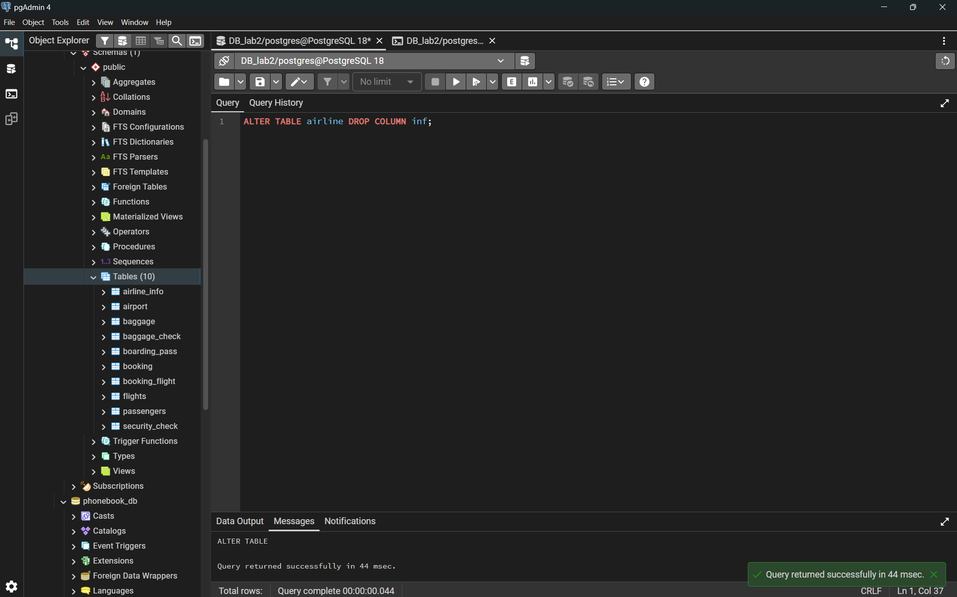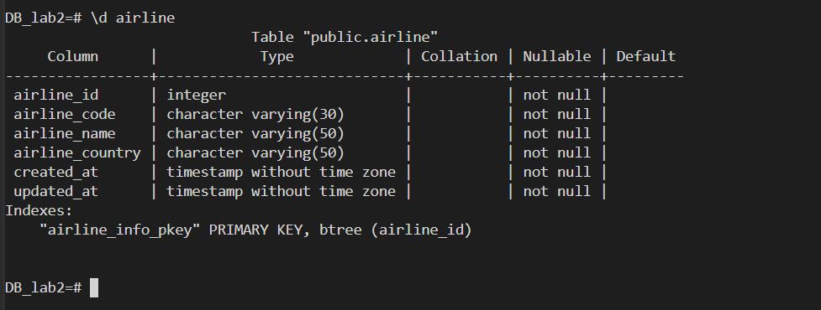

1.7 Creating relationships (Foreign Keys)
- Passengers --- Security_check, Booking, Baggage_check (through passenger_id)
- 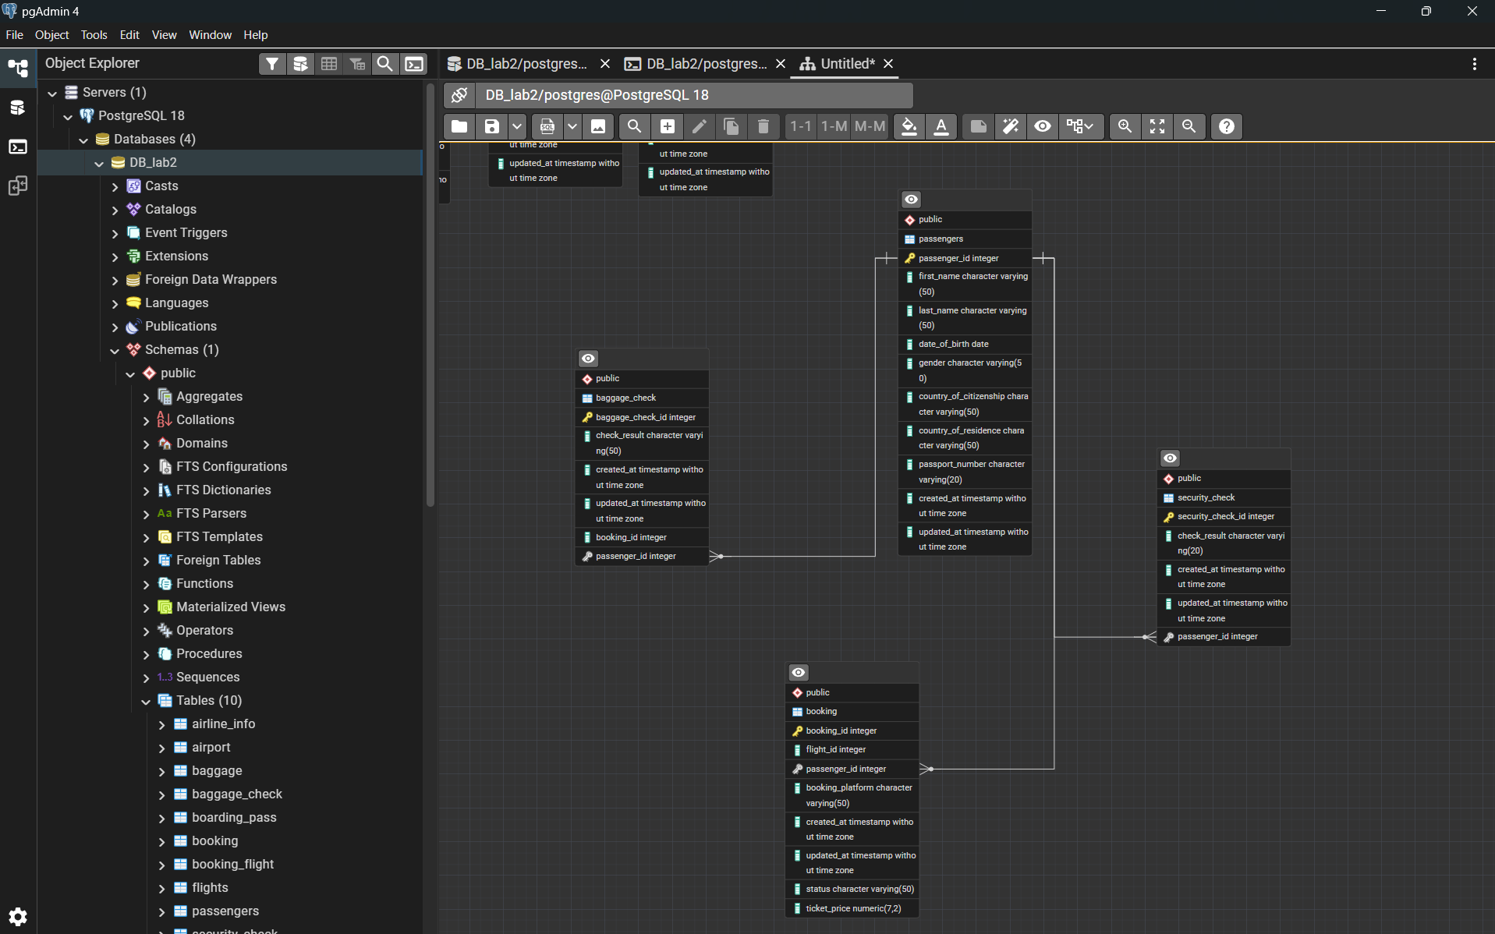

- Booking --- Baggage_check, Baggage, Boarding_pass, Booking_flight (through booking_id)
- 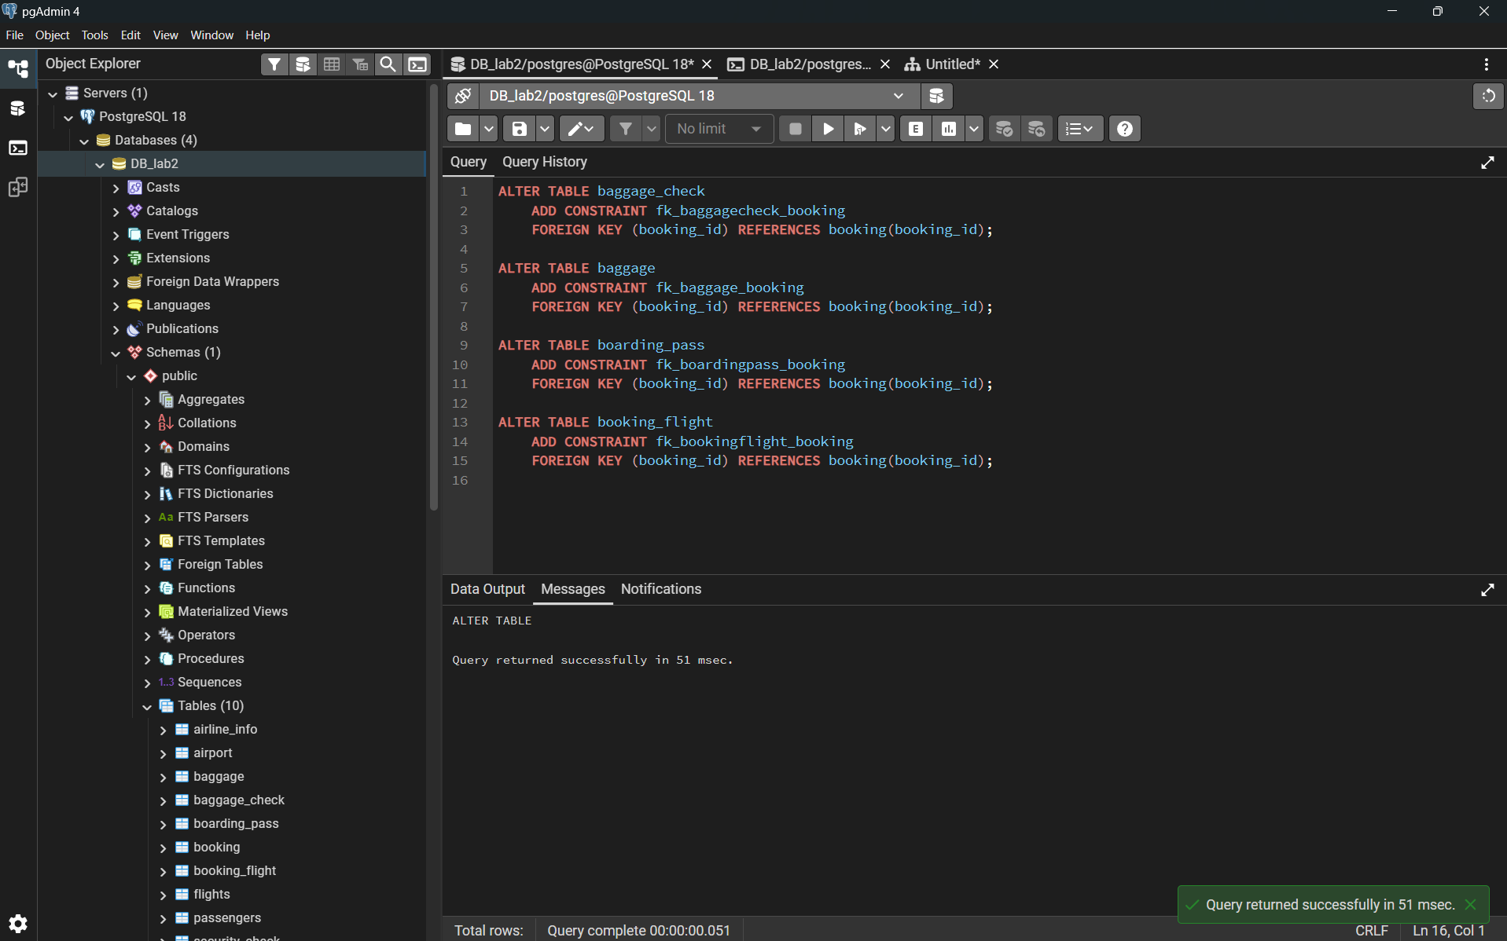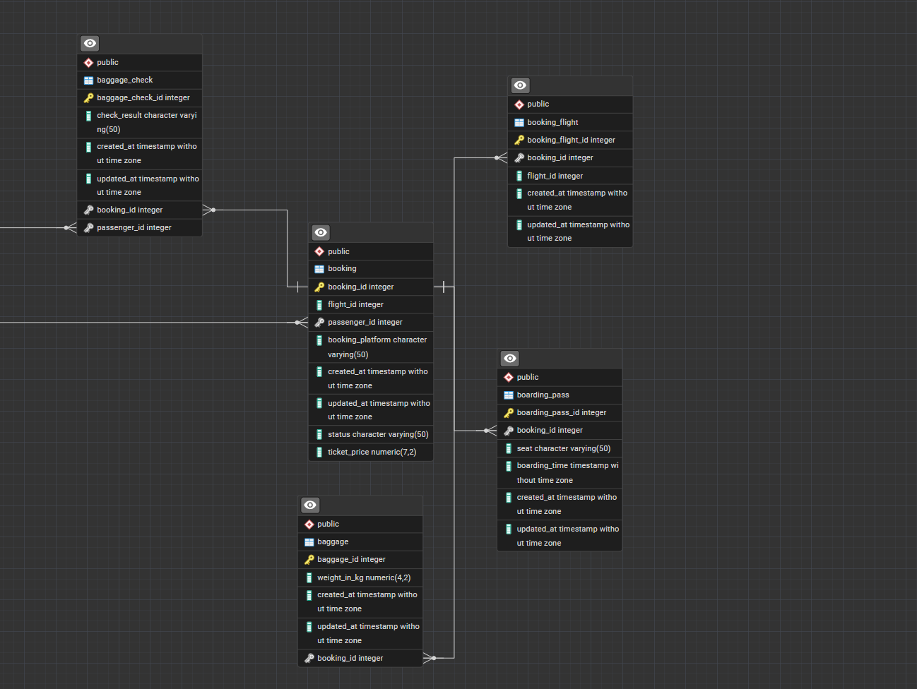
- Flights -- Booking_flight (through flight_id)
- 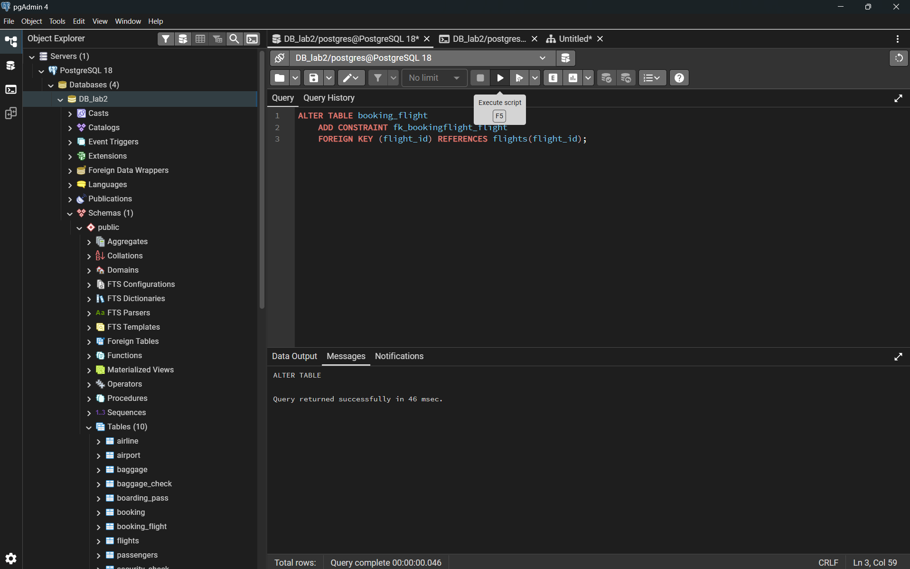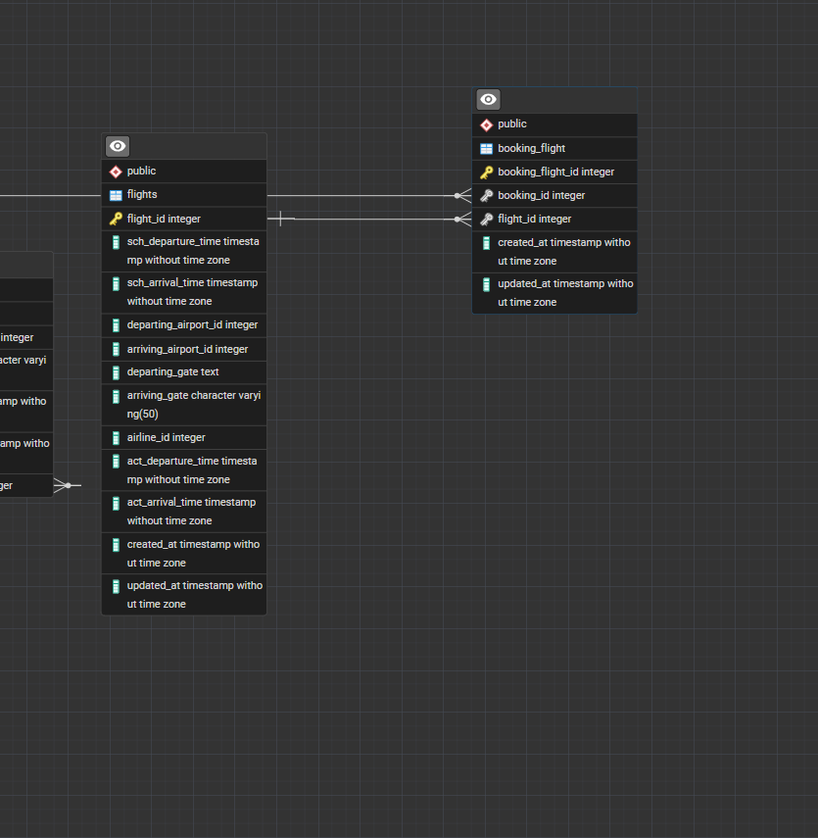
- Airport ---Flights (through departing_airport_id) (through arriving_airport_id)
- 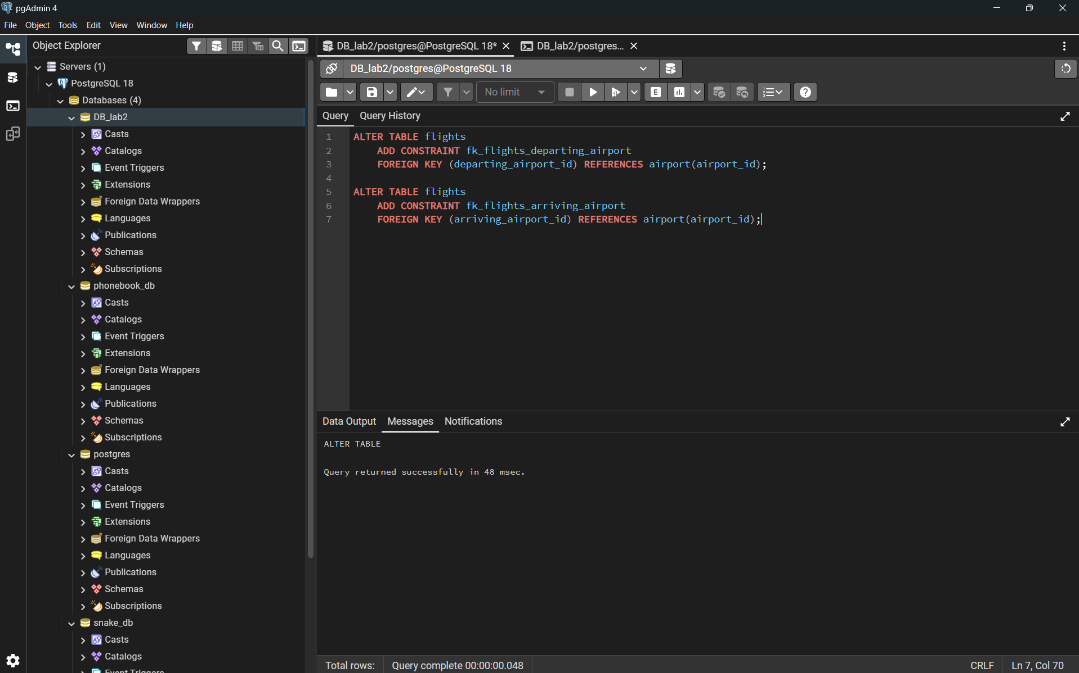

- Airline ---Flights (through airline_id)


