Assignment 2
Task1. Import the data to R, remove variable “duration” and divide into training/validation/test as 40/30/30: use data partitioning code specified in Lecture 2a.

Variable ‘duration’ is removed by assigning a empty vector to that column and code from Lecture 2a is used and seed set to 12345.
data$duration <- c()
Task2. Fit decision trees to the training data so that you change the default settings one by one (i.e. not simultaneously):
a. Decision Tree with default settings.
b. Decision Tree with smallest allowed node size equal to 7000.
c. Decision trees minimum deviance to 0.0005.
and report the misclassification rates for the training and validation data. Which model is the best one among these three? Report how changing the deviance and node size affected the size of the trees and explain why.

The smallest allowed node size and minimum deviance together other parameters of tree function can be controlled by an inbuilt function ‘tree. control’. With different parameters defined, misclassification rates are obtained respectively. The results are shown as follow:
Parameters | Train data | Validation data
Default parameters | 0.1048441 | 0.1092679
Smallest allowed node size=7000 | 0.1048441 | 0.1092679
Minimum deviance =0.0005 | 0.09378456 | 0.1119221
The results from model a and model b are the same despite there are 5 terminal nodes in model b. The number of terminal nodes in model is 6. Model c has 122 terminal nodes and 13 out 15 factors have been used for classification. Results can be seen in Figure 1, Figure 2, and Figure 3.

Combing the results with model complexity, model b is believed to have the best performance as it has similar classification errors but least complex model.
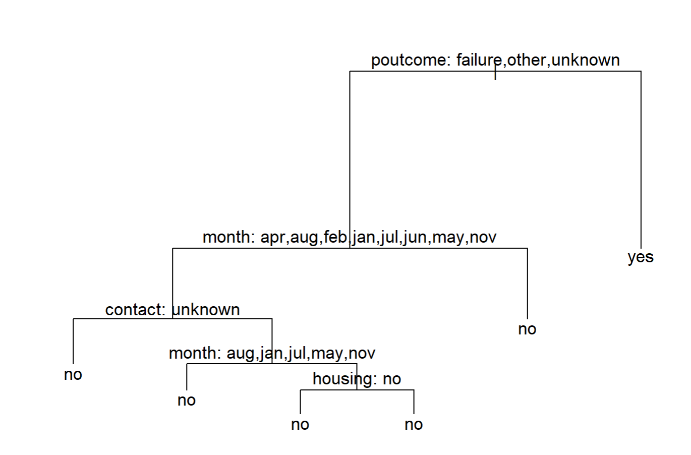
Figure 1 Model a, with terminal nodes.
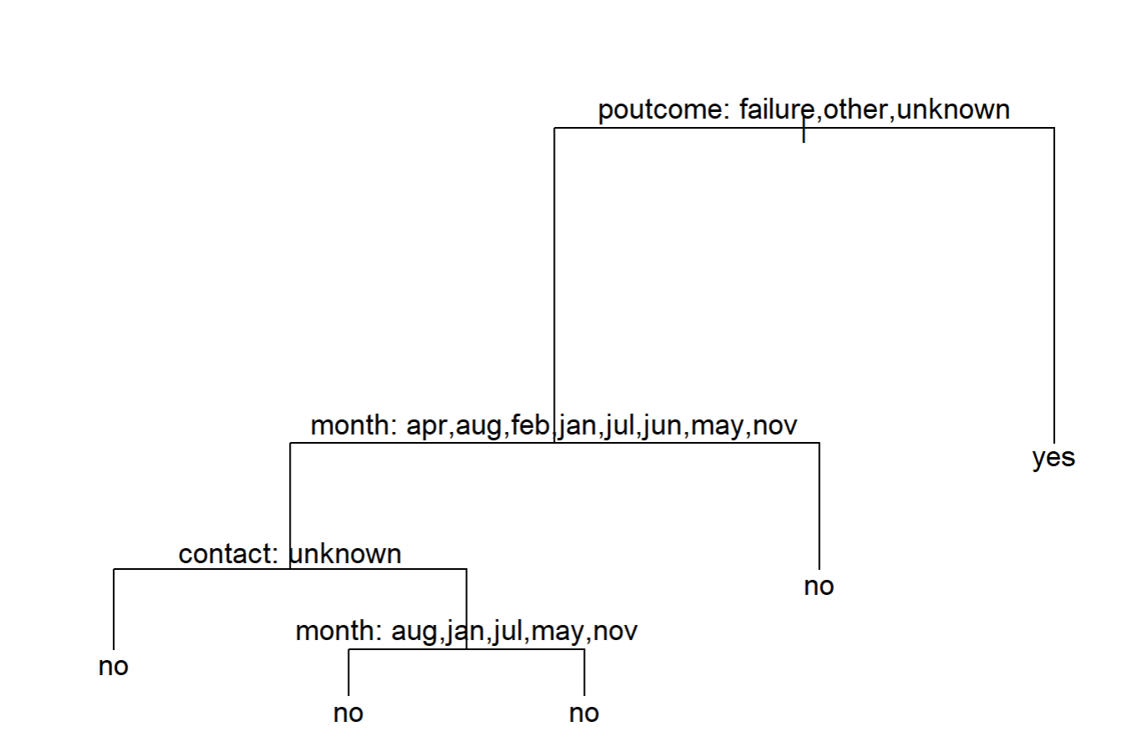
Figure 2 Model b, with terminal nodes.
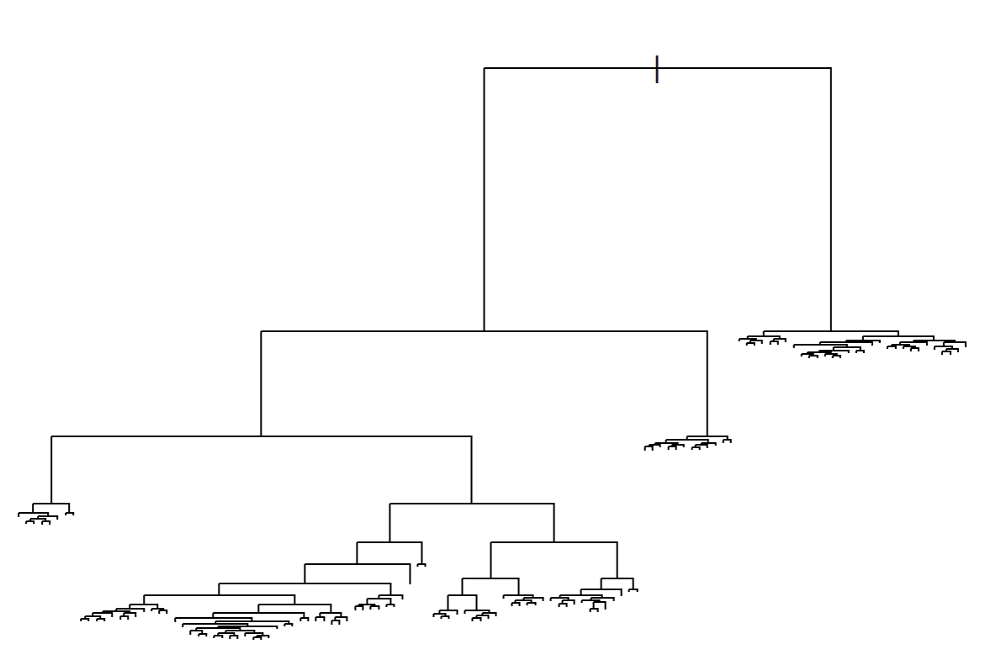
Figure 3 Model C, the most complex model with 122 terminal nodes.
Task3. Use training and validation sets to choose the optimal tree depth in the model 2c: study the trees up to

With model 3c applied, both train score and test score decrease significantly in beginning, meaning the underfitting of tree model when there are only very few leaves. The training score decreases from 11835,8 to 9948,3 when the belonging tree number increases from 2 to 50. While the test score has a decreasing trend for trees with fewer (<21) tree leaves, and then it consolidates before a gradual increase to around 9370. Detailed information can be seen in Figure 4.

The minimum test score is found when the tree has 21 leaves, which indicates the risk of overfitting for the tree with leaves more than 21. In order to better choose the optimal number of leaves, a zooming-in picture is plotted as Figure 5 for the non-overfitting range (2-21 tree leaves). As is clearly shown from Figure 5, the dramatic decreasing trend for train score ends at for the 13 leaves tree and then the decrease in train score is almost neglectable. Meanwhile, the test score is quite low. Therefore, the tree model with 13 leaves is picked as the optimal tree.

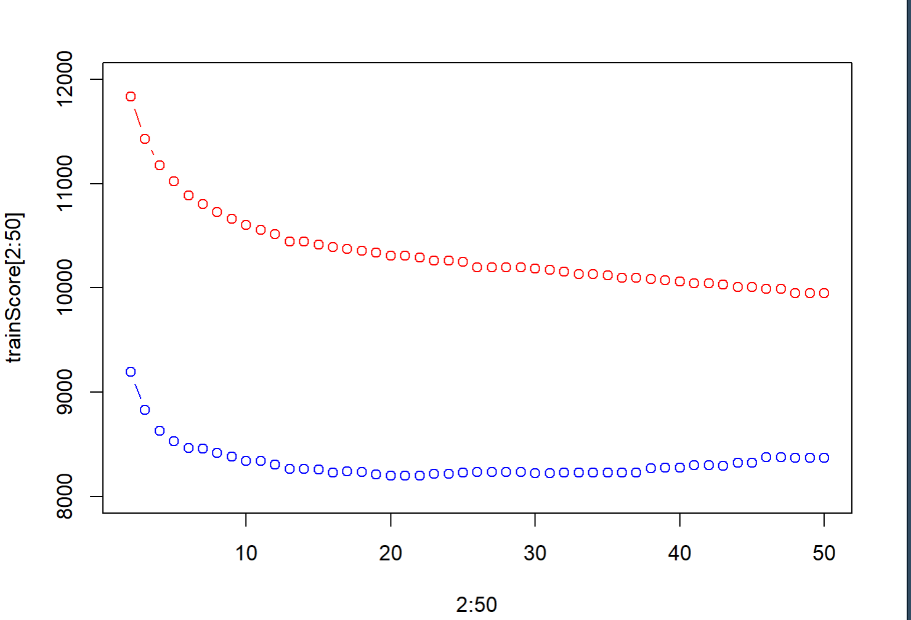
Figure 4 Test score and train score vs number of tree leaves (2-50)
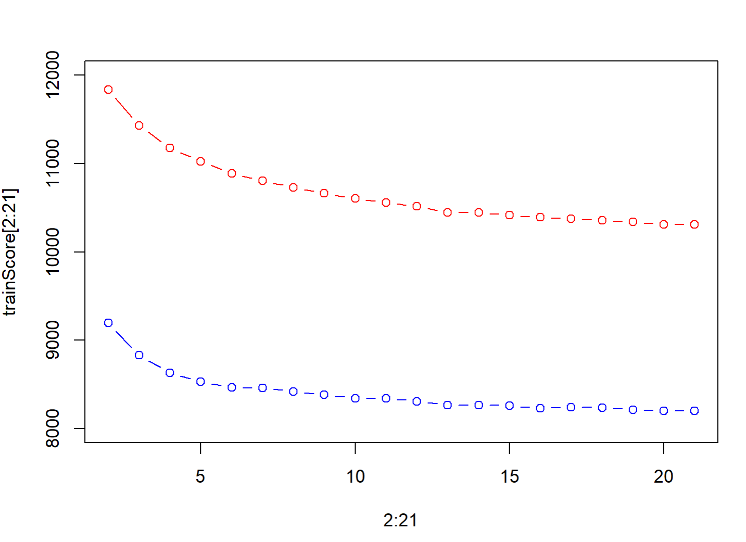
Figure 5 Zooming into the figure, 2-20 tree leave number vs train score and test score.
Task4. Estimate the confusion matrix, accuracy and F1 score for the test data by using the optimal model from step 3. Comment whether the model has a good predictive power and which of the measures (accuracy or F1-score) should be preferred here.
Confusion matrix is present as follow:
 | no | yes
No | 11812 | 167
yes | 1294 | 291
The accuracy is calculated to be 0.8922884. F1 score is 0.2848752.
Despite the model has a quite high accuracy (approximately 90%), the model has a limitation in the prediction of true ‘yes’ with the accuracy at around 18%. In this case, where the sample is not equally distributed, F1 score is a better representative of model’s true prediction power.

Task5. Perform a decision tree classification of the test data with the following loss
matrix,
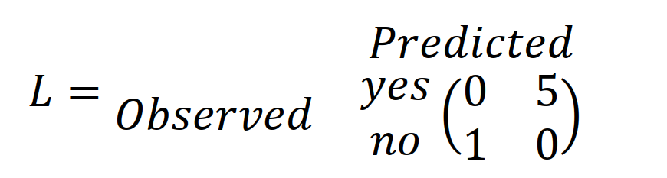
and report the confusion matrix for the test data. Compare the results with the results from step 4 and discuss how the rates has changed and why.

Confusion matrix is present as follow:
 | no | yes
No | 11766 | 219
yes | 1262 | 323
The accuracy is calculated to be 0.8912563. F1 score is 0.3045733. Neither confusion matrix nor f1 score has significant changed,

Task6. Use the optimal tree and a logistic regression model to classify the test data by
using the following principle:
where 𝜋 = 0.05,0.1,0.15, … 0.9,0.95. Compute the TPR and FPR values for the two models and plot the corresponding ROC curves. Conclusion? Why precision-recall curve could be a better option here?

#The ROC curves show the trade-off between true positive rate and false positive rate for the two models. The decision tree model appears to have a higher TPR (sensitivity) at lower FPR (1 - specificity) values, indicating better performance at classifying the positive class. However, the logistic regression model may have better overall performance, especially at higher FPR values. The precision-recall curve could be a better option to evaluate the models, as it focuses on the trade-off between precision and recall, which may be more relevant in this case if the cost of false positives is high. To further analyze the models, you could compute the AUC (Area Under the Curve) for the ROC curves and the average precision for the precision-recall curves, and compare the performance metrics between the two models.

Assignment 3
Task1. Scale all variables except of ViolentCrimesPerPop and implement PCA by using function eigen(). Report how many components are needed to obtain at least 95% of variance in the data. What is the proportion of variation explained by each of the first two principal components?

We used preProcess() function to scale the data and then used eigen() to implement PCA after computed the covariance matrix. Finally, by calculating the cumulative proportion, we get: the number of components are needed to obtain at least 95% of variance is 35. The proportions of variance explained by PC1 and PC2 are 0.2501699 and 0.1693597,respectively.

Task2. Repeat PCA analysis by using princomp() function and make the trace plot of the first principle component. Do many features have a notable contribution to this component? Report which 5 features contribute mostly (by the absolute value) to the first principle component. Comment whether these features have anything in common and whether they may have a logical
relationship to the crime level. Also provide a plot of the PC scores in the coordinates (PC1, PC2) in which the color of the points is given by ViolentCrimesPerPop. Analyse this plot (hint: use ggplot2 package ).

There are many features have contribution to PC1. Ranked by contribution values, the top 5 contributing features in PC1 are: "medFamInc""medIncome""PctKids2Par""pctWInvInc" and "PctPopUnderPov". These characteristics have a common theme, namely economic stress. Most of the features are related to household income plus the percentage of children living with both parents. These factors are logically related to crime levels, as elevated financial pressures force individuals to engage in illegal activities. Areas with limited economic opportunities and higher population densities tend to experience higher rates of criminal activity.
The trace plot of PC1 is like:
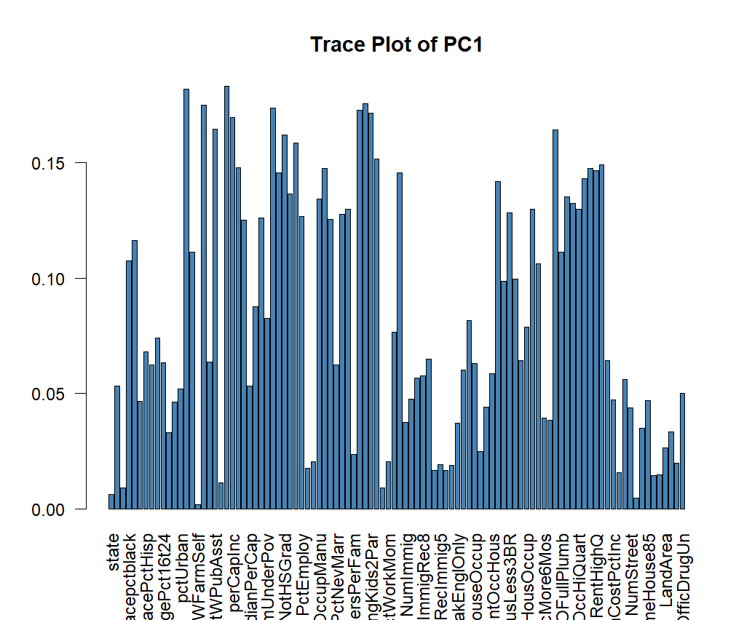
Fig.1 The trace plot of PC1
Scatter plots for PC1 and PC2:
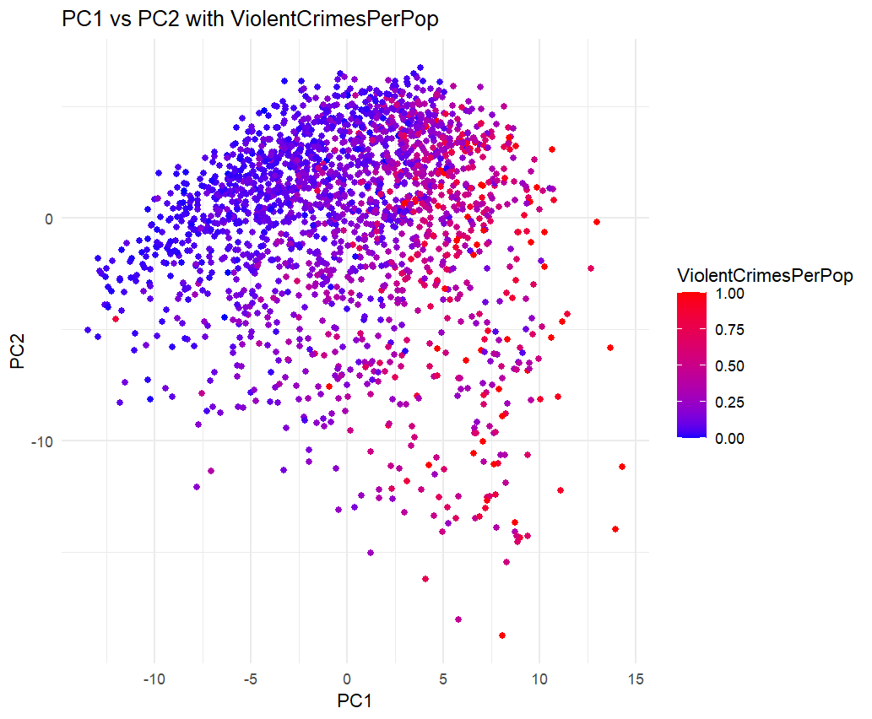
Fig.2 Scatter plot for PC1 and PC2

- In this figure, the horizontal axis (PC1) has a wide range, from about -10 to 15, and along the direction of PC1, the color change is more obvious, and the larger the PC1 (moving to the right), the higher the corresponding crime rate (red) seems to be, indicating that the key features of the data points are mainly reflected in PC1.
- PC2 ranges from approximately -10 to 10, indicating that data points have a certain distribution on PC2. However, compared with PC1, the color gradient does not change significantly in the PC2 direction. This suggests that the effect of PC2 is weaker, but still present.
- Red dots (high crime rates) are mostly found in the upper right and lower right corners (where PC1 is high). This suggests that areas with high crime rates may have certain characteristics in common, which are seized upon by PC1.
- The color of the dots is gradual from blue to red, indicating that the ViolentCrimesPerPop is continuously varying, with no significant faulting or grouping.

Task3. Split the original data into training and test (50/50) and scale both features and response appropriately, and estimate a linear regression model from training data in which ViolentCrimesPerPop is target and all other data columns are features. Compute training and test errors for these data and comment on the quality of model.

As result, the MSE for training data is 0.2752071,and the MSE for test data is 0.4248011. The current model has a small error on the training data. When generalized to the test data, the test error (0.424) is higher than the training error (0.275), but the gap is not large, and it can be optimized.

Task4. Implement a function that depends on parameter vector theta and represents the cost function for linear regression without intercept on the training data set. Afterwards, use BFGS method (optim() function without gradient specified) to optimize this cost with starting point theta⁰ = 0 and compute training and test errors for every iteration number. Present a plot showing dependence of both errors on the iteration number and comment which iteration number is optimal according to the early stopping criterion. Compute the training and test error in the optimal model, compare them with results in step 3 and make conclusions.

We defined the cost function:
cost_function <- function(theta, X, y) {
predictions <- X %*% theta
mse <- mean((y - predictions)^2)
return(mse)
}We Optimized the cost function using BFGS and the error for each iteration is recorded.
The plot , discard initial iterations is like:
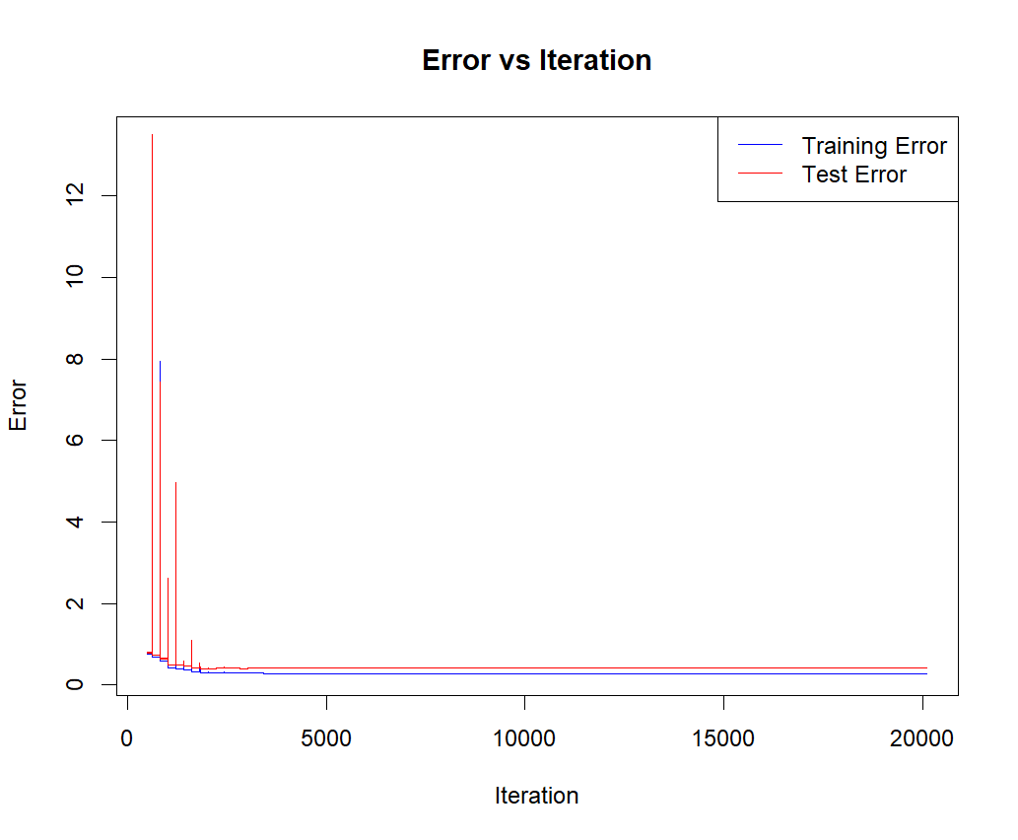
Fig.3 Error plot
The optimal iteration is 2182, and training MSE at optimal iteration is 0.3032999, test MSE at optimal iteration is 0.4002329. The optimization results show that compared with task3, the error of the training set is larger and the error of the test set (MSE) is smaller. This may be because the BFGS algorithm may make large parameter adjustments to the training data in order to avoid overfitting or updating the algorithm parameters increased the complexity of the model . While the error of the training set increased, the test error decreased significantly and stabilized at relatively low levels. This means that the generalization ability of the model is improved.

Assignment 4
• What are the practical approaches for reducing the expected new data error, according to the book?
The expected new data error can be made smaller by a smarter choice of loss function.Examples of when this is the case include gradient boosting (Chapter 7) and support vector machines.(P65)

• What important aspect should be considered when selecting minibatches,
according to the book?
-When using mini-batches it is important to ensure that the different mini-batches are balanced and representative for the whole dataset. Skewed or biased minibatches can lead to poor convergence or suboptimal training outcomes. The selection process should balance computational efficiency with maintaining variability in the data.(P125)

• Provide an example of modifications in a loss function and in data that can be done to take into account the data imbalance, according to the book.
-we can formulate the loss function based on the predicted class probability 𝑔(x) or some other continuous quantity used to compute the class prediction.For a binary classifier that predicts conditional class probabilities 𝑝(𝑦 = 1 | x) in terms of a function 𝑔(x), the cross-entropy loss is a natural choice:
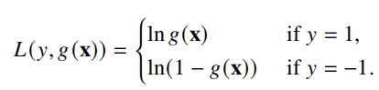
Besides, We can define loss functions for binary classification in another way in terms of the margin, by assigning a small loss to positive margins (correct classifications) and a large loss to negative margins (misclassifications). We can, for instance, re-formulate the logistic loss in terms of the margin as:(P99-100)
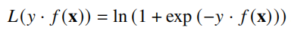
A similar effect can also be achieved by, for this example, simply duplicating all positive training data points times in the training data, instead of modifying the loss function. That is to say oversampling the minority class or undersampling the majority class can create a more balanced dataset.

