Assignment3
- Which filter do you return to the user ? filter0, filter1, filter2 or filter3? Why?
The filter returned to the user is filter0. This is because filter0 is the filter trained on the training set with the optimal parameter C selected by minimizing the validation error. The purpose of this approach is to identify the most suitable model by minimizing the validation error. As for other filters:
filter1 evaluates the performance of the model with the optimized parameter on the test set.
filter2 retrains the model on the combined training and validation sets to see if using more data improves performance.
filter3 trains the model using all available data to assess its potential performance when fully trained on the entire dataset.
- What is the estimate of the generalization error of the filter returned to the user? err0, err1, err2 or err3? Why?
The estimate of the generalization error for the filter returned to the user is err0. Because it applies the optimal parameters found by the verification set to the verification set, the calculated error is an evaluation of the model's performance. As for other errors:
err1 used to evaluate the performance of the model after tuning with the validation set.
err2 used to evaluate the performance of the model retrained on the combined training and validation sets.
err3 used to evaluate the performance of the model retrained on all available data.
- Implementation of SVM predictions
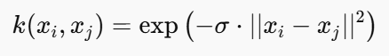
We used the RBF to calculate k2:

sv<-alphaindex(filter3)[[1]]
co<-coef(filter3)[[1]]
inte<- - b(filter3)
k<-NULL
for(i in 1:10){ # We produce predictions for just the first 10 points in the dataset.
k2<-NULL
for(j in 1:length(sv)){
k2<- c(k2, exp(-0.05 * sum((as.numeric(spam[i, -58]) - as.numeric(spam[sv[j], -58]))^2)))
}
k<-c(k, sum(co * k2) + inte)
}
k
predict(filter3,spam[1:10,-58], type = "decision")

The result is as follows:
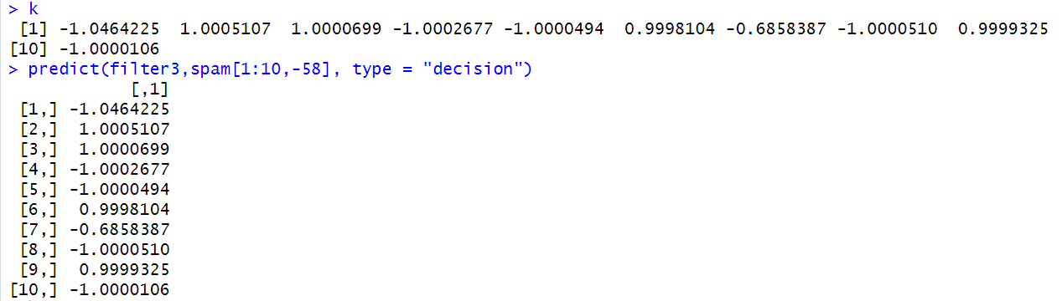
The results are the same as the output of the function prediction.

Assignment4
Task1
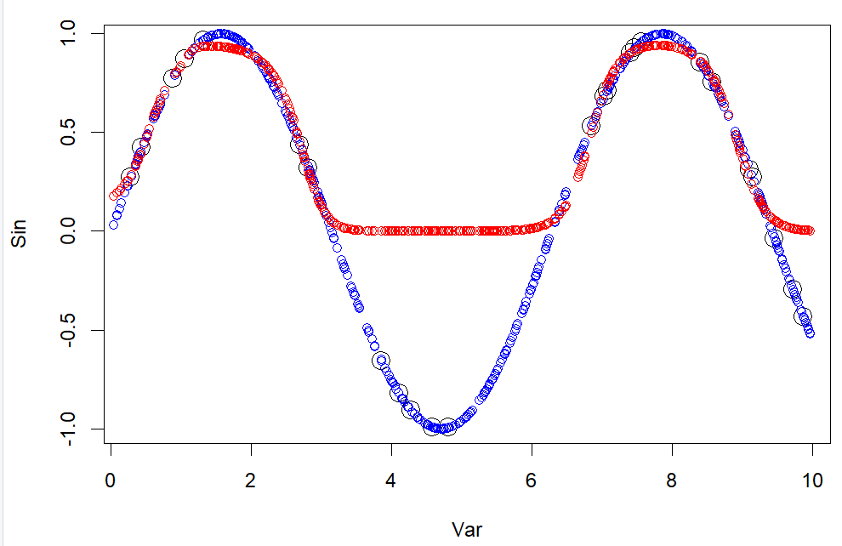
Fig.1
The black circles represent training data points. The results show that:
The red curve (the prediction result of the neural network) basically fluctuates along the main mode of the sine curve, which can simulate the periodic change of the sine function well. The fit is very good when the true sine is greater than 0, and the predicted value is identical to 0 when the true sine is less than 0. This may be because the activation function here is "logistic", the output range of this function is (0,1), and it cannot output negative values.
This phenomenon usually indicates that the neural network has not fully learned all the patterns of the input data, possibly due to the small amount of training data or the type of activation function.

Task2
Repeat question (1) with the following custom activation functions: h1(x) = x, h2(x) = max{0, x} and h3(x) = ln(1 + exp x) (a.k.a. linear, ReLU and softplus). We get the following results: when using softplus as the activation function, the part of the curve above the X-axis fits better. Of course, this is because the output value of the activation function is always greater than 0. When linear and relu are used as activation functions, the predicted value is almost constant.
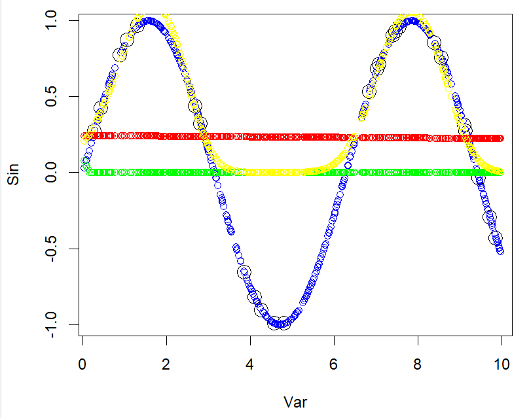
Fig.2
Task3
After using the NN learned in question (1) to predict the sine function value for 500 new points, we get the following results:
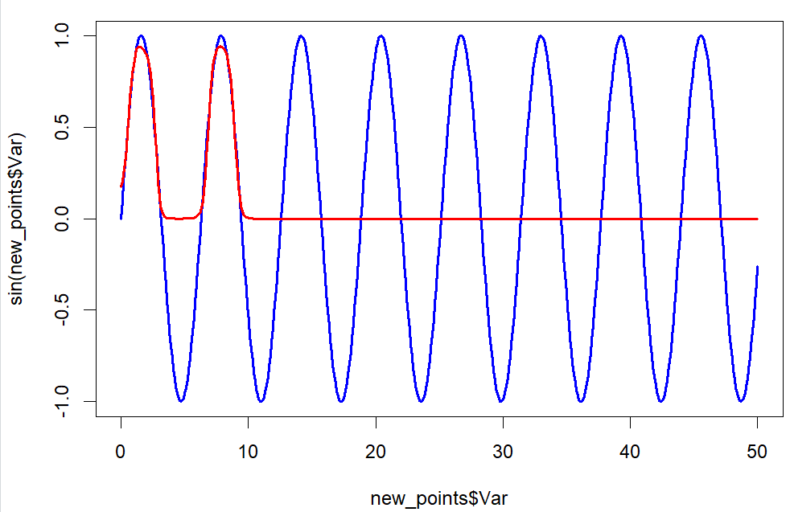
Fig.3
The figure shows that in the range of 0-10, the model can well predict the part of the true value greater than 0. However, since the learning range of the model is 0-10, and the activation function cannot output a value less than 0, the predicted value is identical to 0 for variables greater than 10.

Task4
As mentioned in question 3. For inputs outside the training range, the network does not have access to additional information to adjust the weights, so the weights may not be sufficient to support subsequent fits. In addition, the output range of the activation function is limited, so the actual predicted value will tend to be a constant value for the true value outside the output range. So in the end, the predictions seem to converge to some value.

Task5
Learn the mapping of x from the target value sinx. Since this mapping is not one-to-one, the effect will be poor. The result is as follows:
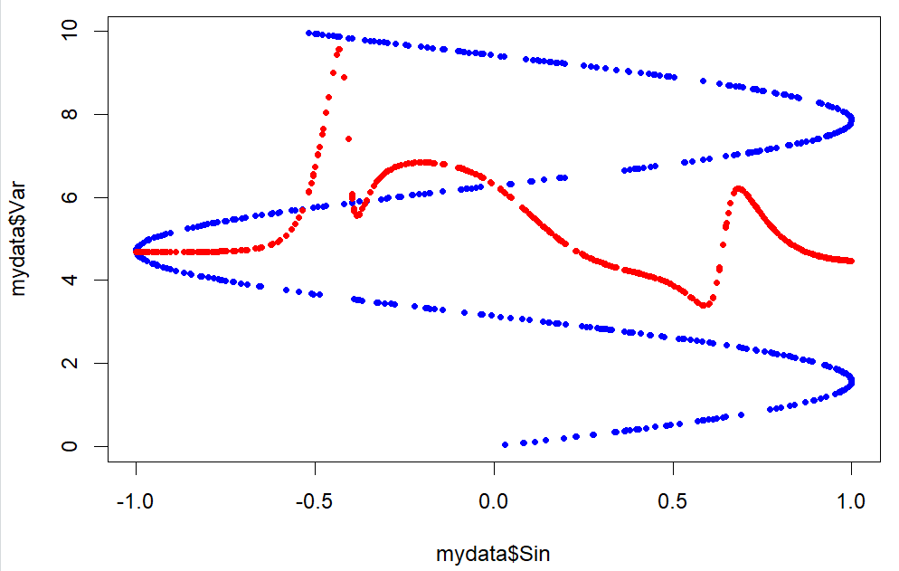
Fig.4

