Assignment3
- Which filter do you return to the user ? filter0, filter1, filter2 or filter3? Why?
The filter returned to the user is filter2. This is because both filter2 and filter3 utilize more data for training, potentially leading to better model performance. However, the test set should remain entirely independent to ensure reliable evaluation.Therefore, filter2 is more suitable than filter3. As for other filters:
Filter0 created using the training set (tr) and tuned with the validation set (va) to determine the optimal C. It has low data utilization and does not make full use of validation set (va) data to train the model.Moreover, validation set is used for parameter adjustment and validation, and can not be directly used to evaluate the generalization ability of the final model.
filter1 also uses only the tr for training, the va for tuning only, and then directly on the test set (te) for performance evaluation. Insufficient amount of training data may result in poor model performance, which is inconsistent with the performance in real applications.
- What is the estimate of the generalization error of the filter returned to the user? err0, err1, err2 or err3? Why?
The estimate of the generalization error for the filter returned to the user is err2. Because it applies the optimal parameters found by the verification set to the test set, the calculated error is an evaluation of the model's performance. As for other errors:
err0: The error rate on the validation set, used for tuning C. The ability to generalize cannot be assessed
err1: The error rate on the test set for a model trained only on the training set. Training uses less data and may be underfitted.
err3: The error rate on the test set for a model trained on the entire dataset (spam). That could turn out to be too optimistic
- Implementation of SVM predictions
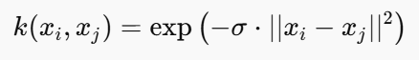
We used the RBF to calculate k2:

sv<-alphaindex(filter3)[[1]]
co<-coef(filter3)[[1]]
inte<- - b(filter3)
k<-NULL
for(i in 1:10){ # We produce predictions for just the first 10 points in the dataset.
k2<-NULL
for(j in 1:length(sv)){
k2<- c(k2, exp(-0.05 * sum((as.numeric(spam[i, -58]) - as.numeric(spam[sv[j], -58]))^2)))
}
k<-c(k, sum(co * k2) + inte)
}
k
predict(filter3,spam[1:10,-58], type = "decision")

The result is as follows:
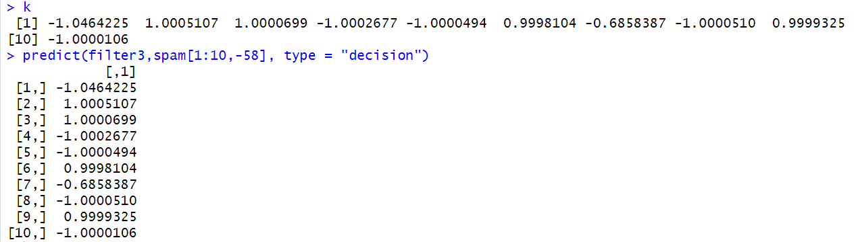
The results are the same as the output of the function prediction.

Assignment4
Task1
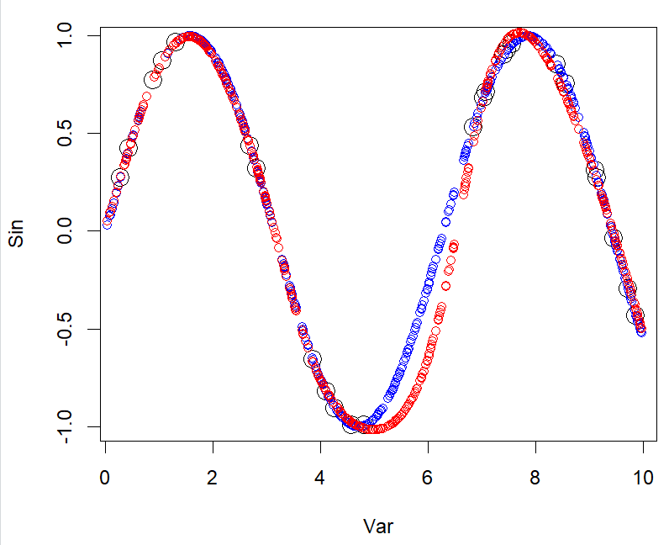
Fig.1
The black circles represent training data points. The results show that:
The red curve (the prediction result of the neural network) basically fluctuates along the main mode of the sine curve, which can simulate the periodic change of the sine function well. The fit is very good although there are some minor errors.
This phenomenon usually indicates that the neural network has not fully learned all the patterns of the input data, possibly due to the small amount of training data or the type of activation function.

Task2
Repeat question (1) with the following custom activation functions: h1(x) = x, h2(x) = max{0, x} and h3(x) = ln(1 + exp x) (a.k.a. linear(red line), ReLU (green line) and softplus (yellow line)). We get the following results: when using softplus as the activation function, the curve fits better. When linear and relu are used as activation functions, the error is more obvious.
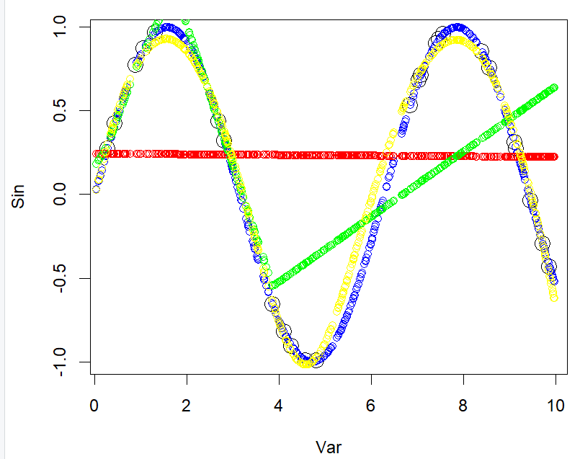
Fig.2
Task3
After using the NN learned in question (1) to predict the sine function value for 500 new points, we get the following results:
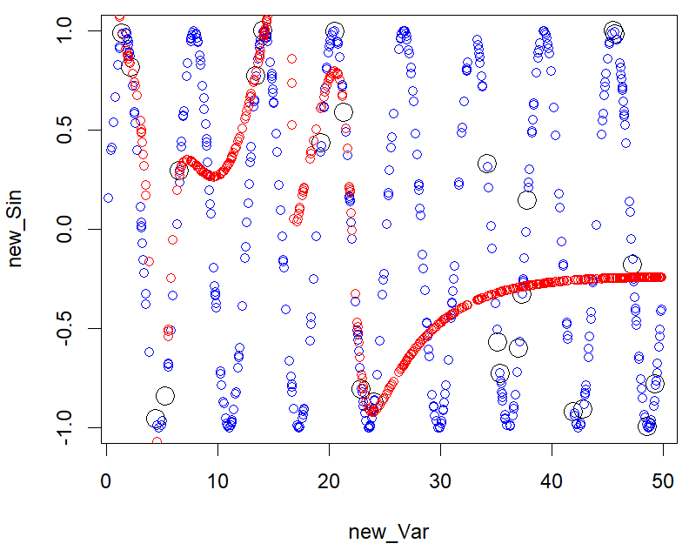
Fig.3
The figure shows that in the range of 0-10, the model can predict the trend generally since the learning range of the model is 0-10. However, for larger ranges, the accuracy of the forecast trend gradually declines, and eventually tends to converge to a certain constant.

Task4
We extracted the weights from the input layer to the hidden layer and the hidden layer to the output layer:
Through the data, we found that some weights are particularly large and some weights are relatively small, such as -217.70885 and -0.2059661. After passing through the sigmoid function, their values are mapped in the finite range of [0,1].
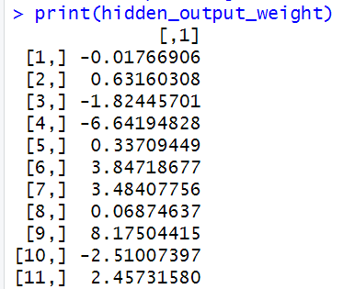
However, the fluctuation range of the weight data from the hidden layer to the output layer is relatively small, and basically around 0. This means that small weight fluctuations cannot effectively reflect nonlinear combinations. Therefore, the results will show a tendency to approximate convergence.

Task5
Learn the mapping of x from the target value sinx. Since this mapping is not one-to-one, the effect will be poor. The result is as follows:
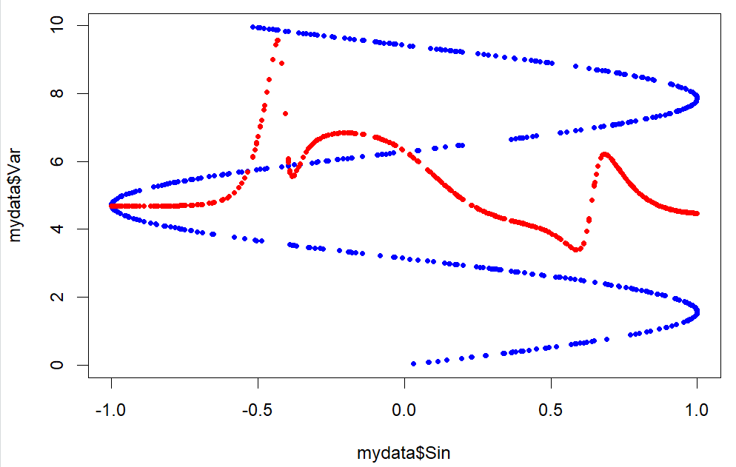
Fig.4

