Assignment 3
Task1 . Scale all variables except of ViolentCrimesPerPop and implement PCA by using function eigen(). Report how many components are needed to obtain at least 95% of variance in the data. What is the proportion of variation explained by each of the first two principal components?

We used preProcess() function to scale the data and then used eigen() to implement PCA after computed the covariance matrix. Finally, by calculating the cumulative proportion, we get: the number of components are needed to obtain at least 95% of variance is 35. The proportions of variance explained by PC1 and PC2 are 0.2501699 and 0.1693597,respectively.

Task2. Repeat PCA analysis by using princomp() function and make the trace plot of the first principle component. Do many features have a notable contribution to this component? Report which 5 features contribute mostly (by the absolute value) to the first principle component. Comment whether these features have anything in common and whether they may have a logical
relationship to the crime level. Also provide a plot of the PC scores in the coordinates (PC1, PC2) in which the color of the points is given by ViolentCrimesPerPop. Analyse this plot (hint: use ggplot2 package ).

There are many features have contribution to PC1. Ranked by contribution values, the top 5 contributing features in PC1 are: "medFamInc""medIncome""PctKids2Par""pctWInvInc" and "PctPopUnderPov". These characteristics have a common theme, namely economic stress. Most of the features are related to household income plus the percentage of children living with both parents. These factors are logically related to crime levels, as elevated financial pressures force individuals to engage in illegal activities. Areas with limited economic opportunities and higher population densities tend to experience higher rates of criminal activity.
The trace plot of PC1 is like:
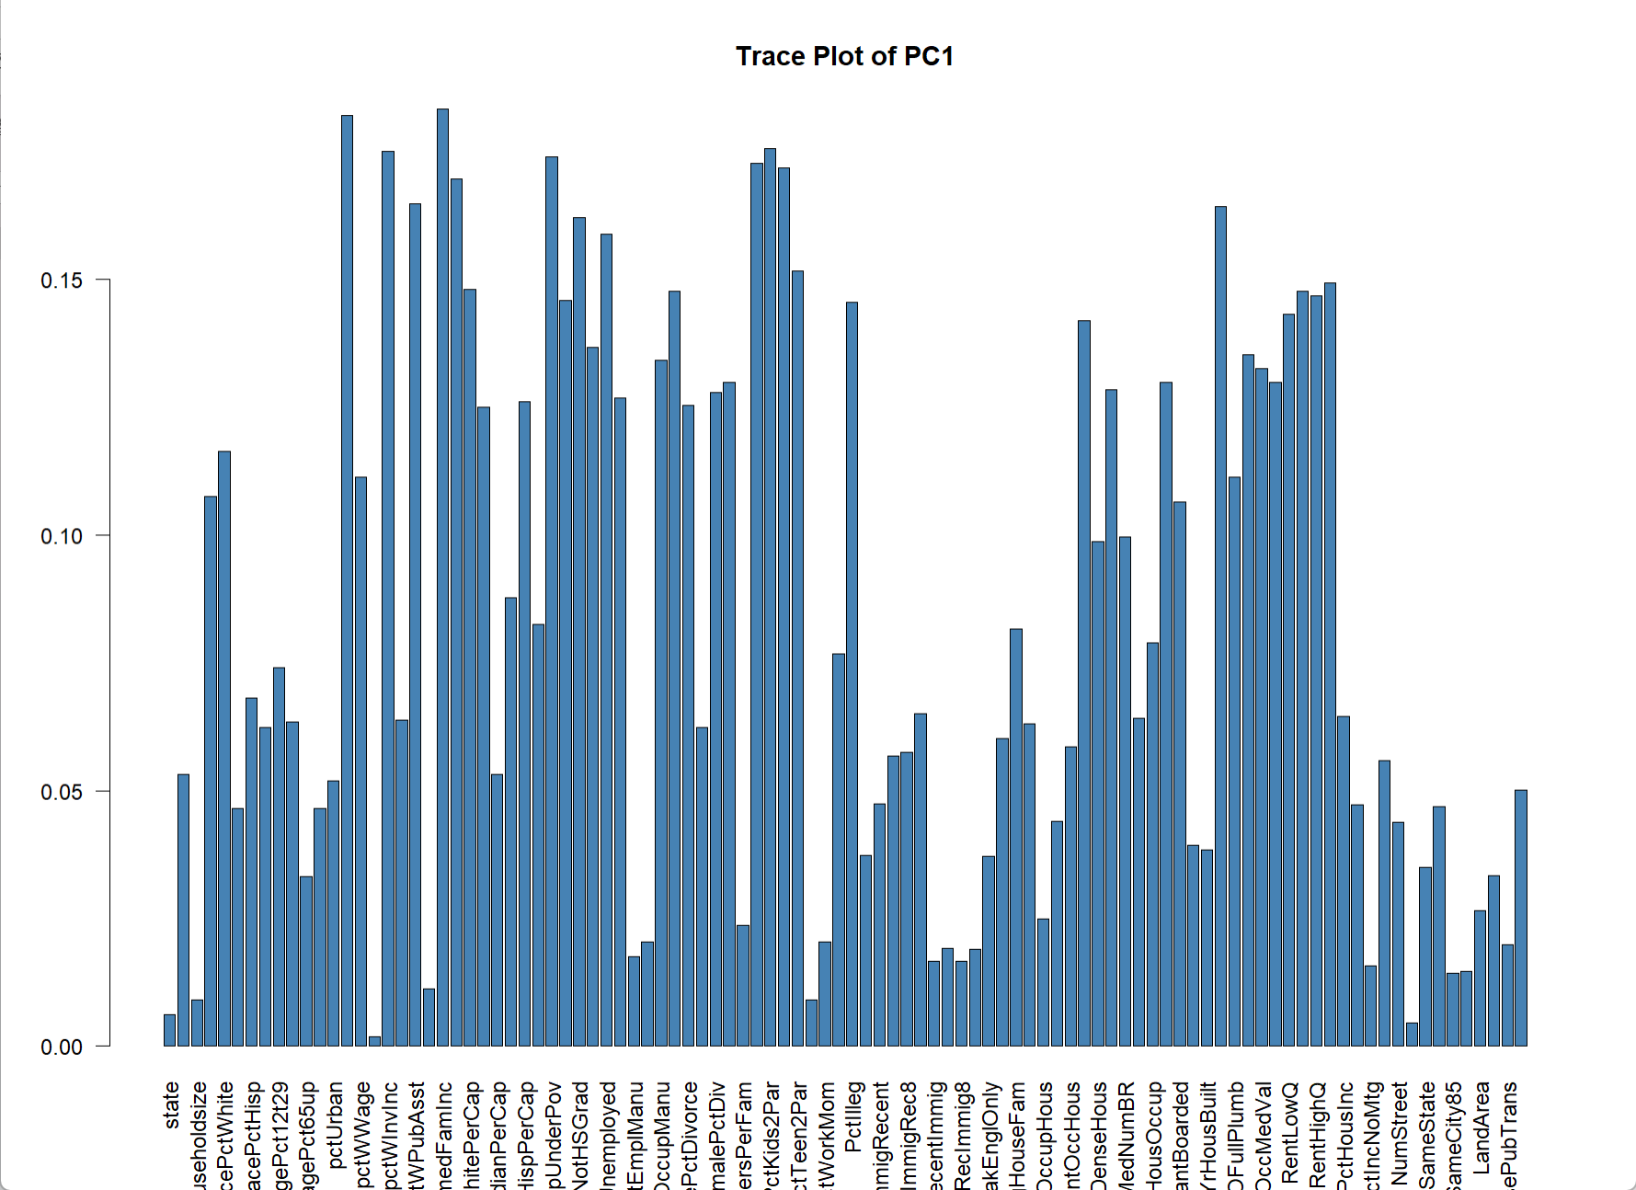
Fig.1 The trace plot of PC1
Scatter plots for PC1 and PC2:
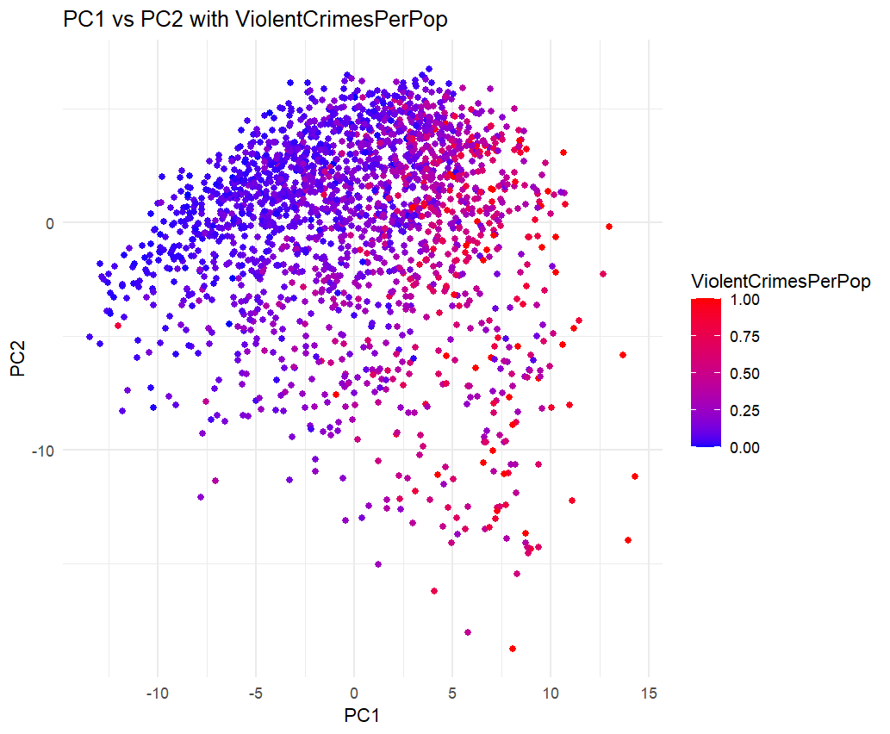
Fig.2 Scatter plot for PC1 and PC2

- In this figure, the horizontal axis (PC1) has a wide range, from about -10 to 15, and along the direction of PC1, the color change is more obvious, and the larger the PC1 (moving to the right), the higher the corresponding crime rate (red) seems to be, indicating that the key features of the data points are mainly reflected in PC1.
- PC2 ranges from approximately -10 to 10, indicating that data points have a certain distribution on PC2. However, compared with PC1, the color gradient does not change significantly in the PC2 direction. This suggests that the effect of PC2 is weaker, but still present.
- Red dots (high crime rates) are mostly found in the upper right and lower right corners (where PC1 is high). This suggests that areas with high crime rates may have certain characteristics in common, which are seized upon by PC1.
- The color of the dots is gradual from blue to red, indicating that the ViolentCrimesPerPop is continuously varying, with no significant faulting or grouping.

Task3. Split the original data into training and test (50/50) and scale both features and response appropriately, and estimate a linear regression model from training data in which ViolentCrimesPerPop is target and all other data columns are features. Compute training and test errors for these data and comment on the quality of model.

As result, the MSE for training data is 0.2752071,and the MSE for test data is 0.4248011. The current model has a small error on the training data. When generalized to the test data, the test error (0.424) is higher than the training error (0.275), but the gap is not large, and it can be optimized.

Task4. Implement a function that depends on parameter vector theta and represents the cost function for linear regression without intercept on the training data set. Afterwards, use BFGS method (optim() function without gradient specified) to optimize this cost with starting point theta⁰ = 0 and compute training and test errors for every iteration number. Present a plot showing dependence of both errors on the iteration number and comment which iteration number is optimal according to the early stopping criterion. Compute the training and test error in the optimal model, compare them with results in step 3 and make conclusions.

We defined the cost function:

cost_function <- function(theta, X, y) {
predictions <- X %*% theta
mse <- mean((y - predictions)^2)
return(mse)
}
We Optimized the cost function using BFGS and the error for each iteration is recorded.
The plot , discard initial iterations is like:
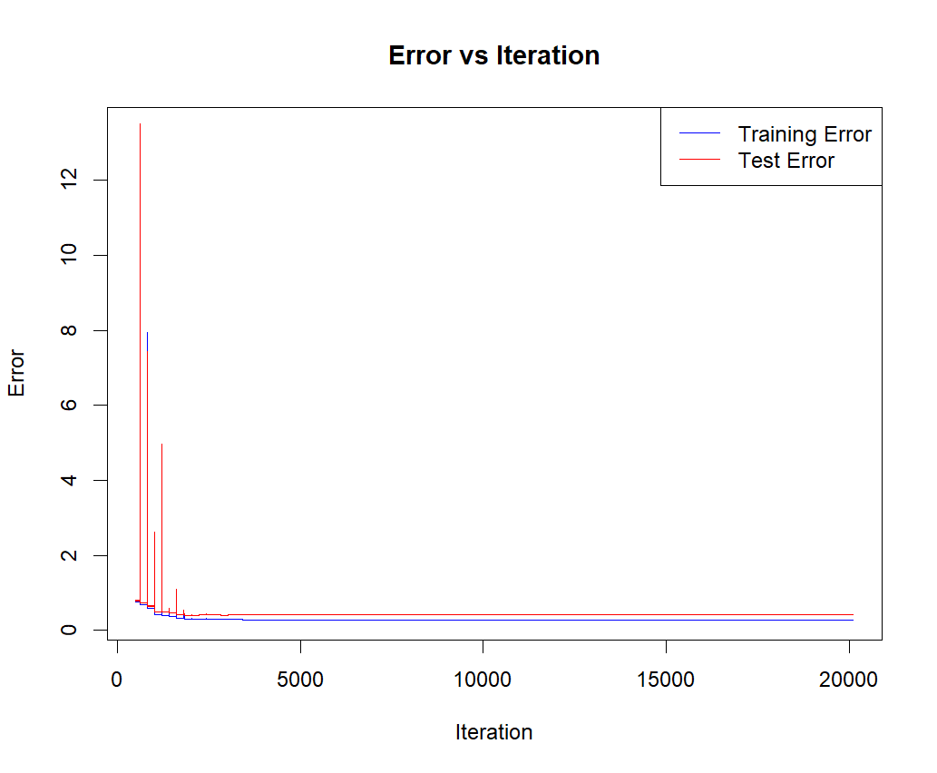
Fig.3 Error plot
The optimal iteration is 2182, and training MSE at optimal iteration is 0.3032999, test MSE at optimal iteration is 0.4002329. The optimization results show that compared with task3, the error of the training set is larger and the error of the test set (MSE) is smaller. This may be because the BFGS algorithm may make large parameter adjustments to the training data in order to avoid overfitting or updating the algorithm parameters increased the complexity of the model . While the error of the training set increased, the test error decreased significantly and stabilized at relatively low levels. This means that the generalization ability of the model is improved.

Assignment 4
• What are the practical approaches for reducing the expected new data error, according to the book?
The expected new data error can be made smaller by a smarter choice of loss function.Examples of when this is the case include gradient boosting (Chapter 7) and support vector machines.(P65)

• What important aspect should be considered when selecting minibatches,
according to the book?
-When using mini-batches it is important to ensure that the different mini-batches are balanced and representative for the whole dataset. Skewed or biased minibatches can lead to poor convergence or suboptimal training outcomes. The selection process should balance computational efficiency with maintaining variability in the data.(P125)

• Provide an example of modifications in a loss function and in data that can be done to take into account the data imbalance, according to the book.
-we can formulate the loss function based on the predicted class probability 𝑔(x) or some other continuous quantity used to compute the class prediction.For a binary classifier that predicts conditional class probabilities 𝑝(𝑦 = 1 | x) in terms of a function 𝑔(x), the cross-entropy loss is a natural choice:
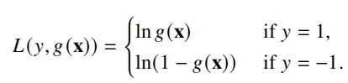
Besides, We can define loss functions for binary classification in another way in terms of the margin, by assigning a small loss to positive margins (correct classifications) and a large loss to negative margins (misclassifications). We can, for instance, re-formulate the logistic loss in terms of the margin as:(P99-100)
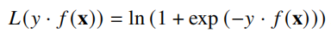
A similar effect can also be achieved by, for this example, simply duplicating all positive training data points times in the training data, instead of modifying the loss function. That is to say oversampling the minority class or undersampling the majority class can create a more balanced dataset.

