Gan Wan Cheng Isaac

Reflection

Looking back at my experience building the task manager, I have learn much about the processes taking place in the frontend and backend which has always been a black box to be. I had little software development experience prior to this and this project has taught me about basic concepts in web development such as HTTP requests, the DOM manipulation, creating and querying APIs and events handling. Initially, I spent a good part of my time reading and learning about concepts in rails, using the default rails Model View Controller (MVC) model to dictate data flow and handle user requests and actions to achieve a CRUD functionality for tasks. However, after using the webpacker for react and setting up the API controller, I realized that the API controller would be able to handle requests for me and I only have to define the relational model of the database for the API controller.

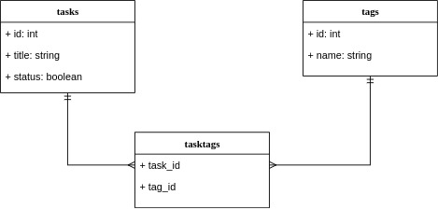

The bulk of the logic for the application built React and I learn much about different state management strategies such as prop passing, and context thought I did not use the latter as components needing the parent state are not nested that deeply. I was also introduced to the noti on of reusable components where React’s composition model can be used to specialize components for different use cases. This makes the web application to be very versatile and scalable. I also made mistakes and encountered difficulties along the way such as writing the client side code without carefully considering how the JSON returned from the API will look like and needing to rewrite some front end code.

To sum, I think my code can be vastly improved when looking back at it and should have included some form of user input validation and also some testing could be done for the different components which I did not have much time to get to. Finally, I am glad we live in a time where different UI libraries exists and don’t have to explicitly handle much of the styling. Thanks MaterialUI!

User manual

Feature: Create Task
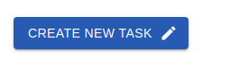
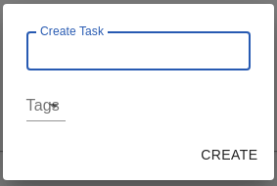
- Click on the Create New Task button to toggle dialog box
- When Dialog box opens, enter the task title in the text field and then select the relevant tags and then click ‘CREATE’ to create task

Feature: Check Task
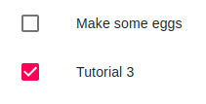
- Click the checkbox of the taskitem to ‘mark’ the task, this would cause the task to move to the bottom of the tasklist

Feature: Show Tags

- Click on the tags icon to see the tags associated with the task item

Feature: Edit Task

- Click on the edit icon to toggle the edit dialog box
- When Dialog box opens, you can update the task item and the tags and the can click the ‘EDIT’ to edit the task.

Feature: Delete Task
- Click on the Delete icon to delete the taskitem

Feature: Search Task by Tag
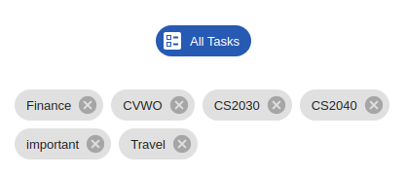
Click on a particular tag to search for tasks associated with the tag
- Click on the All Tasks chip to show all the tasks in the taskslist

Feature: Create Tag
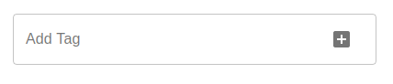
- Enter the tag name in the text field of the sidebar and then click on the + button to add the tag to the taglist

Feature: Delete Tag
- Click on the delete icon of the tag chip to delete the tag

