**Flight booking system using c :-**

**This Project provides a basic flight booking system where users can register, log in, view available flights, book flights, and view their booked flights. The booking process includes entering passenger details, which are then displayed when viewing booked flights. Error handling is added to ensure the program does not crash on invalid inputs or conditions.**

### **Testing the Functions:**

**\*\*.Compile and Run the Program:**  
gcc flight_booking_system.c -o flight_booking_system

./flight_booking_system

1. **Register a User:**
   * Choose option 1 from the main menu.
   * Enter the user details.
2. **Login:**
   * Choose option 2 from the main menu.
   * Enter the user ID and password.
3. **User Menu Options:**
   * View flights: Choose option 1.
   * Book a flight: Choose option 2 (ensure flights are already available in flights.txt).
   * View booked flights: Choose option 3.
   * Logout: Choose option 4.

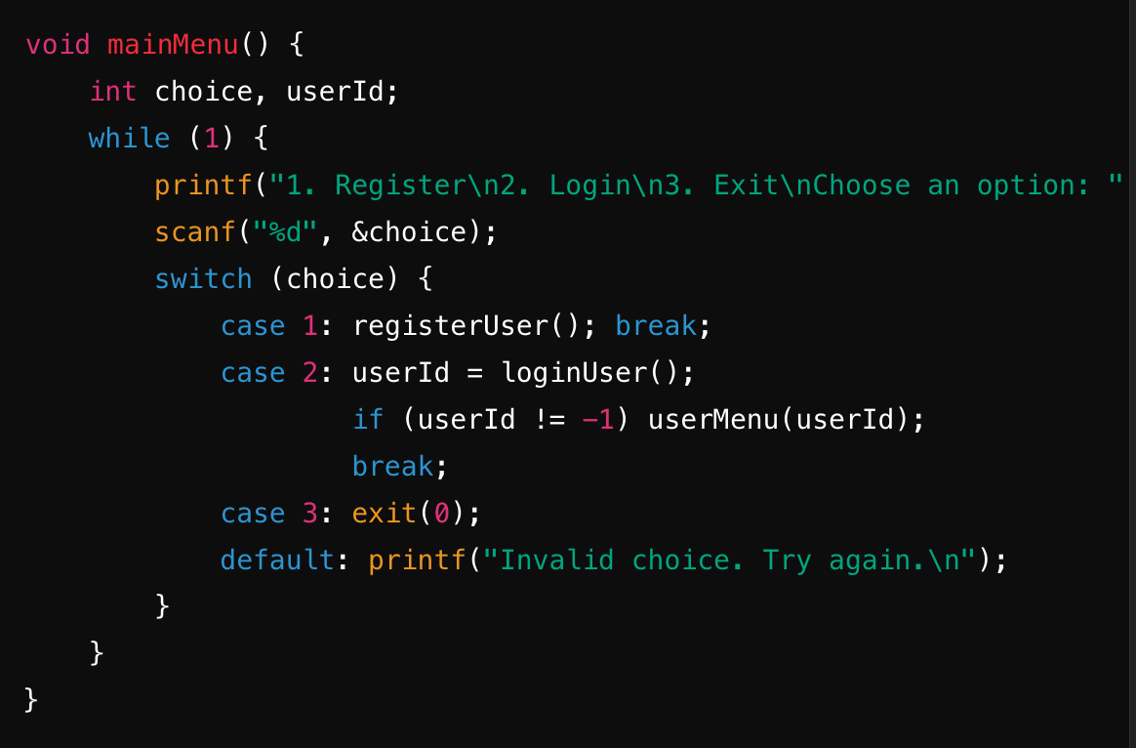

**Purpose:** Displays the main menu and handles user input.

**Functionality:**

* Presents options to register, login, or exit.
* Calls the corresponding functions based on the user's choice.
* If the user logs in successfully, it calls userMenu() with the logged-in user's ID.

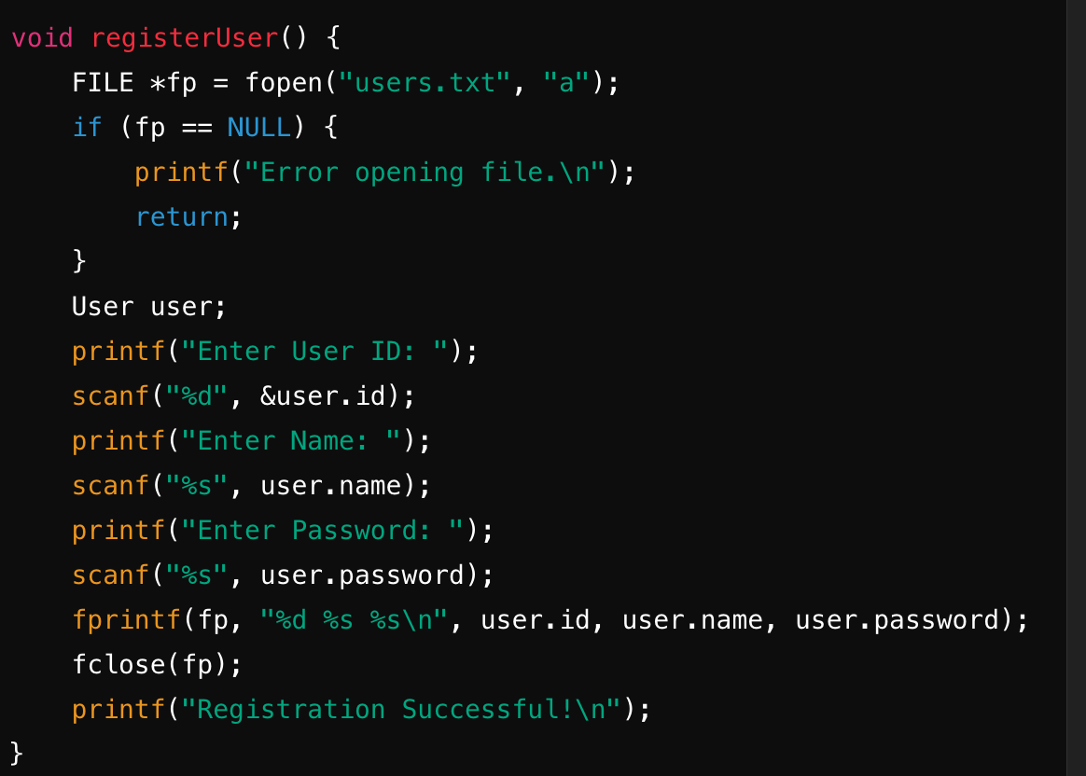

* **Purpose:** Registers a new user.
* **Functionality:**
  + Prompts the user to enter a user ID, name, and password.
  + Stores this information in the users.txt file.

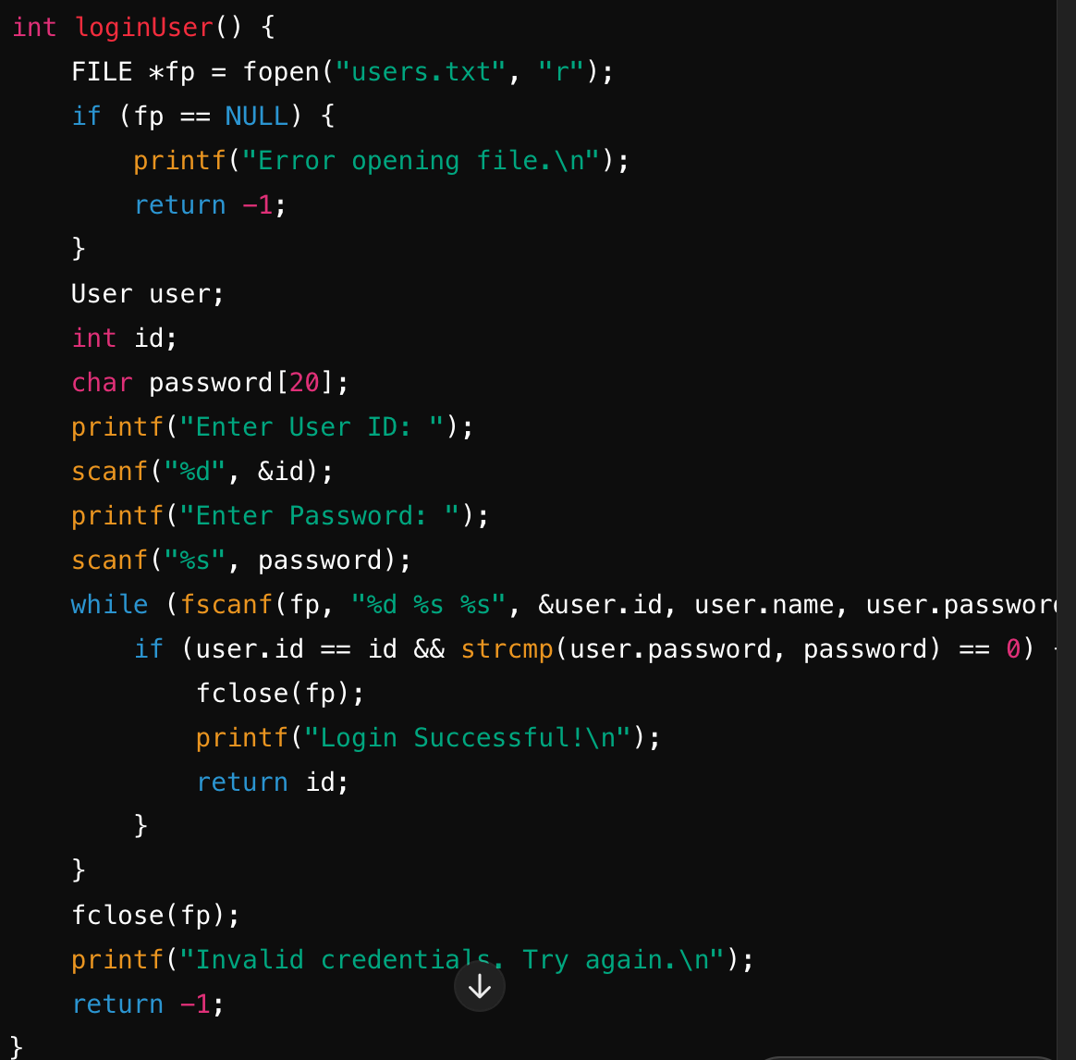

**Purpose:** Logs in an existing user.

* **Functionality:**
  + Prompts the user to enter their user ID and password.
  + Checks the credentials against those stored in users.txt.
  + If the credentials match, returns the user ID; otherwise, returns -1.
  + 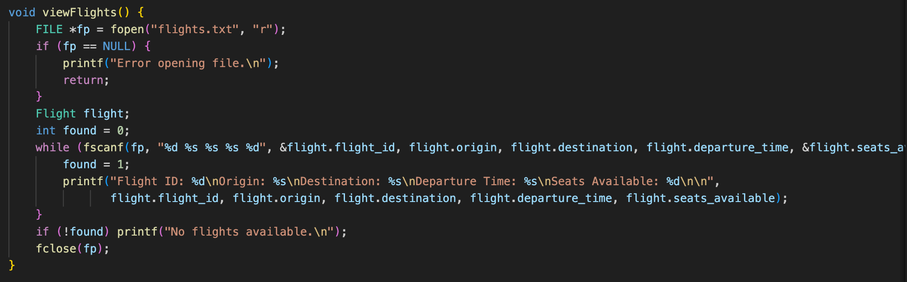

**Purpose:** Displays available flights.

**Functionality:**

* Reads flight information from flights.txt.
* Displays each flight's ID, origin, destination, departure time, and available seats.
* If no flights are available, displays a message.

“”bookFlight()””

**Functionality:**

* Prompts the user to enter the flight ID and the number of seats to book.
* If the flight is found and enough seats are available, the user is prompted to enter details for each passenger.
* Updates the flight's available seats and records the booking in bookings.txt.

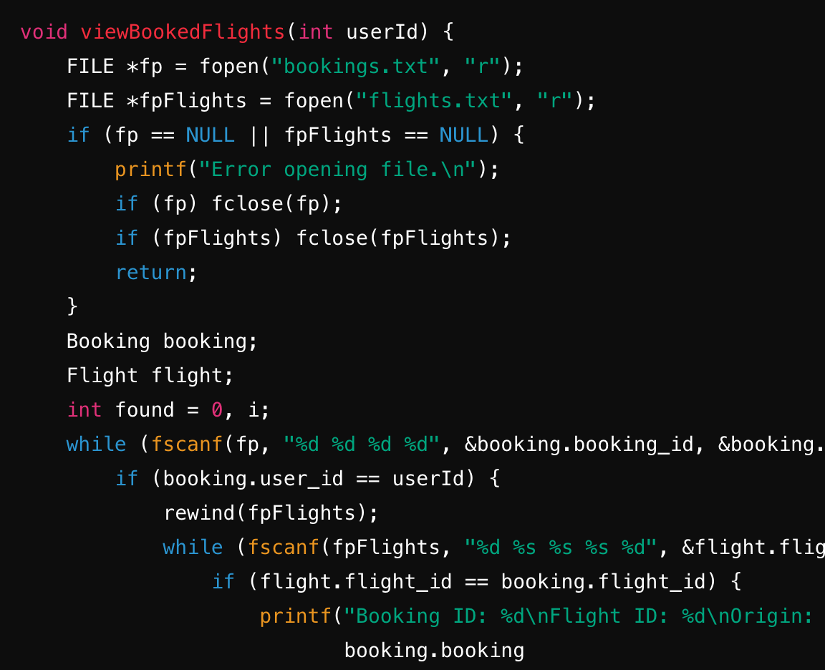



**Functionality:**

* Reads booking information from bookings.txt.
* Displays flight details and passenger information for each booking made by the user, If no bookings are found, displays a message.