[](http://www.opencores.org/)

LPFFIR  
FPGA Characterization

*Author: Vladimir Armstrong*

*vladimirarmstrong@opencores.org*

**Rev. 1.0**

**March 25, 2019**

*This page has been intentionally left blank.*

**Revision History**

| **Rev.** | **Date** | **Author** | **Description** |
| --- | --- | --- | --- |
| 1.0 | 03/25/19 | Vladimir Armstrong | First Draft |
|  |  |  |  |
|  |  |  |  |
|  |  |  |  |
|  |  |  |  |
|  |  |  |  |
|  |  |  |  |

**Contents**

Introduction 1

Measurement Equipment 2

Expected Behavior 3

Expected Magnitude Response Equation 3

Expected Phase Response Equation 3

Measurement Results 5

Measurement Analysis 6

Appendix A 7

Magnitude Response Script Requirements 7

Phase Response Script Requirements 7

Appendix B 8

ADC Key Features 8

DAC Key Features 8

Index 9

Introduction

The LPFFIR [1] FPGA implementation Device Under Test (DUT) is characterized by magnitude and phase response. The magnitude and phase measurement results [4] is obtained by running scripts [Appendix A] on measurement equipment setup [2]. The magnitude and phase measurement results analysis [5] is done by comparing expected behavior [3] versus measurement results [4].

## 

Measurement Equipment

The Measurement Equipment consist of PC, Mixed Signal Oscilloscope [5], FPGA prototyping board [2] , ADC [3] and DAC [4] peripheral modules. The Waveform Generator is connected to ADC peripheral module and Oscilloscope channel 1 (CH1). The Oscilloscope channel 2 (CH2) is connected to DAC peripheral module as shown below.



Figure Measurement equipment block diagram

## 

Expected Behavior

### Expected Magnitude Response Equation

$$\left|H\left(z=e^{iω}\right)\right|=2\left|cos\frac{5}{2}ω+cos\frac{3}{2}ω+ cos\frac{1}{2}ω)\right|$$

### Expected Phase Response Equation

$$∡ H\left(z=e^{iω}\right)=-\frac{5}{2}ω$$

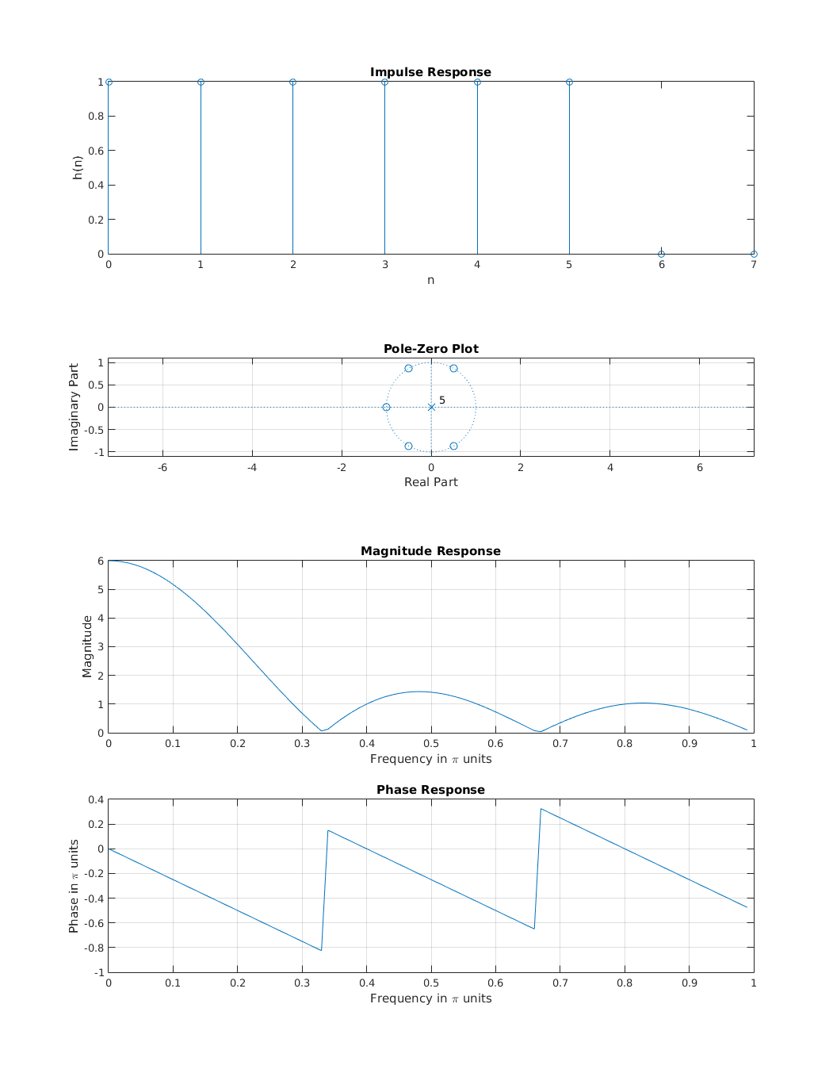

Figure Expected magnitude and phase response plots

## 

Measurement Results

TBD

## 

Measurement Analysis

TBD



Measurement Scripts

The Measurement Scripts consist of SCPI [7] with Python wrapper [6] and is used to controlling the measurement equipment [2] to generate a magnitude and phase response of LPFFIR FPGA implementation.

### Magnitude Response Script Requirements

1. The script shall control the Waveform Generator to output a 1 V amplitude sinusoidal signal in 1 Hz to 25 MHz frequency range with 1 Hz frequency increment step.
2. The script shall control Oscilloscope to sample the output of DAC.
3. The script shall generate a magnitude response array by comparing the amplitude of sinusoidal signal from Waveform Generator with DAC output.

### Phase Response Script Requirements

1. The script shall control the Waveform Generator to output a 1 V amplitude sinusoidal signal in 1 Hz to 25 MHz frequency range with 1 Hz frequency increment step.
2. The script shall control Oscilloscope to sample the output of DAC.
3. The script shall generate a phase response array by comparing the phase of sinusoidal signal from Waveform Generator with DAC output.

Peripheral Modules

The Analog-to-Digital Converter (ADC) [3] and Digital-to-Analog Converter (DAC) [4] peripheral modules are used for LPFFIR FPGA implementation characterization. The summary of key features of ADC and DCA are listed below:

### ADC Key Features

* TBD sample period
* 12-bit analog to digital converter
* I2C interface

### DAC Key Features

* TBD sample period
* 12-bit analog to digital converter
* SPI interface

2. LPFFIR IP Core Specification: <https://opencores.org/projects/lpffir>
3. FPGA prototyping board: <https://reference.digilentinc.com/reference/programmable-logic/basys-3/reference-manual>
4. ADC peripheral module: <https://reference.digilentinc.com/reference/pmod/pmodad2/reference-manual>
5. DAC peripheral module: <https://reference.digilentinc.com/reference/pmod/pmodda4/reference-manual>
6. Mixed Signal Oscilloscope: <https://www.rigolna.com/products/digital-oscilloscopes/mso5000>
7. Python wrapper: <https://pypi.org/project/scpi>
8. Standard Commands for Programmable Instruments (SCPI): <https://en.wikipedia.org/wiki/Standard_Commands_for_Programmable_Instruments>