4 Experiments
We evaluate CE-RAG on scientific paper question answering, focusing on answerability judgment, evidence grounding, and abstention under insufficient evidence. The experiments compare CE-RAG with retrieval-based baselines and examine whether claim-evidence reasoning chains, evidence sufficiency estimation, and answer verification improve reliable paper understanding.

4.1 Dataset and Setup
The evaluation uses a pilot dataset of 53 computer science papers and 318 question-answer pairs. Each paper is associated with six questions covering method, evidence, result, contribution, limitation/critical analysis, and unanswerable cases. Among all questions, 253 are answerable and 65 are unanswerable. The unanswerable questions mainly test whether a system can avoid over-generalized claims, such as asserting that a method outperforms all methods, tasks, or datasets when the paper reports only limited experimental evidence.
All methods are evaluated on the same paper collection and gold answerability labels. CE-RAG represents each paper as a scholarly object graph containing sections, claims, evidence, experiments, results, and limitations, and retrieves reasoning chains from this graph before generation.
Table 1. Dataset statistics.
Item | Value
Papers | 53
QA pairs | 318
Questions per paper | 6
Question types | Method, Evidence, Result, Contribution, Critical, Unanswerable
Answerable / Unanswerable | 253 / 65
Domain | Computer science

4.2 Baselines and Metrics
We compare CE-RAG with Chunk-based RAG and Hybrid RAG. Chunk-based RAG retrieves semantically similar text chunks and generates answers from the retrieved passages. Hybrid RAG combines dense retrieval with lightweight keyword or structural matching. In contrast, CE-RAG retrieves claim-evidence-result reasoning chains, estimates evidence sufficiency, and verifies answer-evidence consistency.
The primary metric is answerability accuracy, which measures whether the system answers answerable questions and abstains from unanswerable questions. We also report average latency. For CE-RAG, we additionally report confidence, evidence sufficiency, reasoning consistency, and evidence coverage, which are produced by its verification module.
Table 2. Compared methods.
Method | Retrieval / Reasoning Strategy
Chunk-based RAG | Dense retrieval over text chunks
Hybrid RAG | Dense retrieval plus keyword or structural matching
CE-RAG | Scholarly object graph, reasoning-chain retrieval, sufficiency estimation, and verification

4.3 Main Results
Table 3 shows the main results. CE-RAG achieves the highest overall answerability accuracy among the compared methods. Although CE-RAG has higher latency because it performs graph-based retrieval, sufficiency estimation, and answer verification, the additional computation improves reliability in deciding whether a question should be answered.
Table 3. Main answerability results.
Method | Answerability Accuracy | Correct / Total | Avg. Latency
Chunk-based RAG | 0.557 | 177 / 318 | 1.18s
Hybrid RAG | 0.415 | 132 / 318 | 1.13s
CE-RAG | 0.893 | 284 / 318 | 5.51s

CE-RAG predicts 239 questions as answerable and 79 as unanswerable or insufficient. This behavior is consistent with the goal of faithful scientific QA: the system should not only answer questions when evidence is available, but also avoid unsupported answers when the paper does not provide sufficient evidence.
Table 4. CE-RAG verification diagnostics.
Metric | Value
Avg. confidence | 0.800
Avg. evidence sufficiency | 0.694
Avg. reasoning consistency | 0.659
Avg. evidence coverage | 0.727
Sufficiency labels | 218 sufficient / 21 partial / 79 insufficient

4.4 Results by Question Type
Table 5 reports answerability accuracy by question type. CE-RAG performs strongly on method, evidence, result, and contribution questions, showing that structured scholarly objects are effective for ordinary paper understanding questions. It also correctly abstains on all unanswerable questions in this dataset, indicating that evidence sufficiency estimation helps prevent unsupported universal claims.
Table 5. Answerability accuracy by question type.
Question Type | Chunk-based RAG | Hybrid RAG | CE-RAG
Method | 0.566 | 0.189 | 1.000
Evidence | 0.434 | 0.340 | 1.000
Result | 0.509 | 0.283 | 1.000
Contribution / General | 0.528 | 0.415 | 1.000
Critical / Limitation | 0.302 | 0.264 | 0.358
Unanswerable | 1.000 | 1.000 | 1.000

The critical/limitation category is the most challenging. Some limitation-seeking questions require inferring limitations from experimental scope, ablation results, or discussion sections, while CE-RAG requires explicit support before providing a full answer. This conservative behavior lowers accuracy on this category but helps avoid unsupported critical claims.

4.5 Analysis of Evidence Sufficiency
The sufficiency labels in Table 4 show that CE-RAG does not treat all retrieved contexts as equally reliable. Among 318 questions, 218 are judged sufficient, 21 partial, and 79 insufficient. The insufficient cases largely correspond to unanswerable questions or questions whose requested conclusion is broader than the available evidence. This supports the role of evidence sufficiency estimation as a reliability control mechanism for scientific paper QA.
A typical failure mode of retrieval-only systems is that topically relevant passages may still be insufficient to support the user's conclusion. CE-RAG addresses this by checking whether the retrieved claims, evidence, and results cover the scope required by the question. This is especially important for questions involving universal claims over all tasks, all datasets, or all existing methods.

4.6 Discussion
The results suggest that modeling a paper as a claim-evidence graph is useful not only for retrieving relevant content, but also for determining the boundary of what the paper actually supports. CE-RAG is particularly effective for questions that require linking claims with evidence and results, and for over-generalized unanswerable questions where flat retrieval may still provide superficially relevant but insufficient passages.
At the same time, CE-RAG is conservative for some limitation-oriented questions. Scientific papers often discuss limitations implicitly through experimental scope, ablation results, or discussion sections rather than explicit limitation statements. Future work should distinguish limitation-seeking questions from over-generalized unanswerable questions more precisely, so that the system can provide partial but useful answers when evidence is incomplete while still rejecting unsupported universal claims.

Figures
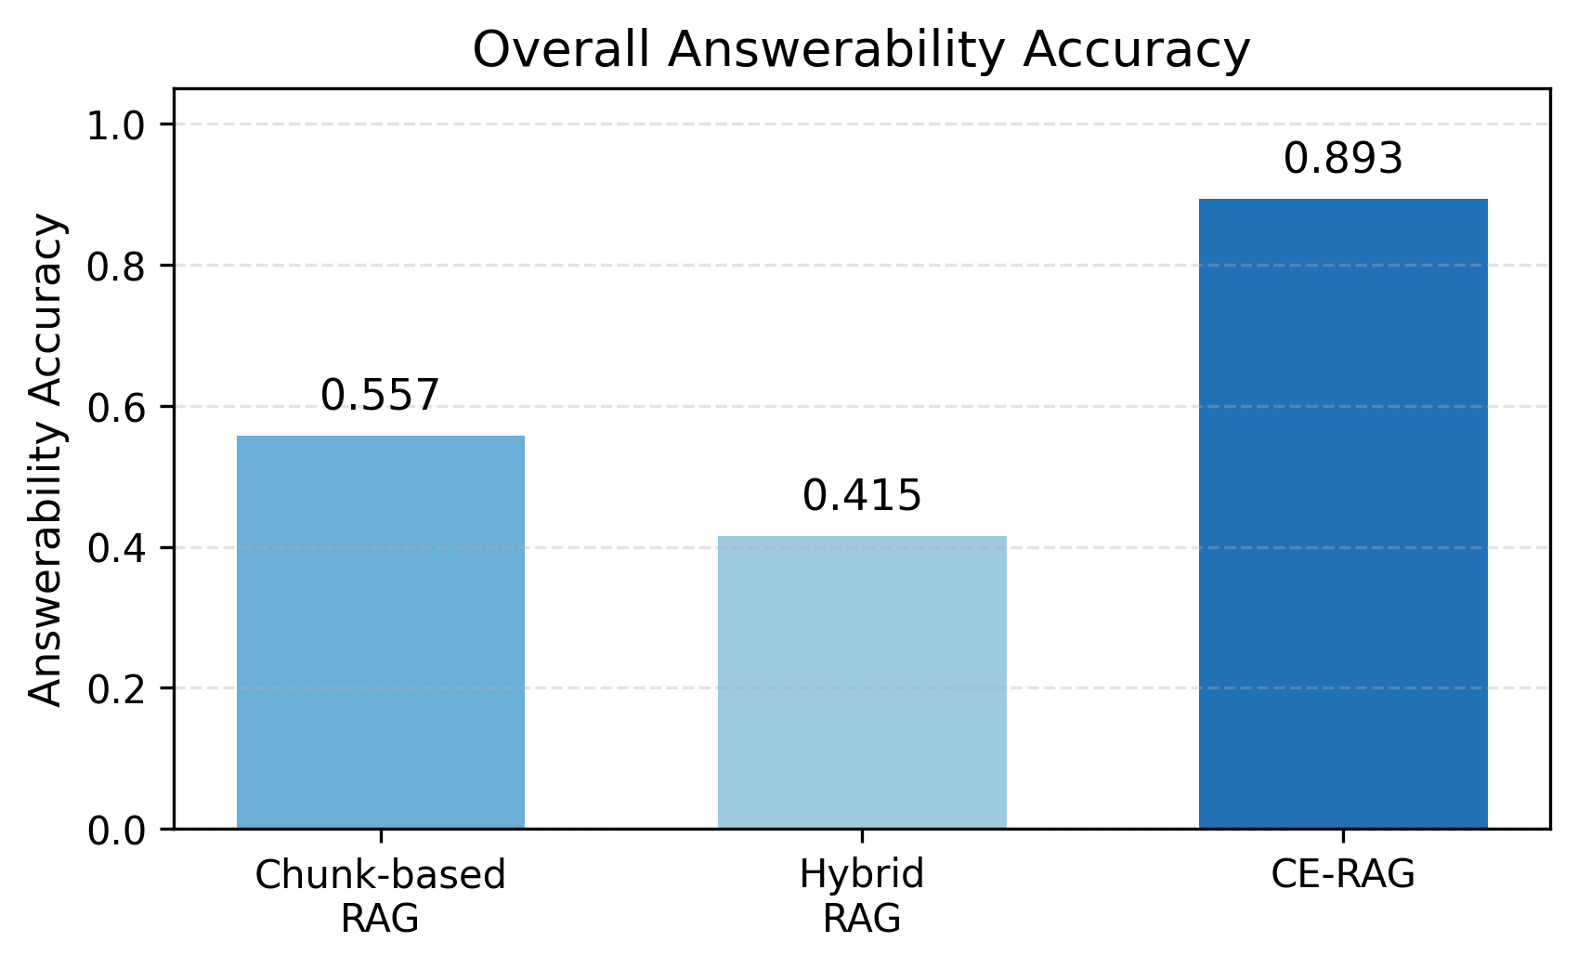
Figure 1. Overall answerability accuracy of the compared methods.
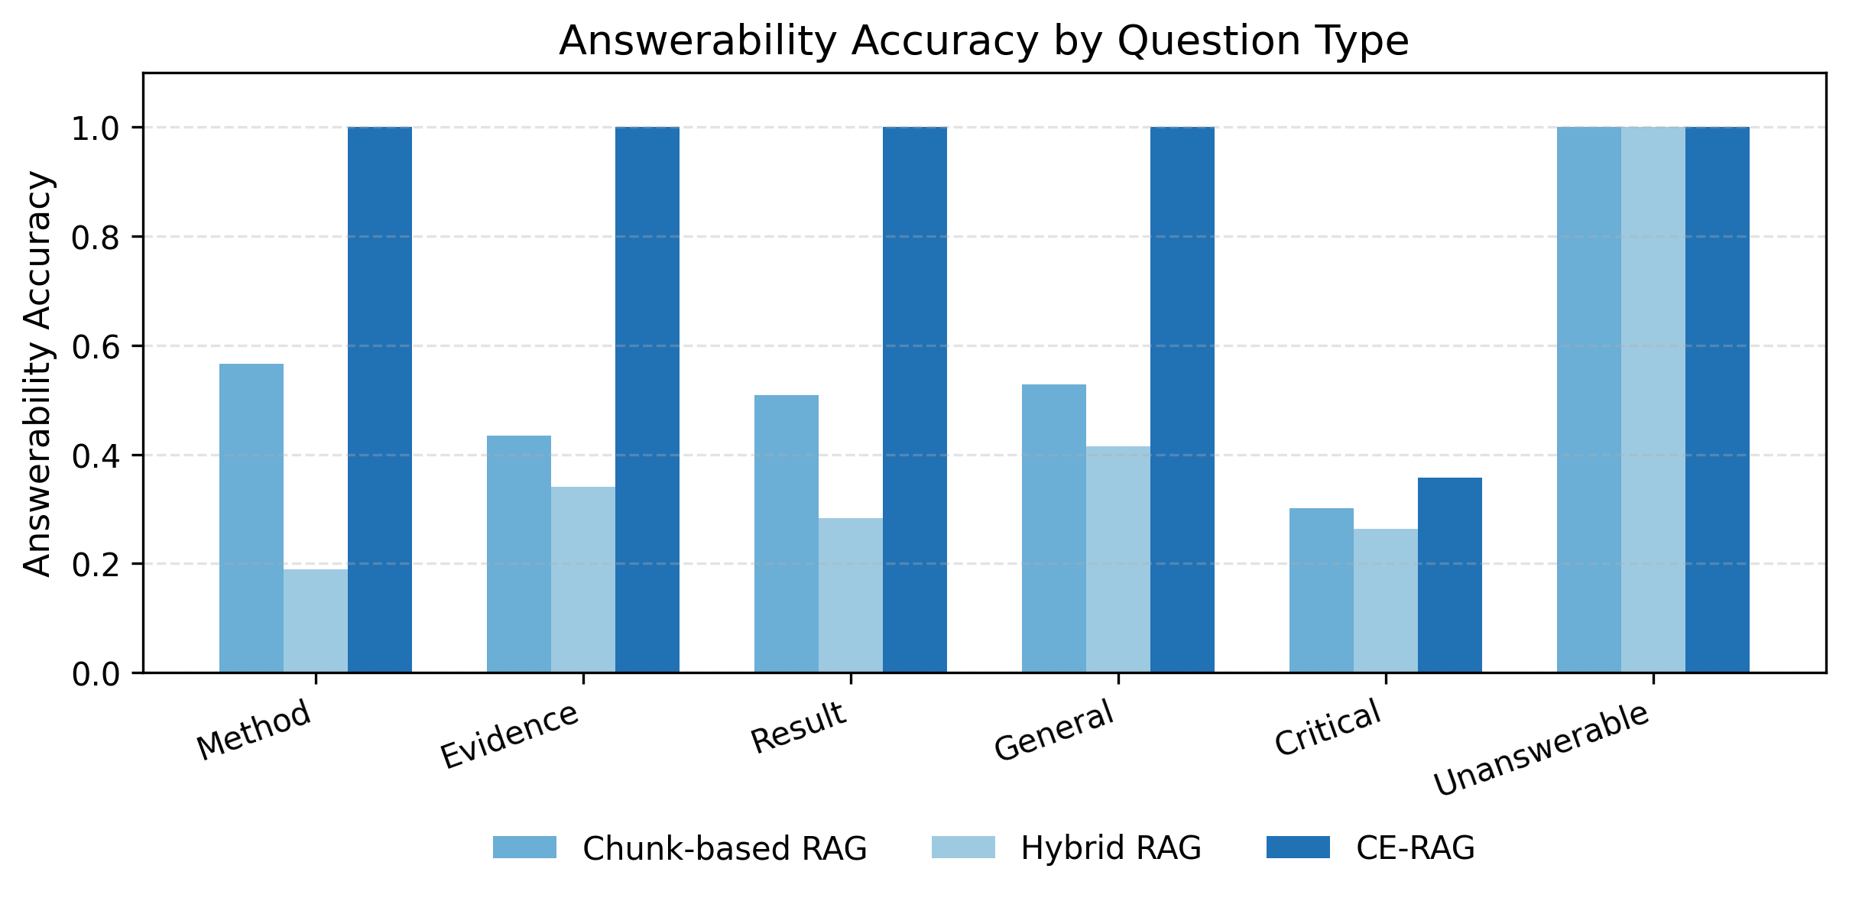
Figure 2. Answerability accuracy by question type.
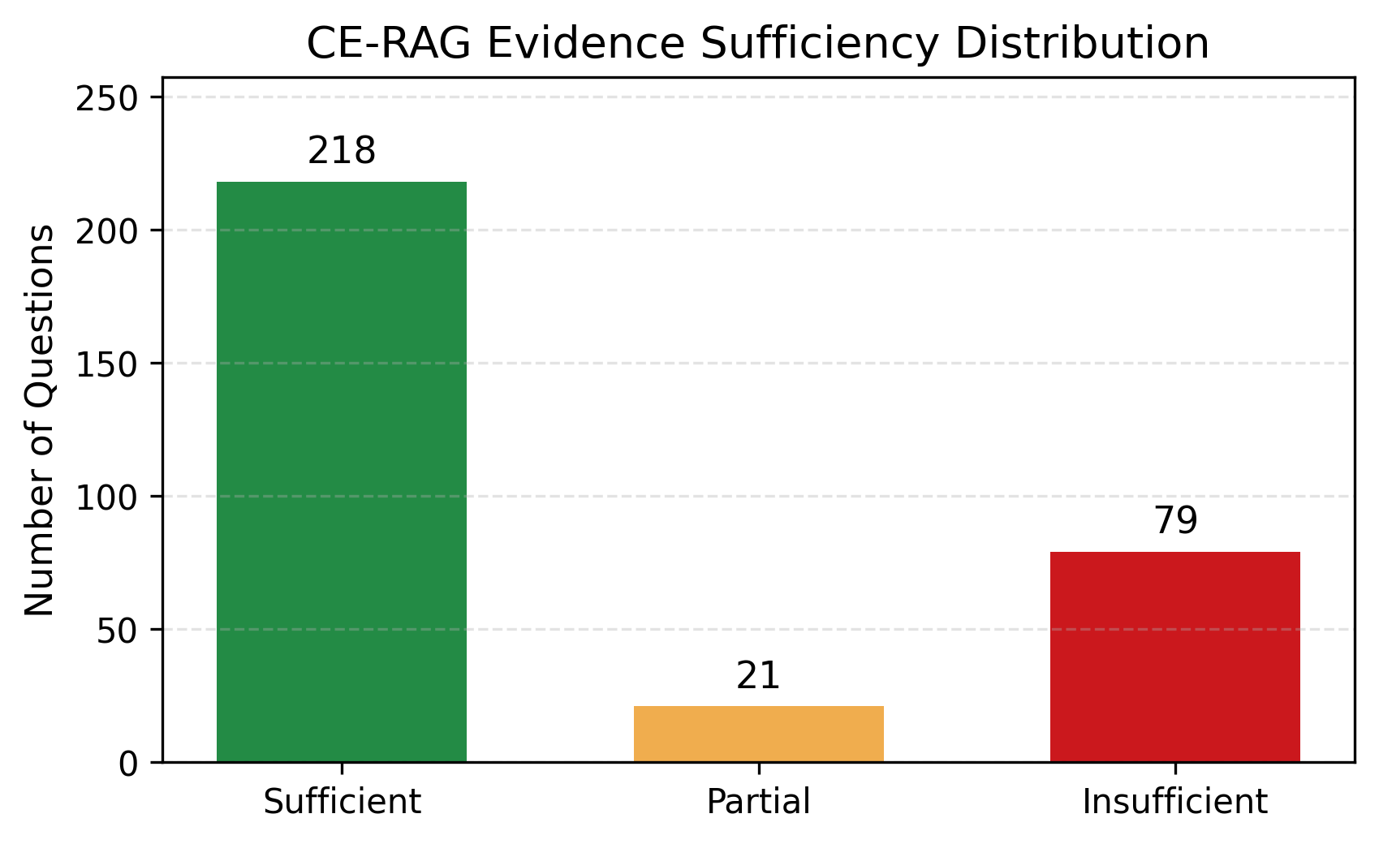
Figure 3. Distribution of CE-RAG evidence sufficiency labels.

