West Bengal Assembly Election Outcomes

Onkar Singh

2021-05-10

## Reading data

West Bengal Assembly election was one of the most keenly watched Assembly election in any Indian state. One of the reasons for this interest was unexpected rise of Bharatiya Janata Party in a state mostly known for its contests between the Left and the Trinmool Congress. The BJP had only 3 seats in the last Assembly election of 2016 whereas the ruling TMC had 212. BJP was never a major player in state expect during the last Parliamentary election where BJP bagged 18 of the 42 parliament seats. This rasied a very high hopes in the saffron camp and they put all their political might in the recently concluded West Bengal Legislative Assembly election where it was pitted against the ruling TMC led by firebrand leader Mamta Banerjee. The stakes were so high that BJP made some of its central ministers resign to contest the assembly elections to bolster party chances in the state traditionally considered home to the non-BJP political forces. This was coupled with the high decimal election campaign lead by the Prime Minister Narendra Modi, along with Home Minister Amit Shah and BJP President JP Nadda. On the other hand, Two time chief minister Mamata Banerjee led the incumbent party from the front and ran a highly successful campaingn leading to her party’s victory in the Assembly Election. This marked the beginning of the third term of the TMC government in the State.

While the BJP ran the campaign targeting 200 seats, the TMC’s poll strategist Prashant Kishor was so confident that he declared if BJP crossed the 100 seats he would leave his role as political adviser.

The opinion and exit polls were equally divided some giving edge to the ruling TMC while other giving slight edge to the BJP. However, the final results on 2nd May 2021, put all speculations to rest with TMC winning 213 of the seats, whereas BJP managed to win only 77 seats.

This paper analyzes the election results data obtained from Election Commission of India and Ashoka University.

## Total Number of Political Parties in the Fray

A total of 59 political parties took part in West Bengal assembly election 2021. Top

Total Number of Political Parties in the Election)

| party | number_of_seats_contested |
| --- | --- |
| IND | 611 |
| BJP | 291 |
| AITC | 288 |
| SUCI | 188 |
| BSP | 162 |
| CPM | 138 |
| INC | 91 |
| Bahujan Mukti Party | 45 |
| Amra Bangalee | 40 |
| RSSCMJP | 32 |
| AIFB | 21 |
| JD(U) | 16 |
| Kamatapur People’s Party (United) | 15 |
| CPI(ML)(L) | 12 |
| Purvanchal Mahapanchayat | 12 |
| CPI | 10 |
| LJP | 10 |
| RSP | 10 |
| Bharatiya Nyay-Adhikar Raksha Party | 8 |
| Justice and Development Party, | 7 |
| Party for Democratic Socialism | 7 |
| AIMIM | 6 |
| United Socialist Party | 6 |
| Bahujan Maha Party | 5 |
| Indian Unity Centre | 5 |
| Republican Party of India (A) | 5 |
| Ambedkarite Party of India | 4 |
| IUML | 4 |
| Jan Sangh Party | 4 |
| National Republic Party Of India | 4 |
| Republican Party of India (Athawale) | 4 |
| SDPI | 4 |
| Socialist Party (India) | 4 |
| Welfare Party Of India | 4 |
| Communist Party of India (Marxist-Leninist) Red Star | 3 |
| Democratic Socialist Party of India | 3 |
| HAM | 3 |
| Humanity Universal Motion Party | 3 |
| NPP | 3 |
| Akhil Bharat Hindu Mahasabha | 2 |
| All India Minorities Front | 2 |
| Bharatiya Momin Front | 2 |
| Bhartiya Tribal Party | 2 |
| Guru Chand Mukti Morcha | 2 |
| Mulnibasi Party of India | 2 |
| Right to Recall Party | 2 |
| West Bengal Socialist Party | 2 |
| AJSUP | 1 |
| Bharateeya Manavadhikar party | 1 |
| Jamat-E-Seratul Mustakim | 1 |
| Lok Samya Party | 1 |
| New Democratic Party of India | 1 |
| Paradise Party | 1 |
| Progressive People's Party | 1 |
| Rashtravadi Janata Party | 1 |
| Revolutionary Socialist Party of India(Marxist) | 1 |
| Sajag Samaj Party | 1 |
| Samajwadi Jan Parishad | 1 |
| Vikas India Party | 1 |

10 Parties with number of seats contested

## Top Political parties by number of seats contested

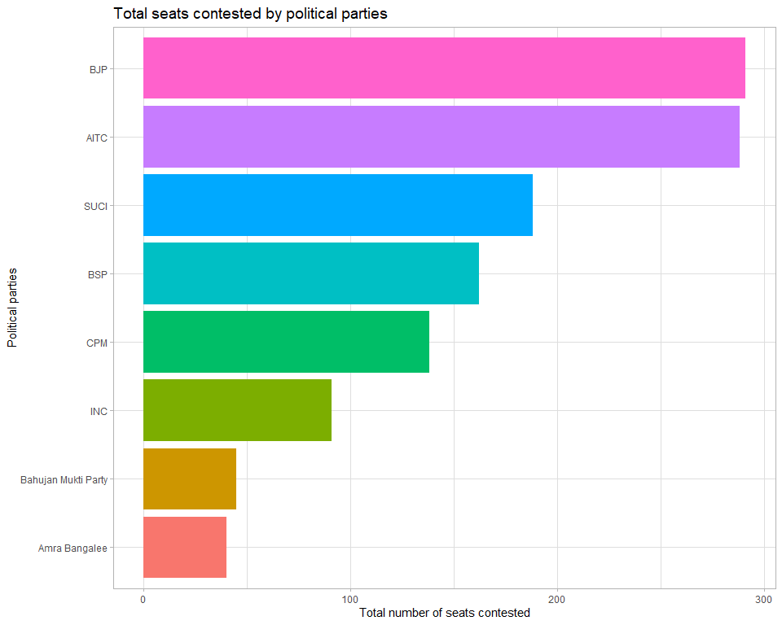

## Total number of turncoats fielded by each political party

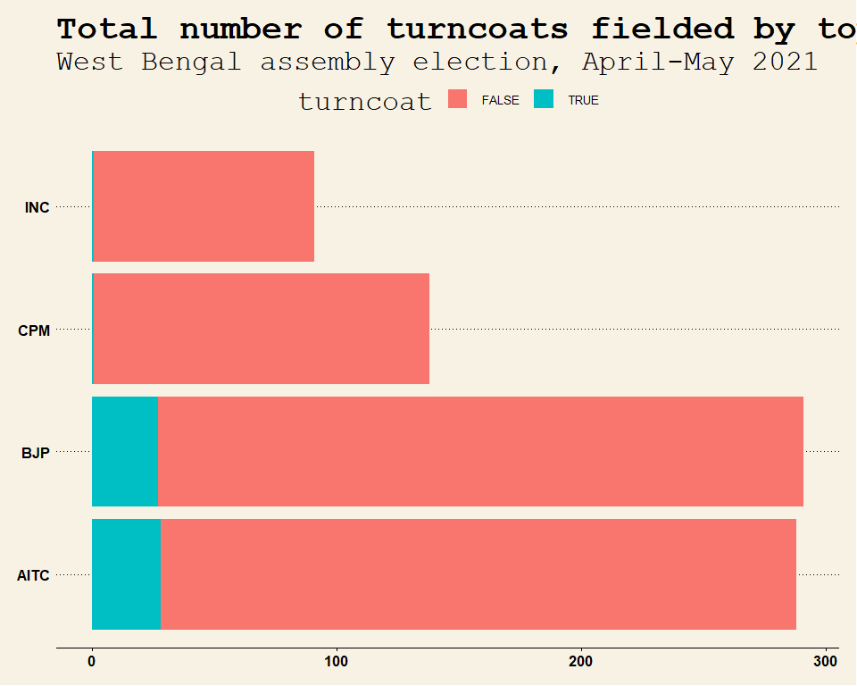

## Total number of repeat political party

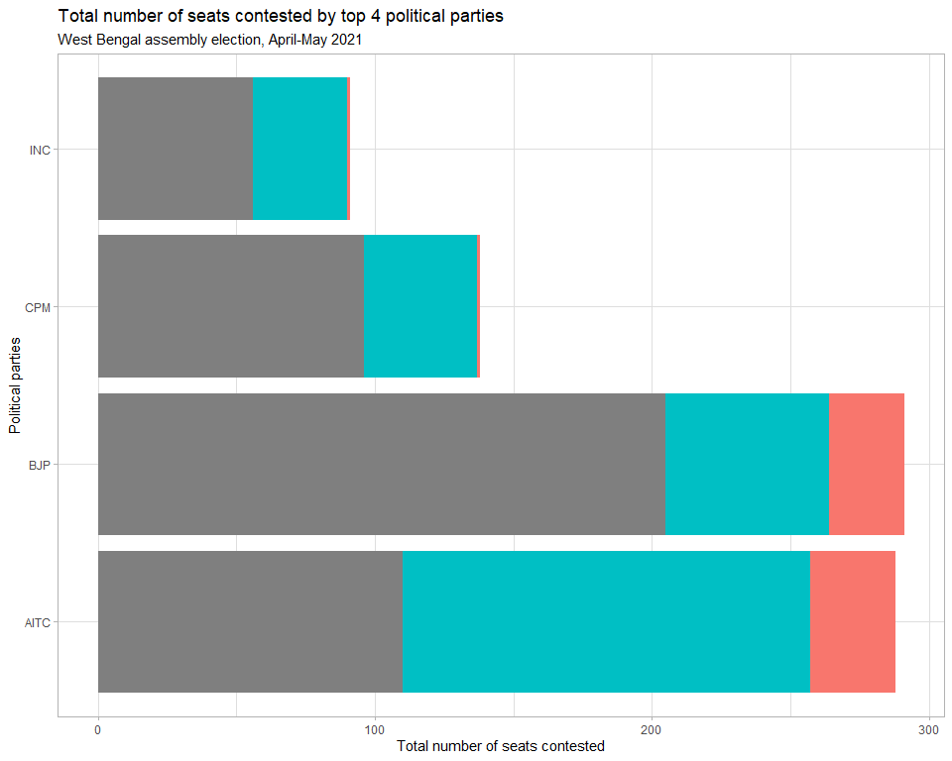

## Total number of repeat constituency by candiates

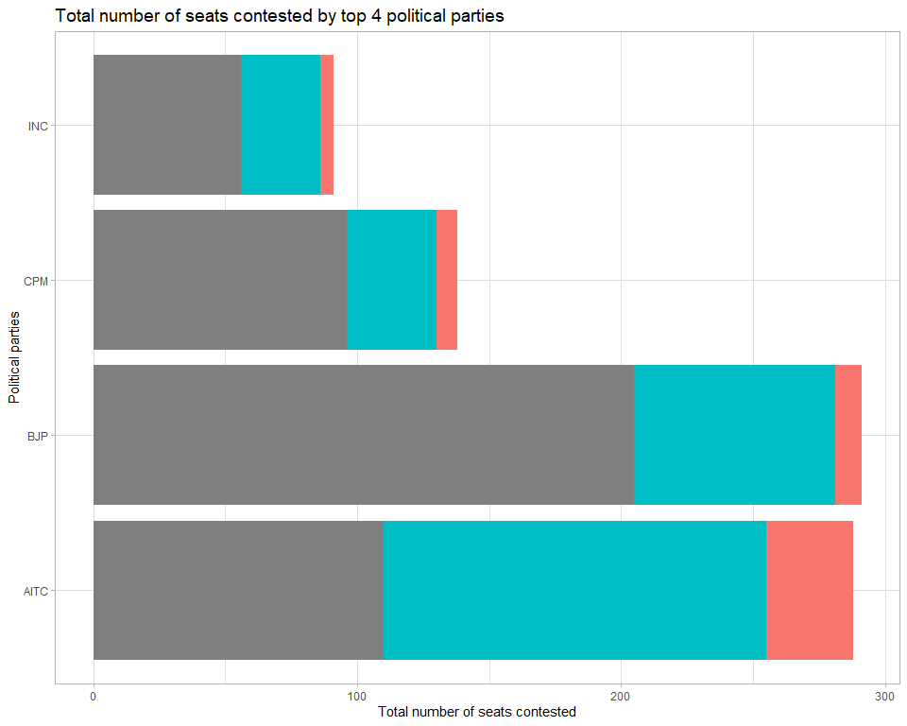

## Total number of repeat candidates

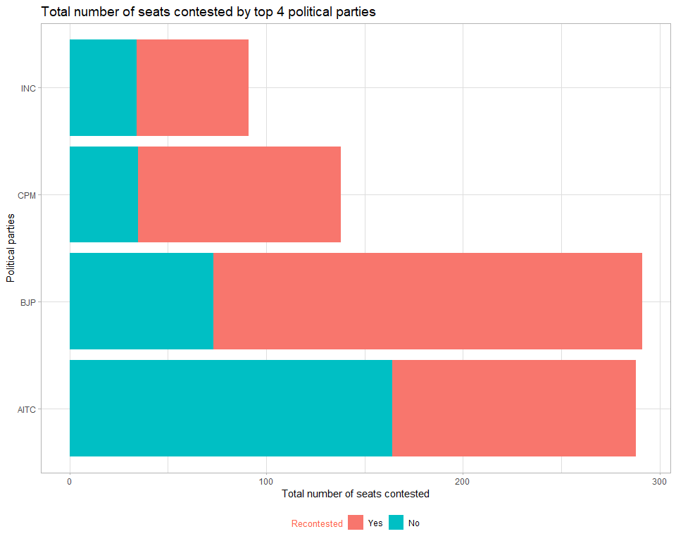

## Total number of incumbents

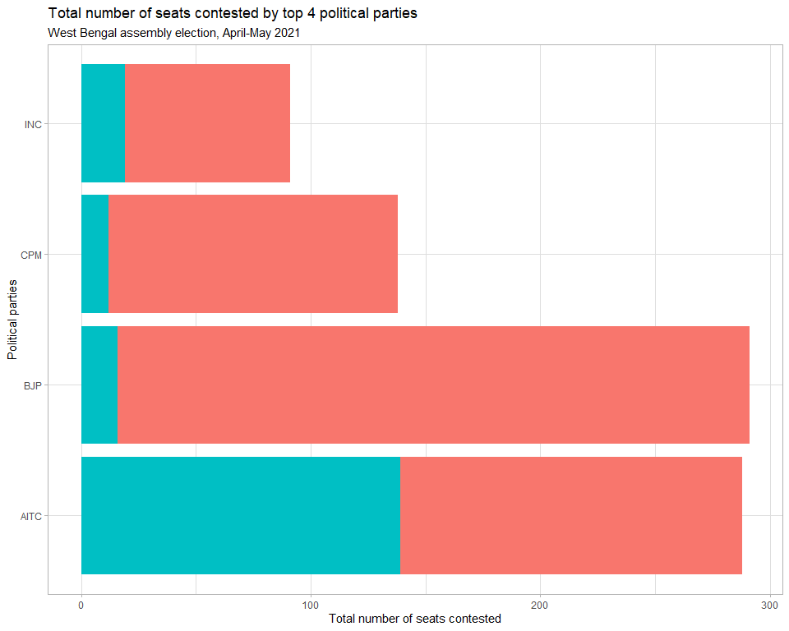

## Total number of Votes secured by major political party

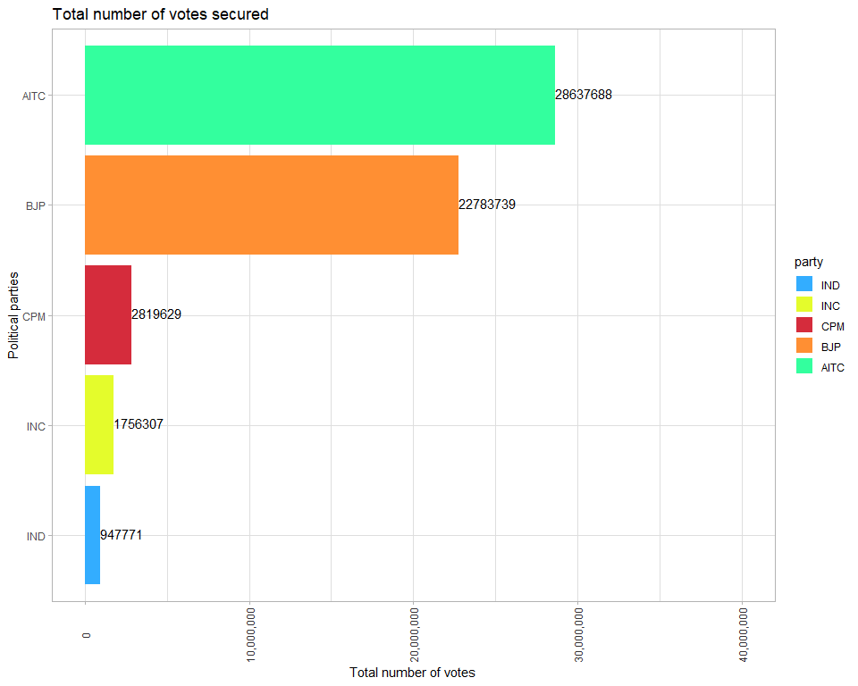

While the ruling party TMC bagged 2.86 crore or 28.6 million votes, BJP got 2.27 corores or 22.7 million votes. CPM bagged 28 lakhs or 2.8 million votes, while Congress could manage to over 17 lakha or 1.7 million votes.

## Total percentage of Votes secured by each political party

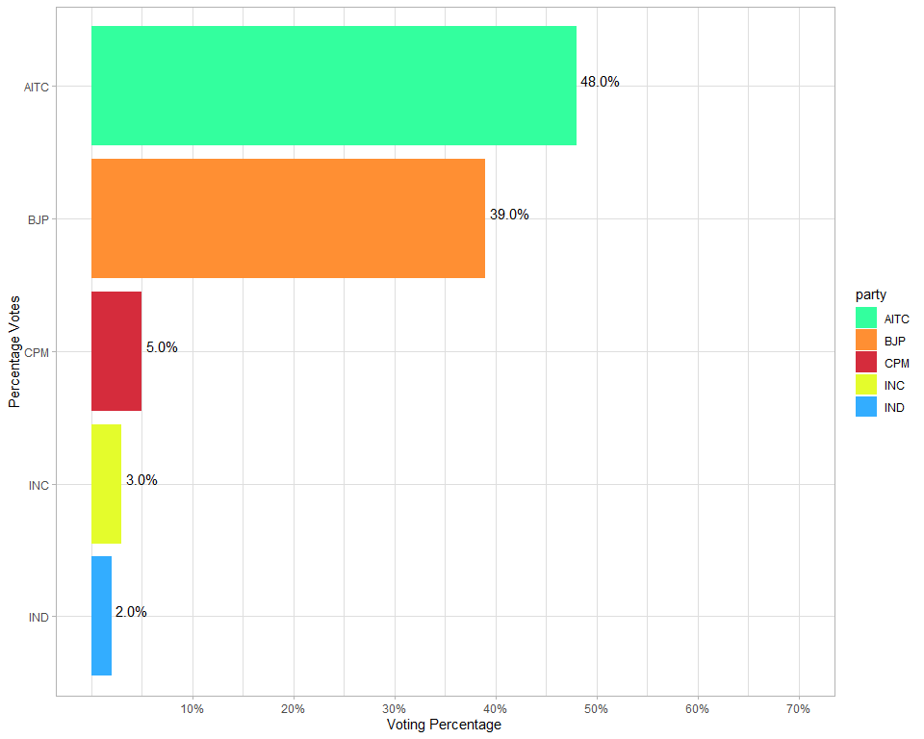

The TMC emerged victorious with 38% of the total popular votes while the opposition BJP got 39% of the popular votes. CPM managed to win 5% followed by Congress and Independents with 3% and 2 % of the popular votes. This shows that contest was highly polarized and bipolar in nature between the incumbent Trinmool Congress and the challenger Bhartiya Janata Party.

## Total number of seats secured by each political party

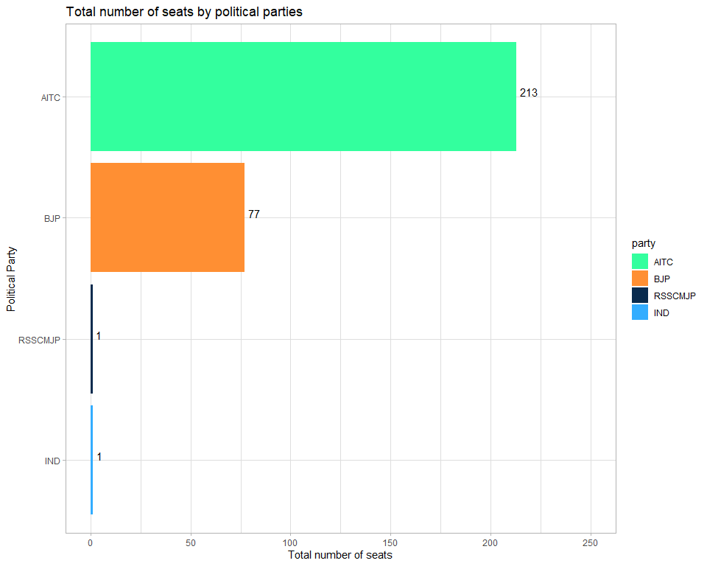

TMC won 213 (73% of total seats) seats bettering even its 2016 tallies whereas the BJP came to distant second with 77 (26%) seats even though raising its stock significantly in the West Bengal Assembly from its 2016 tally of a meager 3.

## Total number of seats secured by each political party by region

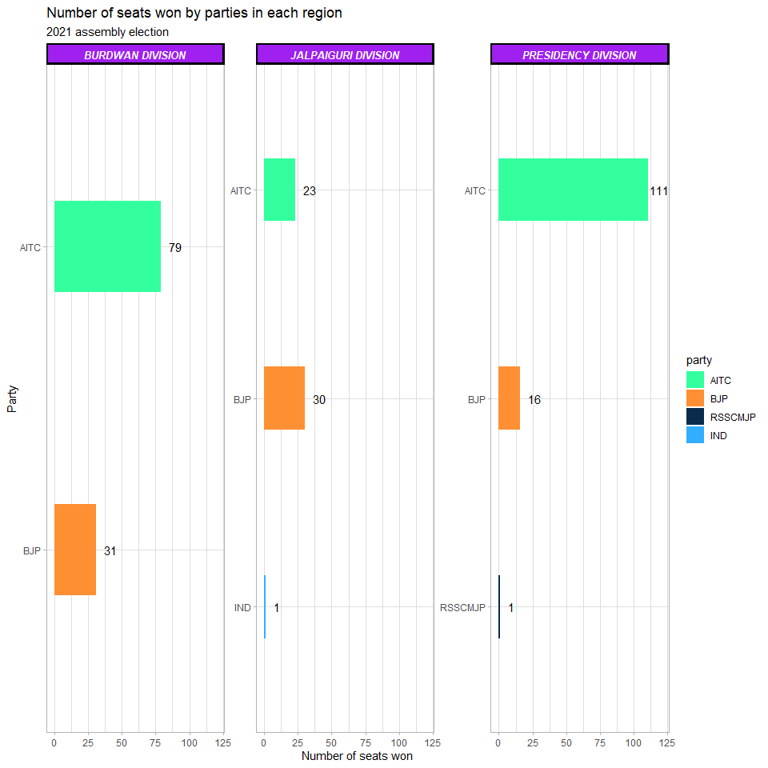

TMC lead the seats by a huge margins in the Presidency (TMC: 111 vs BJP: 16) and Burdwan (TMC: 79 vs BJP: 31) divisions whereas BJP emerged as a dominant force in the Jalpaiguri division ( BJP 30 vs TMC 23).

## Total number of seats secured by each political party by district

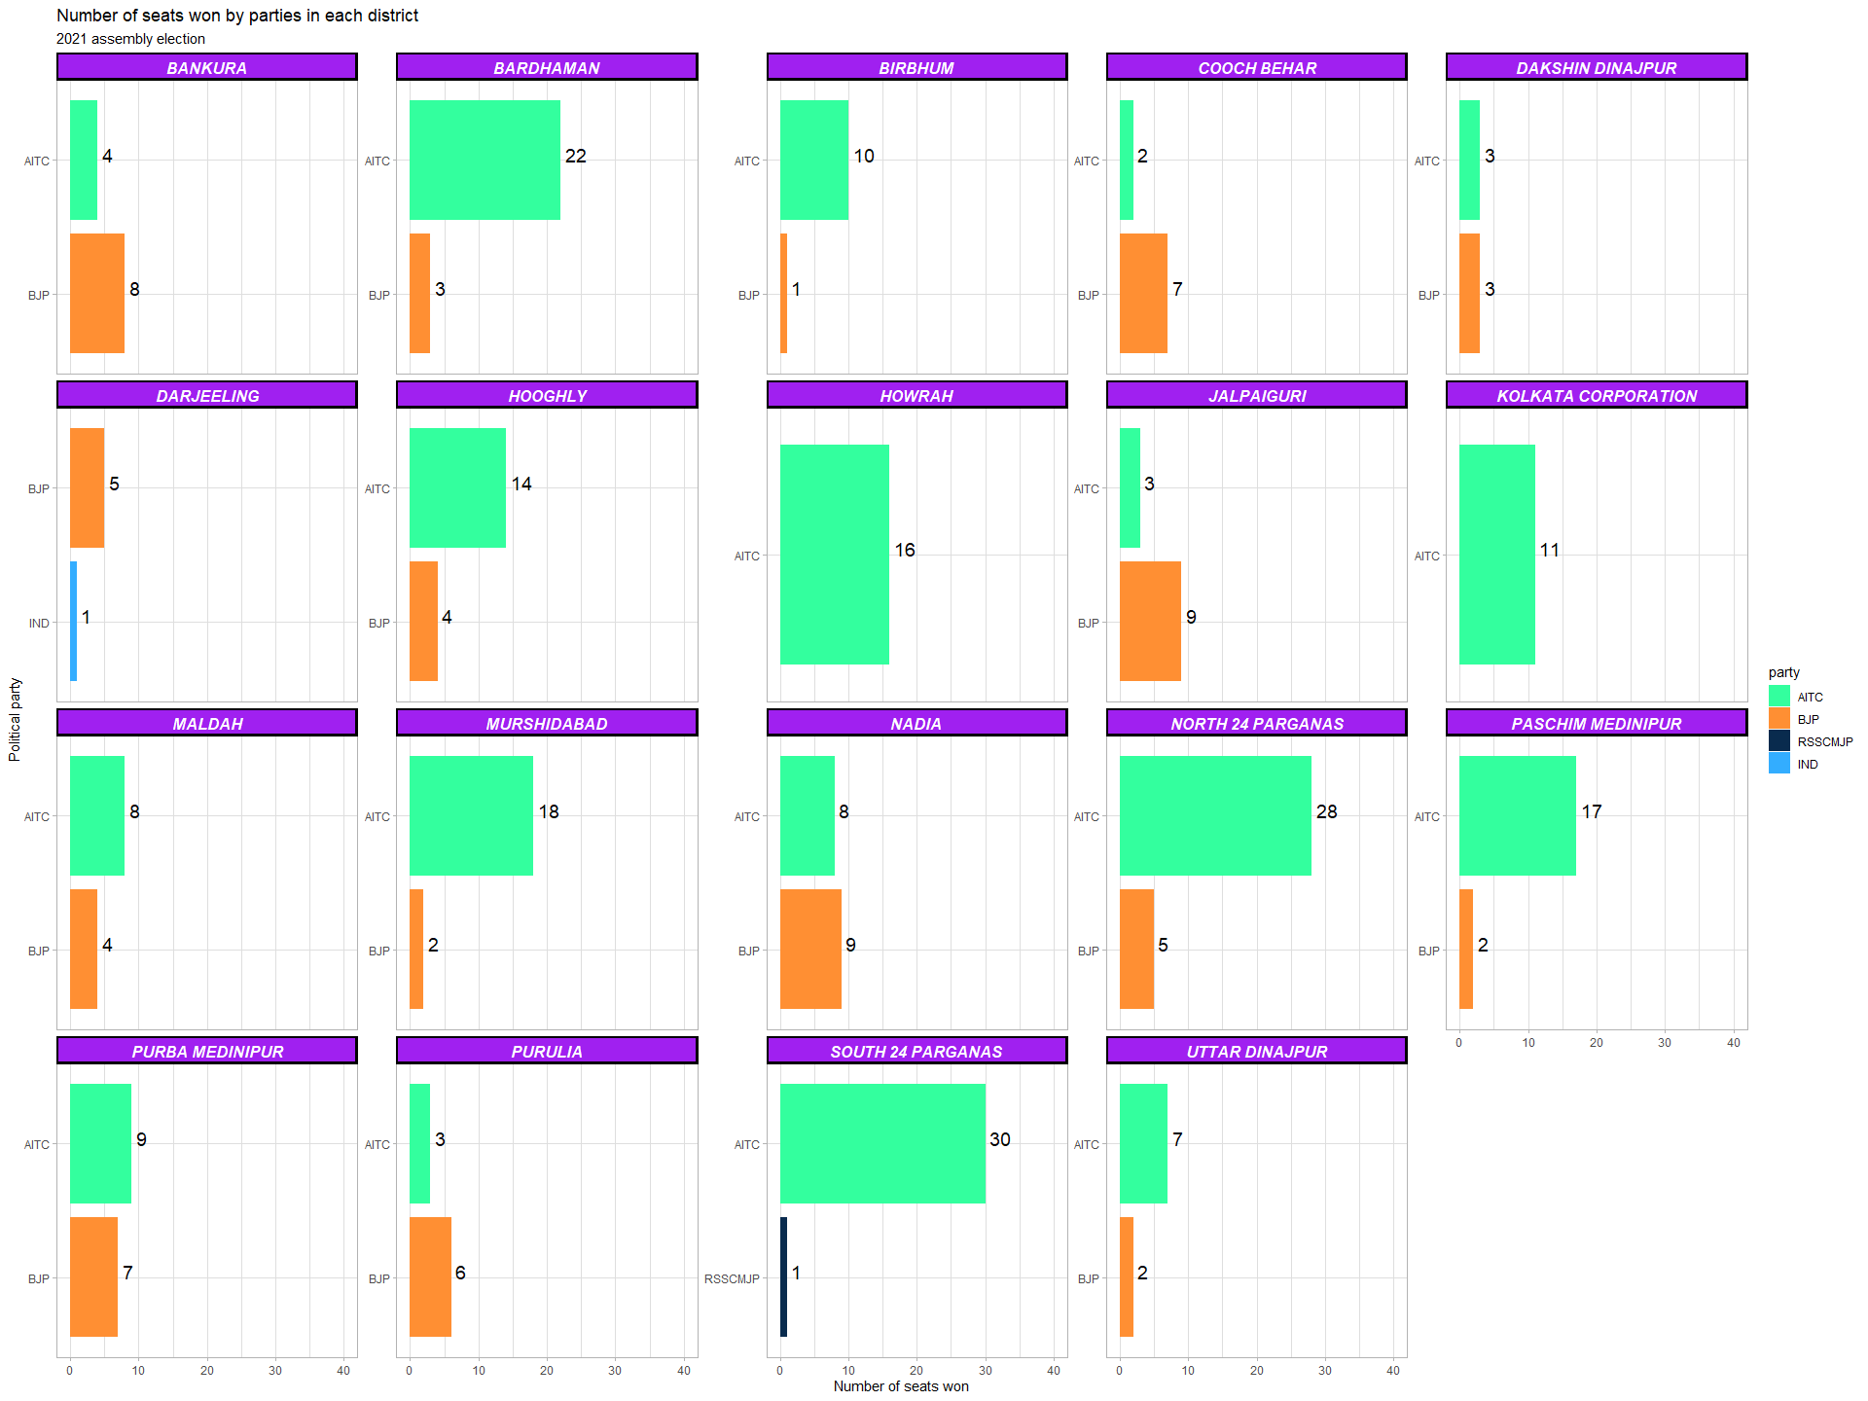

Out of the total 19 districts, TMC bagged more number of seats in 12 districts (Bardhaman, Birbhum, Hooghly, Howrah, Kolkata Corporation, Maldah, Murshidabad, North 24 Parganas, Paschim Medinipur, Purba Medinipur, South 24 Parganas, Uttar Dinajpur ) whereas BJP had bigger share of seats in only 6 districts (Bankura, Cooch Behar, Darjeeling, Jalpaiguri, Nadia and Purulia). BJP didnt win any seats in Howrah (16), Kolkata Corproation(11) and South 24 Parganas(30) districts, whereas TMC din’t win any seat in Darjeeling(6).

### First three candidates in Bankura District

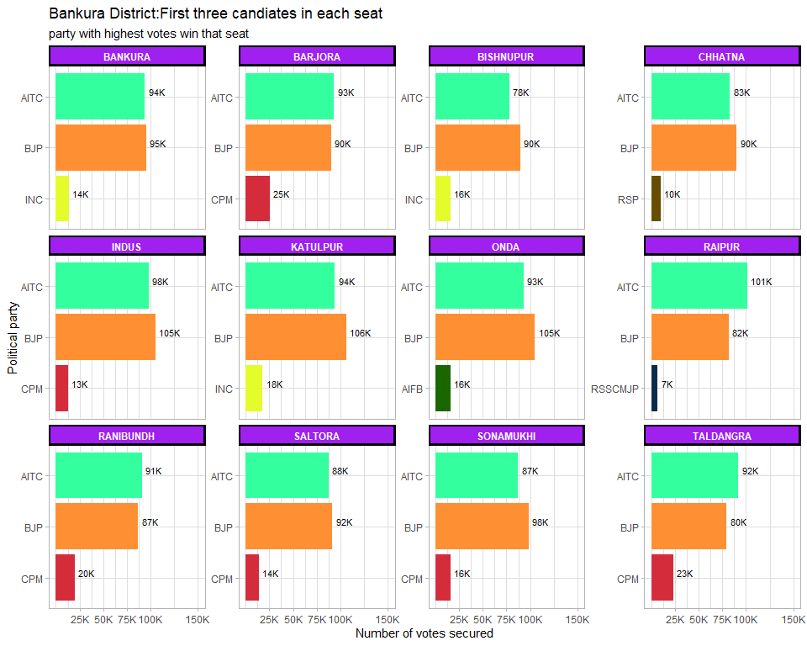

### BARDHAMAN District: Winners per constituency and top 3 candidate

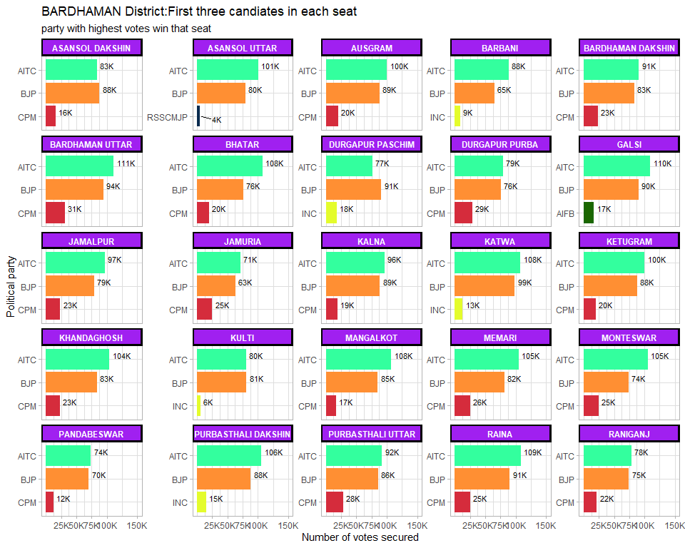 ### BIRBHUM District: Winners per constituency and top 3 candidate 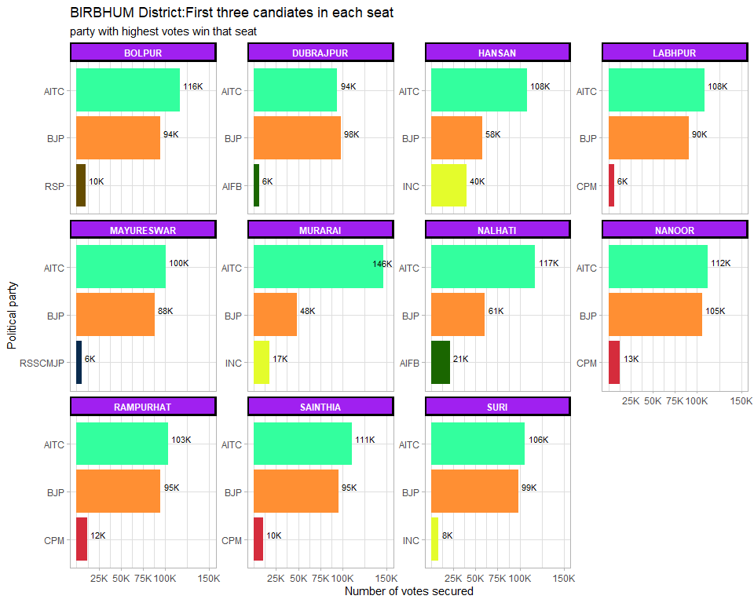

### COOCH BEHAR District: Winners per constituency and top 3 candidate

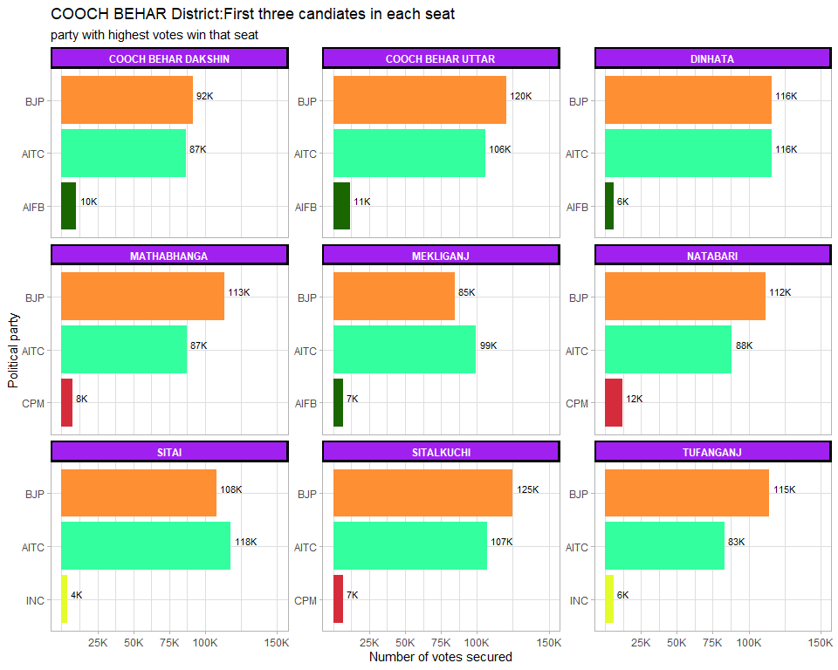

### DAKSHIN DINAJPUR District: Winners per constituency and top 3 candidate

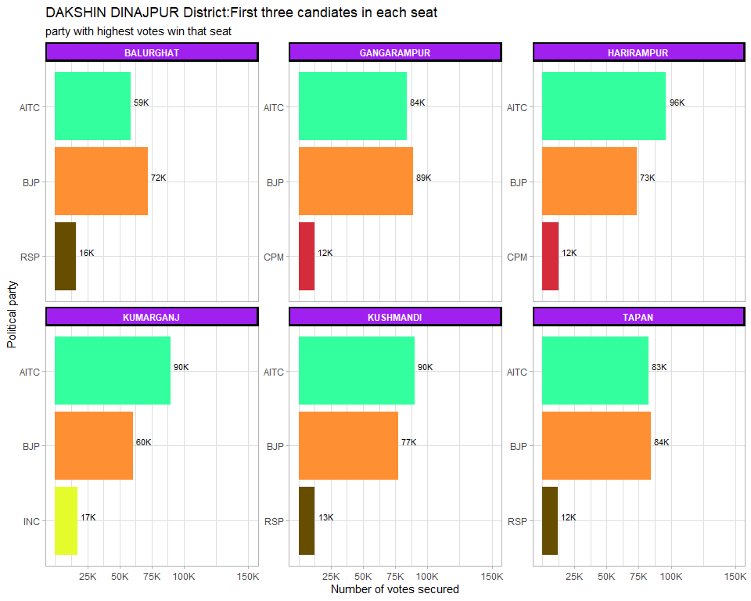

### DARJEELING District: Winners per constituency and top 3 candidate

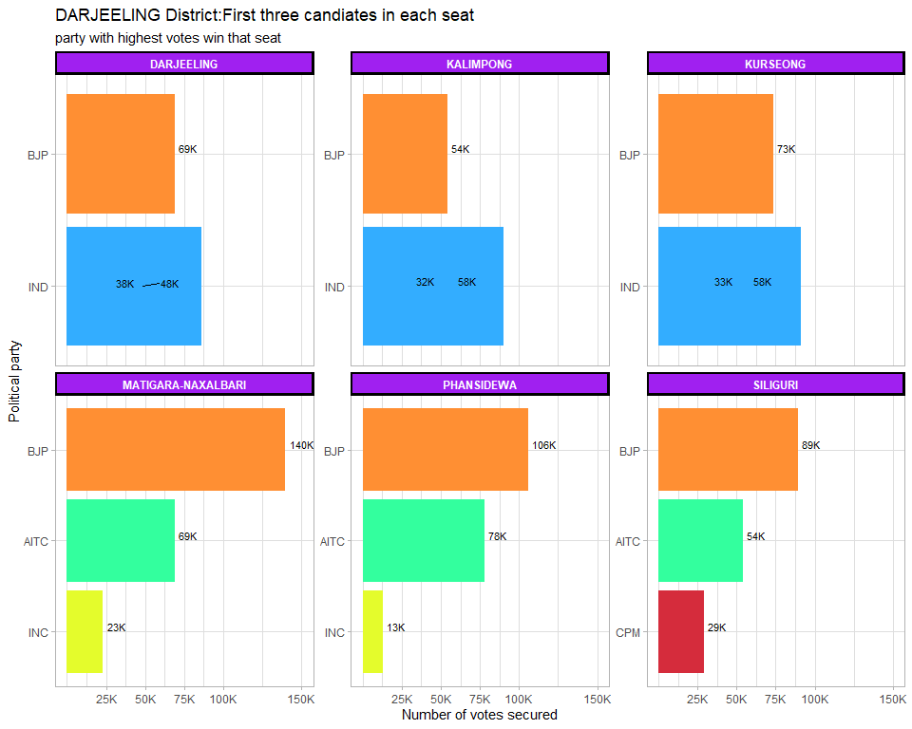

### HOOGHLY District: Winners per constituency and top 3 candidate

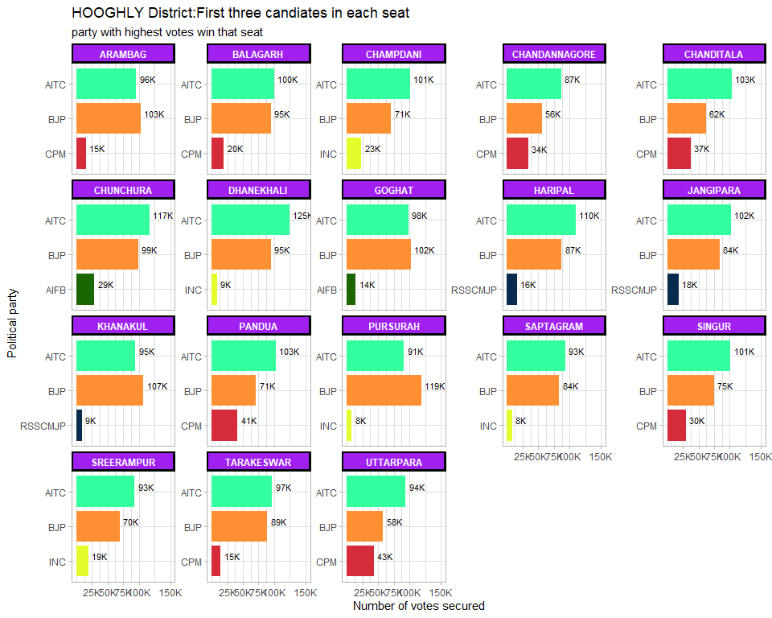

### HOWRAH District: Winners per constituency and top 3 candidate

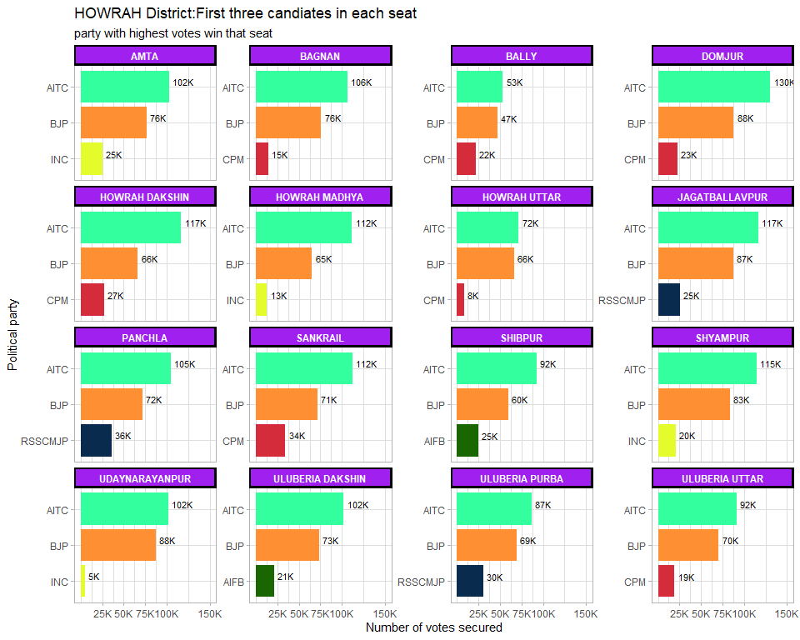

### JALPAIGURI District: Winners per constituency and top 3 candidate

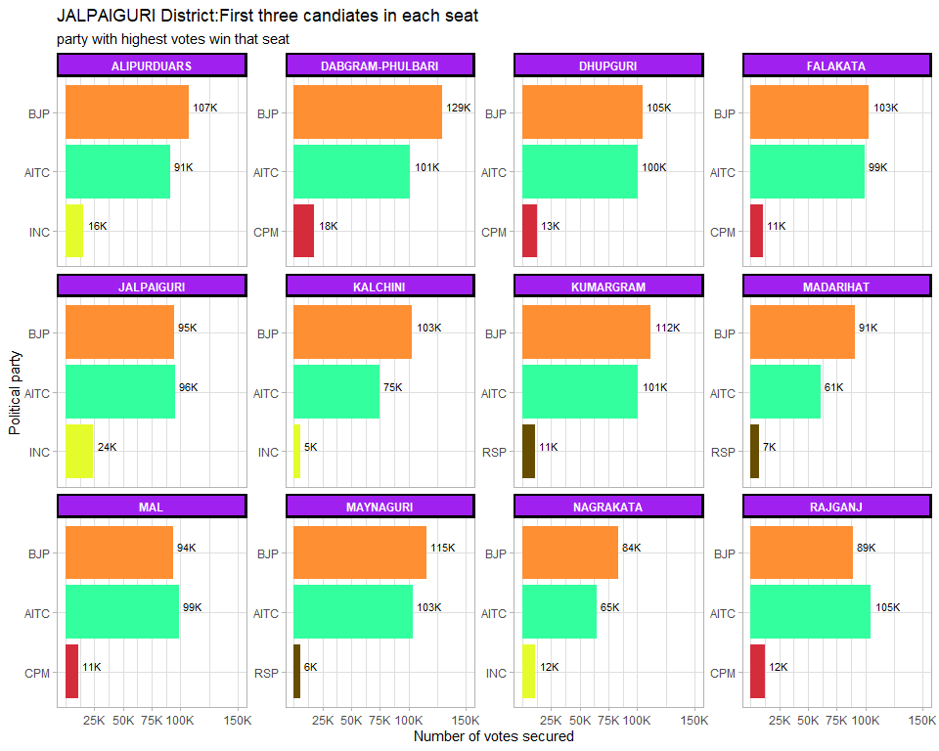

### KOLKATA CORPORATION District: Winners per constituency and top 3 candidate

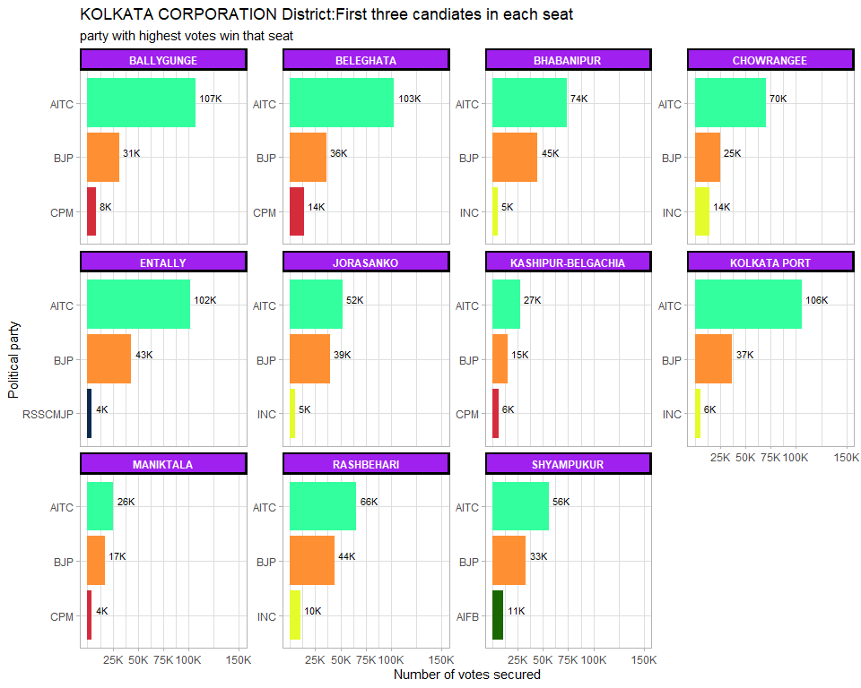

### MALDAH District: Winners per constituency and top 3 candidate

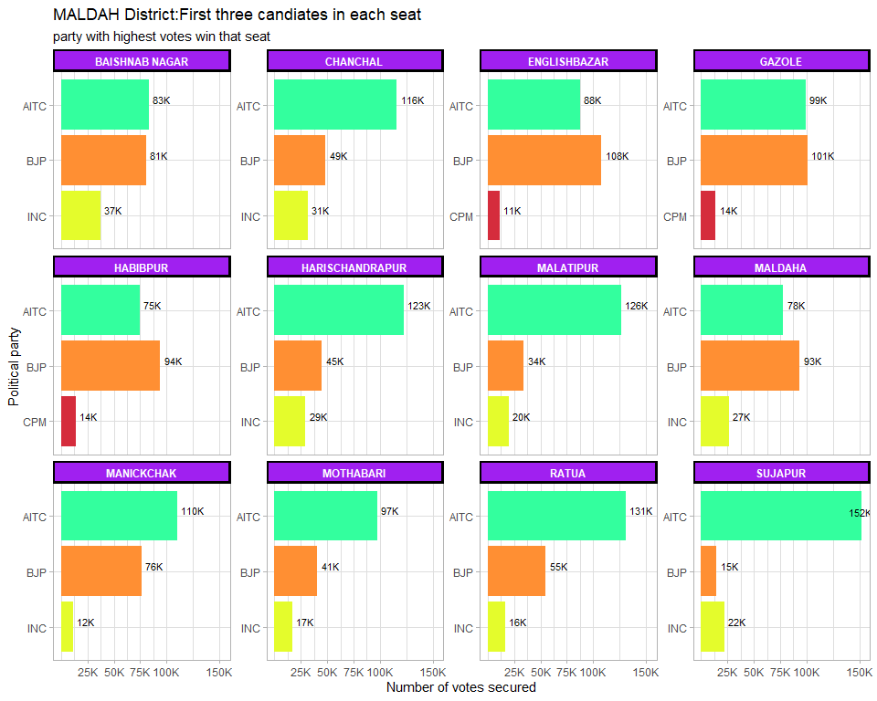

### MURSHIDABAD District: Winners per constituency and top 3 candidate

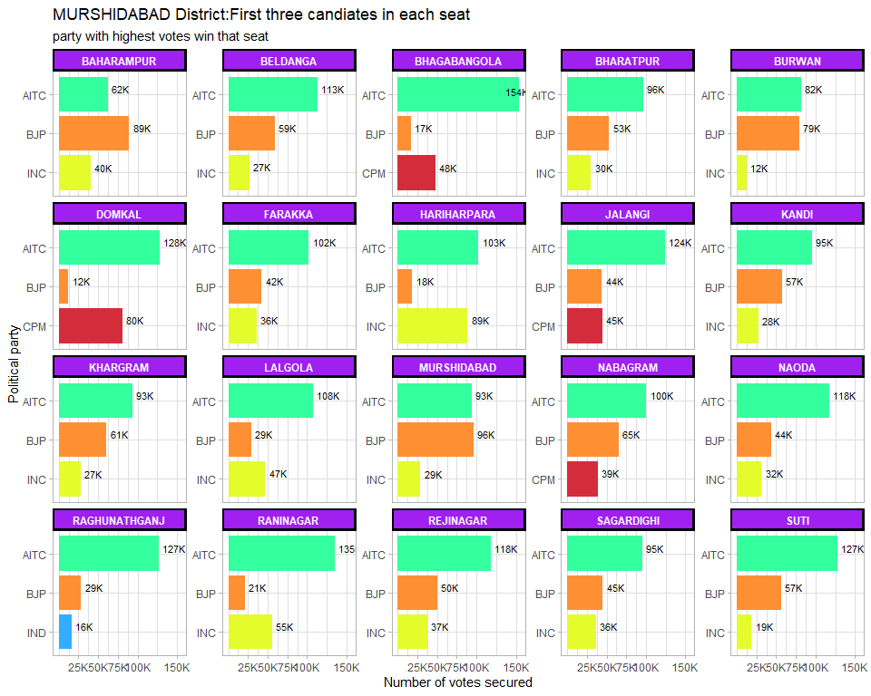

### NADIA District: Winners per constituency and top 3 candidate

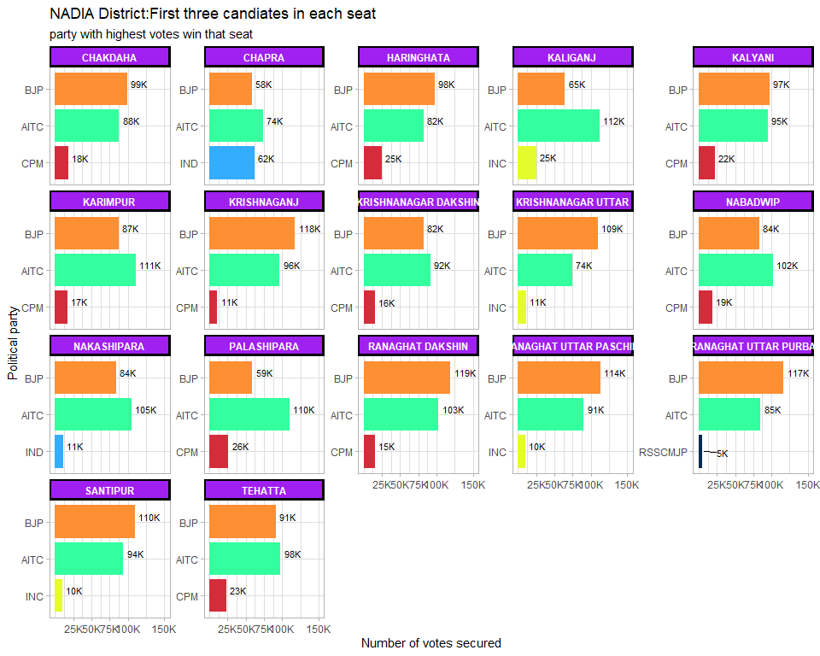

### NORTH 24 PARGANAS District: Winners per constituency and top 3 candidate

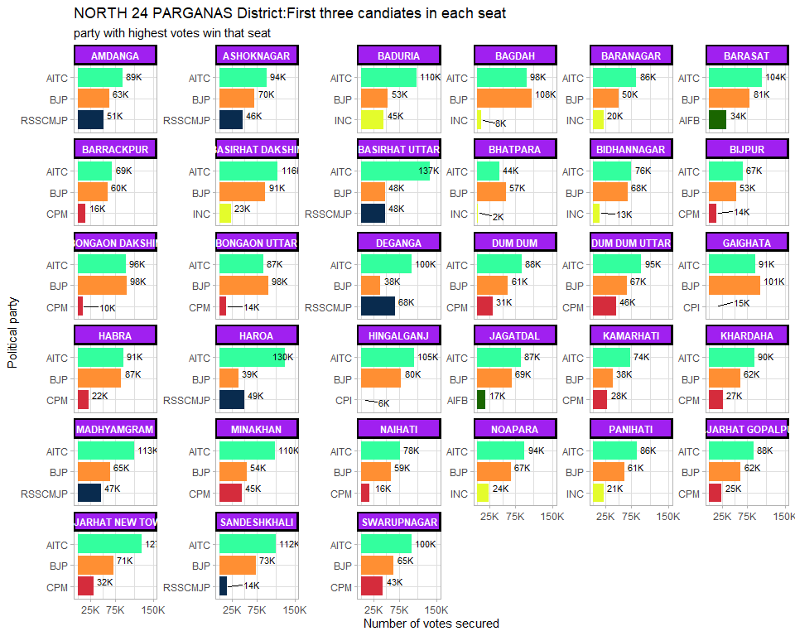

### PASCHIM MEDINIPUR District: Winners per constituency and top 3 candidate

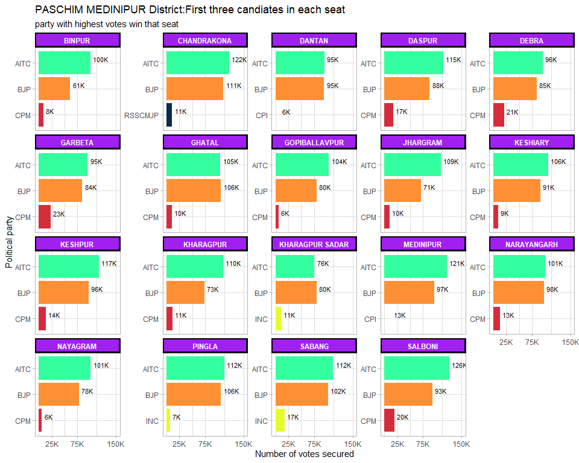

### PURBA MEDINIPUR District: Winners per constituency and top 3 candidate

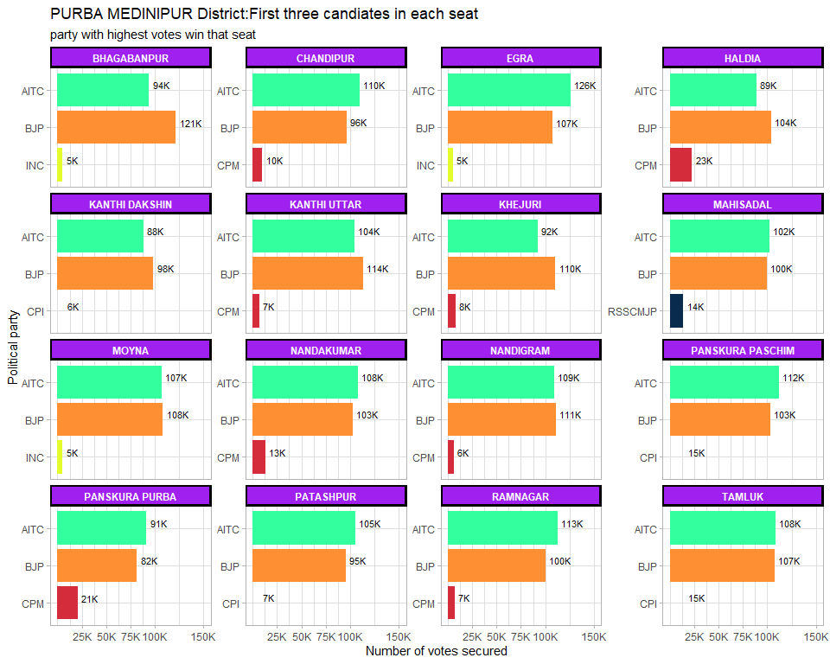

### PURULIA District: Winners per constituency and top 3 candidate

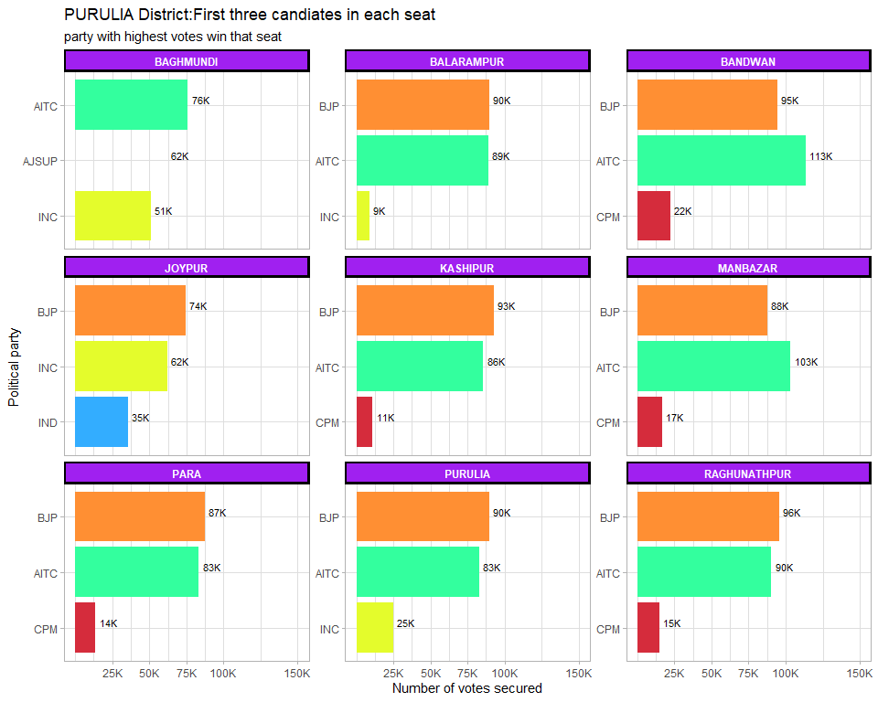

### SOUTH 24 PARGANAS District: Winners per constituency and top 3 candidate

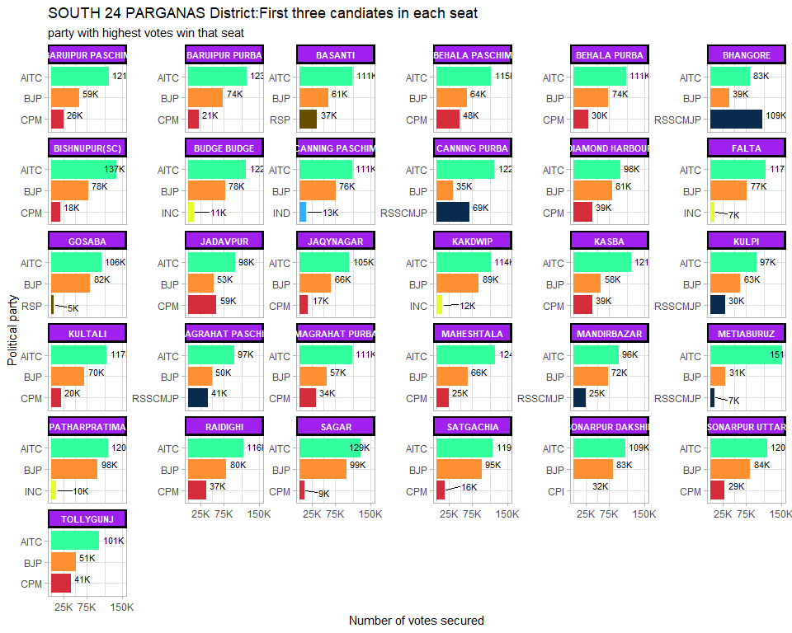

### UTTAR DINAJPUR District: Winners per constituency and top 3 candidate

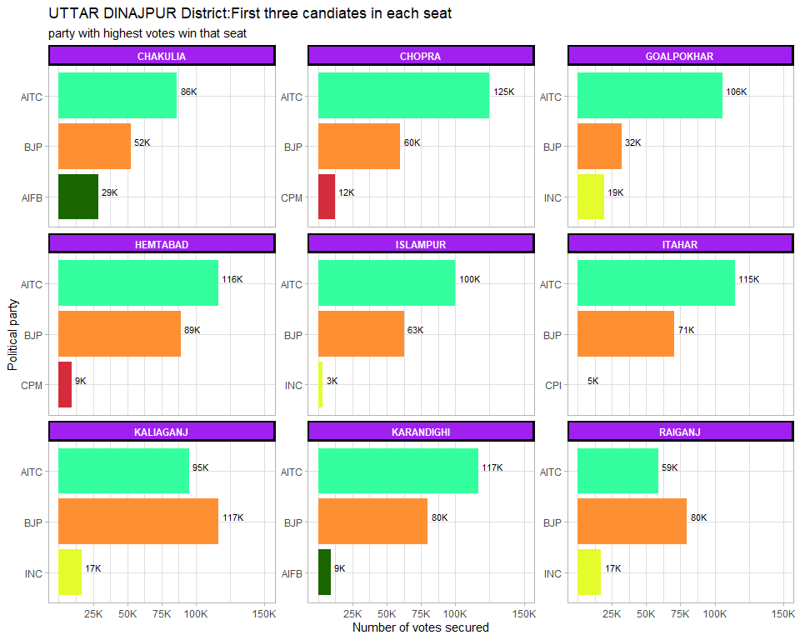

## # A tibble: 19 x 2  
## district_name n  
## <chr> <int>  
## 1 BANKURA 79  
## 2 BARDHAMAN 151  
## 3 BIRBHUM 66  
## 4 COOCH BEHAR 70  
## 5 DAKSHIN DINAJPUR 39  
## 6 DARJEELING 48  
## 7 HOOGHLY 103  
## 8 HOWRAH 137  
## 9 JALPAIGURI 98  
## 10 KOLKATA CORPORATION 123  
## 11 MALDAH 100  
## 12 MURSHIDABAD 159  
## 13 NADIA 126  
## 14 NORTH 24 PARGANAS 236  
## 15 PASCHIM MEDINIPUR 110  
## 16 PURBA MEDINIPUR 91  
## 17 PURULIA 63  
## 18 SOUTH 24 PARGANAS 245  
## 19 UTTAR DINAJPUR 72

## Has the voters rewarded the turncoats

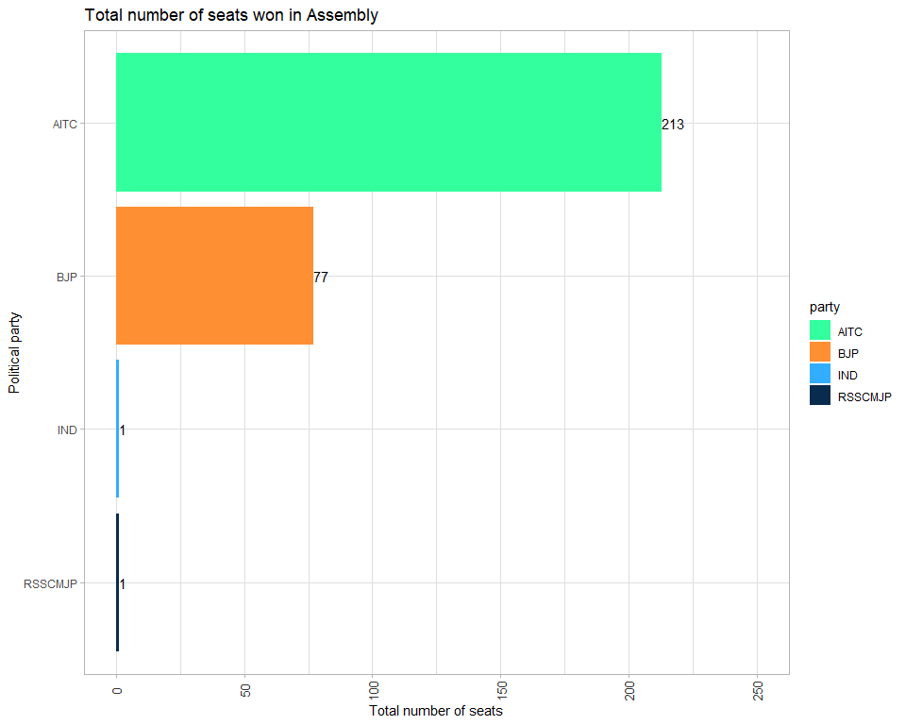

## Gender split of Winner candidates by party

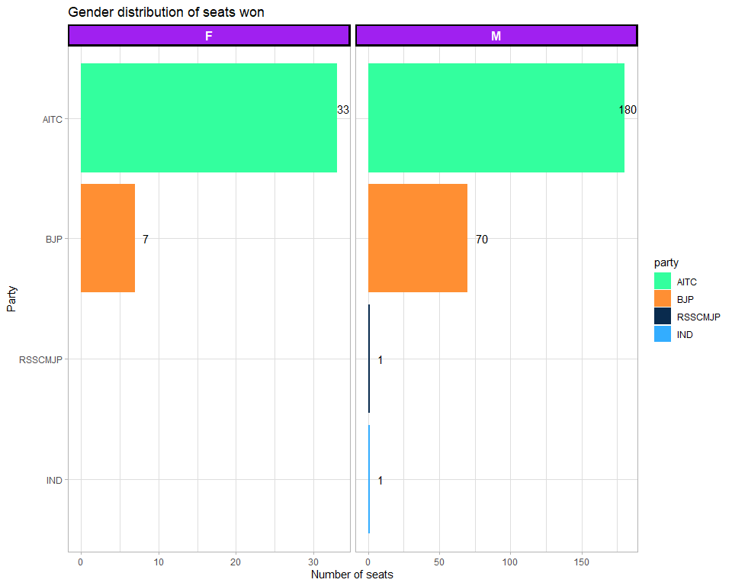

Out of the total seats won by TMC, the seats won by women were 33 or 15.5% of the total seats of 213 whereas for the BJP, it was 7 or 9% of the total seats of 77.

## Winner by constituency type

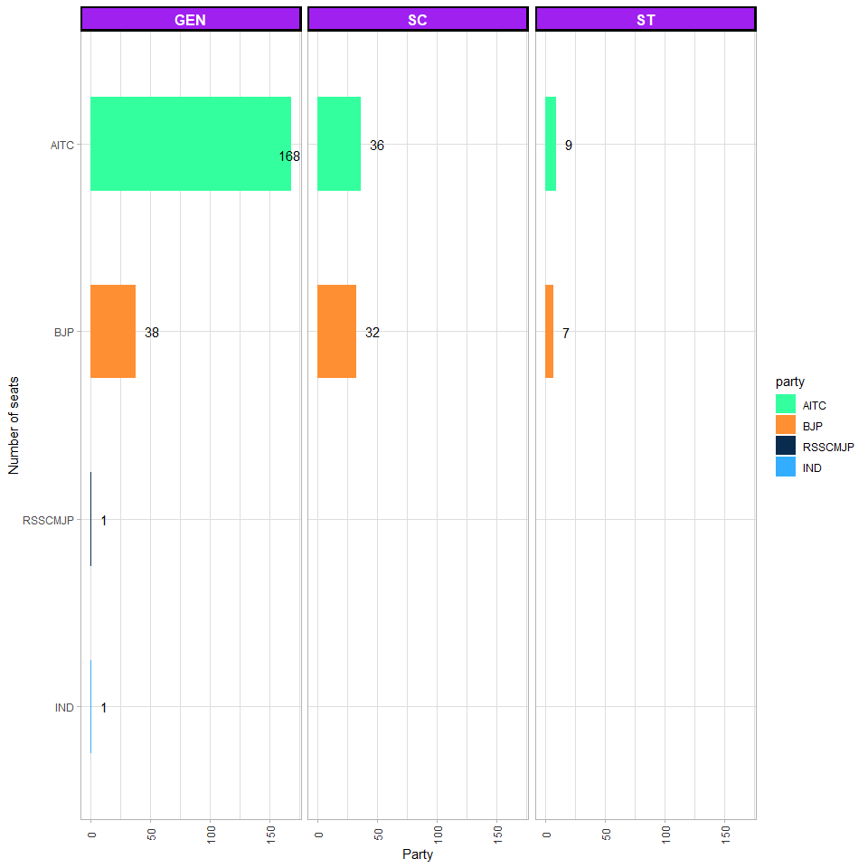

TMC won 82% of the total general or non reserved (168 out of 206) seats, whereas it won 53% (36 out of 68) of the SC and 56 % of the ST (9 out of 16) reserved seats.

BJP won 18% of the total general or non reserved (18 out of 206) seats and 47% of the SC (32 out of 68) and 44 % of the ST (7 out of 16) reserved seats.

## Winner by margin of 5000 or less

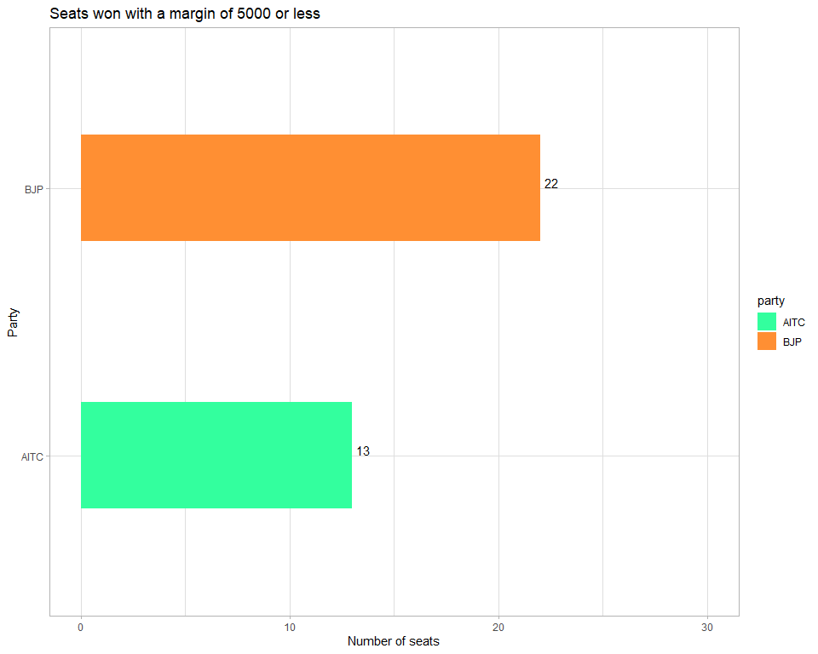

Total candidates who won by a margin of 5000 or less were 35 or around 12% of the total assembly seats. Out of total 35, 63% or 22 were won by BJP and 37% of 13 were won by TMC.

### Distribution of Candidates Age by Sex

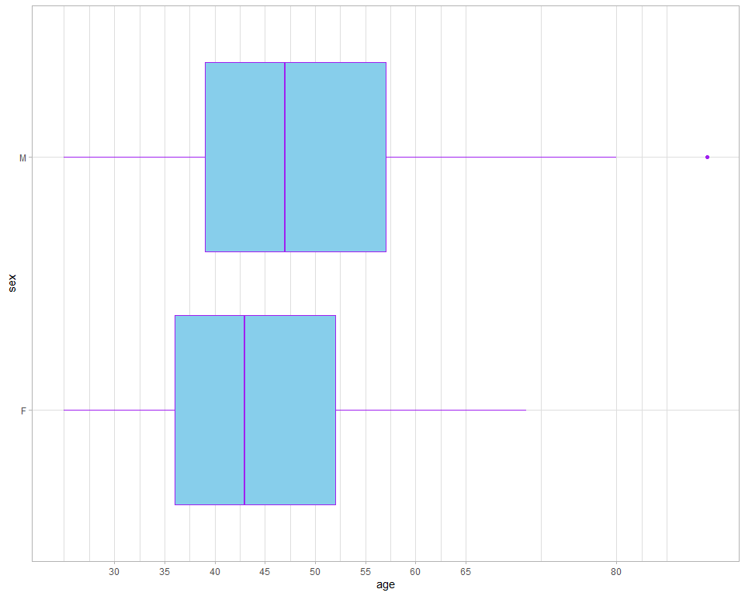

The mean and median age of the candidates in the fray were 47 and three and three quarter of all candidates fell between the age range of 39 to 56. The minimum candidate age was 25 and the maxium age was 89.

## Summmary of all numeric and logical varibles.

## election_type state_name assembly_no constituency_no  
## Length:2116 Length:2116 Min. :17 Min. : 1.0   
## Class :character Class :character 1st Qu.:17 1st Qu.: 70.0   
## Mode :character Mode :character Median :17 Median :143.0   
## Mean :17 Mean :140.5   
## 3rd Qu.:17 3rd Qu.:207.0   
## Max. :17 Max. :294.0   
## year month poll_no delim_id position   
## Min. :2021 Min. :5 Min. :0 Min. :4 Min. : 1.000   
## 1st Qu.:2021 1st Qu.:5 1st Qu.:0 1st Qu.:4 1st Qu.: 2.000   
## Median :2021 Median :5 Median :0 Median :4 Median : 5.000   
## Mean :2021 Mean :5 Mean :0 Mean :4 Mean : 5.009   
## 3rd Qu.:2021 3rd Qu.:5 3rd Qu.:0 3rd Qu.:4 3rd Qu.: 7.000   
## Max. :2021 Max. :5 Max. :0 Max. :4 Max. :16.000   
## candidate sex party votes   
## Length:2116 Length:2116 Length:2116 Min. : 50.0   
## Class :character Class :character Class :character 1st Qu.: 751.8   
## Mode :character Mode :character Mode :character Median : 1709.5   
## Mean : 27931.2   
## 3rd Qu.: 57694.5   
## Max. :153795.0   
## candidate_type valid_votes electors constituency_name   
## Mode:logical Min. : 48820 Min. : 77678 Length:2116   
## NA's:2116 1st Qu.:192634 1st Qu.:236135 Class :character   
## Median :208810 Median :251344 Mode :character   
## Mean :202054 Mean :249576   
## 3rd Qu.:221872 3rd Qu.:266480   
## Max. :258969 Max. :315439   
## constituency_type sub_region n_cand turnout_percentage  
## Length:2116 Length:2116 Min. : 3.000 Min. :49.84   
## Class :character Class :character 1st Qu.: 6.000 1st Qu.:77.83   
## Mode :character Mode :character Median : 8.000 Median :82.98   
## Mean : 7.966 Mean :80.67   
## 3rd Qu.:10.000 3rd Qu.:85.57   
## Max. :15.000 Max. :90.00   
## vote_share_percentage deposit_lost margin margin_percentage  
## Min. : 0.03 Length:2116 Min. : 0.00 Min. : 0.000   
## 1st Qu.: 0.38 Class :character 1st Qu.: 55.75 1st Qu.: 0.030   
## Median : 0.85 Mode :character Median : 454.50 Median : 0.230   
## Mean :13.65 Mean : 13949.83 Mean : 6.834   
## 3rd Qu.:30.13 3rd Qu.: 18840.00 3rd Qu.: 9.488   
## Max. :76.85 Max. :130163.00 Max. :62.700   
## enop pid party_type_tcpd party_id   
## Min. :1.610 Length:2116 Mode:logical Mode:logical   
## 1st Qu.:2.330 Class :character NA's:2116 NA's:2116   
## Median :2.440 Mode :character   
## Mean :2.486   
## 3rd Qu.:2.630   
## Max. :3.850   
## last_poll contested last_party last_party_id   
## Mode:logical Min. : 1.000 Length:2116 Mode:logical   
## TRUE:2116 1st Qu.: 1.000 Class :character NA's:2116   
## Median : 1.000 Mode :character   
## Mean : 1.575   
## 3rd Qu.: 2.000   
## Max. :11.000   
## last_constituency_name same_constituency same_party no_terms   
## Length:2116 Mode :logical Mode :logical Min. :0.0000   
## Class :character FALSE:118 FALSE:110 1st Qu.:0.0000   
## Mode :character TRUE :466 TRUE :474 Median :0.0000   
## NA's :1532 NA's :1532 Mean :0.3932   
## 3rd Qu.:0.0000   
## Max. :8.0000   
## turncoat incumbent recontest age   
## Mode :logical Mode :logical Mode :logical Min. :25.00   
## FALSE:2029 FALSE:1925 FALSE:1601 1st Qu.:39.00   
## TRUE :87 TRUE :191 TRUE :515 Median :47.00   
## Mean :47.63   
## 3rd Qu.:56.00   
## Max. :89.00   
## district_name   
## Length:2116   
## Class :character   
## Mode :character   
##   
##   
##

## Distribution of Voting percentage by constituency type

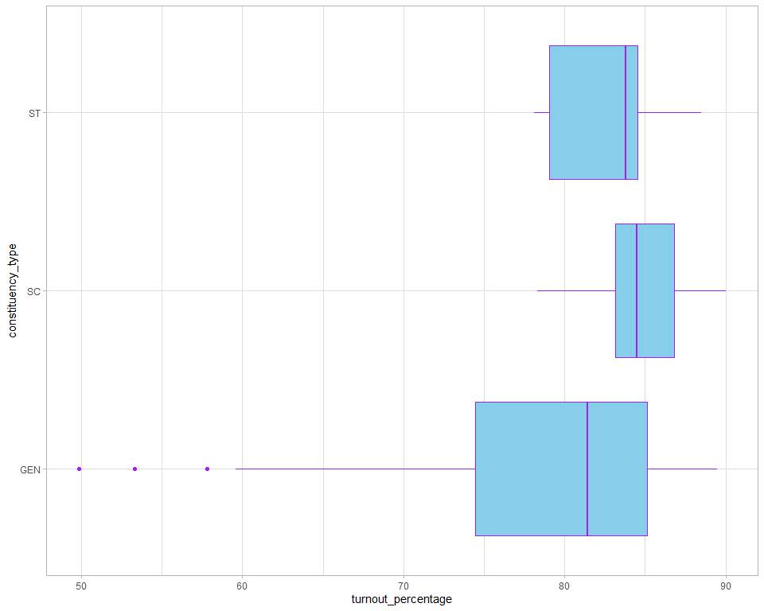

The average voting percentage in the SC, ST and General seats were xx %, xx % and xx % respectively.

## Distribution of Voting percentage by Sub Region

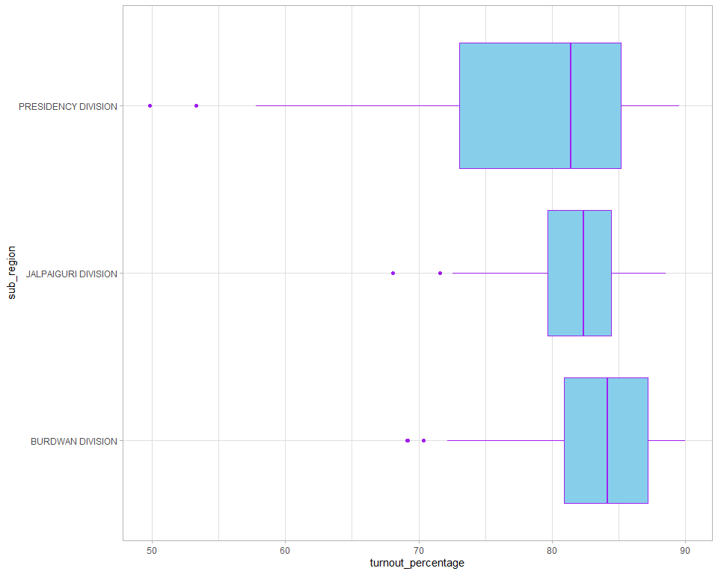

## Constituency with lower voter turnout

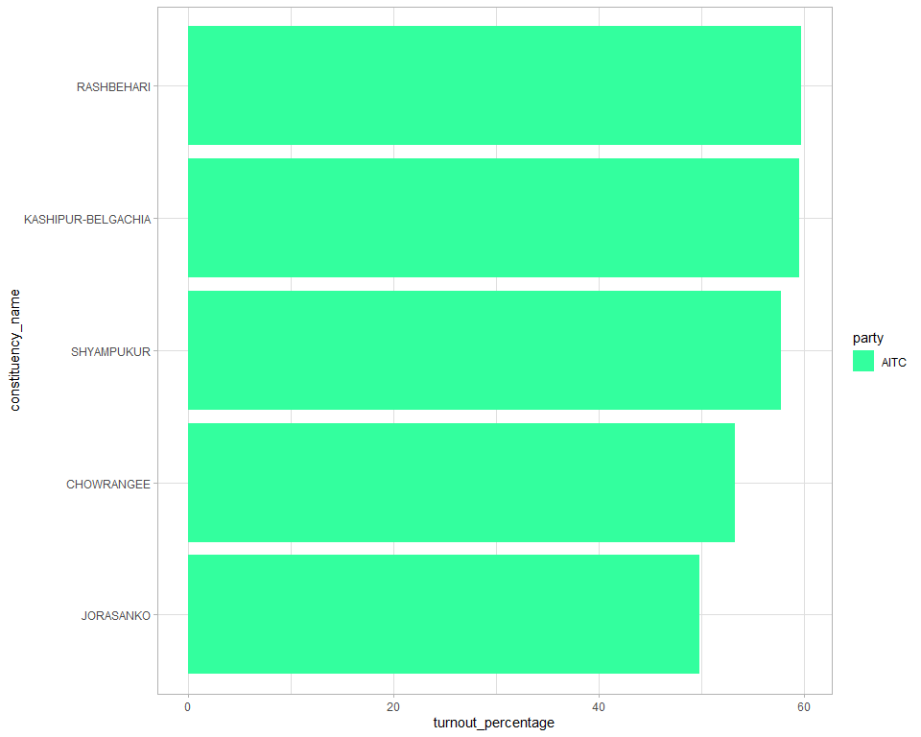

## Constituency with higher voter turnout

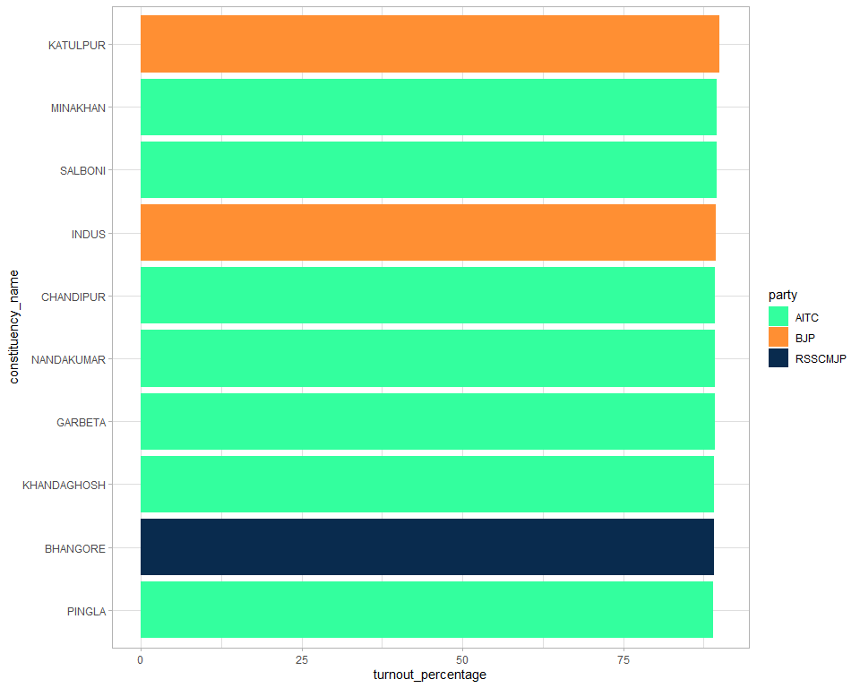

## The CM’s Constituency

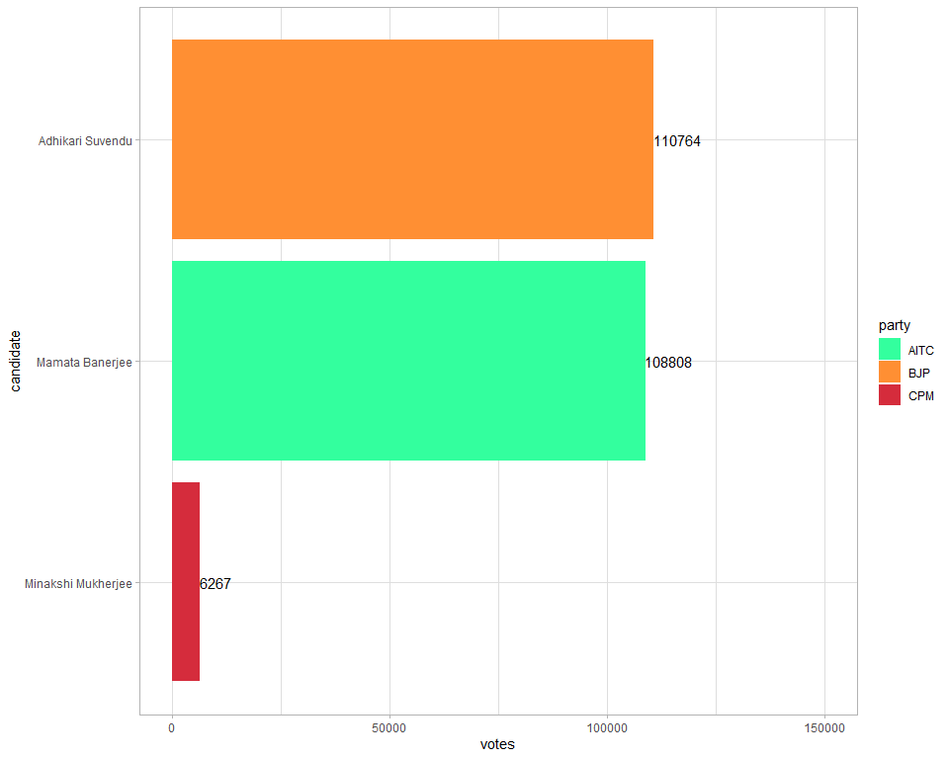

## Victory Margins across the seats and parties

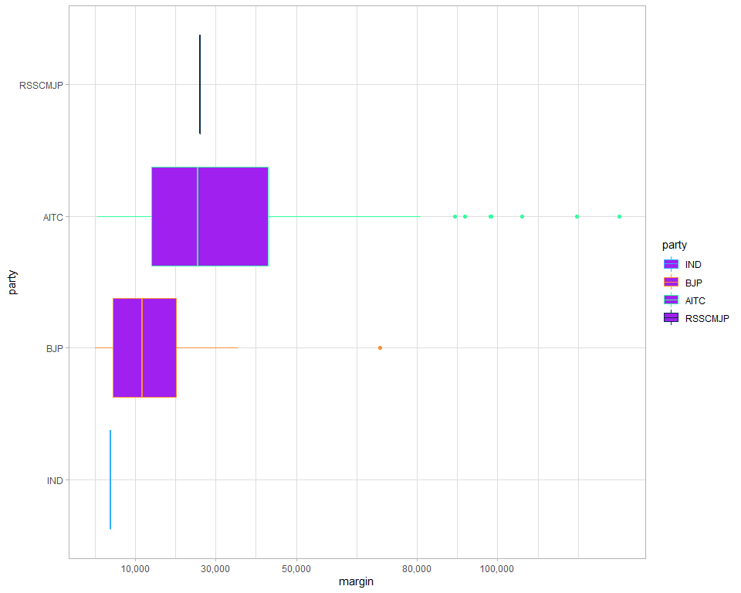

## VIP Constinuency

### References

### APA style

### Authors guidelines |

#### ADR