West Bengal Assembly Election 2021: An Analysis

**Onkar Singh**

Global Corporate Citizenship, Accenture, Bangalore, India. Email: os2137@caa.columbia.edu | ORCID:

### 

## 

**Abstract**

West Bengal Assembly election was one of the most keenly watched assembly elections in India in 2021. One of the reasons for this interest was the unexpected rise of the Bharatiya Janata Party in a state mostly known for its contests between the Left parties, the Indian National Congress, and the All-India Trinamool Congress. The Bhartiya Janata Party (BJP) had only 3 seats in the last assembly election of 2016, whereas the ruling All India Trinamool Congress (AITC or TMC) party had 212 seats. The BJP was never a major player in the state except during the last parliamentary election (2019) when BJP bagged 18 out of the 42 parliamentary seats. The analysis presented in this paper analyzes the constituency-wise figures for each of the 294 constituencies spread over 19 districts of the state of West Bengal in India.

The TMC emerged victorious with 48% of the total popular votes, while the opposition BJP got 39% of the popular votes. Also, TMC won 213 (73% of total seats), whereas the BJP came to a distant second with 77 (26%) seats, even though it raised its stock significantly in the West Bengal Assembly from its 2016 tally of a meager 3 seats. After the West Bengal 2021 election results, Mamata Banerjee emerged as one of the main challengers of BJP at the national arena of Indian politics. This paper will benefit and help anyone interested in Indian political analysis and would also provide key insights for the political analysts and the political parties interested in a seat-by-seat deep dive. The analysis was done with the help of Microsoft Excel and R Software.

## 1. INTRODUCTION

West Bengal[1] Assembly election was one of the most keenly watched assembly elections in India in 2021. One of the reasons for this interest was the unexpected rise of the Bharatiya Janata Party[2] in a state mostly known for its contests between the Left[3] parties, the Indian National Congress[4] , and the All-India Trinamool Congress[5]. The Bhartiya Janata Party (BJP) had only 3 seats in the last assembly election of 2016, whereas the ruling All India Trinamool Congress (AITC or TMC) party had 212 seats. The BJP was never a major player in the state except during the last parliamentary election (2019) when BJP bagged 18 out of the 42 parliamentary seats. This raised the optimisms in the BJP camp. The party put all its political might in the West Bengal Legislative Assembly election, which was concluded in May 2021, where it was pitted against the ruling TMC led by its supremo Mamata Banerjee. The stakes were so high that BJP made some of its central ministers resign to contest the assembly elections to bolster the party’s prospects in the state, traditionally considered home to the non-BJP political forces.

This was coupled with the high decibel election campaign led by Prime Minister Narendra Modi along with the Home Minister Amit Shah and BJP President J.P. Nadda. On the other hand, the two-time chief minister of West Bengal, Mamata Banerjee, led the incumbent party from the front and ran a highly successful campaign leading to her party’s victory in the assembly election. This marked the beginning of the third term of the TMC government in the state. The opinion and exit polls were equally divided some predicted edge to the ruling TMC while others giving a slight edge to the BJP. However, the final results, announced on 2nd May 2021, put all speculations to rest with TMC winning 213 seats, whereas BJP managed to win only 77 seats.

The analysis presented in this paper attempts to analyze the constituency-wise figures for each of the 294 constituencies spread over 19 districts of the state of West Bengal in India. This paper will benefit and help anyone interested in Indian political analysis and would also provide key insights for the political analysts and the political parties interested in a seat-by-seat deep dive. The study conducted to prepare this paper aims at synthesizing the political data using visualization for a better understanding of the election results. This would also be helpful for political analysts, political and social scientists, and political parties to further analyze the election results at a granular level. The future scope of this study would entail a demographic extrapolation on the election results to understand various social economic and political contexts that determine the election outcomes in India.

## 2. METHODOLOGY

The data for the analysis conducted under this study was obtained from the Election Commission of India portal[6] and Trivedi Center for Political Data[7] at the Ashoka University, India. The analysis was done with the help of Microsoft Excel and R Software and its ggplot2 package for Visualization. The various reports and publications were used as a secondary source in the process of this analysis. The analysis covers each of 19 districts of the West Bengal state represented in figure 1 and provides with election results for each of the 294 assembly constituencies in West Bengal.

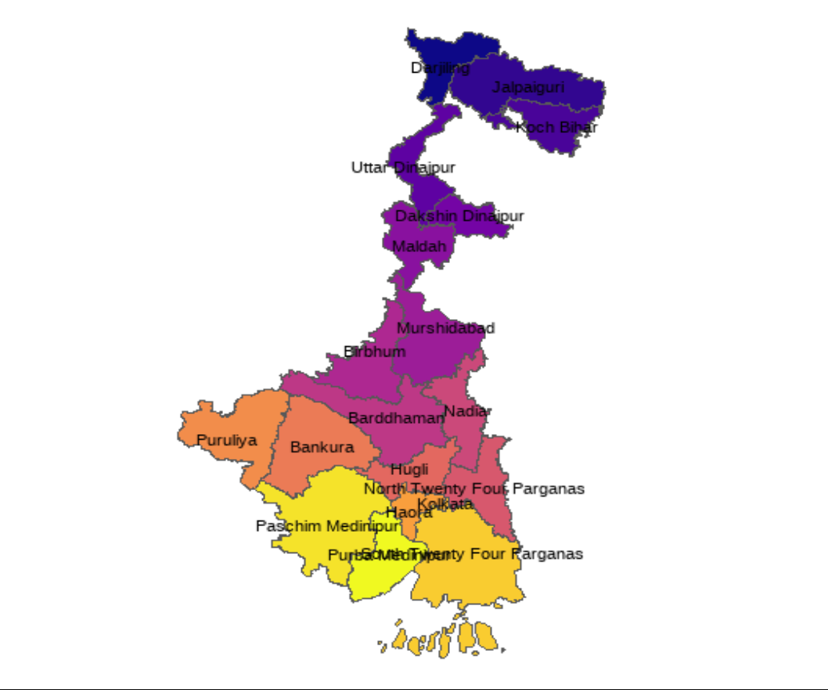

# 

Figure 1: Map of West Bengal Districts

# 3. RESULTS AND DISCUSSION

This and the subsequent sections provide the details of political parties which participated in the West Bengal election, key election results such as by number and percentage of seats, regional and gender distribution of winning candidates per party and then follows with a district-wise summary of election outcomes and delves deeper into the election results of all seats in each district of the state of West Bengal.

## 3.1 Total Number of Political Parties in the Fray

As mentioned in table 1, a large number of independent candidates (611) and a total of 57 political parties took part in the West Bengal assembly election 2021. The main parties include Bharatiya Janata Party (BJP), All India Trinamool Congress (AITC/TMC), Communist Party of India Marxist (CPIM), and Indian National Congress (INC/Congress). The BJP, TMC, CPIM, and Congress contested 291, 288, 138, and 91 seats, respectively (Figure 2).

## Table 1: Political parties and number of seats contested

|  |  |  |
| --- | --- | --- |
| S.No. | *Political Party* | *No. of Contested Seats* |
|  | Independents (IND) | 611 |
|  | Bhartiya Janata Party (BJP) | 291 |
|  | All India Trinamool Congress (AITC) | 288 |
|  | Socialist Unity Centre of India (Communist) [SUCI] | 188 |
|  | Bahujan Samaj Party (BSP) | 162 |
|  | Communist Party of India (Marxist)(CPM) | 138 |
|  | Indian National Congress (INC) | 91 |
|  | Bahujan Mukti Party | 45 |
|  | Amra Bangalee | 40 |
|  | Indian Secular Front (ISF/RSSCMJP) | 32 |
|  | All India Forward Bloc (AIFB) | 21 |
|  | Janata Dal (United) [JD(U)] | 16 |
|  | Kamatapur People’s Party (United) | 15 |
|  | Communist Party of India (Marxist–Leninist) Liberation  [CPI(ML)(L)] | 12 |
|  | Purvanchal Mahapanchayat | 12 |
|  | Communist Party of India (CPI) | 10 |
|  | Lok Janshakti Party (LJP) | 10 |
|  | Revolutionary Socialist Party (RSP) | 10 |
|  | Bharatiya Nyay-Adhikar Raksha Party | 8 |
|  | Justice and Development Party, | 7 |
|  | Party for Democratic Socialism | 7 |
|  | All India Majlis-e-Ittehadul Muslimeen (AIMIM) | 6 |
|  | United Socialist Party | 6 |
|  | Bahujan Maha Party | 5 |
|  | Indian Unity Centre | 5 |
|  | Republican Party of India (A) | 5 |
|  | Ambedkarite Party of India | 4 |
|  | Indian Union Muslim League (IUML) | 4 |
|  | Jan Sangh Party | 4 |
|  | National Republic Party of India | 4 |
|  | Republican Party of India (Athawale) | 4 |
|  | Social Democratic Party of India (SDPI) | 4 |
|  | Socialist Party (India) | 4 |
|  | Welfare Party of India | 4 |
|  | Communist Party of India (Marxist-Leninist) Red Star | 3 |
|  | Democratic Socialist Party of India | 3 |
|  | Hindustani Awam Morcha (HAM) | 3 |
|  | Humanity Universal Motion Party | 3 |
|  | National People's Party (NPP) | 3 |
|  | Akhil Bharat Hindu Mahasabha | 2 |
|  | All India Minorities Front | 2 |
|  | Bharatiya Momin Front | 2 |
|  | Bhartiya Tribal Party | 2 |
|  | Guru Chand Mukti Morcha | 2 |
|  | Mulnibasi Party of India | 2 |
|  | Right to Recall Party | 2 |
|  | West Bengal Socialist Party | 2 |
|  | All Jharkhand Students Union (AJSUP) | 1 |
|  | Bharateeya Manavadhikar party | 1 |
|  | Jamat-E-Seratul Mustakim | 1 |
|  | Lok Samya Party | 1 |
|  | New Democratic Party of India | 1 |
|  | Paradise Party | 1 |
|  | Progressive People's Party | 1 |
|  | Rashtravadi Janata Party | 1 |
|  | Revolutionary Socialist Party of India(Marxist) | 1 |
|  | Sajag Samaj Party | 1 |
|  | Samajwadi Jan Parishad | 1 |
|  | Vikas India Party | 1 |

## 3.2 Main Political Parties by Number of Seats Contested

Both TMC and BJP contested almost all of the seats, whereas other main parties in the state like CPM and Congress, had an alliance with Indian Secular Front (ISF[8]), a newly formed party led by Abbas Siddiqui, as mentioned in table 1.

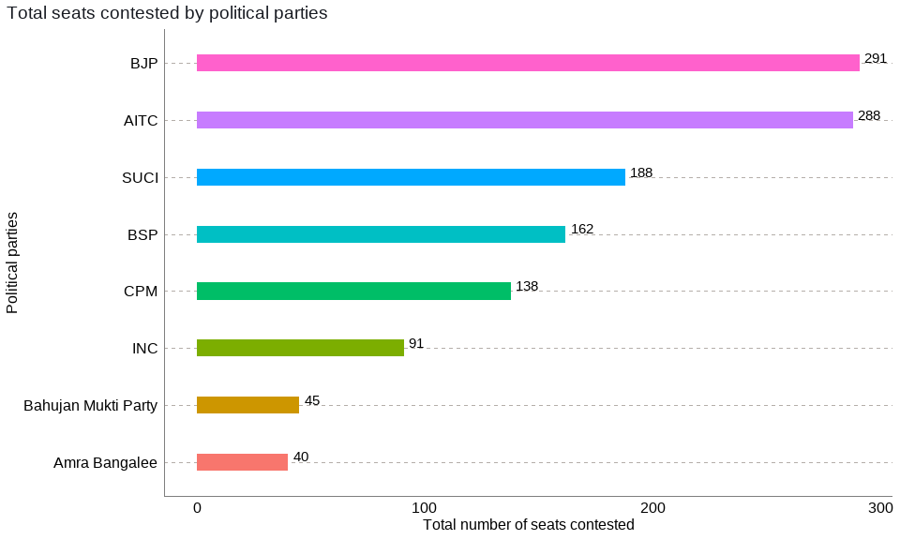

Figure 2: Main Political parties by number of seats contested

## 3.3 Total Number of Repeat vs. New Candidates

In figure 3, it is depicted that a larger number of repeat candidates were fielded by the TMC, because it had the largest number of members of legislative assembly (MLAs) in the outgoing assembly, and it is not common that parties replace their seating candidates. The BJP fielded the largest number of new candidates. Since all other political parties had fewer MLAs in the assembly, they likely bet on the newer candidates than those who lost the election on their ticket last time.

## 

Figure 3: Total number of repeat vs new candidates

## 3.4 Total Number of Votes Secured by Each Political Party

As shown in figure 4 below, while the ruling party TMC bagged 28.6 million votes, the BJP got 22.7 million votes. The difference in votes between the two main parties is of 5.9 million votes. CPM bagged 2.8 million votes, whereas the Congress could manage to get over 1.7 million votes.

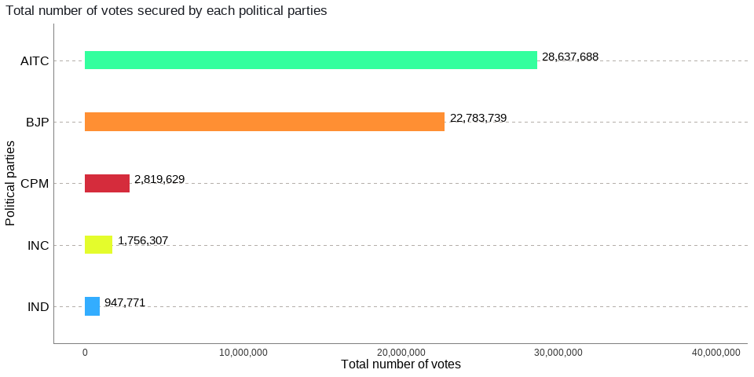

Figure 4: Total number of votes secured by each political party

**3.5 Total Percentage of Votes and the Total Number of Seats won by Parties**

The analysis in figure 5 indicates that TMC emerged victorious with 48% of the total popular votes, while the opposition BJP got 39% of the popular votes. The CPM managed to win 5% of the votes followed by the Congress and Independents with 3% and 2% of the popular votes, respectively. This shows that the contest was highly polarized and bipolar between the incumbent Trinamool Congress (AITC) and the opposition Bharatiya Janata Party (BJP).

As indicated in figure 6 below, TMC won 213 (73% of total seats), whereas the BJP came to a distant second with 77 (26%) seats, even though it raised its stock significantly in the West Bengal Assembly from its 2016 tally of a meager 3 seats.

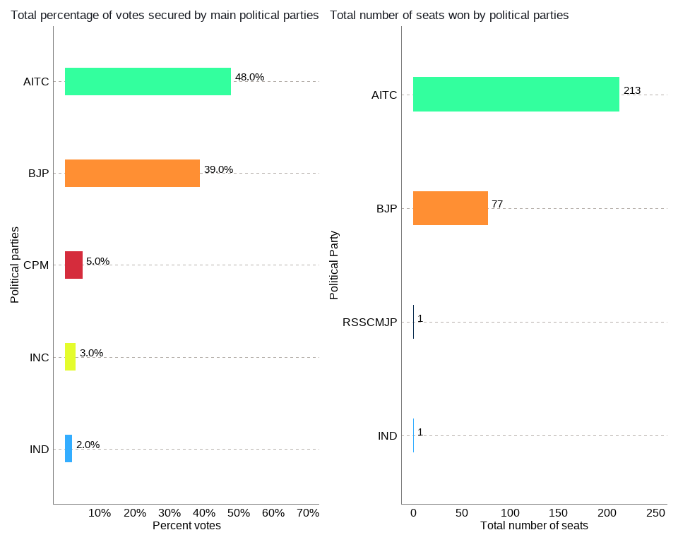

Figure 5 (left): Total percentage of votes secured by each political party

Figure 6 (right): Total number of seats secured by each political party

## 

**3.6 Total Number of Seats Secured by Each Political Party Per Region**

As per figure 7 below, TMC won the largest proportions of seats in the Presidency (TMC: 111 vs. BJP: 16) and Burdwan (TMC: 79 vs. BJP: 31) divisions whereas BJP emerged as a dominant force in the Jalpaiguri division (BJP 30 vs. TMC 23).

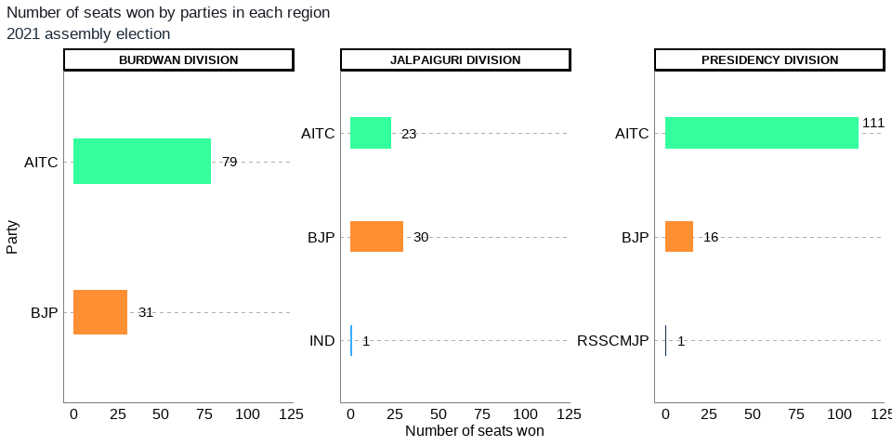

Figure 7: Total number of seats secured by each political party per region

**3.7 Seats by Constituency Type**

As per the figure 8 below, TMC won 82% of the General (or non-reserved) (168 out of 206) seats, and it won 53% (36 out of 68) of the SC and 56% of the ST (9 out of 16) reserved seats.[9] TMC has done better electorally in General seats compared to SC and ST reserved seats. BJP won 18% of the total General or non-reserved (18 out of 206) seats and 47% of the SC (32 out of 68) and 44% of the ST (7 out of 16) reserved seats. The BJP has done better electorally in SC and ST seats compared to the General seats.

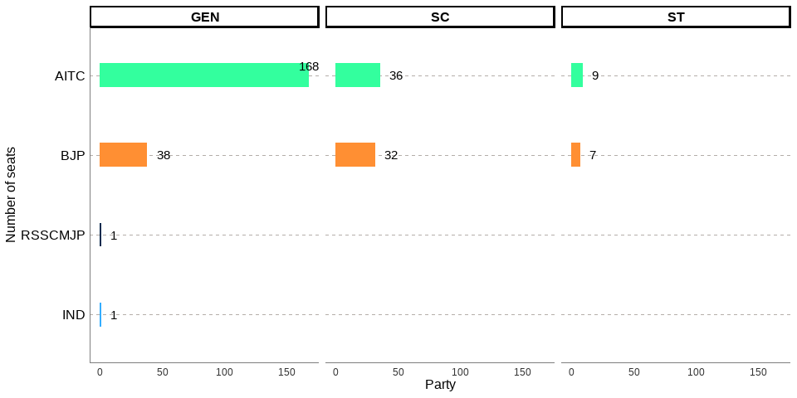

Figure 8: Winner by constituency type

## 3.8 Seats with a Victory Margin of 5000 or Below

The total number of candidates who won by a margin of 5000 or less was 35 or around 12% of the total assembly seats. Out of the total 35, 63% or 22 were won by BJP and 37% or 13 were won by TMC. This indicates that more candidates from BJP won by a lower margin than TMC.

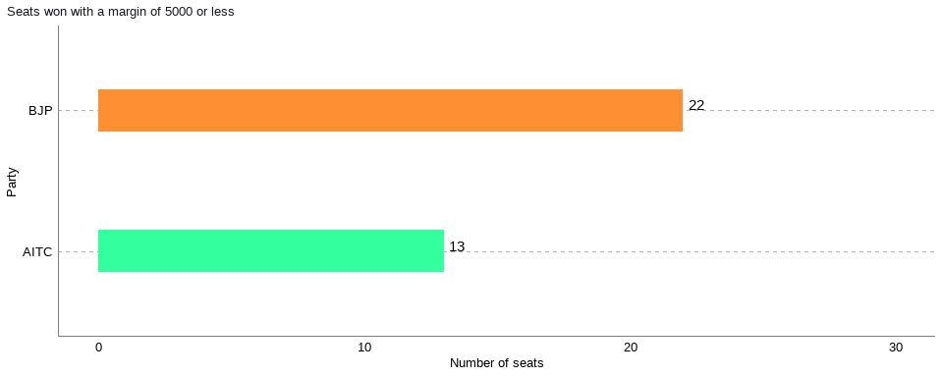

## Figure 9: Winner by a margin of 5000 or less

## 

## 3.9 Constituencies with Lower Voter Turnout

As depicted in figure 10 below, there were 5 constituencies with a turnout of 60% and below; in all these five constituencies the winning candidates were from the ruling TMC. However, since the seats with lower turnouts were just 5, this could just be a mere coincidence or some underlying factors that need to be further investigated if lower voter turnout favored one party over another in this state election.

## 

## Figure 10: Constituencies with lower voter turnout

## 3.10 Constituencies with Higher Voter Turnout

As per the figure 11 below, there were 10 constituencies with a turnout of 85 percent and above, and in these 10 constituencies, 7 were won by TMC, 2 by BJP, and 1 by Independents. Higher or lower voter turnout seems to be benefiting TMC. However, this could be a coincidental outcome as well, given TMC has a higher number of seats across the state when compared to BJP and these higher or lower turnout constituencies could be a reflection of the results across the state. This is something that needs to be investigated further.

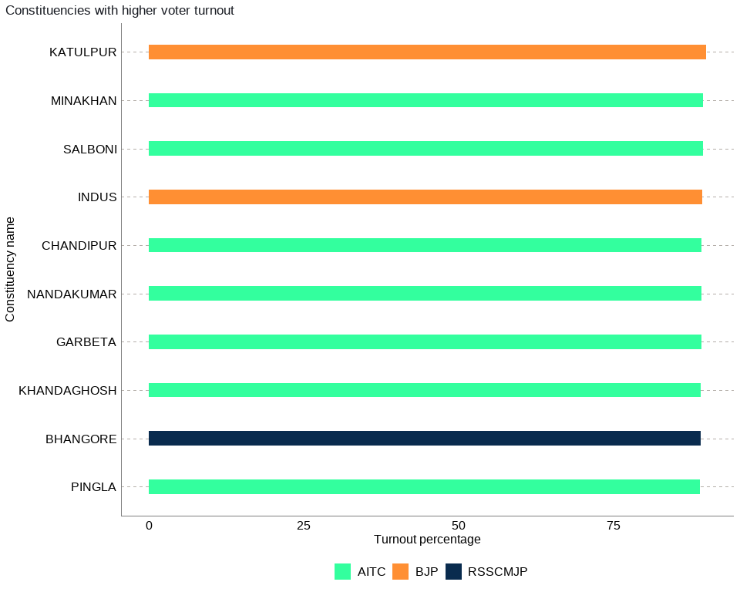

Figure 11: Constituencies with higher voter turnout

## 3.11 The Chief Minister’s Constituency

The Chief Minister Mamata Banerjee left her traditional safe seat and challenged her one-time confidante turned rival, Suvendu Adhikari, at his home turf in Nandigram. This contest was fierce and very close in which Suvendhu Adhikari of the BJP emerged victorious with a narrow margin of 1,956. Mamata Banerjee lost her seat, but her party, TMC, secured two-thirds of the majority in a fiercely fought West Bengal election. Eventually, she was elected Chief Minister of West Bengal for a straight third term.

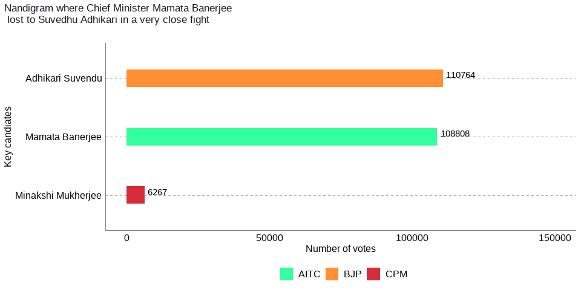

Figure 12: The Chief Minister’s Constituency

## 3.12 The Gender Split of Winners by Party

Mamata Banerjee is the first woman Chief Minister of West Bengal and today is the most prominent leader of not only Bengal but also in India. Let us look at the gender splits of MLAs in her party versus the opposition BJP.As per the figure 13 below, out of the total seats won by TMC, the seats won by women were 33 or 15.5% of the total seats of 213, whereas for the BJP it was 7 seats or 9% of the total seats of 77. The proportion of women who got elected as members of the legislative assembly (MLAs) on TMC tickets is higher than that of the BJP.

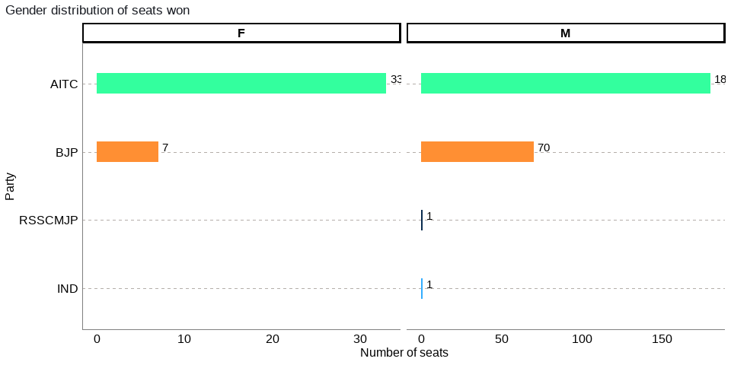

Figure 13: The gender split of winners by party

**4. ANALYSIS OF RESULTS: DISTRICT-WISE**

## 4.1 Results Summary Per District: Total number of seats secured by each political party by district

As illustrated in table 2 and figure 14 below, out of the total 19 districts, TMC bagged more seats than BJP in 12 districts (Bardhaman, Birbhum, Hooghly, Howrah, Kolkata Corporation, Maldah, Murshidabad, North 24 Parganas, Paschim Medinipur, Purba Medinipur, South 24 Parganas, and Uttar Dinajpur), whereas BJP had a bigger share of seats in only 6 districts (Bankura, Cooch Behar, Darjeeling, Jalpaiguri, Nadia, and Purulia). BJP did not win any seat in Howrah (16 seats), Kolkata Corporation (11 seats), and South 24 Parganas (30 seats) districts, whereas TMC did not win any seat in Darjeeling (6 seats).

Table 2: Total number of seats secured by each political party by district

|  |  |  |  |
| --- | --- | --- | --- |
| *S.No.* | *District Name* | *Party* | *Total Number of Seats* |
|  | Bankura | BJP | 8 |
|  | Bankura | AITC | 4 |
|  | Bardhaman | AITC | 22 |
|  | Bardhaman | BJP | 3 |
|  | Birbhum | AITC | 10 |
|  | Birbhum | BJP | 1 |
|  | Cooch Behar | BJP | 7 |
|  | Cooch Behar | AITC | 2 |
|  | Dakshin Dinajpur | AITC | 3 |
|  | Dakshin Dinajpur | BJP | 3 |
|  | Darjeeling | BJP | 5 |
|  | Darjeeling | IND | 1 |
|  | Hooghly | AITC | 14 |
|  | Hooghly | BJP | 4 |
|  | Howrah | AITC | 16 |
|  | Jalpaiguri | BJP | 9 |
|  | Jalpaiguri | AITC | 3 |
|  | Kolkata Corporation | AITC | 11 |
|  | Maldah | AITC | 8 |
|  | Maldah | BJP | 4 |
|  | Murshidabad | AITC | 18 |
|  | Murshidabad | BJP | 2 |
|  | Nadia | BJP | 9 |
|  | Nadia | AITC | 8 |
|  | North 24 Parganas | AITC | 28 |
|  | North 24 Parganas | BJP | 5 |
|  | Paschim Medinipur | AITC | 17 |
|  | Paschim Medinipur | BJP | 2 |
|  | Purba Medinipur | AITC | 9 |
|  | Purba Medinipur | BJP | 7 |
|  | Purulia | BJP | 6 |
|  | Purulia | AITC | 3 |
|  | South 24 Parganas | AITC | 30 |
|  | South 24 Parganas | RSSCMJP | 1 |
|  | Uttar Dinajpur | AITC | 7 |
|  | Uttar Dinajpur | BJP | 2 |

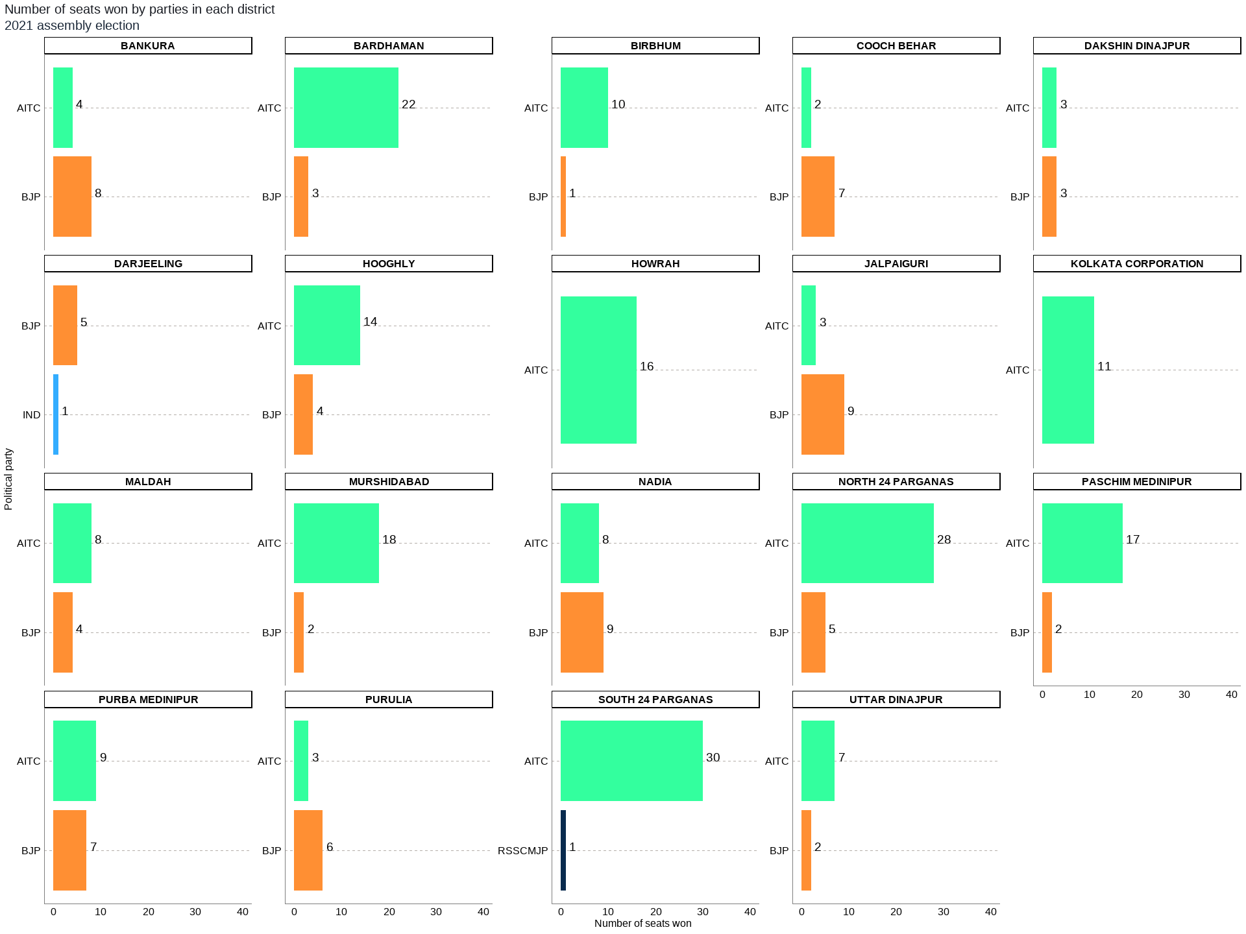

## Figure 14: Total number of seats secured by each political party by district

District-wise analysis of seats earned by each political party has been given below.

## 4.2 Bankura District

In accordance with the analysis in figure 15 below and Annex 1, the district of Bankura has a total of 12 legislative constituencies. The district has 6 reserved constituencies out of which 4 seats are reserved for the Scheduled Castes[10] (SC) community and 2 seats are reserved for the Scheduled Tribes[11] (ST) community. Seats reserved for SC include Saltora, Katulpur, Indus and Sonamukhi, and the seats reserved for ST include Ranibundh, and Raipur.

Out of the total 12 seats in the Bankura district, the largest number of seats i.e., 8 were won by the BJP while the AITC won 4 seats. The seats won by BJP were Saltora, Chhatna, Bankura, Onda, Bishnupur, Katulpur, Indus and Sonamukhi, and the seats won by AITC include Ranibundh, Raipur, Taldangra and Barjora.

Out of the total polled votes of 2,470,633, BJP secured a total of 1,119,399 (45%) votes, while the AITC secured 1,092,741 (44%) votes. The CPM with a vote share of 110,909 (4%) was on third place, while the INC was on the fourth position after securing 47,335 (2%) of the total votes in the district.

## 

## Figure 15: Bankura District: Winners per constituency and top 3 candidates

## 4.3. Bardhaman District

As the analysis in figure 16 below and Annex 2, district of Bardhaman has a total of 25 legislative constituencies. The district has 7 reserved constituencies, and all 7 seats are reserved for the Scheduled Castes (SC) community. Seats reserved for SC include Khandaghosh, Raina, Jamalpur, Kalna, Bardhaman Uttar, Ausgram and Galsi.

Out of the total 25 seats in the Bardhaman district, the largest number of seats i.e., 22 were won by the AITC, while the BJP won 3 seats. The seats won by AITC were Khandaghosh, Bardhaman Dakshin, Raina, Jamalpur, Monteswar, Kalna, Memari, Bardhaman Uttar, Bhatar, Purbasthali Dakshin, Purbasthali Uttar, Katwa, Ketugram, Mangalkot, Ausgram, Galsi, Pandabeswar, Durgapur Purba, Raniganj, Jamuria, Asansol Uttar and Barbani, and the seats won by BJP were Durgapur Paschim, Asansol Dakshin and Kulti.

Out of total polled votes of 5,044,003, AITC secured a total of 2,382,485 (47%) votes, while the BJP secured 2,062,687 (41%) votes. The CPM with a vote share of 404,042 (8%) was on third place, while the INC was on the fourth position after securing 60,824 (1%) of the total votes in the district.

## 

## Figure 16: Bardhaman District: Winners per constituency and top 3 candidates

## 4.4. Birbhum District

The figure 17 below and Annex 3 indicate that the district of Birbhum has 11 legislative constituencies. The district has 3 reserved constituencies, and all 3 seats are reserved for the Scheduled Castes (SC) community. Seats reserved for SC include Dubrajpur, Nanoor and Sainthia.

From total 11 seats in the Birbhum district, the largest number of seats i.e., 10 were won by the AITC, while the BJP won only 1 seat. The seats won by AITC were Suri, Bolpur, Nanoor, Labhpur, Sainthia, Mayureswar, Rampurhat, Hansan, Nalhati and Murarai, and the seat won by BJP was Dubrajpur.

Of total polled votes of 2,348,347, AITC secured 1,223,569 (52%) votes, while the BJP secured 931,633 (40%) of the total votes. The INC with a vote share of 65,369 (3%) was on third place, while the CPM was on the fourth position after securing 41,433 (2%) of the total votes in the district.

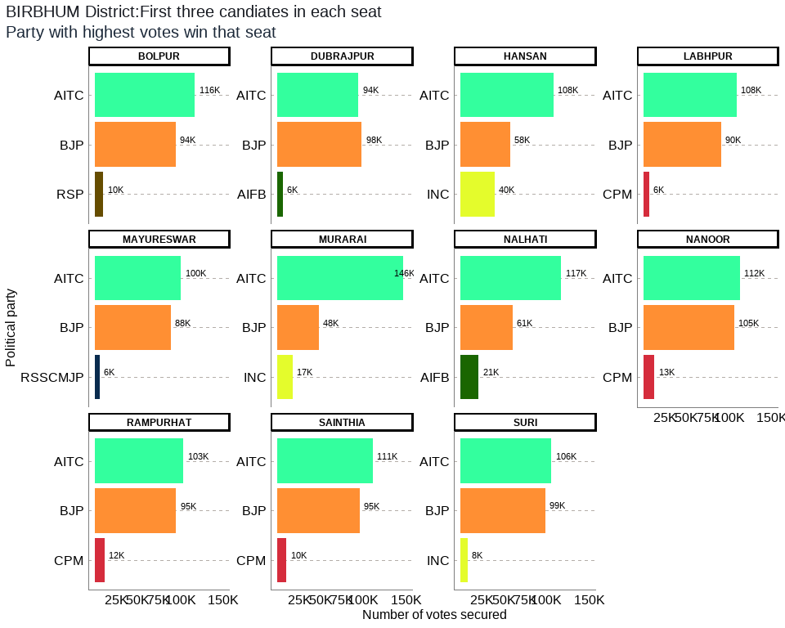

## Figure 17: Birbhum District: Winners per constituency and top 3 candidates

## 4.5. Cooch Behar District

The analysis presented in figure 18 below and Annex 4 highlights that the district of Cooch Behar has a total of 9 legislative constituencies. The district consists of 5 reserved constituencies and all 5 seats are reserved for the Scheduled Castes (SC) community. The seats reserved for SC include Mekliganj, Mathabhanga, Cooch Behar Uttar, Sitalkuchi and Sitai.

From total 9 seats in Cooch Behar district, the largest number of seats, i.e. 7, were won by the BJP, while the AITC won 2 seats. The seats won by BJP were Mathabhanga, Cooch Behar Uttar, Cooch Behar Dakshin, Sitalkuchi, Dinhata, Natabari and Tufanganj, and the seats won by AITC were Mekliganj and Sitai.

Out of the total polled votes of 1,991,218, the BJP secured a total of 984,977 (49%) votes, while the AITC secured 891,584 (45%) of the votes. The AIFB with a vote share of 34,643 (2%) was on third place, while the CPM was on the fourth position after securing 26,277 (1%) of the total votes in the district.

## 

## Figure 18: Cooch Bihar District: Winners per constituency and top 3 candidates

## 4.6. Dakshin Dinajpur District

The analysis depicted in figure 19 below and Annex 5 tells that the district of Dakshin Dinajpur has a total of 6 legislative constituencies. The district comprises 3 reserved constituencies out of which 2 seats are reserved for the Scheduled Castes (SC) community, whereas 1 seat is reserved for the Scheduled Tribes (ST) community. The seats reserved for SC community include Kushmandi and Gangarampur, and the seat reserved for ST includes Tapan.

Viewing the results, out of the total 6 seats in the Dakshin Dinajpur district, 3 seats each were won by the AITC and the BJP, respectively. The seats won by AITC were Kushmandi, Kumarganj and Harirampur, and the seats won by BJP include Balurghat, Tapan and Gangarampur.

Coming to the total polled votes of 1,061,300, AITC secured a total of 501,418 (47%) votes, while the BJP secured 456,473 (43%) of the votes. The RSP with a vote share of 40,812 (4%) was on third place, while the CPM was on the fourth position having secured 24,717 (2%) of the total votes in the district.

## 

## Figure 19: Dakshin Dinajpur District: Winners per constituency and top 3 candidates

## 4.7. Darjeeling District

Figure 20 below and Annex 6 reflect that the district of Darjeeling bears a total of 6 legislative constituencies. The district has 2 reserved constituencies out of which 1 seat is reserved for the Scheduled Castes (SC) community, whereas 1 seat is reserved for the Scheduled Tribes (ST) community. The seats reserved for SC include Matigara-Naxalbari, and the seat reserved for ST includes Phansidewa.

In Darjeeling district, the largest number of seats, i.e. 5, out of total 6, were won by the BJP, while the Independent candidate won 1 seat. The seats won by BJP were Darjeeling, Kurseong, Matigara-Naxalbari, Siliguri and Phansidewa, and the seat won by the Independent candidate was Kalimpong.

Looking at the votes distribution, BJP secured a total of 531,524 (48%) votes from total polled votes of 1,110,136, while the Independents secured 290,173 (26%) of the votes. The AITC with a vote share of 200,661 (18%) was on third place, while the INC was on the fourth position with a share of 37,590 (3%).

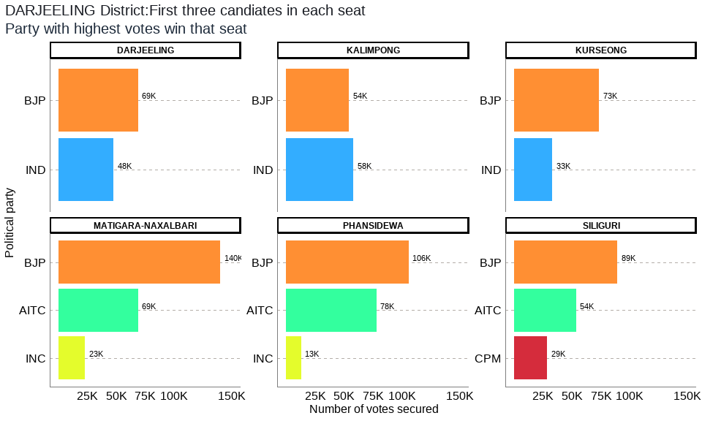

## Figure 20: Darjeeling District: Winners per constituency and top 3 candidates

## 4.8. Hooghly District

According to the analysis portrayed in figure 21 below and Annex 7, the district of Hooghly comprises a total of 18 legislative constituencies. The district has 4 reserved constituencies and all 4 seats are reserved for the Scheduled Castes (SC) community. Seats reserved for SC include Balagarh, Dhanekhali, Arambag and Goghat.

From total 18 seats in the Hooghly district, the largest number of seats, i.e. 14, were won by the AITC, while 4 seats were won by the BJP. The seats won by AITC were Uttarpara, Sreerampur, Champdani, Singur, Chandannagore, Chunchura, Balagarh, Pandua, Saptagram, Chanditala, Jangipara, Haripal, Dhanekhali and Tarakeswar, and the seats won by BJP were Pursurah, Arambag, Goghat and Khanakul.

Out of the total polled votes of 3,778,058, AITC secured a total of 1,805,779 (48%) votes while the BJP secured 1,525,889 (40%) of the votes. The CPM with a vote share of 234,397 (6%) was on third place, while the INC was on the fourth position having secured 67,866 (2%) of the total votes in the district.

## 

Figure 21: Hooghly District: Winners per constituency and top 3 candidates

## 4.9. Howrah District

With regard to the analysis given in figure 22 below and Annex 8, the district of Howrah possesses a total of 16 legislative constituencies. The district comprises 2 reserved constituencies and both the seats are reserved for the Scheduled Castes (SC) community. Seats reserved for SC are Sankrail and Uluberia Uttar.

Out of the total 16 seats in the Howrah district, all seats, i.e. 16, were won by the AITC. The seats won by AITC were Bally, Howrah Uttar, Howrah Madhya, Shibpur, Howrah Dakshin, Sankrail, Panchla, Uluberia Purba, Uluberia Uttar, Uluberia Dakshin, Shyampur, Bagnan, Amta, Udaynarayanpur, Jagatballavpur and Domjur.

What was the distribution of polled votes of 3,176,015? The AITC secured a total of 1,613,916 (51%) votes, while the BJP secured 1,159,043 (36%) of the votes. The CPM with a vote share of 148,219 (5%) remained on third place, while the RSSCMJP came on to the fourth position with the vote share of 91,396 (3%) in the district.

## 

Figure 22: Howrah District: Winners per constituency and top 3 candidates

## 4.10. Jalpaiguri District

The analysis in figure 23 below and Annex 9 reveals that the district of Jalpaiguri has a total of 12 legislative constituencies. The district has 10 reserved constituencies out of which 5 seats are reserved for the Scheduled Castes (SC) community and 5 seats reserved for the Scheduled Tribes (ST) community. The seats reserved for SC are Falakata, Dhupguri, Maynaguri, Jalpaiguri and Rajganj, whereas the seats reserved for ST include Kumargram, Kalchini, Madarihat, Mal and Nagrakata.

Of the total 12 seats in the Jalpaiguri district, the largest number of seats, i.e. 9, were won by the BJP, while the AITC won 3 seats. The seats won by BJP were Kumargram, Kalchini, Alipurduars, Falakata, Madarihat, Dhupguri, Maynaguri, Dabgram-Phulbari and Nagrakata, and the seats won by AITC were Jalpaiguri, Rajganj and Mal.

Analysis of the total polled votes of 2,553,048 suggests that BJP secured a total of 1,226,127 (48%) votes, while the AITC secured 1,096,150 (43%) of the votes. The CPM having a vote share of 64,914 (3%) was on third place, while the INC was on the fourth place after obtaining 56,962 (2%) of the total votes in the district.

## 

Figure 23: Jalpaiguri District: Winners per constituency and top 3 candidates

## 4.11. Kolkata Corporation District

As per the analysis in figure 24 below and Annex 10, the district of Kolkata Corporation comprises a total of 11 legislative constituencies. The district has no reserved constituency.

From total 11 seats in the Kolkata Corporation district, all seats, i.e. 11, were won by the AITC. The seats won by AITC were Kolkata Port, Bhabanipur, Rashbehari, Ballygunge, Chowrangee, Entally, Beleghata, Jorasanko, Shyampukur, Maniktala and Kashipur-Belgachia.

Break up of total polled votes of 1,269,450 indicates that AITC secured a total of 787,308 (62%) votes, while the BJP secured 365,982 (29%) of the votes. The INC having a vote share of 40,150 (3%) reached on third place, while the CPM was on the fourth position after securing 33,142 (3%) of the total votes in the district.

## 

Figure 24: Kolkata Corporation District: Winners per constituency and top 3 candidates

## 4.12. Maldah District

The analysis in figure 25 below and Annex 11 shows that the district of Maldah has a total of 12 legislative constituencies. The district has 3 reserved constituencies out of which 2 seats are reserved for the Scheduled Castes (SC) community and 1 seat reserved for the Scheduled Tribes (ST) community. The seats reserved for SC include Gazole and Maldaha and the seat reserved for ST includes Habibpur.

The results of total 12 seats in the Maldah district indicate that the largest number of seats, i.e. 8, were won by the AITC with the BJP having won 4 seats. The seats won by AITC were Chanchal, Harischandrapur, Malatipur, Ratua, Manickchak, Mothabari, Sujapur and Baishnab Nagar, while the seats won by BJP were Habibpur, Gazole, Maldaha and Englishbazar.

Out of the total polled votes of 2,412,438, AITC attained a total of 1,277,474 (53%) votes, while the BJP secured 791,356 (33%) of the votes. The INC with a vote share of 211,488 (9%) came on third place, with the CPM at the fourth place having secured 38,708 (2%) in the total votes in the district.

## 

Figure 25: Maldah District: Winners per constituency and top 3 candidates

## 4.13. Murshidabad District

As per the analysis shown in figure 26 below and Annex 12, the district of Murshidabad consists of a total of 20 legislative constituencies. The district has 3 reserved constituencies and all 3 seats are reserved for the Scheduled Castes (SC) community. The seats reserved for SC include Nabagram, Khargram and Burwan.

From the total 20 seats in the Murshidabad district, the largest number of seats, i.e. 18, were secured by the AITC, with the BJP securing 2 seats. The seats won by AITC were Farakka, Suti, Raghunathganj, Sagardighi, Lalgola, Bhagabangola, Raninagar, Nabagram, Khargram, Burwan, Kandi, Bharatpur, Rejinagar, Beldanga, Hariharpara, Naoda, Domkal and Jalangi. The seats won by BJP were Murshidabad and Baharampur.

Seeing the distribution of total polled votes of 4,029,623, AITC had secured a total of 2,174,705 (54%) votes, while the BJP got 967,637 (24%) of the votes. The INC received 557,285 (14%) reaching the third place, and the CPM came on the fourth position having secured 211,922 (5%) of the total votes during the election.

## 

Figure 26: Murshidabad District: Winners per constituency and top 3 candidates

## 4.14. Nadia District

Data in figure 27 below and Annex 13 reveals that the district of Nadia has a total of 17 legislative constituencies. The district comprises 5 reserved constituencies and all 5 seats are reserved for the Scheduled Castes (SC) community. Seats reserved for SC include Krishnaganj, Ranaghat Uttar Purba, Ranaghat Dakshin, Kalyani and Haringhata.

The largest number of seats (i.e., 9 out of the total 17 seats) were won by the BJP, while the AITC got 8 seats. The seats won by BJP were Krishnanagar Uttar, Santipur, Ranaghat Uttar Paschim, Krishnaganj, Ranaghat Uttar Purba, Ranaghat Dakshin, Chakdaha, Kalyani and Haringhata. On the other hand, the seats won by AITC were Karimpur, Tehatta, Palashipara, Kaliganj, Nakashipara, Chapra, Nabadwip and Krishnanagar Dakshin.

AITC secured a total of 1,611,050 (44%) votes out of total polled votes of 3,625,258, while the BJP secured 1,590,147 (44%) of the votes. The CPM with a vote share of 208,699 (6%) was on third place, while the Independents were on the fourth position after securing 99,485 (3%) of the total votes.

## 

Figure 27: Nadia District: Winners per constituency and top 3 candidates

## 4.15. North 24 Parganas

As per the analysis given in figure 28 below and Annex 14, the district of North 24 Parganas is divided into total of 33 legislative constituencies. The district has 8 reserved constituencies out of which 7 seats are reserved for the Scheduled Castes (SC) community and 1 seat reserved for the Scheduled Tribes (ST) community. The seats reserved for SC include Bagdah, Bongaon Uttar, Bongaon Dakshin, Gaighata, Swarupnagar, Minakhan and Hingalganj, whereas the seat reserved for ST includes Sandeshkhali.

Total 33 seats in the North 24 Parganas district were analyzed. The largest number of seats, i.e. 28, were secured by the AITC, while the BJP got 5 seats. The seats won by AITC were Swarupnagar, Baduria, Habra, Ashoknagar, Amdanga, Bijpur, Naihati, Jagatdal, Noapara, Barrackpur, Khardaha, Dum Dum Uttar, Panihati, Kamarhati, Baranagar, Dum Dum, Rajarhat New Town, Bidhannagar, Rajarhat Gopalpur, Madhyamgram, Barasat, Deganga, Haroa, Minakhan, Sandeshkhali, Basirhat Dakshin, Basirhat Uttar and Hingalganj. On the other side, the seats secured by BJP were Bagdah, Bongaon Uttar, Bongaon Dakshin, Gaighata and Bhatpara.

The total polled votes of 6,380,727 were analyzed. The AITC secured a total of 3,131,141 (49%) votes, whereas the BJP secured 2,217,198 (35%) of the votes. The CPM having 368,123 (6%) votes was on third place, with the RSSCMJP on the fourth position after securing 322,688 (5%) of the total votes.

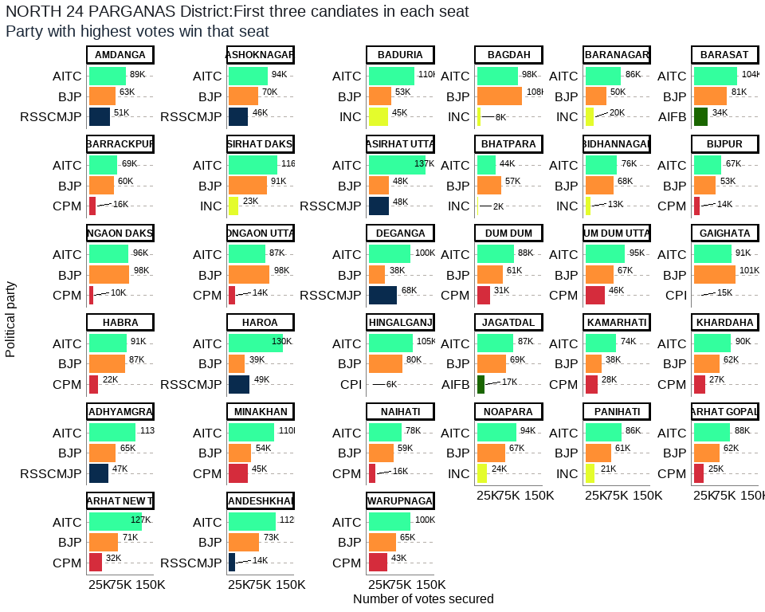

Figure 28: North 24 Parganas: Winners per constituency and top 3 candidates

## 4.16. Paschim Medinipur District

In accordance with the data shown in figure 29 below and Annex 15, the district of Paschim Medinipur has a total of 19 legislative constituencies. The district has 6 reserved constituencies out of which 3 seats are reserved for the Scheduled Castes (SC) community and another 3 seats are reserved for the Scheduled Tribes (ST) community. The seats reserved for SC include Ghatal, Chandrakona and Keshpur, and the seats reserved for ST include Nayagram, Keshiary and Binpur.

Of 19 seats in the Paschim Medinipur district, the largest number of seats (i.e., 17) were occupied by the AITC, with the BJP secured 2 seats. The seats won by AITC were Dantan, Nayagram, Gopiballavpur, Jhargram, Keshiary, Narayangarh, Sabang, Pingla, Kharagpur, Debra, Daspur, Chandrakona, Garbeta, Salboni, Keshpur, Medinipur and Binpur. Likewise, the seats won by BJP were Kharagpur Sadar and Ghatal.

From the total polled votes of 4,028,773, AITC secured a total of 2,023,763 (50%) votes with the BJP having secured 1,695,443 (42%) votes. The CPM having vote share of 168,713 (4%) was on third place, while the INC was on the fourth place with 35,337 (1%) of the total votes in the district.

## 

Figure 29: Paschim Medinipur: Winners per constituency and top 3 candidates

## 4.17. Purba Medinipur District

As per the analysis contained in the figure 30 below and Annex 16, the district of Purba Medinipur has a total of 16 legislative constituencies. The district comprises 2 reserved constituencies and both the seats are reserved for the Scheduled Castes (SC) community. Seats reserved for SC include Haldia and Khejuri.

Out of the total 16 seats in the Purba Medinipur district, the largest number of seats (i.e. 9) were won by the AITC while the BJP won 7 seats. The seats secured by AITC were Tamluk, Panskura Purba, Panskura Paschim, Nandakumar, Mahisadal, Chandipur, Patashpur, Ramnagar and Egra. BJP won the seats of Moyna, Haldia, Nandigram, Kanthi Uttar, Bhagabanpur, Khejuri and Kanthi Dakshin.

The distribution of polled votes of 3,519,791 shows that BJP secured a total of 1,660,061 (47%) votes while the AITC secured 1,658,308 (47%) of the votes. On the third position was the CPM having a vote share of 93,358 (3%), while the CPI was at the fourth position after securing 42,487 (1%) in the total votes in the district.

## 

Figure 30: Purba Medinipur: Winners per constituency and top 3 candidates

## 4.18. Purulia District

As per the analysis depicted in the figure 31 below and Annex 17 data, the district of Purulia comprises a total of 9 legislative constituencies, from which 4 are reserved constituencies. Out of those 4, 2 seats are reserved for the Scheduled Castes (SC) community, whereas 2 seats are reserved for the Scheduled Tribes (ST) community. The seats reserved for SC include Para and Raghunathpur, and the seats reserved for ST include Bandwan and Manbazar.

Out of the 9 seats in the Purulia district, the largest number of seats (i.e., 6) were received by the BJP, while the AITC got 3 seats. The seats won by BJP were Balarampur, Joypur, Purulia, Kashipur, Para and Raghunathpur, and the seats won by AITC include Bandwan, Baghmundi and Manbazar.

Of the total polled votes of 1,847,059, the AITC obtained a total of 723,576 (39%) votes, with the BJP securing 711,977 (39%) votes. The INC came on third position with a vote share of 147,117 (8%), when the CPM was on the fourth position with 78,399 (4%) votes.

## 

Figure 31: Purulia District: Winners per constituency and top 3 candidates

## 4.19. South 24 Parganas District

According to the data in figure 32 below and Annex 18, the district of South 24 Parganas comprises a total of 31 legislative constituencies, from which 9 are reserved constituencies, and all 9 seats are reserved for the Scheduled Castes (SC) community. The seats reserved for SC include Gosaba, Basanti, Kultali, Mandirbazar, Jaqynagar, Baruipur Purba, Canning Paschim, Magrahat Purba and Bishnupur (SC).

Out of the total 31 seats in the South 24 Parganas district, the largest number of seats (i.e. 30) were obtained by the AITC, while the RSSCMJP got only 1 seat. The seats won by AITC were Gosaba, Basanti, Kultali, Patharpratima, Kakdwip, Sagar, Kulpi, Raidighi, Mandirbazar, Jaqynagar, Baruipur Purba, Canning Paschim, Canning Purba, Baruipur Paschim, Magrahat Purba, Magrahat Paschim, Diamond Harbour, Falta, Satgachia, Bishnupur (SC), Sonarpur Dakshin, Kasba, Jadavpur, Sonarpur Uttar, Tollygunj, Behala Purba, Behala Paschim, Maheshtala, Budge Budge and Metiaburuz. The seats secured by RSSCMJP included Bhangore.

From total polled votes of 6,734,075, AITC secured a total of 3,523,407 (52%) votes, while the BJP secured 2,142,477 (32%) of the votes. The CPM with a vote share of 508,632 (8%) was on third place, while the RSSCMJP was on the fourth position with 281,963 (4%) votes in the district.

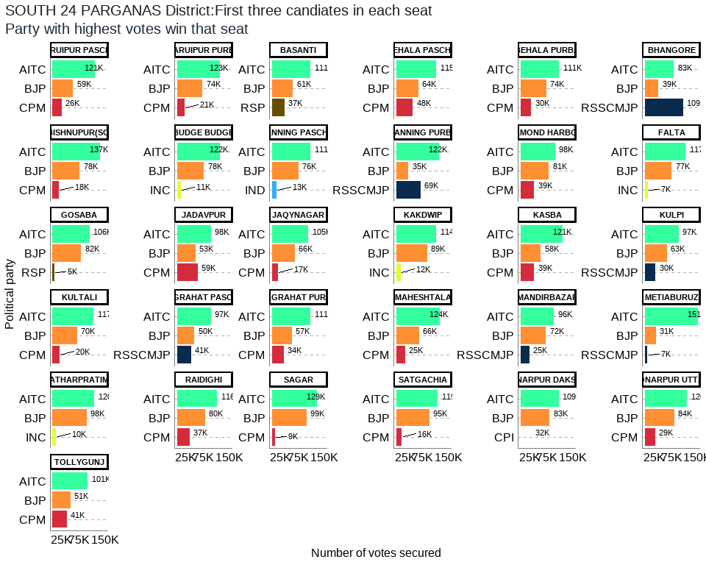

Figure 32: South 24 Parganas District: Winners per constituency and top 3 candidates

## 4.20. Uttar Dinajpur District

Figure 33 below and Annex 19 demonstrate that the district of Uttar Dinajpur has a total of 9 legislative constituencies, with 2 reserved constituencies for the Scheduled Castes (SC) community. These seats reserved for SC include Hemtabad and Kaliaganj.

Who secured what out of the total 9 seats in the Uttar Dinajpur district? The largest number of seats (i.e. 7) went to AITC, while the BJP got 2 seats. The seats won by AITC were Chopra, Islampur, Goalpokhar, Chakulia, Karandighi, Hemtabad and Itahar, while the seats obtained by BJP included Kaliaganj and Raiganj.

Out of the total polled votes of 1,722,482, AITC secured a total of 918,653 (53%) votes while the BJP secured 643,709 (37%) of the votes. The INC having a vote share of 56,820 (3%) remained on third place, whereas the AIFB reached to the fourth position after securing 37,850 (2%) votes in the district.

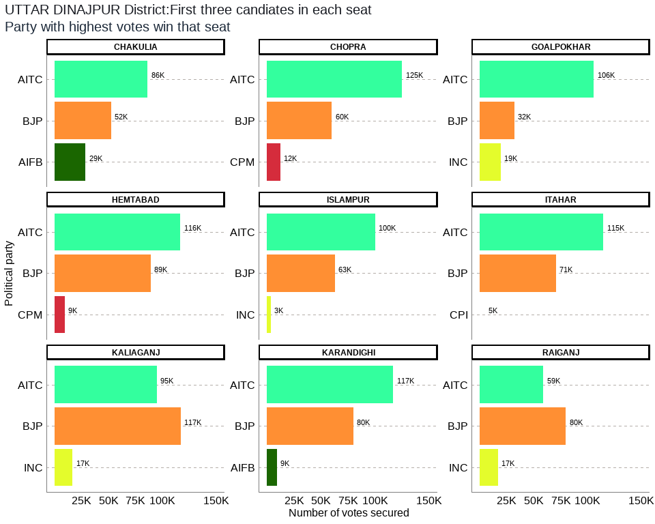

Figure 33: Uttar Dinajpur District: Winners per constituency and top 3 candidates

## 5. CONCLUSION

The AITC won the election comprehensively, while the BJP consolidated its position as the main opposition party in West Bengal relegating the Left parties and Congress to an insignificant player in the politics of West Bengal. After the West Bengal 2021 election results, Mamata Banerjee emerged as one of the main challengers of BJP at the national arena of Indian politics. What lessons Bengal election offers to the country remains to be seen yet, but the state and central government’s handling of the second wave of Covid-19 crisis (in which many Indians lost lives) and associated social and economic crisis has kept the political battle open for the forthcoming Uttar P radish election in 2022 and the India’s general election in 2024. It has also infused fresh energy in opposition parties to challenge the election machinery and public image of Prime Minister Narendra Modi. With the global and national uncertainties looming large due to the Covid-19 crisis and a prediction of the third wave of the virus in the country, governments both at the state and the central level need to do much more than business as usual to win the trust of the people, if they want to acquire significant position in elections

## References

Bhattacharya, A. (2021). Why did the BJP lose Bengal 2021? India Today, 3 May 2021. Retrieved from [<https://www.indiatoday.in/news-analysis/story/why-did-bjp-lose-bengal-elections-2021-1798260-2021-05-03>](https://www.indiatoday.in/news-analysis/story/why-did-bjp-lose-bengal-elections-2021-1798260-2021-05-03)

Chaturvedi, R. M. (2021). ET Analysis: How TMC beat BJP at its own game in West Bengal elections. Economic Times, 4 May 2021. Retrieved from [<https://m.economictimes.com/news/elections/assembly-elections/west-bengal/et-analysis-tmc-beat-bjp-at-its-own-game-turned-around-saffron-poll-planks-for-its-own-gains/amp_articleshow/82383821.cms>](https://m.economictimes.com/news/elections/assembly-elections/west-bengal/et-analysis-tmc-beat-bjp-at-its-own-game-turned-around-saffron-poll-planks-for-its-own-gains/amp_articleshow/82383821.cms)

Dasgupta, S. (2021). Lessons learnt The results of the West Bengal assembly elections deserve a close analysis. The Telegraph, 3 May 2021. Retrieved from [<https://www.telegraphindia.com/opinion/the-results-of-the-west-bengal-assembly-elections-deserve-a-close-analysis/cid/1815369>](https://www.telegraphindia.com/opinion/the-results-of-the-west-bengal-assembly-elections-deserve-a-close-analysis/cid/1815369)

Ghatak, M., & Maitra, P. (2021). 2021 West Bengal Assembly election: Did the Covid-19 surge matter? Ideas for India, 12 May 2021. Retrieved from [<https://www.ideasforindia.in/topics/governance/2021-west-bengal-assembly-election-did-the-covid-19-surge-matter.html>](https://www.ideasforindia.in/topics/governance/2021-west-bengal-assembly-election-did-the-covid-19-surge-matter.html)

Iyengar, P. (2021). Statistical Afternotes: TMC May Have Won Bengal, but BJP Did Not Do Badly. The Wire, 7 May 2021. Retrieved from [<https://thewire.in/politics/statistical-afternotes-tmc-may-have-won-bengal-but-bjp-did-not-do-badly>](https://thewire.in/politics/statistical-afternotes-tmc-may-have-won-bengal-but-bjp-did-not-do-badly)

Kishore, R., & Jha, A. (2021). West Bengal Assembly Election: 3 crucial takeaways from Bengal results. Hindustan Times, 4 May 2021. Retrieved from <https://www.hindustantimes.com/elections/west-bengal-assembly-election/3-crucial-takeaways-from-bengal-results-101620086556255.html>

Tiwari, A. (2021). In Charts: How Mamata Banerjee Scripted A Record Win In West Bengal*.* BloombergQuint, 6 May 2021. Retrieved from [<https://www.bloombergquint.com/politics/how-mamata-banerjee-scripted-a-record-win-in-west-bengal-election-results-2021-in-charts>](https://www.bloombergquint.com/politics/how-mamata-banerjee-scripted-a-record-win-in-west-bengal-election-results-2021-in-charts)

Annex 1:Bankura District Election Results: Top 3 Candidates by Votes in Each Constituency

| *Constituency* | *Type* | *Party* | *Candidate* | *Position* | *Votes* | *Margin* |
| --- | --- | --- | --- | --- | --- | --- |
| BANKURA | GEN | BJP | Niladri Sekhar Dana | 1 | 95,466 | 1,468 |
| BANKURA | GEN | AITC | Sayantika Banerjee | 2 | 93,998 | 80,234 |
| BANKURA | GEN | INC | Radharani Banerjee | 3 | 13,764 | 9,257 |
| BARJORA | GEN | AITC | Alok Mukherjee | 1 | 93,290 | 3,269 |
| BARJORA | GEN | BJP | Supriti Chatterjee | 2 | 90,021 | 64,786 |
| BARJORA | GEN | CPM | Sujit Chakraborty | 3 | 25,235 | 20,332 |
| BISHNUPUR | GEN | BJP | Tanmay Ghosh (Bumba) | 1 | 89,689 | 11,420 |
| BISHNUPUR | GEN | AITC | Archita Bid | 2 | 78,269 | 62,455 |
| BISHNUPUR | GEN | INC | Debu Chatterjee | 3 | 15,814 | 12,395 |
| CHHATNA | GEN | BJP | Satyanarayan Mukhopadhyay | 1 | 90,233 | 7,164 |
| CHHATNA | GEN | AITC | Subasish Batabyal | 2 | 83,069 | 73,369 |
| CHHATNA | GEN | RSP | Falguni Mukherjee | 3 | 9,700 | 6,186 |
| INDUS | SC | BJP | Nirmal Kumar Dhara | 1 | 104,936 | 7,220 |
| INDUS | SC | AITC | Runu Mete | 2 | 97,716 | 85,097 |
| INDUS | SC | CPM | Nayan Kumar Shill (Bagdi) | 3 | 12,619 | 9,437 |
| KATULPUR | SC | BJP | Harakali Protiher | 1 | 106,022 | 11,785 |
| KATULPUR | SC | AITC | Sangeeta Malik | 2 | 94,237 | 76,480 |
| KATULPUR | SC | INC | Akshay Santra | 3 | 17,757 | 15,238 |
| ONDA | GEN | BJP | Amarnath Shakha | 1 | 104,940 | 11,551 |
| ONDA | GEN | AITC | Arup Kumar Khan | 2 | 93,389 | 77,776 |
| ONDA | GEN | AIFB | Tarapada Chakrabarti | 3 | 15,613 | 10,734 |
| RAIPUR | ST | AITC | Mrityunjoy Murmu | 1 | 101,043 | 19,398 |
| RAIPUR | ST | BJP | Sudhanshu Hansda | 2 | 81,645 | 75,052 |
| RAIPUR | ST | RSSCMJP | Milan Mandi | 3 | 6,593 | 3,607 |
| RANIBUNDH | ST | AITC | Jyotsna Mandi | 1 | 90,928 | 3,939 |
| RANIBUNDH | ST | BJP | Kshudiram Tudu | 2 | 86,989 | 66,932 |
| RANIBUNDH | ST | CPM | Deblina Hembram | 3 | 20,057 | 15,250 |
| SALTORA | SC | BJP | Bauri Chandana | 1 | 91,648 | 4,145 |
| SALTORA | SC | AITC | Sontosh Kumar Mondal | 2 | 87,503 | 73,419 |
| SALTORA | SC | CPM | Nandadulal Bauri | 3 | 14,084 | 10,530 |
| SONAMUKHI | SC | BJP | Dibakar Gharami | 1 | 98,161 | 10,888 |
| SONAMUKHI | SC | AITC | Dr. Shyamal Santra | 2 | 87,273 | 71,548 |
| SONAMUKHI | SC | CPM | Ajit Ray | 3 | 15,725 | 12,953 |
| TALDANGRA | GEN | AITC | Arup Chakraborty | 1 | 92,026 | 12,377 |
| TALDANGRA | GEN | BJP | Shyamal Kumar Sarkar (Benu) | 2 | 79,649 | 56,460 |
| TALDANGRA | GEN | CPM | Manoranjan Patra | 3 | 23,189 | 19,671 |

## Annex 2: Bardhaman District Election Results: Top 3 Candidates by Votes in Each Constituency

| *Constituency* | *Type* | *Party* | *Candidate* | *Position* | *Votes* | *Margin* |
| --- | --- | --- | --- | --- | --- | --- |
| Asansol Dakshin | GEN | BJP | Agnimitra Paul | 1 | 87,881 | 4,487 |
| Asansol Dakshin | GEN | AITC | Sayani Ghosh | 2 | 83,394 | 67,422 |
| Asansol Dakshin | GEN | CPM | Prasanta Ghosh | 3 | 15,972 | 12,506 |
| Asansol Uttar | GEN | AITC | Ghatak Moloy | 1 | 100,931 | 21,110 |
| Asansol Uttar | GEN | BJP | Krishnendu Mukherjee | 2 | 79,821 | 75,350 |
| Asansol Uttar | GEN | RSSCMJP | Mohammad Mustaqim | 3 | 4,471 | 1,123 |
| Ausgram | SC | AITC | Abhedananda Thander | 1 | 100,392 | 11,815 |
| Ausgram | SC | BJP | Kalita Maji | 2 | 88,577 | 68,178 |
| Ausgram | SC | CPM | Chanchal Kumar Majhi | 3 | 20,399 | 16,360 |
| Barbani | GEN | AITC | Bidhan Upadhyay | 1 | 88,430 | 23,457 |
| Barbani | GEN | BJP | Arijit Roy | 2 | 64,973 | 56,011 |
| Barbani | GEN | INC | Ranendra Nath Bagchi | 3 | 8,962 | 5,923 |
| Bardhaman Dakshin | GEN | AITC | Khokan Das | 1 | 91,015 | 8,105 |
| Bardhaman Dakshin | GEN | BJP | Sandip Nandi | 2 | 82,910 | 59,564 |
| Bardhaman Dakshin | GEN | CPM | Pritha Tah | 3 | 23,346 | 19,639 |
| Bardhaman Uttar | SC | AITC | Nisith Kumar Malik | 1 | 111,211 | 17,268 |
| Bardhaman Uttar | SC | BJP | Radha Kanta Roy | 2 | 93,943 | 62,915 |
| Bardhaman Uttar | SC | CPM | Chandi Choran Let | 3 | 31,028 | 27,681 |
| Bhatar | GEN | AITC | Adhikari Mangobinda | 1 | 108,028 | 31,741 |
| Bhatar | GEN | BJP | Mahendranath Kowar | 2 | 76,287 | 56,680 |
| Bhatar | GEN | CPM | Nazrul Haque | 3 | 19,607 | 15,261 |
| Durgapur Paschim | GEN | BJP | Lakshman Chandra Ghorui | 1 | 91,186 | 14,664 |
| Durgapur Paschim | GEN | AITC | Biswanath Parial | 2 | 76,522 | 58,492 |
| Durgapur Paschim | GEN | INC | Debesh Chakraborty | 3 | 18,030 | 15,406 |
| Durgapur Purba | GEN | AITC | Pradip Mazumdar | 1 | 79,303 | 3,746 |
| Durgapur Purba | GEN | BJP | Colonel Diptansu Chaudhury | 2 | 75,557 | 46,494 |
| Durgapur Purba | GEN | CPM | Abhas Ray Chaudhuri | 3 | 29,063 | 26,435 |
| Galsi | SC | AITC | Nepal Ghorui | 1 | 109,504 | 19,262 |
| Galsi | SC | BJP | Bikash Biswas | 2 | 90,242 | 73,222 |
| Galsi | SC | AIFB | Nandalal Pondit | 3 | 17,020 | 13,502 |
| Jamalpur | SC | AITC | Alok Kumar Majhi | 1 | 96,999 | 17,971 |
| Jamalpur | SC | BJP | Balaram Bapari | 2 | 79,028 | 55,730 |
| Jamalpur | SC | CPM | Samar Hazra | 3 | 23,298 | 20,433 |
| Jamuria | GEN | AITC | Hareram Singh | 1 | 71,002 | 8,051 |
| Jamuria | GEN | BJP | Tapas Kumar Roy | 2 | 62,951 | 38,133 |
| Jamuria | GEN | CPM | Aishe Ghosh | 3 | 24,818 | 22,409 |
| Kalna | SC | AITC | Deboprasad Bag (Poltu) | 1 | 96,073 | 7,478 |
| Kalna | SC | BJP | Biswajit Kundu | 2 | 88,595 | 69,590 |
| Kalna | SC | CPM | Nirab Khan | 3 | 19,005 | 16,498 |
| Katwa | GEN | AITC | Rabindranath Chatterjee | 1 | 107,894 | 9,155 |
| Katwa | GEN | BJP | Shyama Majumdar | 2 | 98,739 | 85,763 |
| Katwa | GEN | INC | Prabir Ganguli | 3 | 12,976 | 11,196 |
| Ketugram | GEN | AITC | Sekh Sahonawez | 1 | 100,226 | 12,683 |
| Ketugram | GEN | BJP | Anadi Ghosh (Mathura) | 2 | 87,543 | 67,451 |
| Ketugram | GEN | CPM | Mizanul Kabir (Dhiraj) | 3 | 20,092 | 16,472 |
| Khandaghosh | SC | AITC | Nabin Chandra Bag | 1 | 104,264 | 20,886 |
| Khandaghosh | SC | BJP | Bijan Mandal | 2 | 83,378 | 60,455 |
| Khandaghosh | SC | CPM | Asima Roy | 3 | 22,923 | 19,458 |
| Kulti | GEN | BJP | Ajay Kumar Poddar | 1 | 81,112 | 679 |
| Kulti | GEN | AITC | Ujjal Chatterjee | 2 | 80,433 | 74,638 |
| Kulti | GEN | INC | Chandi Das Chatterjee | 3 | 5,795 | 2,242 |
| Mangalkot | GEN | AITC | Apurba Chowdhury (Achal) | 1 | 107,596 | 22,337 |
| Mangalkot | GEN | BJP | Rana Protap Goswami | 2 | 85,259 | 68,476 |
| Mangalkot | GEN | CPM | Choudhury Sahajahan | 3 | 16,783 | 12,957 |
| Memari | GEN | AITC | Madhusudan Bhattacharya | 1 | 104,851 | 23,078 |
| Memari | GEN | BJP | Bhismadeb Bhattacharya | 2 | 81,773 | 56,155 |
| Memari | GEN | CPM | Sanat Banerjee | 3 | 25,618 | 23,497 |
| Monteswar | GEN | AITC | Chowdhury Siddiqullah | 1 | 105,460 | 31,805 |
| Monteswar | GEN | BJP | Saikat Panja | 2 | 73,655 | 48,915 |
| Monteswar | GEN | CPM | Anupam Ghosh | 3 | 24,740 | 22,863 |
| Pandabeswar | GEN | AITC | Narendranath Chakraborty | 1 | 73,922 | 3,803 |
| Pandabeswar | GEN | BJP | Kumar Jitendra Tewari | 2 | 70,119 | 57,923 |
| Pandabeswar | GEN | CPM | Subhas Bauri | 3 | 12,196 | 9,461 |
| Purbasthali Dakshin | GEN | AITC | Swapan Debnath | 1 | 105,698 | 17,410 |
| Purbasthali Dakshin | GEN | BJP | Rajib Kumar Bhowmick | 2 | 88,288 | 73,227 |
| Purbasthali Dakshin | GEN | INC | Abhijit Bhattacharyya | 3 | 15,061 | 11,956 |
| Purbasthali Uttar | GEN | AITC | Tapan Chatterjee | 1 | 92,421 | 6,706 |
| Purbasthali Uttar | GEN | BJP | Gobardhan Das | 2 | 85,715 | 57,581 |
| Purbasthali Uttar | GEN | CPM | Pradip Kumar Saha | 3 | 28,134 | 26,227 |
| Raina | SC | AITC | Shampa Dhara | 1 | 108,752 | 18,205 |
| Raina | SC | BJP | Manik Roy | 2 | 90,547 | 65,215 |
| Raina | SC | CPM | Basudeb Khan | 3 | 25,332 | 23,461 |
| Raniganj | GEN | AITC | Tapas Banerjee | 1 | 78,164 | 3,556 |
| Raniganj | GEN | BJP | Dr. Bijan Mukherjee | 2 | 74,608 | 52,920 |
| Raniganj | GEN | CPM | Hemant Kumar Prabhakar | 3 | 21,688 | 19,682 |

## Annex 3: Birbhum District Election Results: Top 3 Candidates by Votes in Each Constituency

| *Constituency* | *Type* | *Party* | *Candidate* | *Position* | *Votes* | *Margin* |
| --- | --- | --- | --- | --- | --- | --- |
| Bolpur | GEN | AITC | Sinha Chandranath | 1 | 116,443 | 22,280 |
| Bolpur | GEN | BJP | Anirban Ganguly | 2 | 94,163 | 84,198 |
| Bolpur | GEN | RSP | Tapan Hore | 3 | 9,965 | 6,628 |
| Dubrajpur | SC | BJP | Anup Kumar Saha | 1 | 98,083 | 3,863 |
| Dubrajpur | SC | AITC | Debabrata Saha | 2 | 94,220 | 88,206 |
| Dubrajpur | SC | AIFB | Bijoy Bagdi | 3 | 6,014 | 2,857 |
| Hansan | GEN | AITC | Dr. Asok Kumar Chattopadhyay | 1 | 108,289 | 50,613 |
| Hansan | GEN | BJP | Nikhil Banerjee | 2 | 57,676 | 17,861 |
| Hansan | GEN | INC | Miltan Rasid | 3 | 39,815 | 37,395 |
| Labhpur | GEN | AITC | Abhijit Sinha (Rana) | 1 | 108,423 | 17,975 |
| Labhpur | GEN | BJP | Biswajit Mondal | 2 | 90,448 | 83,969 |
| Labhpur | GEN | CPM | Syed Mahfuzul Karim | 3 | 6,479 | 3,422 |
| Mayureswar | GEN | AITC | Abhijit Roy | 1 | 100,425 | 12,075 |
| Mayureswar | GEN | BJP | Shyamapada Mondal | 2 | 88,350 | 82,788 |
| Mayureswar | GEN | RSSCMJP | Kashinath Pal | 3 | 5,562 | 2,759 |
| Murarai | GEN | AITC | Dr Mosarraf Hossain | 1 | 146,496 | 98,246 |
| Murarai | GEN | BJP | Debasish Roy | 2 | 48,250 | 30,963 |
| Murarai | GEN | INC | Asif Ekbal | 3 | 17,287 | 15,430 |
| Nalhati | GEN | AITC | Rajendra Prasad Singh (Raju Singh) | 1 | 117,438 | 56,905 |
| Nalhati | GEN | BJP | Tapas Kumar Yadav(Ananda Yadav) | 2 | 60,533 | 39,205 |
| Nalhati | GEN | AIFB | Dipak Chatterjee | 3 | 21,328 | 19,428 |
| Nanoor | SC | AITC | Bidhan Chandra Majhi | 1 | 112,116 | 6,670 |
| Nanoor | SC | BJP | Tarakeswar Saha | 2 | 105,446 | 92,568 |
| Nanoor | SC | CPM | Shyamali Pradhan | 3 | 12,878 | 10,139 |
| Rampurhat | GEN | AITC | Asish Banerjee | 1 | 103,276 | 8,472 |
| Rampurhat | GEN | BJP | Subhasis Choudhury (Khokan) | 2 | 94,804 | 83,097 |
| Rampurhat | GEN | CPM | Sanjib Barman (Gopi) | 3 | 11,707 | 8,326 |
| Sainthia | SC | AITC | Nilabati Saha | 1 | 110,572 | 15,243 |
| Sainthia | SC | BJP | Piya Saha | 2 | 95,329 | 84,960 |
| Sainthia | SC | CPM | Mausumi Konai | 3 | 10,369 | 8,271 |
| Suri | GEN | AITC | Bikash Roychoudhury | 1 | 105,871 | 7,320 |
| Suri | GEN | BJP | Chattopadhyay Jagannath | 2 | 98,551 | 90,284 |
| Suri | GEN | INC | Chanchal Chatterjee | 3 | 8,267 | 6,183 |

## Annex 4: Cooch Behar District Election Results: Top 3 Candidates by Votes in Each Constituency

| *Constituency* | *Type* | *Party* | *Candidate* | *Position* | *Votes* | *Margin* |
| --- | --- | --- | --- | --- | --- | --- |
| Cooch Behar Dakshin | GEN | BJP | Nikhil Ranjan Dey | 1 | 91,560 | 4,931 |
| Cooch Behar Dakshin | GEN | AITC | Avijit De Bhowmik | 2 | 86,629 | 76,383 |
| Cooch Behar Dakshin | GEN | AIFB | Akshay Thakur | 3 | 10,246 | 8,761 |
| Cooch Behar Uttar | SC | BJP | Sukumar Roy | 1 | 120,483 | 14,615 |
| Cooch Behar Uttar | SC | AITC | Binay Krishna Barman | 2 | 105,868 | 94,393 |
| Cooch Behar Uttar | SC | AIFB | Nagendra Nath Roy | 3 | 11,475 | 9,905 |
| Dinhata | GEN | BJP | Nisith Pramanik | 1 | 116,035 | 57 |
| Dinhata | GEN | AITC | Udayan Guha | 2 | 115,978 | 109,909 |
| Dinhata | GEN | AIFB | Abdur Rouf | 3 | 6,069 | 4,532 |
| Mathabhanga | SC | BJP | Sushil Barman | 1 | 113,249 | 26,134 |
| Mathabhanga | SC | AITC | Girindra Nath Barman | 2 | 87,115 | 79,397 |
| Mathabhanga | SC | CPM | Ashok Barman | 3 | 7,718 | 6,275 |
| Mekliganj | SC | AITC | Adhikary Paresh Chandra | 1 | 99,338 | 14,685 |
| Mekliganj | SC | BJP | Dadhiram Ray | 2 | 84,653 | 77,800 |
| Mekliganj | SC | AIFB | Gobinda Chandra Roy | 3 | 6,853 | 4,406 |
| Natabari | GEN | BJP | Mihir Goswami | 1 | 111,743 | 23,440 |
| Natabari | GEN | AITC | Rabindra Nath Ghosh | 2 | 88,303 | 76,464 |
| Natabari | GEN | CPM | Akik Hassan | 3 | 11,839 | 10,498 |
| Sitai | SC | AITC | Jagadish Chandra Barma Basunia | 1 | 117,908 | 10,112 |
| Sitai | SC | BJP | Dipak Kumar Roy | 2 | 107,796 | 103,832 |
| Sitai | SC | INC | Keshab Chandra Ray | 3 | 3,964 | 1,573 |
| Sitalkuchi | SC | BJP | Baren Chandra Barman | 1 | 124,955 | 17,815 |
| Sitalkuchi | SC | AITC | Partha Pratim Ray | 2 | 107,140 | 100,420 |
| Sitalkuchi | SC | CPM | Sudhangshu Pramanik | 3 | 6,720 | 3,977 |
| Tufanganj | GEN | BJP | Malati Rava Roy | 1 | 114,503 | 31,198 |
| Tufanganj | GEN | AITC | Pranab Kumar Dey | 2 | 83,305 | 77,332 |
| Tufanganj | GEN | INC | Rabin Roy | 3 | 5,973 | 3,904 |

## Annex 5: Dakshin Dinajpur District Election Results: Top 3 Candidates by Votes in Each Constituency

| *Constituency* | *Type* | *Party* | *Candidate* | *Position* | *Votes* | *Margin* |
| --- | --- | --- | --- | --- | --- | --- |
| Balurghat | GEN | BJP | Ashok Kumar Lahiri | 1 | 72,129 | 13,436 |
| Balurghat | GEN | AITC | Sekhar Dasgupta | 2 | 58,693 | 42,540 |
| Balurghat | GEN | RSP | Sucheta Biswas | 3 | 16,153 | 14,323 |
| Gangarampur | SC | BJP | Satyendra Nath Ray | 1 | 88,724 | 4,592 |
| Gangarampur | SC | AITC | Goutam Das | 2 | 84,132 | 71,859 |
| Gangarampur | SC | CPM | Nanda Lal Hazra | 3 | 12,273 | 11,104 |
| Harirampur | GEN | AITC | Biplab Mitra | 1 | 96,131 | 22,672 |
| Harirampur | GEN | BJP | Nilanjan Roy | 2 | 73,459 | 61,015 |
| Harirampur | GEN | CPM | Rafikul Islam | 3 | 12,444 | 10,613 |
| Kumarganj | GEN | AITC | Toraf Hossain Mandal | 1 | 89,763 | 29,367 |
| Kumarganj | GEN | BJP | Manas Sarkar | 2 | 60,396 | 42,918 |
| Kumarganj | GEN | INC | Chaudhuri Nargis Banu | 3 | 17,478 | 16,263 |
| Kushmandi | SC | AITC | Rekha Roy | 1 | 89,968 | 12,584 |
| Kushmandi | SC | BJP | Ranjit Kumar Roy | 2 | 77,384 | 64,813 |
| Kushmandi | SC | RSP | Narmada Chandra Roy | 3 | 12,571 | 10,973 |
| Tapan | ST | BJP | Budhrai Tudu | 1 | 84,381 | 1,650 |
| Tapan | ST | AITC | Kalpana Kisku | 2 | 82,731 | 70,643 |
| Tapan | ST | RSP | Raghu Urow | 3 | 12,088 | 9,942 |

## Annex 6: Darjeeling District Election Results: Top 3 Candidates by Votes in Each Constituency

| *Constituency* | *Type* | *Party* | *Candidate* | *Position* | *Votes* | *Margin* |
| --- | --- | --- | --- | --- | --- | --- |
| Darjeeling | GEN | BJP | Neeraj Tamang Zimba | 1 | 68,907 | 21,276 |
| Darjeeling | GEN | IND | Keshav Raj Sharma | 2 | 47,631 | 9,391 |
| Darjeeling | GEN | IND | Pemba Tshering | 3 | 38,240 | 35,385 |
| Kalimpong | GEN | IND | Ruden Sada Lepcha | 1 | 58,206 | 3,870 |
| Kalimpong | GEN | BJP | Suva Pradhan | 2 | 54,336 | 22,480 |
| Kalimpong | GEN | IND | Dr. R.b. Bhujel | 3 | 31,856 | 29,696 |
| Kurseong | GEN | BJP | Bishnu Prasad Sharma (Alias B.p. Bajgain) | 1 | 73,475 | 15,515 |
| Kurseong | GEN | IND | Tshering Lama | 2 | 57,960 | 24,866 |
| Kurseong | GEN | IND | Narbu Lama | 3 | 33,094 | 30,549 |
| Matigara-Naxalbari | SC | BJP | Anandamay Barman | 1 | 139,785 | 70,848 |
| Matigara-Naxalbari | SC | AITC | Rajen Sundas | 2 | 68,937 | 45,877 |
| Matigara-Naxalbari | SC | INC | Sankar Malakar | 3 | 23,060 | 19,148 |
| Phansidewa | ST | BJP | Durga Murmu | 1 | 105,651 | 27,711 |
| Phansidewa | ST | AITC | Chhotan Kisku | 2 | 77,940 | 65,125 |
| Phansidewa | ST | INC | Sunil Chandra Tirkey | 3 | 12,815 | 10,028 |
| Siliguri | GEN | BJP | Sankar Ghosh | 1 | 89,370 | 35,586 |
| Siliguri | GEN | AITC | Dr. Omprakash Mishra | 2 | 53,784 | 24,949 |
| Siliguri | GEN | CPM | Asok Bhattacharya | 3 | 28,835 | 26,761 |

Annex 7: Hooghly District Election Results: Top 3 Candidates by Votes in Each Constituency

| *Constituency* | *Type* | *Party* | *Candidate* | *Position* | *Votes* | *Margin* |
| --- | --- | --- | --- | --- | --- | --- |
| Arambag | SC | BJP | Madhusudan Bag | 1 | 103,108 | 7,172 |
| Arambag | SC | AITC | Sujata Mondal | 2 | 95,936 | 80,971 |
| Arambag | SC | CPM | Sakti Mohon Malik | 3 | 14,965 | 11,794 |
| Balagarh | SC | AITC | Manoranjan Bapari | 1 | 100,364 | 5,784 |
| Balagarh | SC | BJP | Subhas Chandra Haldar | 2 | 94,580 | 74,814 |
| Balagarh | SC | CPM | Mahamaya Mondal | 3 | 19,766 | 16,661 |
| Champdani | GEN | AITC | Arindam Guin (Bubai) | 1 | 100,972 | 30,078 |
| Champdani | GEN | BJP | Dilip Singh | 2 | 70,894 | 47,622 |
| Champdani | GEN | INC | Abdul Mannan | 3 | 23,272 | 19,925 |
| Chandannagore | GEN | AITC | Indranil Sen | 1 | 86,778 | 31,029 |
| Chandannagore | GEN | BJP | Deepanjan Kumar Guha | 2 | 55,749 | 22,047 |
| Chandannagore | GEN | CPM | Gautam Sarkar | 3 | 33,702 | 30,679 |
| Chanditala | GEN | AITC | Swati Khandoker | 1 | 103,118 | 41,347 |
| Chanditala | GEN | BJP | Debashish Dasgupta(Yash D Guptaa) | 2 | 61,771 | 24,610 |
| Chanditala | GEN | CPM | Md. Salim | 3 | 37,161 | 35,005 |
| Chunchura | GEN | AITC | Asit Mazumder (Tapan) | 1 | 117,104 | 18,417 |
| Chunchura | GEN | BJP | Locket Chatterjee | 2 | 98,687 | 69,910 |
| Chunchura | GEN | AIFB | Pranab Kumar Ghosh | 3 | 28,777 | 24,439 |
| Dhanekhali | SC | AITC | Asima Patra | 1 | 124,776 | 30,159 |
| Dhanekhali | SC | BJP | Tusar Kumar Majumdar | 2 | 94,617 | 85,584 |
| Dhanekhali | SC | INC | Anirban Saha | 3 | 9,033 | 5,803 |
| Goghat | SC | BJP | Biswanath Karak | 1 | 102,227 | 4,147 |
| Goghat | SC | AITC | Manas Majumdar | 2 | 98,080 | 83,702 |
| Goghat | SC | AIFB | Shiba Prasad Malick | 3 | 14,378 | 11,896 |
| Haripal | GEN | AITC | Dr. Karabi Manna | 1 | 110,215 | 23,072 |
| Haripal | GEN | BJP | Samiran Mitra | 2 | 87,143 | 71,348 |
| Haripal | GEN | RSSCMJP | Simal Saren | 3 | 15,795 | 12,428 |
| Jangipara | GEN | AITC | Snehasis Chakraborty | 1 | 101,885 | 17,926 |
| Jangipara | GEN | BJP | Debjit Sarkar | 2 | 83,959 | 66,203 |
| Jangipara | GEN | RSSCMJP | Sk. Mainuddin | 3 | 17,756 | 14,716 |
| Khanakul | GEN | BJP | Susanta Ghosh | 1 | 107,403 | 12,884 |
| Khanakul | GEN | AITC | Munsi Nazbul Karim | 2 | 94,519 | 85,787 |
| Khanakul | GEN | RSSCMJP | Faisal Khan | 3 | 8,732 | 5,454 |
| Pandua | GEN | AITC | Dr. Ratna De Nag | 1 | 102,874 | 31,858 |
| Pandua | GEN | BJP | Partha Sharma | 2 | 71,016 | 29,542 |
| Pandua | GEN | CPM | Amjad Hossain Sk. | 3 | 41,474 | 39,310 |
| Pursurah | GEN | BJP | Biman Ghosh | 1 | 119,334 | 28,178 |
| Pursurah | GEN | AITC | Dilip Yadav | 2 | 91,156 | 83,328 |
| Pursurah | GEN | INC | Monika Malik Ghosh | 3 | 7,828 | 5,040 |
| Saptagram | GEN | AITC | Tapan Dasgupta | 1 | 93,328 | 9,772 |
| Saptagram | GEN | BJP | Debabrata Biswas | 2 | 83,556 | 75,224 |
| Saptagram | GEN | INC | Pabitra Deb | 3 | 8,332 | 5,295 |
| Singur | GEN | AITC | Becharam Manna | 1 | 101,077 | 25,923 |
| Singur | GEN | BJP | Rabindranath Bhattacharya | 2 | 75,154 | 45,138 |
| Singur | GEN | CPM | Srijan Bhattacharyya | 3 | 30,016 | 27,671 |
| Sreerampur | GEN | AITC | Dr. Sudipto Roy | 1 | 93,021 | 23,433 |
| Sreerampur | GEN | BJP | Kabir Shankar Bose | 2 | 69,588 | 50,187 |
| Sreerampur | GEN | INC | Alok Ranjan Banerjee | 3 | 19,401 | 17,001 |
| Tarakeswar | GEN | AITC | Ramendu Sinharay | 1 | 96,698 | 7,484 |
| Tarakeswar | GEN | BJP | Dr. Swapan Dasgupta | 2 | 89,214 | 74,619 |
| Tarakeswar | GEN | CPM | Surajit Ghosh | 3 | 14,595 | 11,843 |
| Uttarpara | GEN | AITC | Kanchan Mullick | 1 | 93,878 | 35,989 |
| Uttarpara | GEN | BJP | Prabir Kumar Ghosal | 2 | 57,889 | 15,171 |
| Uttarpara | GEN | CPM | Rajat Banerjee (Bappa) | 3 | 42,718 | 39,365 |

## Annex 8: Howrah District Election Results: Top 3 Candidates by Votes in Each Constituency

| *Constituency* | *Type* | *Party* | *Candidate* | *Position* | *Votes* | *Margin* |
| --- | --- | --- | --- | --- | --- | --- |
| Amta | GEN | AITC | Sukanta Kumar Paul | 1 | 102,445 | 26,205 |
| Amta | GEN | BJP | Debtanu Bhattacharya | 2 | 76,240 | 51,131 |
| Amta | GEN | INC | Asit Mitra | 3 | 25,109 | 23,807 |
| Bagnan | GEN | AITC | Arunava Sen (Raja) | 1 | 106,042 | 30,120 |
| Bagnan | GEN | BJP | Anupam Mallik | 2 | 75,922 | 61,367 |
| Bagnan | GEN | CPM | Sk Bosir Ahmed | 3 | 14,555 | 13,007 |
| Bally | GEN | AITC | Rana Chatterjee | 1 | 53,347 | 6,237 |
| Bally | GEN | BJP | Baishali Dalmiya | 2 | 47,110 | 25,070 |
| Bally | GEN | CPM | Dipsita Dhar | 3 | 22,040 | 20,835 |
| Domjur | GEN | AITC | Kalyan Ghosh | 1 | 130,499 | 42,620 |
| Domjur | GEN | BJP | Rajib Banerjee S/O- Late Dhananjoy Banerjee | 2 | 87,879 | 65,111 |
| Domjur | GEN | CPM | Uttam Bera | 3 | 22,768 | 19,913 |
| Howrah Dakshin | GEN | AITC | Nandita Chowdhury | 1 | 116,839 | 50,569 |
| Howrah Dakshin | GEN | BJP | Rantidev Sengupta | 2 | 66,270 | 38,983 |
| Howrah Dakshin | GEN | CPM | Sumitro Adhikary | 3 | 27,287 | 24,339 |
| Howrah Madhya | GEN | AITC | Arup Roy, S/O Late Prabhat Roy | 1 | 111,554 | 46,547 |
| Howrah Madhya | GEN | BJP | Sanjay Singh | 2 | 65,007 | 52,065 |
| Howrah Madhya | GEN | INC | Palash Bhandari | 3 | 12,942 | 10,207 |
| Howrah Uttar | GEN | AITC | Gautam Chowdhuri | 1 | 71,575 | 5,522 |
| Howrah Uttar | GEN | BJP | Umesh Rai | 2 | 66,053 | 57,920 |
| Howrah Uttar | GEN | CPM | Pawan Kumar Singh | 3 | 8,133 | 6,463 |
| Jagatballavpur | GEN | AITC | Sitanath Ghosh | 1 | 116,562 | 29,196 |
| Jagatballavpur | GEN | BJP | Anupam Ghosh | 2 | 87,366 | 62,004 |
| Jagatballavpur | GEN | RSSCMJP | Sk Sabbir Ahmed | 3 | 25,362 | 22,593 |
| Panchla | GEN | AITC | Gulsan Mullick | 1 | 104,572 | 32,751 |
| Panchla | GEN | BJP | Mohit Lal Ghanti | 2 | 71,821 | 36,245 |
| Panchla | GEN | RSSCMJP | Abdul Jalil Sk | 3 | 35,576 | 33,165 |
| Sankrail | SC | AITC | Priya Paul | 1 | 111,888 | 40,427 |
| Sankrail | SC | BJP | Probhakar Pandit | 2 | 71,461 | 37,317 |
| Sankrail | SC | CPM | Samir Malick | 3 | 34,144 | 32,294 |
| Shibpur | GEN | AITC | Manoj Tiwary | 1 | 92,372 | 32,603 |
| Shibpur | GEN | BJP | Rathin Chakrabarty | 2 | 59,769 | 34,799 |
| Shibpur | GEN | AIFB | Jagannath Bhattacharyya | 3 | 24,970 | 23,058 |
| Shyampur | GEN | AITC | Kalipada Mandal | 1 | 114,804 | 31,511 |
| Shyampur | GEN | BJP | Tnusree Chakraborty | 2 | 83,293 | 62,885 |
| Shyampur | GEN | INC | Amitabha Chakraborti | 3 | 20,408 | 19,266 |
| Udaynarayanpur | GEN | AITC | Samir Kumar Panja | 1 | 101,510 | 13,998 |
| Udaynarayanpur | GEN | BJP | Sumit Ranjan Karar | 2 | 87,512 | 82,334 |
| Udaynarayanpur | GEN | INC | Aloke Koley | 3 | 5,178 | 3,460 |
| Uluberia Dakshin | GEN | AITC | Pulak Roy | 1 | 101,880 | 28,438 |
| Uluberia Dakshin | GEN | BJP | Papia Dey (Adhikary) | 2 | 73,442 | 52,332 |
| Uluberia Dakshin | GEN | AIFB | Sk Kutub Uddin Ahmed | 3 | 21,110 | 19,636 |
| Uluberia Purba | GEN | AITC | Bidesh Ranjan Bose | 1 | 86,526 | 17,126 |
| Uluberia Purba | GEN | BJP | Pratyush Mandal | 2 | 69,400 | 38,942 |
| Uluberia Purba | GEN | RSSCMJP | Abbas Uddin Khan | 3 | 30,458 | 28,347 |
| Uluberia Uttar | SC | AITC | Dr. Nirmal Maji | 1 | 91,501 | 21,003 |
| Uluberia Uttar | SC | BJP | Chiran Bera | 2 | 70,498 | 51,206 |
| Uluberia Uttar | SC | CPM | Ashok Dalui | 3 | 19,292 | 18,044 |

## Annex 9: Jalpaiguri District Election Results: Top 3 Candidates by Votes in Each Constituency

| *Constituency* | *Type* | *Party* | *Candidate* | *Position* | *Votes* | *Margin* |
| --- | --- | --- | --- | --- | --- | --- |
| Alipurduars | GEN | BJP | Suman Kanjilal | 1 | 107,333 | 16,007 |
| Alipurduars | GEN | AITC | Sourav Chakraborty (Ghutis) | 2 | 91,326 | 75,675 |
| Alipurduars | GEN | INC | Deba Prasad Roy | 3 | 15,651 | 13,300 |
| Dabgram-Phulbari | GEN | BJP | Sikha Chatterjee | 1 | 129,088 | 27,593 |
| Dabgram-Phulbari | GEN | AITC | Goutam Deb | 2 | 101,495 | 83,497 |
| Dabgram-Phulbari | GEN | CPM | Dilip Singh | 3 | 17,998 | 14,619 |
| Dhupguri | SC | BJP | Bishnu Pada Ray | 1 | 104,688 | 4,355 |
| Dhupguri | SC | AITC | Mitali Roy | 2 | 100,333 | 87,226 |
| Dhupguri | SC | CPM | Pradip Kumar Roy | 3 | 13,107 | 10,929 |
| Falakata | SC | BJP | Dipak Barman | 1 | 102,993 | 3,990 |
| Falakata | SC | AITC | Subhash Chandra Roy | 2 | 99,003 | 88,231 |
| Falakata | SC | CPM | Kshitish Chandra Ray | 3 | 10,772 | 8,802 |
| Jalpaiguri | SC | AITC | Dr. Pradip Kumar Barma | 1 | 95,668 | 941 |
| Jalpaiguri | SC | BJP | Soujit Singha (Piku) | 2 | 94,727 | 70,499 |
| Jalpaiguri | SC | INC | Sukhbilas Barma | 3 | 24,228 | 20,847 |
| Kalchini | ST | BJP | Bishal Lama | 1 | 103,104 | 28,576 |
| Kalchini | ST | AITC | Passang Lama | 2 | 74,528 | 69,046 |
| Kalchini | ST | INC | Avijit Narjinary | 3 | 5,482 | 3,057 |
| Kumargram | ST | BJP | Manoj Kumar Oraon | 1 | 111,974 | 11,001 |
| Kumargram | ST | AITC | Leos Kujur (Urao) | 2 | 100,973 | 89,720 |
| Kumargram | ST | RSP | Kishor Minj | 3 | 11,253 | 8,535 |
| Madarihat | ST | BJP | Manoj Tigga | 1 | 90,718 | 29,685 |
| Madarihat | ST | AITC | Rajesh Lakra | 2 | 61,033 | 53,961 |
| Madarihat | ST | RSP | Subhash Lohar | 3 | 7,072 | 4,450 |
| Mal | ST | AITC | Bulu Chik Baraik | 1 | 99,086 | 5,465 |
| Mal | ST | BJP | Mahesh Bagey | 2 | 93,621 | 82,692 |
| Mal | ST | CPM | Manu Oraon | 3 | 10,929 | 6,230 |
| Maynaguri | SC | BJP | Kaushik Roy | 1 | 115,306 | 11,911 |
| Maynaguri | SC | AITC | Manoj Roy | 2 | 103,395 | 97,635 |
| Maynaguri | SC | RSP | Naresh Chandra Roy | 3 | 5,760 | 2,665 |
| Nagrakata | ST | BJP | Puna Bhengra | 1 | 83,707 | 19,038 |
| Nagrakata | ST | AITC | Joseph Munda | 2 | 64,669 | 53,068 |
| Nagrakata | ST | INC | Sukbir Subba | 3 | 11,601 | 6,675 |
| Rajganj | SC | AITC | Khageswar Roy | 1 | 104,641 | 15,773 |
| Rajganj | SC | BJP | Supen Roy | 2 | 88,868 | 76,760 |
| Rajganj | SC | CPM | Ratan Kumar Roy | 3 | 12,108 | 8,933 |

## Annex 10: Kolkata Corporation District Election Results: Top 3 Candidates by Votes in Each Constituency

| *Constituency* | *Type* | *Party* | *Candidate* | *Position* | *Votes* | *Margin* |
| --- | --- | --- | --- | --- | --- | --- |
| Ballygunge | GEN | AITC | Subrata Mukherjee | 1 | 106,585 | 75,359 |
| Ballygunge | GEN | BJP | Lokenath Chatterjee | 2 | 31,226 | 22,752 |
| Ballygunge | GEN | CPM | Dr. Fuad Halim | 3 | 8,474 | 7,157 |
| Beleghata | GEN | AITC | Paresh Paul | 1 | 103,182 | 67,140 |
| Beleghata | GEN | BJP | Kashinath Biswas | 2 | 36,042 | 21,997 |
| Beleghata | GEN | CPM | Rajib Biswas | 3 | 14,045 | 12,481 |
| Bhabanipur | GEN | AITC | Sobhandeb Chattopadhyay | 1 | 73,505 | 28,719 |
| Bhabanipur | GEN | BJP | Rudranil Ghosh | 2 | 44,786 | 39,575 |
| Bhabanipur | GEN | INC | Md. Shadab Khan | 3 | 5,211 | 3,641 |
| Chowrangee | GEN | AITC | Bandyopadhyay Nayna | 1 | 70,101 | 45,344 |
| Chowrangee | GEN | BJP | Devdutta Maji | 2 | 24,757 | 10,491 |
| Chowrangee | GEN | INC | Santosh Kumar Pathak | 3 | 14,266 | 13,054 |
| Entally | GEN | AITC | Swarna Kamal Saha | 1 | 101,709 | 58,257 |
| Entally | GEN | BJP | Priyanka Tibrewal | 2 | 43,452 | 39,098 |
| Entally | GEN | RSSCMJP | Md. Iqbal Alam | 3 | 4,354 | 2,420 |
| Jorasanko | GEN | AITC | Vivek Gupta | 1 | 52,123 | 12,743 |
| Jorasanko | GEN | BJP | Meena Devi Purohit | 2 | 39,380 | 34,611 |
| Jorasanko | GEN | INC | Ajmal Khan | 3 | 4,769 | 3,741 |
| Kashipur-Belgachia | GEN | AITC | Atin Ghosh | 1 | 27,482 | 12,786 |
| Kashipur-Belgachia | GEN | BJP | Sibaji Sinha Roy | 2 | 14,696 | 8,495 |
| Kashipur-Belgachia | GEN | CPM | Pratip Dasgupta | 3 | 6,201 | 5,649 |
| Kolkata Port | GEN | AITC | Firhad Hakim | 1 | 105,543 | 68,554 |
| Kolkata Port | GEN | BJP | Awadh Kishore Gupta | 2 | 36,989 | 31,399 |
| Kolkata Port | GEN | INC | Md Mukhtar | 3 | 5,590 | 4,230 |
| Maniktala | GEN | AITC | Sadhan Pande | 1 | 25,589 | 8,490 |
| Maniktala | GEN | BJP | Kalyan Chaubey | 2 | 17,099 | 12,677 |
| Maniktala | GEN | CPM | Rupa Bagchi | 3 | 4,422 | 3,874 |
| Rashbehari | GEN | AITC | Debasish Kumar | 1 | 65,704 | 21,414 |
| Rashbehari | GEN | BJP | Lt. Gen. (Dr.) Subrata Saha | 2 | 44,290 | 33,976 |
| Rashbehari | GEN | INC | Ashutosh Chatterjee | 3 | 10,314 | 8,652 |
| Shyampukur | GEN | AITC | Dr. Shashi Panja | 1 | 55,785 | 22,520 |
| Shyampukur | GEN | BJP | Sandipan Biswas | 2 | 33,265 | 22,437 |
| Shyampukur | GEN | AIFB | Jiban Prakash Saha | 3 | 10,828 | 9,765 |

## Annex 11: Maldah District Election Results: Top 3 Candidates by Votes in Each Constituency

| *Constituency* | *Type* | *Party* | *Candidate* | *Position* | *Votes* | *Margin* |
| --- | --- | --- | --- | --- | --- | --- |
| Baishnab Nagar | GEN | AITC | Chandana Sarkar | 1 | 83,061 | 2,471 |
| Baishnab Nagar | GEN | BJP | Swadhin Kumar Sarkar | 2 | 80,590 | 43,147 |
| Baishnab Nagar | GEN | INC | Azizul Hoque | 3 | 37,443 | 35,161 |
| Chanchal | GEN | AITC | Nihar Ranjan Ghosh | 1 | 115,966 | 67,338 |
| Chanchal | GEN | BJP | Dipankar Ram (Bankat) | 2 | 48,628 | 17,282 |
| Chanchal | GEN | INC | Asif Mehbub | 3 | 31,346 | 30,132 |
| Englishbazar | GEN | BJP | Sreerupa Mitra Chaudhury(Nirbhoy Didi) | 1 | 107,755 | 20,099 |
| Englishbazar | GEN | AITC | Krishnendu Narayan Choudhury | 2 | 87,656 | 76,703 |
| Englishbazar | GEN | CPM | Koushik Misra(Saheb) | 3 | 10,953 | 7,757 |
| Gazole | SC | BJP | Chinmoy Deb Barman | 1 | 100,655 | 1,798 |
| Gazole | SC | AITC | Basanti Barman | 2 | 98,857 | 84,907 |
| Gazole | SC | CPM | Arun Kumar Biswas | 3 | 13,950 | 12,007 |
| Habibpur | ST | BJP | Joyel Murmu | 1 | 94,075 | 19,517 |
| Habibpur | ST | AITC | Prodip Baskey | 2 | 74,558 | 60,753 |
| Habibpur | ST | CPM | Thakur Tudu | 3 | 13,805 | 7,909 |
| Harischandrapur | GEN | AITC | Tajmul Hossain | 1 | 122,527 | 77,473 |
| Harischandrapur | GEN | BJP | Md. Matibur Rahaman | 2 | 45,054 | 15,658 |
| Harischandrapur | GEN | INC | Alam Mostaque | 3 | 29,396 | 27,923 |
| Malatipur | GEN | AITC | Abdur Rahim Boxi | 1 | 126,157 | 91,949 |
| Malatipur | GEN | BJP | Mousumi Das | 2 | 34,208 | 14,381 |
| Malatipur | GEN | INC | Alberuni Zulkarnain | 3 | 19,827 | 17,793 |
| Maldaha | SC | BJP | Gopal Chandra Saha | 1 | 93,398 | 15,456 |
| Maldaha | SC | AITC | Ujjwal Kumar Chowdhury | 2 | 77,942 | 51,379 |
| Maldaha | SC | INC | Bhupendra Nath Halder (Arjun) | 3 | 26,563 | 23,745 |
| Manickchak | GEN | AITC | Sabitri Mitra | 1 | 110,234 | 33,878 |
| Manickchak | GEN | BJP | Gour Chandra Mandal | 2 | 76,356 | 64,801 |
| Manickchak | GEN | INC | Alam Mottakin | 3 | 11,555 | 8,812 |
| Mothabari | GEN | AITC | Yeasmin Sabina | 1 | 97,397 | 56,573 |
| Mothabari | GEN | BJP | Shyamchand Ghosh | 2 | 40,824 | 23,921 |
| Mothabari | GEN | INC | Dulal Sk | 3 | 16,903 | 13,318 |
| Ratua | GEN | AITC | Samar Mukherjee | 1 | 130,674 | 75,650 |
| Ratua | GEN | BJP | Abishek Singhania | 2 | 55,024 | 38,851 |
| Ratua | GEN | INC | Khatun Najema | 3 | 16,173 | 7,545 |
| Sujapur | GEN | AITC | Md Abdul Ghani | 1 | 152,445 | 130,163 |
| Sujapur | GEN | INC | Isha Khan Choudhury | 2 | 22,282 | 7,493 |
| Sujapur | GEN | BJP | Sk Ziauddin | 3 | 14,789 | 3,616 |

## Annex 12: Murshidabad District Election Results: Top 3 Candidates by Votes in Each Constituency

| *Constituency* | *Type* | *Party* | *Candidate* | *Position* | *Votes* | *Margin* |
| --- | --- | --- | --- | --- | --- | --- |
| Baharampur | GEN | BJP | Subrata Maitra (Kanchan) | 1 | 89,340 | 26,852 |
| Baharampur | GEN | AITC | Naru Gopal Mukherjee | 2 | 62,488 | 22,321 |
| Baharampur | GEN | INC | Manoj Chakraborty | 3 | 40,167 | 37,642 |
| Beldanga | GEN | AITC | Hasanuzzaman Sk | 1 | 112,862 | 53,832 |
| Beldanga | GEN | BJP | Sumit Ghosh | 2 | 59,030 | 32,081 |
| Beldanga | GEN | INC | Safiujjaman Seikh | 3 | 26,949 | 24,981 |
| Bhagabangola | GEN | AITC | Idris Ali | 1 | 153,795 | 106,008 |
| Bhagabangola | GEN | CPM | Md. Kamal Hossain | 2 | 47,787 | 31,080 |
| Bhagabangola | GEN | BJP | Mehebub Alam | 3 | 16,707 | 13,311 |
| Bharatpur | GEN | AITC | Humayun Kabir | 1 | 96,226 | 43,083 |
| Bharatpur | GEN | BJP | Iman Kalyan Mukherjee | 2 | 53,143 | 23,027 |
| Bharatpur | GEN | INC | Kamalesh Chatterjee (Gopal) | 3 | 30,116 | 27,535 |
| Burwan | SC | AITC | Jiban Krishna Saha | 1 | 81,890 | 2,749 |
| Burwan | SC | BJP | Amiya Kumar Das | 2 | 79,141 | 66,881 |
| Burwan | SC | INC | Shiladitya Haldar | 3 | 12,260 | 10,252 |
| Domkal | GEN | AITC | Jafikul Islam | 1 | 127,671 | 47,229 |
| Domkal | GEN | CPM | Md. Mostafijur Rahaman (Rana) | 2 | 80,442 | 68,094 |
| Domkal | GEN | BJP | Biyamma Mondal (Rubia) | 3 | 12,348 | 9,929 |
| Farakka | GEN | AITC | Manirul Islam | 1 | 102,319 | 59,945 |
| Farakka | GEN | BJP | Ghosh Hemanta | 2 | 42,374 | 6,169 |
| Farakka | GEN | INC | Mainul Haque | 3 | 36,205 | 34,558 |
| Hariharpara | GEN | AITC | Niamot Sheikh | 1 | 102,660 | 14,066 |
| Hariharpara | GEN | INC | Mir Alamgir (Palash) | 2 | 88,594 | 70,216 |
| Hariharpara | GEN | BJP | Tanmoy Biswas | 3 | 18,378 | 16,653 |
| Jalangi | GEN | AITC | Abdur Razzak | 1 | 123,840 | 79,276 |
| Jalangi | GEN | CPM | Saiful Islam Molla | 2 | 44,564 | 791 |
| Jalangi | GEN | BJP | Chandan Mandal | 3 | 43,773 | 39,584 |
| Kandi | GEN | AITC | Apurba Sarkar (David) | 1 | 95,399 | 38,080 |
| Kandi | GEN | BJP | Goutam Roy | 2 | 57,319 | 29,764 |
| Kandi | GEN | INC | Shafiul Alam Khan (Bonu) | 3 | 27,555 | 24,424 |
| Khargram | SC | AITC | Ashis Marjit | 1 | 93,255 | 32,573 |
| Khargram | SC | BJP | Aditya Moulik | 2 | 60,682 | 33,259 |
| Khargram | SC | INC | Bipad Taran Bagdi | 3 | 27,423 | 25,738 |
| Lalgola | GEN | AITC | Ali Mohammad | 1 | 107,860 | 60,707 |
| Lalgola | GEN | INC | Abu Hena | 2 | 47,153 | 17,689 |
| Lalgola | GEN | BJP | Kalpana Ghosh | 3 | 29,464 | 27,773 |
| Murshidabad | GEN | BJP | Gouri Sankar Ghosh | 1 | 95,967 | 2,491 |
| Murshidabad | GEN | AITC | Shaoni Singha Roy | 2 | 93,476 | 64,641 |
| Murshidabad | GEN | INC | Neajuddin Sk | 3 | 28,835 | 25,931 |
| Nabagram | SC | AITC | Kanai Chandra Mondal | 1 | 100,455 | 35,533 |
| Nabagram | SC | BJP | Mohan Halder | 2 | 64,922 | 25,793 |
| Nabagram | SC | CPM | Kripalini Ghosh | 3 | 39,129 | 36,500 |
| Naoda | GEN | AITC | Sahina Momtaz Khan | 1 | 117,684 | 74,153 |
| Naoda | GEN | BJP | Anupam Mandal | 2 | 43,531 | 11,943 |
| Naoda | GEN | INC | Mosaraf Hossain Mondal (Madhu) | 3 | 31,588 | 27,195 |
| Raghunathganj | GEN | AITC | Akhruzzaman | 1 | 126,834 | 98,313 |
| Raghunathganj | GEN | BJP | Golam Modaswer | 2 | 28,521 | 12,277 |
| Raghunathganj | GEN | IND | Nasir Saikh | 3 | 16,244 | 3,445 |
| Raninagar | GEN | AITC | Abdul Soumik Hossain | 1 | 134,957 | 79,702 |
| Raninagar | GEN | INC | Firoza Begam | 2 | 55,255 | 34,117 |
| Raninagar | GEN | BJP | Mst Masuara Khatun | 3 | 21,138 | 18,364 |
| Rejinagar | GEN | AITC | Rabiul Alam Chowdhury | 1 | 118,494 | 68,268 |
| Rejinagar | GEN | BJP | Arabinda Biswas | 2 | 50,226 | 12,944 |
| Rejinagar | GEN | INC | Kafiruddin Sk | 3 | 37,282 | 35,722 |
| Sagardighi | GEN | AITC | Subrata Saha | 1 | 95,189 | 50,206 |
| Sagardighi | GEN | BJP | Khatun Mafuja | 2 | 44,983 | 8,639 |
| Sagardighi | GEN | INC | Sk M Hasanuzzaman (Bappa) | 3 | 36,344 | 32,894 |
| Suti | GEN | AITC | Emani Biswas | 1 | 127,351 | 70,701 |
| Suti | GEN | BJP | Koushik Das | 2 | 56,650 | 37,890 |
| Suti | GEN | INC | Humayun Reza | 3 | 18,760 | 10,754 |

## Annex 13: Nadia District Election Results: Top 3 Candidates by Votes in Each Constituency

| *Constituency* | *Type* | *Party* | *Candidate* | *Position* | *Votes* | *Margin* |
| --- | --- | --- | --- | --- | --- | --- |
| Chakdaha | GEN | BJP | Bankim Chandra Ghosh | 1 | 99,368 | 11,680 |
| Chakdaha | GEN | AITC | Subhankar Singha (Jishu) | 2 | 87,688 | 69,876 |
| Chakdaha | GEN | CPM | Narayan Das Gupta | 3 | 17,812 | 16,129 |
| Chapra | GEN | AITC | Rukbanur Rahman | 1 | 73,866 | 12,118 |
| Chapra | GEN | IND | Jeber Sekh | 2 | 61,748 | 3,580 |
| Chapra | GEN | BJP | Kalyan Kumar Nandi | 3 | 58,168 | 46,446 |
| Haringhata | SC | BJP | Asim Kumar Sarkar | 1 | 97,666 | 15,200 |
| Haringhata | SC | AITC | Nilima Nag (Mallick) | 2 | 82,466 | 57,666 |
| Haringhata | SC | CPM | Alakesh Das | 3 | 24,800 | 23,373 |
| Kaliganj | GEN | AITC | Nasiruddin Ahamed (Lal) | 1 | 111,696 | 46,987 |
| Kaliganj | GEN | BJP | Abhijit Ghosh | 2 | 64,709 | 39,633 |
| Kaliganj | GEN | INC | Abul Kashem | 3 | 25,076 | 23,025 |
| Kalyani | SC | BJP | Ambika Roy | 1 | 97,026 | 2,206 |
| Kalyani | SC | AITC | Aniruddha Biswas | 2 | 94,820 | 72,655 |
| Kalyani | SC | CPM | Sabuj Das | 3 | 22,165 | 19,588 |
| Karimpur | GEN | AITC | Bimalendu Sinha Roy | 1 | 110,911 | 23,575 |
| Karimpur | GEN | BJP | Samarendranath Ghosh | 2 | 87,336 | 70,151 |
| Karimpur | GEN | CPM | Prabhas Majumdar | 3 | 17,185 | 15,716 |
| Krishnaganj | SC | BJP | Ashis Kumar Biswas | 1 | 117,668 | 21,277 |
| Krishnaganj | SC | AITC | Dr. Tapas Mandal | 2 | 96,391 | 85,478 |
| Krishnaganj | SC | CPM | Jhunu Baidya | 3 | 10,913 | 8,814 |
| Krishnanagar Dakshin | GEN | AITC | Ujjal Biswas | 1 | 91,738 | 9,305 |
| Krishnanagar Dakshin | GEN | BJP | Mahadev Sarkar | 2 | 82,433 | 66,827 |
| Krishnanagar Dakshin | GEN | CPM | Biswas Sumit | 3 | 15,606 | 13,441 |
| Krishnanagar Uttar | GEN | BJP | Mukul Roy | 1 | 109,357 | 35,089 |
| Krishnanagar Uttar | GEN | AITC | Koushani Mukherjee | 2 | 74,268 | 62,861 |
| Krishnanagar Uttar | GEN | INC | Silvi Saha | 3 | 11,407 | 9,556 |
| Nabadwip | GEN | AITC | Pundarikakshya Saha | 1 | 102,170 | 18,571 |
| Nabadwip | GEN | BJP | Sidhartha Shankar Naskar | 2 | 83,599 | 65,059 |
| Nabadwip | GEN | CPM | Swarnendu Sinha | 3 | 18,540 | 16,196 |
| Nakashipara | GEN | AITC | Kallol Khan | 1 | 104,812 | 21,271 |
| Nakashipara | GEN | BJP | Santanu Dey | 2 | 83,541 | 72,264 |
| Nakashipara | GEN | IND | Tanmay Ganguli | 3 | 11,277 | 5,912 |
| Palashipara | GEN | AITC | Dr. Manik Bhattacharya | 1 | 110,274 | 51,336 |
| Palashipara | GEN | BJP | Bibhash Chandra Mandal | 2 | 58,938 | 32,710 |
| Palashipara | GEN | CPM | S.m. Sadi | 3 | 26,228 | 24,532 |
| Ranaghat Dakshin | SC | BJP | Mukut Mani Adhikari | 1 | 119,260 | 16,515 |
| Ranaghat Dakshin | SC | AITC | Barnali Dey Roy | 2 | 102,745 | 87,621 |
| Ranaghat Dakshin | SC | CPM | Rama Biswas | 3 | 15,124 | 13,458 |
| Ranaghat Uttar Paschim | GEN | BJP | Parthasarathi Chatterjee | 1 | 113,637 | 23,128 |
| Ranaghat Uttar Paschim | GEN | AITC | Sankar Singha | 2 | 90,509 | 80,164 |
| Ranaghat Uttar Paschim | GEN | INC | Bijayendu Biswas (Habu) | 3 | 10,345 | 8,087 |
| Ranaghat Uttar Purba | SC | BJP | Ashim Biswas | 1 | 116,786 | 31,782 |
| Ranaghat Uttar Purba | SC | AITC | Samir Kumar Poddar | 2 | 85,004 | 79,800 |
| Ranaghat Uttar Purba | SC | RSSCMJP | Dinesh Chandra Biswas | 3 | 5,204 | 2,845 |
| Santipur | GEN | BJP | Jagannath Sarkar | 1 | 109,722 | 15,878 |
| Santipur | GEN | AITC | Ajoy Dey | 2 | 93,844 | 83,996 |
| Santipur | GEN | INC | Ritzu Ghosal | 3 | 9,848 | 7,463 |
| Tehatta | GEN | AITC | Tapas Kumar Saha | 1 | 97,848 | 6,915 |
| Tehatta | GEN | BJP | Ashutosh Paul | 2 | 90,933 | 67,694 |
| Tehatta | GEN | CPM | Subodh Chandra Biswas | 3 | 23,239 | 21,363 |

## Annex 14: North 24 Parganas District Election Results: Top 3 Candidates by Votes in Each Constituency

| *Constituency* | *Type* | *Party* | *Candidate* | *Position* | *Votes* | *Margin* |
| --- | --- | --- | --- | --- | --- | --- |
| Amdanga | GEN | AITC | Rafiqur Rahaman | 1 | 88,935 | 25,480 |
| Amdanga | GEN | BJP | Joydev Manna | 2 | 63,455 | 12,550 |
| Amdanga | GEN | RSSCMJP | Jamal Uddin | 3 | 50,905 | 48,581 |
| Ashoknagar | GEN | AITC | Narayan Goswami | 1 | 93,587 | 23,532 |
| Ashoknagar | GEN | BJP | Tanuja Chakraborty | 2 | 70,055 | 24,260 |
| Ashoknagar | GEN | RSSCMJP | Tapas Banerjee | 3 | 45,795 | 44,184 |
| Baduria | GEN | AITC | Abdur Rahim Quazi | 1 | 109,701 | 56,444 |
| Baduria | GEN | BJP | Sukalyan Baidya | 2 | 53,257 | 8,026 |
| Baduria | GEN | INC | Abdus Sattar | 3 | 45,231 | 43,278 |
| Bagdah | SC | BJP | Biswajit Das | 1 | 108,111 | 9,792 |
| Bagdah | SC | AITC | Paritosh Kumar Saha | 2 | 98,319 | 90,069 |
| Bagdah | SC | INC | Kirttaniya Prabir (Bapi) | 3 | 8,250 | 6,010 |
| Baranagar | GEN | AITC | Tapas Roy | 1 | 85,615 | 35,147 |
| Baranagar | GEN | BJP | Parno Mittra | 2 | 50,468 | 30,333 |
| Baranagar | GEN | INC | Amal Kumar Mukhopadhyay | 3 | 20,135 | 17,757 |
| Barasat | GEN | AITC | Chiranjeet Chakrabarti | 1 | 104,431 | 23,783 |
| Barasat | GEN | BJP | Sankar Chatterjee | 2 | 80,648 | 46,477 |
| Barasat | GEN | AIFB | Sanjib Chattopadhyay | 3 | 34,171 | 31,483 |
| Barrackpur | GEN | AITC | Raju Chakraborty (Raj) | 1 | 68,887 | 9,222 |
| Barrackpur | GEN | BJP | Chandramani Shukla | 2 | 59,665 | 43,520 |
| Barrackpur | GEN | CPM | Debasish Bhowmick | 3 | 16,145 | 14,215 |
| Basirhat Dakshin | GEN | AITC | Dr. Saptarshi Banerjee | 1 | 115,873 | 24,468 |
| Basirhat Dakshin | GEN | BJP | Tarak Nath Ghosh | 2 | 91,405 | 68,316 |
| Basirhat Dakshin | GEN | INC | Amit Majumdar | 3 | 23,089 | 21,400 |
| Basirhat Uttar | GEN | AITC | Rafikul Islam Mondal | 1 | 137,216 | 89,351 |
| Basirhat Uttar | GEN | RSSCMJP | Md Baijid Amin | 2 | 47,865 | 360 |
| Basirhat Uttar | GEN | BJP | Narayan Chandra Mondal | 3 | 47,505 | 45,491 |
| Bhatpara | GEN | BJP | Pawan Kumar Singh | 1 | 57,244 | 13,687 |
| Bhatpara | GEN | AITC | Jitendra Shaw (Jitu) | 2 | 43,557 | 41,388 |
| Bhatpara | GEN | INC | Dharmendra Shaw | 3 | 2,169 | 1,009 |
| Bidhannagar | GEN | AITC | Sujit Bose S/O - Late Ajit Bose | 1 | 75,912 | 7,997 |
| Bidhannagar | GEN | BJP | Sabya Sachi Dutta S/O - Late Gouri Sankar Dutta | 2 | 67,915 | 55,094 |
| Bidhannagar | GEN | INC | Abhisek Banerjee | 3 | 12,821 | 10,608 |
| Bijpur | GEN | AITC | Subodh Adhikary | 1 | 66,625 | 13,347 |
| Bijpur | GEN | BJP | Subhranshu Roy | 2 | 53,278 | 38,788 |
| Bijpur | GEN | CPM | Sukanta Rakshit (Babin) | 3 | 14,490 | 12,948 |
| Bongaon Dakshin | SC | BJP | Swapan Majumder | 1 | 97,828 | 2,004 |
| Bongaon Dakshin | SC | AITC | Alo Rani Sarkar | 2 | 95,824 | 85,755 |
| Bongaon Dakshin | SC | CPM | Tapas Kumar Biswas | 3 | 10,069 | 8,527 |
| Bongaon Uttar | SC | BJP | Ashok Kirtania | 1 | 97,761 | 10,488 |
| Bongaon Uttar | SC | AITC | Shyamal Roy | 2 | 87,273 | 73,222 |
| Bongaon Uttar | SC | CPM | Pijush Kanti Saha | 3 | 14,051 | 12,218 |
| Deganga | GEN | AITC | Rahima Mondal | 1 | 100,105 | 32,537 |
| Deganga | GEN | RSSCMJP | Karim Ali | 2 | 67,568 | 29,122 |
| Deganga | GEN | BJP | Dipika Chattarjee | 3 | 38,446 | 35,504 |
| Dum Dum | GEN | AITC | Brtya Basu | 1 | 87,999 | 26,731 |
| Dum Dum | GEN | BJP | Bimalshankar Nanda | 2 | 61,268 | 30,615 |
| Dum Dum | GEN | CPM | Palash Das | 3 | 30,653 | 28,614 |
| Dum Dum Uttar | GEN | AITC | Chandrima Bhattacharya | 1 | 95,465 | 28,499 |
| Dum Dum Uttar | GEN | BJP | Dr. Archana Majumdar | 2 | 66,966 | 21,238 |
| Dum Dum Uttar | GEN | CPM | Tanmoy Bhattacharya | 3 | 45,728 | 43,617 |
| Gaighata | SC | BJP | Subrata Thakur | 1 | 100,808 | 9,578 |
| Gaighata | SC | AITC | Narottam Biswas | 2 | 91,230 | 76,392 |
| Gaighata | SC | CPI | Kapil Krishna Thakur | 3 | 14,838 | 13,312 |
| Habra | GEN | AITC | Jyoti Priya Mallick | 1 | 90,533 | 3,841 |
| Habra | GEN | BJP | Biswajit Sinha | 2 | 86,692 | 64,698 |
| Habra | GEN | CPM | Rijinandan Biswas | 3 | 21,994 | 20,704 |
| Haroa | GEN | AITC | Islam Sk Nurul (Haji) | 1 | 130,398 | 80,978 |
| Haroa | GEN | RSSCMJP | Kutubuddin Fathe | 2 | 49,420 | 10,914 |
| Haroa | GEN | BJP | Rajendra Saha (Somu) | 3 | 38,506 | 35,576 |
| Hingalganj | SC | AITC | Debes Mandal | 1 | 104,706 | 24,916 |
| Hingalganj | SC | BJP | Nemai Das | 2 | 79,790 | 73,782 |
| Hingalganj | SC | CPI | Ranjan Kumar Mondal | 3 | 6,008 | 4,272 |
| Jagatdal | GEN | AITC | Somenath Shyam Ichini | 1 | 87,030 | 18,364 |
| Jagatdal | GEN | BJP | Arindam Bhattacharya | 2 | 68,666 | 51,918 |
| Jagatdal | GEN | AIFB | Nemai Saha | 3 | 16,748 | 14,180 |
| Kamarhati | GEN | AITC | Madan Mitra | 1 | 73,845 | 35,408 |
| Kamarhati | GEN | BJP | Anindya Banerjee | 2 | 38,437 | 10,127 |
| Kamarhati | GEN | CPM | Sayandeep Mitra | 3 | 28,310 | 26,757 |
| Khardaha | GEN | AITC | Kajal Sinha | 1 | 89,807 | 28,140 |
| Khardaha | GEN | BJP | Silbhadra Datta | 2 | 61,667 | 34,751 |
| Khardaha | GEN | CPM | Debajyoti Das (Subho) | 3 | 26,916 | 24,501 |
| Madhyamgram | GEN | AITC | Rathin Ghosh | 1 | 112,741 | 48,126 |
| Madhyamgram | GEN | BJP | Rajasree Rajbanshi | 2 | 64,615 | 17,867 |
| Madhyamgram | GEN | RSSCMJP | Biswajit Maity | 3 | 46,748 | 43,596 |
| Minakhan | SC | AITC | Usha Rani Mondal | 1 | 109,818 | 55,830 |
| Minakhan | SC | BJP | Jayanta Mondal | 2 | 53,988 | 9,382 |
| Minakhan | SC | CPM | Pradyut Roy | 3 | 44,606 | 40,666 |
| Naihati | GEN | AITC | Partha Bhowmick | 1 | 77,753 | 18,855 |
| Naihati | GEN | BJP | Phalguni Patra | 2 | 58,898 | 43,073 |
| Naihati | GEN | CPM | Indrani Kundu Mukherjee | 3 | 15,825 | 14,124 |
| Noapara | GEN | AITC | Manju Basu | 1 | 94,203 | 26,710 |
| Noapara | GEN | BJP | Sunil Singh | 2 | 67,493 | 43,991 |
| Noapara | GEN | INC | Subhankar Sarkar | 3 | 23,502 | 20,616 |
| Panihati | GEN | AITC | Nirmal Ghosh | 1 | 86,495 | 25,177 |
| Panihati | GEN | BJP | Sanmoy Bandyopadhyay | 2 | 61,318 | 40,149 |
| Panihati | GEN | INC | Tapas Majumder | 3 | 21,169 | 18,835 |
| Rajarhat Gopalpur | GEN | AITC | Aditi Munshi | 1 | 87,650 | 25,296 |
| Rajarhat Gopalpur | GEN | BJP | Samik Bhattacharya | 2 | 62,354 | 37,843 |
| Rajarhat Gopalpur | GEN | CPM | Subhajit Dasgupta | 3 | 24,511 | 22,253 |
| Rajarhat New Town | GEN | AITC | Tapash Chatterjee | 1 | 127,374 | 56,432 |
| Rajarhat New Town | GEN | BJP | Bhaskar Roy S/O - Dulal Roy | 2 | 70,942 | 39,399 |
| Rajarhat New Town | GEN | CPM | Saptarshi Deb | 3 | 31,543 | 29,511 |
| Sandeshkhali | ST | AITC | Sukumar Mahata | 1 | 112,450 | 39,685 |
| Sandeshkhali | ST | BJP | Dr. Bhaskar Sardar | 2 | 72,765 | 58,378 |
| Sandeshkhali | ST | RSSCMJP | Barun Mahato | 3 | 14,387 | 11,931 |
| Swarupnagar | SC | AITC | Bina Mondal | 1 | 99,784 | 34,800 |
| Swarupnagar | SC | BJP | Brindaban Sarkar | 2 | 64,984 | 21,702 |
| Swarupnagar | SC | CPM | Biswajit Mandal | 3 | 43,282 | 42,026 |

## Annex 15: Paschim Medinipur District Election Results: Top 3 Candidates by Votes in Each Constituency

| *Constituency* | *Type* | *Party* | *Candidate* | *Position* | *Votes* | *Margin* |
| --- | --- | --- | --- | --- | --- | --- |
| Binpur | ST | AITC | Debnath Hansda | 1 | 100,277 | 39,494 |
| Binpur | ST | BJP | Palan Saren | 2 | 60,783 | 52,430 |
| Binpur | ST | CPM | Dibakar Hansda | 3 | 8,353 | 2,035 |
| Chandrakona | SC | AITC | Arup Dhara | 1 | 121,846 | 11,281 |
| Chandrakona | SC | BJP | Sibaram Das | 2 | 110,565 | 99,764 |
| Chandrakona | SC | RSSCMJP | Gouranga Das | 3 | 10,801 | 7,895 |
| Dantan | GEN | AITC | Bikram Chandra Pradhan | 1 | 95,209 | 623 |
| Dantan | GEN | BJP | Saktipada Nayak | 2 | 94,586 | 88,934 |
| Dantan | GEN | CPI | Sisir Kumar Patra | 3 | 5,652 | 4,402 |
| Daspur | GEN | AITC | Mamata Bhunia | 1 | 114,753 | 26,842 |
| Daspur | GEN | BJP | Prasanta Bera | 2 | 87,911 | 70,866 |
| Daspur | GEN | CPM | Dhruba Sekhar Mandal | 3 | 17,045 | 15,658 |
| Debra | GEN | AITC | Humayun Kabir | 1 | 95,850 | 11,226 |
| Debra | GEN | BJP | Bharati Ghosh | 2 | 84,624 | 63,901 |
| Debra | GEN | CPM | Prankrishna Mondal | 3 | 20,723 | 19,214 |
| Garbeta | GEN | AITC | Uttara Singha (Hazra) | 1 | 94,928 | 10,572 |
| Garbeta | GEN | BJP | Madan Ruidas | 2 | 84,356 | 61,314 |
| Garbeta | GEN | CPM | Ghosh Kumar Tapan | 3 | 23,042 | 20,323 |
| Ghatal | SC | BJP | Sital Kapat | 1 | 105,812 | 966 |
| Ghatal | SC | AITC | Shankar Dolai | 2 | 104,846 | 94,681 |
| Ghatal | SC | CPM | Kamal Chandra Dolui | 3 | 10,165 | 8,157 |
| Gopiballavpur | GEN | AITC | Dr. Khagendra Nath Mahata | 1 | 104,115 | 23,768 |
| Gopiballavpur | GEN | BJP | Sanjit Mahata | 2 | 80,347 | 74,528 |
| Gopiballavpur | GEN | CPM | Prasanta Kumar Das | 3 | 5,819 | 3,028 |
| Jhargram | GEN | AITC | Birbaha Hansda | 1 | 109,493 | 38,240 |
| Jhargram | GEN | BJP | Sukhamay Satpathy (Jahar) | 2 | 71,253 | 60,823 |
| Jhargram | GEN | CPM | Madhuja Sen Roy | 3 | 10,430 | 6,794 |
| Keshiary | ST | AITC | Paresh Murmu | 1 | 106,366 | 15,330 |
| Keshiary | ST | BJP | Sonali Murmu Soren | 2 | 91,036 | 81,766 |
| Keshiary | ST | CPM | Dr. Pulin Bihari Baske | 3 | 9,270 | 6,700 |
| Keshpur | SC | AITC | Seuli Saha | 1 | 116,992 | 20,720 |
| Keshpur | SC | BJP | Pritish Ranjan Kuar | 2 | 96,272 | 82,602 |
| Keshpur | SC | CPM | Rameswar Doloi | 3 | 13,670 | 10,372 |
| Kharagpur | GEN | AITC | Dinen Roy | 1 | 109,727 | 36,230 |
| Kharagpur | GEN | BJP | Tapan Bhuya | 2 | 73,497 | 62,252 |
| Kharagpur | GEN | CPM | Syed Saddam Ali | 3 | 11,245 | 8,931 |
| Kharagpur Sadar | GEN | BJP | Hiranmoy Chattopadhyaya | 1 | 79,607 | 3,771 |
| Kharagpur Sadar | GEN | AITC | Pradip Sarkar | 2 | 75,836 | 65,045 |
| Kharagpur Sadar | GEN | INC | Reeta Sharma | 3 | 10,791 | 8,148 |
| Medinipur | GEN | AITC | June Maliah | 1 | 121,175 | 24,397 |
| Medinipur | GEN | BJP | Samit Kumar Dash | 2 | 96,778 | 83,794 |
| Medinipur | GEN | CPI | Tarun Kumar Ghosh | 3 | 12,984 | 9,056 |
| Narayangarh | GEN | AITC | Atta Surja Kanta | 1 | 100,894 | 2,416 |
| Narayangarh | GEN | BJP | Rama Prasad Giri | 2 | 98,478 | 85,249 |
| Narayangarh | GEN | CPM | Tapas Sinha | 3 | 13,229 | 10,396 |
| Nayagram | ST | AITC | Dulal Murmu | 1 | 100,903 | 22,754 |
| Nayagram | ST | BJP | Bakul Murmu | 2 | 78,149 | 72,286 |
| Nayagram | ST | CPM | Haripada Saren | 3 | 5,863 | 2,777 |
| Pingla | GEN | AITC | Ajit Maity | 1 | 112,435 | 6,656 |
| Pingla | GEN | BJP | Antara Bhattacharyya | 2 | 105,779 | 98,676 |
| Pingla | GEN | INC | Samir Roy | 3 | 7,103 | 5,030 |
| Sabang | GEN | AITC | Manas Ranjan Bhunia | 1 | 112,098 | 9,864 |
| Sabang | GEN | BJP | Amulya Maity | 2 | 102,234 | 84,791 |
| Sabang | GEN | INC | Chiranjib Bhowmik | 3 | 17,443 | 15,909 |
| Salboni | GEN | AITC | Srikanta Mahata | 1 | 126,020 | 32,644 |
| Salboni | GEN | BJP | Rajib Kundu | 2 | 93,376 | 73,517 |
| Salboni | GEN | CPM | Ghosh Susanta | 3 | 19,859 | 17,216 |

## Annex 16: Purba Medinipur District Election Results: Top 3 Candidates by Votes in Each Constituency

| *Constituency* | *Type* | *Party* | *Candidate* | *Position* | *Votes* | *Margin* |
| --- | --- | --- | --- | --- | --- | --- |
| Bhagabanpur | GEN | BJP | Rabindranath Maity | 1 | 121,480 | 27,549 |
| Bhagabanpur | GEN | AITC | Ardhendu Maity | 2 | 93,931 | 88,657 |
| Bhagabanpur | GEN | INC | Shiu Maiti | 3 | 5,274 | 4,255 |
| Chandipur | GEN | AITC | Soham Chakraborty | 1 | 109,770 | 13,472 |
| Chandipur | GEN | BJP | Pulak Kanti Guria | 2 | 96,298 | 86,461 |
| Chandipur | GEN | CPM | Ashis Kumar Guchhait | 3 | 9,837 | 8,472 |
| Egra | GEN | AITC | Tarun Kumar Maity | 1 | 125,763 | 18,491 |
| Egra | GEN | BJP | Arup Dash | 2 | 107,272 | 102,186 |
| Egra | GEN | INC | Manas Kumar Karmahapatra | 3 | 5,086 | 3,693 |
| Haldia | SC | BJP | Tapasi Mondal | 1 | 104,126 | 15,008 |
| Haldia | SC | AITC | Swapan Naskar | 2 | 89,118 | 66,430 |
| Haldia | SC | CPM | Kar Paik Manika | 3 | 22,688 | 20,766 |
| Kanthi Dakshin | GEN | BJP | Arup Kumar Das | 1 | 98,477 | 10,293 |
| Kanthi Dakshin | GEN | AITC | Jyotirmoy Kar | 2 | 88,184 | 82,170 |
| Kanthi Dakshin | GEN | CPI | Anurup Panda | 3 | 6,014 | 4,878 |
| Kanthi Uttar | GEN | BJP | Sumita Sinha | 1 | 113,524 | 9,330 |
| Kanthi Uttar | GEN | AITC | Tarun Kumar Jana | 2 | 104,194 | 97,690 |
| Kanthi Uttar | GEN | CPM | Sutanu Maity | 3 | 6,504 | 5,012 |
| Khejuri | SC | BJP | Santanu Pramanik | 1 | 110,407 | 17,965 |
| Khejuri | SC | AITC | Partha Pratim Das | 2 | 92,442 | 84,630 |
| Khejuri | SC | CPM | Himangshu Das | 3 | 7,812 | 6,676 |
| Mahisadal | GEN | AITC | Tilak Kumar Chakraborty | 1 | 101,986 | 2,386 |
| Mahisadal | GEN | BJP | Biswanath Banerjee | 2 | 99,600 | 85,804 |
| Mahisadal | GEN | RSSCMJP | Bikram Chatterjee | 3 | 13,796 | 12,031 |
| Moyna | GEN | BJP | Ashoke Dinda | 1 | 108,109 | 1,260 |
| Moyna | GEN | AITC | Sangram Kumar Dolai | 2 | 106,849 | 101,741 |
| Moyna | GEN | INC | Manik Bhaumik | 3 | 5,108 | 3,434 |
| Nandakumar | GEN | AITC | Sukumar De | 1 | 108,181 | 5,406 |
| Nandakumar | GEN | BJP | Adhikary Nilanjan | 2 | 102,775 | 89,993 |
| Nandakumar | GEN | CPM | Karuna Sankar Bhowmik | 3 | 12,782 | 11,309 |
| Nandigram | GEN | BJP | Adhikari Suvendu | 1 | 110,764 | 1,956 |
| Nandigram | GEN | AITC | Mamata Banerjee | 2 | 108,808 | 102,541 |
| Nandigram | GEN | CPM | Minakshi Mukherjee | 3 | 6,267 | 5,177 |
| Panskura Paschim | GEN | AITC | Phiroja Bibi | 1 | 111,705 | 8,889 |
| Panskura Paschim | GEN | BJP | Sintu Senapati | 2 | 102,816 | 87,692 |
| Panskura Paschim | GEN | CPI | Chittaranjan Dasthakur | 3 | 15,124 | 13,787 |
| Panskura Purba | GEN | AITC | Biplab Roy Chowdhury | 1 | 91,213 | 9,660 |
| Panskura Purba | GEN | BJP | Debabrata Pattanayek | 2 | 81,553 | 60,836 |
| Panskura Purba | GEN | CPM | Ibrahim Ali Sk | 3 | 20,717 | 19,259 |
| Patashpur | GEN | AITC | Uttam Barik | 1 | 105,299 | 9,994 |
| Patashpur | GEN | BJP | Ambujaksha Mahanti | 2 | 95,305 | 88,674 |
| Patashpur | GEN | CPI | Saikat Giri | 3 | 6,631 | 5,770 |
| Ramnagar | GEN | AITC | Akhil Giri | 1 | 112,622 | 12,517 |
| Ramnagar | GEN | BJP | Swadesh Ranjan Nayak | 2 | 100,105 | 93,354 |
| Ramnagar | GEN | CPM | Sabyasachi Jana | 3 | 6,751 | 5,518 |
| Tamluk | GEN | AITC | Saumen Kumar Mahapatra | 1 | 108,243 | 793 |
| Tamluk | GEN | BJP | Hare Krishna Bera | 2 | 107,450 | 92,732 |
| Tamluk | GEN | CPI | Goutam Panda | 3 | 14,718 | 11,962 |

## Annex 17: Purulia District Election Results: Top 3 Candidates by Votes in Each Constituency

| *Constituency* | *Type* | *Party* | *Candidate* | *Position* | *Votes* | *Margin* |
| --- | --- | --- | --- | --- | --- | --- |
| Baghmundi | GEN | AITC | Sushanta Mahato | 1 | 75,905 | 13,969 |
| Baghmundi | GEN | AJSUP | Ashutosh Mahato | 2 | 61,936 | 10,890 |
| Baghmundi | GEN | INC | Nepal Chandra Mahato | 3 | 51,046 | 39,204 |
| Balarampur | GEN | BJP | Baneswar Mahato | 1 | 89,521 | 423 |
| Balarampur | GEN | AITC | Shantiram Mahato | 2 | 89,098 | 80,203 |
| Balarampur | GEN | INC | Uttam Kumar Bandyopadhyay | 3 | 8,895 | 6,454 |
| Bandwan | ST | AITC | Rajib Lochan Saren | 1 | 113,337 | 18,831 |
| Bandwan | ST | BJP | Parcy Murmu | 2 | 94,506 | 72,302 |
| Bandwan | ST | CPM | Besra Susanta Kumar | 3 | 22,204 | 17,137 |
| Joypur | GEN | BJP | Nara Hari Mahato | 1 | 74,380 | 12,200 |
| Joypur | GEN | INC | Phanibhushan Kumar | 2 | 62,180 | 26,751 |
| Joypur | GEN | IND | Dibyajoti Singh Deo | 3 | 35,429 | 16,016 |
| Kashipur | GEN | BJP | Kamalakanta Hansda | 1 | 92,938 | 7,387 |
| Kashipur | GEN | AITC | Swapan Kumar Beltharia | 2 | 85,551 | 74,624 |
| Kashipur | GEN | CPM | Mallika Mahata | 3 | 10,927 | 8,526 |
| Manbazar | ST | AITC | Sandhyarani Tudu | 1 | 103,298 | 15,516 |
| Manbazar | ST | BJP | Gouri Singh Sardar | 2 | 87,782 | 70,933 |
| Manbazar | ST | CPM | Yaminikanta Mandi | 3 | 16,849 | 14,558 |
| Para | SC | BJP | Nadiar Chand Bouri | 1 | 87,347 | 4,007 |
| Para | SC | AITC | Umapada Bauri | 2 | 83,340 | 69,659 |
| Para | SC | CPM | Swapan Kumar Bauri | 3 | 13,681 | 10,024 |
| Purulia | GEN | BJP | Sudip Kumar Mukherjee | 1 | 89,733 | 7,018 |
| Purulia | GEN | AITC | Sujoy Banerjee | 2 | 82,715 | 57,719 |
| Purulia | GEN | INC | Partha Pratim Banerjee | 3 | 24,996 | 22,408 |
| Raghunathpur | SC | BJP | Vivekananda Bauri | 1 | 95,770 | 5,438 |
| Raghunathpur | SC | AITC | Bouri Hazari | 2 | 90,332 | 75,594 |
| Raghunathpur | SC | CPM | Ganesh Bouri | 3 | 14,738 | 10,909 |

## Annex 18: South 24 Parganas District Election Results: Top 3 Candidates by Votes in Each Constituency

| *Constituency* | *Type* | *Party* | *Candidate* | *Position* | *Votes* | *Margin* |
| --- | --- | --- | --- | --- | --- | --- |
| Baruipur Paschim | GEN | AITC | Biman Banerjee | 1 | 121,006 | 61,910 |
| Baruipur Paschim | GEN | BJP | Debopam Chattopadhyaya(Babu) | 2 | 59,096 | 33,457 |
| Baruipur Paschim | GEN | CPM | Md Lahek Ali | 3 | 25,639 | 23,870 |
| Baruipur Purba | SC | AITC | Bivas Sardar (Vobo) | 1 | 123,243 | 49,641 |
| Baruipur Purba | SC | BJP | Chandan Mondal | 2 | 73,602 | 52,135 |
| Baruipur Purba | SC | CPM | Swapan Naskar | 3 | 21,467 | 19,612 |
| Basanti | SC | AITC | Shyamal Mondal | 1 | 111,453 | 50,642 |
| Basanti | SC | BJP | Ramesh Majhi | 2 | 60,811 | 24,123 |
| Basanti | SC | RSP | Subhas Naskar | 3 | 36,688 | 34,781 |
| Behala Paschim | GEN | AITC | Partha Chatterjee | 1 | 114,778 | 50,884 |
| Behala Paschim | GEN | BJP | Srabanti Chatterjee | 2 | 63,894 | 16,385 |
| Behala Paschim | GEN | CPM | Nihar Bhakta | 3 | 47,509 | 45,076 |
| Behala Purba | GEN | AITC | Ratna Chatterjee | 1 | 110,968 | 37,428 |
| Behala Purba | GEN | BJP | Payel Sarkar | 2 | 73,540 | 43,368 |
| Behala Purba | GEN | CPM | Samita Har Chowdhury | 3 | 30,172 | 27,337 |
| Bhangore | GEN | RSSCMJP | Md. Nawsad Siddique | 1 | 109,237 | 26,151 |
| Bhangore | GEN | AITC | Karim Rezaul | 2 | 83,086 | 44,360 |
| Bhangore | GEN | BJP | Soumi Hati | 3 | 38,726 | 33,796 |
| Bishnupur(Sc) | SC | AITC | Dilip Mondal | 1 | 136,509 | 58,832 |
| Bishnupur(Sc) | SC | BJP | Agniswar Naskar | 2 | 77,677 | 59,682 |
| Bishnupur(Sc) | SC | CPM | Jhuma Kayal | 3 | 17,995 | 15,286 |
| Budge Budge | GEN | AITC | Ashok Kumar Deb | 1 | 122,357 | 44,714 |
| Budge Budge | GEN | BJP | Dr. Tarun Kumar Adak | 2 | 77,643 | 66,834 |
| Budge Budge | GEN | INC | Sk Mujibar Rahaman | 3 | 10,809 | 8,074 |
| Canning Paschim | SC | AITC | Paresh Ram Das | 1 | 111,059 | 35,243 |
| Canning Paschim | SC | BJP | Arnab Roy | 2 | 75,816 | 62,426 |
| Canning Paschim | SC | IND | Meghnath Halder | 3 | 13,390 | 1,482 |
| Canning Purba | GEN | AITC | Saokat Molla | 1 | 122,301 | 53,007 |
| Canning Purba | GEN | RSSCMJP | Gazi Shahabuddin Siraji | 2 | 69,294 | 34,791 |
| Canning Purba | GEN | BJP | Kalipada Naskar | 3 | 34,503 | 31,817 |
| Diamond Harbour | GEN | AITC | Pannalal Halder | 1 | 98,478 | 16,996 |
| Diamond Harbour | GEN | BJP | Dipak Kumar Halder | 2 | 81,482 | 42,763 |
| Diamond Harbour | GEN | CPM | Pratik Ur Rahaman | 3 | 38,719 | 37,134 |
| Falta | GEN | AITC | Sankar Kumar Naskar | 1 | 116,713 | 39,928 |
| Falta | GEN | BJP | Bidhan Parui | 2 | 76,785 | 69,316 |
| Falta | GEN | INC | Abdur Razzak Molla | 3 | 7,469 | 5,793 |
| Gosaba | SC | AITC | Jayanta Naskar | 1 | 105,723 | 23,709 |
| Gosaba | SC | BJP | Barun Pramanik (Chitta) | 2 | 82,014 | 77,143 |
| Gosaba | SC | RSP | Anil Chandra Mondal | 3 | 4,871 | 3,600 |
| Jadavpur | GEN | AITC | Debabrata Majumdar (Malay) | 1 | 98,100 | 38,869 |
| Jadavpur | GEN | CPM | Dr. Sujan Chakraborty | 2 | 59,231 | 6,092 |
| Jadavpur | GEN | BJP | Rinku Naskar | 3 | 53,139 | 50,409 |
| Jaqynagar | SC | AITC | Biswanath Das | 1 | 104,952 | 38,683 |
| Jaqynagar | SC | BJP | Rabin Sardar | 2 | 66,269 | 48,901 |
| Jaqynagar | SC | CPM | Apurba Pramanik (Apu) | 3 | 17,368 | 7,945 |
| Kakdwip | GEN | AITC | Manturam Pakhira | 1 | 114,493 | 25,302 |
| Kakdwip | GEN | BJP | Dipankar Jana | 2 | 89,191 | 76,957 |
| Kakdwip | GEN | INC | Indranil Rout | 3 | 12,234 | 10,604 |
| Kasba | GEN | AITC | Ahmed Javed Khan | 1 | 121,372 | 63,622 |
| Kasba | GEN | BJP | Dr. Indranil Khan | 2 | 57,750 | 18,570 |
| Kasba | GEN | CPM | Shatarup Ghosh | 3 | 39,180 | 36,704 |
| Kulpi | GEN | AITC | Jogaranjan Halder | 1 | 96,577 | 33,818 |
| Kulpi | GEN | BJP | Pranab Kumar Mallik | 2 | 62,759 | 32,798 |
| Kulpi | GEN | RSSCMJP | Siraj Uddin Gazi | 3 | 29,961 | 28,276 |
| Kultali | SC | AITC | Ganesh Chandra Mondal | 1 | 117,238 | 47,177 |
| Kultali | SC | BJP | Mintu Halder | 2 | 70,061 | 50,051 |
| Kultali | SC | CPM | Ram Sankar Halder | 3 | 20,010 | 4,704 |
| Magrahat Paschim | GEN | AITC | Gias Uddin Molla | 1 | 97,006 | 46,941 |
| Magrahat Paschim | GEN | BJP | Dhurjati Saha (Manas) | 2 | 50,065 | 9,380 |
| Magrahat Paschim | GEN | RSSCMJP | Maidul Islam Molla | 3 | 40,685 | 38,399 |
| Magrahat Purba | SC | AITC | Namita Saha | 1 | 110,945 | 54,079 |
| Magrahat Purba | SC | BJP | Chandan Kumar Naskar | 2 | 56,866 | 23,044 |
| Magrahat Purba | SC | CPM | Chandan Saha | 3 | 33,822 | 32,342 |
| Maheshtala | GEN | AITC | Dulal Chandra Das | 1 | 124,008 | 57,949 |
| Maheshtala | GEN | BJP | Umesh Das | 2 | 66,059 | 40,783 |
| Maheshtala | GEN | CPM | Pravat Chowdhury | 3 | 25,276 | 23,227 |
| Mandirbazar | SC | AITC | Joydeb Halder | 1 | 95,834 | 23,492 |
| Mandirbazar | SC | BJP | Dilip Kumar Jatua | 2 | 72,342 | 46,945 |
| Mandirbazar | SC | RSSCMJP | Sanchay Kumar Sarkar | 3 | 25,397 | 23,575 |
| Metiaburuz | GEN | AITC | Abdul Khaleque Molla | 1 | 151,066 | 119,604 |
| Metiaburuz | GEN | BJP | Ramjit Prasad | 2 | 31,462 | 24,073 |
| Metiaburuz | GEN | RSSCMJP | Nuruzaman Molla | 3 | 7,389 | 4,381 |
| Patharpratima | GEN | AITC | Samir Kumar Jana | 1 | 120,181 | 22,134 |
| Patharpratima | GEN | BJP | Asit Kumar Haldar | 2 | 98,047 | 87,865 |
| Patharpratima | GEN | INC | Shukdeb Bera | 3 | 10,182 | 8,518 |
| Raidighi | GEN | AITC | Aloke Jaldata | 1 | 115,707 | 35,568 |
| Raidighi | GEN | BJP | Santanu Bapuli | 2 | 80,139 | 43,208 |
| Raidighi | GEN | CPM | Kanti Ganguly | 3 | 36,931 | 34,069 |
| Sagar | GEN | AITC | Bankim Chandra Hazra | 1 | 129,000 | 29,846 |
| Sagar | GEN | BJP | Kamila Bikash | 2 | 99,154 | 90,058 |
| Sagar | GEN | CPM | Sk Muklesur Rahaman | 3 | 9,096 | 8,071 |
| Satgachia | GEN | AITC | Mohan Chandra Naskar | 1 | 118,635 | 23,318 |
| Satgachia | GEN | BJP | Chandan Pal | 2 | 95,317 | 79,097 |
| Satgachia | GEN | CPM | Goutam Pal | 3 | 16,220 | 14,595 |
| Sonarpur Dakshin | GEN | AITC | Arundhuti Maitra (Lovely) | 1 | 109,222 | 26,181 |
| Sonarpur Dakshin | GEN | BJP | Anjana Basu | 2 | 83,041 | 51,263 |
| Sonarpur Dakshin | GEN | CPI | Shuvam Banerjee | 3 | 31,778 | 29,228 |
| Sonarpur Uttar | GEN | AITC | Firdousi Begum | 1 | 119,957 | 36,090 |
| Sonarpur Uttar | GEN | BJP | Ranjan Baidya | 2 | 83,867 | 54,467 |
| Sonarpur Uttar | GEN | CPM | Monalisa Sinha | 3 | 29,400 | 27,286 |
| Tollygunj | GEN | AITC | Aroop Biswas | 1 | 101,440 | 50,080 |
| Tollygunj | GEN | BJP | Babul Supriyo | 2 | 51,360 | 10,763 |
| Tollygunj | GEN | CPM | Debdut Ghosh | 3 | 40,597 | 38,287 |

## Annex 19: Uttar Dinajpur District Election Results: Top 3 Candidates by Votes in Each Constituency

| *Constituency* | *Type* | *Party* | *Candidate* | *Position* | *Votes* | *Margin* |
| --- | --- | --- | --- | --- | --- | --- |
| Chakulia | GEN | AITC | Azad Minhajul Arfin | 1 | 86,311 | 33,837 |
| Chakulia | GEN | BJP | Sachin Prasad | 2 | 52,474 | 23,770 |
| Chakulia | GEN | AIFB | Ali Imran Ramz | 3 | 28,704 | 25,979 |
| Chopra | GEN | AITC | Hamidul Rahaman | 1 | 124,923 | 64,905 |
| Chopra | GEN | BJP | Md. Shahin Akhter | 2 | 60,018 | 47,739 |
| Chopra | GEN | CPM | Anwarul Haque | 3 | 12,279 | 9,113 |
| Goalpokhar | GEN | AITC | Md. Ghulam Rabbani | 1 | 105,649 | 73,514 |
| Goalpokhar | GEN | BJP | Md. Ghulam Sarwar | 2 | 32,135 | 12,744 |
| Goalpokhar | GEN | INC | Masood Md. Naseem Ahsen | 3 | 19,391 | 17,375 |
| Hemtabad | SC | AITC | Satyajit Barman | 1 | 116,425 | 27,215 |
| Hemtabad | SC | BJP | Chandima Roy | 2 | 89,210 | 79,757 |
| Hemtabad | SC | CPM | Bhupen Barman | 3 | 9,453 | 7,293 |
| Islampur | GEN | AITC | Abdul Karim Chowdhary | 1 | 100,131 | 37,440 |
| Islampur | GEN | BJP | Saumyaroop Mandal | 2 | 62,691 | 59,230 |
| Islampur | GEN | INC | Sadiqul Islam | 3 | 3,461 | 1,485 |
| Itahar | GEN | AITC | Mosaraf Hussen | 1 | 114,645 | 43,975 |
| Itahar | GEN | BJP | Amit Kumar Kundu | 2 | 70,670 | 65,762 |
| Itahar | GEN | CPI | Srikumar Mukherjee | 3 | 4,908 | 3,668 |
| Kaliaganj | SC | BJP | Soumen Roy | 1 | 116,768 | 21,820 |
| Kaliaganj | SC | AITC | Tapan Deb Singha | 2 | 94,948 | 78,178 |
| Kaliaganj | SC | INC | Pravash Sarkar | 3 | 16,770 | 12,766 |
| Karandighi | GEN | AITC | Goutam Paul | 1 | 116,594 | 36,626 |
| Karandighi | GEN | BJP | Subhas Chandra Sinha S/O: Haranarayan Sinha | 2 | 79,968 | 70,822 |
| Karandighi | GEN | AIFB | Md. Hafizul Iqbal | 3 | 9,146 | 6,697 |
| Raiganj | GEN | BJP | Krishna Kalyani | 1 | 79,775 | 20,748 |
| Raiganj | GEN | AITC | Agarwal Kanaia Lal | 2 | 59,027 | 41,829 |
| Raiganj | GEN | INC | Mohit Sengupta | 3 | 17,198 | 14,730 |

1. West Bengal is eastern state of India. <https://wb.gov.in/>; <https://en.wikipedia.org/wiki/West_Bengal>
2. Presently the largest political party, which is also ruling in the centre (Union of India). <https://www.bjp.org/>
3. Refers to the Communist Party of India (Marxist) (CPM) which rule the state of West Bengal for more than three decades https://en.wikipedia.org/wiki/Communist_Party_of_India_(Marxist)
4. The oldest political of India having ruled the country for longest period. <https://www.inc.in/>
5. <https://aitcofficial.org/>; <https://en.wikipedia.org/wiki/All_India_Trinamool_Congress>
6. <https://eci.gov.in/>
7. https://tcpd.ashoka.edu.in/
8. ISF fought the election on the Rashtriya Secular Majlis Party (RSMP) of Bihar which has the 'envelope' symbol. <http://www.millenniumpost.in/kolkata/isf-to-fight-polls-on-borrowed-symbol-434695>
9. **Reservation** is a system of [affirmative action](https://en.wikipedia.org/wiki/Affirmative_action) in [India](https://en.wikipedia.org/wiki/India) that provides historically disadvantaged groups representation in education, employment and politics. https://en.wikipedia.org/wiki/Reservation_in_India
10. https://en.wikipedia.org/wiki/Scheduled_Castes_and_Scheduled_Tribes
11. https://en.wikipedia.org/wiki/Scheduled_Castes_and_Scheduled_Tribes