West Bengal Assembly Election 2021: An Analysis

Onkar Singh

2021-08-21

### ABOUT THE AUTHOR

Onkar Singh holds a Master in International Affairs from Columbia University and is interested in Indian Political Affairs. Currently, he works with Accenture’s Global Corporate Citizenship team as Program Management and M&E Lead. The analysis presented here is his independent effort and he confirms he is solely responsible for the consequences of this work. Onkar can be reached at os2137@caa.columbia.edu for any suggestions or criticism of this analysis.

## METHODOLOGY

The data for the above analysis was obtained from the [Election Commission of India portal](https://eci.gov.in/) and [Trivedi Center for Political Data](https://tcpd.ashoka.edu.in/) at the Ashoka University, India. The analysis was done with the help of Microsoft Excel and R Software and its ggplot2 package for Visualization. The various reports and publications referenced below serve as a secondary source in the process of this analysis. The analysis covers each district of the West Bengal states represented in the map below and provides election results for each of the 294 assembly constituencies in West Bengal.

Map of West Bengal: Districts

Map of West Bengal: Districts

## INTRODUCTION

The West Bengal Assembly election was one of the most keenly watched Assembly elections in India in 2021. One of the reasons for this interest was an unexpected rise of the Bharatiya Janata Party in a state mostly known for its contests between the Left, Congress, and the Trinamool Congress.

BJP had only 3 seats in the last Assembly election of 2016 whereas the ruling TMC had 212. BJP was never a major player in the state except during the last Parliamentary election where BJP bagged 18 of the 42 parliamentary seats. This raised very high hopes in the BJP camp and the party put all its political might in the West Bengal Legislative Assembly election concluded in May 2021 where it was pitted against the ruling TMC led by its leader Mamta Banerjee. The stakes were so high that BJP made some of its central ministers resign to contest assembly elections to bolster the party’s prospects in a state traditionally considered home to non-BJP political forces.

This was coupled with the high decibel election campaign led by Prime Minister Narendra Modi, along with Home Minister Amit Shah and BJP President JP Nadda. On the other side, the two-time chief minister Mamata Banerjee led the incumbent party from the front and ran a highly successful campaign leading to her party’s victory in the Assembly Election. This marked the beginning of the third term of the TMC government in the State.

Opinion and exit polls were equally divided: some predicted an edge to the ruling TMC while others gave a slight edge to the BJP. However, the final results on 2nd May 2021, put all speculations to rest with TMC winning 213 of the seats, whereas BJP managed to win only 77 seats.

The data for the above analysis was obtained from the Election Commission of India portal and Trivedi Center for Political Data at the Ashoka University, India.

# RESULTS AND DISCUSSION

## Total Number of Political Parties in the Fray

A total of 59 political parties took part in the West Bengal assembly election 2021.

## Table 1: Number of Seats Contested by Each Political Parties

| **Political Party** | **No. of Contested Seats** |
| --- | --- |
| IND | 611 |
| BJP | 291 |
| AITC | 288 |
| SUCI | 188 |
| BSP | 162 |
| CPM | 138 |
| INC | 91 |
| Bahujan Mukti Party | 45 |
| Amra Bangalee | 40 |
| RSSCMJP | 32 |
| AIFB | 21 |
| JD(U) | 16 |
| Kamatapur People’s Party (United) | 15 |
| CPI(ML)(L) | 12 |
| Purvanchal Mahapanchayat | 12 |
| CPI | 10 |
| LJP | 10 |
| RSP | 10 |
| Bharatiya Nyay-Adhikar Raksha Party | 8 |
| Justice and Development Party, | 7 |
| Party for Democratic Socialism | 7 |
| AIMIM | 6 |
| United Socialist Party | 6 |
| Bahujan Maha Party | 5 |
| Indian Unity Centre | 5 |
| Republican Party of India (A) | 5 |
| Ambedkarite Party of India | 4 |
| IUML | 4 |
| Jan Sangh Party | 4 |
| National Republic Party Of India | 4 |
| Republican Party of India (Athawale) | 4 |
| SDPI | 4 |
| Socialist Party (India) | 4 |
| Welfare Party Of India | 4 |
| Communist Party of India (Marxist-Leninist) Red Star | 3 |
| Democratic Socialist Party of India | 3 |
| HAM | 3 |
| Humanity Universal Motion Party | 3 |
| NPP | 3 |
| Akhil Bharat Hindu Mahasabha | 2 |
| All India Minorities Front | 2 |
| Bharatiya Momin Front | 2 |
| Bhartiya Tribal Party | 2 |
| Guru Chand Mukti Morcha | 2 |
| Mulnibasi Party of India | 2 |
| Right to Recall Party | 2 |
| West Bengal Socialist Party | 2 |
| AJSUP | 1 |
| Bharateeya Manavadhikar party | 1 |
| Jamat-E-Seratul Mustakim | 1 |
| Lok Samya Party | 1 |
| New Democratic Party of India | 1 |
| Paradise Party | 1 |
| Progressive People's Party | 1 |
| Rashtravadi Janata Party | 1 |
| Revolutionary Socialist Party of India(Marxist) | 1 |
| Sajag Samaj Party | 1 |
| Samajwadi Jan Parishad | 1 |
| Vikas India Party | 1 |

## Main Political parties by number of seats contested

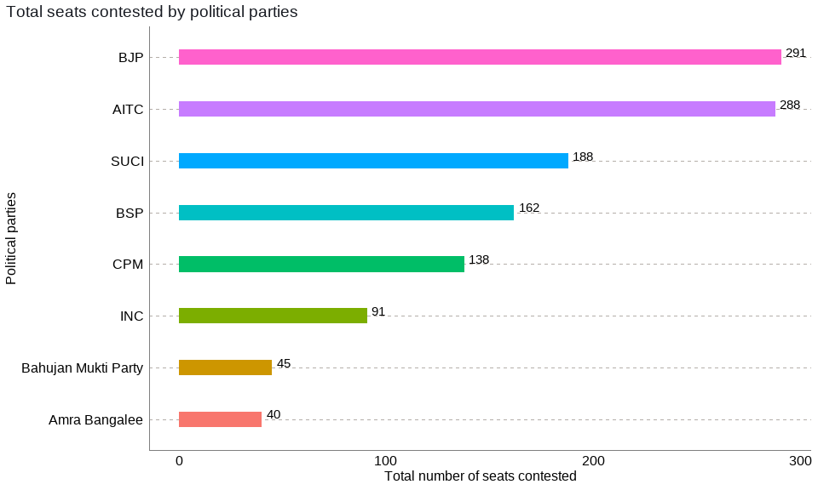 Figure 2: Main Political parties by number of seats contested

Both TMC and BJP contested almost all of the seats whereas other main parties in the state CPM, Congress had an alliance with ISF, a newly formed party led by Abbas Siddiqui.

## Total number of repeat vs new candidates

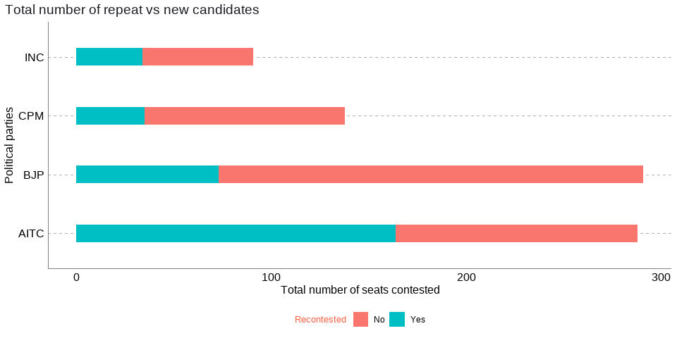

Figure 3: Total number of repeat vs new candidates As expected, a larger number of repeat candidates were fielded by the TMC, this could be because it had the largest number of MLAs in the outgoing assembly, and it’s not common that parties replace their seating candidates. The BJP fielded the largest number of new candidates. The largest number of candidates from TMC were in the fray to defend their existing membership in the assembly. And since all other political parties had fewer MLAs in the assembly, they likely bet on the newer candidates than those who lost the election on their ticket last time.

## Total number of votes secured by each political party

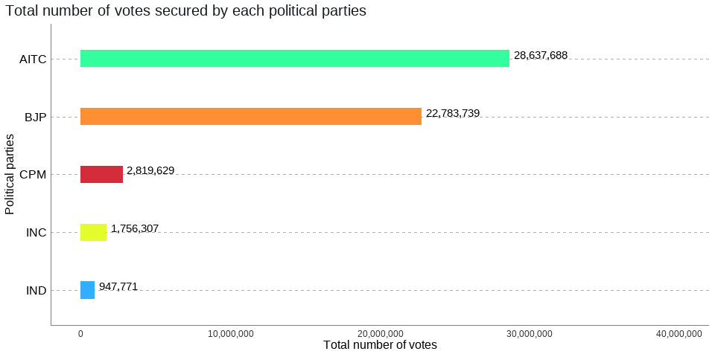

Figure 4: Total number of votes secured by each political party

While the ruling party TMC bagged 2.86 crores or 28.6 million votes, BJP got 2.27 crores or 22.7 million votes. The difference in votes between the two main parties is 59 lakhs or 5.9 million votes. CPM bagged 28 lakhs or 2.8 million votes, while Congress could manage to get over 17 lakhs or 1.7 million votes.

## Total percentage of votes secured by each political party

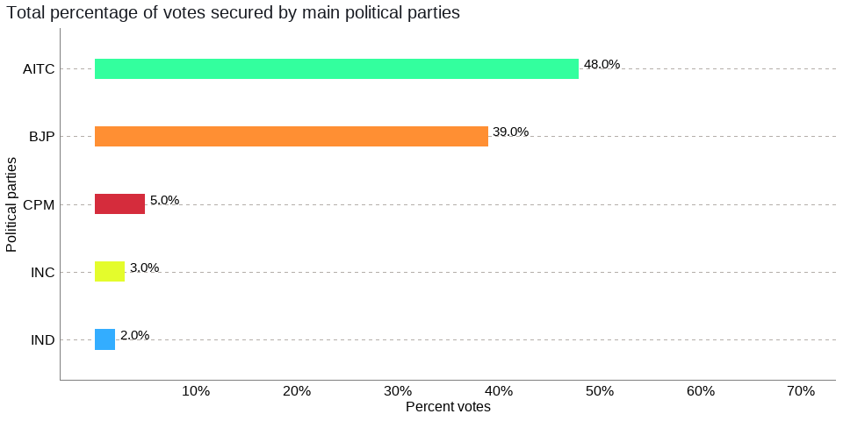

Figure 5: Total percentage of votes secured by each political party

The TMC emerged victorious with 48% of the total popular votes, while the opposition BJP got 39% of the popular votes. CPM managed to win 5% of the votes followed by Congress and Independents with 3% and 2 % of the popular votes respectively. This shows that the contest was highly polarized and bipolar between the incumbent Trinamool Congress (AITC) and the challenger Bhartiya Janata Party (BJP).

## Total number of seats secured by each political party

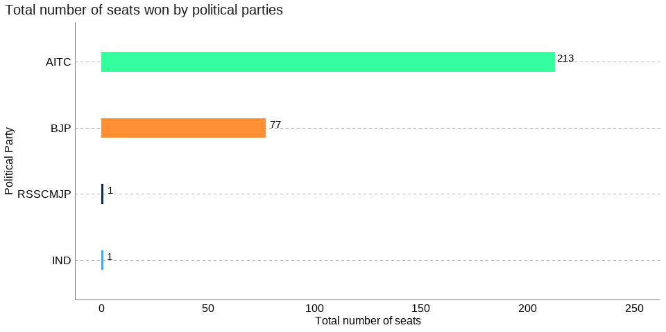 Figure 6: Total number of seats secured by each political party

TMC won 213 (73% of total seats), whereas the BJP came to a distant second with 77 (26%) seats, even though it raised its stock significantly in the West Bengal Assembly from its 2016 tally of a meager 3.

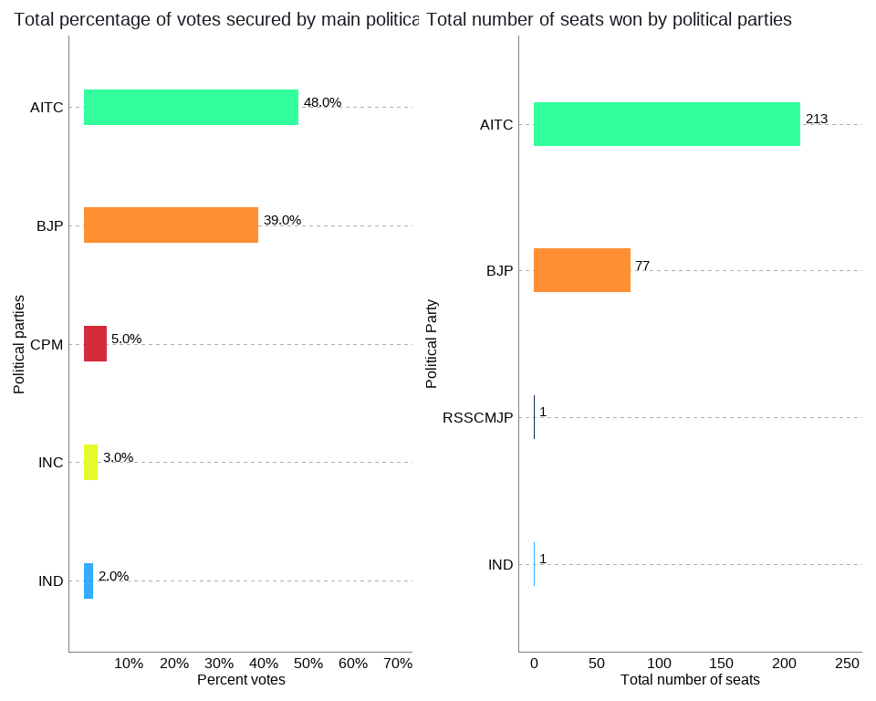

## Total number of seats secured by each political party per region

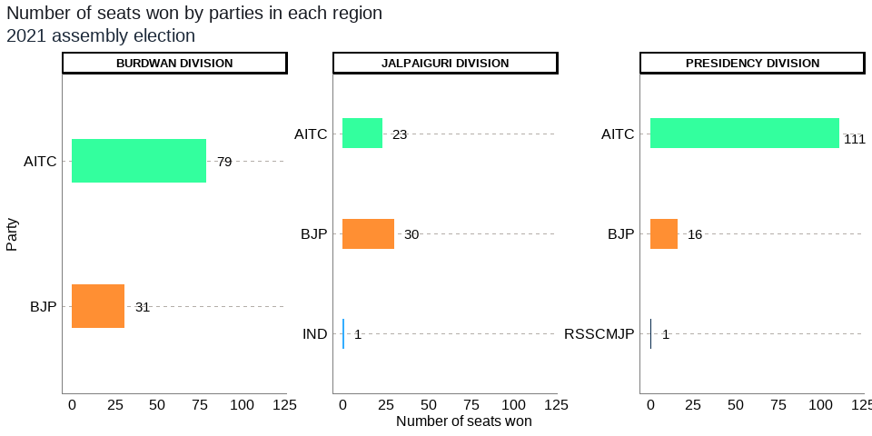

Figure 7: Total number of seats secured by each political party per region

TMC won the largest proportions of seats in the Presidency (TMC: 111 vs BJP: 16) and Burdwan (TMC: 79 vs BJP: 31) divisions whereas BJP emerged as a dominant force in the Jalpaiguri division ( BJP 30 vs TMC 23).

## Seats by constituency type

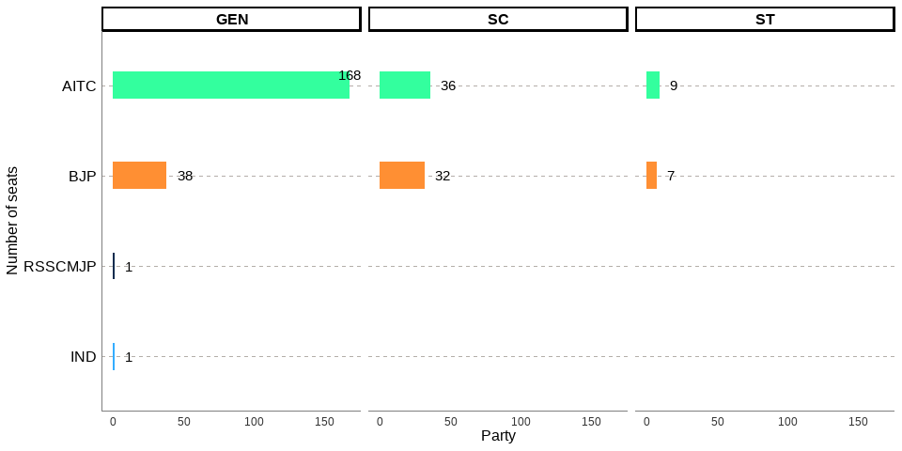 Figure 8: Winner by constituency type

TMC won 82% of the General or non-reserved (168 out of 206) seats, whereas it won 53% (36 out of 68) of the SC and 56 % of the ST (9 out of 16) reserved seats. TMC has done better electorally in General seats when compared to SC and ST seats. BJP won 18% of the total General or non-reserved (18 out of 206) seats and 47% of the SC (32 out of 68) and 44 % of the ST (7 out of 16) reserved seats. The BJP has done better electorally in SC and ST seats when compared to the General seats.

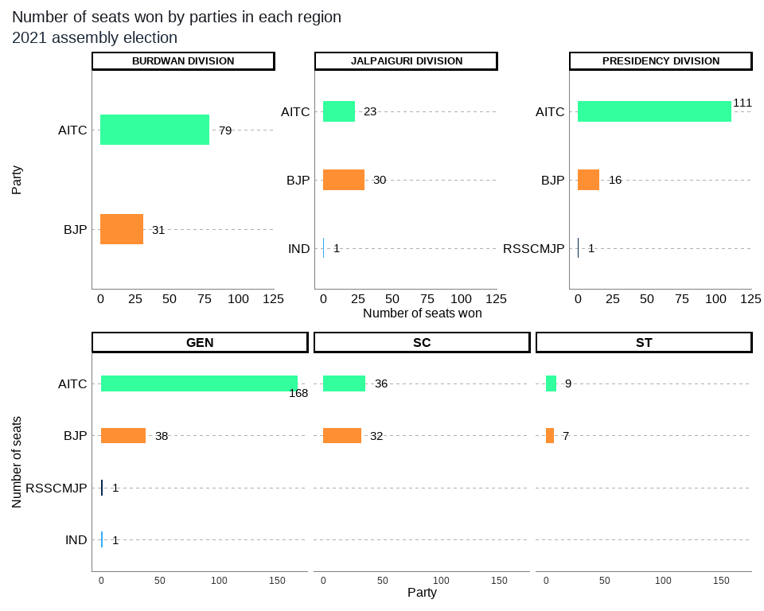

## Winner by margin of 5000 or less

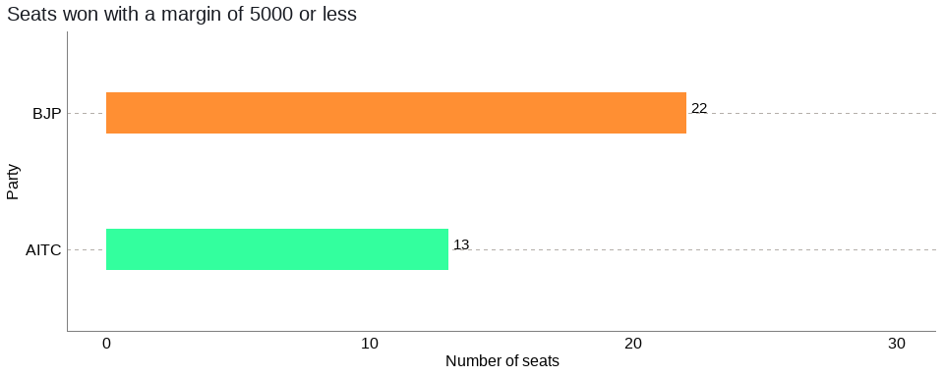

The total number of candidates who won by a margin of 5000 or less was 35 or around 12% of the total assembly seats. Out of the total 35, 63% or 22 were won by BJP and 37% or 13 were won by TMC. This indicates that more candidates from BJP won by a lower margin than TMC.

## Constituencies with lower voter turnout

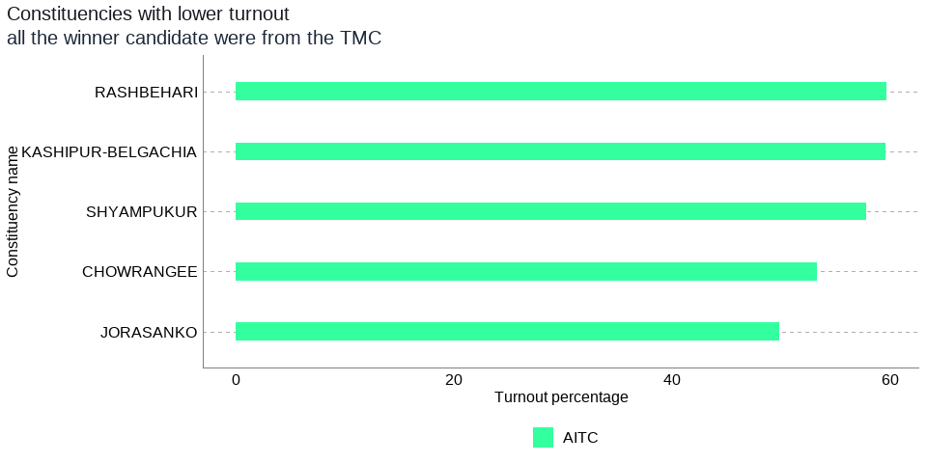 Figure 10: Constituencies with lower voter turnout There were 5 constituencies with a turnout of 60 percent and below, in all these five constituencies the winning candidates were from the ruling TMC. However, since the seats with lower turnouts were just 5, this could just be a pure coincidence or some underlying factors which need to be further investigated, if lower voter turnout favored one party over the other in this state election.

## Constituencies with higher voter turnout

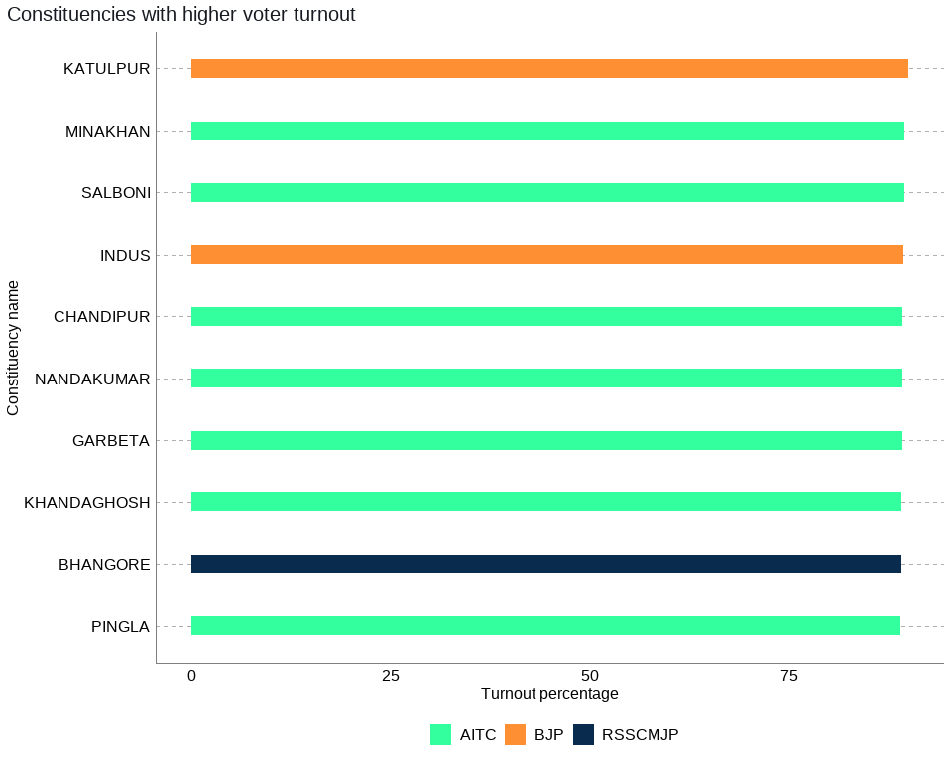

Figure 11: Constituencies with higher voter turnout

There were 10 constituencies with a turnout of 85 percent and above and in these 10 constituencies seven were won by TMC, two by BJP ,and one by independents. Higher or lower voter turnout seems to be benefiting TMC. However, this could be a coincidental outcome as well, given TMC has a higher number of seats across the state when compared to BJP and these higher or lower turnout constituencies could be a reflection of the results across the state. This is something that needs to be investigated further.

## The Chief Minister’s Constituency

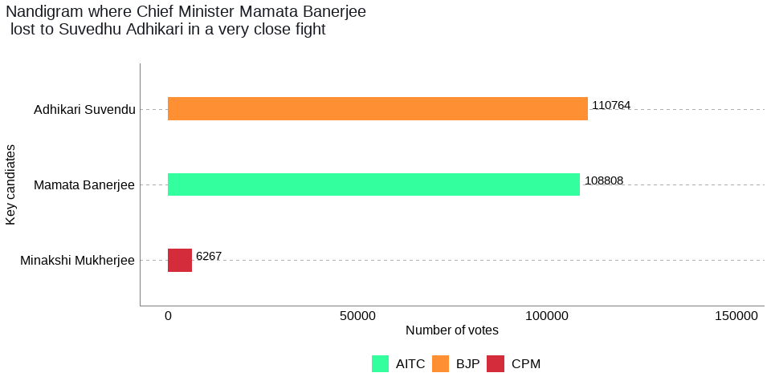

Figure 12: The Chief Minister’s Constituency

Chief Minster Mamta Banerjee left her traditional safe seat and challenged his one-time confidante turned rival, Sudhadu Adhikar at his home turf in Nandigram. This contest was fierce and very close in which Suvendhu Adhikari of the BJP emerged victorious with a narrow margin. Mamta Banerjee lost her seat, but she was the real winner with her party, TMC, securing two-thirds of the majority in a fiercely fought West Bengal election. Eventually, she was elected Chief Minister of West Bengal for a straight third term.

## The Gender split of Winner candidates by party

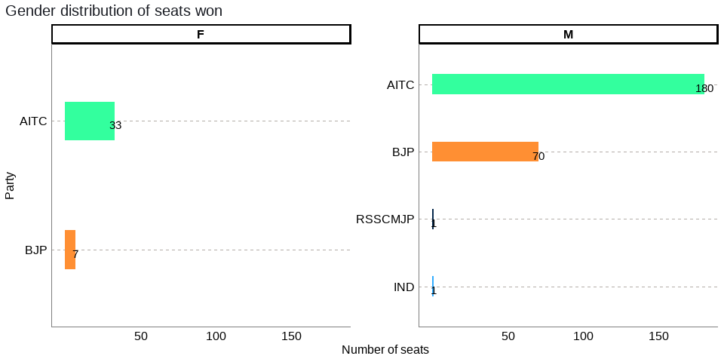 Figure 13: The Gender split of Winner candidates by party

Out of the total seats won by TMC, the seats won by women were 33 or 15.5% of the total seats of 213 whereas for the BJP, it was 7 or 9% of the total seats of 77.

## Total number of seats secured by each political party by district

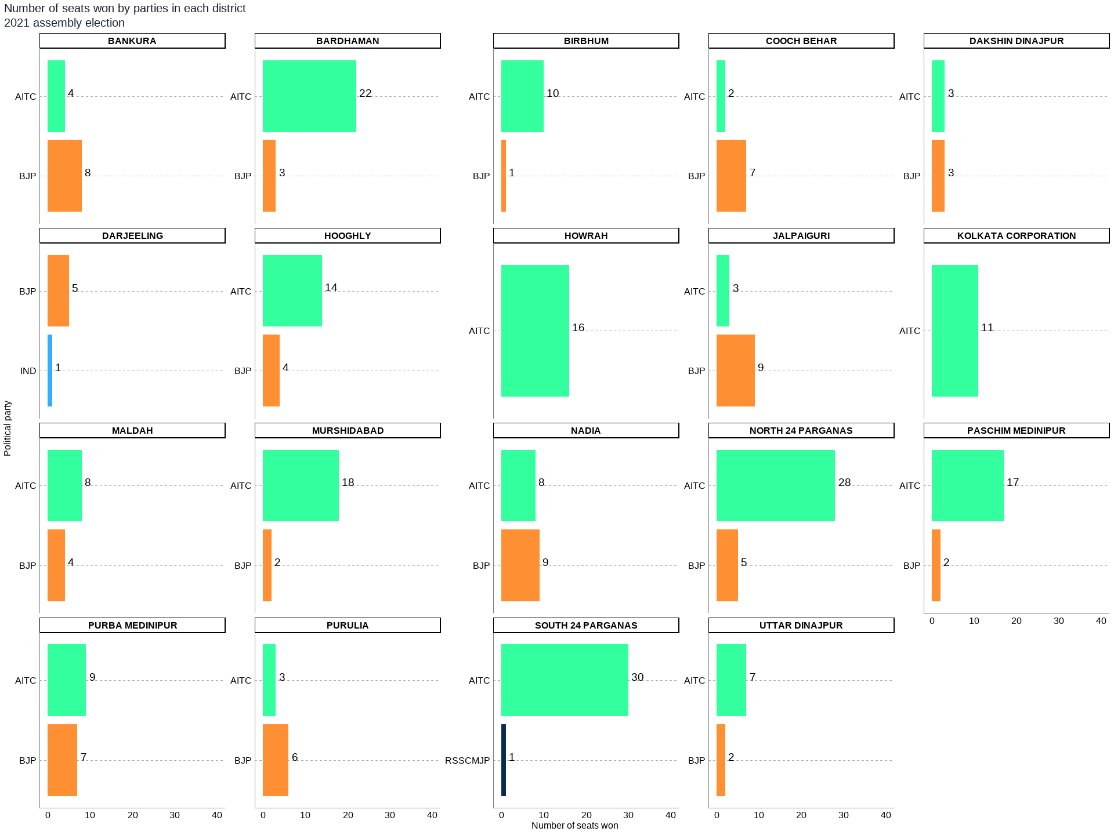

Out of the total 19 districts, TMC bagged more seats in 12 districts (Bardhaman, Birbhum, Hooghly, Howrah, Kolkata Corporation, Maldah, Murshidabad, North 24 Parganas, Paschim Medinipur, Purba Medinipur, South 24 Parganas, Uttar Dinajpur) whereas BJP had a bigger share of seats in only 6 districts (Bankura, Cooch Behar, Darjeeling, Jalpaiguri, Nadia, and Purulia). BJP didn’t win any seats in Howrah (16), Kolkata Corporation(11), and South 24 Parganas(30) districts, whereas TMC didn’t win any seats in Darjeeling(6).

##Table 2: Total number of seats secured by each political party by district

| **District Name** | **Party** | **Total Number of Seats** |
| --- | --- | --- |
| BANKURA | BJP | 8 |
| BANKURA | AITC | 4 |
| BARDHAMAN | AITC | 22 |
| BARDHAMAN | BJP | 3 |
| BIRBHUM | AITC | 10 |
| BIRBHUM | BJP | 1 |
| COOCH BEHAR | BJP | 7 |
| COOCH BEHAR | AITC | 2 |
| DAKSHIN DINAJPUR | AITC | 3 |
| DAKSHIN DINAJPUR | BJP | 3 |
| DARJEELING | BJP | 5 |
| DARJEELING | IND | 1 |
| HOOGHLY | AITC | 14 |
| HOOGHLY | BJP | 4 |
| HOWRAH | AITC | 16 |
| JALPAIGURI | BJP | 9 |
| JALPAIGURI | AITC | 3 |
| KOLKATA CORPORATION | AITC | 11 |
| MALDAH | AITC | 8 |
| MALDAH | BJP | 4 |
| MURSHIDABAD | AITC | 18 |
| MURSHIDABAD | BJP | 2 |
| NADIA | BJP | 9 |
| NADIA | AITC | 8 |
| NORTH 24 PARGANAS | AITC | 28 |
| NORTH 24 PARGANAS | BJP | 5 |
| PASCHIM MEDINIPUR | AITC | 17 |
| PASCHIM MEDINIPUR | BJP | 2 |
| PURBA MEDINIPUR | AITC | 9 |
| PURBA MEDINIPUR | BJP | 7 |
| PURULIA | BJP | 6 |
| PURULIA | AITC | 3 |
| SOUTH 24 PARGANAS | AITC | 30 |
| SOUTH 24 PARGANAS | RSSCMJP | 1 |
| UTTAR DINAJPUR | AITC | 7 |
| UTTAR DINAJPUR | BJP | 2 |

## 1. BANKURA District: Winners per constituency and top 3 candidates

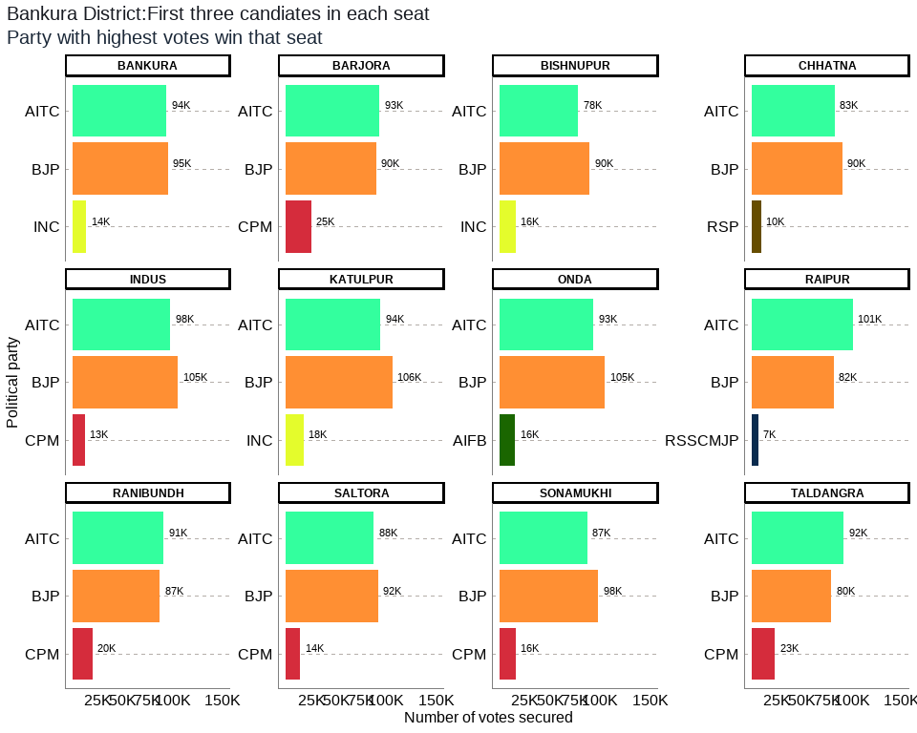

## Table 2: BANKURA District Election Results: Top 3 Candidates by Votes in Each Constituency

| **Constituency** | **Type** | **Party** | **Candidate** | **Position** | **Votes** | **Margin** |
| --- | --- | --- | --- | --- | --- | --- |
| BANKURA | GEN | BJP | Niladri Sekhar Dana | 1 | 95,466 | 1,468 |
| BANKURA | GEN | AITC | Sayantika Banerjee | 2 | 93,998 | 80,234 |
| BANKURA | GEN | INC | Radharani Banerjee | 3 | 13,764 | 9,257 |
| BARJORA | GEN | AITC | Alok Mukherjee | 1 | 93,290 | 3,269 |
| BARJORA | GEN | BJP | Supriti Chatterjee | 2 | 90,021 | 64,786 |
| BARJORA | GEN | CPM | Sujit Chakraborty | 3 | 25,235 | 20,332 |
| BISHNUPUR | GEN | BJP | Tanmay Ghosh (Bumba) | 1 | 89,689 | 11,420 |
| BISHNUPUR | GEN | AITC | Archita Bid | 2 | 78,269 | 62,455 |
| BISHNUPUR | GEN | INC | Debu Chatterjee | 3 | 15,814 | 12,395 |
| CHHATNA | GEN | BJP | Satyanarayan Mukhopadhyay | 1 | 90,233 | 7,164 |
| CHHATNA | GEN | AITC | Subasish Batabyal | 2 | 83,069 | 73,369 |
| CHHATNA | GEN | RSP | Falguni Mukherjee | 3 | 9,700 | 6,186 |
| INDUS | SC | BJP | Nirmal Kumar Dhara | 1 | 104,936 | 7,220 |
| INDUS | SC | AITC | Runu Mete | 2 | 97,716 | 85,097 |
| INDUS | SC | CPM | Nayan Kumar Shill (Bagdi) | 3 | 12,619 | 9,437 |
| KATULPUR | SC | BJP | Harakali Protiher | 1 | 106,022 | 11,785 |
| KATULPUR | SC | AITC | Sangeeta Malik | 2 | 94,237 | 76,480 |
| KATULPUR | SC | INC | Akshay Santra | 3 | 17,757 | 15,238 |
| ONDA | GEN | BJP | Amarnath Shakha | 1 | 104,940 | 11,551 |
| ONDA | GEN | AITC | Arup Kumar Khan | 2 | 93,389 | 77,776 |
| ONDA | GEN | AIFB | Tarapada Chakrabarti | 3 | 15,613 | 10,734 |
| RAIPUR | ST | AITC | Mrityunjoy Murmu | 1 | 101,043 | 19,398 |
| RAIPUR | ST | BJP | Sudhanshu Hansda | 2 | 81,645 | 75,052 |
| RAIPUR | ST | RSSCMJP | Milan Mandi | 3 | 6,593 | 3,607 |
| RANIBUNDH | ST | AITC | Jyotsna Mandi | 1 | 90,928 | 3,939 |
| RANIBUNDH | ST | BJP | Kshudiram Tudu | 2 | 86,989 | 66,932 |
| RANIBUNDH | ST | CPM | Deblina Hembram | 3 | 20,057 | 15,250 |
| SALTORA | SC | BJP | Bauri Chandana | 1 | 91,648 | 4,145 |
| SALTORA | SC | AITC | Sontosh Kumar Mondal | 2 | 87,503 | 73,419 |
| SALTORA | SC | CPM | Nandadulal Bauri | 3 | 14,084 | 10,530 |
| SONAMUKHI | SC | BJP | Dibakar Gharami | 1 | 98,161 | 10,888 |
| SONAMUKHI | SC | AITC | Dr. Shyamal Santra | 2 | 87,273 | 71,548 |
| SONAMUKHI | SC | CPM | Ajit Ray | 3 | 15,725 | 12,953 |
| TALDANGRA | GEN | AITC | Arup Chakraborty | 1 | 92,026 | 12,377 |
| TALDANGRA | GEN | BJP | Shyamal Kumar Sarkar (Benu) | 2 | 79,649 | 56,460 |
| TALDANGRA | GEN | CPM | Manoranjan Patra | 3 | 23,189 | 19,671 |

The district of Bankura has a total of 12 legislative constituencies. The district has 6 reserved constituencies out of which 4 seats are reserved for the Scheduled Castes (SC) community whereas 2 seats are reserved for the Scheduled Tribes (ST) community. Seats reserved for SC include Saltora, Katulpur, Indus, Sonamukhi, and the seats reserved for ST include Ranibundh, Raipur respectively.

Out of the total 12 seats in the Bankura district, the largest number of seats i.e. 8 were won by the BJP while the AITC won 4 seats. The seats won by BJP were Saltora, Chhatna, Bankura, Onda, Bishnupur, Katulpur, Indus, Sonamukhi , and the seats won by AITC include Ranibundh, Raipur, Taldangra, Barjora respectively.

Out of the total polled votes of 2470633, BJP secured a total of 1119399 (45%) votes while the AITC secured 1092741 (44%) votes. The CPM with a vote share of 110909 (4%) was in third place, while the INC was in the fourth position after securing 47335 (2%) of the total votes in the district.

## 2. BARDHAMAN District: Winners per constituency and top 3 candidates

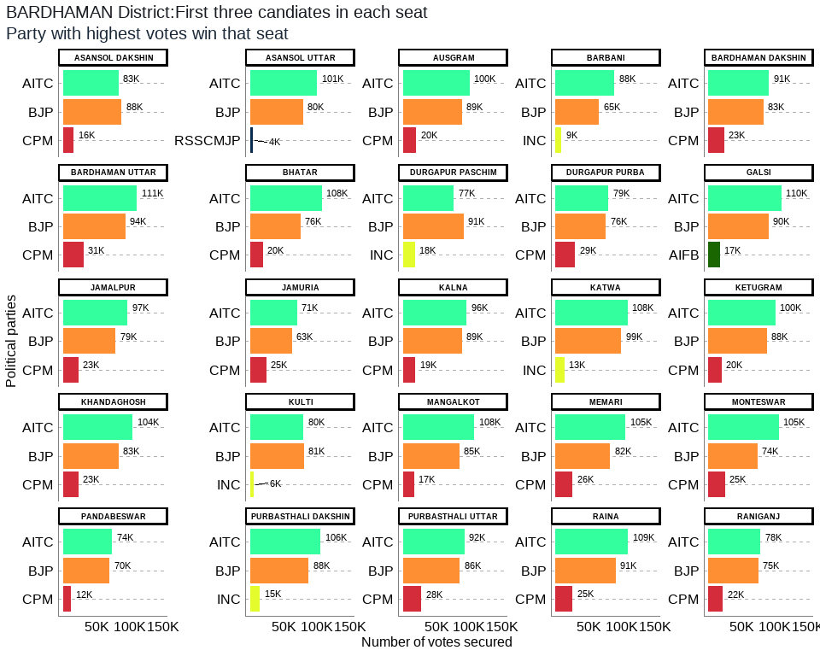

## Table 3: BARDHAMAN District Election Results: Top 3 Candidates by Votes in Each Constituency

| **Constituency** | **Type** | **Party** | **Candidate** | **Position** | **Votes** | **Margin** |
| --- | --- | --- | --- | --- | --- | --- |
| ASANSOL DAKSHIN | GEN | BJP | Agnimitra Paul | 1 | 87,881 | 4,487 |
| ASANSOL DAKSHIN | GEN | AITC | Sayani Ghosh | 2 | 83,394 | 67,422 |
| ASANSOL DAKSHIN | GEN | CPM | Prasanta Ghosh | 3 | 15,972 | 12,506 |
| ASANSOL UTTAR | GEN | AITC | Ghatak Moloy | 1 | 100,931 | 21,110 |
| ASANSOL UTTAR | GEN | BJP | Krishnendu Mukherjee | 2 | 79,821 | 75,350 |
| ASANSOL UTTAR | GEN | RSSCMJP | Mohammad Mustaqim | 3 | 4,471 | 1,123 |
| AUSGRAM | SC | AITC | Abhedananda Thander | 1 | 100,392 | 11,815 |
| AUSGRAM | SC | BJP | Kalita Maji | 2 | 88,577 | 68,178 |
| AUSGRAM | SC | CPM | Chanchal Kumar Majhi | 3 | 20,399 | 16,360 |
| BARBANI | GEN | AITC | Bidhan Upadhyay | 1 | 88,430 | 23,457 |
| BARBANI | GEN | BJP | Arijit Roy | 2 | 64,973 | 56,011 |
| BARBANI | GEN | INC | Ranendra Nath Bagchi | 3 | 8,962 | 5,923 |
| BARDHAMAN DAKSHIN | GEN | AITC | Khokan Das | 1 | 91,015 | 8,105 |
| BARDHAMAN DAKSHIN | GEN | BJP | Sandip Nandi | 2 | 82,910 | 59,564 |
| BARDHAMAN DAKSHIN | GEN | CPM | Pritha Tah | 3 | 23,346 | 19,639 |
| BARDHAMAN UTTAR | SC | AITC | Nisith Kumar Malik | 1 | 111,211 | 17,268 |
| BARDHAMAN UTTAR | SC | BJP | Radha Kanta Roy | 2 | 93,943 | 62,915 |
| BARDHAMAN UTTAR | SC | CPM | Chandi Choran Let | 3 | 31,028 | 27,681 |
| BHATAR | GEN | AITC | Adhikari Mangobinda | 1 | 108,028 | 31,741 |
| BHATAR | GEN | BJP | Mahendranath Kowar | 2 | 76,287 | 56,680 |
| BHATAR | GEN | CPM | Nazrul Haque | 3 | 19,607 | 15,261 |
| DURGAPUR PASCHIM | GEN | BJP | Lakshman Chandra Ghorui | 1 | 91,186 | 14,664 |
| DURGAPUR PASCHIM | GEN | AITC | Biswanath Parial | 2 | 76,522 | 58,492 |
| DURGAPUR PASCHIM | GEN | INC | Debesh Chakraborty | 3 | 18,030 | 15,406 |
| DURGAPUR PURBA | GEN | AITC | Pradip Mazumdar | 1 | 79,303 | 3,746 |
| DURGAPUR PURBA | GEN | BJP | Colonel Diptansu Chaudhury | 2 | 75,557 | 46,494 |
| DURGAPUR PURBA | GEN | CPM | Abhas Ray Chaudhuri | 3 | 29,063 | 26,435 |
| GALSI | SC | AITC | Nepal Ghorui | 1 | 109,504 | 19,262 |
| GALSI | SC | BJP | Bikash Biswas | 2 | 90,242 | 73,222 |
| GALSI | SC | AIFB | Nandalal Pondit | 3 | 17,020 | 13,502 |
| JAMALPUR | SC | AITC | Alok Kumar Majhi | 1 | 96,999 | 17,971 |
| JAMALPUR | SC | BJP | Balaram Bapari | 2 | 79,028 | 55,730 |
| JAMALPUR | SC | CPM | Samar Hazra | 3 | 23,298 | 20,433 |
| JAMURIA | GEN | AITC | Hareram Singh | 1 | 71,002 | 8,051 |
| JAMURIA | GEN | BJP | Tapas Kumar Roy | 2 | 62,951 | 38,133 |
| JAMURIA | GEN | CPM | Aishe Ghosh | 3 | 24,818 | 22,409 |
| KALNA | SC | AITC | Deboprasad Bag (Poltu) | 1 | 96,073 | 7,478 |
| KALNA | SC | BJP | Biswajit Kundu | 2 | 88,595 | 69,590 |
| KALNA | SC | CPM | Nirab Khan | 3 | 19,005 | 16,498 |
| KATWA | GEN | AITC | Rabindranath Chatterjee | 1 | 107,894 | 9,155 |
| KATWA | GEN | BJP | Shyama Majumdar | 2 | 98,739 | 85,763 |
| KATWA | GEN | INC | Prabir Ganguli | 3 | 12,976 | 11,196 |
| KETUGRAM | GEN | AITC | Sekh Sahonawez | 1 | 100,226 | 12,683 |
| KETUGRAM | GEN | BJP | Anadi Ghosh (Mathura) | 2 | 87,543 | 67,451 |
| KETUGRAM | GEN | CPM | Mizanul Kabir (Dhiraj) | 3 | 20,092 | 16,472 |
| KHANDAGHOSH | SC | AITC | Nabin Chandra Bag | 1 | 104,264 | 20,886 |
| KHANDAGHOSH | SC | BJP | Bijan Mandal | 2 | 83,378 | 60,455 |
| KHANDAGHOSH | SC | CPM | Asima Roy | 3 | 22,923 | 19,458 |
| KULTI | GEN | BJP | Ajay Kumar Poddar | 1 | 81,112 | 679 |
| KULTI | GEN | AITC | Ujjal Chatterjee | 2 | 80,433 | 74,638 |
| KULTI | GEN | INC | Chandi Das Chatterjee | 3 | 5,795 | 2,242 |
| MANGALKOT | GEN | AITC | Apurba Chowdhury (Achal) | 1 | 107,596 | 22,337 |
| MANGALKOT | GEN | BJP | Rana Protap Goswami | 2 | 85,259 | 68,476 |
| MANGALKOT | GEN | CPM | Choudhury Sahajahan | 3 | 16,783 | 12,957 |
| MEMARI | GEN | AITC | Madhusudan Bhattacharya | 1 | 104,851 | 23,078 |
| MEMARI | GEN | BJP | Bhismadeb Bhattacharya | 2 | 81,773 | 56,155 |
| MEMARI | GEN | CPM | Sanat Banerjee | 3 | 25,618 | 23,497 |
| MONTESWAR | GEN | AITC | Chowdhury Siddiqullah | 1 | 105,460 | 31,805 |
| MONTESWAR | GEN | BJP | Saikat Panja | 2 | 73,655 | 48,915 |
| MONTESWAR | GEN | CPM | Anupam Ghosh | 3 | 24,740 | 22,863 |
| PANDABESWAR | GEN | AITC | Narendranath Chakraborty | 1 | 73,922 | 3,803 |
| PANDABESWAR | GEN | BJP | Kumar Jitendra Tewari | 2 | 70,119 | 57,923 |
| PANDABESWAR | GEN | CPM | Subhas Bauri | 3 | 12,196 | 9,461 |
| PURBASTHALI DAKSHIN | GEN | AITC | Swapan Debnath | 1 | 105,698 | 17,410 |
| PURBASTHALI DAKSHIN | GEN | BJP | Rajib Kumar Bhowmick | 2 | 88,288 | 73,227 |
| PURBASTHALI DAKSHIN | GEN | INC | Abhijit Bhattacharyya | 3 | 15,061 | 11,956 |
| PURBASTHALI UTTAR | GEN | AITC | Tapan Chatterjee | 1 | 92,421 | 6,706 |
| PURBASTHALI UTTAR | GEN | BJP | Gobardhan Das | 2 | 85,715 | 57,581 |
| PURBASTHALI UTTAR | GEN | CPM | Pradip Kumar Saha | 3 | 28,134 | 26,227 |
| RAINA | SC | AITC | Shampa Dhara | 1 | 108,752 | 18,205 |
| RAINA | SC | BJP | Manik Roy | 2 | 90,547 | 65,215 |
| RAINA | SC | CPM | Basudeb Khan | 3 | 25,332 | 23,461 |
| RANIGANJ | GEN | AITC | Tapas Banerjee | 1 | 78,164 | 3,556 |
| RANIGANJ | GEN | BJP | Dr. Bijan Mukherjee | 2 | 74,608 | 52,920 |
| RANIGANJ | GEN | CPM | Hemant Kumar Prabhakar | 3 | 21,688 | 19,682 |

The district of Bardhaman has a total of 25 legislative constituencies. The district has 7 reserved constituencies and all 7 seats are reserved for the Scheduled Castes (SC) community. Seats reserved for SC include Khandaghosh, Raina, Jamalpur, Kalna, Bardhaman Uttar, Ausgram, Galsi.

Out of the total 25 seats in the Bardhaman district, the largest number of seats i.e. 22 were won by the AITC while the BJP won 3 seats. The seats won by AITC were Khandaghosh, Bardhaman Dakshin, Raina, Jamalpur, Monteswar, Kalna, Memari, Bardhaman Uttar, Bhatar, Purbasthali Dakshin, Purbasthali Uttar, Katwa, Ketugram, Mangalkot, Ausgram, Galsi, Pandabeswar, Durgapur Purba, Raniganj, Jamuria, Asansol Uttar, Barbani and the seats won by BJP were Durgapur Paschim, Asansol Dakshin, Kulti respectively.

Out of total polled votes of 5044003, AITC secured a total of 2382485 (47%) votes while the BJP secured 2062687 (41%) of the votes. The CPM with a vote share of 404042 (8%) was in third place, while the INC was in the fourth position after securing 60824 (1%) of the total votes in the district.

## 3. BIRBHUM District: Winners per constituency and top 3 candidates

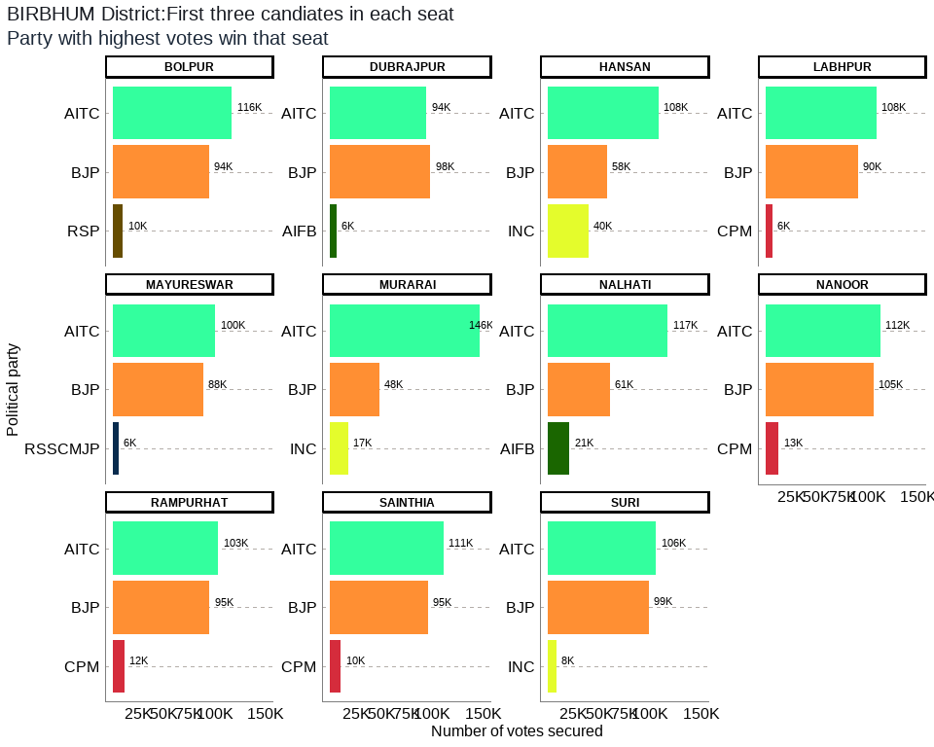

## Table 4: BIRBHUM District Election Results: Top 3 Candidates by Votes in Each Constituency

| **Constituency** | **Type** | **Party** | **Candidate** | **Position** | **Votes** | **Margin** |
| --- | --- | --- | --- | --- | --- | --- |
| BOLPUR | GEN | AITC | Sinha Chandranath | 1 | 116,443 | 22,280 |
| BOLPUR | GEN | BJP | Anirban Ganguly | 2 | 94,163 | 84,198 |
| BOLPUR | GEN | RSP | Tapan Hore | 3 | 9,965 | 6,628 |
| DUBRAJPUR | SC | BJP | Anup Kumar Saha | 1 | 98,083 | 3,863 |
| DUBRAJPUR | SC | AITC | Debabrata Saha | 2 | 94,220 | 88,206 |
| DUBRAJPUR | SC | AIFB | Bijoy Bagdi | 3 | 6,014 | 2,857 |
| HANSAN | GEN | AITC | Dr. Asok Kumar Chattopadhyay | 1 | 108,289 | 50,613 |
| HANSAN | GEN | BJP | Nikhil Banerjee | 2 | 57,676 | 17,861 |
| HANSAN | GEN | INC | Miltan Rasid | 3 | 39,815 | 37,395 |
| LABHPUR | GEN | AITC | Abhijit Sinha (Rana) | 1 | 108,423 | 17,975 |
| LABHPUR | GEN | BJP | Biswajit Mondal | 2 | 90,448 | 83,969 |
| LABHPUR | GEN | CPM | Syed Mahfuzul Karim | 3 | 6,479 | 3,422 |
| MAYURESWAR | GEN | AITC | Abhijit Roy | 1 | 100,425 | 12,075 |
| MAYURESWAR | GEN | BJP | Shyamapada Mondal | 2 | 88,350 | 82,788 |
| MAYURESWAR | GEN | RSSCMJP | Kashinath Pal | 3 | 5,562 | 2,759 |
| MURARAI | GEN | AITC | Dr Mosarraf Hossain | 1 | 146,496 | 98,246 |
| MURARAI | GEN | BJP | Debasish Roy | 2 | 48,250 | 30,963 |
| MURARAI | GEN | INC | Asif Ekbal | 3 | 17,287 | 15,430 |
| NALHATI | GEN | AITC | Rajendra Prasad Singh (Raju Singh) | 1 | 117,438 | 56,905 |
| NALHATI | GEN | BJP | Tapas Kumar Yadav(Ananda Yadav) | 2 | 60,533 | 39,205 |
| NALHATI | GEN | AIFB | Dipak Chatterjee | 3 | 21,328 | 19,428 |
| NANOOR | SC | AITC | Bidhan Chandra Majhi | 1 | 112,116 | 6,670 |
| NANOOR | SC | BJP | Tarakeswar Saha | 2 | 105,446 | 92,568 |
| NANOOR | SC | CPM | Shyamali Pradhan | 3 | 12,878 | 10,139 |
| RAMPURHAT | GEN | AITC | Asish Banerjee | 1 | 103,276 | 8,472 |
| RAMPURHAT | GEN | BJP | Subhasis Choudhury (Khokan) | 2 | 94,804 | 83,097 |
| RAMPURHAT | GEN | CPM | Sanjib Barman (Gopi) | 3 | 11,707 | 8,326 |
| SAINTHIA | SC | AITC | Nilabati Saha | 1 | 110,572 | 15,243 |
| SAINTHIA | SC | BJP | Piya Saha | 2 | 95,329 | 84,960 |
| SAINTHIA | SC | CPM | Mausumi Konai | 3 | 10,369 | 8,271 |
| SURI | GEN | AITC | Bikash Roychoudhury | 1 | 105,871 | 7,320 |
| SURI | GEN | BJP | Chattopadhyay Jagannath | 2 | 98,551 | 90,284 |
| SURI | GEN | INC | Chanchal Chatterjee | 3 | 8,267 | 6,183 |

The district of Birbhum has 11 legislative constituencies. The district has 3 reserved constituencies and all 3 seats are reserved for the Scheduled Castes (SC) community. Seats reserved for SC include Dubrajpur, Nanoor, Sainthia.

Out of the total 11 seats in the Birbhum district, the largest number of seats i.e. 10 were won by the AITC while the BJP won 1 seat. The seats won by AITC were Suri, Bolpur, Nanoor, Labhpur, Sainthia, Mayureswar, Rampurhat, Hansan, Nalhati, Murarai and the seat won by BJP is Dubrajpur.

Out of the total polled votes of 2348347, AITC secured a total of 1223569 (52%) votes while the BJP secured 931633 (40%) of the votes. The INC with a vote share of 65369 (3%) was in third place, while the CPM was in the fourth position after securing 41433 (2%) of the total votes in the district.

## 4. COOCH BEHAR District: Winners per constituency and top 3 candidates

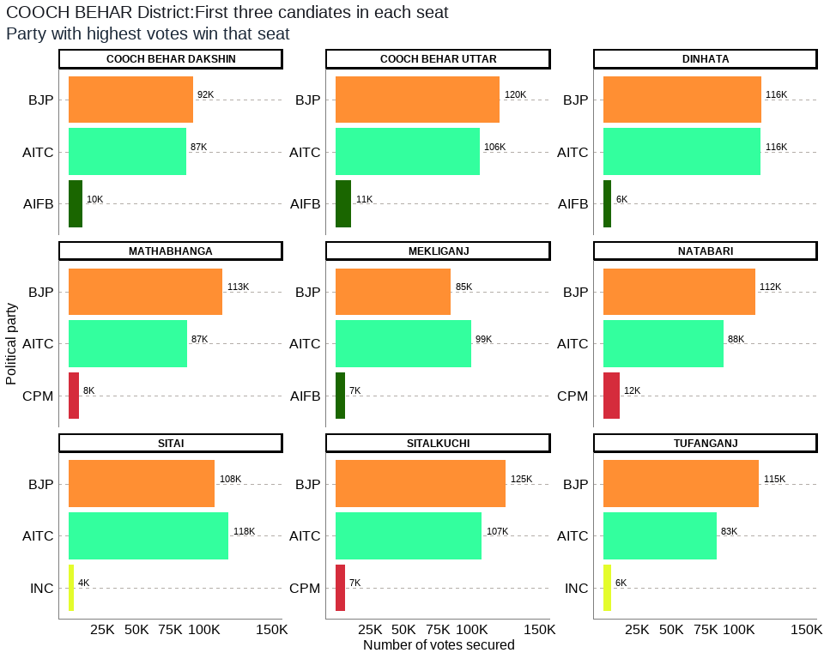

## Table 5: COOCH BEHAR District Election Results: Top 3 Candidates by Votes in Each Constituency

| **Constituency** | **Type** | **Party** | **Candidate** | **Position** | **Votes** | **Margin** |
| --- | --- | --- | --- | --- | --- | --- |
| COOCH BEHAR DAKSHIN | GEN | BJP | Nikhil Ranjan Dey | 1 | 91,560 | 4,931 |
| COOCH BEHAR DAKSHIN | GEN | AITC | Avijit De Bhowmik | 2 | 86,629 | 76,383 |
| COOCH BEHAR DAKSHIN | GEN | AIFB | Akshay Thakur | 3 | 10,246 | 8,761 |
| COOCH BEHAR UTTAR | SC | BJP | Sukumar Roy | 1 | 120,483 | 14,615 |
| COOCH BEHAR UTTAR | SC | AITC | Binay Krishna Barman | 2 | 105,868 | 94,393 |
| COOCH BEHAR UTTAR | SC | AIFB | Nagendra Nath Roy | 3 | 11,475 | 9,905 |
| DINHATA | GEN | BJP | Nisith Pramanik | 1 | 116,035 | 57 |
| DINHATA | GEN | AITC | Udayan Guha | 2 | 115,978 | 109,909 |
| DINHATA | GEN | AIFB | Abdur Rouf | 3 | 6,069 | 4,532 |
| MATHABHANGA | SC | BJP | Sushil Barman | 1 | 113,249 | 26,134 |
| MATHABHANGA | SC | AITC | Girindra Nath Barman | 2 | 87,115 | 79,397 |
| MATHABHANGA | SC | CPM | Ashok Barman | 3 | 7,718 | 6,275 |
| MEKLIGANJ | SC | AITC | Adhikary Paresh Chandra | 1 | 99,338 | 14,685 |
| MEKLIGANJ | SC | BJP | Dadhiram Ray | 2 | 84,653 | 77,800 |
| MEKLIGANJ | SC | AIFB | Gobinda Chandra Roy | 3 | 6,853 | 4,406 |
| NATABARI | GEN | BJP | Mihir Goswami | 1 | 111,743 | 23,440 |
| NATABARI | GEN | AITC | Rabindra Nath Ghosh | 2 | 88,303 | 76,464 |
| NATABARI | GEN | CPM | Akik Hassan | 3 | 11,839 | 10,498 |
| SITAI | SC | AITC | Jagadish Chandra Barma Basunia | 1 | 117,908 | 10,112 |
| SITAI | SC | BJP | Dipak Kumar Roy | 2 | 107,796 | 103,832 |
| SITAI | SC | INC | Keshab Chandra Ray | 3 | 3,964 | 1,573 |
| SITALKUCHI | SC | BJP | Baren Chandra Barman | 1 | 124,955 | 17,815 |
| SITALKUCHI | SC | AITC | Partha Pratim Ray | 2 | 107,140 | 100,420 |
| SITALKUCHI | SC | CPM | Sudhangshu Pramanik | 3 | 6,720 | 3,977 |
| TUFANGANJ | GEN | BJP | Malati Rava Roy | 1 | 114,503 | 31,198 |
| TUFANGANJ | GEN | AITC | Pranab Kumar Dey | 2 | 83,305 | 77,332 |
| TUFANGANJ | GEN | INC | Rabin Roy | 3 | 5,973 | 3,904 |

The district of Cooch Behar has a total of 9 legislative constituencies. The district has 5 reserved constituencies and all 5 seats are reserved for the Scheduled Castes (SC) community. The seats reserved for SC include Mekliganj, Mathabhanga, Cooch Behar Uttar, Sitalkuchi, Sitai.

Out of the total 9 seats in Cooch Behar district, the largest number of seats i.e. 7 were won by the BJP while the AITC won 2 seats. The seats won by BJP were Mathabhanga, Cooch Behar Uttar, Cooch Behar Dakshin, Sitalkuchi, Dinhata, Natabari, Tufanganj , and the seats won by AITC were Mekliganj, Sitai respectively.

Out of the total polled votes of 1991218, BJP secured a total of 984977 (49%) votes while the AITC secured 891584 (45%) of the votes. The AIFB with a vote share of 34643 (2%) was in third place, while the CPM was in the fourth position after securing 26277 (1%) of the total votes in the district.

## 5. DAKSHIN DINAJPUR District: Winners per constituency and top 3 candidates

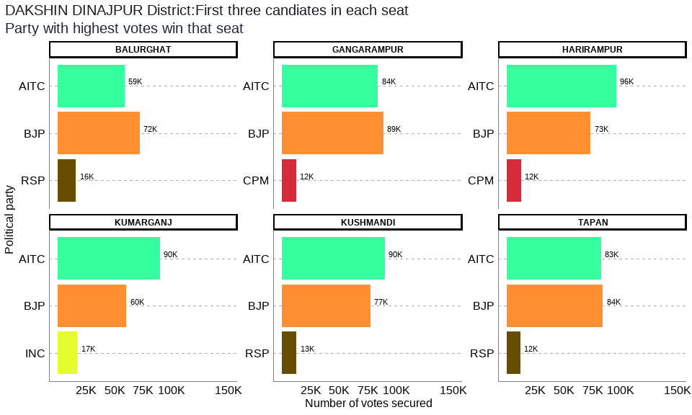

## Table 6: DAKSHIN DINAJPUR District Election Results: Top 3 Candidates by Votes in Each Constituency

| **Constituency** | **Type** | **Party** | **Candidate** | **Position** | **Votes** | **Margin** |
| --- | --- | --- | --- | --- | --- | --- |
| BALURGHAT | GEN | BJP | Ashok Kumar Lahiri | 1 | 72,129 | 13,436 |
| BALURGHAT | GEN | AITC | Sekhar Dasgupta | 2 | 58,693 | 42,540 |
| BALURGHAT | GEN | RSP | Sucheta Biswas | 3 | 16,153 | 14,323 |
| GANGARAMPUR | SC | BJP | Satyendra Nath Ray | 1 | 88,724 | 4,592 |
| GANGARAMPUR | SC | AITC | Goutam Das | 2 | 84,132 | 71,859 |
| GANGARAMPUR | SC | CPM | Nanda Lal Hazra | 3 | 12,273 | 11,104 |
| HARIRAMPUR | GEN | AITC | Biplab Mitra | 1 | 96,131 | 22,672 |
| HARIRAMPUR | GEN | BJP | Nilanjan Roy | 2 | 73,459 | 61,015 |
| HARIRAMPUR | GEN | CPM | Rafikul Islam | 3 | 12,444 | 10,613 |
| KUMARGANJ | GEN | AITC | Toraf Hossain Mandal | 1 | 89,763 | 29,367 |
| KUMARGANJ | GEN | BJP | Manas Sarkar | 2 | 60,396 | 42,918 |
| KUMARGANJ | GEN | INC | Chaudhuri Nargis Banu | 3 | 17,478 | 16,263 |
| KUSHMANDI | SC | AITC | Rekha Roy | 1 | 89,968 | 12,584 |
| KUSHMANDI | SC | BJP | Ranjit Kumar Roy | 2 | 77,384 | 64,813 |
| KUSHMANDI | SC | RSP | Narmada Chandra Roy | 3 | 12,571 | 10,973 |
| TAPAN | ST | BJP | Budhrai Tudu | 1 | 84,381 | 1,650 |
| TAPAN | ST | AITC | Kalpana Kisku | 2 | 82,731 | 70,643 |
| TAPAN | ST | RSP | Raghu Urow | 3 | 12,088 | 9,942 |

The district of Dakshin Dinajpur has a total of 6 legislative constituencies. The district has 3 reserved constituencies out of which 2 seats are reserved for the Scheduled Castes (SC) community whereas 1 seat is reserved for the Scheduled Tribes (ST) community. Seats reserved for SC include Kushmandi, Gangarampur and the seat reserved for ST include Tapan.

Out of the total 6 seats in the Dakshin Dinajpur district, 3 seats each were won by the AITC and the BJP. The seats won by AITC were Kushmandi, Kumarganj, and Harirampur, and the seats won by BJP include Balurghat, Tapan, and Gangarampur respectively.

Out of the total polled votes of 1061300, AITC secured a total of 501418 (47%) votes while the BJP secured 456473 (43%) of the votes. The RSP with a vote share of 40812 (4%) was in third place, while the CPM was in the fourth position after securing 24717 (2%) of the total votes in the district.

## 6. DARJEELING District: Winners per constituency and top 3 candidates

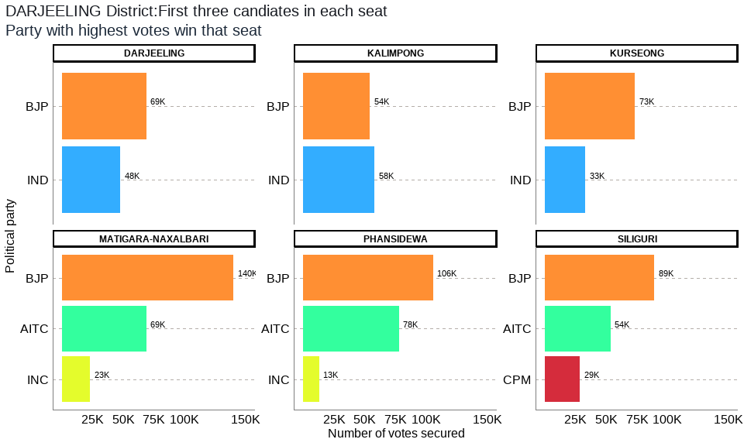

## Table 7: DARJEELING District Election Results: Top 3 Candidates by Votes in Each Constituency

| **Constituency** | **Type** | **Party** | **Candidate** | **Position** | **Votes** | **Margin** |
| --- | --- | --- | --- | --- | --- | --- |
| DARJEELING | GEN | BJP | Neeraj Tamang Zimba | 1 | 68,907 | 21,276 |
| DARJEELING | GEN | IND | Keshav Raj Sharma | 2 | 47,631 | 9,391 |
| DARJEELING | GEN | IND | Pemba Tshering | 3 | 38,240 | 35,385 |
| KALIMPONG | GEN | IND | Ruden Sada Lepcha | 1 | 58,206 | 3,870 |
| KALIMPONG | GEN | BJP | Suva Pradhan | 2 | 54,336 | 22,480 |
| KALIMPONG | GEN | IND | Dr. R.b. Bhujel | 3 | 31,856 | 29,696 |
| KURSEONG | GEN | BJP | Bishnu Prasad Sharma (Alias B.p. Bajgain) | 1 | 73,475 | 15,515 |
| KURSEONG | GEN | IND | Tshering Lama | 2 | 57,960 | 24,866 |
| KURSEONG | GEN | IND | Narbu Lama | 3 | 33,094 | 30,549 |
| MATIGARA-NAXALBARI | SC | BJP | Anandamay Barman | 1 | 139,785 | 70,848 |
| MATIGARA-NAXALBARI | SC | AITC | Rajen Sundas | 2 | 68,937 | 45,877 |
| MATIGARA-NAXALBARI | SC | INC | Sankar Malakar | 3 | 23,060 | 19,148 |
| PHANSIDEWA | ST | BJP | Durga Murmu | 1 | 105,651 | 27,711 |
| PHANSIDEWA | ST | AITC | Chhotan Kisku | 2 | 77,940 | 65,125 |
| PHANSIDEWA | ST | INC | Sunil Chandra Tirkey | 3 | 12,815 | 10,028 |
| SILIGURI | GEN | BJP | Sankar Ghosh | 1 | 89,370 | 35,586 |
| SILIGURI | GEN | AITC | Dr. Omprakash Mishra | 2 | 53,784 | 24,949 |
| SILIGURI | GEN | CPM | Asok Bhattacharya | 3 | 28,835 | 26,761 |

The district of Darjeeling has a total of 6 legislative constituencies. The district has 2 reserved constituencies out of which 1 seat is reserved for the Scheduled Castes (SC) community whereas 1 seat is reserved for the Scheduled Tribes (ST) community. Seats reserved for SC include Matigara-Naxalbari and the seats reserved for ST include Phansidewa respectively.

Out of the total 6 seats in the Darjeeling district, the largest number of seats i.e. 5 were won by the BJP while the IND won 1 seat. The seats won by BJP were Darjeeling, Kurseong, Matigara-Naxalbari, Siliguri, Phansidewa and the seat won by IND was Kalimpong respectively.

Out of the total polled votes of 1110136, BJP secured a total of 531524 (48%) votes while the IND secured 290173 (26%) of the votes. The AITC with a vote share of 200661 (18%) was inthird place, while the INC was in the fourth position after securing 37590 (3%) of the total votes in the district.

## 7. HOOGHLY District: Winners per constituency and top 3 candidates

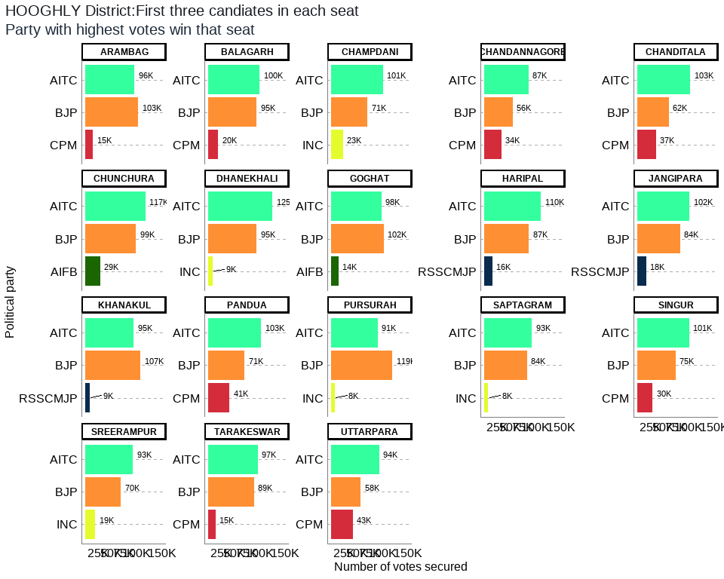

## Table 8: HOOGHLY District Election Results: Top 3 Candidates by Votes in Each Constituency

| **Constituency** | **Type** | **Party** | **Candidate** | **Position** | **Votes** | **Margin** |
| --- | --- | --- | --- | --- | --- | --- |
| ARAMBAG | SC | BJP | Madhusudan Bag | 1 | 103,108 | 7,172 |
| ARAMBAG | SC | AITC | Sujata Mondal | 2 | 95,936 | 80,971 |
| ARAMBAG | SC | CPM | Sakti Mohon Malik | 3 | 14,965 | 11,794 |
| BALAGARH | SC | AITC | Manoranjan Bapari | 1 | 100,364 | 5,784 |
| BALAGARH | SC | BJP | Subhas Chandra Haldar | 2 | 94,580 | 74,814 |
| BALAGARH | SC | CPM | Mahamaya Mondal | 3 | 19,766 | 16,661 |
| CHAMPDANI | GEN | AITC | Arindam Guin (Bubai) | 1 | 100,972 | 30,078 |
| CHAMPDANI | GEN | BJP | Dilip Singh | 2 | 70,894 | 47,622 |
| CHAMPDANI | GEN | INC | Abdul Mannan | 3 | 23,272 | 19,925 |
| CHANDANNAGORE | GEN | AITC | Indranil Sen | 1 | 86,778 | 31,029 |
| CHANDANNAGORE | GEN | BJP | Deepanjan Kumar Guha | 2 | 55,749 | 22,047 |
| CHANDANNAGORE | GEN | CPM | Gautam Sarkar | 3 | 33,702 | 30,679 |
| CHANDITALA | GEN | AITC | Swati Khandoker | 1 | 103,118 | 41,347 |
| CHANDITALA | GEN | BJP | Debashish Dasgupta(Yash D Guptaa) | 2 | 61,771 | 24,610 |
| CHANDITALA | GEN | CPM | Md. Salim | 3 | 37,161 | 35,005 |
| CHUNCHURA | GEN | AITC | Asit Mazumder (Tapan) | 1 | 117,104 | 18,417 |
| CHUNCHURA | GEN | BJP | Locket Chatterjee | 2 | 98,687 | 69,910 |
| CHUNCHURA | GEN | AIFB | Pranab Kumar Ghosh | 3 | 28,777 | 24,439 |
| DHANEKHALI | SC | AITC | Asima Patra | 1 | 124,776 | 30,159 |
| DHANEKHALI | SC | BJP | Tusar Kumar Majumdar | 2 | 94,617 | 85,584 |
| DHANEKHALI | SC | INC | Anirban Saha | 3 | 9,033 | 5,803 |
| GOGHAT | SC | BJP | Biswanath Karak | 1 | 102,227 | 4,147 |
| GOGHAT | SC | AITC | Manas Majumdar | 2 | 98,080 | 83,702 |
| GOGHAT | SC | AIFB | Shiba Prasad Malick | 3 | 14,378 | 11,896 |
| HARIPAL | GEN | AITC | Dr. Karabi Manna | 1 | 110,215 | 23,072 |
| HARIPAL | GEN | BJP | Samiran Mitra | 2 | 87,143 | 71,348 |
| HARIPAL | GEN | RSSCMJP | Simal Saren | 3 | 15,795 | 12,428 |
| JANGIPARA | GEN | AITC | Snehasis Chakraborty | 1 | 101,885 | 17,926 |
| JANGIPARA | GEN | BJP | Debjit Sarkar | 2 | 83,959 | 66,203 |
| JANGIPARA | GEN | RSSCMJP | Sk. Mainuddin | 3 | 17,756 | 14,716 |
| KHANAKUL | GEN | BJP | Susanta Ghosh | 1 | 107,403 | 12,884 |
| KHANAKUL | GEN | AITC | Munsi Nazbul Karim | 2 | 94,519 | 85,787 |
| KHANAKUL | GEN | RSSCMJP | Faisal Khan | 3 | 8,732 | 5,454 |
| PANDUA | GEN | AITC | Dr. Ratna De Nag | 1 | 102,874 | 31,858 |
| PANDUA | GEN | BJP | Partha Sharma | 2 | 71,016 | 29,542 |
| PANDUA | GEN | CPM | Amjad Hossain Sk. | 3 | 41,474 | 39,310 |
| PURSURAH | GEN | BJP | Biman Ghosh | 1 | 119,334 | 28,178 |
| PURSURAH | GEN | AITC | Dilip Yadav | 2 | 91,156 | 83,328 |
| PURSURAH | GEN | INC | Monika Malik Ghosh | 3 | 7,828 | 5,040 |
| SAPTAGRAM | GEN | AITC | Tapan Dasgupta | 1 | 93,328 | 9,772 |
| SAPTAGRAM | GEN | BJP | Debabrata Biswas | 2 | 83,556 | 75,224 |
| SAPTAGRAM | GEN | INC | Pabitra Deb | 3 | 8,332 | 5,295 |
| SINGUR | GEN | AITC | Becharam Manna | 1 | 101,077 | 25,923 |
| SINGUR | GEN | BJP | Rabindranath Bhattacharya | 2 | 75,154 | 45,138 |
| SINGUR | GEN | CPM | Srijan Bhattacharyya | 3 | 30,016 | 27,671 |
| SREERAMPUR | GEN | AITC | Dr. Sudipto Roy | 1 | 93,021 | 23,433 |
| SREERAMPUR | GEN | BJP | Kabir Shankar Bose | 2 | 69,588 | 50,187 |
| SREERAMPUR | GEN | INC | Alok Ranjan Banerjee | 3 | 19,401 | 17,001 |
| TARAKESWAR | GEN | AITC | Ramendu Sinharay | 1 | 96,698 | 7,484 |
| TARAKESWAR | GEN | BJP | Dr. Swapan Dasgupta | 2 | 89,214 | 74,619 |
| TARAKESWAR | GEN | CPM | Surajit Ghosh | 3 | 14,595 | 11,843 |
| UTTARPARA | GEN | AITC | Kanchan Mullick | 1 | 93,878 | 35,989 |
| UTTARPARA | GEN | BJP | Prabir Kumar Ghosal | 2 | 57,889 | 15,171 |
| UTTARPARA | GEN | CPM | Rajat Banerjee (Bappa) | 3 | 42,718 | 39,365 |

The district of Hooghly has a total of 18 legislative constituencies. The district has 4 reserved constituencies and all 4 seats are reserved for the Scheduled Castes (SC) community. Seats reserved for SC include Balagarh, Dhanekhali, Arambag, Goghat.

Out of the total 18 seats in the Hooghly district, the largest number of seats i.e. 14 were won by the AITC while the BJP won 4 seats. The seats won by AITC were Uttarpara, Sreerampur, Champdani, Singur, Chandannagore, Chunchura, Balagarh, Pandua, Saptagram, Chanditala, Jangipara, Haripal, Dhanekhali, Tarakeswar and the seats won by BJP were Pursurah, Arambag, Goghat, Khanakul respectively.

Out of the total polled votes of 3778058, AITC secured a total of 1805779 (48%) votes while the BJP secured 1525889 (40%) of the votes. The CPM with a vote share of 234397 (6%) was in third place, while the INC was in the fourth position after securing 67866 (2%) of the total votes in the district.

## 8. HOWRAH District: Winners per constituency and top 3 candidates

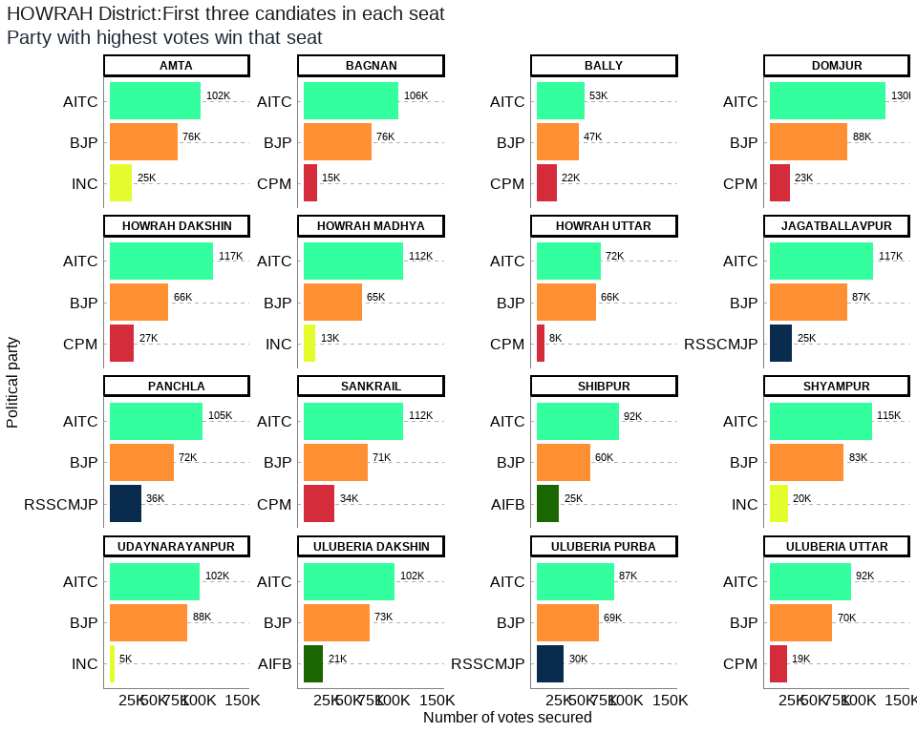

## Table 9: HOWRAH District Election Results: Top 3 Candidates by Votes in Each Constituency

| **Constituency** | **Type** | **Party** | **Candidate** | **Position** | **Votes** | **Margin** |
| --- | --- | --- | --- | --- | --- | --- |
| AMTA | GEN | AITC | Sukanta Kumar Paul | 1 | 102,445 | 26,205 |
| AMTA | GEN | BJP | Debtanu Bhattacharya | 2 | 76,240 | 51,131 |
| AMTA | GEN | INC | Asit Mitra | 3 | 25,109 | 23,807 |
| BAGNAN | GEN | AITC | Arunava Sen (Raja) | 1 | 106,042 | 30,120 |
| BAGNAN | GEN | BJP | Anupam Mallik | 2 | 75,922 | 61,367 |
| BAGNAN | GEN | CPM | Sk Bosir Ahmed | 3 | 14,555 | 13,007 |
| BALLY | GEN | AITC | Rana Chatterjee | 1 | 53,347 | 6,237 |
| BALLY | GEN | BJP | Baishali Dalmiya | 2 | 47,110 | 25,070 |
| BALLY | GEN | CPM | Dipsita Dhar | 3 | 22,040 | 20,835 |
| DOMJUR | GEN | AITC | Kalyan Ghosh | 1 | 130,499 | 42,620 |
| DOMJUR | GEN | BJP | Rajib Banerjee S/O- Late Dhananjoy Banerjee | 2 | 87,879 | 65,111 |
| DOMJUR | GEN | CPM | Uttam Bera | 3 | 22,768 | 19,913 |
| HOWRAH DAKSHIN | GEN | AITC | Nandita Chowdhury | 1 | 116,839 | 50,569 |
| HOWRAH DAKSHIN | GEN | BJP | Rantidev Sengupta | 2 | 66,270 | 38,983 |
| HOWRAH DAKSHIN | GEN | CPM | Sumitro Adhikary | 3 | 27,287 | 24,339 |
| HOWRAH MADHYA | GEN | AITC | Arup Roy, S/O Late Prabhat Roy | 1 | 111,554 | 46,547 |
| HOWRAH MADHYA | GEN | BJP | Sanjay Singh | 2 | 65,007 | 52,065 |
| HOWRAH MADHYA | GEN | INC | Palash Bhandari | 3 | 12,942 | 10,207 |
| HOWRAH UTTAR | GEN | AITC | Gautam Chowdhuri | 1 | 71,575 | 5,522 |
| HOWRAH UTTAR | GEN | BJP | Umesh Rai | 2 | 66,053 | 57,920 |
| HOWRAH UTTAR | GEN | CPM | Pawan Kumar Singh | 3 | 8,133 | 6,463 |
| JAGATBALLAVPUR | GEN | AITC | Sitanath Ghosh | 1 | 116,562 | 29,196 |
| JAGATBALLAVPUR | GEN | BJP | Anupam Ghosh | 2 | 87,366 | 62,004 |
| JAGATBALLAVPUR | GEN | RSSCMJP | Sk Sabbir Ahmed | 3 | 25,362 | 22,593 |
| PANCHLA | GEN | AITC | Gulsan Mullick | 1 | 104,572 | 32,751 |
| PANCHLA | GEN | BJP | Mohit Lal Ghanti | 2 | 71,821 | 36,245 |
| PANCHLA | GEN | RSSCMJP | Abdul Jalil Sk | 3 | 35,576 | 33,165 |
| SANKRAIL | SC | AITC | Priya Paul | 1 | 111,888 | 40,427 |
| SANKRAIL | SC | BJP | Probhakar Pandit | 2 | 71,461 | 37,317 |
| SANKRAIL | SC | CPM | Samir Malick | 3 | 34,144 | 32,294 |
| SHIBPUR | GEN | AITC | Manoj Tiwary | 1 | 92,372 | 32,603 |
| SHIBPUR | GEN | BJP | Rathin Chakrabarty | 2 | 59,769 | 34,799 |
| SHIBPUR | GEN | AIFB | Jagannath Bhattacharyya | 3 | 24,970 | 23,058 |
| SHYAMPUR | GEN | AITC | Kalipada Mandal | 1 | 114,804 | 31,511 |
| SHYAMPUR | GEN | BJP | Tnusree Chakraborty | 2 | 83,293 | 62,885 |
| SHYAMPUR | GEN | INC | Amitabha Chakraborti | 3 | 20,408 | 19,266 |
| UDAYNARAYANPUR | GEN | AITC | Samir Kumar Panja | 1 | 101,510 | 13,998 |
| UDAYNARAYANPUR | GEN | BJP | Sumit Ranjan Karar | 2 | 87,512 | 82,334 |
| UDAYNARAYANPUR | GEN | INC | Aloke Koley | 3 | 5,178 | 3,460 |
| ULUBERIA DAKSHIN | GEN | AITC | Pulak Roy | 1 | 101,880 | 28,438 |
| ULUBERIA DAKSHIN | GEN | BJP | Papia Dey (Adhikary) | 2 | 73,442 | 52,332 |
| ULUBERIA DAKSHIN | GEN | AIFB | Sk Kutub Uddin Ahmed | 3 | 21,110 | 19,636 |
| ULUBERIA PURBA | GEN | AITC | Bidesh Ranjan Bose | 1 | 86,526 | 17,126 |
| ULUBERIA PURBA | GEN | BJP | Pratyush Mandal | 2 | 69,400 | 38,942 |
| ULUBERIA PURBA | GEN | RSSCMJP | Abbas Uddin Khan | 3 | 30,458 | 28,347 |
| ULUBERIA UTTAR | SC | AITC | Dr. Nirmal Maji | 1 | 91,501 | 21,003 |
| ULUBERIA UTTAR | SC | BJP | Chiran Bera | 2 | 70,498 | 51,206 |
| ULUBERIA UTTAR | SC | CPM | Ashok Dalui | 3 | 19,292 | 18,044 |

The district of Howrah has a total of 16 legislative constituencies. The district has 2 reserved constituencies and both seats are reserved for the Scheduled Castes (SC) community. Seats reserved for SC include Sankrail, Uluberia Uttar.

Out of the total 16 seats in the Howrah district, all seats i.e. 16 were won by the AITC. The seats won by AITC were Bally, Howrah Uttar, Howrah Madhya, Shibpur, Howrah Dakshin, Sankrail, Panchla, Uluberia Purba, Uluberia Uttar, Uluberia Dakshin, Shyampur, Bagnan, Amta, Udaynarayanpur, Jagatballavpur, Domjur.

Out of the total polled votes of 3176015, AITC secured a total of 1613916 (51%) votes while the BJP secured 1159043 (36%) of the votes. The CPM with a vote share of 148219 (5%) was in third place, while the RSSCMJP was in the fourth position after securing 91396 (3%) of the total votes in the district.

## 9. JALPAIGURI District: Winners per constituency and top 3 candidates

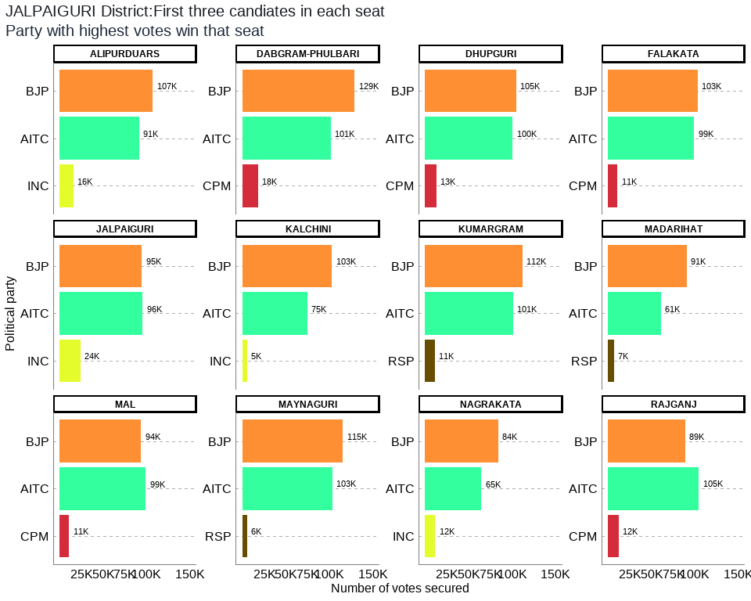

## Table 10: JALPAIGURI District Election Results: Top 3 Candidates by Votes in Each Constituency

| **Constituency** | **Type** | **Party** | **Candidate** | **Position** | **Votes** | **Margin** |
| --- | --- | --- | --- | --- | --- | --- |
| ALIPURDUARS | GEN | BJP | Suman Kanjilal | 1 | 107,333 | 16,007 |
| ALIPURDUARS | GEN | AITC | Sourav Chakraborty (Ghutis) | 2 | 91,326 | 75,675 |
| ALIPURDUARS | GEN | INC | Deba Prasad Roy | 3 | 15,651 | 13,300 |
| DABGRAM-PHULBARI | GEN | BJP | Sikha Chatterjee | 1 | 129,088 | 27,593 |
| DABGRAM-PHULBARI | GEN | AITC | Goutam Deb | 2 | 101,495 | 83,497 |
| DABGRAM-PHULBARI | GEN | CPM | Dilip Singh | 3 | 17,998 | 14,619 |
| DHUPGURI | SC | BJP | Bishnu Pada Ray | 1 | 104,688 | 4,355 |
| DHUPGURI | SC | AITC | Mitali Roy | 2 | 100,333 | 87,226 |
| DHUPGURI | SC | CPM | Pradip Kumar Roy | 3 | 13,107 | 10,929 |
| FALAKATA | SC | BJP | Dipak Barman | 1 | 102,993 | 3,990 |
| FALAKATA | SC | AITC | Subhash Chandra Roy | 2 | 99,003 | 88,231 |
| FALAKATA | SC | CPM | Kshitish Chandra Ray | 3 | 10,772 | 8,802 |
| JALPAIGURI | SC | AITC | Dr. Pradip Kumar Barma | 1 | 95,668 | 941 |
| JALPAIGURI | SC | BJP | Soujit Singha (Piku) | 2 | 94,727 | 70,499 |
| JALPAIGURI | SC | INC | Sukhbilas Barma | 3 | 24,228 | 20,847 |
| KALCHINI | ST | BJP | Bishal Lama | 1 | 103,104 | 28,576 |
| KALCHINI | ST | AITC | Passang Lama | 2 | 74,528 | 69,046 |
| KALCHINI | ST | INC | Avijit Narjinary | 3 | 5,482 | 3,057 |
| KUMARGRAM | ST | BJP | Manoj Kumar Oraon | 1 | 111,974 | 11,001 |
| KUMARGRAM | ST | AITC | Leos Kujur (Urao) | 2 | 100,973 | 89,720 |
| KUMARGRAM | ST | RSP | Kishor Minj | 3 | 11,253 | 8,535 |
| MADARIHAT | ST | BJP | Manoj Tigga | 1 | 90,718 | 29,685 |
| MADARIHAT | ST | AITC | Rajesh Lakra | 2 | 61,033 | 53,961 |
| MADARIHAT | ST | RSP | Subhash Lohar | 3 | 7,072 | 4,450 |
| MAL | ST | AITC | Bulu Chik Baraik | 1 | 99,086 | 5,465 |
| MAL | ST | BJP | Mahesh Bagey | 2 | 93,621 | 82,692 |
| MAL | ST | CPM | Manu Oraon | 3 | 10,929 | 6,230 |
| MAYNAGURI | SC | BJP | Kaushik Roy | 1 | 115,306 | 11,911 |
| MAYNAGURI | SC | AITC | Manoj Roy | 2 | 103,395 | 97,635 |
| MAYNAGURI | SC | RSP | Naresh Chandra Roy | 3 | 5,760 | 2,665 |
| NAGRAKATA | ST | BJP | Puna Bhengra | 1 | 83,707 | 19,038 |
| NAGRAKATA | ST | AITC | Joseph Munda | 2 | 64,669 | 53,068 |
| NAGRAKATA | ST | INC | Sukbir Subba | 3 | 11,601 | 6,675 |
| RAJGANJ | SC | AITC | Khageswar Roy | 1 | 104,641 | 15,773 |
| RAJGANJ | SC | BJP | Supen Roy | 2 | 88,868 | 76,760 |
| RAJGANJ | SC | CPM | Ratan Kumar Roy | 3 | 12,108 | 8,933 |

The district of Jalpaiguri has a total of 12 legislative constituencies. The district has 10 reserved constituencies out of which 5 seats are reserved for the Scheduled Castes (SC) community whereas 5 seats are reserved for the Scheduled Tribes (ST) community. The seats reserved for SC include Falakata, Dhupguri, Maynaguri, Jalpaiguri, Rajganj, and the seats reserved for ST include Kumargram, Kalchini, Madarihat, Mal, Nagrakata respectively.

Out of the total 12 seats in the Jalpaiguri district, the largest number of seats i.e. 9 were won by the BJP while the AITC won 3 seats. The seats won by BJP were Kumargram, Kalchini, Alipurduars, Falakata, Madarihat, Dhupguri, Maynaguri, Dabgram-Phulbari, Nagrakata and the seats won by AITC were Jalpaiguri, Rajganj, Mal respectively.

Out of the total polled votes of 2553048, BJP secured a total of 1226127 (48%) votes while the AITC secured 1096150 (43%) of the votes. The CPM with a vote share of 64914 (3%) was in third place, while the INC was in the fourth position after securing 56962 (2%) of the total votes in the district.

## 10. KOLKATA CORPORATION District: Winners per constituency and top 3 candidates

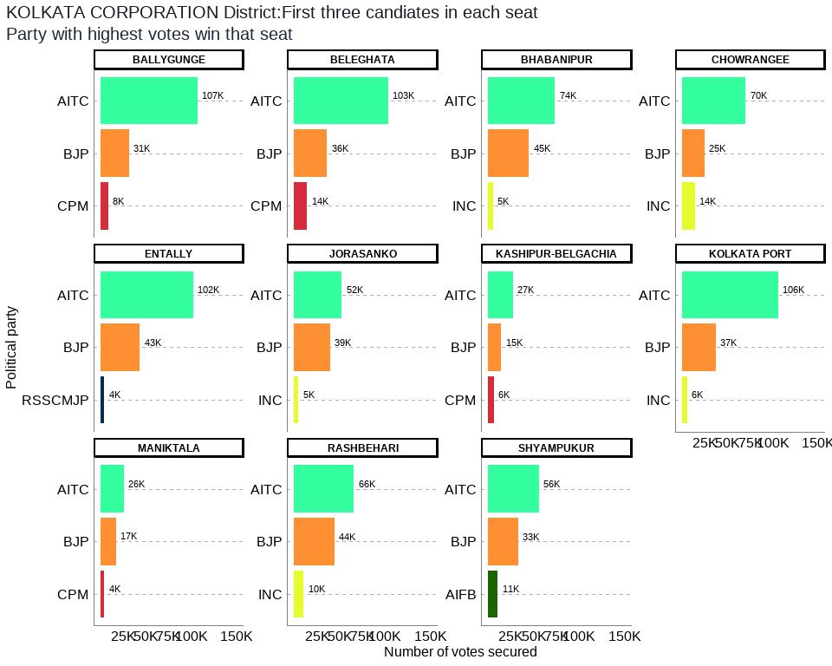

## Table 11: KOLKATA CORPORATION District Election Results: Top 3 Candidates by Votes in Each Constituency

| **Constituency** | **Type** | **Party** | **Candidate** | **Position** | **Votes** | **Margin** |
| --- | --- | --- | --- | --- | --- | --- |
| BALLYGUNGE | GEN | AITC | Subrata Mukherjee | 1 | 106,585 | 75,359 |
| BALLYGUNGE | GEN | BJP | Lokenath Chatterjee | 2 | 31,226 | 22,752 |
| BALLYGUNGE | GEN | CPM | Dr. Fuad Halim | 3 | 8,474 | 7,157 |
| BELEGHATA | GEN | AITC | Paresh Paul | 1 | 103,182 | 67,140 |
| BELEGHATA | GEN | BJP | Kashinath Biswas | 2 | 36,042 | 21,997 |
| BELEGHATA | GEN | CPM | Rajib Biswas | 3 | 14,045 | 12,481 |
| BHABANIPUR | GEN | AITC | Sobhandeb Chattopadhyay | 1 | 73,505 | 28,719 |
| BHABANIPUR | GEN | BJP | Rudranil Ghosh | 2 | 44,786 | 39,575 |
| BHABANIPUR | GEN | INC | Md. Shadab Khan | 3 | 5,211 | 3,641 |
| CHOWRANGEE | GEN | AITC | Bandyopadhyay Nayna | 1 | 70,101 | 45,344 |
| CHOWRANGEE | GEN | BJP | Devdutta Maji | 2 | 24,757 | 10,491 |
| CHOWRANGEE | GEN | INC | Santosh Kumar Pathak | 3 | 14,266 | 13,054 |
| ENTALLY | GEN | AITC | Swarna Kamal Saha | 1 | 101,709 | 58,257 |
| ENTALLY | GEN | BJP | Priyanka Tibrewal | 2 | 43,452 | 39,098 |
| ENTALLY | GEN | RSSCMJP | Md. Iqbal Alam | 3 | 4,354 | 2,420 |
| JORASANKO | GEN | AITC | Vivek Gupta | 1 | 52,123 | 12,743 |
| JORASANKO | GEN | BJP | Meena Devi Purohit | 2 | 39,380 | 34,611 |
| JORASANKO | GEN | INC | Ajmal Khan | 3 | 4,769 | 3,741 |
| KASHIPUR-BELGACHIA | GEN | AITC | Atin Ghosh | 1 | 27,482 | 12,786 |
| KASHIPUR-BELGACHIA | GEN | BJP | Sibaji Sinha Roy | 2 | 14,696 | 8,495 |
| KASHIPUR-BELGACHIA | GEN | CPM | Pratip Dasgupta | 3 | 6,201 | 5,649 |
| KOLKATA PORT | GEN | AITC | Firhad Hakim | 1 | 105,543 | 68,554 |
| KOLKATA PORT | GEN | BJP | Awadh Kishore Gupta | 2 | 36,989 | 31,399 |
| KOLKATA PORT | GEN | INC | Md Mukhtar | 3 | 5,590 | 4,230 |
| MANIKTALA | GEN | AITC | Sadhan Pande | 1 | 25,589 | 8,490 |
| MANIKTALA | GEN | BJP | Kalyan Chaubey | 2 | 17,099 | 12,677 |
| MANIKTALA | GEN | CPM | Rupa Bagchi | 3 | 4,422 | 3,874 |
| RASHBEHARI | GEN | AITC | Debasish Kumar | 1 | 65,704 | 21,414 |
| RASHBEHARI | GEN | BJP | Lt. Gen. (Dr.) Subrata Saha | 2 | 44,290 | 33,976 |
| RASHBEHARI | GEN | INC | Ashutosh Chatterjee | 3 | 10,314 | 8,652 |
| SHYAMPUKUR | GEN | AITC | Dr. Shashi Panja | 1 | 55,785 | 22,520 |
| SHYAMPUKUR | GEN | BJP | Sandipan Biswas | 2 | 33,265 | 22,437 |
| SHYAMPUKUR | GEN | AIFB | Jiban Prakash Saha | 3 | 10,828 | 9,765 |

The district of Kolkata Corporation has a total of 11 legislative constituencies. The district has 0 reserved constituencies.

Out of the total 11 seats in the Kolkata Corporation district, all seats i.e. 11 were won by the AITC. The seats won by AITC are Kolkata Port, Bhabanipur, Rashbehari, Ballygunge, Chowrangee, Entally, Beleghata, Jorasanko, Shyampukur, Maniktala, Kashipur-Belgachia.

Out of the total polled votes of 1269450, AITC secured a total of 787308 (62%) votes while the BJP secured 365982 (29%) of the votes. The INC with a vote share of 40150 (3%) was in third place, while the CPM was in the fourth position after securing 33142 (3%) of the total votes in the district.

## 11. MALDAH District: Winners per constituency and top 3 candidates

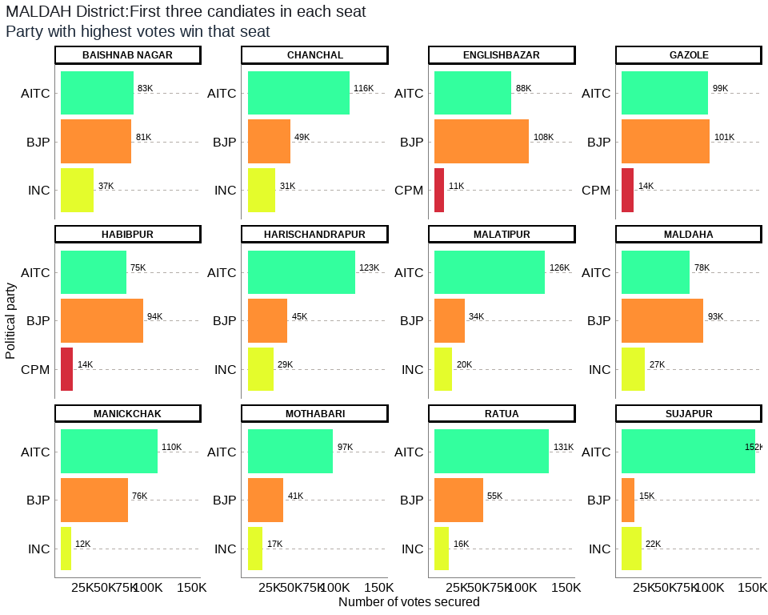

## Table 12: MALDAH District Election Results: Top 3 Candidates by Votes in Each Constituency

| **Constituency** | **Type** | **Party** | **Candidate** | **Position** | **Votes** | **Margin** |
| --- | --- | --- | --- | --- | --- | --- |
| BAISHNAB NAGAR | GEN | AITC | Chandana Sarkar | 1 | 83,061 | 2,471 |
| BAISHNAB NAGAR | GEN | BJP | Swadhin Kumar Sarkar | 2 | 80,590 | 43,147 |
| BAISHNAB NAGAR | GEN | INC | Azizul Hoque | 3 | 37,443 | 35,161 |
| CHANCHAL | GEN | AITC | Nihar Ranjan Ghosh | 1 | 115,966 | 67,338 |
| CHANCHAL | GEN | BJP | Dipankar Ram (Bankat) | 2 | 48,628 | 17,282 |
| CHANCHAL | GEN | INC | Asif Mehbub | 3 | 31,346 | 30,132 |
| ENGLISHBAZAR | GEN | BJP | Sreerupa Mitra Chaudhury(Nirbhoy Didi) | 1 | 107,755 | 20,099 |
| ENGLISHBAZAR | GEN | AITC | Krishnendu Narayan Choudhury | 2 | 87,656 | 76,703 |
| ENGLISHBAZAR | GEN | CPM | Koushik Misra(Saheb) | 3 | 10,953 | 7,757 |
| GAZOLE | SC | BJP | Chinmoy Deb Barman | 1 | 100,655 | 1,798 |
| GAZOLE | SC | AITC | Basanti Barman | 2 | 98,857 | 84,907 |
| GAZOLE | SC | CPM | Arun Kumar Biswas | 3 | 13,950 | 12,007 |
| HABIBPUR | ST | BJP | Joyel Murmu | 1 | 94,075 | 19,517 |
| HABIBPUR | ST | AITC | Prodip Baskey | 2 | 74,558 | 60,753 |
| HABIBPUR | ST | CPM | Thakur Tudu | 3 | 13,805 | 7,909 |
| HARISCHANDRAPUR | GEN | AITC | Tajmul Hossain | 1 | 122,527 | 77,473 |
| HARISCHANDRAPUR | GEN | BJP | Md. Matibur Rahaman | 2 | 45,054 | 15,658 |
| HARISCHANDRAPUR | GEN | INC | Alam Mostaque | 3 | 29,396 | 27,923 |
| MALATIPUR | GEN | AITC | Abdur Rahim Boxi | 1 | 126,157 | 91,949 |
| MALATIPUR | GEN | BJP | Mousumi Das | 2 | 34,208 | 14,381 |
| MALATIPUR | GEN | INC | Alberuni Zulkarnain | 3 | 19,827 | 17,793 |
| MALDAHA | SC | BJP | Gopal Chandra Saha | 1 | 93,398 | 15,456 |
| MALDAHA | SC | AITC | Ujjwal Kumar Chowdhury | 2 | 77,942 | 51,379 |
| MALDAHA | SC | INC | Bhupendra Nath Halder (Arjun) | 3 | 26,563 | 23,745 |
| MANICKCHAK | GEN | AITC | Sabitri Mitra | 1 | 110,234 | 33,878 |
| MANICKCHAK | GEN | BJP | Gour Chandra Mandal | 2 | 76,356 | 64,801 |
| MANICKCHAK | GEN | INC | Alam Mottakin | 3 | 11,555 | 8,812 |
| MOTHABARI | GEN | AITC | Yeasmin Sabina | 1 | 97,397 | 56,573 |
| MOTHABARI | GEN | BJP | Shyamchand Ghosh | 2 | 40,824 | 23,921 |
| MOTHABARI | GEN | INC | Dulal Sk | 3 | 16,903 | 13,318 |
| RATUA | GEN | AITC | Samar Mukherjee | 1 | 130,674 | 75,650 |
| RATUA | GEN | BJP | Abishek Singhania | 2 | 55,024 | 38,851 |
| RATUA | GEN | INC | Khatun Najema | 3 | 16,173 | 7,545 |
| SUJAPUR | GEN | AITC | Md Abdul Ghani | 1 | 152,445 | 130,163 |
| SUJAPUR | GEN | INC | Isha Khan Choudhury | 2 | 22,282 | 7,493 |
| SUJAPUR | GEN | BJP | Sk Ziauddin | 3 | 14,789 | 3,616 |

The district of Maldah has a total of 12 legislative constituencies. The district has 3 reserved constituencies out of which 2 seats are reserved for the Scheduled Castes (SC) community whereas 1 seat is reserved for the Scheduled Tribes (ST) community. The seats reserved for SC include Gazole, Maldaha and the seat reserved for ST include Habibpur.

Out of the total 12 seats in the Maldah district, the largest number of seats i.e. 8 were won by the AITC while the BJP won 4 seats. The seats won by AITC were Chanchal, Harischandrapur, Malatipur, Ratua, Manickchak, Mothabari, Sujapur, Baishnab Nagar and the seats won by BJP were Habibpur, Gazole, Maldaha, Englishbazar respectively.

Out of the total polled votes of 2412438, AITC secured a total of 1277474 (53%) votes while the BJP secured 791356 (33%) of the votes. The INC with a vote share of 211488 (9%) was in third place, while the CPM was at the fourth position after securing 38708 (2%) in the total votes in the district.

## 12. MURSHIDABAD District: Winners per constituency and top 3 candidates

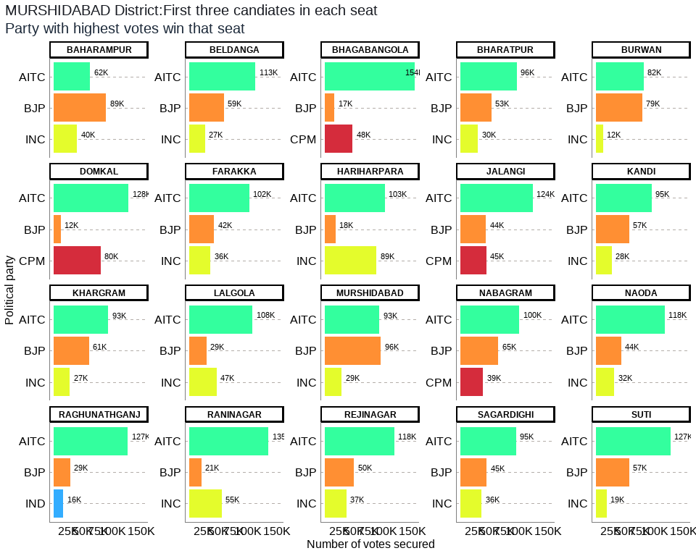

## Table 13: MURSHIDABAD District Election Results: Top 3 Candidates by Votes in Each Constituency

| **Constituency** | **Type** | **Party** | **Candidate** | **Position** | **Votes** | **Margin** |
| --- | --- | --- | --- | --- | --- | --- |
| BAHARAMPUR | GEN | BJP | Subrata Maitra (Kanchan) | 1 | 89,340 | 26,852 |
| BAHARAMPUR | GEN | AITC | Naru Gopal Mukherjee | 2 | 62,488 | 22,321 |
| BAHARAMPUR | GEN | INC | Manoj Chakraborty | 3 | 40,167 | 37,642 |
| BELDANGA | GEN | AITC | Hasanuzzaman Sk | 1 | 112,862 | 53,832 |
| BELDANGA | GEN | BJP | Sumit Ghosh | 2 | 59,030 | 32,081 |
| BELDANGA | GEN | INC | Safiujjaman Seikh | 3 | 26,949 | 24,981 |
| BHAGABANGOLA | GEN | AITC | Idris Ali | 1 | 153,795 | 106,008 |
| BHAGABANGOLA | GEN | CPM | Md. Kamal Hossain | 2 | 47,787 | 31,080 |
| BHAGABANGOLA | GEN | BJP | Mehebub Alam | 3 | 16,707 | 13,311 |
| BHARATPUR | GEN | AITC | Humayun Kabir | 1 | 96,226 | 43,083 |
| BHARATPUR | GEN | BJP | Iman Kalyan Mukherjee | 2 | 53,143 | 23,027 |
| BHARATPUR | GEN | INC | Kamalesh Chatterjee (Gopal) | 3 | 30,116 | 27,535 |
| BURWAN | SC | AITC | Jiban Krishna Saha | 1 | 81,890 | 2,749 |
| BURWAN | SC | BJP | Amiya Kumar Das | 2 | 79,141 | 66,881 |
| BURWAN | SC | INC | Shiladitya Haldar | 3 | 12,260 | 10,252 |
| DOMKAL | GEN | AITC | Jafikul Islam | 1 | 127,671 | 47,229 |
| DOMKAL | GEN | CPM | Md. Mostafijur Rahaman (Rana) | 2 | 80,442 | 68,094 |
| DOMKAL | GEN | BJP | Biyamma Mondal (Rubia) | 3 | 12,348 | 9,929 |
| FARAKKA | GEN | AITC | Manirul Islam | 1 | 102,319 | 59,945 |
| FARAKKA | GEN | BJP | Ghosh Hemanta | 2 | 42,374 | 6,169 |
| FARAKKA | GEN | INC | Mainul Haque | 3 | 36,205 | 34,558 |
| HARIHARPARA | GEN | AITC | Niamot Sheikh | 1 | 102,660 | 14,066 |
| HARIHARPARA | GEN | INC | Mir Alamgir (Palash) | 2 | 88,594 | 70,216 |
| HARIHARPARA | GEN | BJP | Tanmoy Biswas | 3 | 18,378 | 16,653 |
| JALANGI | GEN | AITC | Abdur Razzak | 1 | 123,840 | 79,276 |
| JALANGI | GEN | CPM | Saiful Islam Molla | 2 | 44,564 | 791 |
| JALANGI | GEN | BJP | Chandan Mandal | 3 | 43,773 | 39,584 |
| KANDI | GEN | AITC | Apurba Sarkar (David) | 1 | 95,399 | 38,080 |
| KANDI | GEN | BJP | Goutam Roy | 2 | 57,319 | 29,764 |
| KANDI | GEN | INC | Shafiul Alam Khan (Bonu) | 3 | 27,555 | 24,424 |
| KHARGRAM | SC | AITC | Ashis Marjit | 1 | 93,255 | 32,573 |
| KHARGRAM | SC | BJP | Aditya Moulik | 2 | 60,682 | 33,259 |
| KHARGRAM | SC | INC | Bipad Taran Bagdi | 3 | 27,423 | 25,738 |
| LALGOLA | GEN | AITC | Ali Mohammad | 1 | 107,860 | 60,707 |
| LALGOLA | GEN | INC | Abu Hena | 2 | 47,153 | 17,689 |
| LALGOLA | GEN | BJP | Kalpana Ghosh | 3 | 29,464 | 27,773 |
| MURSHIDABAD | GEN | BJP | Gouri Sankar Ghosh | 1 | 95,967 | 2,491 |
| MURSHIDABAD | GEN | AITC | Shaoni Singha Roy | 2 | 93,476 | 64,641 |
| MURSHIDABAD | GEN | INC | Neajuddin Sk | 3 | 28,835 | 25,931 |
| NABAGRAM | SC | AITC | Kanai Chandra Mondal | 1 | 100,455 | 35,533 |
| NABAGRAM | SC | BJP | Mohan Halder | 2 | 64,922 | 25,793 |
| NABAGRAM | SC | CPM | Kripalini Ghosh | 3 | 39,129 | 36,500 |
| NAODA | GEN | AITC | Sahina Momtaz Khan | 1 | 117,684 | 74,153 |
| NAODA | GEN | BJP | Anupam Mandal | 2 | 43,531 | 11,943 |
| NAODA | GEN | INC | Mosaraf Hossain Mondal (Madhu) | 3 | 31,588 | 27,195 |
| RAGHUNATHGANJ | GEN | AITC | Akhruzzaman | 1 | 126,834 | 98,313 |
| RAGHUNATHGANJ | GEN | BJP | Golam Modaswer | 2 | 28,521 | 12,277 |
| RAGHUNATHGANJ | GEN | IND | Nasir Saikh | 3 | 16,244 | 3,445 |
| RANINAGAR | GEN | AITC | Abdul Soumik Hossain | 1 | 134,957 | 79,702 |
| RANINAGAR | GEN | INC | Firoza Begam | 2 | 55,255 | 34,117 |
| RANINAGAR | GEN | BJP | Mst Masuara Khatun | 3 | 21,138 | 18,364 |
| REJINAGAR | GEN | AITC | Rabiul Alam Chowdhury | 1 | 118,494 | 68,268 |
| REJINAGAR | GEN | BJP | Arabinda Biswas | 2 | 50,226 | 12,944 |
| REJINAGAR | GEN | INC | Kafiruddin Sk | 3 | 37,282 | 35,722 |
| SAGARDIGHI | GEN | AITC | Subrata Saha | 1 | 95,189 | 50,206 |
| SAGARDIGHI | GEN | BJP | Khatun Mafuja | 2 | 44,983 | 8,639 |
| SAGARDIGHI | GEN | INC | Sk M Hasanuzzaman (Bappa) | 3 | 36,344 | 32,894 |
| SUTI | GEN | AITC | Emani Biswas | 1 | 127,351 | 70,701 |
| SUTI | GEN | BJP | Koushik Das | 2 | 56,650 | 37,890 |
| SUTI | GEN | INC | Humayun Reza | 3 | 18,760 | 10,754 |

The district of Murshidabad has a total of 20 legislative constituencies. The district has 3 reserved constituencies and all 3 seats are reserved for the Scheduled Castes (SC) community. The seats reserved for SC include Nabagram, Khargram, Burwan.

Out of the total 20 seats in the Murshidabad district, the largest number of seats i.e. 18 were won by the AITC while the BJP won 2 seats. The seats won by AITC were Farakka, Suti, Raghunathganj, Sagardighi, Lalgola, Bhagabangola, Raninagar, Nabagram, Khargram, Burwan, Kandi, Bharatpur, Rejinagar, Beldanga, Hariharpara, Naoda, Domkal, Jalangi and the seats won by BJP were Murshidabad, Baharampur respectively.

Out of the total polled votes of 4029623, AITC secured a total of 2174705 (54%) votes while the BJP secured 967637 (24%) of the votes. The INC with a vote share of 557285 (14%) was in third place, while the CPM was in the fourth position after securing 211922 (5%) of the total votes in the district.

## 13. NADIA District: Winners per constituency and top 3 candidates

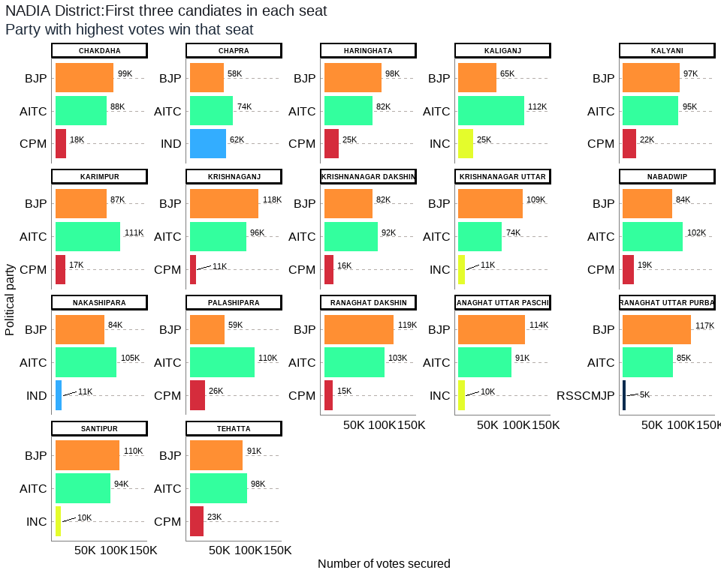

## Table 14: NADIA District Election Results: Top 3 Candidates by Votes in Each Constituency

| **Constituency** | **Type** | **Party** | **Candidate** | **Position** | **Votes** | **Margin** |
| --- | --- | --- | --- | --- | --- | --- |
| CHAKDAHA | GEN | BJP | Bankim Chandra Ghosh | 1 | 99,368 | 11,680 |
| CHAKDAHA | GEN | AITC | Subhankar Singha (Jishu) | 2 | 87,688 | 69,876 |
| CHAKDAHA | GEN | CPM | Narayan Das Gupta | 3 | 17,812 | 16,129 |
| CHAPRA | GEN | AITC | Rukbanur Rahman | 1 | 73,866 | 12,118 |
| CHAPRA | GEN | IND | Jeber Sekh | 2 | 61,748 | 3,580 |
| CHAPRA | GEN | BJP | Kalyan Kumar Nandi | 3 | 58,168 | 46,446 |
| HARINGHATA | SC | BJP | Asim Kumar Sarkar | 1 | 97,666 | 15,200 |
| HARINGHATA | SC | AITC | Nilima Nag (Mallick) | 2 | 82,466 | 57,666 |
| HARINGHATA | SC | CPM | Alakesh Das | 3 | 24,800 | 23,373 |
| KALIGANJ | GEN | AITC | Nasiruddin Ahamed (Lal) | 1 | 111,696 | 46,987 |
| KALIGANJ | GEN | BJP | Abhijit Ghosh | 2 | 64,709 | 39,633 |
| KALIGANJ | GEN | INC | Abul Kashem | 3 | 25,076 | 23,025 |
| KALYANI | SC | BJP | Ambika Roy | 1 | 97,026 | 2,206 |
| KALYANI | SC | AITC | Aniruddha Biswas | 2 | 94,820 | 72,655 |
| KALYANI | SC | CPM | Sabuj Das | 3 | 22,165 | 19,588 |
| KARIMPUR | GEN | AITC | Bimalendu Sinha Roy | 1 | 110,911 | 23,575 |
| KARIMPUR | GEN | BJP | Samarendranath Ghosh | 2 | 87,336 | 70,151 |
| KARIMPUR | GEN | CPM | Prabhas Majumdar | 3 | 17,185 | 15,716 |
| KRISHNAGANJ | SC | BJP | Ashis Kumar Biswas | 1 | 117,668 | 21,277 |
| KRISHNAGANJ | SC | AITC | Dr. Tapas Mandal | 2 | 96,391 | 85,478 |
| KRISHNAGANJ | SC | CPM | Jhunu Baidya | 3 | 10,913 | 8,814 |
| KRISHNANAGAR DAKSHIN | GEN | AITC | Ujjal Biswas | 1 | 91,738 | 9,305 |
| KRISHNANAGAR DAKSHIN | GEN | BJP | Mahadev Sarkar | 2 | 82,433 | 66,827 |
| KRISHNANAGAR DAKSHIN | GEN | CPM | Biswas Sumit | 3 | 15,606 | 13,441 |
| KRISHNANAGAR UTTAR | GEN | BJP | Mukul Roy | 1 | 109,357 | 35,089 |
| KRISHNANAGAR UTTAR | GEN | AITC | Koushani Mukherjee | 2 | 74,268 | 62,861 |
| KRISHNANAGAR UTTAR | GEN | INC | Silvi Saha | 3 | 11,407 | 9,556 |
| NABADWIP | GEN | AITC | Pundarikakshya Saha | 1 | 102,170 | 18,571 |
| NABADWIP | GEN | BJP | Sidhartha Shankar Naskar | 2 | 83,599 | 65,059 |
| NABADWIP | GEN | CPM | Swarnendu Sinha | 3 | 18,540 | 16,196 |
| NAKASHIPARA | GEN | AITC | Kallol Khan | 1 | 104,812 | 21,271 |
| NAKASHIPARA | GEN | BJP | Santanu Dey | 2 | 83,541 | 72,264 |
| NAKASHIPARA | GEN | IND | Tanmay Ganguli | 3 | 11,277 | 5,912 |
| PALASHIPARA | GEN | AITC | Dr. Manik Bhattacharya | 1 | 110,274 | 51,336 |
| PALASHIPARA | GEN | BJP | Bibhash Chandra Mandal | 2 | 58,938 | 32,710 |
| PALASHIPARA | GEN | CPM | S.m. Sadi | 3 | 26,228 | 24,532 |
| RANAGHAT DAKSHIN | SC | BJP | Mukut Mani Adhikari | 1 | 119,260 | 16,515 |
| RANAGHAT DAKSHIN | SC | AITC | Barnali Dey Roy | 2 | 102,745 | 87,621 |
| RANAGHAT DAKSHIN | SC | CPM | Rama Biswas | 3 | 15,124 | 13,458 |
| RANAGHAT UTTAR PASCHIM | GEN | BJP | Parthasarathi Chatterjee | 1 | 113,637 | 23,128 |
| RANAGHAT UTTAR PASCHIM | GEN | AITC | Sankar Singha | 2 | 90,509 | 80,164 |
| RANAGHAT UTTAR PASCHIM | GEN | INC | Bijayendu Biswas (Habu) | 3 | 10,345 | 8,087 |
| RANAGHAT UTTAR PURBA | SC | BJP | Ashim Biswas | 1 | 116,786 | 31,782 |
| RANAGHAT UTTAR PURBA | SC | AITC | Samir Kumar Poddar | 2 | 85,004 | 79,800 |
| RANAGHAT UTTAR PURBA | SC | RSSCMJP | Dinesh Chandra Biswas | 3 | 5,204 | 2,845 |
| SANTIPUR | GEN | BJP | Jagannath Sarkar | 1 | 109,722 | 15,878 |
| SANTIPUR | GEN | AITC | Ajoy Dey | 2 | 93,844 | 83,996 |
| SANTIPUR | GEN | INC | Ritzu Ghosal | 3 | 9,848 | 7,463 |
| TEHATTA | GEN | AITC | Tapas Kumar Saha | 1 | 97,848 | 6,915 |
| TEHATTA | GEN | BJP | Ashutosh Paul | 2 | 90,933 | 67,694 |
| TEHATTA | GEN | CPM | Subodh Chandra Biswas | 3 | 23,239 | 21,363 |

The district of Nadia has a total of 17 legislative constituencies. The district has 5 reserved constituencies and all 5 seats are reserved for the Scheduled Castes (SC) community . Seats reserved for SC include Krishnaganj, Ranaghat Uttar Purba, Ranaghat Dakshin, Kalyani, Haringhata.

Out of the total 17 seats in the Nadia district, the largest number of seats i.e. 9 were won by the BJP while the AITC won 8 seats. The seats won by BJP were Krishnanagar Uttar, Santipur, Ranaghat Uttar Paschim, Krishnaganj, Ranaghat Uttar Purba, Ranaghat Dakshin, Chakdaha, Kalyani, Haringhata and the seats won by AITC were Karimpur, Tehatta, Palashipara, Kaliganj, Nakashipara, Chapra, Nabadwip, Krishnanagar Dakshin respectively.

Out of the total polled votes of 3625258, AITC secured a total of 1611050 (44%) votes while the BJP secured 1590147 (44%) of the votes. The CPM with a vote share of 208699 (6%) was in third place, while the IND was in the fourth position after securing 99485 (3%) of the total votes in the district.

## 14. NORTH 24 PARGANAS District: Winners per constituency and top 3 candidates

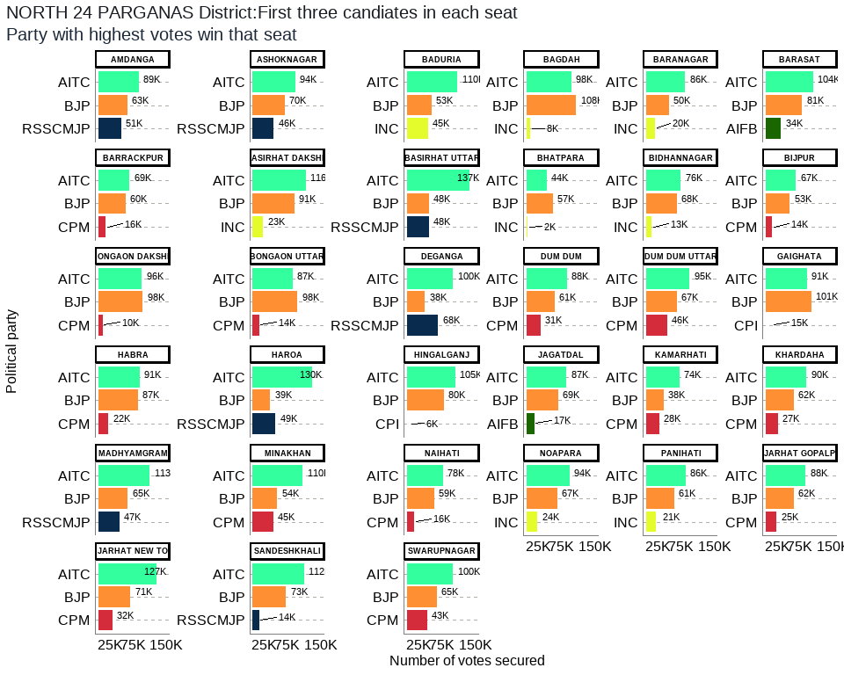

## Table 15: NORTH 24 PARGANAS District Election Results: Top 3 Candidates by Votes in Each Constituency

| **Constituency** | **Type** | **Party** | **Candidate** | **Position** | **Votes** | **Margin** |
| --- | --- | --- | --- | --- | --- | --- |
| AMDANGA | GEN | AITC | Rafiqur Rahaman | 1 | 88,935 | 25,480 |
| AMDANGA | GEN | BJP | Joydev Manna | 2 | 63,455 | 12,550 |
| AMDANGA | GEN | RSSCMJP | Jamal Uddin | 3 | 50,905 | 48,581 |
| ASHOKNAGAR | GEN | AITC | Narayan Goswami | 1 | 93,587 | 23,532 |
| ASHOKNAGAR | GEN | BJP | Tanuja Chakraborty | 2 | 70,055 | 24,260 |
| ASHOKNAGAR | GEN | RSSCMJP | Tapas Banerjee | 3 | 45,795 | 44,184 |
| BADURIA | GEN | AITC | Abdur Rahim Quazi | 1 | 109,701 | 56,444 |
| BADURIA | GEN | BJP | Sukalyan Baidya | 2 | 53,257 | 8,026 |
| BADURIA | GEN | INC | Abdus Sattar | 3 | 45,231 | 43,278 |
| BAGDAH | SC | BJP | Biswajit Das | 1 | 108,111 | 9,792 |
| BAGDAH | SC | AITC | Paritosh Kumar Saha | 2 | 98,319 | 90,069 |
| BAGDAH | SC | INC | Kirttaniya Prabir (Bapi) | 3 | 8,250 | 6,010 |
| BARANAGAR | GEN | AITC | Tapas Roy | 1 | 85,615 | 35,147 |
| BARANAGAR | GEN | BJP | Parno Mittra | 2 | 50,468 | 30,333 |
| BARANAGAR | GEN | INC | Amal Kumar Mukhopadhyay | 3 | 20,135 | 17,757 |
| BARASAT | GEN | AITC | Chiranjeet Chakrabarti | 1 | 104,431 | 23,783 |
| BARASAT | GEN | BJP | Sankar Chatterjee | 2 | 80,648 | 46,477 |
| BARASAT | GEN | AIFB | Sanjib Chattopadhyay | 3 | 34,171 | 31,483 |
| BARRACKPUR | GEN | AITC | Raju Chakraborty (Raj) | 1 | 68,887 | 9,222 |
| BARRACKPUR | GEN | BJP | Chandramani Shukla | 2 | 59,665 | 43,520 |
| BARRACKPUR | GEN | CPM | Debasish Bhowmick | 3 | 16,145 | 14,215 |
| BASIRHAT DAKSHIN | GEN | AITC | Dr. Saptarshi Banerjee | 1 | 115,873 | 24,468 |
| BASIRHAT DAKSHIN | GEN | BJP | Tarak Nath Ghosh | 2 | 91,405 | 68,316 |
| BASIRHAT DAKSHIN | GEN | INC | Amit Majumdar | 3 | 23,089 | 21,400 |
| BASIRHAT UTTAR | GEN | AITC | Rafikul Islam Mondal | 1 | 137,216 | 89,351 |
| BASIRHAT UTTAR | GEN | RSSCMJP | Md Baijid Amin | 2 | 47,865 | 360 |
| BASIRHAT UTTAR | GEN | BJP | Narayan Chandra Mondal | 3 | 47,505 | 45,491 |
| BHATPARA | GEN | BJP | Pawan Kumar Singh | 1 | 57,244 | 13,687 |
| BHATPARA | GEN | AITC | Jitendra Shaw (Jitu) | 2 | 43,557 | 41,388 |
| BHATPARA | GEN | INC | Dharmendra Shaw | 3 | 2,169 | 1,009 |
| BIDHANNAGAR | GEN | AITC | Sujit Bose S/O - Late Ajit Bose | 1 | 75,912 | 7,997 |
| BIDHANNAGAR | GEN | BJP | Sabya Sachi Dutta S/O - Late Gouri Sankar Dutta | 2 | 67,915 | 55,094 |
| BIDHANNAGAR | GEN | INC | Abhisek Banerjee | 3 | 12,821 | 10,608 |
| BIJPUR | GEN | AITC | Subodh Adhikary | 1 | 66,625 | 13,347 |
| BIJPUR | GEN | BJP | Subhranshu Roy | 2 | 53,278 | 38,788 |
| BIJPUR | GEN | CPM | Sukanta Rakshit (Babin) | 3 | 14,490 | 12,948 |
| BONGAON DAKSHIN | SC | BJP | Swapan Majumder | 1 | 97,828 | 2,004 |
| BONGAON DAKSHIN | SC | AITC | Alo Rani Sarkar | 2 | 95,824 | 85,755 |
| BONGAON DAKSHIN | SC | CPM | Tapas Kumar Biswas | 3 | 10,069 | 8,527 |
| BONGAON UTTAR | SC | BJP | Ashok Kirtania | 1 | 97,761 | 10,488 |
| BONGAON UTTAR | SC | AITC | Shyamal Roy | 2 | 87,273 | 73,222 |
| BONGAON UTTAR | SC | CPM | Pijush Kanti Saha | 3 | 14,051 | 12,218 |
| DEGANGA | GEN | AITC | Rahima Mondal | 1 | 100,105 | 32,537 |
| DEGANGA | GEN | RSSCMJP | Karim Ali | 2 | 67,568 | 29,122 |
| DEGANGA | GEN | BJP | Dipika Chattarjee | 3 | 38,446 | 35,504 |
| DUM DUM | GEN | AITC | Brtya Basu | 1 | 87,999 | 26,731 |
| DUM DUM | GEN | BJP | Bimalshankar Nanda | 2 | 61,268 | 30,615 |
| DUM DUM | GEN | CPM | Palash Das | 3 | 30,653 | 28,614 |
| DUM DUM UTTAR | GEN | AITC | Chandrima Bhattacharya | 1 | 95,465 | 28,499 |
| DUM DUM UTTAR | GEN | BJP | Dr. Archana Majumdar | 2 | 66,966 | 21,238 |
| DUM DUM UTTAR | GEN | CPM | Tanmoy Bhattacharya | 3 | 45,728 | 43,617 |
| GAIGHATA | SC | BJP | Subrata Thakur | 1 | 100,808 | 9,578 |
| GAIGHATA | SC | AITC | Narottam Biswas | 2 | 91,230 | 76,392 |
| GAIGHATA | SC | CPI | Kapil Krishna Thakur | 3 | 14,838 | 13,312 |
| HABRA | GEN | AITC | Jyoti Priya Mallick | 1 | 90,533 | 3,841 |
| HABRA | GEN | BJP | Biswajit Sinha | 2 | 86,692 | 64,698 |
| HABRA | GEN | CPM | Rijinandan Biswas | 3 | 21,994 | 20,704 |
| HAROA | GEN | AITC | Islam Sk Nurul (Haji) | 1 | 130,398 | 80,978 |
| HAROA | GEN | RSSCMJP | Kutubuddin Fathe | 2 | 49,420 | 10,914 |
| HAROA | GEN | BJP | Rajendra Saha (Somu) | 3 | 38,506 | 35,576 |
| HINGALGANJ | SC | AITC | Debes Mandal | 1 | 104,706 | 24,916 |
| HINGALGANJ | SC | BJP | Nemai Das | 2 | 79,790 | 73,782 |
| HINGALGANJ | SC | CPI | Ranjan Kumar Mondal | 3 | 6,008 | 4,272 |
| JAGATDAL | GEN | AITC | Somenath Shyam Ichini | 1 | 87,030 | 18,364 |
| JAGATDAL | GEN | BJP | Arindam Bhattacharya | 2 | 68,666 | 51,918 |
| JAGATDAL | GEN | AIFB | Nemai Saha | 3 | 16,748 | 14,180 |
| KAMARHATI | GEN | AITC | Madan Mitra | 1 | 73,845 | 35,408 |
| KAMARHATI | GEN | BJP | Anindya Banerjee | 2 | 38,437 | 10,127 |
| KAMARHATI | GEN | CPM | Sayandeep Mitra | 3 | 28,310 | 26,757 |
| KHARDAHA | GEN | AITC | Kajal Sinha | 1 | 89,807 | 28,140 |
| KHARDAHA | GEN | BJP | Silbhadra Datta | 2 | 61,667 | 34,751 |
| KHARDAHA | GEN | CPM | Debajyoti Das (Subho) | 3 | 26,916 | 24,501 |
| MADHYAMGRAM | GEN | AITC | Rathin Ghosh | 1 | 112,741 | 48,126 |
| MADHYAMGRAM | GEN | BJP | Rajasree Rajbanshi | 2 | 64,615 | 17,867 |
| MADHYAMGRAM | GEN | RSSCMJP | Biswajit Maity | 3 | 46,748 | 43,596 |
| MINAKHAN | SC | AITC | Usha Rani Mondal | 1 | 109,818 | 55,830 |
| MINAKHAN | SC | BJP | Jayanta Mondal | 2 | 53,988 | 9,382 |
| MINAKHAN | SC | CPM | Pradyut Roy | 3 | 44,606 | 40,666 |
| NAIHATI | GEN | AITC | Partha Bhowmick | 1 | 77,753 | 18,855 |
| NAIHATI | GEN | BJP | Phalguni Patra | 2 | 58,898 | 43,073 |
| NAIHATI | GEN | CPM | Indrani Kundu Mukherjee | 3 | 15,825 | 14,124 |
| NOAPARA | GEN | AITC | Manju Basu | 1 | 94,203 | 26,710 |
| NOAPARA | GEN | BJP | Sunil Singh | 2 | 67,493 | 43,991 |
| NOAPARA | GEN | INC | Subhankar Sarkar | 3 | 23,502 | 20,616 |
| PANIHATI | GEN | AITC | Nirmal Ghosh | 1 | 86,495 | 25,177 |
| PANIHATI | GEN | BJP | Sanmoy Bandyopadhyay | 2 | 61,318 | 40,149 |
| PANIHATI | GEN | INC | Tapas Majumder | 3 | 21,169 | 18,835 |
| RAJARHAT GOPALPUR | GEN | AITC | Aditi Munshi | 1 | 87,650 | 25,296 |
| RAJARHAT GOPALPUR | GEN | BJP | Samik Bhattacharya | 2 | 62,354 | 37,843 |
| RAJARHAT GOPALPUR | GEN | CPM | Subhajit Dasgupta | 3 | 24,511 | 22,253 |
| RAJARHAT NEW TOWN | GEN | AITC | Tapash Chatterjee | 1 | 127,374 | 56,432 |
| RAJARHAT NEW TOWN | GEN | BJP | Bhaskar Roy S/O - Dulal Roy | 2 | 70,942 | 39,399 |
| RAJARHAT NEW TOWN | GEN | CPM | Saptarshi Deb | 3 | 31,543 | 29,511 |
| SANDESHKHALI | ST | AITC | Sukumar Mahata | 1 | 112,450 | 39,685 |
| SANDESHKHALI | ST | BJP | Dr. Bhaskar Sardar | 2 | 72,765 | 58,378 |
| SANDESHKHALI | ST | RSSCMJP | Barun Mahato | 3 | 14,387 | 11,931 |
| SWARUPNAGAR | SC | AITC | Bina Mondal | 1 | 99,784 | 34,800 |
| SWARUPNAGAR | SC | BJP | Brindaban Sarkar | 2 | 64,984 | 21,702 |
| SWARUPNAGAR | SC | CPM | Biswajit Mandal | 3 | 43,282 | 42,026 |

The district of North 24 Parganas has a total of 33 legislative constituencies. The district has 8 reserved constituencies out of which 7 seats are reserved for the Scheduled Castes (SC) community whereas 1 seat is reserved for the Scheduled Tribes (ST) community. The seats reserved for SC include Bagdah, Bongaon Uttar, Bongaon Dakshin, Gaighata, Swarupnagar, Minakhan, Hingalganj and the seat reserved for ST include Sandeshkhali.

Out of the total 33 seats in the North 24 Parganas district, the largest number of seats i.e. 28 were won by the AITC while the BJP won 5 seats. The seats won by AITC were Swarupnagar, Baduria, Habra, Ashoknagar, Amdanga, Bijpur, Naihati, Jagatdal, Noapara, Barrackpur, Khardaha, Dum Dum Uttar, Panihati, Kamarhati, Baranagar, Dum Dum, Rajarhat New Town, Bidhannagar, Rajarhat Gopalpur, Madhyamgram, Barasat, Deganga, Haroa, Minakhan, Sandeshkhali, Basirhat Dakshin, Basirhat Uttar, Hingalganj and the seats won by BJP were Bagdah, Bongaon Uttar, Bongaon Dakshin, Gaighata, Bhatpara respectively.

Out of the total polled votes of 6380727, AITC secured a total of 3131141 (49%) votes while the BJP secured 2217198 (35%) of the votes. The CPM with a vote share of 368123 (6%) was in third place, while the RSSCMJP was in the fourth position after securing 322688 (5%) of the total votes in the district.

## 15. PASCHIM MEDINIPUR District: Winners per constituency and top 3 candidates

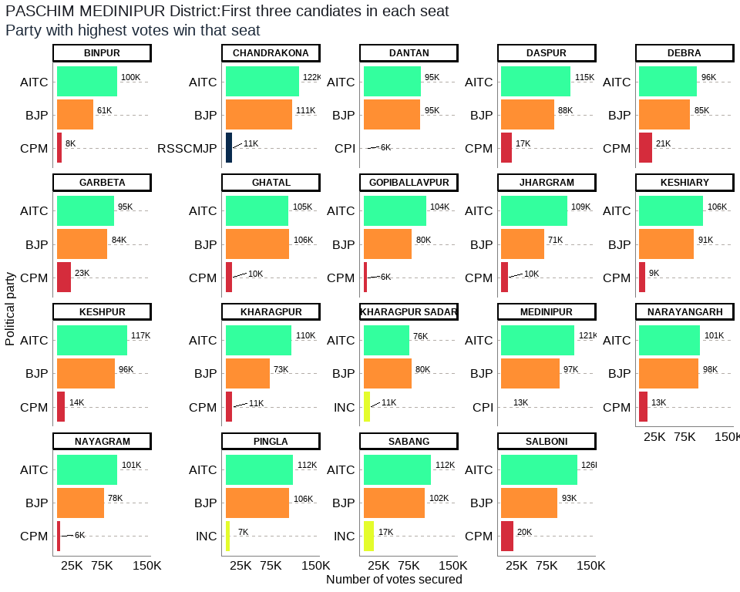

## Table 16: PASCHIM MEDINIPUR District Election Results: Top 3 Candidates by Votes in Each Constituency

| **Constituency** | **Type** | **Party** | **Candidate** | **Position** | **Votes** | **Margin** |
| --- | --- | --- | --- | --- | --- | --- |
| BINPUR | ST | AITC | Debnath Hansda | 1 | 100,277 | 39,494 |
| BINPUR | ST | BJP | Palan Saren | 2 | 60,783 | 52,430 |
| BINPUR | ST | CPM | Dibakar Hansda | 3 | 8,353 | 2,035 |
| CHANDRAKONA | SC | AITC | Arup Dhara | 1 | 121,846 | 11,281 |
| CHANDRAKONA | SC | BJP | Sibaram Das | 2 | 110,565 | 99,764 |
| CHANDRAKONA | SC | RSSCMJP | Gouranga Das | 3 | 10,801 | 7,895 |
| DANTAN | GEN | AITC | Bikram Chandra Pradhan | 1 | 95,209 | 623 |
| DANTAN | GEN | BJP | Saktipada Nayak | 2 | 94,586 | 88,934 |
| DANTAN | GEN | CPI | Sisir Kumar Patra | 3 | 5,652 | 4,402 |
| DASPUR | GEN | AITC | Mamata Bhunia | 1 | 114,753 | 26,842 |
| DASPUR | GEN | BJP | Prasanta Bera | 2 | 87,911 | 70,866 |
| DASPUR | GEN | CPM | Dhruba Sekhar Mandal | 3 | 17,045 | 15,658 |
| DEBRA | GEN | AITC | Humayun Kabir | 1 | 95,850 | 11,226 |
| DEBRA | GEN | BJP | Bharati Ghosh | 2 | 84,624 | 63,901 |
| DEBRA | GEN | CPM | Prankrishna Mondal | 3 | 20,723 | 19,214 |
| GARBETA | GEN | AITC | Uttara Singha (Hazra) | 1 | 94,928 | 10,572 |
| GARBETA | GEN | BJP | Madan Ruidas | 2 | 84,356 | 61,314 |
| GARBETA | GEN | CPM | Ghosh Kumar Tapan | 3 | 23,042 | 20,323 |
| GHATAL | SC | BJP | Sital Kapat | 1 | 105,812 | 966 |
| GHATAL | SC | AITC | Shankar Dolai | 2 | 104,846 | 94,681 |
| GHATAL | SC | CPM | Kamal Chandra Dolui | 3 | 10,165 | 8,157 |
| GOPIBALLAVPUR | GEN | AITC | Dr. Khagendra Nath Mahata | 1 | 104,115 | 23,768 |
| GOPIBALLAVPUR | GEN | BJP | Sanjit Mahata | 2 | 80,347 | 74,528 |
| GOPIBALLAVPUR | GEN | CPM | Prasanta Kumar Das | 3 | 5,819 | 3,028 |
| JHARGRAM | GEN | AITC | Birbaha Hansda | 1 | 109,493 | 38,240 |
| JHARGRAM | GEN | BJP | Sukhamay Satpathy (Jahar) | 2 | 71,253 | 60,823 |
| JHARGRAM | GEN | CPM | Madhuja Sen Roy | 3 | 10,430 | 6,794 |
| KESHIARY | ST | AITC | Paresh Murmu | 1 | 106,366 | 15,330 |
| KESHIARY | ST | BJP | Sonali Murmu Soren | 2 | 91,036 | 81,766 |
| KESHIARY | ST | CPM | Dr. Pulin Bihari Baske | 3 | 9,270 | 6,700 |
| KESHPUR | SC | AITC | Seuli Saha | 1 | 116,992 | 20,720 |
| KESHPUR | SC | BJP | Pritish Ranjan Kuar | 2 | 96,272 | 82,602 |
| KESHPUR | SC | CPM | Rameswar Doloi | 3 | 13,670 | 10,372 |
| KHARAGPUR | GEN | AITC | Dinen Roy | 1 | 109,727 | 36,230 |
| KHARAGPUR | GEN | BJP | Tapan Bhuya | 2 | 73,497 | 62,252 |
| KHARAGPUR | GEN | CPM | Syed Saddam Ali | 3 | 11,245 | 8,931 |
| KHARAGPUR SADAR | GEN | BJP | Hiranmoy Chattopadhyaya | 1 | 79,607 | 3,771 |
| KHARAGPUR SADAR | GEN | AITC | Pradip Sarkar | 2 | 75,836 | 65,045 |
| KHARAGPUR SADAR | GEN | INC | Reeta Sharma | 3 | 10,791 | 8,148 |
| MEDINIPUR | GEN | AITC | June Maliah | 1 | 121,175 | 24,397 |
| MEDINIPUR | GEN | BJP | Samit Kumar Dash | 2 | 96,778 | 83,794 |
| MEDINIPUR | GEN | CPI | Tarun Kumar Ghosh | 3 | 12,984 | 9,056 |
| NARAYANGARH | GEN | AITC | Atta Surja Kanta | 1 | 100,894 | 2,416 |
| NARAYANGARH | GEN | BJP | Rama Prasad Giri | 2 | 98,478 | 85,249 |
| NARAYANGARH | GEN | CPM | Tapas Sinha | 3 | 13,229 | 10,396 |
| NAYAGRAM | ST | AITC | Dulal Murmu | 1 | 100,903 | 22,754 |
| NAYAGRAM | ST | BJP | Bakul Murmu | 2 | 78,149 | 72,286 |
| NAYAGRAM | ST | CPM | Haripada Saren | 3 | 5,863 | 2,777 |
| PINGLA | GEN | AITC | Ajit Maity | 1 | 112,435 | 6,656 |
| PINGLA | GEN | BJP | Antara Bhattacharyya | 2 | 105,779 | 98,676 |
| PINGLA | GEN | INC | Samir Roy | 3 | 7,103 | 5,030 |
| SABANG | GEN | AITC | Manas Ranjan Bhunia | 1 | 112,098 | 9,864 |
| SABANG | GEN | BJP | Amulya Maity | 2 | 102,234 | 84,791 |
| SABANG | GEN | INC | Chiranjib Bhowmik | 3 | 17,443 | 15,909 |
| SALBONI | GEN | AITC | Srikanta Mahata | 1 | 126,020 | 32,644 |
| SALBONI | GEN | BJP | Rajib Kundu | 2 | 93,376 | 73,517 |
| SALBONI | GEN | CPM | Ghosh Susanta | 3 | 19,859 | 17,216 |

The district of Paschim Medinipur has a total of 19 legislative constituencies. The district has 6 reserved constituencies out of which 3 seats are reserved for the Scheduled Castes (SC) community whereas 3 seats are reserved for the Scheduled Tribes (ST) community. The seats reserved for SC include Ghatal, Chandrakona, Keshpur ,and the seats reserved for ST include Nayagram, Keshiary, Binpur respectively.

Out of the total 19 seats in the Paschim Medinipur district, the largest number of seats i.e. 17 were won by the AITC while the BJP won 2 seats. The seats won by AITC were Dantan, Nayagram, Gopiballavpur, Jhargram, Keshiary, Narayangarh, Sabang, Pingla, Kharagpur, Debra, Daspur, Chandrakona, Garbeta, Salboni, Keshpur, Medinipur, Binpur and the seats won by BJP were Kharagpur Sadar, Ghatal respectively.

Out of the total polled votes of 4028773, AITC secured a total of 2023763 (50%) votes while the BJP secured 1695443 (42%) of the votes. The CPM with a vote share of 168713 (4%) was in third place, while the INC was in the fourth position after securing 35337 (1%) of the total votes in the district.

## 16. PURBA MEDINIPUR District: Winners per constituency and top 3 candidates

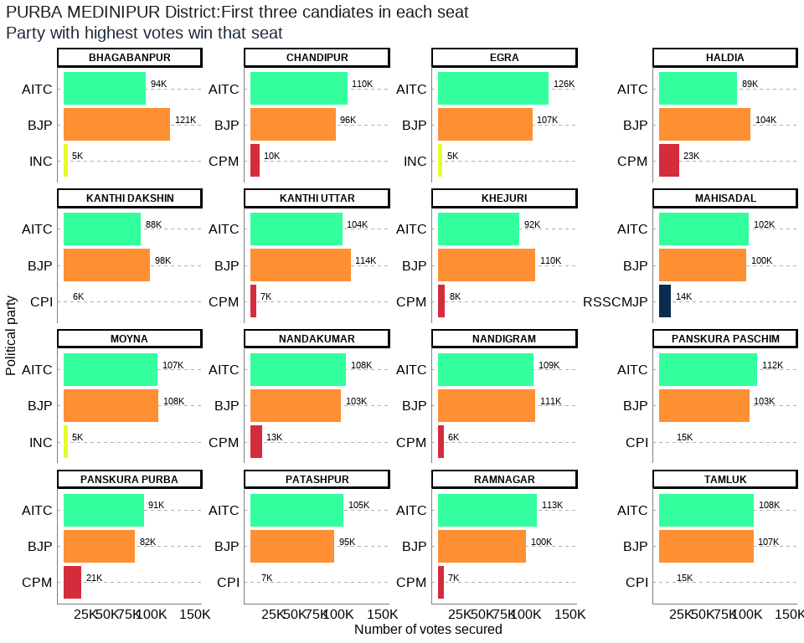

## Table 17: PURBA MEDINIPUR District Election Results: Top 3 Candidates by Votes in Each Constituency

| **Constituency** | **Type** | **Party** | **Candidate** | **Position** | **Votes** | **Margin** |
| --- | --- | --- | --- | --- | --- | --- |
| BHAGABANPUR | GEN | BJP | Rabindranath Maity | 1 | 121,480 | 27,549 |
| BHAGABANPUR | GEN | AITC | Ardhendu Maity | 2 | 93,931 | 88,657 |
| BHAGABANPUR | GEN | INC | Shiu Maiti | 3 | 5,274 | 4,255 |
| CHANDIPUR | GEN | AITC | Soham Chakraborty | 1 | 109,770 | 13,472 |
| CHANDIPUR | GEN | BJP | Pulak Kanti Guria | 2 | 96,298 | 86,461 |
| CHANDIPUR | GEN | CPM | Ashis Kumar Guchhait | 3 | 9,837 | 8,472 |
| EGRA | GEN | AITC | Tarun Kumar Maity | 1 | 125,763 | 18,491 |
| EGRA | GEN | BJP | Arup Dash | 2 | 107,272 | 102,186 |
| EGRA | GEN | INC | Manas Kumar Karmahapatra | 3 | 5,086 | 3,693 |
| HALDIA | SC | BJP | Tapasi Mondal | 1 | 104,126 | 15,008 |
| HALDIA | SC | AITC | Swapan Naskar | 2 | 89,118 | 66,430 |
| HALDIA | SC | CPM | Kar Paik Manika | 3 | 22,688 | 20,766 |
| KANTHI DAKSHIN | GEN | BJP | Arup Kumar Das | 1 | 98,477 | 10,293 |
| KANTHI DAKSHIN | GEN | AITC | Jyotirmoy Kar | 2 | 88,184 | 82,170 |
| KANTHI DAKSHIN | GEN | CPI | Anurup Panda | 3 | 6,014 | 4,878 |
| KANTHI UTTAR | GEN | BJP | Sumita Sinha | 1 | 113,524 | 9,330 |
| KANTHI UTTAR | GEN | AITC | Tarun Kumar Jana | 2 | 104,194 | 97,690 |
| KANTHI UTTAR | GEN | CPM | Sutanu Maity | 3 | 6,504 | 5,012 |
| KHEJURI | SC | BJP | Santanu Pramanik | 1 | 110,407 | 17,965 |
| KHEJURI | SC | AITC | Partha Pratim Das | 2 | 92,442 | 84,630 |
| KHEJURI | SC | CPM | Himangshu Das | 3 | 7,812 | 6,676 |
| MAHISADAL | GEN | AITC | Tilak Kumar Chakraborty | 1 | 101,986 | 2,386 |
| MAHISADAL | GEN | BJP | Biswanath Banerjee | 2 | 99,600 | 85,804 |
| MAHISADAL | GEN | RSSCMJP | Bikram Chatterjee | 3 | 13,796 | 12,031 |
| MOYNA | GEN | BJP | Ashoke Dinda | 1 | 108,109 | 1,260 |
| MOYNA | GEN | AITC | Sangram Kumar Dolai | 2 | 106,849 | 101,741 |
| MOYNA | GEN | INC | Manik Bhaumik | 3 | 5,108 | 3,434 |
| NANDAKUMAR | GEN | AITC | Sukumar De | 1 | 108,181 | 5,406 |
| NANDAKUMAR | GEN | BJP | Adhikary Nilanjan | 2 | 102,775 | 89,993 |
| NANDAKUMAR | GEN | CPM | Karuna Sankar Bhowmik | 3 | 12,782 | 11,309 |
| NANDIGRAM | GEN | BJP | Adhikari Suvendu | 1 | 110,764 | 1,956 |
| NANDIGRAM | GEN | AITC | Mamata Banerjee | 2 | 108,808 | 102,541 |
| NANDIGRAM | GEN | CPM | Minakshi Mukherjee | 3 | 6,267 | 5,177 |
| PANSKURA PASCHIM | GEN | AITC | Phiroja Bibi | 1 | 111,705 | 8,889 |
| PANSKURA PASCHIM | GEN | BJP | Sintu Senapati | 2 | 102,816 | 87,692 |
| PANSKURA PASCHIM | GEN | CPI | Chittaranjan Dasthakur | 3 | 15,124 | 13,787 |
| PANSKURA PURBA | GEN | AITC | Biplab Roy Chowdhury | 1 | 91,213 | 9,660 |
| PANSKURA PURBA | GEN | BJP | Debabrata Pattanayek | 2 | 81,553 | 60,836 |
| PANSKURA PURBA | GEN | CPM | Ibrahim Ali Sk | 3 | 20,717 | 19,259 |
| PATASHPUR | GEN | AITC | Uttam Barik | 1 | 105,299 | 9,994 |
| PATASHPUR | GEN | BJP | Ambujaksha Mahanti | 2 | 95,305 | 88,674 |
| PATASHPUR | GEN | CPI | Saikat Giri | 3 | 6,631 | 5,770 |
| RAMNAGAR | GEN | AITC | Akhil Giri | 1 | 112,622 | 12,517 |
| RAMNAGAR | GEN | BJP | Swadesh Ranjan Nayak | 2 | 100,105 | 93,354 |
| RAMNAGAR | GEN | CPM | Sabyasachi Jana | 3 | 6,751 | 5,518 |
| TAMLUK | GEN | AITC | Saumen Kumar Mahapatra | 1 | 108,243 | 793 |
| TAMLUK | GEN | BJP | Hare Krishna Bera | 2 | 107,450 | 92,732 |
| TAMLUK | GEN | CPI | Goutam Panda | 3 | 14,718 | 11,962 |

The district of Purba Medinipur has a total of 16 legislative constituencies. The district has 2 reserved constituencies and both seats are reserved for the Scheduled Castes (SC) community. Seats reserved for SC include Haldia, Khejuri.

Out of the total 16 seats in the Purba Medinipur district, the largest number of seats i.e. 9 were won by the AITC while the BJP won 7 seats. The seats won by AITC were Tamluk, Panskura Purba, Panskura Paschim, Nandakumar, Mahisadal, Chandipur, Patashpur, Ramnagar, Egra and the seats won by BJP were Moyna, Haldia, Nandigram, Kanthi Uttar, Bhagabanpur, Khejuri, Kanthi Dakshin respectively.

Out of the total polled votes of 3519791, BJP secured a total of 1660061 (47%) votes while the AITC secured 1658308 (47%) of the votes. The CPM with a vote share of 93358 (3%) was in third place, while the CPI was at the fourth position after securing 42487 (1%) in the total votes in the district.

## 17. PURULIA District: Winners per constituency and top 3 candidates

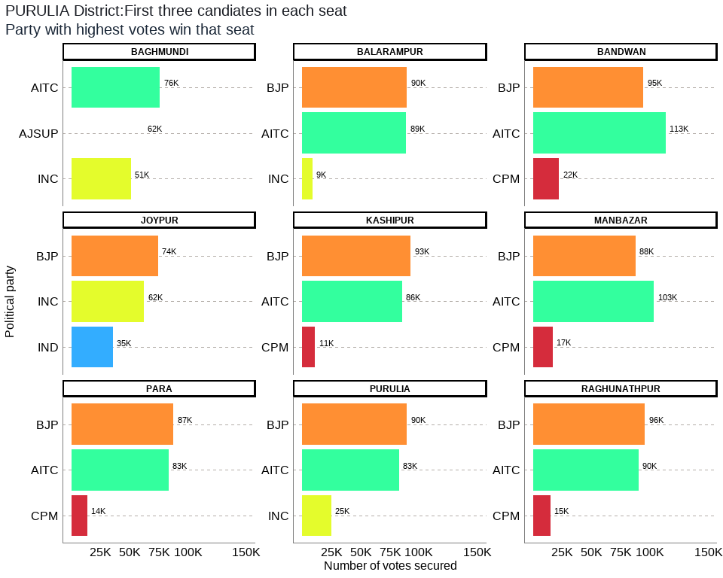

## Table 18: PURULIA District Election Results: Top 3 Candidates by Votes in Each Constituency

| **Constituency** | **Type** | **Party** | **Candidate** | **Position** | **Votes** | **Margin** |
| --- | --- | --- | --- | --- | --- | --- |
| BAGHMUNDI | GEN | AITC | Sushanta Mahato | 1 | 75,905 | 13,969 |
| BAGHMUNDI | GEN | AJSUP | Ashutosh Mahato | 2 | 61,936 | 10,890 |
| BAGHMUNDI | GEN | INC | Nepal Chandra Mahato | 3 | 51,046 | 39,204 |
| BALARAMPUR | GEN | BJP | Baneswar Mahato | 1 | 89,521 | 423 |
| BALARAMPUR | GEN | AITC | Shantiram Mahato | 2 | 89,098 | 80,203 |
| BALARAMPUR | GEN | INC | Uttam Kumar Bandyopadhyay | 3 | 8,895 | 6,454 |
| BANDWAN | ST | AITC | Rajib Lochan Saren | 1 | 113,337 | 18,831 |
| BANDWAN | ST | BJP | Parcy Murmu | 2 | 94,506 | 72,302 |
| BANDWAN | ST | CPM | Besra Susanta Kumar | 3 | 22,204 | 17,137 |
| JOYPUR | GEN | BJP | Nara Hari Mahato | 1 | 74,380 | 12,200 |
| JOYPUR | GEN | INC | Phanibhushan Kumar | 2 | 62,180 | 26,751 |
| JOYPUR | GEN | IND | Dibyajoti Singh Deo | 3 | 35,429 | 16,016 |
| KASHIPUR | GEN | BJP | Kamalakanta Hansda | 1 | 92,938 | 7,387 |
| KASHIPUR | GEN | AITC | Swapan Kumar Beltharia | 2 | 85,551 | 74,624 |
| KASHIPUR | GEN | CPM | Mallika Mahata | 3 | 10,927 | 8,526 |
| MANBAZAR | ST | AITC | Sandhyarani Tudu | 1 | 103,298 | 15,516 |
| MANBAZAR | ST | BJP | Gouri Singh Sardar | 2 | 87,782 | 70,933 |
| MANBAZAR | ST | CPM | Yaminikanta Mandi | 3 | 16,849 | 14,558 |
| PARA | SC | BJP | Nadiar Chand Bouri | 1 | 87,347 | 4,007 |
| PARA | SC | AITC | Umapada Bauri | 2 | 83,340 | 69,659 |
| PARA | SC | CPM | Swapan Kumar Bauri | 3 | 13,681 | 10,024 |
| PURULIA | GEN | BJP | Sudip Kumar Mukherjee | 1 | 89,733 | 7,018 |
| PURULIA | GEN | AITC | Sujoy Banerjee | 2 | 82,715 | 57,719 |
| PURULIA | GEN | INC | Partha Pratim Banerjee | 3 | 24,996 | 22,408 |
| RAGHUNATHPUR | SC | BJP | Vivekananda Bauri | 1 | 95,770 | 5,438 |
| RAGHUNATHPUR | SC | AITC | Bouri Hazari | 2 | 90,332 | 75,594 |
| RAGHUNATHPUR | SC | CPM | Ganesh Bouri | 3 | 14,738 | 10,909 |

The district of Purulia has a total of 9 legislative constituencies. The district has 4 reserved constituencies out of which 2 seats are reserved for the Scheduled Castes (SC) community whereas 2 seats are reserved for the Scheduled Tribes (ST) community. Seats reserved for SC include Para, Raghunathpur and the seats reserved for ST include Bandwan, Manbazar respectively.

Out of the total 9 seats in the Purulia district, the largest number of seats i.e. 6 were won by the BJP while the AITC won 3 seats. The seats won by BJP were Balarampur, Joypur, Purulia, Kashipur, Para, Raghunathpur and the seats won by AITC include Bandwan, Baghmundi, Manbazar respectively.

Out of the total polled votes of 1847059, AITC secured a total of 723576 (39%) votes while the BJP secured 711977 (39%) of the votes. The INC with a vote share of 147117 (8%) was in third place, while the CPM was in the fourth position after securing 78399 (4%) of the total votes in the district.

## 18. SOUTH 24 PARGANAS District: Winners per constituency and top 3 candidates

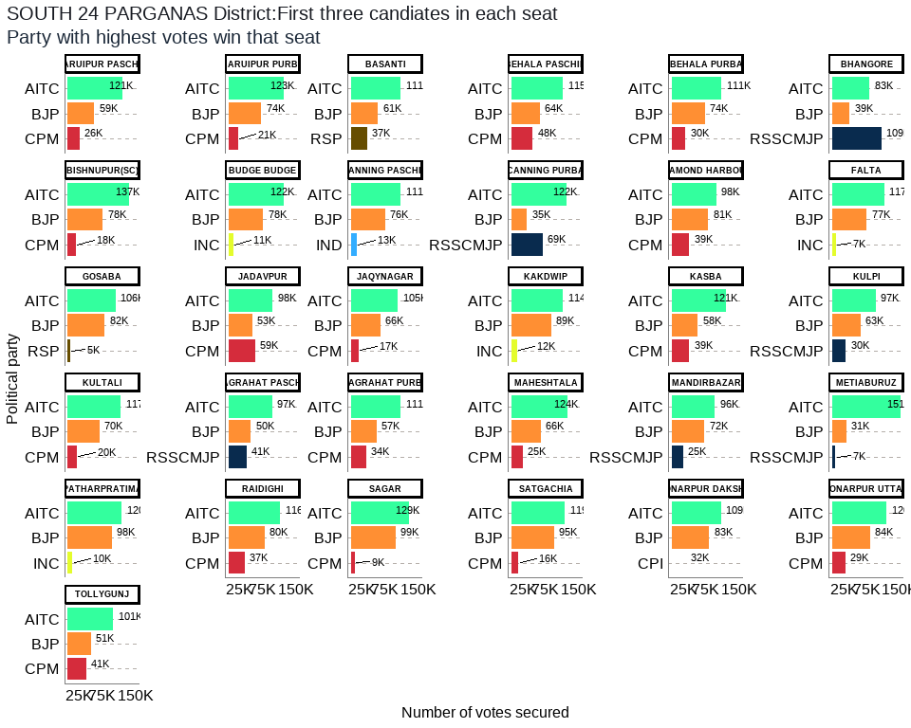

## Table 19: SOUTH 24 PARGANAS District Election Results: Top 3 Candidates by Votes in Each Constituency

| **Constituency** | **Type** | **Party** | **Candidate** | **Position** | **Votes** | **Margin** |
| --- | --- | --- | --- | --- | --- | --- |
| BARUIPUR PASCHIM | GEN | AITC | Biman Banerjee | 1 | 121,006 | 61,910 |
| BARUIPUR PASCHIM | GEN | BJP | Debopam Chattopadhyaya(Babu) | 2 | 59,096 | 33,457 |
| BARUIPUR PASCHIM | GEN | CPM | Md Lahek Ali | 3 | 25,639 | 23,870 |
| BARUIPUR PURBA | SC | AITC | Bivas Sardar (Vobo) | 1 | 123,243 | 49,641 |
| BARUIPUR PURBA | SC | BJP | Chandan Mondal | 2 | 73,602 | 52,135 |
| BARUIPUR PURBA | SC | CPM | Swapan Naskar | 3 | 21,467 | 19,612 |
| BASANTI | SC | AITC | Shyamal Mondal | 1 | 111,453 | 50,642 |
| BASANTI | SC | BJP | Ramesh Majhi | 2 | 60,811 | 24,123 |
| BASANTI | SC | RSP | Subhas Naskar | 3 | 36,688 | 34,781 |
| BEHALA PASCHIM | GEN | AITC | Partha Chatterjee | 1 | 114,778 | 50,884 |
| BEHALA PASCHIM | GEN | BJP | Srabanti Chatterjee | 2 | 63,894 | 16,385 |
| BEHALA PASCHIM | GEN | CPM | Nihar Bhakta | 3 | 47,509 | 45,076 |
| BEHALA PURBA | GEN | AITC | Ratna Chatterjee | 1 | 110,968 | 37,428 |
| BEHALA PURBA | GEN | BJP | Payel Sarkar | 2 | 73,540 | 43,368 |
| BEHALA PURBA | GEN | CPM | Samita Har Chowdhury | 3 | 30,172 | 27,337 |
| BHANGORE | GEN | RSSCMJP | Md. Nawsad Siddique | 1 | 109,237 | 26,151 |
| BHANGORE | GEN | AITC | Karim Rezaul | 2 | 83,086 | 44,360 |
| BHANGORE | GEN | BJP | Soumi Hati | 3 | 38,726 | 33,796 |
| BISHNUPUR(SC) | SC | AITC | Dilip Mondal | 1 | 136,509 | 58,832 |
| BISHNUPUR(SC) | SC | BJP | Agniswar Naskar | 2 | 77,677 | 59,682 |
| BISHNUPUR(SC) | SC | CPM | Jhuma Kayal | 3 | 17,995 | 15,286 |
| BUDGE BUDGE | GEN | AITC | Ashok Kumar Deb | 1 | 122,357 | 44,714 |
| BUDGE BUDGE | GEN | BJP | Dr. Tarun Kumar Adak | 2 | 77,643 | 66,834 |
| BUDGE BUDGE | GEN | INC | Sk Mujibar Rahaman | 3 | 10,809 | 8,074 |
| CANNING PASCHIM | SC | AITC | Paresh Ram Das | 1 | 111,059 | 35,243 |
| CANNING PASCHIM | SC | BJP | Arnab Roy | 2 | 75,816 | 62,426 |
| CANNING PASCHIM | SC | IND | Meghnath Halder | 3 | 13,390 | 1,482 |
| CANNING PURBA | GEN | AITC | Saokat Molla | 1 | 122,301 | 53,007 |
| CANNING PURBA | GEN | RSSCMJP | Gazi Shahabuddin Siraji | 2 | 69,294 | 34,791 |
| CANNING PURBA | GEN | BJP | Kalipada Naskar | 3 | 34,503 | 31,817 |
| DIAMOND HARBOUR | GEN | AITC | Pannalal Halder | 1 | 98,478 | 16,996 |
| DIAMOND HARBOUR | GEN | BJP | Dipak Kumar Halder | 2 | 81,482 | 42,763 |
| DIAMOND HARBOUR | GEN | CPM | Pratik Ur Rahaman | 3 | 38,719 | 37,134 |
| FALTA | GEN | AITC | Sankar Kumar Naskar | 1 | 116,713 | 39,928 |
| FALTA | GEN | BJP | Bidhan Parui | 2 | 76,785 | 69,316 |
| FALTA | GEN | INC | Abdur Razzak Molla | 3 | 7,469 | 5,793 |
| GOSABA | SC | AITC | Jayanta Naskar | 1 | 105,723 | 23,709 |
| GOSABA | SC | BJP | Barun Pramanik (Chitta) | 2 | 82,014 | 77,143 |
| GOSABA | SC | RSP | Anil Chandra Mondal | 3 | 4,871 | 3,600 |
| JADAVPUR | GEN | AITC | Debabrata Majumdar (Malay) | 1 | 98,100 | 38,869 |
| JADAVPUR | GEN | CPM | Dr. Sujan Chakraborty | 2 | 59,231 | 6,092 |
| JADAVPUR | GEN | BJP | Rinku Naskar | 3 | 53,139 | 50,409 |
| JAQYNAGAR | SC | AITC | Biswanath Das | 1 | 104,952 | 38,683 |
| JAQYNAGAR | SC | BJP | Rabin Sardar | 2 | 66,269 | 48,901 |
| JAQYNAGAR | SC | CPM | Apurba Pramanik (Apu) | 3 | 17,368 | 7,945 |
| KAKDWIP | GEN | AITC | Manturam Pakhira | 1 | 114,493 | 25,302 |
| KAKDWIP | GEN | BJP | Dipankar Jana | 2 | 89,191 | 76,957 |
| KAKDWIP | GEN | INC | Indranil Rout | 3 | 12,234 | 10,604 |
| KASBA | GEN | AITC | Ahmed Javed Khan | 1 | 121,372 | 63,622 |
| KASBA | GEN | BJP | Dr. Indranil Khan | 2 | 57,750 | 18,570 |
| KASBA | GEN | CPM | Shatarup Ghosh | 3 | 39,180 | 36,704 |
| KULPI | GEN | AITC | Jogaranjan Halder | 1 | 96,577 | 33,818 |
| KULPI | GEN | BJP | Pranab Kumar Mallik | 2 | 62,759 | 32,798 |
| KULPI | GEN | RSSCMJP | Siraj Uddin Gazi | 3 | 29,961 | 28,276 |
| KULTALI | SC | AITC | Ganesh Chandra Mondal | 1 | 117,238 | 47,177 |
| KULTALI | SC | BJP | Mintu Halder | 2 | 70,061 | 50,051 |
| KULTALI | SC | CPM | Ram Sankar Halder | 3 | 20,010 | 4,704 |
| MAGRAHAT PASCHIM | GEN | AITC | Gias Uddin Molla | 1 | 97,006 | 46,941 |
| MAGRAHAT PASCHIM | GEN | BJP | Dhurjati Saha (Manas) | 2 | 50,065 | 9,380 |
| MAGRAHAT PASCHIM | GEN | RSSCMJP | Maidul Islam Molla | 3 | 40,685 | 38,399 |
| MAGRAHAT PURBA | SC | AITC | Namita Saha | 1 | 110,945 | 54,079 |
| MAGRAHAT PURBA | SC | BJP | Chandan Kumar Naskar | 2 | 56,866 | 23,044 |
| MAGRAHAT PURBA | SC | CPM | Chandan Saha | 3 | 33,822 | 32,342 |
| MAHESHTALA | GEN | AITC | Dulal Chandra Das | 1 | 124,008 | 57,949 |
| MAHESHTALA | GEN | BJP | Umesh Das | 2 | 66,059 | 40,783 |
| MAHESHTALA | GEN | CPM | Pravat Chowdhury | 3 | 25,276 | 23,227 |
| MANDIRBAZAR | SC | AITC | Joydeb Halder | 1 | 95,834 | 23,492 |
| MANDIRBAZAR | SC | BJP | Dilip Kumar Jatua | 2 | 72,342 | 46,945 |
| MANDIRBAZAR | SC | RSSCMJP | Sanchay Kumar Sarkar | 3 | 25,397 | 23,575 |
| METIABURUZ | GEN | AITC | Abdul Khaleque Molla | 1 | 151,066 | 119,604 |
| METIABURUZ | GEN | BJP | Ramjit Prasad | 2 | 31,462 | 24,073 |
| METIABURUZ | GEN | RSSCMJP | Nuruzaman Molla | 3 | 7,389 | 4,381 |
| PATHARPRATIMA | GEN | AITC | Samir Kumar Jana | 1 | 120,181 | 22,134 |
| PATHARPRATIMA | GEN | BJP | Asit Kumar Haldar | 2 | 98,047 | 87,865 |
| PATHARPRATIMA | GEN | INC | Shukdeb Bera | 3 | 10,182 | 8,518 |
| RAIDIGHI | GEN | AITC | Aloke Jaldata | 1 | 115,707 | 35,568 |
| RAIDIGHI | GEN | BJP | Santanu Bapuli | 2 | 80,139 | 43,208 |
| RAIDIGHI | GEN | CPM | Kanti Ganguly | 3 | 36,931 | 34,069 |
| SAGAR | GEN | AITC | Bankim Chandra Hazra | 1 | 129,000 | 29,846 |
| SAGAR | GEN | BJP | Kamila Bikash | 2 | 99,154 | 90,058 |
| SAGAR | GEN | CPM | Sk Muklesur Rahaman | 3 | 9,096 | 8,071 |
| SATGACHIA | GEN | AITC | Mohan Chandra Naskar | 1 | 118,635 | 23,318 |
| SATGACHIA | GEN | BJP | Chandan Pal | 2 | 95,317 | 79,097 |
| SATGACHIA | GEN | CPM | Goutam Pal | 3 | 16,220 | 14,595 |
| SONARPUR DAKSHIN | GEN | AITC | Arundhuti Maitra (Lovely) | 1 | 109,222 | 26,181 |
| SONARPUR DAKSHIN | GEN | BJP | Anjana Basu | 2 | 83,041 | 51,263 |
| SONARPUR DAKSHIN | GEN | CPI | Shuvam Banerjee | 3 | 31,778 | 29,228 |
| SONARPUR UTTAR | GEN | AITC | Firdousi Begum | 1 | 119,957 | 36,090 |
| SONARPUR UTTAR | GEN | BJP | Ranjan Baidya | 2 | 83,867 | 54,467 |
| SONARPUR UTTAR | GEN | CPM | Monalisa Sinha | 3 | 29,400 | 27,286 |
| TOLLYGUNJ | GEN | AITC | Aroop Biswas | 1 | 101,440 | 50,080 |
| TOLLYGUNJ | GEN | BJP | Babul Supriyo | 2 | 51,360 | 10,763 |
| TOLLYGUNJ | GEN | CPM | Debdut Ghosh | 3 | 40,597 | 38,287 |

The district of South 24 Parganas has a total of 31 legislative constituencies. The district has 9 reserved constituencies and all 9 seats are reserved for the Scheduled Castes (SC) community. Seats reserved for SC include Gosaba, Basanti, Kultali, Mandirbazar, Jaqynagar, Baruipur Purba, Canning Paschim, Magrahat Purba, Bishnupur(Sc).

Out of the total 31 seats in the South 24 Parganas district, the largest number of seats i.e. 30 were won by the AITC while the RSSCMJP won 1 seat. The seats won by AITC were Gosaba, Basanti, Kultali, Patharpratima, Kakdwip, Sagar, Kulpi, Raidighi, Mandirbazar, Jaqynagar, Baruipur Purba, Canning Paschim, Canning Purba, Baruipur Paschim, Magrahat Purba, Magrahat Paschim, Diamond Harbour, Falta, Satgachia, Bishnupur(Sc), Sonarpur Dakshin, Kasba, Jadavpur, Sonarpur Uttar, Tollygunj, Behala Purba, Behala Paschim, Maheshtala, Budge Budge, Metiaburuz and the seats won by RSSCMJP include Bhangore respectively.

Out of the total polled votes of 6734075, AITC secured a total of 3523407 (52%) votes while the BJP secured 2142477 (32%) of the votes. The CPM with a vote share of 508632 (8%) was in third place, while the RSSCMJP was in the fourth position after securing 281963 (4%) of the total votes in the district.

## 19. UTTAR DINAJPUR District: Winners per constituency and top 3 candidates

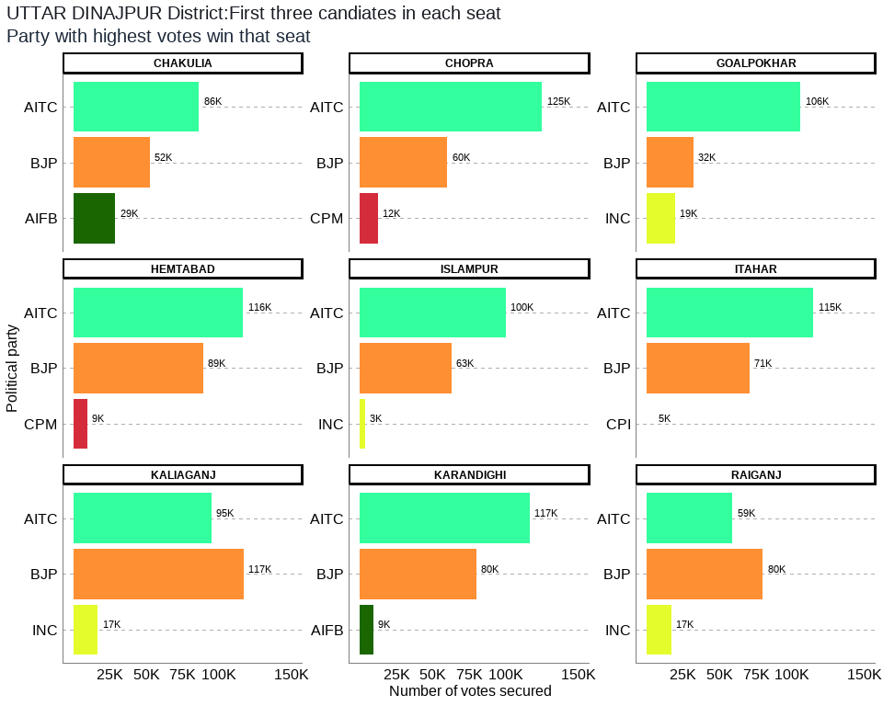

## Table 20: UTTAR DINAJPUR District Election Results: Top 3 Candidates by Votes in Each Constituency

| **Constituency** | **Type** | **Party** | **Candidate** | **Position** | **Votes** | **Margin** |
| --- | --- | --- | --- | --- | --- | --- |
| CHAKULIA | GEN | AITC | Azad Minhajul Arfin | 1 | 86,311 | 33,837 |
| CHAKULIA | GEN | BJP | Sachin Prasad | 2 | 52,474 | 23,770 |
| CHAKULIA | GEN | AIFB | Ali Imran Ramz | 3 | 28,704 | 25,979 |
| CHOPRA | GEN | AITC | Hamidul Rahaman | 1 | 124,923 | 64,905 |
| CHOPRA | GEN | BJP | Md. Shahin Akhter | 2 | 60,018 | 47,739 |
| CHOPRA | GEN | CPM | Anwarul Haque | 3 | 12,279 | 9,113 |
| GOALPOKHAR | GEN | AITC | Md. Ghulam Rabbani | 1 | 105,649 | 73,514 |
| GOALPOKHAR | GEN | BJP | Md. Ghulam Sarwar | 2 | 32,135 | 12,744 |
| GOALPOKHAR | GEN | INC | Masood Md. Naseem Ahsen | 3 | 19,391 | 17,375 |
| HEMTABAD | SC | AITC | Satyajit Barman | 1 | 116,425 | 27,215 |
| HEMTABAD | SC | BJP | Chandima Roy | 2 | 89,210 | 79,757 |
| HEMTABAD | SC | CPM | Bhupen Barman | 3 | 9,453 | 7,293 |
| ISLAMPUR | GEN | AITC | Abdul Karim Chowdhary | 1 | 100,131 | 37,440 |
| ISLAMPUR | GEN | BJP | Saumyaroop Mandal | 2 | 62,691 | 59,230 |
| ISLAMPUR | GEN | INC | Sadiqul Islam | 3 | 3,461 | 1,485 |
| ITAHAR | GEN | AITC | Mosaraf Hussen | 1 | 114,645 | 43,975 |
| ITAHAR | GEN | BJP | Amit Kumar Kundu | 2 | 70,670 | 65,762 |
| ITAHAR | GEN | CPI | Srikumar Mukherjee | 3 | 4,908 | 3,668 |
| KALIAGANJ | SC | BJP | Soumen Roy | 1 | 116,768 | 21,820 |
| KALIAGANJ | SC | AITC | Tapan Deb Singha | 2 | 94,948 | 78,178 |
| KALIAGANJ | SC | INC | Pravash Sarkar | 3 | 16,770 | 12,766 |
| KARANDIGHI | GEN | AITC | Goutam Paul | 1 | 116,594 | 36,626 |
| KARANDIGHI | GEN | BJP | Subhas Chandra Sinha S/O: Haranarayan Sinha | 2 | 79,968 | 70,822 |
| KARANDIGHI | GEN | AIFB | Md. Hafizul Iqbal | 3 | 9,146 | 6,697 |
| RAIGANJ | GEN | BJP | Krishna Kalyani | 1 | 79,775 | 20,748 |
| RAIGANJ | GEN | AITC | Agarwal Kanaia Lal | 2 | 59,027 | 41,829 |
| RAIGANJ | GEN | INC | Mohit Sengupta | 3 | 17,198 | 14,730 |

The district of Uttar Dinajpur has a total of 9 legislative constituencies. The district has 2 reserved constituencies and both seats are reserved for the Scheduled Castes (SC) community. Seats reserved for SC include Hemtabad, Kaliaganj.

Out of the total 9 seats in the Uttar Dinajpur district, the largest number of seats i.e. 7 were won by the AITC while the BJP won 2 seats. The seats won by AITC were Chopra, Islampur, Goalpokhar, Chakulia, Karandighi, Hemtabad, Itahar, and the seats won by BJP include Kaliaganj, Raiganj respectively.

Out of the total polled votes of 1722482, AITC secured a total of 918653 (53%) votes while the BJP secured 643709 (37%) of the votes. The INC with a vote share of 56820 (3%) was in third place, while the AIFB was in the fourth position after securing 37850 (2%) of the total votes in the district.

## CONCLUSION

What lessons Bengal election provides to the country remains to be seen, but the State and Central Government’s handling of the second wave of Covid19 crisis (in which many Indians lost lives) and associated social and economic crisis, has kept the political battle open for the UP election 2022 and the General election 2024. It has also infused fresh energy in opposition parties to challenge the election machinery and public image of Prime Minister Narendra Modi which has taken a beating in surveys conducted in recent months. With the global and national uncertainties looming large due to the Covid19 crisis and a prediction of the third wave of the virus in the country, governments both at the state and the central level need to do much more than business as usual to win the trust of the people.

## References

Chaturvedi, R. M. (2021). *ET Analysis: How TMC beat BJP at its own game in West Bengal elections*. E**conomic Times.** Retrieved from [<https://m.economictimes.com/news/elections/assembly-elections/west-bengal/et-analysis-tmc-beat-bjp-at-its-own-game-turned-around-saffron-poll-planks-for-its-own-gains/amp_articleshow/82383821.cms>](https://m.economictimes.com/news/elections/assembly-elections/west-bengal/et-analysis-tmc-beat-bjp-at-its-own-game-turned-around-saffron-poll-planks-for-its-own-gains/amp_articleshow/82383821.cms) on May 4.

Ghatak, M., & Maitra, P. (2021). *2021 West Bengal Assembly election: Did the Covid-19 surge matter?* **Ideas for India**. Retrieved from [<https://www.ideasforindia.in/topics/governance/2021-west-bengal-assembly-election-did-the-covid-19-surge-matter.html>](https://www.ideasforindia.in/topics/governance/2021-west-bengal-assembly-election-did-the-covid-19-surge-matter.html) on May 12.

Tiwari, A. (2021). *In Charts: How Mamata Banerjee Scripted A Record Win In West Bengal.* . **BloombergQuint**. Retrieved from [<https://www.bloombergquint.com/politics/how-mamata-banerjee-scripted-a-record-win-in-west-bengal-election-results-2021-in-charts>](https://www.bloombergquint.com/politics/how-mamata-banerjee-scripted-a-record-win-in-west-bengal-election-results-2021-in-charts) on May 6.

Iyengar, P. (2021). *Statistical Afternotes: TMC May Have Won Bengal, but BJP Did Not Do Badly*. **The Wire**. Retrieved from [<https://thewire.in/politics/statistical-afternotes-tmc-may-have-won-bengal-but-bjp-did-not-do-badly>](https://thewire.in/politics/statistical-afternotes-tmc-may-have-won-bengal-but-bjp-did-not-do-badly) on May 7.

Kishore, R., & Jha, A. (2021). *WEST BENGAL ASSEMBLY ELECTION 3 crucial takeaways from Bengal results*. **Hindustan Times.** Retrieved from ([<https://www.hindustantimes.com/elections/west-bengal-assembly-election/3-crucial-takeaways-from-bengal-results-101620086556255.html>]<https://www.hindustantimes.com/elections/west-bengal-assembly-election/3-crucial-takeaways-from-bengal-results-101620086556255.html>){.uri} on May 4.

Bhattacharya, A. (2021). *Why did the BJP lose Bengal 2021?* **India Today.** Retrieved from [<https://www.indiatoday.in/news-analysis/story/why-did-bjp-lose-bengal-elections-2021-1798260-2021-05-03>](https://www.indiatoday.in/news-analysis/story/why-did-bjp-lose-bengal-elections-2021-1798260-2021-05-03) on May 5.

Dasgupta, S. (2021). *Lessons learnt The results of the West Bengal assembly elections deserve a close analysis*. **The Telegraph.** Retrieved from [<https://www.telegraphindia.com/opinion/the-results-of-the-west-bengal-assembly-elections-deserve-a-close-analysis/cid/1815369>](https://www.telegraphindia.com/opinion/the-results-of-the-west-bengal-assembly-elections-deserve-a-close-analysis/cid/1815369) on May 3.