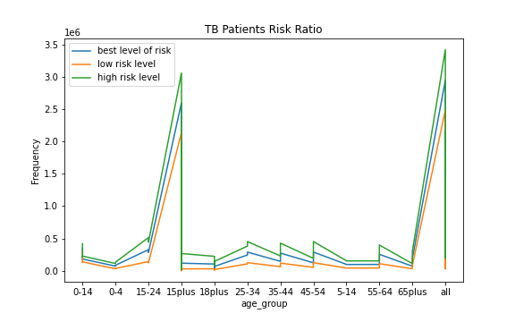

The given line plot shows the details of frequencies of TB patients in India (Number one country from the TB patients) in different risk levels, according to the various age groups. From the chart we can get conclusion about risk of TB is highest between (15-24) age group and 15plus age group as well as over 65plus age group. And the high risk patients are greater than both low and best risk level patients.

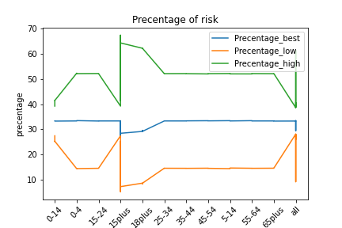

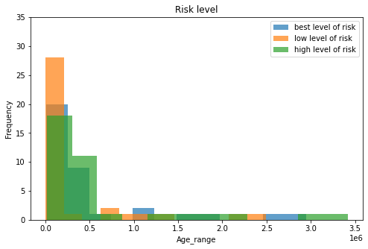

According to the line plot it is bit difficult to find details because the age groups not mention in proper manner in the data sheet, therefore to clarify risk level frequency plot it as a histograms and subplot

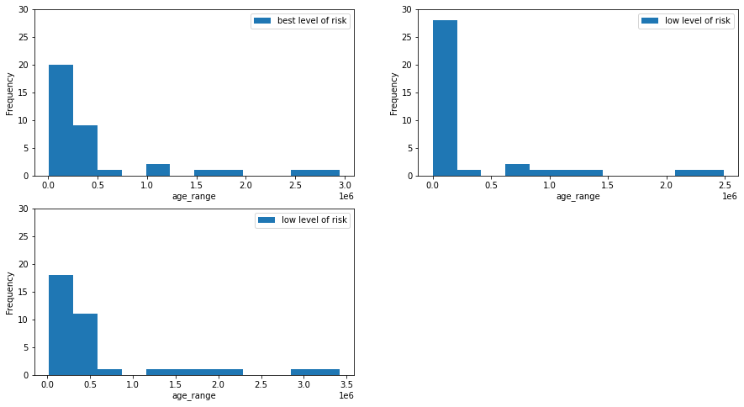

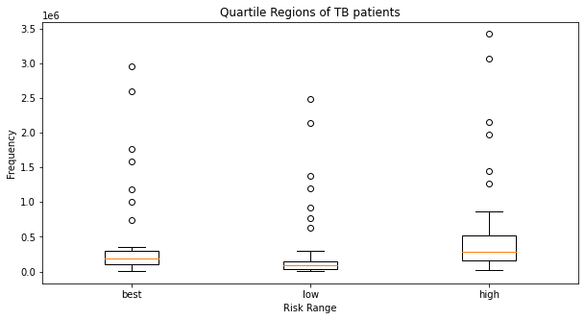

From the boxplot we can easily identify the mean, median values and dispersion of data set. Because of that I plot my dataset into box plot to identify the measurements of data according to the risk levels.