dbt Learning Program
Week 5 Recap & Week 6 Guide
Automate with Airflow
This guide walks through everything covered in Week 5 and introduces the new concepts for Week 6, with diagrams for each major idea. Week 5 was about making dbt run SQL around your model builds. Week 6 is about making something other than you run dbt at all — on a schedule, unattended, and with sensible behaviour when a step fails. This is the last week of the program, and it's the one that turns a pile of models into a pipeline.

What's Inside
- Part 1 — Week 5 Recap: the post-hook index, the project-level grant, and what your EXPLAIN ANALYZE actually told you
- Part 2 — Week 6 Guide: DAGs, the BashOperator, dbt build, retries and catchup, explained with diagrams
- Part 3 — Walkthrough of all three Week 6 tasks with code
- Part 4 — Mistakes to Avoid, Word List, and Quick Quiz

Part 1 — Week 5 Recap: Hooks
Week 5 was about the SQL that runs around a model rather than inside it. That idea comes straight back this week: a hook fires as part of a build, and from Week 6 onwards those builds are triggered by Airflow at 06:00 rather than by you at your keyboard. Everything you attached to a model keeps working — which is exactly the point of putting it in the project instead of in your shell history.

What You Actually Built in Week 5

1. A Post-Hook That Creates an Index
You added a post_hook to the config() block of fct_order_items so that dbt itself creates the idx_fct_order_items_order_id index every time the model builds. Two details carried the lesson: {{ this }} resolves to the fully-qualified name of the model dbt just built, so the hook stays correct in any target; and IF NOT EXISTS makes the hook idempotent, which matters because the hook fires on every single run.

2. A Project-Level GRANT
Rather than repeating a GRANT in all eleven models, you declared one +post-hook in dbt_project.yml. Note the spelling changes between the two places — post_hook with an underscore inside a model's config(), +post-hook with a hyphen and a plus in the project file. They stack rather than override, so fct_order_items runs both of its hooks.

3. You Measured It
Finally you timed the join with EXPLAIN ANALYZE before and after, and wrote the real numbers into week_5/notes.md. On a 313-row table the planner may well still choose a sequential scan, and reporting that honestly was the full-credit answer. An index you never measured is a guess.
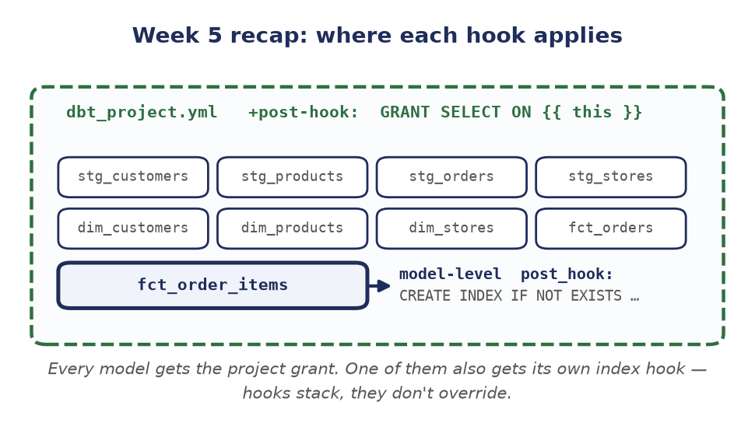
Figure 1 — Recap: the project-level grant reaches every model, while the index hook belongs to one. That model runs both — hooks accumulate.

Self-Check Before Moving On
If any of these feel shaky, it's worth revisiting the Week 5 material before starting Week 6:
- Why does the index hook need IF NOT EXISTS, when you only create the index once?
- What does {{ this }} resolve to, and why is it safer than writing "DEV".fct_order_items?
- Your fct_order_items has its own post_hook and dbt_project.yml defines one too. Which runs?

Part 2 — Week 6: Automate with Airflow
Budget: roughly 2 hours. Up to now every build has started with you typing a dbt command. That works right up until it needs to happen at 06:00 every day, in order, whether or not you are awake. Airflow is the scheduler that does the typing for you — and, just as importantly, the place you go to see what ran, what failed, and why.

What's New This Week (In Plain Terms)

A DAG Is Just a Picture of What Runs, and When
A DAG (Directed Acyclic Graph) is a Python file that describes tasks and the order they run in. "Directed" because the arrows point one way, "acyclic" because they never loop back. Your SQL does not change at all — the DAG only describes which dbt commands run, and in what order. The file that does this already exists at airflow/dags/dbt_pipeline.py, and Task 6.1 is simply to read it and run it.
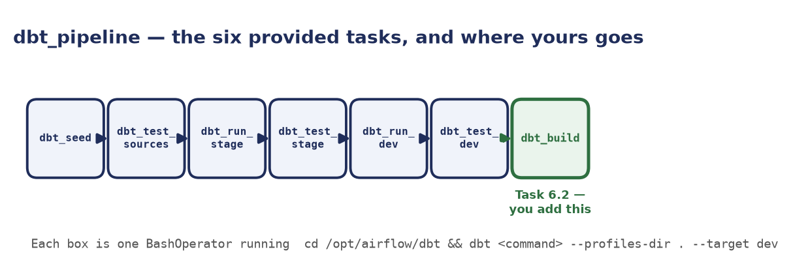
Figure 2 — The six tasks the DAG already runs, in a straight line, and the dbt_build task you add onto the end in Task 6.2.

The BashOperator Runs Your dbt Commands
An operator is the kind of work a task does. The BashOperator is the simplest one: it runs a shell command. Each task in this DAG shells out and runs exactly the sort of dbt command you have been typing by hand for five weeks, which is why the logs look so familiar when you open them.
There is no Docker-in-Docker here: dbt is installed directly into the Airflow image (see Dockerfile.airflow), and docker-compose.yml mounts your dbt_learning/ folder at /opt/airflow/dbt inside the container. That is why every task starts with cd /opt/airflow/dbt, and why a model you edit on your machine is picked up with no rebuild at all.

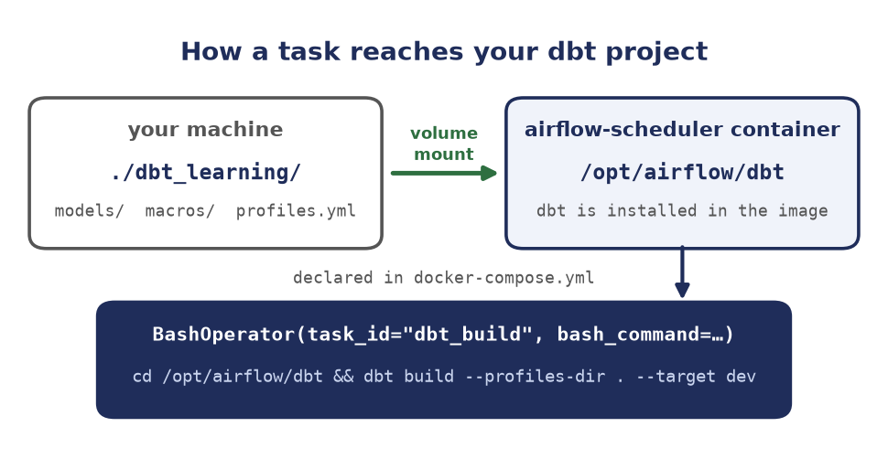
Figure 3 — Your project folder is mounted into the container, so a BashOperator can cd into it and run dbt exactly as you would.

dbt build — One Step Instead of Two
The provided DAG runs run and test as separate tasks for each layer. dbt build interleaves them: it builds each model and immediately runs that model's tests before anything downstream of it starts. A bad model stops its own dependents instead of quietly feeding wrong numbers into the rest of the warehouse.
This is where Week 3 pays off: dbt build fails the task on any error-severity test failure. The tests you deliberately set to severity: warn back in Week 3 are precisely the ones that will warn here rather than halting your pipeline at 06:00.

Retries and Catchup
Two settings separate "it worked on my laptop" from "it runs unattended". retries gives a task another go before it is declared failed, with retry_delay between attempts — a dropped database connection then fixes itself instead of waking somebody. catchup controls what happens when you turn the DAG on: left at its default of True, Airflow queues one run for every scheduled interval since start_date, which on an old start date means a stampede of runs all hitting the same Postgres at once.
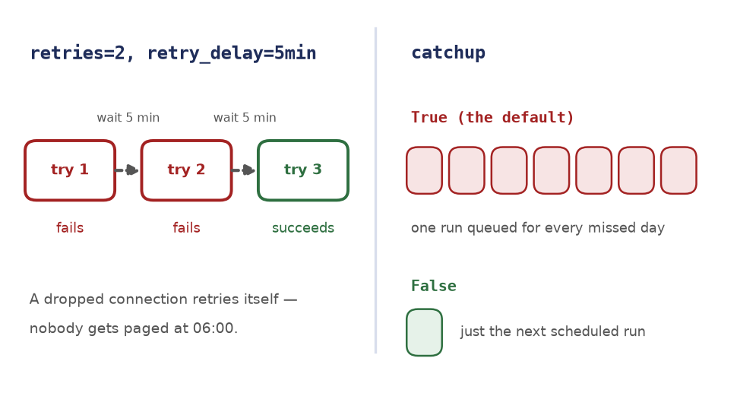
Figure 4 — Retries buy a flaky task two more attempts; catchup=False stops Airflow working through every run it thinks it missed.

Part 3 — Task Walkthrough

Task 6.1 — Read & Run the DAG (30 pts)
Bring the stack up. This builds the Airflow image with dbt inside it, then starts Postgres, the scheduler, and the web UI:
docker compose build
docker compose up -d

Open http://localhost:8080 and log in with admin / admin. Before changing anything, read airflow/dags/dbt_pipeline.py top to bottom — find the dbt_task() helper and satisfy yourself that you could write out the exact bash command any one of the six tasks will run. Then unpause dbt_pipeline with the toggle on the left, hit Trigger, and watch the Graph view. If a task goes red, click it and open Logs: the dbt output is in there verbatim.
If the DAG never appears in the list, it failed to import. Ask Airflow why rather than guessing: docker compose exec airflow-scheduler airflow dags list-import-errors

The deliverable is a screenshot of the Graph view with all six tasks green, saved into the week_6/ folder as a .png or .jpg and committed alongside the README.

Task 6.2 — Add a Build Task (50 pts)
Add a seventh task that runs dbt build. Use the dbt_task() helper that is already in the file — that is what it is there for:
dbt_build = dbt_task(dag, "dbt_build", "build")

Then extend the dependency chain so it runs last:
(
dbt_seed
>> dbt_test_sources
>> dbt_run_stage
>> dbt_test_stage
>> dbt_run_dev
>> dbt_test_dev
>> dbt_build
)

Trigger the DAG again and confirm the new task shows up in the graph and finishes green.

Task 6.3 — Basic Retry Config (20 pts)
Give every task two attempts in reserve, five minutes apart. timedelta is already imported at the top of the file:
default_args = {
"owner": "student_name",
"depends_on_past": False,
"retries": 2,
"retry_delay": timedelta(minutes=5),
}

Then stop Airflow backfilling by adding catchup=False to the DAG call:
with DAG(
dag_id="dbt_pipeline",
...
schedule="0 6 * * *",
catchup=False,
tags=["dbt", "dataops"],
) as dag:

What catchup actually does: it defaults to True. With a daily schedule and a start_date in the past, unpausing the DAG queues one run for every day since that date and works through the backlog — sixty days old means sixty pipeline runs, all at once, all against the same database.

Grading Your Work
Once all three tasks are complete, run:
python scripts/grade_assignment.py --week 6

Fix any items marked with an X and re-run the grader until everything passes.

Part 4 — Mistakes to Avoid, Word List, and Quick Quiz

Mistakes to Avoid
- Editing the DAG but never re-triggering it — the scheduler picks the file up within a minute or so, but the run you are looking at is the old one. Trigger a fresh run before deciding your change didn't work.
- Defining dbt_build but forgetting to wire it in — a task with no >> connecting it still appears in the file, but it is an island. The grader checks for the >> specifically, and so does the graph view.
- Leaving catchup at its default — the DAG appears to work, then queues dozens of runs the moment it is unpaused. Always set it explicitly, even when the answer is False.
- Putting retries on one task instead of in default_args — it works, but only for that task. default_args is how a setting reaches every task in the DAG at once — the same instinct as the project-level hook in Week 5.
- Hardcoding a path other than /opt/airflow/dbt — that path is the container's view of your project, set by the volume mount in docker-compose.yml. Your Windows or Mac path means nothing inside the container.
- Reading the red task and not its log — the graph tells you that something failed; only the log tells you why, and it is the ordinary dbt error you already know how to read.
- Assuming a green DAG means correct data — green means every command exited zero. Whether the numbers are right is still what your Week 3 tests are for.

Word List
Term | Meaning
DAG | A Python file describing tasks and the order they run in. Directed, and never loops back on itself.
Task | One unit of work in a DAG — here, one dbt command.
Operator | The kind of work a task does. BashOperator runs a shell command; PythonOperator calls a function.
BashOperator | The operator every task in this DAG uses, via the dbt_task() helper.
schedule | The cron expression saying when the DAG runs. "0 6 * * *" is daily at 06:00 UTC.
catchup | Whether Airflow runs every interval missed since start_date. Defaults to True; you set it to False.
Backfill | The pile of historical runs catchup produces.
retries | How many extra attempts a failing task gets before it is declared failed.
retry_delay | How long Airflow waits between those attempts.
dbt build | Runs and tests each model together, so a broken model stops its own dependents.

Quick Quiz
Answer these before calling Week 6 done — if any answer doesn't come quickly, go back and re-read that section rather than guessing.
- What does the "acyclic" in Directed Acyclic Graph rule out, and why would a loop be a problem for a scheduler?
- Every task's bash command starts with cd /opt/airflow/dbt. Where does that folder come from, and why isn't it your own project path?
- What does dbt build do that running dbt run followed by dbt test does not?
- You unpause a DAG whose start_date is two months ago and whose schedule is daily. What happens, and which setting controls it?
- A task fails once at 06:00 and succeeds at 06:05 with no human involved. Which two settings made that happen?
That's the end of the program — you've gone from raw CSVs to a tested, documented star schema that rebuilds itself on a schedule. Questions or stuck on something? Reach out before spending too long on one blocker.

