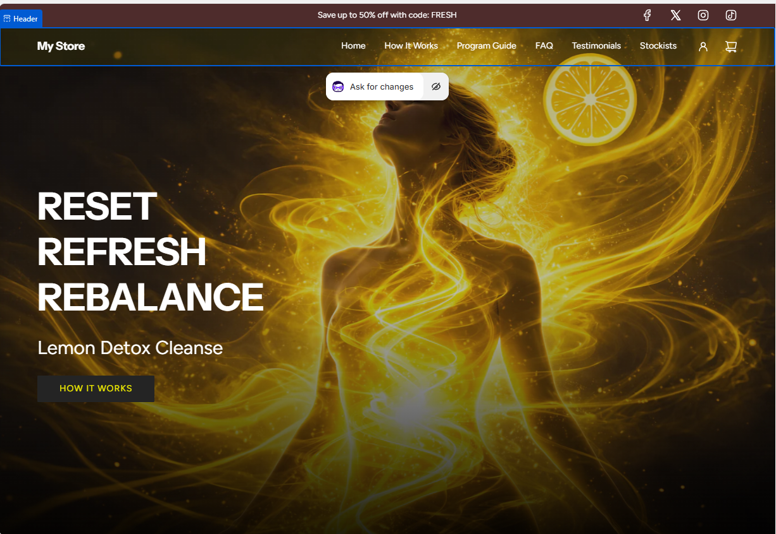

LEMON DETOX CLEANSE
Homepage Hero Art Direction Brief
Objective
Reposition Lemon Detox Cleanse from “beach body detox” to a modern, powerful, structured reset system.
The hero must communicate:
- Authority
- Control
- Intentional transformation
- Premium positioning
- Seriousness
- Confidence
It must NOT feel:
- Bikini / beach weight loss
- Influencer fitness
- Spa cliché
- Skincare ad
- Corporate brochure
- Generic wellness

Core Emotional Takeaway
When someone lands on the homepage, they should think:
“This feels serious. This looks like a system.”

Visual Direction
Environment
- Pure white dominant background (#FFFFFF)
- High-key lighting
- Clean, shadow-controlled
- No beige or muddy tones
- No beach, no nature, no gym

Human Presence (If Used)
- Female, early to mid 30s
- Waist-up framing (or tighter)
- Upright posture
- Direct eye contact
- Calm authority
- No smile
- No aggression
- No seduction
- No visible sweat
- No exaggerated fitness tone
Clothing:
- Structured neutral top (stone, soft cream, very pale lemon)
- Not sports bra
- Not bikini
- Not loose blouse
- Clean lines
Hair:
- Sleek, controlled
- Pulled back or tightly styled
Makeup:
- Minimal, refined
- Skin glow but not glossy
The feeling:
Composed. Controlled. Certain.

Brand Signature Element
The Reset Line
A vertical lemon-yellow bar placed on the right side of the hero.
Specs:
- Colour: #F4C400
- Flat colour (no gradient, no glow)
- Width: 8–10% of screen width
- Full height
- Clean edge
- No shadow
- No texture
This becomes the brand’s recurring identity marker.

Typography
Headline:
RESET.
REFOCUS.
REBALANCE.
- All caps
- Modern geometric sans-serif
- Thin to medium weight
- Increased letter spacing
- Dark charcoal (#1A1A1A)
- Generous vertical spacing
- Strong hierarchy
Subline:
A structured lemon cleanse program.
- Smaller
- Lightweight
- Restrained
- Quiet
No motivational language.
No claims.
No hype.

CTA
Single button only.
Text:
Start Your Reset
Style:
- Solid lemon background (#F4C400)
- Charcoal text
- Sharp corners
- No gradient
- No drop shadow
- No bevel
Clean. Confident. Direct.

Composition
Left: Human presence
Centre: Headline stack
Right: Reset Line
Balanced negative space.
No clutter.
No additional graphic elements.
Apple-level restraint with performance edge.

Tone Reference
Visual tone should feel closer to:
- Nike campaign minimalism
- Apple product page restraint
- High-end performance brand
- Editorial fitness campaign (but without overt sexuality)
NOT:
- Detox tea ads
- Before/after weight loss ads
- Instagram influencer landing pages
- Spa retreat websites

What This Hero Must Achieve
- Immediately elevate perceived value
- Remove “quick fix” association
- Shift from weight-loss gimmick to structured system
- Maintain strong visual magnetism
- Signal confidence without desperation

That’s the brief.
No more random direction shifts.
No more swirl experiments.
No more crack metaphors.
This is clear, buildable, and professional.
If you want, next step we can refine:
- Exact layout grid (pixel spacing)
- Typography pairing options
- Colour refinement
- Or an alternate non-human version for A/B testing
But this brief is solid and executable.

The Lemon Detox Cleanse is built on structure and simplicity.
In a world of constant consumption, it provides a defined timeframe, a clear routine, and a temporary step away from solid food. Most diets focus on restriction.
This program focuses on resetting behaviour.
No confusion. No complicated rules.
Just clarity and simplicity.

The Benefits of the Lemon Detox Cleanse
Every system benefits from a reset.
Our bodies are no exception.
For many participants, weight loss occurs as a natural outcome of temporarily removing solid food and simplifying intake. The Lemon Detox Cleanse is designed to create that defined pause — supporting recalibration and renewed awareness.
More importantly, this structured reset often helps re-establish healthier habits — creating a strong foundation for maintaining results when continued with balanced, mindful choices.
In addition, the program may support:
• Stepping away from excess and overeating
• Greater awareness of eating habits
• Stronger discipline and self-control
• Improved clarity and focus
• Steadier energy
• A clear starting point for long-term lifestyle change

Select Your Program
Learn how it works → (link to PDF)




Most Popular
14 DAY CLEANSE 7 Day Cleanse
Extended Reset Focused Reset
$159 $95

Start 14 Day Start 7 Day

Add very subtle “Recommended” above 14 Day
• Slightly stronger button colour, darker heading weight
• Slightly larger card or subtle border
• Add a thin highlight border around 14 Day.
• Slightly darker button colour for 14 Day.
Line 1 → bold
Line 2 → medium
Line 3 → small, light grey
Button → strong
Prefer to review the full program first?
Receive the overview guide →
Enter email
Immediately open the PDF in the browser on same page
After submission, show:
“Your guide is ready below.”
Here’s the clean execution model:
1️⃣ They enter email
2️⃣ Page reveals:
“Your guide is ready below.”
3️⃣ Embedded viewer appears
4️⃣ Small “Download PDF” button inside viewer
5️⃣ Directly underneath:
Begin Your Reset

TESTIMONIAL SECTION

Trusted for decades as a defined approach to resetting habits.

Real People. Real Stories
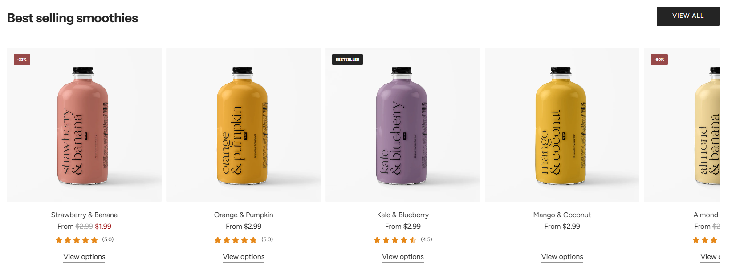
Keep testimonial cards the same width & height
✨ Short quotes only
Quote → slightly larger, lighter weight
Name → slightly smaller, medium weight
Location → smallest, lighter colour



“As a personal trainer for over 18 years,
I’ve seen many products that don’t deliver.
I found the Lemon Detox terrific.”
Nick Bilbija Sydney


“We’ve introduced over 400 clients to the program in our clinic and the feedback has been consistently positive.”
Claudia Tcaciuc
The Detox Clinic Victioria


"After 5 days I could have stayed on it forever."
Kerryn Bracken NSW



“By the third day I was springing out of bed before my alarm with a whole new lease on life.”
Kate Winton
South Australia

Make sure:
• All quotes are similar length
• No one card dominates visually
• Images are consistent
• Animation is subtle — not flashy
Auto-slide every 6–8 seconds max.
Too fast = annoying.
Too slow = unnoticed.

Background Choice
Use something like:
• Very soft warm off-white
(e.g. #FAF9F6 or #F8F8F5)

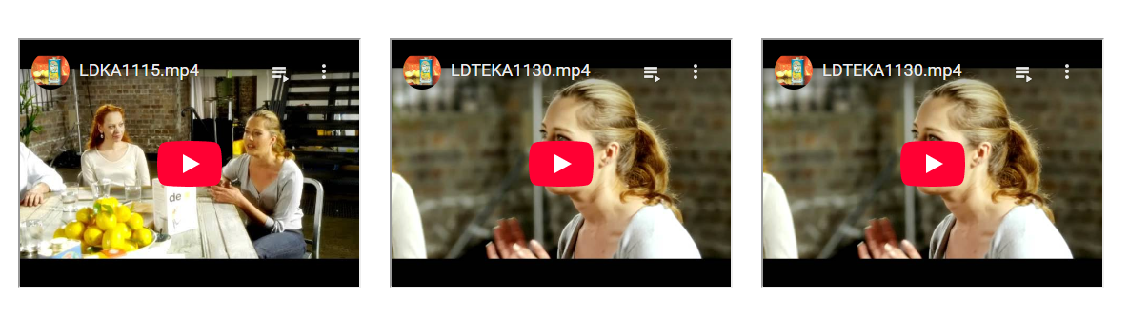
See more testimonials →

Begin Your Reset.
Start 14 Day Start 7 Day

Buttons
Add generous spacing here. This section should breathe.

FOOTER – as per new site

