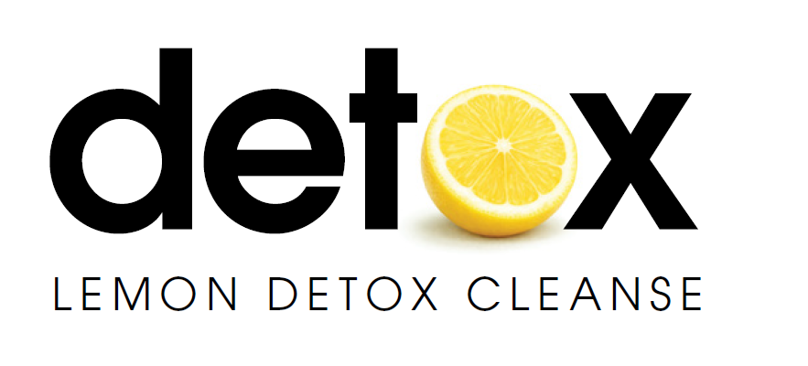

LEMON DETOX
PROGRAM GUIDE

A structured cleanse for reset,
weight loss and renewed control.

Reset. Reduce. Restore.

CONTENTS
A step-by-step guide to preparing for, following and completing the Lemon Detox program.
This guide explains how the program works, how to prepare the Lemon Detox drink, how to support elimination, what you may experience during the cleanse, and how to return to eating gradually afterwards.
_______________________________________________________________
1 — Why People Choose a Reset
Modern habits, overconsumption and the value of structure.

2 — What This Program Is
A clear explanation of the Lemon Detox Cleanse and the structure behind the program.

03 — The Lemon Detox Drink
The role of Madal Bal® Natural Tree Syrup, fresh lemon juice, cayenne pepper and water.

04 — Benefits of the Lemon Detox Cleanse

04 — How to Make the Lemon Detox Drink
Daily batch recipe, single glass recipe and preparation tips.

05 — The Daily Structure
How to follow the cleanse across the day with consistency and routine.

06 — Elimination Support
Water intake, herbal tea and sea salt water guidance.

07 — Choosing Your Program
Standard, Optimum and Relaxed program options.

Lemon Detox Cleanse Program Guide 1

1 WHY PEOPLE CHOOSE A RESET
We live in a fast-paced world filled with constant pressure, stress and daily demands. Over time, these demands can take a toll on the body and mind, leaving many people feeling heavy, sluggish, tired and out of balance.
The body is naturally designed to process what it receives, use what it needs, and eliminate what it does not. However, modern life can place a heavy burden on this natural process. Processed foods, excess intake, alcohol, stimulants, artificial additives, environmental exposure, lack of sleep, stress and irregular routines can all affect how we feel and function.
When the body is constantly dealing with too much, it can become harder to feel clear, light and in control. Many people notice this through low energy, weight gain, bloating, poor digestion, cravings, irritability, restless sleep or simply feeling out of rhythm with themselves.

The Lemon Detox Cleanse is designed as a structured pause from regular eating habits and daily excess. By replacing solid food for a defined period with the Lemon Detox drink, the program gives the body a simple routine to follow while reducing the demands of constant eating and digestion.
For many people, this creates an opportunity to reset — physically, mentally and emotionally. It can support weight reduction, renewed discipline, clearer focus and a stronger sense of control around food, habits and lifestyle.
The program is not a miracle solution. It requires preparation, commitment and consistency. Its strength lies in its simplicity: a clear timeframe, a clear drink and a clear structure to follow.
Because every person’s lifestyle is different, the Lemon Detox Cleanse offers different program versions to suit different needs — from a more committed full cleanse to a relaxed version for those who require greater flexibility.

Lemon Detox Cleanse Program Guide 2
2 BENEFITS OF THE LEMON DETOX CLEANSE

People choose the Lemon Detox Cleanse for different reasons, but many are looking for the same outcome: to feel lighter, cleaner, more energised and back in control.
The program is designed as a structured period of detoxification, weight loss and reset. By replacing regular meals for a defined period with the Lemon Detox drink, it reduces daily intake while giving you a clear routine to follow.

Many users have reported benefits such as:
Weight loss and body reduction
A key reason many people choose the cleanse is to reduce weight and feel lighter in their body.
More energy
Many users report feeling more energised as the program progresses, especially after the first few days.
Feeling lighter and less bloated
The cleanse gives the body a break from heavy meals, constant snacking and daily excess.
Clearer focus
The simple routine can help reduce distractions around food and support a clearer, more disciplined mindset.
Reduced cravings and better control
For many people, the cleanse helps interrupt old habits and reset their relationship with food.
Renewed confidence and motivation
Completing the program can create a strong sense of achievement and encourage better choices afterwards.

THE BENEFITS GO BEYOND WEIGHT LOSS
Many people use the Lemon Detox Cleanse
to reset their body, regain discipline and feel back in control.
Detoxify. Reduce. Rebalance.

2 WHAT THIS PROGRAM IS
The Lemon Detox Cleanse is a short-term, structured cleanse designed to replace regular meals for a defined period with the Lemon Detox drink.
The program gives you a simple daily framework to follow. Instead of making constant food choices throughout the day, you follow a simple structure that helps you stay focused and consistent.
This temporary pause from solid food is intended to reduce daily intake, support digestive rest and help create a focused period of reset, weight reduction and renewed control.
The cleanse is not designed as a long-term eating plan. It is a short, intentional program that requires preparation, consistency and discipline.
Different versions of the program are available depending on your goals, lifestyle and level of commitment.
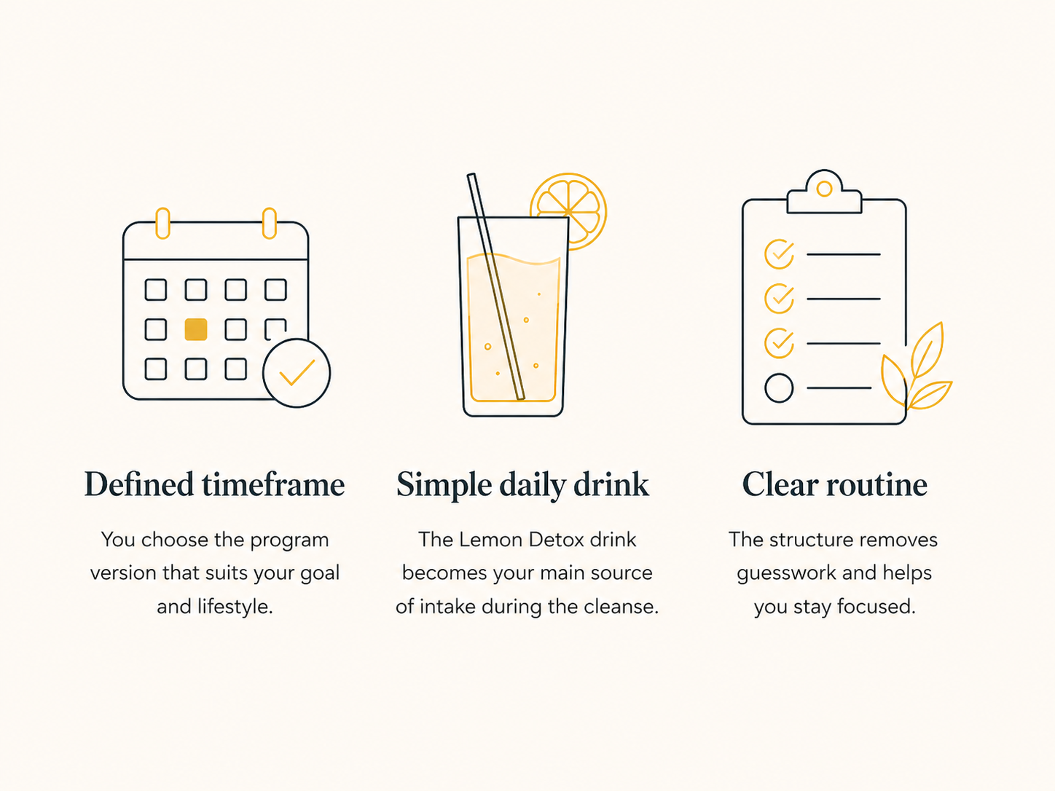

The Program is built around

Together, these create the structure needed to reset, reduce and restore.

Lemon Detox Cleanse Program Guide 3

3 THE LEMON DETOX DRINK
The Lemon Detox drink is the foundation of the program.
It is used throughout the cleanse in place of regular meals and provides the simple structure that makes the program easy to follow.
The Lemon Detox drink supports the body by providing the necessary nutrients needed while undertaking the Lemon Detox Program.
The drink is made from four key ingredients: Madal Bal® Natural Tree Syrup, fresh lemon juice, cayenne pepper and water. Together, these create the drink used across each day of the cleanse.

Each ingredient has a specific role.


Madal Bal® Natural Tree Syrup
The most important ingredient. It provides natural carbohydrates and essential minerals to help support energy during the program.

Fresh lemon juice
Lemons have been used for thousands of years for their cleansing value. The lemon juice acts as a detergent, cleansing your inner organs.



Pure Water
Gives your body an internal bath, carrying away all of the released wastes and toxins. Sufficient levels of water also keeps your body hydrated during the Lemon Detox program.

Cayenne Pepper
Cayenne Pepper ensures that your body's metabolism is still optimal during the cleanse. It also supports circulation and adds a nice zing to the drink

The drink is prepared fresh each day and consumed throughout the day as needed.

Lemon Detox Cleanse Program Guide 4
4 HOW TO MAKE THE LEMON DETOX DRINK
The Lemon Detox drink can be prepared as a full daily batch or made one glass at a time.

Most people find it easier to prepare the full daily amount in the morning, so the drink is ready throughout the day.

DAILY BATCH RECIPE (Recommended)
For approximately 2 litres
140 ml Madal Bal® Natural Tree Syrup
Juice of 3½ fresh lemons (minimum 140ml)
2–3 pinches cayenne pepper
Add pure or filtered water to make up approximately 2 litres


SINGLE GLASS RECIPE
To make one glass
20 ml Madal Bal® Natural Tree Syrup 20ml freshly squeezed lemon juice (about half a lemon) A small pinch of cayenne pepper At least 250 ml pure or filtered water

Preparation Notes
Use fresh lemon juice, not bottled lemon juice.
Shake or stir the drink before serving, as ingredients may settle.
The drink can be served cold, room temperature or warm. Do not boil.
Once opened, store the Madal Bal® Natural Tree Syrup in the refrigerator.

Lemon Detox Cleanse Program Guide 5
5 THE DAILY STRUCTURE

The program follows a simple daily rhythm designed to support detoxification, elimination, weight loss and steady energy throughout the cleanse.


The day typically begins with the elimination routine.
This involves drinking the sea salt water mixture or, alternatively, a cup of herbal laxative tea. This step helps stimulate the body’s elimination process and assists in clearing the digestive tract.
The Lemon Detox drink can be made fresh in the morning or prepared the night before for convenience. The full daily batch can also be taken with you to work if necessary.

The Lemon Detox drink is consumed regularly throughout the day.
The mixture provides liquid nourishment and helps sustain energy while giving the digestive system a temporary break from processing solid food. By replacing regular meals for a defined period, the program also reduces daily intake, which is a key reason many people experience weight loss during the cleanse.
Additional water should also be consumed throughout the day to help maintain hydration and support the detoxification and elimination process.


Once the daily Lemon Detox drink mixture has been consumed, a cup of herbal laxative tea is taken before bed. This helps support the body’s elimination process during the cleanse.
Adequate rest is encouraged during the program while the body continues its natural cleansing and restorative processes overnight.

The routine quickly becomes simple and repetitive, allowing participants to focus on detoxification, weight loss, hydration and completing the cleanse.
Lemon Detox Cleanse Program Guide 6
6 WHICH PROGRAM SUITS ME?

Choose the version that best suits your lifestyle, goals and experience level.
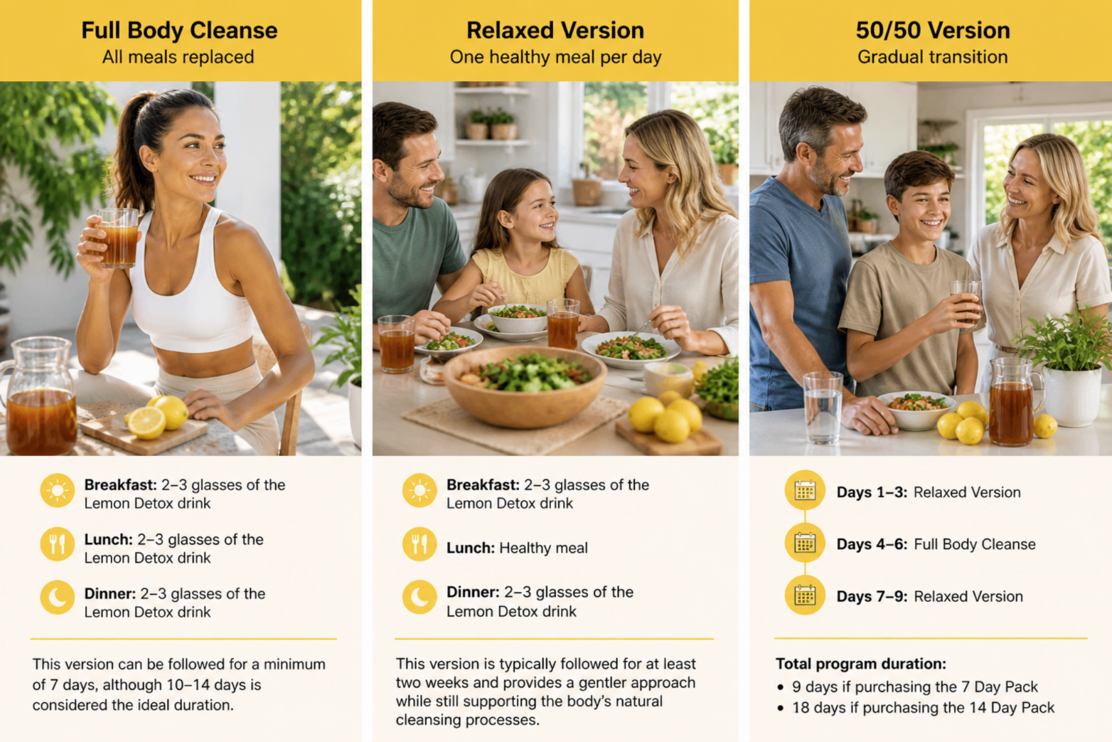





Lemon Detox Cleanse Program Guide 7
BEGIN YOUR RESET

The Lemon Detox Cleanse is a structured program designed to help you step away from excess, simplify your routine and commit to a focused period of detoxification, weight loss and renewed control.
By now, you understand the program, the drink, the daily rhythm and the version that best suits your lifestyle.

Your next step is simple:
Choose your program, prepare your ingredients and begin.
The strength of the Lemon Detox Cleanse lies in its clarity.
No complicated meal plans.
No constant decisions.
Just a defined timeframe, a clear routine and the commitment to see it through.
Whether your goal is to detoxify, reduce weight, regain discipline or create a fresh starting point, this program gives you the structure to begin with confidence.

Your reset begins with one decision.
Start today.



Reset. Reduce. Restore.

Lemon Detox Cleanse Program Guide 8

Lemon Detox Cleanse Program Guide 9

Lemon Detox Cleanse Program Guide 7

