HOME PAGE:

1. Remove top black banner –“Complimentary shipping etc”…
2. Centre the top menu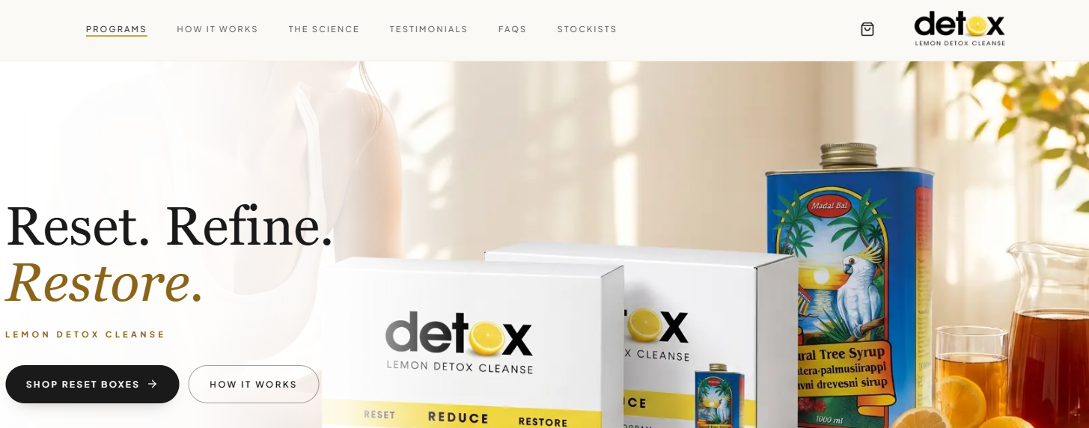

3. Reduce the font size of top menu – same as manus
4. Banner – ill have to make a new banner to fill the whole page.

SECOND SECTION – with female
5. Try change text & colour similar to Manus for whole site. This section should be white background.

LARGE HEADINGS
Black Font colour: #1a1a1a - https://www.color-hex.com/color/1a1a1a
Gold font colour: #8a6418 - https://www.color-hex.com/color/8a6418
Cormorant Garmond Bold 700 for headings

https://fonts.google.com/specimen/Cormorant+Garamond?specimen.preview.text=Every+system+benefits+from+a+reset


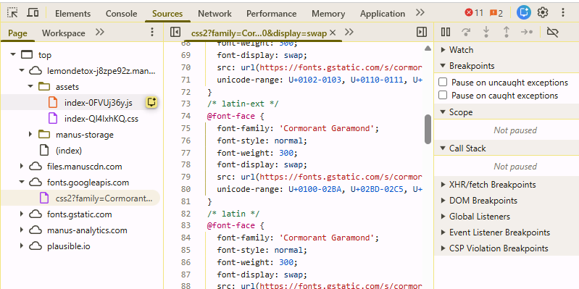

Main text: font colour #2b2e2F - https://www.color-hex.com/color/2b2e2f
Plus Jakarta Sans – Normal 400 as below
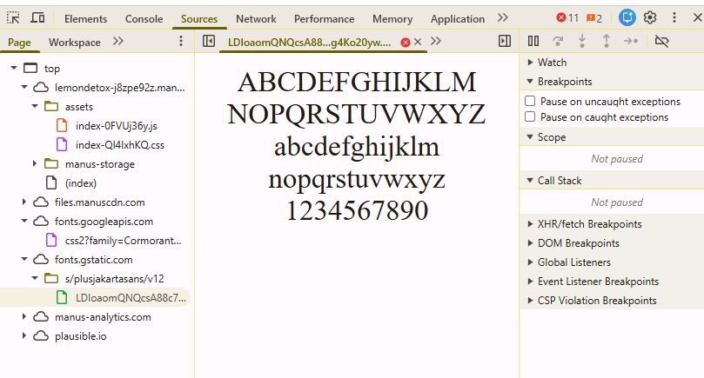

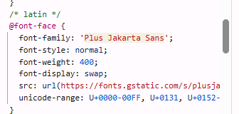

7. Remove ‘In a world of constant consumption, it’ in main paragraph as it repeats with the heading. Add instead, “ The Lemon Detox Cleanse provides”
8. Have next sentence over two lines as below
No confusion. No complicated rules.
Just clarity and simplicity.

THIRD SECTION – Every System…..
9. Change the page colour as on Manus.
#faf9f6 Color Hex
Above section should be white background and this section light beige like on Manus.
10. Remove WHAT CHANGES banner
11. In the heading, make ‘a reset’ same font size as rest of heading.
12. IN ADDITION, THE PROGRAM MAY SUPPORT: - Change the header to IN ADDITION, THE PROGRAM SUPPORTS: and font needs changing
13. Replace points to below and make the dots slightly larger
Weight loss, with 3–6kg in 10 days commonly reported
Better energy and endurance
Stronger self-discipline
Improved confidence and motivation
Greater awareness around eating habits
Brighter-looking skin
A greater sense of wellbeing
Renewed vitality

13. On second line of 1st paragraph, move ‘The Lemon” to next line.
Might have to make main body longer to even out two side.

FOURTH SECTION – Choose our cleanse
14. remove banner – Select your program but keep the text in front of white background
15, Switch 14 day Cleanse and 7 day Cleanse
16. Titles should just be ’14 Day Cleanse ‘ and ‘7 day Cleanse. If you can make the 14 and 7 sit under the main text as on Manus.
17. Border around products should be as manus.
18. I don’t think we need to have – Price (AUD) ?
19. recommended needs to change to ‘Most Popular’- top left of box
20. Prefer left justified content in box as Manus
21. Buy Now buttons too wide – adjust like Manus
21a. On Manus when you hover over Buy Now button it changes colour
22. Under the products, Change ‘Need more Convincing’ to ‘Want to know more before you start?’
23. Reduce the size of ‘Download the program guide’ as on Manus
24. Remove: A beautifully designed guide covering everything you need to know before you commit. And replace with

25. From here when they enter their email address,
Immediately open the PDF in the browser on same page
After submission, show: “Your guide is ready below.”
Embedded viewer appears
Small “Download PDF” button inside viewer

26. Remove PDF-10 pages 3.3mb

FIFTH SECTION: VOICES from the cleanse

27. remove banner completely. Should be the lighter background

28. Change the heading ‘ Real People……’ to below - style as per manus
Trusted for decades. – smaller font
Everyday People. Real Stories. – larger font

29. Add the below testimonial cards across the page

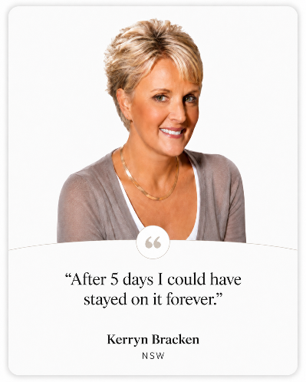

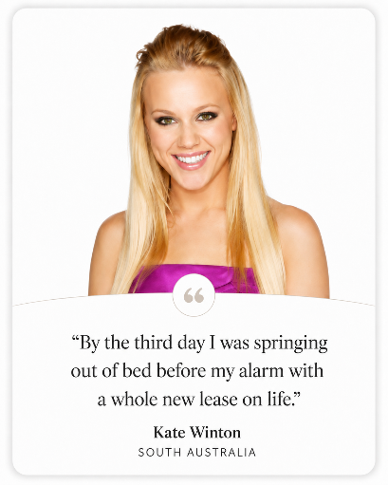
30. Change button to read – READ MORE TESTIMONIALS
31. Under this section need a call to action:
Add Begin Your Reset, as is at end of page and add Buy Now Button



Reset · Reduce · Restore (same as currently onsite)
31. DELETE THE REST OF PAGE except for footer

HOW IT WORKS PAGE
Section 1: How the Lemon Detox works…

1. Replace image with below image. – image should move when you hover over.
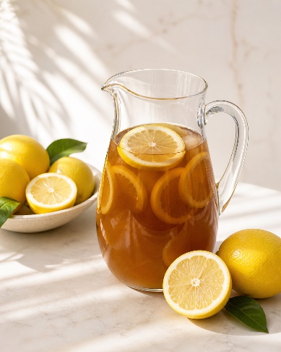

2. Add and remove single line
3. Second paragraph-last line – Remove the words ‘let the body’ and replace with ‘allow the body to’
4. The inserted banner on new image should now read
7 to 14 days
One clear rhythm

Section 2: The Pause
5. Menu should be same as Manus.
6. use correct background colours

Section 3: Daily rhythm
7. Change image to below image
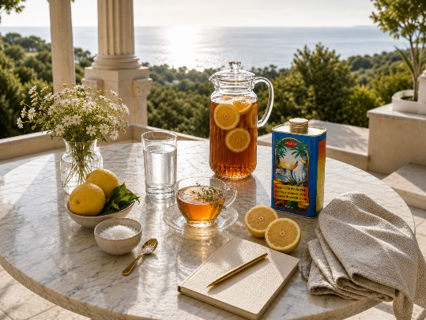

8. Throughout the day section – This section was left out. Its on the manus site.
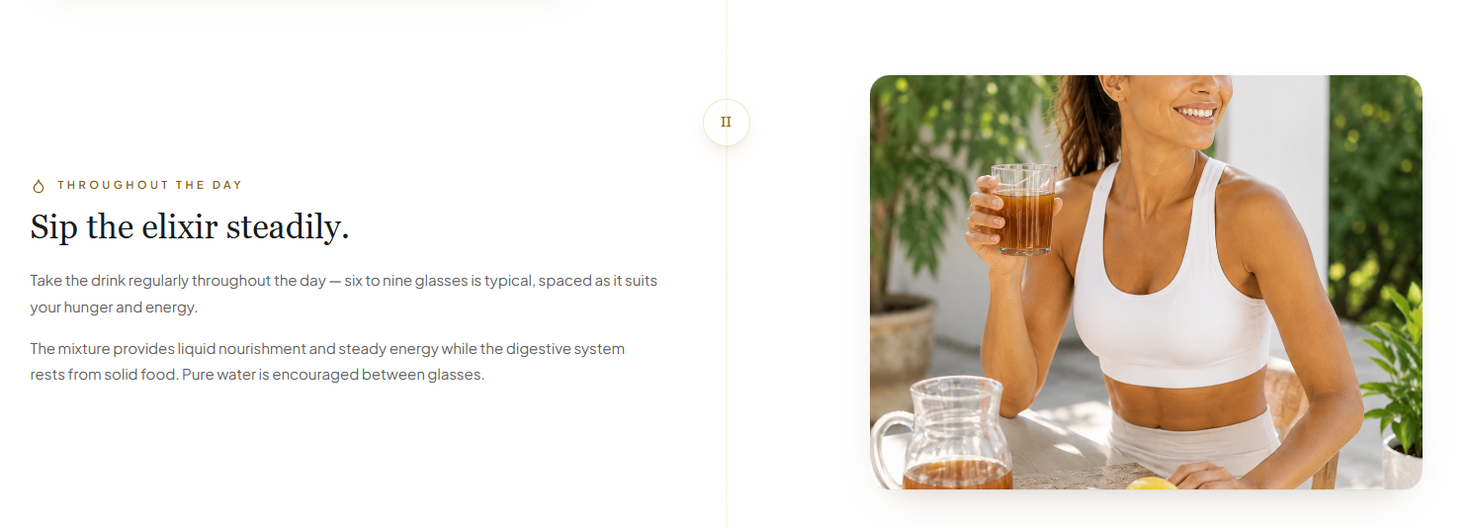
9. Remove the title ‘Sip the Elixir steadily’ to Through the day (first line)
Drink it gradually and consistently. (main heading)
10. Change image to below image

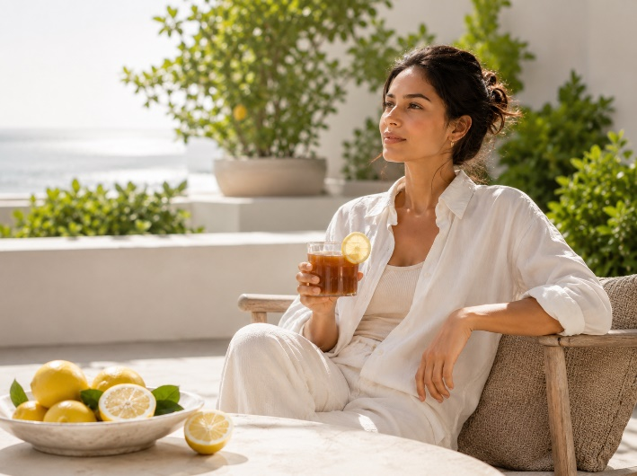

11. In the Evening Section - Keep the below text all under the image

The routine quickly becomes simple and repetitive — leaving you free to focus on rest, hydration, and the cleanse itself. –

SECTION 4 – The Formula
12. Bold - Madal Bal Natural Tree Syrup
13. Replace second paragraph –
During the cleanse, this drink replaces regular meals while supplying natural sugars, minerals and hydration. The digestive system rests — yet you remain energised throughout the day.
WITH
During the cleanse, this drink replaces regular meals while supplying your body with natural carbohydrates, minerals and hydration. The digestive system rests — yet you remain energised throughout the day. Simple liquid nourishment!

14. Keep 4 cards wide but replace last card with below card. The Senna tea banner, we will move down the page later.


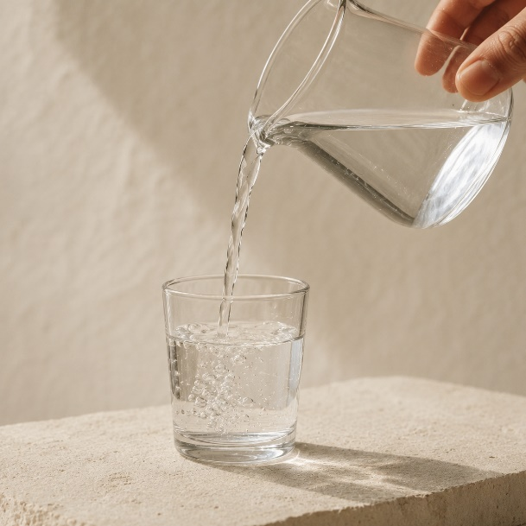

Pure water
Clean, pure water helps carry the formula through the body while maintaining hydration during the cleanse and supporting the body’s natural cleansing processes.

15. Change text in Fresh Lemon Juice to below
Freshly squeezed lemons provide vitamin C and citrus polyphenols. Traditionally valued for their cleansing properties, a refreshing flavour while supporting the body's own detoxification pathways.

16. Change text in Madal Bal card below
The key ingredient, a balanced blend of Canadian Grade C maple syrup and the purest Palm syrups providing energy in the form of easily digestible carbohydrates and a high level of potassium.

17. The images of the cards should be part of the outer border as on Manus

SECTION 5 – Mixing
18. Remove all text on right -
Two equivalent ways to mix the drink — choose whichever fits your day. The 2-litre batch is the easiest if you'll be away from home; the single-glass measure is handy for travel or first-timers.

AND REPLACE with the text from the bottom of the section-(as below)
The Lemon Detox drink is simple, natural and easy to prepare. Fresh ingredients give the best flavour and the most effective cleanse experience.

19. Keep the text on right of heading withing the height of the main heading as it currently sits too high.

SECTION 6 – Elimination
20. Remove text under heading and replace with below text:
Effective elimination is the key to a successful Lemon Detox program, helping the body remove waste products released during the cleanse.
Sea Salt and Senna Tea are provided to help stimulate the body’s natural elimination process during the cleanse.

21. Make the 2 headings in the banners a bit larger and increase the size of the icons as on Manus site.
22. Change the text in Evening banner to below-
EVENING – HERBAL SENNA TEA
Senna tea, a mild herbal laxative taken before bed, supports overnight elimination of waste released during the cleanse.

23. Bold the text in the section as on Manus site. Alos include bolding ‘taken before bed’ as above.

SECTION 7 – Versions
24. Bring the text on right to under the heading as on Manus.
25.cards should move when you hover over
26.Images should be part of the border of the cards as per Manus
27. Make images same height as Manus
28. Change the image in Relaxed version to below

29. Change the Full Body version image to below


30. Change the Relaxed Version image to below
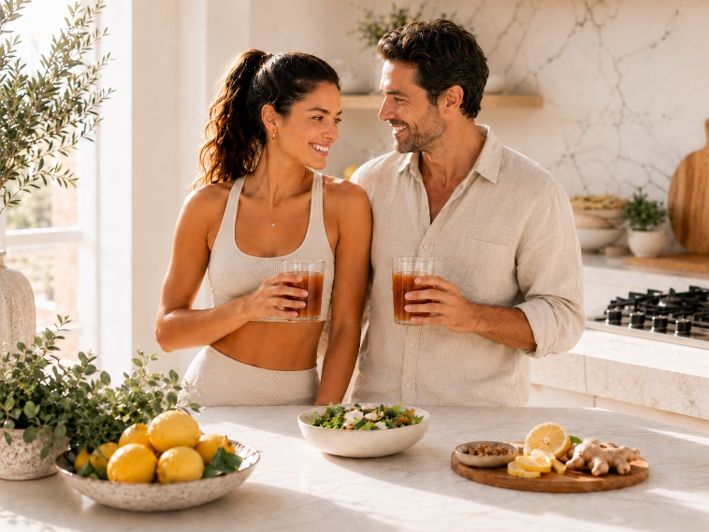

30. Change the 50;50 version image to below



31. Change the BUY NOW banners to 1 banner in black

START YOUR CLEANSE TODAY

SECTION 8 – Depth
32. Keep heading same as Manus.

LAST SECTION
33. remove Read the science and place START YOUR RESET TODAY in the middle

