SmartAttendance – Technical Documentation
Version 1.0 | Prepared by Development Team | Date: November 2025

1. System Overview
SmartAttendance is a university-wide web-based attendance system built using Java Spring Boot (backend), React (frontend), and MongoDB (database). It allows lecturers to create attendance sessions and students to mark attendance by sharing their live location. Attendance validation uses a geofence radius, and fraud detection is handled using device fingerprinting and IP tracking.

2. Technology Stack
• Frontend: React.js + Tailwind CSS
• Backend: Java + Spring Boot (REST API)
• Database: MongoDB
• Authentication: JWT
• Reporting: CSV + Email via Spring Boot Mail
• Fraud Detection: IP, Browser Fingerprint, Local Storage

3. System Architecture
The architecture follows a three-tier structure consisting of frontend (React), backend (Spring Boot REST API), and database (MongoDB). Communication is secured with JWT tokens. The lecturer receives attendance reports via automated emails.
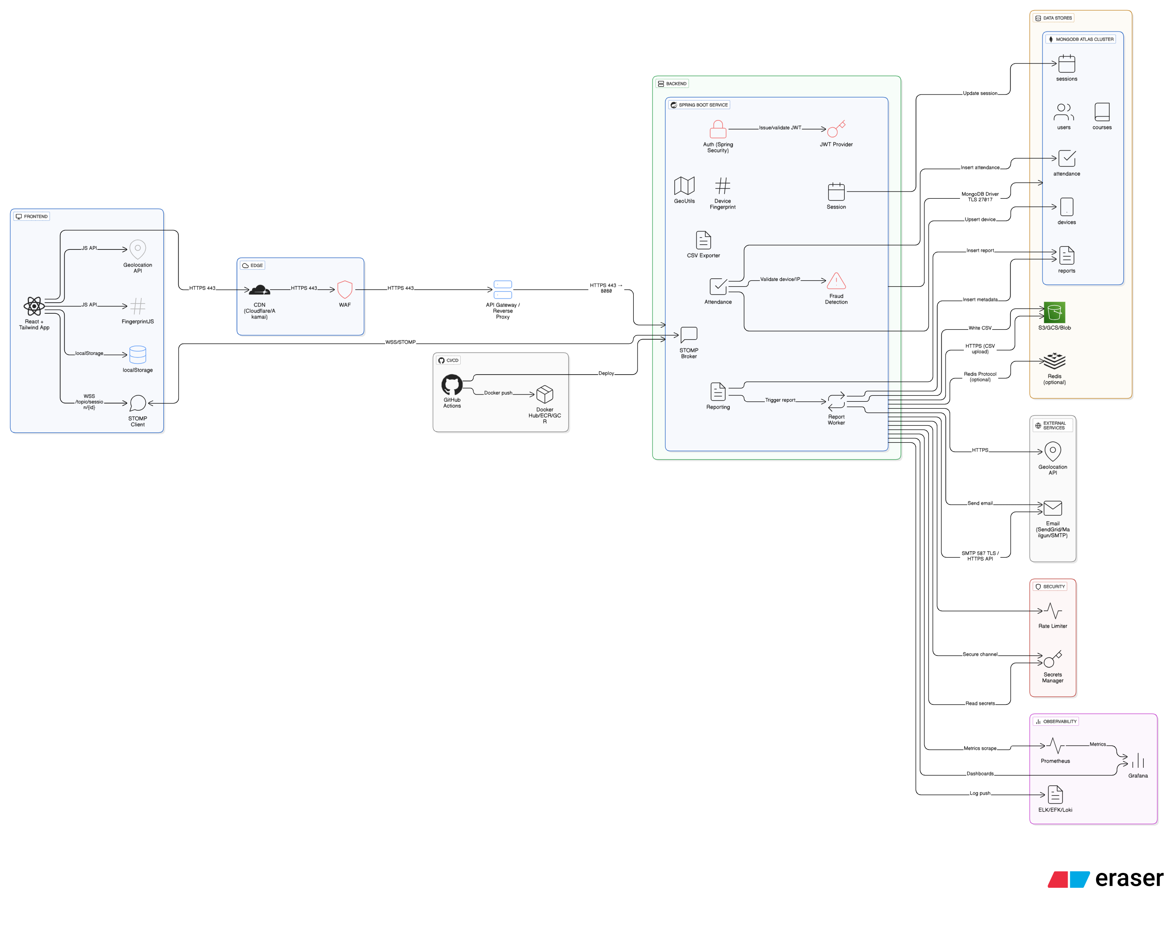

4. UML Diagrams
Class Diagram:
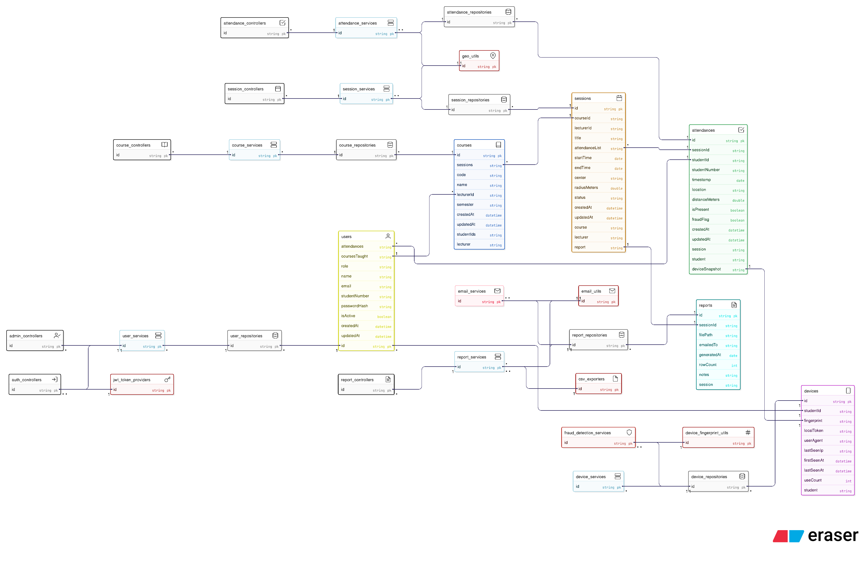
Sequence Diagram:
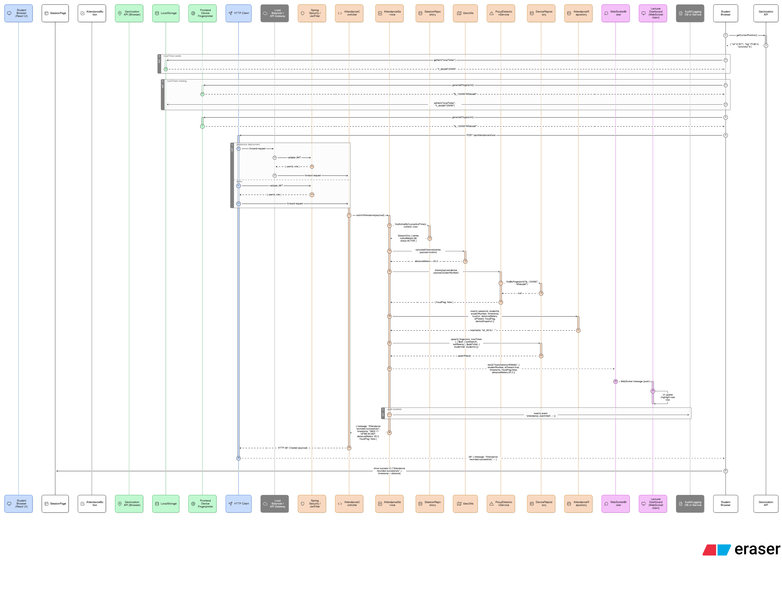
EER Diagram:
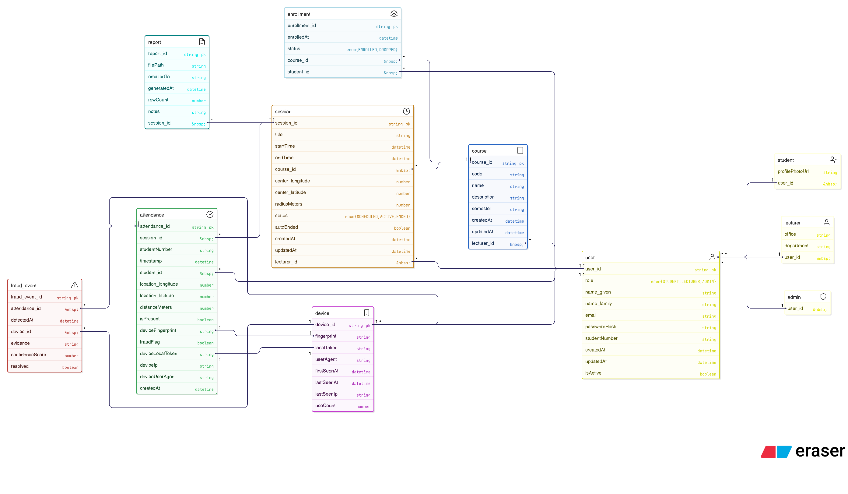
Use Case Diagram
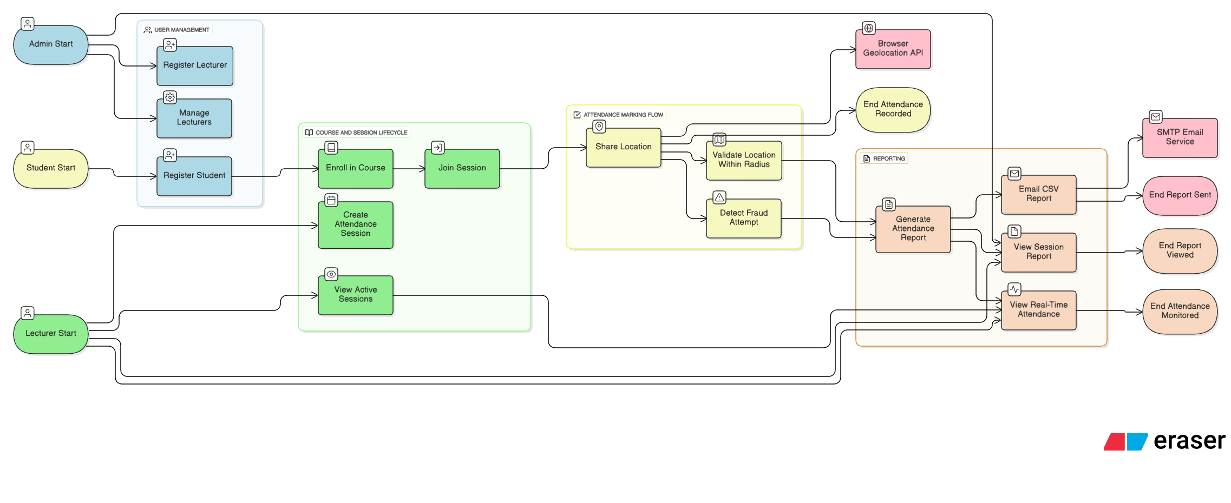

5. REST API Design
Endpoints:
POST /api/auth/login – Authenticate and return JWT
POST /api/students/register – Register student
POST /api/lecturer/session – Create new session
POST /api/attendance/share – Submit location
GET /api/session/{id}/report – Generate attendance report

6. Database Schema
Collections:
• users: _id, name, email, role, passwordHash
• sessions: _id, lecturerId, courseId, radius, startTime, endTime
• attendance: _id, sessionId, studentId, timestamp, location, isPresent, fraudFlag
• devices: _id, studentId, fingerprint, ipAddress, userAgent

7. Fraud Detection Workflow
1. Log student device fingerprint and IP during attendance submission.
2. Compare identifiers with previous records.
3. If mismatch occurs, mark attendance as suspicious but still present.
4. Display fraud flag in lecturer dashboard.

8. Attendance Report & Email Automation
CSV files are generated at the end of each session and emailed to the lecturer automatically. Reports are also stored permanently in the system for later review.

9. Deployment & Environment
SmartAttendance can be deployed using Docker or as a Spring Boot JAR. MongoDB Atlas is used for cloud data storage. Environment variables hold JWT secrets, DB credentials, and SMTP settings.

