Experiments for Kiribathgoda | Testing accuracy | Training accuracy | precison | recall | F1 score | Confusion matrix | Feature imporatance
Basic RF | 77.27% | 98.86% | 0 | 0 | 0 | 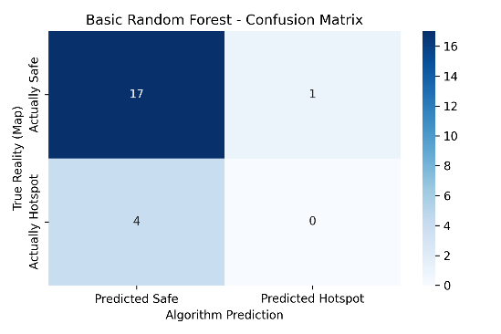 | 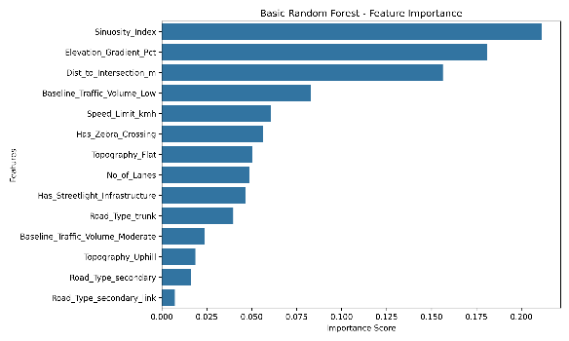
Tuned RF | 77.27% | 92.05% | 0.40 | 0.50 | 0.44 | 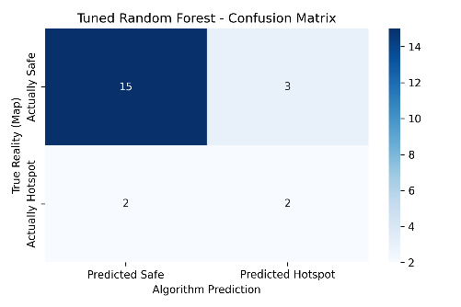 | 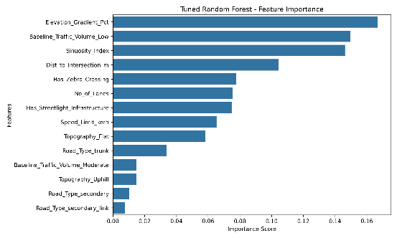
With SMOTE | 72.73% | 100.00% | 0.25 | 0.25 | 0.25 | 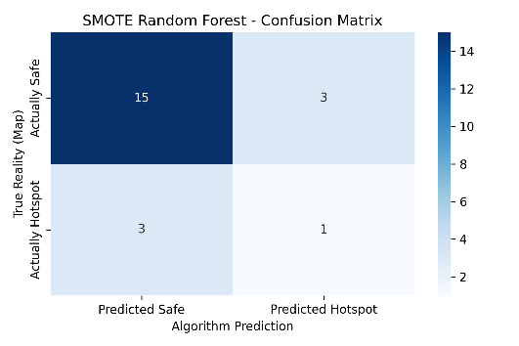 | 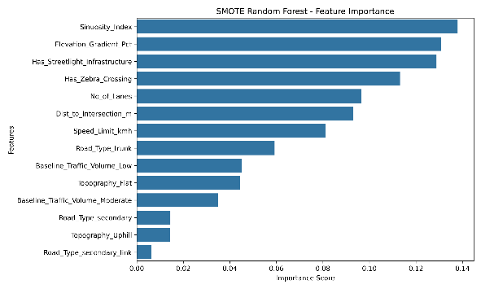
After tuning  With smote | 77.27% | 88.64% | 0.40 | 0.50 | 0.44 | 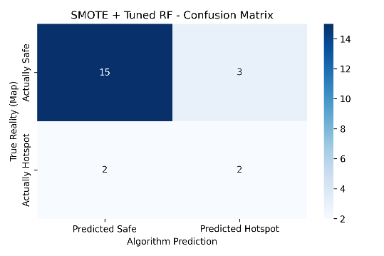 | 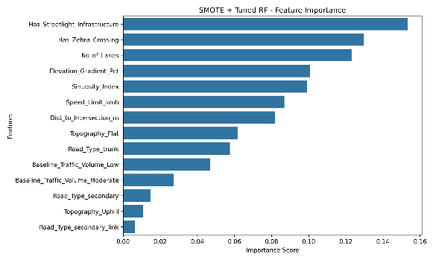
Ella random forest
Experiments for Ella | Testing accuracy | Training accuracy | precison | recall | F1 score | Confusion matrix | Feature imporatance
Basic RF | 83.33% | 100.00% | 0.33 | 0.09 | 0.14 | 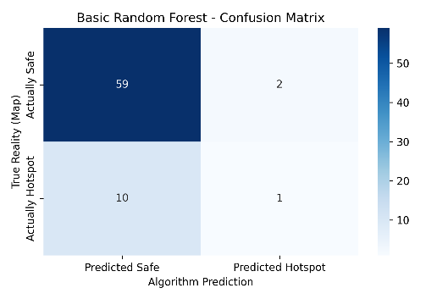 | 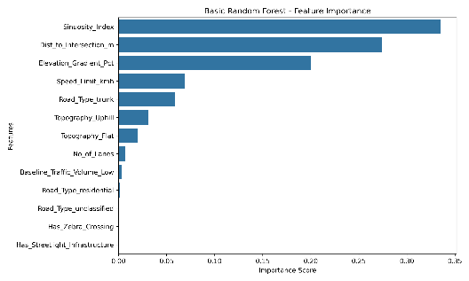
Tuned RF | 75.00% | 87.04% | 0.29 | 0.45 | 0.36 | 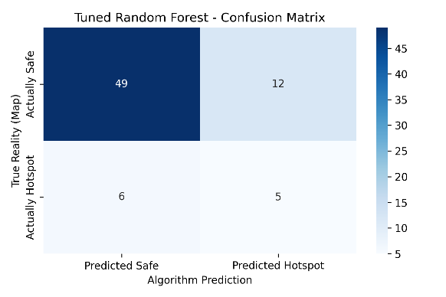 | 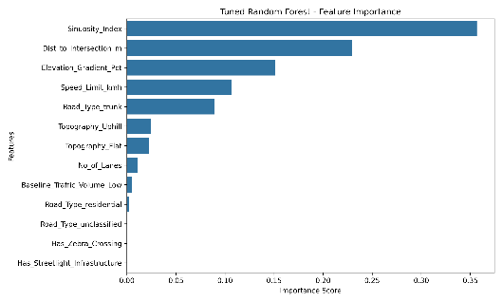
With SMOTE | 72.22% | 100.00% | 0.15 | 0.18 | 0.17 | 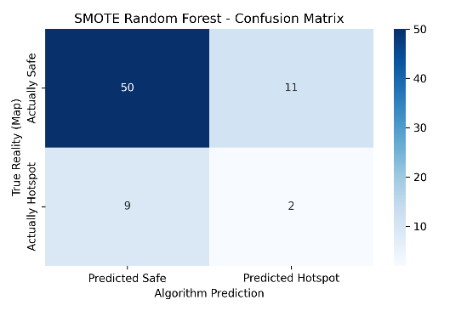 | 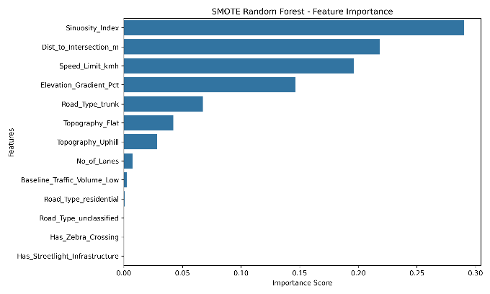
After tuning  With smote | 73.61% | 86.11% | 0.21 | 0.27 | 0.24 | 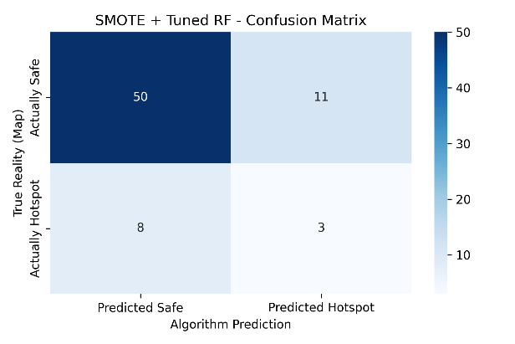 | 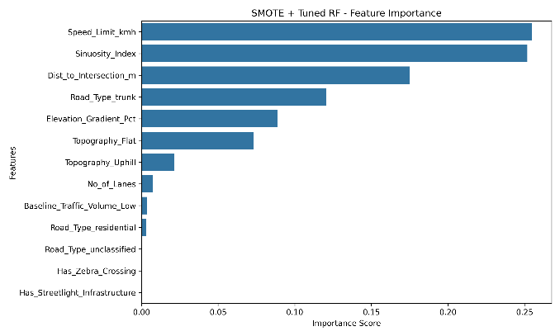

Anuradapura
Experiments for Anuradhapura | Testing accuracy | Training accuracy | precison | recall | F1 score | Confusion matrix | Feature imporatance
Basic RF | 90.55% | 100.00% | 0.50 | 0.08 | 0.14 | 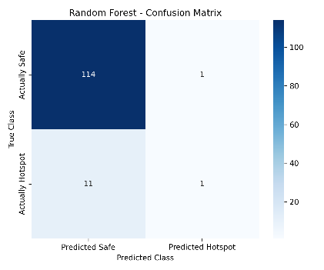 | 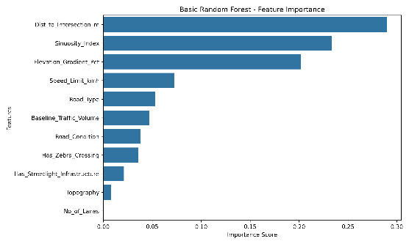
Tuned RF | 88.98% | 98.41% | 0.25 | 0.08 | 0.12 | 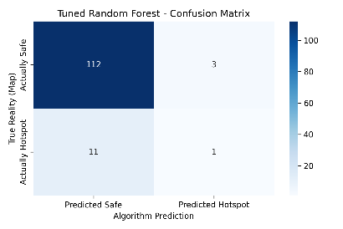 | 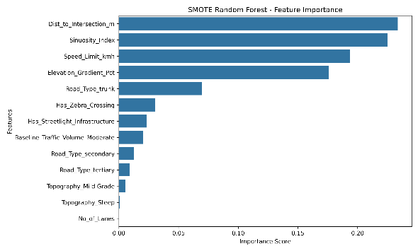
With SMOTE | 89.76% | 100.00% | 0.40 | 0.17 | 0.24 | 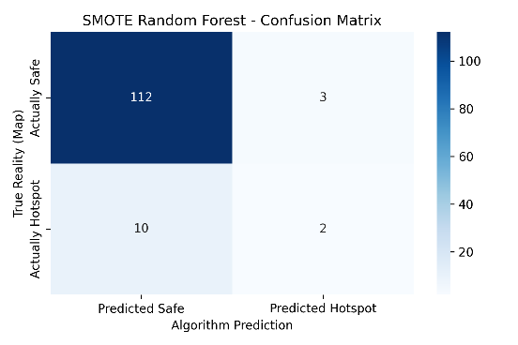 | 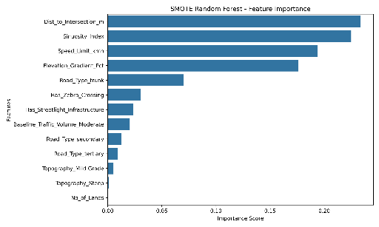
After tuning  With smote | 88.98% | 100.00% | 0.33 | 0.17 | 0.22 | 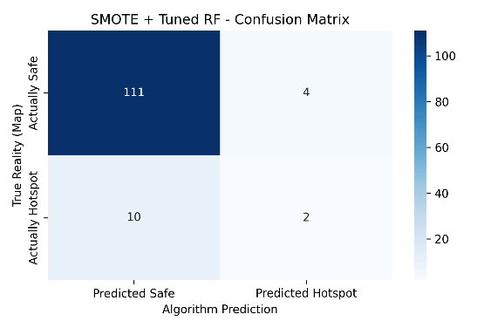 | 