LABORATORY ASSIGNMENT 4
PLANNING

TASK 2:
The problem flow will be the next: Shakey starts always in the central room, which also has a box. This room will be surrounded by other rooms, each of them containing a small object. Our goal will be to rotate the objects from one room to contiguous one, the lights on the rooms we will try types of problem, one with the lights on and another with them off and we will increase the number of rooms.
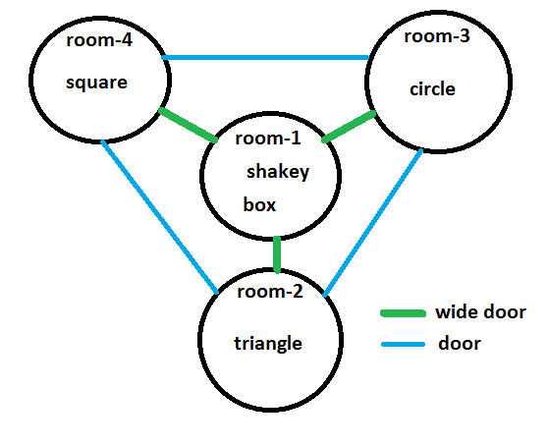
As the problem solvers showed no difficulties to solve this problem with a small number of rooms, we wrote a python script called “problem_creator.py”. This script, automates the problem creation, we just have to decide how many peripheral rooms (rooms around the central one) we need and the script will write the pddl file for us. Using this script, we can escalate our base approach as much as we like with ease.

Even if you can’t see them, the result for the 10 rooms problem are there. The only problem that couldn’t be solved is the one with 100 rooms with the lights on, now let’s analyse the results:
- FF: problems with the lights on: The solution for the 10 rooms problem took the planner 0.01s and 45 steps to solve. The 50 rooms problems results are 18.68s and 245 steps, it took surprisingly more time to solve than 50 rooms with lights off even tough the number of steps for the solution is lower. Finally, the 100 rooms problem .-.-.-.-.-.-.--.
- LAMA: problems with the lights off: In this case the 10 rooms problems was solved in 0.1s and 45 steps. The 50 rooms one 1.12s and 208 steps. Lastly the 100 rooms was solved in 8.64s and 409 steps.
Contrast: We can see how LAMA always finds better solutions for the problems than FF (in number of steps) even though it may take a little more time to solve than FF. We don’t have a good explanation about why

