Some cases in which poisoned reverse may fail

Poisoned reverse only works if the size of the loop that is trying to avoid is 2. If the size is larger, the loop will form again and poisoned reverse won't work as expected.

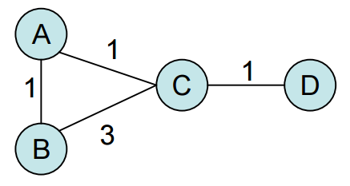

If we apply Poisoned reverse to this example and C – D fails, B will advertise his optimal path to D to C (B-A-C-D) and as the cost from C to D will be infinite, C will accept the route through B as the fastest route. This will create a loop.

A solution to this problem

To solve this problem we can use Holddown timer. When the connections to a node fail, all the routers set up a timer. Until the timer expires, the routers will ignore all the new routes to the fallen node. When the timer expires the network is supposed to be estable and loops shouldn't form.

