Scenario #1 | (Brief description)
Cause(s)
Key Factor(s)
Consensus Rating

- Insert evaluator names in left column.
- After a complete and thorough description of all scenarios, each evaluator assigns the value of 100 to the scenario that he or she believes is the most likely to be true. Then each evaluator must estimate the likelihood of each scenario as a proportion of the reference value 100. There is room on this sheet for 6 scenarios (1-6).
- The proportionality of the assigned values is very important and should be thoroughly analyzed for consideration.
- All scenarios with the same assigned value have the same likelihood of being true.
- Proportional values need not add up to any particular value. Whole offer sufficient accuracy and should be used.

3. Add each scenario column and put this sum in the “Subtotal Down” space at the bottom of each column.
4. Add the “Subtotals Down” row across and put the sum in “Total Across” for all of the rows. This value now becomes the denominator for the fraction that will be used to determine the scenario weight.
5. Calculate Scenario Weights by dividing each “Subtotal Down” figure under each scenario column by the total of all scenario weights. (Subtotal Down ÷ Total of all evaluator weights = % weight for each scenario). Scenario weights must add up to 1.00 or 100%
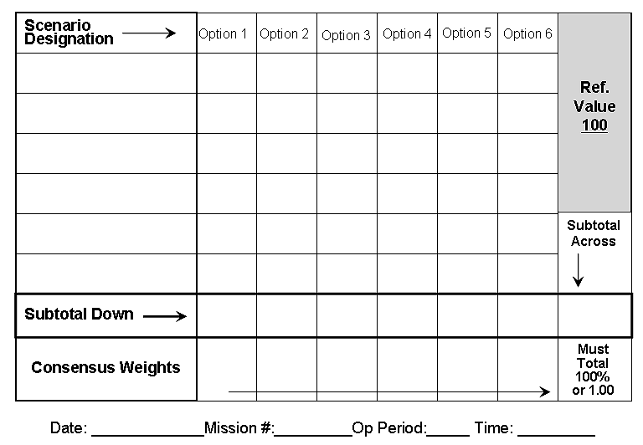

Likely Subject Actions
Unlikely Actions
Appropriate Search Action/Methods
Speculate Condition of Subject
Implications / Deductions

