User’s Manual

EvolMAP: Reconstructing ancestral genome content based on symmetrical best alignments and Dollo parsimony

By Onur Sakarya, Kenneth Kosik and Todd Oakley,
University of California, Santa Barbara, 2007

Table of Contents

- Installing and Running EvolMAP 3
  - Required files 3
  - Collecting a unique gene set 4
  - Running with the options file 4
  - Options 5
  - Output files 7
  - Running from graphical user interface 10

- Algorithm and Implementation details 16
  - All-to-all gene similarity matrix 17
  - Phase 1: Detecting ancestral genes 19
  - Phase 2: Detecting gene gains and losses 21

- Installing and Running EvolMAP

EvolMAP source code is freely available. It was compiled with JDK 1.5 and JDK 1.6 and works fine with both JVMs (Java 1.5.0 or Java 1.6.0). Below sections explain the required input files for each analysis, how to use the program from command interface or graphical user interface and the format of the output files.

a. Required Files:
EvolMAP.jar: Java executable archive file containing compiled java code. It should work in all operating systems with a Java Virtual Machine.
blosum62.txt: Blosum62 scoring matrix for amino-acid
analyses
options.txt: This file contains run-time options as well as tags for fasta sequences whose format is explained below
blastall and formatdb: These NCBI packages are freely available from ftp://ftp.ncbi.nih.gov/blast/executables/
EvolMAP is compatible with version 2.2.16 but should be compatible with newer versions unless the execution commands are changed.
hmmpfam: [for domain analyses only] This HMMER package is available from http://hmmer.janelia.org/ EvolMAP is compatible with version 2.3.2 but should be compatible with newer versions unless the execution commands are changed.
species specific fasta files: Sequence file for each gene set should be in fasta format and non-redundant [i.e. a gene only represented once, no splice variants, no double entries as they will be treated as duplicates]. After parsing the options file, EvolMAP looks for each species name in the species tree plus the tag. For example, if species tree is “((human,chimp),rat)” and tag is “.fa”, program searches for the files human.fa, chimp.fa and rat.fa under the same directory.

b. Collecting a unique gene set:
JGI assembled protein peptide sequences are in a unique gene format and can be downloaded from:
http://genome.jgi-psf.org/euk_home.html
Ensembl gene sets include splice variants, but splice variants are specified at the fasta header, so are easily removable. The provided jar file Ensembl_Splice_Remover.jar can be used to eliminate multiple splice variants keeping only the largest splice variant of each gene. That program is executed from command line using:
java –jar Ensembl_Splice_Remover.jar input_file output_file
An example input_file would be human.fa and output file human.ufa, where human.fa is all human peptides downloaded from Ensembl. Ensembl gene sets are available from: http://www.ensembl.org/info/data/download.html

c. Running with the options file
With all required files under the same folder, EvolMAP is executed by the following command:
java –jar –Xms1000m –Xmx1000m EvolMAP.jar options.txt
Here, Xms and Xmx specify the minimum and maximum memory assigned to Java Virtual Machine. We observed that a 2GB memory was sufficient for analyses of up to 250,000 sequences. All options and file names are specified in the options.txt file whose format is explained as below.

d. Options: [default values as specified]
tree = (((human,chimp),(mouse,rat)),dog)
newick format species tree
tag = .fa
looks for human.fa, chimp.fa, mouse.fa, rat.fa, dog.fa
protein = true
amino-acid or nucleotide file
database_name = mammal_genomes
analysis name, fasta database would be mammal_genomes.gd.fa for the above options
read_database = false
if true reads already created fasta database from disk
blastall = true
Runs blastall first -- if false it generates all-to-all Needleman-wunsch scores which is slow for large datasets. Blast is called by the command “./blastall -p blastp -d database_name.gd+tag –i database_name.gd+tag -o temp.database_name+tag.sparse_scores.BLAST -m 8 -b alignments”
read_blast_scores = false
if true reads already calculated blast scores
alignments = 300
Number of top alignments for each gene to be calculated by blastall (if used)
bit_scores = false
if false, calculates needleman-wusch alignment scores for the blast hits, if true uses blast bit scores
read_scores = false
if true reads scores from already calculated score file (for blast first alignments looks for database_name+tag.sparse_scores , for full alignments looks for database_name+tag.scores
read_ancestors = false
reads already calculated ancestors from file and re-runs Dollo parsimony
view_ancestors = false
open and view already calculated analysis using JTree [needs a computer that supports Java GUI]
ortholog_threshold = 250
minimum similarity threshold for orthologs
diverged_threshold = 250
minimum similarity threshold for diverged paralogs
diverged_std = 3
Diverged paralogs are allowed to be at most this many ortholog divergence standard deviations from the ancestor node’s average sym-bet score. For example if the avg. sym-bet score for the ancestor is 950, std. is 100, and this option is set as 3, a gained gene for the given branch will be set as a diverged in-paralog if it has a similarity score above 650 to any of the present genes of this ancestor. If it is less than that, that gain will be classified as an ambiguous gain.
avg_of_paralogs = true
If true, while calculating similarity between two ancestral genes, avg. score of all its members to members of the other gene are considered, if false only best score between the members is considered
Retrieve_domains = 7tm_1, 7tm_2, 7tm_3, 7tm_4
[Optional] If specified, selected domains [with PFAM HMM files under the directory, i.e. 7tm_1.HMM, etc.] are searched from given species genomes by calling hmmpfam with regular ga_cutoff thresholds. Genes containing any of these domains are parsed and a gene database is created. Each domain analysis is executed separately [following regular EvolMAP] and result files are generated for each of them.

e. Output Files:
database_name+tag.ancestor_results: Result file including the number of sym-bets, present genes, no blast-scoring genes, average sym-bet divergence and standard deviation of sym-bets for each ancestor, and the number of gene losses, in-paralogs, diverged in-paralogs and ambiguous gains for the in-coming branch of each ancestor. At the bottom, ortholog divergence, gene expansion, gene gain and gene loss trees are displayed in newick format.
database_name+tag.ancestor_pass2.rn: This tab-separated file shows each ancestral gene and their descendants. After ANCESTOR node line, the genes of the last common ancestor of all species of the node are shown. Each gene starts with either PRESENT, DIVERGED or SINGULAR tags. All gene names (first word of the fasta header) listed after PRESENT at each line represent the descendants of a single ancestral gene. After DIVERGED, first gene is the source of the diverged in-paralogous gene, and the rest of the gene names are the descents of that gene. A DIVERGED gene is inferred not present in the ancestor, but are duplicated at one of the descendant lineages from the source gene. A SINGULAR gene is not present in this ancestor and is not gained in any of the descendant lineages [but gained in a later branch]
database_name+tag.ancestor_pass2.sum: This tab-separated file summarizes the descendant sizes of the genes of each ancestral genome. Each bin shows the number of families that have as many descendants as specified in its header.
database_name+tag.ancestor_pass2: Pass2 raw output where each gene is specified by the species_gene-order. Otherwise same with .rn file. This file is used for indexing by the program.
database_name+tag.ancestor_pass1: Pass1 raw output. Shows sym-bets, singulars, sym-bet scores, most similar genes for each singular. SYM-BET lines are followed by sym-bet score and the list of descendant genes. SINGULAR lines are followed by most similar singular source, similarity score and list of the genes of that singular.
database_name.gd+tag: Gene database which is a concatenated fasta file with the total number of genes specified in the first line and an extra fasta header line for each sequence where the species and order of gene is specified. This file is created for indexing purposes as well.
database_name.sparse_scores: Tab separated NSS sparse score matrix file which is generated if BLAST is used. Header line shows the indexed order of genes. Each other line shows the top scoring genes for the gene and the normalized similarity score for that gene [they are in the order set in header].
database_name.scores: This is a complete score matrix where a score for each gene is calculated against every other gene using Needleman-Wunsch alignments.
temp.X: These are the files generated by formatdb and blastall packages. temp.database_name+tag.score_matrix.BLAST is the main blast output.

f. Running from Graphical User Interface
Graphical user interface (GUI) offers a graphical input of program options through an step-wise interface rather than the .txt file. Most of the program’s options are supported by GUI. Opening and analyzing program results (ancestral genes and their descendants) is also supported by GUI and further analysis modules may be implemented by modifying ShowAncestor.java. For large analyses use of GUI is not suggested.

All required files (i.e. Blastall, formatdb, Blosum62.txt and fasta files) need to be under the working directory and then double clicking EvolMAP.jar brings the GUI screen. First step is to specify the species tree in newick format, and the sequence file extension which corresponds to the ‘tag’ from options.

After selecting “calculate alignments” option, a gene database needs to be prepared or read from file. Program will look for a fasta file with the specified extension for each of the species when creating the gene database. If previously calculated, it may be read from file.

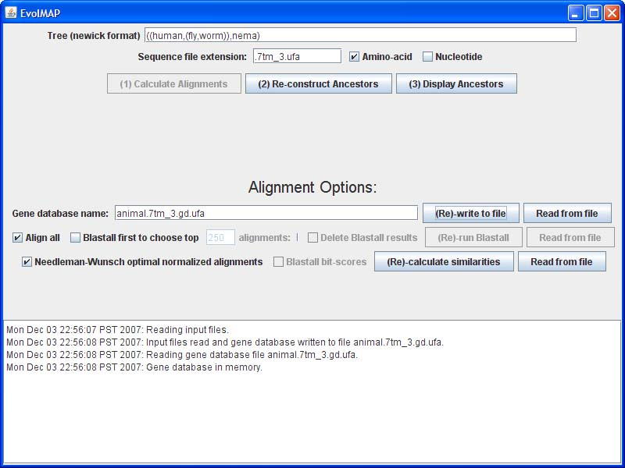
Figure 1. GUI: Preparing gene database.

Then the alignments need to be calculated using BLAST first or directly through Needleman-Wunsch. Both BLAST and pairwise alignments take a while and GUI may not respond until they are finished. Once calculated these score matrix files can be read from file as well. Number of best alignments to be considered for each gene is specified at the input box preceding ‘alignments’, and blastall raw output files can be automatically deleted by checking the corresponding option.

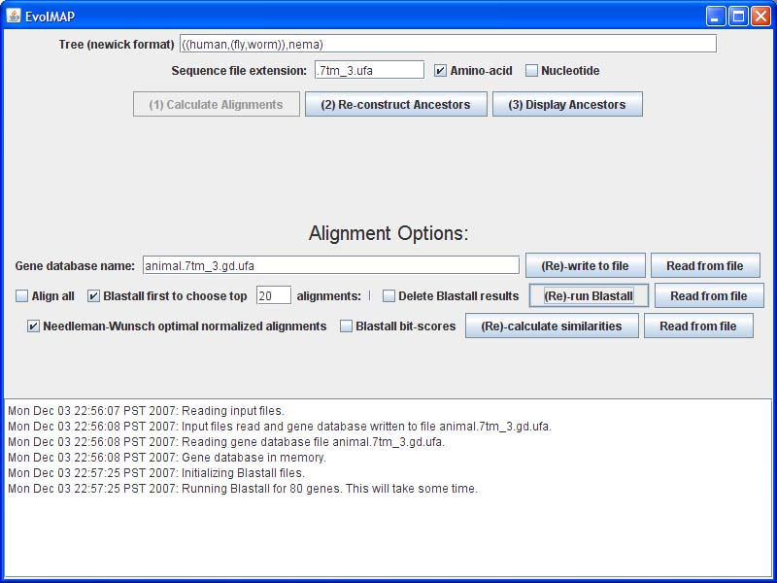
Figure 2. GUI: Running blastall.

By clicking the button ‘(re)-calculate similarities’, the program performs required Needleman-wunsch alignments (either all-to-all or top alignments depending on whether blastall was used first. These are then written to a score matrix file which can later be read for a fast re-analysis.

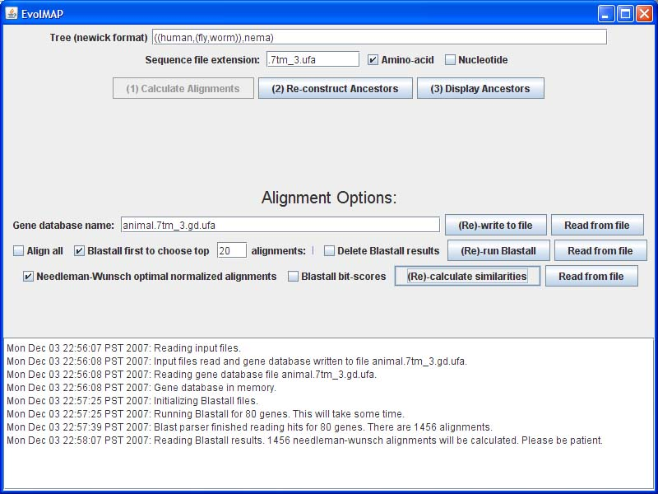
Figure 3. GUI: Calculating Needleman-Wunsch alignments and the normalized similarity matrix.

Next step is to reconstruct ancestors according to calculated alignment scores. Implementation details of the algorithm are explained in the next section. If using previously calculated alignments (i.e. to re-run with different ortholog thresholds), the analysis may be started from this step by reading the pass1 and pass2 files.

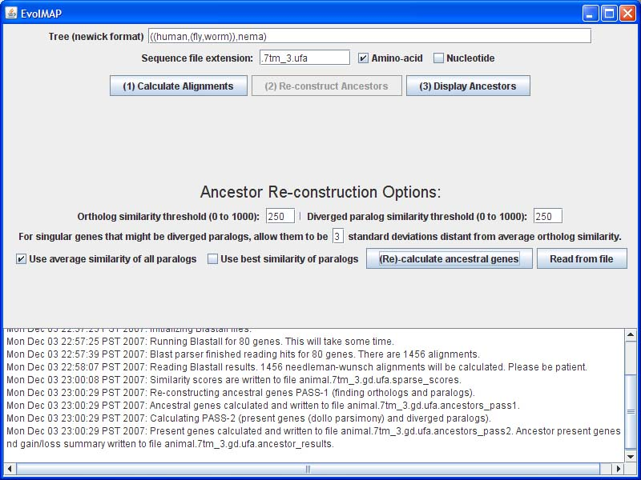
Figure 4. GUI: Ancestral reconstruction (phase1 + phase2 of algorithm)

GUI is primarily good for analyzing the results of EvolMAP, otherwise it is as easy to run the analysis with an options file. By clicking the ‘display ancestors and gene families’ button, which will be enabled only when a gene database and ancestors are loaded to memory, a new window displaying the ancestral genes is opened.
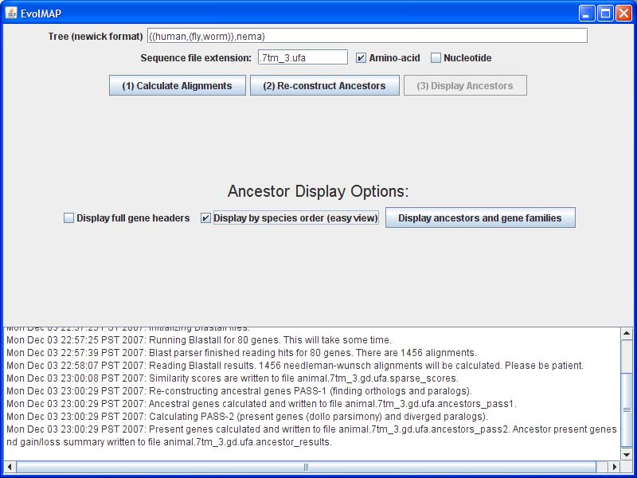
Figure 5. GUI: Displaying reconstructed ancestors using JTree.

Ancestor display window allows the estimated contents of each ancestral genome to be browsed easily. This GUI is in JTree format where clicking an ancestor will pop open the list of ancestral genes of the genome. Clicking any ancestral gene will show the descendants of that ancestral gene. When a modern gene is selected, its fasta sequence will appear at the editor window at bottom. A search for a given modern gene may be performed at a selected ancestor by entering the gene identifier (from its fasta header like a gene ID) into the input box to the right and hitting the ‘Search in Ancestor’ button. A selected gene family (all descendants of that ancestral gene) may be exported as a fasta file (which creates a file under the working directory). This window is good to browse through results perhaps in search of interesting genes.

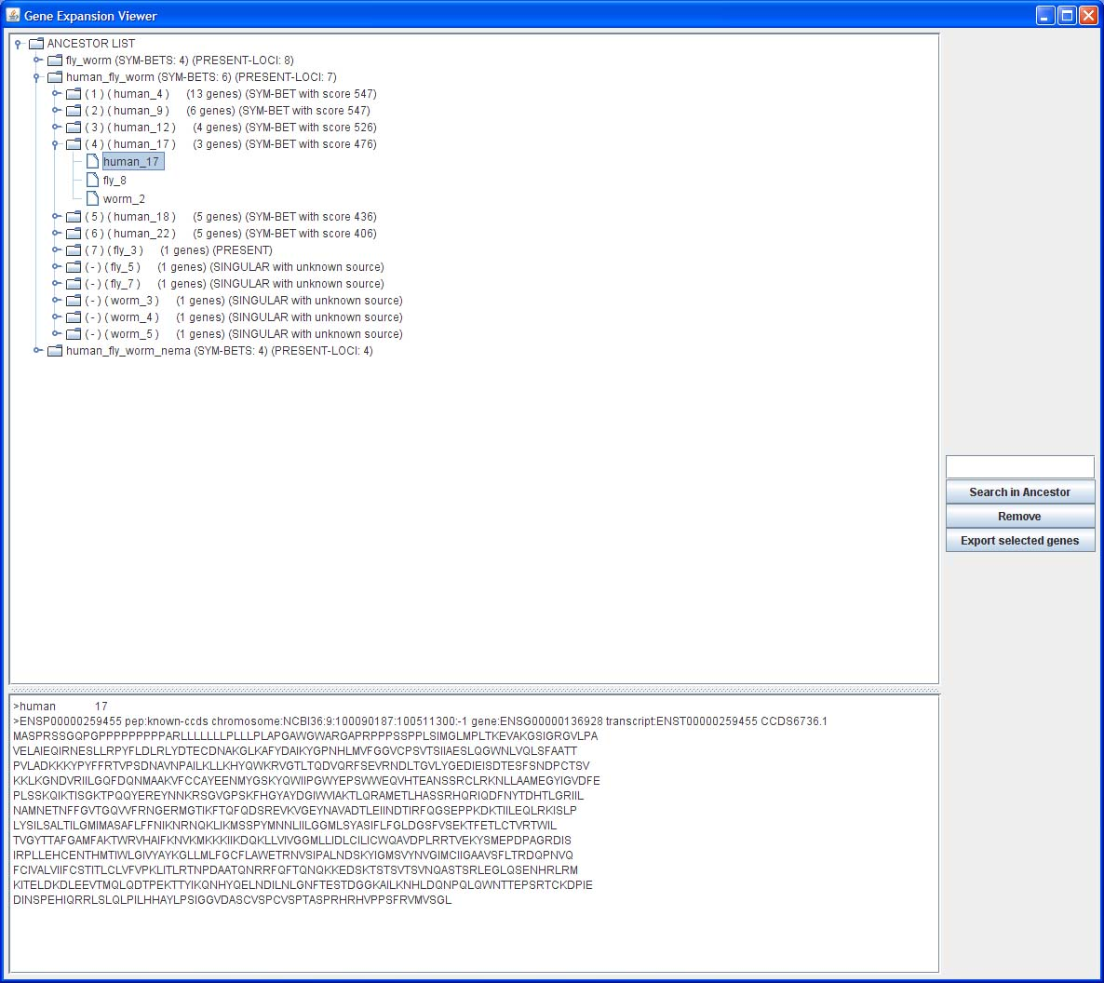
Figure 6. GUI: Ancestor display window.

- Algorithm and Implementation Details

EvolMAP is source code is freely available and works with JDK 1.5 and 1.6 (but not 1.4). The algorithm is described in the publication “Sakarya O, Kosik KS, Oakley TH. Reconstructing ancestral genome content based on symmetrical best alignments and Dollo parsimony, Bioinformatics, X”. It is an intuitive algorithm developed by bringing together simple bioinformatics and phylogenetics principles. Its implementation is optimized for best speed and memory efficiency to allow ancestral reconstructions of several proteomes. EvolMAP’s run-time is primarily bounded by the execution time of blastall which is fairly fast. On a decent desktop computer, blastall analyses of 100,000+ sequences might take a few days to finish, so the user should be ready to commit the processor time. We observed 2GB of virtual memory sufficient for analyses of up to 250,000 sequences. That is making best of 625 billion pairwise sequence comparisons with just 2 billion bytes of memory, which we believe is fairly good. For larger analyses, memory requirement is linearly proportional to the number of sequences.

a. All-to-all gene similarity matrix:
Algorithm first merges all sequences into a single fasta database, and runs an all-to-all BLAST analysis by calling blastall. BLAST takes a while to finish and then results from it are parsed to find top X most similar genes for each gene. X here is input by user, as described above. 250 is suggested for analysis of a set of closely related species. If it is expected that there may be ancestral genes that have more descendants than that number, increasing it may give better accuracy, but will require more run-time and memory. In the second step, a Needleman-Wunsch global optimal alignment with low gap extensions costs (this is like merged local optimal alignments, which we find highly accurate for measuring similarity between diverged multi-domain orthologous genes) is calculated for the most similar genes of each gene. At this step, if there are n sequences, then there will at most be n*X many alignments to be calculated. EvolMAP works for both nucleotide and amino-acid alignments, and uses a Blosum62 scoring matrix for quantifying amino-acid similarity. The matrix may be replaced by another as long as it is in the same format. Needleman-Wunsch alignments are normalized by dividing the alignment score by the maximum alignment score that could be obtained for those two sequences, and a Normalized Similarity Score (NSS) is generated for each gene pair. NSS scores are between 0 and 1 (1 being most similar), however since it is hard to fit all these scores in memory in floating format [score matrix is the bottle-neck for memory usage], it is multiplied by 1000 to obtain an integer representation of the score. At the end, a sparse similarity matrix is generated where there are X most similar genes and X similarity scores for each gene, and scores range from 0 to 1000. If BLAST is not used, then the similarity matrix is not sparse, and contains similarity of every pair of genes. Since that would be and n*n matrix, that type of analysis (although it is more accurate) could be feasible for domain-based analyses or small genomes only.

b. Phase 1 (detecting ancestral genes):
In this phase, traversing the species tree from descendants towards the root ancestor (Figure 7), the contents of each ancestral node is estimated by symmetrical best alignments (sym-bet). All data is stored in primitive arrays, non-redundantly and with an index structure which makes this phase pretty fast.
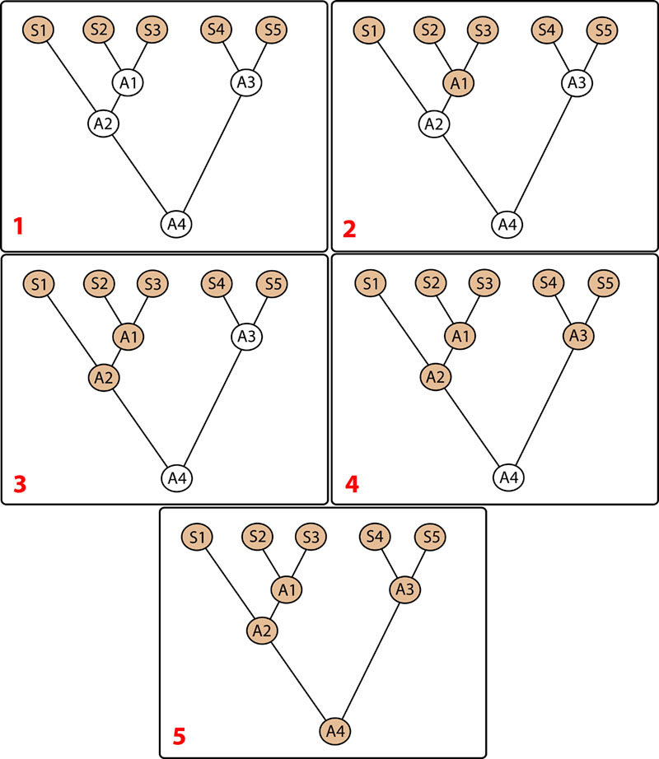
Figure 7: Post-order traversal of the species tree to find sym-bets and singulars of ancestral nodes.

For each ancestral node (in the order A1, A2, A3 and A4), ancestral genes or orthologous groups (sym-bets and their in-paralogs) and singular genes (genes that are neither sym-bets nor in-paralogs) are calculated. A sym-bet is defined as symmetrically best aligning gene from the other genome with an NSS score above a user-defined threshold. In-paralogs are defined as better scoring genes (than the sym-bet score) from the same genome. In-paralogs of in-paralogs are also detected and added to the same orthologous group. When finding similarity between ‘ancestral genes’, we use the average similarity of members of one gene (its already inferred descendants) with that of the other. Figure 8 displays a common case where a sym-bet, two in-paralogs and a singular gene are detected. Note that only the best scoring gene is displayed for S1-g3.

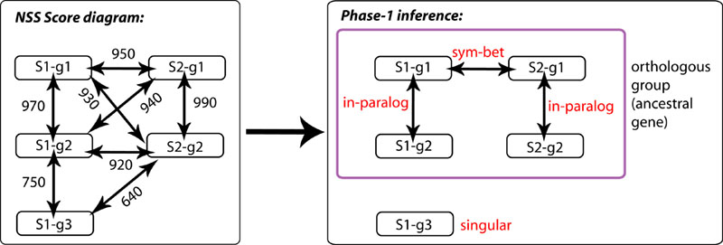
Figure 8: Detection of sym-bets, in-paralogs and singular genes.

Phase 1 completes when orthologous groups and singulars are found for each ancestral node of the tree.
c. Phase 2 (detecting gene gains & losses):

In the second phase, algorithm improves the estimations on composition of ancestral genomes, and maps the gene duplication and loss events onto the branches of the species tree using the Dollo parsimony model.

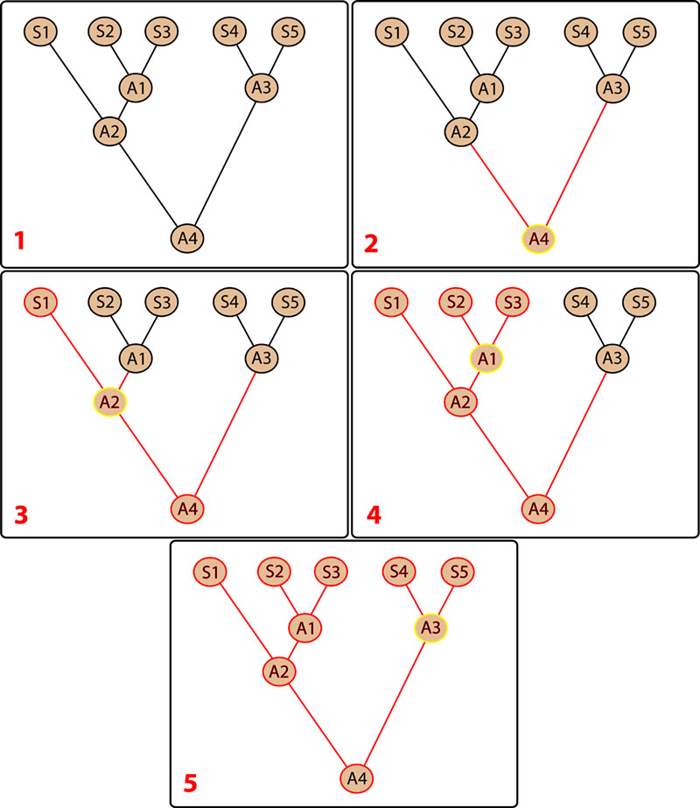
Figure 9: Pre-order traversal of the species tree to find gene gains and losses.
Dollo parsimony basically assumes that a probability of a loss is much greater than that of a gain. It is a fast and accurate model for inferring ancestral genes. Two limitations are that it does not consider horizontal gene transfers or convergent evolution. This phase is essentially a pre-order traversal of the tree (root to descendants) and flow is as shown in Figure 9. At each ancestral node, for each of its sym-bets and singular genes, we ask the following questions:
For singular genes: is this gene found as a sym-bet in any of the earlier ancestors? If so, does that sym-bet include any members of the current descent missing the gene? If it doesn’t it is a gene loss. Figure 10 explains this situation. Otherwise, if it does (i.e. sym-bet includes members from the descent missing the gene), then if this singular is a sym-bet in the descendant containing the gene, this is a diverged in-paralog. Figure 11 shows an example of that situation.
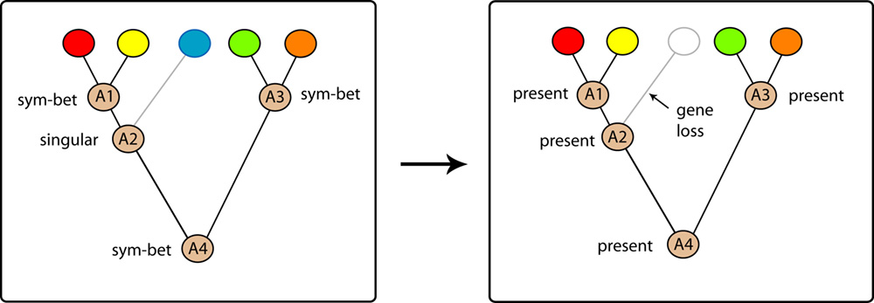
Figure 10. Detection of a Gene loss

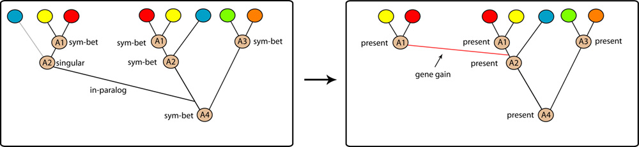
Figure 11. Detection of a gene gain: Diverged Inparalogs

For sym-bets and modern genes: Is this gene an in-paralog of a sym-bet in the immediate early ancestor? If it is, then it is simply present in this genome and is an in-paralog gained at the incoming branch. Otherwise, is it a singular gene in all earlier ancestors? Since all earlier ancestral singular genes are already checked whether they are present or not, there is no ambiguity. If it is, then this gene is gained at the incoming branch. If it is sufficiently similar (scores above user defined statistical threshold, explained in options section) to a sym-bet of this genome, then it will be classified as a diverged in-paralog (Figure 12), if not it is classified as an ambiguously gained gene.

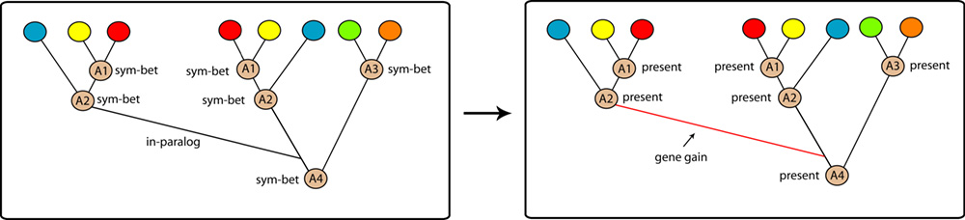
Figure 12: Detection of a gene gain: In-paralogs

