Name :Osama mohammed alsuwaydani

ID: 412112427

|  |  |  |
| --- | --- | --- |
| **CS471 – Web Technologies**  **(Laboratory)** |  | **Lab Week 2** |
| **The Internet Protocols** |

This lab session covers the usage of the Wireshark application to monitor and capture the outgoing and incoming packets from a network connection (WIFI, ethernet, etc.). Specifically, students should be able to analyze HTTP, HTTPS, TCP/IP, and UDP protocols using Wireshark, a network protocol analyzer, and draw conclusions.

**Pre-lab Preparation:**

1. Review the basics and the structure of HTTP, TCP/IP, and UDP protocols,
2. Install Wireshark and ensure it is running on your computer,
3. Create an online, *publically accessible* Git repository to host and upload your work in the labs. We recommend you use GitHub or GitLab.

**Lab Activities:**

**Part 1: Capturing HTTP Traffic.**

**Task 1: Start Wireshark and capture packets.**

Step 1: Open Wireshark.

Step 2: Select the network interface connected to the internet (e.g., Ethernet or Wi-Fi).

Step 3: Click the "Start Capturing Packets" button (the shark fin icon).

Step 4: Open your favorite web browser and navigate to [(https://qu.edu.sa)](https://qu.edu.sa/) website.

Step 5: After the website has fully loaded, stop capturing packets by clicking the red stop button in Wireshark.

**Task 2: Filter HTTP packets and analyze them.**

Step 1: In the filter bar, type http and press Enter. This filters out only the HTTP packets from the capture.

Step 2: Select any HTTP packet to view its details.

Step 3: Observe the HTTP request and response messages. Note the method (GET, POST), URL, response codes (200 OK, 404 Not Found), etc.

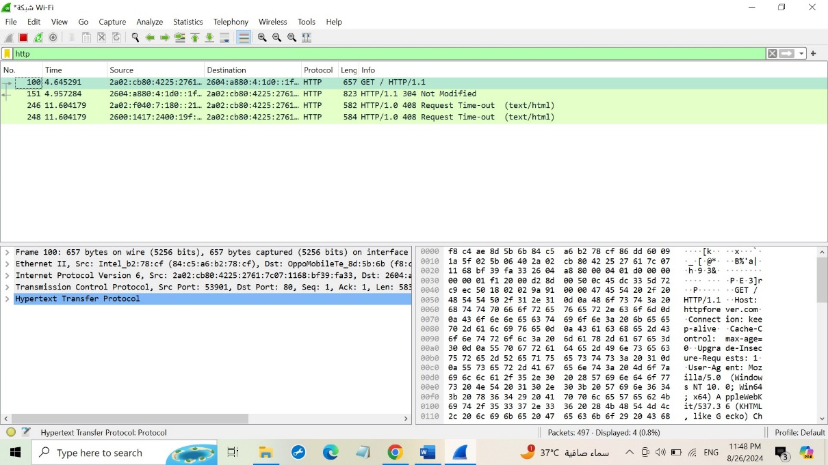

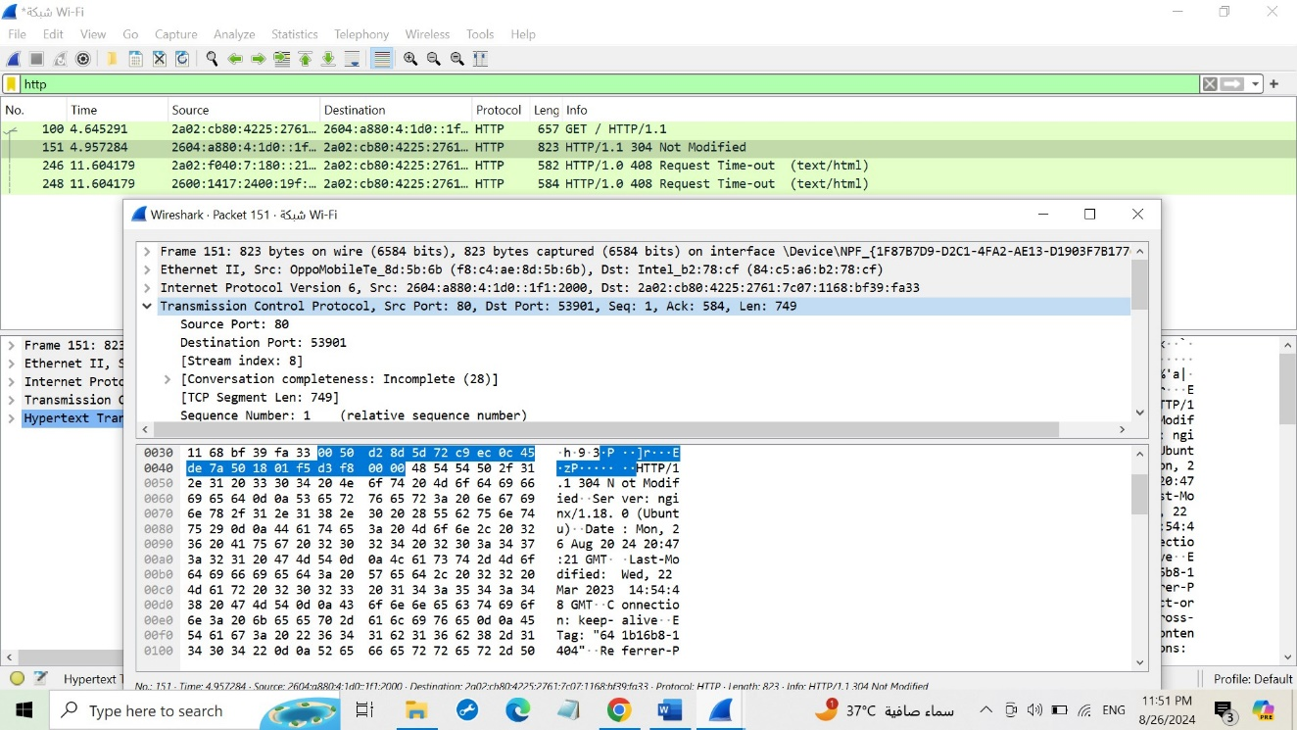

**Part 2: Analyzing TCP/IP Traffic.**

**Task 1: Filter TCP packets**

**Step 1:** Clear the previous filter and type TCP to focus on TCP packets.

**Step 2:** Select a TCP packet related to your HTTP request/response.

**Step 3:** Right-click on the packet and select "Follow" -> "TCP Stream".

**Step 4:** This shows the entire conversation between the client and server.

**Task 2: Analyze TCP handshake and investigate Data Transfer and Termination** **Step 1:** Find and select packets related to the TCP three-way handshake: o SYN: Initiates a connection.

o SYN-ACK: Acknowledges and responds to the SYN.

o ACK: Acknowledges the SYN-ACK and establishes the connection.

**Step 2:** Note the sequence and acknowledgment numbers. Screenshot and upload your image to your online git repository.

**Step 3:** Observe the data packets exchanged between the client and server. Take a screenshot and upload it to your online git repo.

**Step 4:** Look at the TCP termination process (FIN, ACK packets).

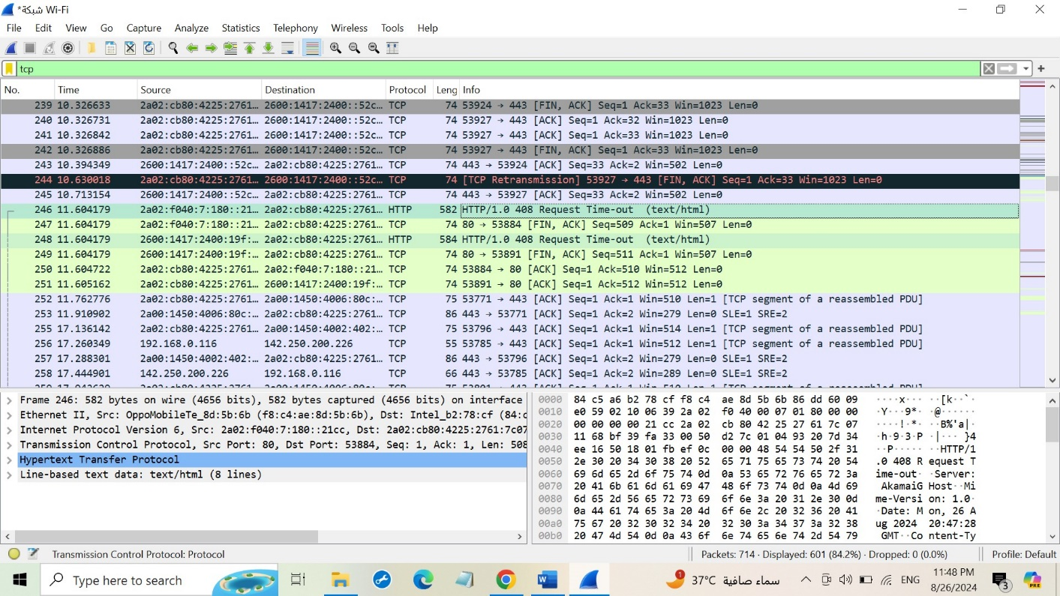

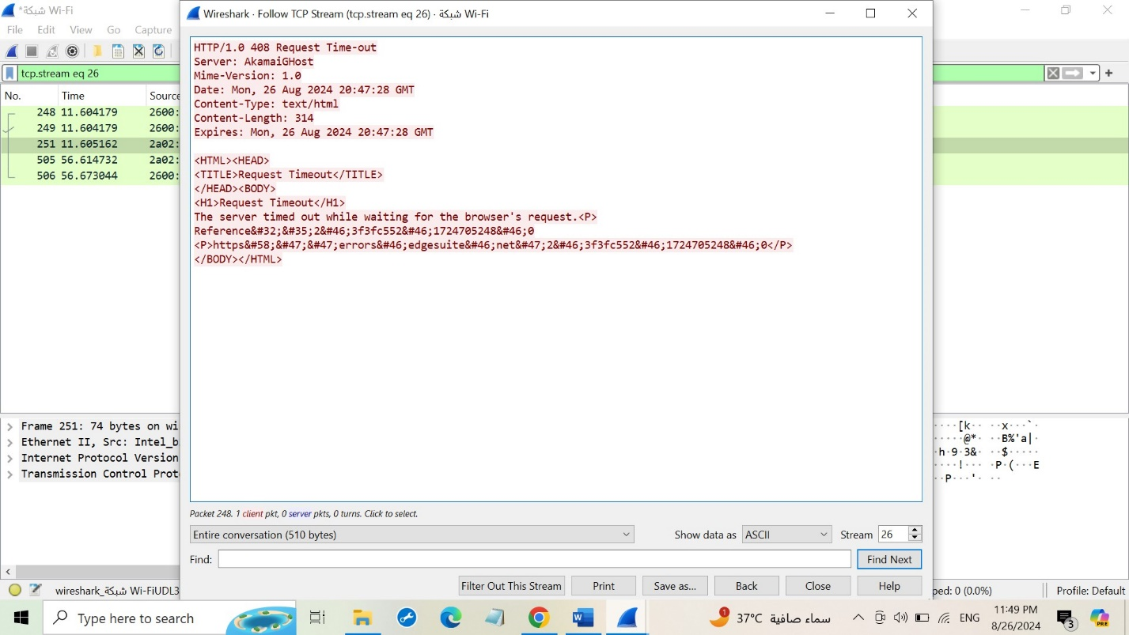

Page 1 of 2

|  |  |  |
| --- | --- | --- |
| **CS471 – Web Technologies**  **(Laboratory)** |  | **Lab Week 2** |
| **The Internet Protocols** |

**Part 3: Capturing and Analyzing UDP Traffic**

**Task 1: Generate UDP traffic and capture packets**

**Step 1:** Open a network application that uses UDP (e.g., streaming video, VoIP software, or custom script).

**Step 2:** Start the application to generate UDP traffic.

**Step 3:** Start capturing packets in Wireshark while the UDP application is running. **Step 4:** After sufficient traffic is generated, stop capturing packets.

**Task 2: Filter and analysis UDP Packets**

**Step 1:** In the filter bar, type UDP and press Enter.

**Step 2:** This filters out only the UDP packets from the capture.

**Step 3:** Select any UDP packet to view its details.

**Step 4:** Observe the source and destination ports, length, and data. **Step 5:** Compare the simplicity of UDP headers with TCP headers.

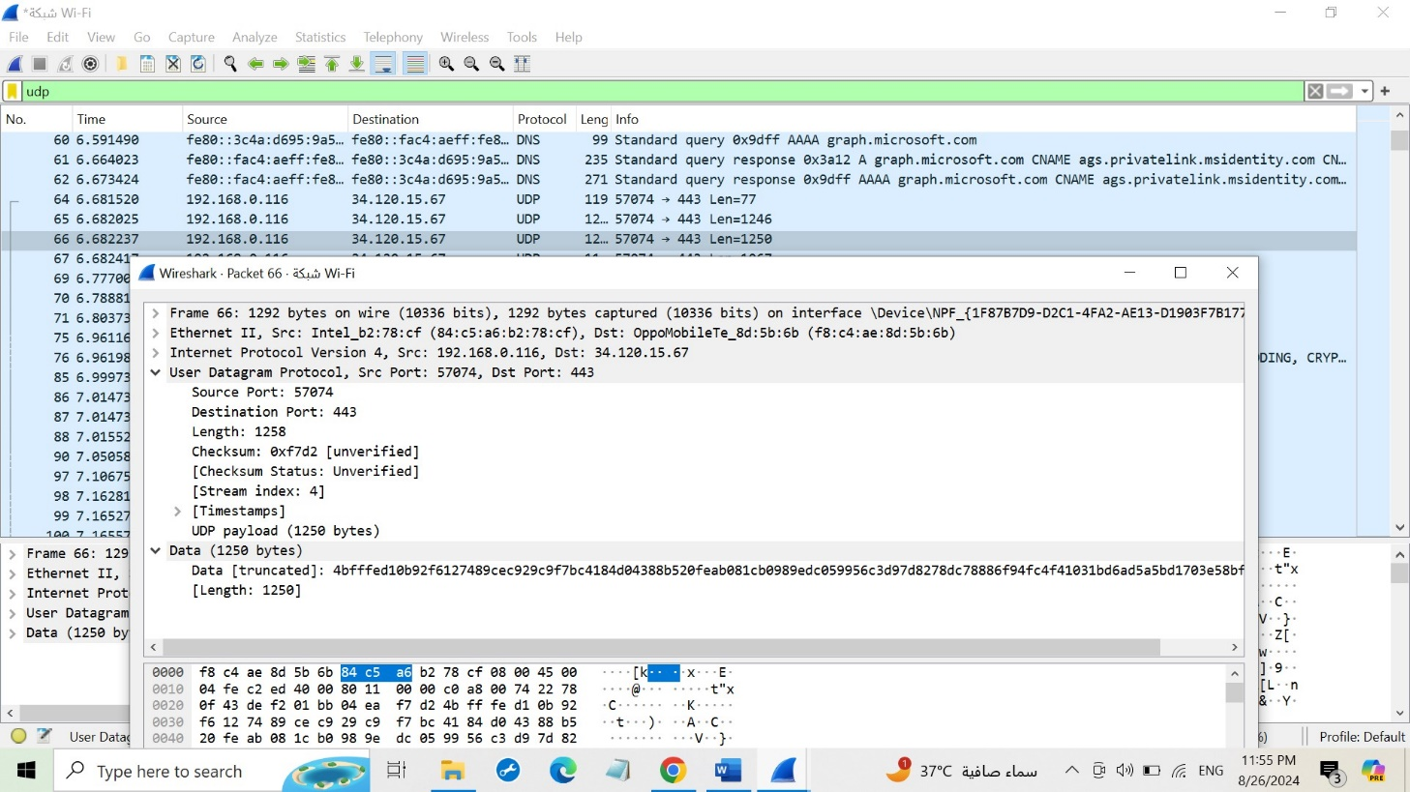

**Part 4: Comparing TCP and UDP by filling in the following tables. Save your work (e.g., in an MS Word document), and upload it to your online git repo.**

**Task 1: Fill in the following table and provide reasons.**

|  |  |  |
| --- | --- | --- |
|  | **TCP or UDP** | **Reasons** |
| Reliability and Connection Establishment | TCP | Reliability: TCP includes mechanisms like acknowledgments, retransmissions, and timeouts.  Connection Establishment: TCP uses a three-way handshake (SYN, SYN-ACK, ACK) to establish a connection. UDP sends data without prior arrangements. |
| Data Integrity and Ordering | TCP | Data Integrity : TCP uses error-checking mechanisms and retransmissions for corrupted data. UDP uses a simple checksum.  Data Ordering: TCP ensures that data arrives in the order it was sent. UDP may deliver packets out of order. |

**Task 2: Identify the use Cases and Performance of TCP and UDP.**

|  |  |  |
| --- | --- | --- |
|  | **TCP** | **UDP** |
| Use cases | * File transfers: TCP ensures reliable delivery of data, making it suitable for transferring large files without errors. * Web browsing: TCP establishes a reliable connection between the client and web server, ensuring that web pages are downloaded correctly. * Email: TCP guarantees the delivery of emails, preventing data loss and ensuring that messages are received intact. * Remote login | * Streaming media: UDP is used for streaming audio and video because it can deliver data in real-time without significant delays. * Online gaming: UDP is preferred for online games due to its low latency and ability to handle packet loss, which is often acceptable in gaming environments. * DNS (Domain Name System): UDP is used for DNS queries due to its speed and efficiency. * Network monitoring: UDP is used for network monitoring tools because it can quickly send and receive packets without establishing a connection. |
| Performance | * Slower: TCP's reliability mechanisms, such as flow control and error correction, can introduce latency and overhead, making it slower than UDP. * Heavier: TCP requires more system resources due to its complex mechanisms, which can impact performance in resource-constrained environments | * Faster: UDP is faster than TCP because it doesn't establish a connection or implement complex reliability mechanisms. * Lighter: UDP requires fewer system resources than TCP, making it suitable for resource-constrained environments. |

Page 2 of 2