UART_Clock_Generator

The following is a breakdown of my implementation of the different modules for the UART_Clock_generator, as well as corresponding verification tests.

**Module 1:** Divide_by_13

For verification, I simply recreated the waveforms from the book.

The source file is: divideby13.v, and the testbench is divideby13_tb.v

**Module 2:** Divide_by_8

For verification, I simply recreated the waveforms similar to Module 1. The output “clock_by_8” is high when the internal counter variable asserts a value of 7 (in line with clk_1 from the previous code).

The source file is: divideby8.v, and the testbench is divideby8_tb.v

**Module 3:** Divide_by_256

For verification, I simply recreated the waveforms similar to Module 1. The output “clock_by_256” is high when the internal counter variable asserts a value of 255 (again, in line with clk_1 from the previous code), as shown in the attached waveform.

The source file is: divideby256.v, and the testbench is divideby256_tb.v



The 8-bit counter is exposed as an output since it has to be used as an input to the multiplexer for the UART_Clock_Generator module.

**Module 4:** 8 to 1 multiplexer

The source file is: 8to1mux.v, and the testbench is 8to1mux _tb.v

For testing, I initialize each of the 8 inputs randomly, cycle through the select pins, and assert the correct output. I also implemented error monitoring, watchdog signals, as well as self-reporting in my testbench. The testbench executes with 0 errors.

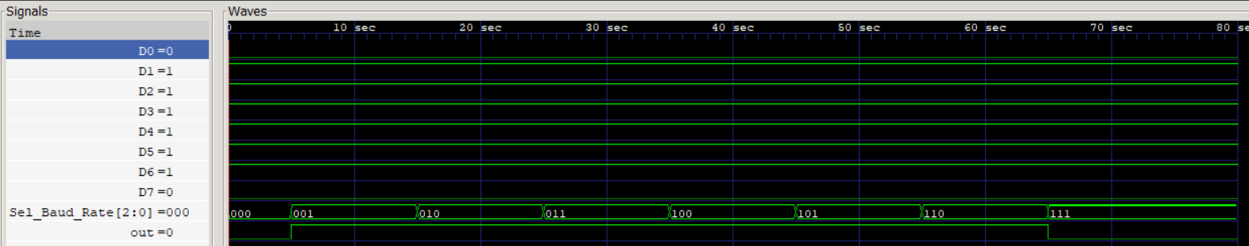

The waveform shows that the inputs are indeed correctly multiplexed on the out pin, based on the 3-bit Sel_Baud_Rate input pin.

Overall Module: UART_Clock_Generator