 | 


Developing a Centralized Role Based Event Coordination Platform for Multi Departments University Workflow Management.

By
Osamah Ahmed Mohammed Al-Naggar
TP078781
APD3F2601CS

A report submitted in partial fulfilment of the requirements for the degree of
B.Sc. (Hons) Computer Science
at Asia Pacific University of Technology and Innovation.

Supervised by Mr. MUSTAFA OTHMAN
2nd Marker: Ms. AIDA RAIHANAH

DECLARATION OF THESIS CONFIDENTIALITY

Author’s full name: Osamah Ahmed Mohammed Al-Naggar
IC No./Passport No.: [IC No. / Passport No.]
Thesis/Project title: Developing a Centralized Role Based Event Coordination Platform for Multi Departments University Workflow Management

I declare that this thesis is classified as:
¨ CONFIDENTIAL
¨ RESTRICTED
þ OPEN ACCESS

I acknowledged that Asia Pacific University of Technology & Innovation (APU) reserves the right as follows:
- The thesis is the property of Asia Pacific University of Technology & Innovation (APU).
- The Library of Asia Pacific University of Technology & Innovation (APU) has the right to make copies for the purpose of research only.
- The Library has the right to make copies of the thesis for academic exchange.

Author’s Signature: | Osamah Ahmed Mohammed Al-Naggar
Date: | 1 September 2026
Supervisor’s Name: | Mr. Mustafa Othman
Date: | 1 September 2026
Signature: | [Signature]

LIBRARY CATALOGUING DETAILS
First Name: Osamah
Middle Name (only if applicable): Ahmed Mohammed
Last Name: Al-Naggar
Title of the Final Year Project / Dissertation / Thesis : Developing a Centralized Role Based Event Coordination Platform for Multi Departments University Workflow Management
Abstract : This project presents the design and development of a centralized, role-based event coordination platform aimed at addressing the inefficiencies inherent in manual and fragmented event management processes within academic institutions. The research problem that motivates this project is the absence of a structured digital infrastructure capable of managing multi-departmental coordination, resulting in communication breakdowns, task duplication, and lack of process transparency during event organization. To address this problem, a comprehensive investigation was conducted through a review of existing event management systems, analysis of similar works, and a study of relevant coordination and workflow management theories and technologies. The preliminary findings indicate that current systems fail to support independent departmental workflows within a unified platform, creating significant operational gaps. The proposed system resolves these gaps by providing a structured environment where a single event request is distributed across multiple departments simultaneously, each operating through its own independent approval and execution workflow. The outcome of the development stage is a fully functional platform, built with Angular, Flask, and a PostgreSQL database, that enhances institutional coordination efficiency, reduces manual overhead, and improves task accountability across all departments involved. The significance of this project lies in its direct contribution to SDG Goal 9: Industry, Innovation and Infrastructure, by establishing a resilient digital coordination infrastructure within the university while introducing process-level innovation through structured, role-based workflow management.
A few keywords associated with the work : Event Management, Role-Based System, Workflow Coordination, Departmental Collaboration, Digital Infrastructure, SDG 9
General Subject: Computer Science
Date of Submission : 1st September 2026

ACKNOWLEDGEMENT
I would like to express my sincere gratitude to all those who contributed to the completion of this report.

First and foremost, I would like to thank my supervisor, MUSTAFA OTHMAN, for his guidance, continuous support, and for giving me the opportunity to undertake this project. His direction throughout the semester has been invaluable in shaping the direction and quality of this work.

I would also like to extend my appreciation to AIDA RAIHANAH, second marker, for the time and effort that will be dedicated to reviewing and evaluating this report.

I am deeply grateful to my parents for their unwavering support, encouragement, and patience throughout this journey. Their belief in me has been a constant source of motivation.

Finally, I would like to thank my friends, Adel and Sohaib, for their companionship, encouragement, and for helping me carry the heavy weight of this semester throughout the academic year.

ABSTRACT
This project presents the design and development of a centralized, role-based event coordination platform aimed at addressing the inefficiencies inherent in manual and fragmented event management processes within academic institutions. The research problem that motivates this project is the absence of a structured digital infrastructure capable of managing multi-departmental coordination, resulting in communication breakdowns, task duplication, and lack of process transparency during event organization. To address this problem, a comprehensive investigation was conducted through a review of existing event management systems, analysis of similar works, and a study of relevant coordination and workflow management theories and technologies. The preliminary findings indicate that current systems fail to support independent departmental workflows within a unified platform, creating significant operational gaps. The proposed system resolves these gaps by providing a structured environment where a single event request is distributed across multiple departments simultaneously, each operating through its own independent approval and execution workflow. The outcome of the development stage is a fully functional platform, built with Angular, Flask, and a PostgreSQL database, that enhances institutional coordination efficiency, reduces manual overhead, and improves task accountability across all departments involved. The significance of this project lies in its direct contribution to SDG Goal 9: Industry, Innovation and Infrastructure, by establishing a resilient digital coordination infrastructure within the university while introducing process-level innovation through structured, role-based workflow management.

Keywords: Event Management, Role-Based System, Workflow Coordination, Departmental Collaboration, Digital Infrastructure, SDG 9

TABLE OF CONTENTS
ACKNOWLEDGEMENT 2
ABSTRACT 3
TABLE OF CONTENTS 4
LIST OF FIGURES 6
LIST OF TABLES 7
CHAPTER 1: INTRODUCTION 8
1.1 Introduction 8
1.2 Problem Background 9
1.2.1 The Core Problem: 9
1.2.2 Problem Statements 9
1.3 Project Aim 11
1.4 Objectives 11
1.5 Scope 12
1.6 Potential Benefits 15
1.7 Overview of the IR 17
1.8 Project Plan 19
CHAPTER 2: LITERATURE REVIEW 22
2.1 Introduction 22
2.2 Domain Research 22
2.2.1 Event Management in Academic Institutions 22
2.2.2 Multi-departments Coordination and Workflow Management 23
2.2.3 Role-Based Access Control (RBAC) in Information Systems 25
2.2.4 Centralized Digital Platforms for Institutional Operations 27
2.2.5 SDG Goal 9 and Digital Infrastructure in Higher Education 29
2.3 Similar Systems / Works 30
2.4 Technical Research 35
2.4.1 Hardware and Software Requirements 35
2.4.2 IDE — Visual Studio Code 36
2.4.3 Libraries and Tools 37
2.4.4 Database Management System — PostgreSQL (Supabase) 39
2.4.5 Operating System 40
2.4.6 Deployment and Hosting Environment 40
2.4.7 Web Browser — Chrome and Firefox 41
2.5 Summary 42
CHAPTER 3: METHODOLOGY 43
3.1 Introduction 43
3.2 Evaluation of Candidate Methodologies 43
3.2.1 The Waterfall Model (Sequential Development) 43
3.2.2 Agile Methodology (The Scrum Framework) 44
3.2.3 Rapid Application Development (RAD) 44
3.2.4 Hybrid Methodologies (Structured-Iterative Blends) 45
3.2.5 Comparative Analysis of Methodologies 47
3.4 Methodology Discussion (Pure vs Hybrid Approaches) 48
3.5 Selected methodology and Justification 48
3.6 Activities and Processes Within Each Phase 50
3.7 Data Gathering Design 51
3.7.1 Data Collection Method 51
3.7.2 Target Participants 51
3.7.3 Sample Size and Distribution 51
3.7.4 Survey Structure and Design 52
3.7.5 Considerations 53
3.7.6 Purpose of Data Collection 53
3.8 Analysis 54
3.8.1 Quantitative Data Presentation 54
3.8.2 Summary of Findings and Synthesis 66
3.9 Summary 67
CHAPTER 4: CONCLUSION 68
4.1 Achievements of the Investigation Stage 68
4.2 Justification of Investigation and SDG Alignment 69
4.3 Gaps in Research and Design — How the Proposed System Addresses Them 70
REFERENCE: 73
APPENDICES 78
Appendix A: Project Proposal Form (PPF) 78
Appendix B: Ethics Forms 79
Appendix C: Log Sheets 84
Appendix D: Gantt Chart 87
Appendix E: Respondent Demographic Profile 88
Appendix F: Turnitin Similarity Report 89

LIST OF FIGURES
Figure 1: Sequential vs Independent Departmental Workflo. 25
Figure 2: RBAC Hierarchy Model — Users, Roles, Permissions. 27
Figure 3: Centralized vs Fragmented Platform Architecture. 29
Figure 4: SDG Goal 9 and vision ISGlobal (n.d.). 31
Figure 5: Visual Studio Code logo WebCatalog (n.d.). 38
Figure 6: Angular logo Angular Press Kit (n.d.). 39
Figure 7: Flask logo Wikimedia Commons (n.d.). 40
Figure 8: PostgreSQL data access through Supabase 41
Figure 9: Deployment and hosting environment of the platform 42
Figure 10: Googe Chrome, Firefox Mozilla Firefox (n.d.); Be Connected (n.d.). 43
Figure 13: Participant Eligibility and Consent 56
Figure 14 : Age eDistribution of Survey Participants 56
Figure 15: Gender Distribution 57
Figure 16: Roles within the University The 57
Figure 17: Academic Year Representation 58
Figure 18: Frequency of Event Participation at APU 59
Figure 19: Current Methods for Handling Event Requests 59
Figure 20: Perceived Challenges in Event Planning 60
Figure 21: Clarity of the Existing Request Process 60
Figure 22: Overall Satisfaction with Current Coordination 61
Figure 23: Perceived Usefulness of a Centralized Platform 62
Figure 24: Likelihood of System Adoption 62
Figure 25: Belief in Problem Reduction via Digital System 63
Figure 26: Potential Impact on Event Frequency 64
Figure 27: Importance of Mobile Accessibility 64
Figure 28: Importance of Real-Time Notifications 65
Figure 29: Preference for Fully Online Management 66
Figure 30: User-Suggested Feature Enhancements 67
Figure 31: Proposal Form (PPF). 80
Figure 32: Proposal Form (PPF). 81
Figure 33: Ethics Forms — Nature of Research - part 1. 82
Figure 34: Ethics Forms — Nature of Research - part 2. 83
Figure 35: Ethics Forms — Target Participants. 84
Figure 36: Ethics Forms — Target Participants. 85
Figure 37: Log Sheets – meeting 1. 86
Figure 38: Log Sheets – meeting 2. 87
Figure 39: Log Sheets – meeting 3. 88
Figure 41: Gantt Chart – part 1. 89
Figure 43: Gantt Chart – part 2. 89

LIST OF TABLES
Table 1: PROJECT PLAN 19
Table 2: SIMILAR SYSTEM 31
Table 4 Comparative Analysis of Software Development Methodologies. 47
Table 5: Respondent Demographic Profile 88

CHAPTER 1: INTRODUCTION

1.1 Introduction
In contemporary academic institutions, the organization of events plays a vital role in fostering community engagement, academic collaboration, and institutional development. Managing such events, however, requires the coordinated effort of multiple departments, each responsible for a distinct set of services ranging from catering and logistics to audio-visual support and transportation. As universities grow in scale and the frequency of events increases, the demand for a structured, efficient, and transparent coordination mechanism becomes increasingly critical.
Currently, event coordination in many academic institutions relies on informal communication channels, manual request processes, and disconnected tools that are not purpose-built for multi-departmental collaboration. This results in recurring challenges such as miscommunication between departments, duplicated efforts, lack of real-time progress visibility, and an overall absence of accountability within the event management process.
This project proposes the development of a centralized, role-based event coordination platform designed for university-wide event management at Asia Pacific University of Technology and Innovation (APU). The platform enables an applicant to create a single structured event request that is automatically distributed to all relevant departments within the institution. These departments include Logistics and Facilities, Transport Services, Photography Services, A/V Services, Student Services, and Food and Beverage services. Each department operates through its own independent workflow, allowing it to review, approve, and execute assigned responsibilities without interference from other departments.
The platform is developed using Angular for the frontend, Flask with Python for the backend, and a PostgreSQL database hosted on Supabase. Beyond the internal coordination workflow, the platform also publishes approved events to a public-facing portal where members of the university and invited external guests can discover and register for events, and it includes an AI assistant that answers questions about events and requests within the boundaries of each user's own access rights. This project directly contributes to SDG Goal 9: Industry, Innovation and Infrastructure by establishing a resilient digital coordination infrastructure within the university.

1.2 Problem Background

1.2.1 The Core Problem:
Event coordination within academic institutions requires the continuous exchange of information, task follow-up, and collaboration among multiple departments. However, when coordination relies on informal communication channels, manual request processes, and direct interactions, the workflow becomes fragmented and difficult to manage. Such fragmentation disrupts communication flow, increases task-switching, and reduces overall efficiency, as activities are handled across multiple unstructured channels instead of within a unified system (Moy et al., 2023).
This situation is further intensified by the absence of a centralized system that integrates communication, tracking, and data management. Without centralization, event-related actions, approvals, and updates are not consistently recorded, resulting in limited visibility and weak transparency. Consequently, event coordinator faces difficulties in monitoring progress, ensuring accountability, and analyzing performance. Prior studies highlight that the lack of integrated data systems restricts the ability to generate meaningful insights and support informed decision-making, ultimately weakening operational effectiveness (Matheus et al., 2020; Khan et al., 2022).

1.2.2 Problem Statements
The following problem statements highlight critical limitations in current event coordination practices. These issues contribute to inefficiencies and operational challenges in event management.

1.2.2.1 Fragmentation of Communication and Coordination Processes
The use of multiple disconnected communication channels, including messaging applications, phone calls, and verbal instructions, leads to fragmented coordination processes. Information becomes scattered across different platforms rather than being maintained within a centralized system, increasing the risk of miscommunication, missed requests, and inconsistencies in execution. This aligns with findings that workflow fragmentation significantly disrupts communication and coordination efficiency (Moy et al., 2023).

1.2.2.2 Inefficiency and Delays in Event Preparation Workflows
Manual and sequential handling of event requests limits the ability to process tasks concurrently, resulting in delays in event preparation. relevant parties involved in event coordination often depend on prior confirmations before proceeding, which slows down workflow execution. Research indicates that fragmented and non-integrated workflows contribute to inefficiencies and delays due to increased task dependency and interruptions (Moy et al., 2023).

1.2.2.3 Lack of Role Clarity, Structured Processes, and Guided Workflow Execution
The absence of structured digital workflows and clearly defined roles creates ambiguity in task responsibilities. Without a guided process, relevant parties involved in event coordination may duplicate tasks or overlook essential responsibilities, leading to coordination errors. Studies on fragmented workflows emphasize that lack of structured processes increases operational complexity and reduces workflow consistency (Moy et al., 2023).

1.2.2.4 Weak Accountability and Lack of Transparency in Task Ownership and Decision-Making
In manual coordination environments, approvals, actions, and task ownership are often not systematically recorded. This lack of traceability reduces transparency and weakens accountability, making it difficult to identify responsibility for decisions or delays. Research shows that systems lacking traceability and structured data records negatively impact transparency and accountability in organizational processes (Khan et al., 2022; Matheus et al., 2020).

1.2.2.5 Limited Data Availability, Insights, and Analytical Capabilities for Decision-Making
The absence of centralized data collection and analytical tools limits the ability to monitor event progress and evaluate performance. Without access to real-time data and historical insights, stakeholders cannot make informed decisions or identify areas for improvement. Prior studies highlight that data-driven systems and dashboards are essential for generating insights and supporting effective decision-making (Matheus et al., 2020).

1.3 Project Aim
To develop a centralized, role-based event coordination platform using Angular, Flask, and PostgreSQL to be employed in university-wide multi-departmental event management at Asia Pacific University of Technology and Innovation (APU).

1.4 Objectives
- To reduce the complexity and difficulty of managing university events by replacing manual, disconnected communication channels including WhatsApp, phone, and verbal instructions. and implement structured digital coordination system.
- To improve efficiency and reduce delays in event preparation by enabling simultaneous request distribution and independent processing by different departments.
- To minimize task duplication and miscommunication by clearly defining responsibilities and ensuring that each department only handles tasks relevant to its role.
- To strengthen accountability across departments by maintaining a clear record of approvals, actions taken, and task ownership throughout the event lifecycle.
- To support data-driven decision-making in event coordination through the implementation of a dashboard that visualizes key analytics related to event activities and user engagement.

1.5 Scope
This section defines the boundaries of the proposed system by clearly outlining its functionalities and limitations. It helps to clarify what the system is intended to achieve within the project and ensures that the development remains focused on the defined objectives without extending beyond its intended context.
What will be included:
The proposed system focuses on the development of a centralized, role-based event coordination platform specifically designed for Asia Pacific University (APU). The system is tailored to align with the institution’s internal operational structure, ensuring that all event coordination activities are managed within a unified and controlled digital environment.

- End-to-End Event Coordination Lifecycle: The system supports the complete lifecycle of event coordination, starting from event creation and submission by the applicant, who may be a student, lecturer, or staff member. Once an event is created, it is automatically distributed to the relevant departments for processing. Each department operates through an independent approval workflow, ensuring that decisions are made according to their internal procedures. The system also supports revision and resubmission handling, allowing requested changes to be tracked and managed within the same workflow. Additionally, tasks can be assigned and executed by department staff, while real-time progress tracking ensures visibility across all ongoing activities. All completed events are stored in a structured event history log for future reference and analysis. Approved events may also be published to the university's event portal, so that the lifecycle continues beyond internal task completion into event announcement, attendance registration, and post-event records.

- Support for Multiple University Departments: The system is designed to accommodate multiple operational departments within APU, each department is responsible for handling its own domain-specific tasks, ensuring clear separation of responsibilities and reducing operational overlap. This separation ensures that each department operates within clearly defined boundaries, which minimizes confusion in task ownership and prevents duplication of work. By structuring departmental involvement in a centralized platform, coordination between departments becomes more systematic and traceable, improving overall operational alignment during event execution. The routed service departments are Logistics and Facilities, Transport Services, Photography Services, A/V Services, and Student Services. Food and Beverage requirements are routed separately according to role, while funding and purchase requirements are captured on the request for financial review rather than routed to a service department.

- Role-Based Access Control: The system implements twelve distinct user roles: Student, Lecturer, Staff, Head of School, Head of Department, CFO, Cafeteria Admin, Cafeteria Manager, Cafeteria Staff, Club Admin, System Admin, and External User. Roles are not held globally but are assigned per organisational unit, so the same person may carry different responsibilities in different departments. The pages each role can reach are controlled through configurable access grants rather than being fixed in the interface, allowing an administrator to adjust visibility without changing the system itself. This role-based structure is essential for maintaining system security, preventing unauthorized actions, and ensuring that each user interacts only with functions relevant to their responsibilities. It also strengthens workflow governance by clearly defining decision-making authority at each level of the system.

- Flexible Task Handling Mechanism: Once a department approves its part of a request, the Head of Department assigns the resulting tasks to individual staff members. Assignment is made for each individual requirement rather than for the request as a whole, so several staff members may work on the same request at once, while requirements that can only be handled by one person are limited to a single assignee. This flexibility allows departments to adapt task execution based on workload and operational needs. It also improves resource utilisation by allowing work to be distributed according to urgency, complexity, and staff availability, ensuring more efficient task completion and workload balancing.

- Responsive Web Accessibility: The platform is designed as a web-based system that is fully responsive across desktop and mobile devices. This ensures accessibility without requiring installation of native applications. By supporting multiple device types, the system enhances usability and ensures that users can access the platform anytime and anywhere. This is particularly important in even coordination scenarios where real-time updates and rapid response are required, enabling continuous interaction with the system regardless of device constraints.

- Public Event Portal and Registration: Approved events may be published to a portal where members of the university, and external guests holding a self-registered account, can browse and search events, view an event calendar, save events of interest, and register to attend. Registrations are approved by the organiser, and attendees may choose which reminders they wish to receive.

- Club Management: The system maintains a directory of university clubs organised by category, together with club membership, join requests with approval or rejection, requests to change a club president, and the activation or deactivation of a club. Club records are managed by a dedicated Club Admin role.

- Cafeteria and Food & Beverage Operations: Cafeteria outlets are managed within the system, including the assignment of managers and staff, menu and pricing management, orders generated from approved food and beverage selections on event requests, and the tracking of those orders through preparation to fulfilment.

- Venue and Catalogue Management: Venues and the selectable options used across request forms are maintained as managed catalogues rather than free text, so that requests are built from controlled and consistent data and reporting remains reliable.

- Automated Email Notification: The system sends email notifications at each decision point in the workflow, together with scheduled reminders for upcoming events and escalation notices when an approval is running late relative to the event date.

- Role-Based Analytics Dashboards: Dashboards are provided for departments, cafeterias, the Food and Beverage unit, and the CFO, each presenting the measures relevant to that role across areas such as demand, capacity, workflow progress, timeliness, and cost. Panels can be filtered and exported for reporting purposes.

- AI Assistant: An assistant built into the platform answers questions about the system and about the user's own records in ordinary language. Every answer is restricted to information the user is already permitted to see, and all interactions are recorded so that administrators can review how the assistant is used.

- System Administration and Configuration: Administrators manage users, organisational units, and role assignments, control which pages each role can reach, maintain the option catalogues used on request forms, and configure institutional policies. Deleted records are retained for a recovery period during which they may be restored before permanent removal.

- Security Controls: Access to the system is protected by token-based authentication with rotating sessions, hashed passwords, controlled registration, and request rate limiting. Every permission decision is made by the server rather than the browser, so the interface cannot be used to obtain access that the user has not been granted.

What Will Not Be Included:
- Financial and Budget Management: The system does not include payment processing, invoicing, or the reconciliation of expenditure against an institutional budget, as the focus is on coordination workflows. Cost information for requested items is captured on the request, and requests above a configurable attendance threshold are routed to the CFO for financial approval, but the movement and reconciliation of money remain the responsibility of separate institutional financial systems. By narrowing the scope in this way, the system avoids unnecessary complexity and maintains a clear focus on event coordination processes.
- Multi-Institution Deployment: The platform is designed exclusively for APU and will not be extended to other universities or external institutions. This decision ensures that the system is highly customized to APU’s internal workflows, policies, and operational structure. By limiting deployment to a single institution, the system can be optimized for specific requirements rather than generalized for multiple environments.
- External System Integration: Integration with third-party platforms or existing university management systems is not included in the current implementation. However, it may be considered in future development phases depending on institutional requirements. This limitation ensures that the current system remains focused on core functionality while maintaining flexibility for potential scalability and future enhancements.
- Native Mobile Applications: The platform is delivered as a responsive web application accessed through a browser. No separate Android or iOS application is developed, as browser access already covers the required devices without the additional overhead of maintaining native clients.

1.6 Potential Benefits
The implementation of a centralized event coordination platform is expected to deliver both operational and organizational improvements by replacing fragmented manual processes with a structured digital workflow system. This section explains the advantages of the proposed system by presenting the expected improvements in event coordination practices, which are categorized into tangible and intangible benefits to distinguish measurable outcomes from qualitative organizational impacts.
Tangible Benefits:
- Reduced Coordination Time: The system reduces coordination time by replacing fragmented communication channels such as email, phone calls, and verbal instructions with a centralized workflow system. This eliminates repeated follow-ups and ensures that event requests are processed efficiently through a structured digital pipeline. As a result, coordination becomes faster and more streamlined, reducing delays caused by manual communication dependencies and improving overall event preparation efficiency.

- Structured Approval Tracking: Every event request follows a clearly defined approval workflow where all decisions, status changes, and actions are recorded. This creates an auditable trail that improves transparency and ensures that approval processes are consistently followed across departments. The presence of structured tracking also reduces uncertainty in decision-making and allows stakeholders to clearly understand the progress and status of each request.
Reduced Task Duplication: Role-based access control ensures that users only interact with tasks relevant to their assigned responsibilities. This prevents overlapping work and reduces redundancy in task execution, improving overall operational efficiency. By clearly defining task ownership within the system, duplication of effort is minimized and workflow execution becomes more organized and controlled.

- Centralized Event History: All completed events and their associated workflows are stored in a centralized system database. This allows the institution to maintain structured historical records, which can be used for future planning and reference. The availability of historical data also supports institutional learning by enabling analysis of past events to improve future coordination strategies.

- Faster Issue Resolution: The system includes a revision and feedback loop mechanism that allows departments to flag issues and resubmit requests with clear explanations. This structured approach reduces delays in resolving operational problems by ensuring that feedback is handled within the same system workflow rather than through external communication channels. As a result, issue resolution becomes more efficient and traceable.

- Automated Notification and Reminders: Decisions, task assignments, and upcoming deadlines are communicated automatically by email, removing the need for manual follow-up messages and ensuring that the person responsible for the next step is informed as soon as it becomes theirs.

- Reporting and Analytical Output: Role-based dashboards convert the records held in the system into measures that each unit can act on, and any panel can be exported for use in institutional reporting, so that coordination data becomes a planning resource rather than an administrative by-product.

- Faster Access to Information: The AI assistant allows users to obtain answers about their own events, requests, and tasks by asking in ordinary language, reducing the time spent locating information across different screens while keeping every answer within the user's existing access rights.

- Wider Event Reach and Attendance Visibility: Publishing approved events to a shared portal gives the university a single place where events are announced and attendance is registered, improving visibility of what is taking place on campus and giving organisers an accurate picture of expected attendance.
Intangible Benefits:
- Improved Departmental Accountability: By recording all actions, approvals, and task assignments within the system, each department develops a stronger sense of responsibility. This traceability ensures that accountability is clearly defined and enforceable, reducing ambiguity in task ownership and improving discipline in task execution across departments.

- Enhanced Inter-Departmental Trust: Transparent workflows allow departments to view the progress of interdependent tasks, reducing miscommunication and operational uncertainty. This visibility fosters trust and improves collaboration between departments as all stakeholders operate within a shared and observable system environment, reducing reliance on informal communication.

- Better Staff Experience: The system provides a simplified and structured interface that displays only relevant tasks to each user. This reduces confusion and improves efficiency by allowing staff to focus solely on their assigned responsibilities. As a result, cognitive load is reduced and users can perform their tasks more effectively without being overwhelmed by unnecessary information.

- Institutional Professionalism: The adoption of a structured digital coordination system enhances the institution’s operational maturity and reflects a more professional and organized approach to event management. This modernization of workflow practices demonstrates improved governance and aligns with contemporary digital transformation standards in higher education institutions.

- Alignment with SDG Goal 9: The system contributes to Sustainable Development Goal 9 by promoting innovation and improving institutional infrastructure through digital transformation in event coordination processes. This alignment demonstrates the project’s contribution to building resilient and efficient institutional systems that support sustainable technological development

1.7 Overview of the Report
This report is structured into six chapters, each designed to systematically present the research, analysis, design, implementation and evaluation of the centralized event coordination platform developed for APU.
Chapter 1 — Introduction
Chapter 1 introduces the overall context of the project, including the domain of event coordination within academic institutions. It presents the problem background supported by academic literature and defines the project aim, objectives, scope, and potential benefits. This chapter also provides an overview of the report structure and outlines the overall project direction.

Chapter 2 — Literature Review
Chapter 2 focuses on domain research across multiple relevant areas related to event management systems. It includes a comparative analysis of existing systems to identify limitations and gaps in current solutions. Additionally, it provides technical justification for the selected technologies and frameworks used in system development.

Chapter 3 — Methodology
Chapter 3 outlines the selected Waterfall-Agile Hybrid with Evolutionary Prototyping development methodology and provides justification for its suitability. It also details the survey-based data collection approach and presents the quantitative analysis of responses from 30 APU students and staff members.
Chapter 4 — Conclusion
Chapter 4 documents the design and implementation of the delivered system. It presents the system architecture, the security and identity model, the use case, activity and sequence models, the database design and data dictionary, the interface design, screenshots of every implemented screen with discussion, and annotated extracts of the source code.
Chapter 5 — Results and Discussions
Chapter 5 presents the testing carried out on the delivered system. It sets out the test plan, the unit test cases designed against the individual programs of the system and the user acceptance testing conducted with representative users, and it discusses the results obtained, the defects identified and the corrections applied.
Chapter 6 — Conclusion
Chapter 6 concludes the project. It critically evaluates what was achieved against the objectives stated in Chapter 1, states the contribution of the project and its strengths, sets out the limitations of the delivered system honestly, and recommends the directions in which the work should be taken forward.
The four chapters above describe the structure of this Investigation Report. The complete Final Year Project documentation continues from this foundation into system design and implementation, testing and evaluation of the delivered platform, and a final conclusion reflecting on the outcome against the objectives stated in this report.

1.8 Project Plan
Table 1: PROJECT PLAN
Task | Duration | Start Date | End Date | Status
1. Project Proposal Form | 2 Days | 09 Feb 2026 | 10 Feb 2026 | Completed
1.1 Introduction | 1 Day | 09 Feb 2026 | 09 Feb 2026 | Completed
1.2 Problem Background | 1 Day | 10 Feb 2026 | 10 Feb 2026 | Completed
1.2.1 The Core Problem | 1 Day | 10 Feb 2026 | 10 Feb 2026 | Completed
1.2.2 Problem Statements | 1 Day | 10 Feb 2026 | 10 Feb 2026 | Completed
1.3 Project Aim | 1 Day | 11 Feb 2026 | 11 Feb 2026 | Completed
1.4 Objectives | 1 Day | 11 Feb 2026 | 11 Feb 2026 | Completed
1.5 Scope | 1 Day | 12 Feb 2026 | 12 Feb 2026 | Completed
1.6 Potential Benefits | 1 Day | 13 Feb 2026 | 13 Feb 2026 | Completed
1.7 Overview of IR | 2 Days | 16 Feb 2026 | 17 Feb 2026 | Completed
1.8 Project Plan | 1 Day | 17 Feb 2026 | 17 Feb 2026 | Completed
2. Chapter 2 | 11 Days | 18 Feb 2026 | 28 Feb 2026 | Completed
2.1 Introduction | 1 Day | 18 Feb 2026 | 18 Feb 2026 | Completed
2.2 Domain Research | 4 Days | 19 Feb 2026 | 22 Feb 2026 | Completed
2.3 Similar Systems | 3 Days | 23 Feb 2026 | 25 Feb 2026 | Completed
2.4 Technical Research | 2 Days | 26 Feb 2026 | 27 Feb 2026 | Completed
2.5 Summary | 1 Day | 28 Feb 2026 | 28 Feb 2026 | Completed
3. Chapter 3 | 15 Days | 01 Mar 2026 | 15 Mar 2026 | Completed
3.1 Introduction | 1 Day | 01 Mar 2026 | 01 Mar 2026 | Completed
3.2 Methodology | 3 Days | 02 Mar 2026 | 04 Mar 2026 | Completed
3.4 Methodology Discussion | 2 Days | 05 Mar 2026 | 06 Mar 2026 | Completed
3.5 Justification | 2 Days | 07 Mar 2026 | 08 Mar 2026 | Completed
3.6 Activities & Processes | 3 Days | 09 Mar 2026 | 11 Mar 2026 | Completed
3.7 Data Gathering Design | 2 Days | 12 Mar 2026 | 13 Mar 2026 | Completed
3.8 Analysis | 2 Days | 14 Mar 2026 | 15 Mar 2026 | Completed
3.9 Summary | 1 Day | 15 Mar 2026 | 15 Mar 2026 | Completed
4. Chapter 4 | 5 Days | 16 Mar 2026 | 20 Mar 2026 | Completed
4.1 Achievements | 1 Day | 16 Mar 2026 | 16 Mar 2026 | Completed
4.2 SDG Alignment | 1 Day | 17 Mar 2026 | 17 Mar 2026 | Completed
4.3 Gaps & Solutions | 1 Day | 18 Mar 2026 | 18 Mar 2026 | Completed
References | 2 Days | 19 Mar 2026 | 20 Mar 2026 | Completed
Appendices | 4 Days | 21 Mar 2026 | 24 Mar 2026 | Completed
Review & Finalization | 5 Days | 25 Mar 2026 | 29 Mar 2026 | Completed
Submission | 1 Day | 22 Apr 2026 | 22 Apr 2026 | Completed
5. FYP Part 2 — System Development | 55 Days | 27 Apr 2026 | 10 Jul 2026 | Completed
5.1 System and Database Design | 10 Days | 27 Apr 2026 | 08 May 2026 | Completed
5.2 Backend Development | 20 Days | 11 May 2026 | 05 Jun 2026 | Completed
5.3 Frontend Development | 20 Days | 08 Jun 2026 | 03 Jul 2026 | Completed
5.4 AI Assistant and Dashboards | 10 Days | 06 Jul 2026 | 17 Jul 2026 | Completed
6. Testing and Evaluation | 15 Days | 20 Jul 2026 | 07 Aug 2026 | Completed
7. Final Report Documentation | 20 Days | 10 Aug 2026 | 04 Sep 2026 | In Progress
8. Final Submission | 1 Day | 11 Sep 2026 | 11 Sep 2026 | Pending

Note. This table presents the detailed project plan and timeline for the development of the system, including all major chapters, tasks, durations, start and end dates, and their completion status throughout the project lifecycle.

CHAPTER 2: LITERATURE REVIEW

2.1 Introduction
This chapter presents the findings of a comprehensive literature review conducted to establish the academic and technical foundation for the proposed centralized, role-based event coordination platform at APU. The review is structured to progress from broad domain knowledge to specific technical considerations, ensuring that all relevant aspects of the project are examined and substantiated through credible academic sources.
The chapter begins with a domain research section covering event management in academic institutions, multi-departmental coordination and workflow management, role-based access control, centralized digital platforms for institutional operations, and SDG Goal 9. This is followed by a review of four similar existing systems, and a technical research section justifying all development components. The chapter concludes with a summary identifying four key research gaps and the proposed system’s solutions.

2.2 Domain Research

2.2.1 Event Management in Academic Institutions
As universities expand in scale and operational complexity, the need for structured digital systems to support these activities has become increasingly evident in academic literature.
Hadiwiyanti et al. (2022) report that universities can organize tens to hundreds of activities within a single academic year and note that a web-based Campus Event Management Information System was developed and implemented to provide better managerial services for managing campus activities for both internal and external parties. Their study further indicates that the evaluated system had not been fully accepted by users, identifying specific difficulties in graphical user interface navigation as a contributing factor (Hadiwiyanti et al., 2022).
Jeny et al. (2022) identify that Event Management Systems are used to manage all facets of an event and present a web-based platform that supports event scheduling across multiple parameters including date, time, location, and equipment, while providing real-time alerts to organizers when stakeholder interactions occur. The authors observe that the motivation for such systems stems from the inadequacy of existing approaches in managing multi-faceted coordination requirements through a unified interface (Jeny et al., 2022).
Arriesgado et al. (2023) present TICaP Hub, an event management system for an academic institution published through Springer, which integrates cloud-based infrastructure and automated task scheduling. The authors identify that academic event management systems benefit from centralized digital platforms that consolidate task tracking and departmental responsibilities into a single accessible environment (Arriesgado et al., 2023). This finding supports the argument that centralization must accompany role-based workflow structure for the system to be operationally effective.

2.2.2 Multi-departments Coordination and Workflow Management
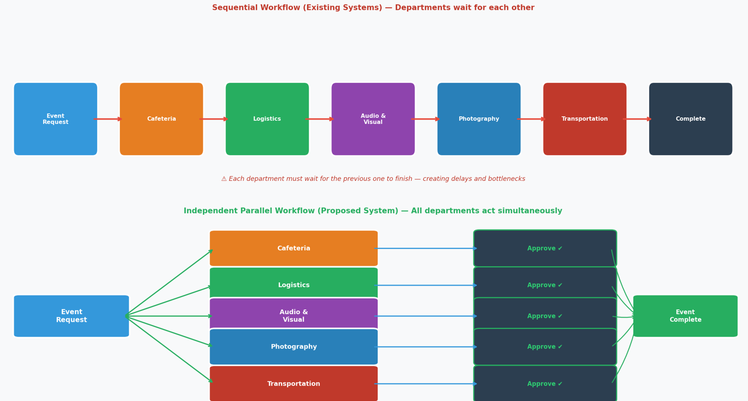
Figure 1: Sequential vs Independent Departmental Workflo.
Workflow management in higher education relies on structured process design that can support the movement of tasks through an organization in a controlled and consistent manner. In the university context, the absence of sufficient automation and an unclear organizational structure can slow down administrative processes and reduce operational efficiency. Research on e-university delivery models shows that process automation can significantly shorten procedures and improve efficiency, particularly where universities move toward digitally managed workflows rather than manual handling (Ismail et al., 2019).
Business process management literature also shows that digital innovations are increasingly reshaping how processes are designed and executed. Instead of treating workflow as a set of isolated tasks, BPM emphasizes the integration of process logic, digital support, and structured control so that organizational activities can be managed more effectively. In this sense, workflow management is not only about speed, but also about ensuring that work is routed through a coherent process that supports consistency and coordination across different units (Ahmad & Van Looy, 2020).
In higher education institutions, digital transformation has become a key enabler for improving administrative effectiveness and supporting more coordinated institutional operations. A systematic review on digital transformation in higher education institutions highlights that HEIs are increasingly adopting digital approaches to improve internal processes and strengthen institutional performance (Benavides et al., 2020). By inference, this supports the use of a centralized event coordination platform, because event requests can be routed, reviewed, and tracked through one managed workflow rather than handled through disconnected communication channels.
Overall, the literature suggests that effective coordination across multiple organizational units depends on automation, structured workflow logic, and digital process management. For the proposed system, this means that event coordination should be designed as a centralized workflow where task routing, approval handling, and progress visibility are controlled within one platform. This approach is consistent with the direction of BPM and higher education digital transformation research, which emphasizes efficiency, process clarity, and improved institutional coordination.

2.2.3 Role-Based Access Control (RBAC) in Information Systems
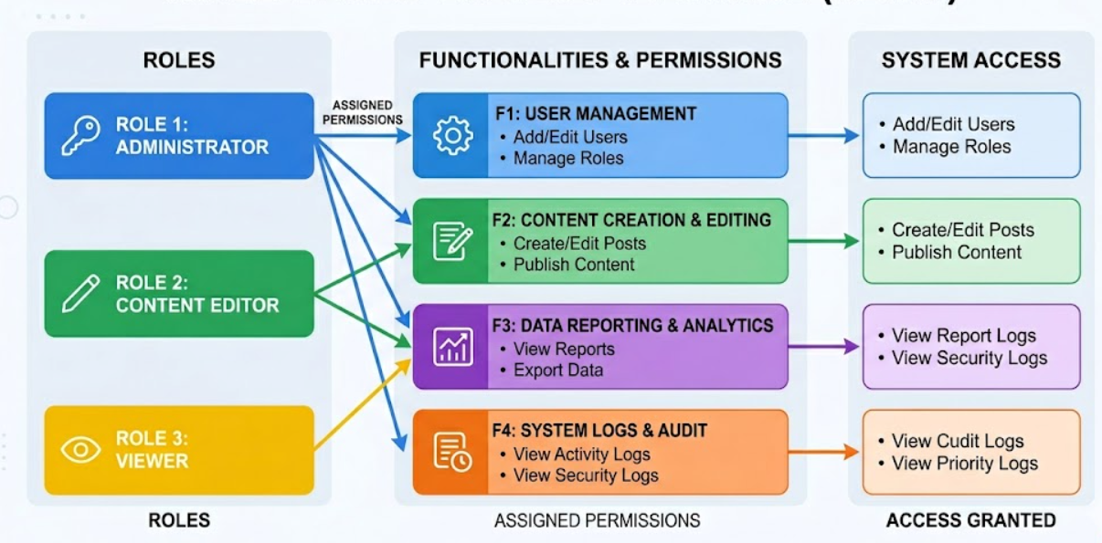
Figure 2: RBAC Hierarchy Model — Users, Roles, Permissions.
Role-Based Access Control (RBAC) is an access control model in which permissions are assigned to roles rather than directly to individual users. Recent literature describes RBAC as a structure that simplifies access management by aligning permissions with organizational units such as job titles, security levels, or departments, which makes it suitable for systems with clearly separated responsibilities (Anderer et al., 2023). RBAC is widely considered more scalable than traditional discretionary access control because it reduces administrative overhead when managing large numbers of users by grouping permissions under defined roles instead of handling them individually.
In multi-domain and multi-user environments, RBAC supports structured role separation by distinguishing between role categories and enforcing controlled access across different operational boundaries. Recent research on cross-domain RBAC models shows that role design can support platform-domain isolation, inter-domain management, and fine-grained sharing, which is especially relevant when a system must coordinate several groups without allowing unrestricted access. Research also shows that RBAC must remain adaptable in real business environments because role assignments can change as organizational responsibilities evolve (Jiao et al., 2022). This adaptability is particularly important in dynamic institutional environments such as universities, where users may shift roles depending on operational needs, semesters, or administrative restructuring.
For the proposed event coordination platform, RBAC is therefore appropriate because it allows each user type to be limited to the functions relevant to their responsibilities while keeping workflows organized across departments. This means that the system can support separate access boundaries for roles such as Event Manager, Department Manager, Department Staff, Admin, and Super Admin without exposing unrelated functions to all users. In this way, RBAC helps maintain controlled workflow execution, clearer responsibility allocation, and more consistent system governance (Zubair et al., 2024). Additionally, RBAC contributes to operational security by ensuring that sensitive actions such as approvals, task assignments, and system configuration changes are only accessible to authorized roles, reducing the risk of unauthorized modifications.
Beyond access restriction, RBAC also plays an indirect role in supporting workflow clarity in multi-user systems. By defining what each role can see and execute, it reduces ambiguity in task execution and ensures that users interact only with relevant system components. This improves system usability and reduces cognitive load on users, as they are not exposed to unnecessary functions outside their operational scope. As a result, RBAC contributes not only to security enforcement but also to improving the efficiency and structure of system interaction in complex organizational workflows.

2.2.4 Centralized Digital Platforms for Institutional Operations
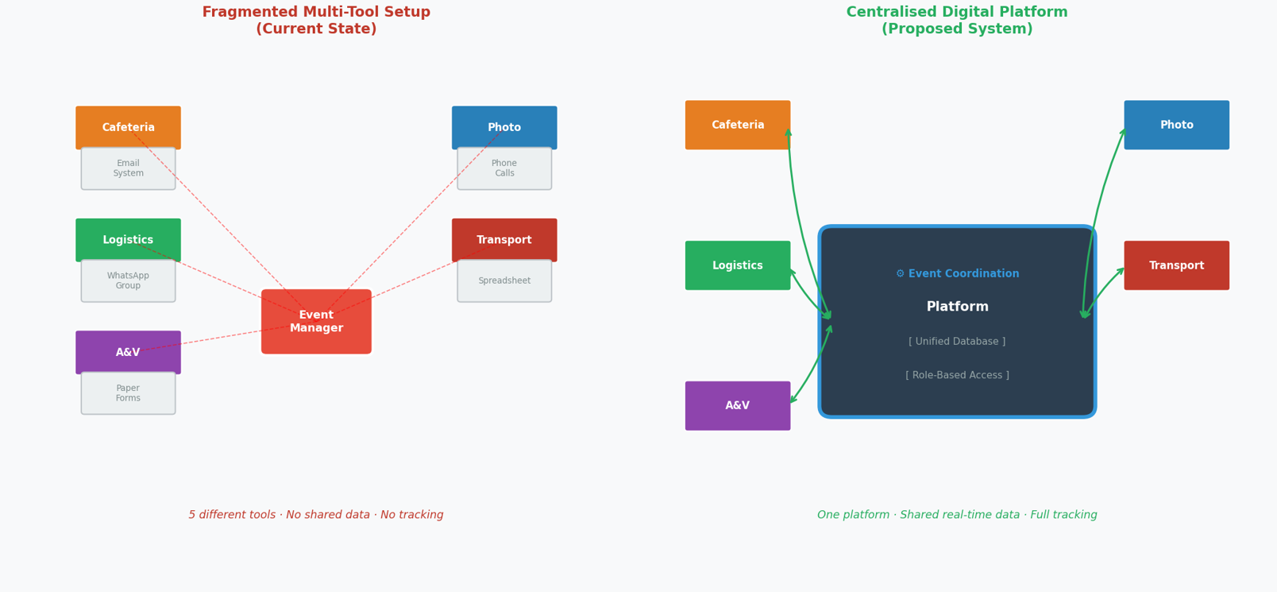
Figure 3: Centralized vs Fragmented Platform Architecture.
Abdul Rahman et al. (2024) emphasize that centralizing institutional event management into a unified digital platform enhances administrative visibility by consolidating all events within a single system. They further note that the absence of a centralized platform can result in unreported events and reduced oversight, particularly in large academic institutions where coordination is distributed across multiple departments. This demonstrates that fragmented systems can lead to inconsistencies in event tracking and weakened institutional control.
Similarly, Habib et al. (2021) highlight that decentralized university administrative systems often lead to duplicated operational activities and inefficiencies due to the lack of a unified coordination structure. Their findings suggest that when institutional processes are distributed across multiple disconnected tools, additional effort is required to reconcile inconsistencies, increasing administrative overhead and reducing operational efficiency.
From an infrastructure perspective, Fernández-Portillo et al. (2023) explain that universities are increasingly adopting centralized cloud-based platforms to integrate institutional resources and support inter-departmental collaboration. Cloud technologies enable scalable access and centralized resource management, reducing system fragmentation. However, they also highlight that effective centralization requires appropriate system governance to ensure that integration does not introduce organizational complexity or reduce clarity in user interactions.
Hadiwiyanti et al. (2022) evaluate a centralized Campus Event Management Information System using the System Usability Scale (SUS) and report a score of 70.80, indicating an “OK/Fair” usability level. The study further identifies usability limitations, particularly difficulties in navigating the graphical user interface, suggesting that the system has not yet achieved optimal user acceptance. Although the system provides a centralized environment for managing event-related activities, the findings indicate that centralization alone does not necessarily guarantee clarity or ease of use in multi-user systems. In complex institutional environments, where multiple user groups interact with the same platform, exposing all functions uniformly to all users may increase interface complexity and reduce overall usability. This highlights the importance of incorporating structured role-based access control and permission mechanisms, where system functionalities are selectively exposed based on user roles, reducing cognitive load and improving interaction efficiency within centralized systems.
In summary, the literature consistently supports the adoption of centralized digital platforms in institutional environments due to their ability to improve coordination, reduce duplication, and enhance visibility of operations. However, it also indicates that centralization must be complemented with structured access control and role-based system design to ensure usability, clarity, and effective user interaction in multi-user environments such as universities.

2.2.5 SDG Goal 9 and Digital Infrastructure in Higher Education
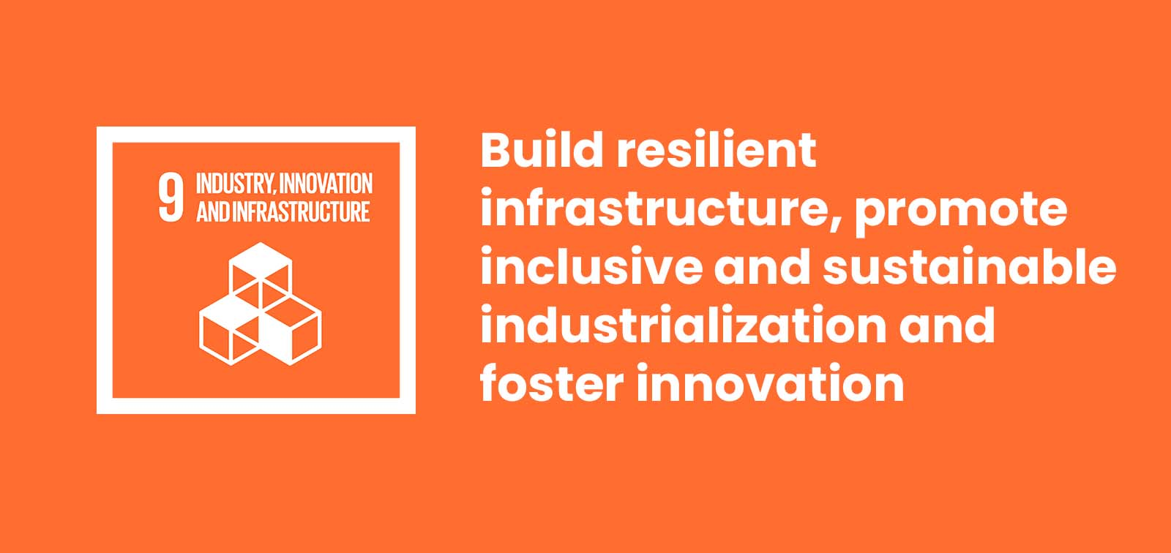
Figure 4: SDG Goal 9 and vision ISGlobal (n.d.).
SDG Goal 9 — Industry, Innovation and Infrastructure — calls for the development of resilient infrastructure, the promotion of inclusive and sustainable industrialization, and the fostering of innovation. Mualla and Mualla (2024), in a Springer publication on digital transformation in higher education, note that institutions in developing regions lacking structured digital administrative systems face significant obstacles in meeting SDG 9 targets, and emphasize that digital transformation in university administrative operations represents a direct contribution to the infrastructure development dimension of SDG 9 (Mualla & Mualla, 2024).
Kaputa et al. (2022), in a Springer publication on social innovation in higher education, reports that digital transformation in higher education institutions serves as a driver of social-oriented innovations and contributes to broader societal goals, including those outlined under SDG 9 (Kaputa et al., 2022). The authors argue that digital transformation in this context represents more than operational improvement — it constitutes a structural contribution to the sustainable development of the institution and the communities it serves.
The proposed centralized, role-based event coordination platform for APU directly contributes to SDG Goal 9 by establishing a purpose-built digital coordination infrastructure that supports SDG 9’s targets for resilient and sustainable institutional infrastructure.

2.3 Similar Systems / Works
A review of existing academic and commercial systems reveals that various platforms have been developed to support event management, workflow coordination, and institutional administrative processes. These systems typically focus on specific aspects such as event scheduling, task management, approval processing, or user collaboration. However, they are generally designed with a limited operational scope and do not fully address the complexity of multi-departmental coordination required in academic institutions.
While these systems provide useful foundations in areas such as centralized event listing, workflow automation, and role-based access, they often lack integration between independent departmental workflows, structured approval hierarchies, and event-specific task execution mechanisms. As a result, there remains a clear gap in existing solutions when it comes to managing end-to-end university event coordination within a unified and role-driven system architecture. This section critically evaluates selected systems to identify these limitations and establish the justification for the proposed centralized event coordination platform.

Table 2: SIMILAR SYSTEM
Research Name & Author (Year) | Research Description | Methods / Technologies | Gaps and Issues | Proposed Improvements
Alesandro et al. (2025). Development of a Campus Project Management System to Enhance Collaboration Using the Agile Method. JAIEA. DOI: https://doi.org/10.59934/jaiea.v4i3.1158 | A web-based campus project management system that helps lecturers, students, and administrative staff manage their projects from one place. The system lets users create projects, add tasks, set deadlines, assign work to team members, and track progress step by step. It also provides simple communication tools (comments, updates, and notifications) so everyone can share information, discuss tasks, and see what has been done and what is still pending. | Agile/Scrum methodology; web-based development | The system does not have a clear step-by-step approval flow between different units (for example: program, faculty, finance).  There is no way for one unit to officially approve or reject a request in the system before work starts.  The system cannot handle several separate approval processes at the same time for different departments on the same request | The proposed system sends each event request to all related departments at the same time. Each department can separately review the request, approve it, or send it back, following its own approval steps in the system.
User-Centered UiTM e-Event using Predictive Software Development Life Cycle (SDLC) – Noorihan Abdul Rahman et al. (2024)  DOI: https://doi.org/10.24191/jcrinn.v9i2.468 | UiTM e-Event web system, an online platform that gathers all student event information for UiTM Machang in one place. The system allows students to easily browse and search for events, while organizers can create, manage, and promote their events through a user-friendly and user-centered interface.. | Uses a predictive SDLC (planning, analysis, design, implementation, testing, maintenance) and user-centered design to build and evaluate a web-based event management system for event creation, management, and viewing. | The paper mostly talks about putting all event information in one place and making it easier to communicate and use the system for UiTM Machang events.  It does not really talk about harder things like many departments working together, different user roles with different steps, or advanced approval and editing processes.  It only shows a simple admin approve/delete feature.  It also does not clearly link the system to SDG 9 or explain technical choices like using the cloud or how the system is built in detail. | Extend the system into a platform where many departments can work together, each with its own steps and roles. Add features like edit/resubmit requests, live progress tracking, a full event history log, and build it using a modern technology stack (Angular, Flask, MySQL, AWS) with an Agile/Scrum development approach.
Cvent (2025). Cvent — All-in-one event management and marketing platform. Retrieved from Link :https://www.cvent.com | Cvent is a website that helps people plan and run events. You can use it to find places, register participants, make event pages, manage guests, run online events, and see how well your event is doing. It works on the cloud and can connect to other systems like Salesforce. | Cloud-based SaaS; web platform; mobile applications; integrations with Salesforce and marketing tools | Cvent mostly helps with planning and promoting events for people outside the organization, like guests, customers, or partners.  It does not really help with the inside work of an institution, like many approval steps, different roles deciding, and different departments working together on the same request. | The proposed system solves this gap by focusing on use inside the institution. It adds separate approval steps for each department, lets users revise and resubmit requests, and supports task assignment and progress tracking after approval. This helps departments work together smoothly before and after an event is approved, which is not what Cvent mainly focuses on.
Essel, D. D., Techie-Menson, H., Oppong, S. O., & Alakuu, A. (2023). Digitalising the Clearance Processes of Higher Education Institutions through an Online Clearance System. IJSRM.  DOI: https://doi.org/10.18535/IJSRM/V11I07.AS01 | An online clearance system that uses a web platform to replace manual, paper-based graduation clearance. Clearing officers in different offices log in to the system and, based on their role, can review student records and either approve or reject the student’s clearance. | ASP.NET MVC 5; MSSQL 2014; JavaScript; HTML; CSS; Agile methodology | The system is mainly about clearing final-year students before graduation, not about wider event processes like planning and running graduation ceremonies or other institutional events.  Each office only does a simple one-step approval or rejection, and the system does not support more complex approval steps inside a department. | The proposed system builds on role-based access and multi-office approvals and extends them to event-specific workflows for each department. In this system, every department can approve requests, assign its own service tasks, and carry them out, with each task tracked by clear status values until the event is completed.  .
Note. This table compares similar existing systems in terms of their purpose, technologies, limitations, and identified gaps, and highlights how the proposed system addresses these shortcomings through improved multi-department workflows and coordination features.

Conclusion — Summary of Similar Systems:
The analysis of existing systems demonstrates that although significant progress has been made in event management systems and workflow-based platforms, current solutions remain fragmented in their functional coverage. Systems such as those proposed by Alesandro et al. (2025) and Essel et al. (2023) primarily focus on structured task execution and approval processes; however, these implementations are limited to single-domain workflows and do not support complex inter-departmental coordination or parallel approval structures required in university-wide event management.
Commercial platforms such as Cvent (2025) provide scalable and feature-rich event management capabilities, particularly for external and public-facing events, but they are not designed to support internal institutional workflows where multiple departments independently evaluate, approve, and execute tasks within a single event lifecycle. Similarly, academic systems such as Abdul Rahman et al. (2024) focus on centralized event information management and usability, but they do not incorporate layered approval mechanisms, revision workflows, or structured task execution across departments.
Overall, the key limitation identified across all reviewed systems is the absence of a fully integrated framework that combines multi-departmental independent workflows, role-based access control, event-specific task distribution, and revision-based approval cycles within a single unified platform. Furthermore, none of the systems explicitly align their operational design with institutional digital infrastructure development goals such as SDG Goal 9. The proposed system addresses these gaps by integrating centralized coordination with structured role-based workflows, enabling efficient, transparent, and scalable event management tailored specifically for academic institutions.

2.4 Technical Research
This section identifies and justifies all technical components selected for the development of the proposed centralized, role-based event coordination platform for APU.

2.4.1 Hardware and Software Requirements
Hardware:
The proposed system is designed as a web-based platform, meaning that no specialized hardware is required on the user side. Users can access the system through any standard device capable of running a modern web browser, including desktops, laptops, and mobile devices. This ensures broad accessibility and ease of use without imposing additional hardware requirements on end users.
The system is developed and executed on a standard Windows workstation, which runs both the Angular client and the Flask application server during development. No dedicated institutional server hardware is required at this stage of the project. The only externally hosted component is the database, which is provided as a managed PostgreSQL service by Supabase. Using a managed database service removes the need to install, secure, and back up a database server on campus, while keeping the data in a single authoritative location that both the development and demonstration environments share.
Software Components:
- Frontend: Angular framework
Angular is used to build the user interface of the system. It follows a component-based structure, allowing the interface to be organized into reusable parts. It also supports dynamic data binding, enabling real-time updates such as task status and progress tracking without reloading the page.
- Backend: Flask with Python
Flask is used to handle the server-side logic of the system. It processes user requests, manages workflows such as approvals and task assignments, and connects the frontend with the database. Its lightweight and flexible design makes it suitable for implementing customized system logic.

- Database: PostgreSQL (hosted on Supabase)
PostgreSQL is used to store and manage system data in a structured format. It handles information such as users, events, tasks, and approval records, ensuring data consistency and enabling efficient retrieval for tracking and reporting purposes. The database instance itself, together with the connection pooling used by the application, is provided by Supabase.

2.4.2 IDE — Visual Studio Code

Figure 5: Visual Studio Code logo WebCatalog (n.d.).
Selected IDE: Visual Studio Code (VS Code) by Microsoft
Key Characteristics:
- Lightweight, open-source, and cross-platform (Windows, macOS, Linux)
- Supports TypeScript, Python, HTML, and SCSS — all languages used in this project
- Extensive extension ecosystem for linting, debugging, and version control integration
Justification:
Tan et al. (2023) report that Visual Studio Code ranked as the most popular developer environment tool in the Stack Overflow 2021 Developer Survey, with 71.06% of over 80,000 respondents indicating its use. The authors attribute this widespread adoption to its cross-platform compatibility and extensive extension ecosystem, which make it particularly well-suited for multi-language development projects. This is directly relevant to the proposed system, as development must be conducted simultaneously across Angular (TypeScript/SCSS) and Flask (Python) within a single unified environment (Tan et al., 2023).

2.4.3 Libraries and Tools
A — Angular (Frontend Framework)

Figure 6: Angular logo Angular Press Kit (n.d.).

Selected Frontend framework: Angular
Key Characteristics:
- TypeScript-Based Ecosystem: An open-source framework developed by Google that utilizes TypeScript to build robust Single-Page Applications (SPAs).
- Structured Modularity: Designed with a modular environment that allows for the organization of complex application logic into manageable units.
- Inherent Scalability: Provides a comprehensive set of tools and architectural patterns specifically engineered to handle high-complexity systems (Vashisht, 2021).
Justification:
As stated by Vashisht (2021), Angular is distinguished by its ability to manage highly complex applications through a strictly structured and modular development platform. This characteristic is particularly important for the proposed system, where twelve user roles must be supported within a single application. The framework's modularity enables role-specific scalability, ensuring that the views used by applicants, Heads of School and Heads of Department, the CFO, cafeteria users, club administrators, and system administrators can remain independent while still operating within the same codebase. The client is built on the principle that it displays what the server permits and decides no access rule of its own, so that the interface remains a presentation layer rather than a security boundary. This supports the development of a scalable and well-organized system architecture aligned with the project's multi-role requirements (Vashisht, 2021).
B — Flask (Backend Framework).


Figure 7: Flask logo Wikimedia Commons (n.d.).
Selected backend: Flask
Key Characteristics:
- Lightweight Python microframework for building REST APIs
- Ranked among the most popular Python web frameworks (Albesher & Alfayez, 2024)
- Commonly used for database integration, API development, authentication, and deployment (Albesher & Alfayez, 2024)
- Modular design supports clear routing and business logic separation
Justification:
Flask is suitable for building RESTful APIs for the proposed system, as it provides a lightweight and flexible framework for developing backend services that can efficiently handle client–server communication (Albesher & Alfayez, 2024). Its design supports the creation of modular and scalable API endpoints, which is essential for managing interactions between the frontend and backend components of the system. In addition, Flask supports core system requirements such as user authentication, database integration, and API request handling, making it well-suited for implementing the functional architecture of the platform. These capabilities allow the system to manage user roles, process event-related requests, and maintain structured data flow across different components, ensuring reliable and efficient backend operations (Albesher & Alfayez, 2024).
In the developed system, the backend is organised into resource-based modules served under a single versioned API path, with the rules of the approval workflow held in a separate service layer rather than inside the request handlers. Database access is written directly in SQL through a managed connection pool instead of an object-relational mapper, which keeps the multi-stage approval queries explicit and easier to reason about. Every change to a request, its departmental tasks, and its history record is applied within a single transaction, so a workflow decision is either recorded completely or not recorded at all.
C — Supporting Libraries and Tools
Beyond the two principal frameworks, the system depends on a set of supporting libraries and tools that provide database access, authentication, validation, documentation, and testing. These are summarised below. Among these, authentication is handled through JSON Web Tokens together with one-way password hashing, an approach widely applied to secure REST APIs and manage sessions between a separate client and server (Dalimunthe et al., 2023).
Library / Tool | Version | Purpose in the system
psycopg2 | 2.9 | PostgreSQL database driver and connection pooling
PyJWT | 2.10 | Issuing and validating authentication tokens
bcrypt | 4.2 | One-way hashing of user passwords
Flask-Cors | 5.0 | Controlling which origins may call the API
Flask-Limiter | 3.10 | Rate limiting of incoming requests
Marshmallow | 3.26 | Validation of incoming request data
apispec | 6.8 | Generation of the API documentation
Gunicorn | 23.0 | Application server used to run the Flask API
pytest | 8.3 | Automated testing of the backend
google-genai | 1.x | Access to the Google Gemini model used by the AI assistant
RxJS | 7.8 | Handling of asynchronous data streams in the Angular client
Vitest | 3.2 | Automated unit testing of the Angular client
Prettier | 3.6 | Consistent code formatting across the project
Table 1: SUPPORTING LIBRARIES AND TOOLS
D — Google Gemini (AI Assistant)
Selected model: Google Gemini, accessed through the google-genai software development kit
Key Characteristics:
- Answers questions written in ordinary language, without the user needing to know how the data is stored
- Two answer paths: a curated knowledge base for questions about how the system works, and a generated database query for questions about individual records
- Every generated query is checked and restricted to the data the asking user is already permitted to see
- All interactions, including refused requests, are recorded so that administrators can review how the assistant is used
Justification:
Large language models are increasingly used as a natural language interface to relational databases, translating a question written in ordinary language into a database query and returning the result to the user. Shi et al. (2025) review this text-to-SQL approach and note that it lowers the barrier for users who need information held in a structured database but are not able to write queries themselves. This is directly relevant to the proposed system, where staff across several departments need answers about events, requests, and tasks without navigating reporting screens belonging to roles other than their own. Google Gemini was selected because it is reached through a documented software development kit, requires no local model hosting, and can be operated within the resource constraints of an individual final year project. Because a generated query would otherwise be able to reach any record in the database, every query produced by the model is validated and constrained to the asking user's own access rights before it is executed, so the assistant cannot return information that the user could not already open in the interface (Shi et al., 2025).

2.4.4 Database Management System — PostgreSQL (Supabase)

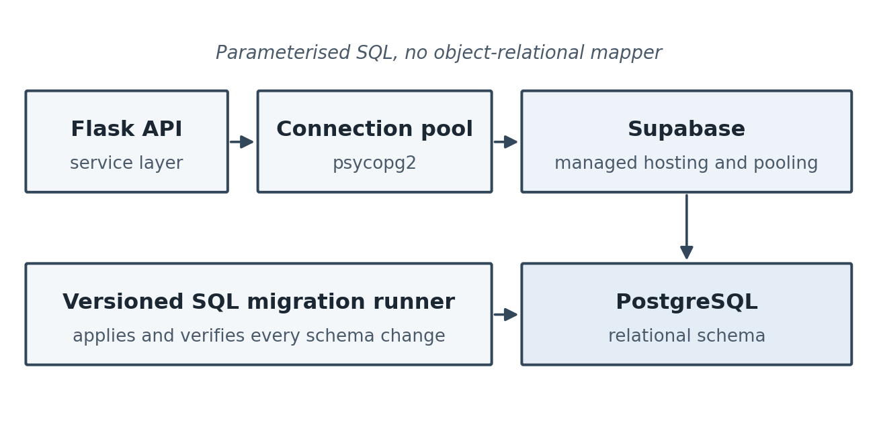
Figure 8: PostgreSQL data access through Supabase
Selected DBMS: PostgreSQL (open-source relational DBMS), hosted on Supabase
Key Characteristics:
- Structured relational database for events, departments, users, tasks, and approval history
- Supports foreign keys, constraints, and transactions for data integrity
- Accessed through parameterised SQL rather than an object-relational mapper, keeping the multi-stage approval queries explicit
- Schema changes applied through a versioned migration runner that records and verifies every file it applies
Justification:
PostgreSQL is well-suited for managing structured relationships within multi-departmental workflows, as it provides a robust relational model that represents entities such as events, departments, users, and tasks. Its support for primary and foreign keys and for table-level constraints ensures data integrity by keeping the relationships between connected records valid, and its transactional behaviour preserves consistency when several users act on the same request at the same time. These capabilities are supported by comparative studies reporting strong query performance for PostgreSQL relative to other widely used database systems (Salunke & Ouda, 2024; Urnikienė et al., 2026). Three further decisions shaped the way the database is used in this project. First, the application accesses the database through parameterised SQL rather than an object-relational mapper, which keeps the multi-stage approval queries visible and predictable. Second, every schema change is applied through a versioned migration runner that records and verifies each file it applies, so the database can be rebuilt from scratch in a known state. Third, the database is hosted on Supabase as a managed service, which supplies the instance, its backups, and the connection pooling used by the application, removing the need to administer a database server as part of the project.

2.4.5 Operating System
The system is web-based and is not bound to any specific client operating system. Users may access the platform from Windows, macOS, Linux, Android, and iOS. On the development side, the application is written and executed on Windows, and the Flask application server runs unchanged on Linux, which is the environment assumed for the scheduled background jobs described in the following section.

2.4.6 Deployment and Hosting Environment
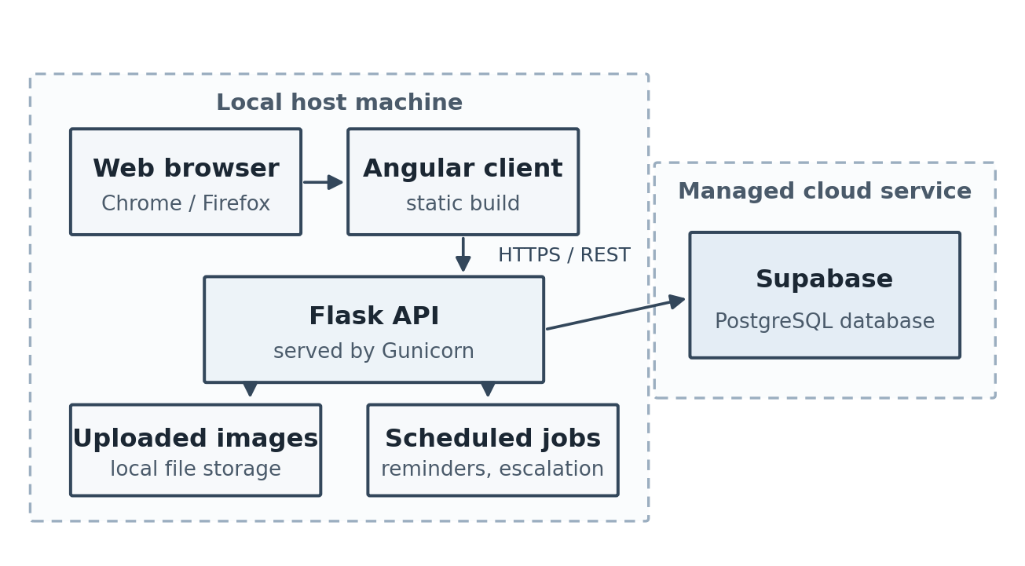
Figure 9: Deployment and hosting environment of the platform
Selected deployment approach: locally hosted application with a managed database service
Key Characteristics:
- The Angular client is served by the framework's own development server and is compiled to static files for release
- The Flask API is run through Gunicorn as its application server
- PostgreSQL is provided as a managed service by Supabase, the only externally hosted component of the system
- Uploaded images are stored on the file system of the machine running the API, and scheduled background jobs handle event reminders and approval escalation
Justification:
The platform is deployed as a locally hosted application supported by a managed database service. The Angular client and the Flask API run on the same host machine, with the client compiled to static files and the API served through Gunicorn, while the PostgreSQL database is hosted by Supabase. This arrangement was chosen deliberately for the scale of the project. The coordination workload is institutional rather than public, so the demand placed on the application tier is predictable and does not require elastic scaling, whereas the database is the component that benefits most from managed hosting because it carries the data that must survive, be backed up, and be reachable from every environment used during development and demonstration. Separating the two in this way keeps the hosting cost and administrative effort proportionate to the project while ensuring that no institutional data depends on a single developer machine. Two limitations of the current arrangement are stated deliberately. Uploaded images are written to the file system of the host machine rather than to an object storage service, so they are not shared between hosts; and the scheduled jobs that send event reminders and process approval escalation depend on an operating system scheduler on a continuously running host, which is why the system also allows a System Admin to trigger the same sweep manually. Both are addressed by moving the application tier to a hosted environment, which is identified as future work rather than claimed as delivered.

2.4.7 Web Browser — Chrome and Firefox

Figure 10: Googe Chrome, Firefox Mozilla Firefox (n.d.); Be Connected (n.d.).
Selected Browsers: Google Chrome and Mozilla Firefox
Key Characteristics:
- Both browsers fully support modern web standards: HTML5, CSS3, and JavaScript ES6+, required for the Angular-based frontend
- No installation is required on the user’s device — access is entirely browser-based
- Both browsers are available on desktop and mobile, ensuring accessibility for all APU internal staff regardless of device
Justification:
Cross-browser inconsistencies in how web applications are interpreted and rendered are a well-documented issue in web development, as differences in browser implementations can lead to variations in application behavior across different platforms (Choudhary, Prasad, & Orso, 2012). These inconsistencies can negatively affect the user experience, particularly in complex web applications that rely on modern frameworks and dynamic user interfaces. Based on this, the use of modern, standards-compliant browsers such as Google Chrome and Mozilla Firefox is recommended to reduce compatibility issues and ensure more consistent execution of web applications. This is especially important for applications built using frameworks such as Angular, where consistent rendering and JavaScript execution are essential for maintaining interface stability and functionality across different devices and operating systems.

2.5 Summary
This chapter presented a literature review supporting the proposed centralized, role-based event coordination platform for APU. It covered three main areas: domain research, similar systems, and technical justification. Domain research examined event management in academic institutions, multi-departmental coordination, RBAC systems, centralized platforms, and SDG Goal 9 in higher education. Similar systems included studies by Alesandro et al. (2025), Abdul Rahman et al. (2024), and Essel et al. (2023), as well as a review of Cvent (2025), focusing on campus event management and clearance management systems. Technical research justified the use of Visual Studio Code, Angular, Flask (Python), PostgreSQL hosted on Supabase, the supporting libraries used across both tiers, the Google Gemini model behind the platform's AI assistant, and the deployment and hosting arrangement adopted for the system.
Several key gaps were identified. Existing systems lack independent multi-department workflows, role-specific interfaces, structured revision loops between coordinators and departments, and post-approval task assignment and execution tracking. To address these, the proposed system introduces independent departmental workflows within a unified platform, role-based interfaces for different users, a selective revision loop for rejected departments, and extended functionality for task tracking beyond approval until completion.

CHAPTER 3: METHODOLOGY

3.1 Introduction
The selection of an appropriate research and development methodology is a fundamental prerequisite for the successful delivery of a complex software system. This chapter establishes the structural framework used to guide the project from the initial investigation through to the final deployment of the centralized event coordination platform. It provides a comprehensive analysis of various Software Development Life Cycle (SDLC) models, evaluating their theoretical foundations and their practical utility in the context of institutional workflow management. By examining traditional, iterative, and blended approaches, this chapter outlines the roadmap for managing departmental requirements, designing multi-layered approval logic, and ensuring the platform remains robust through its development lifecycle. Finally, a specific methodology is justified and selected as the optimal path for this individual-led project.

3.2 Evaluation of Candidate Methodologies

3.2.1 The Waterfall Model (Sequential Development)
The Waterfall model is the most established paradigm in software engineering, predicated on a linear and sequential flow. In this model, development is divided into distinct phases: Requirement Analysis, System Design, Implementation, Integration and Testing, Deployment, and Maintenance. Progress flows strictly in one direction, requiring the complete sign-off of one phase before the next can commence.
Theoretical Foundation and Scholarly Perspective: Academic literature often classifies Waterfall as a "plan-driven" approach. According to Srivastava et al. (2019), the model’s primary strength lies in its discipline and the high level of documentation it produces. This makes it an ideal choice for projects where requirements are static and the technical environment is highly stable. The structured nature of Waterfall provides a clear project timeline and a measurable set of milestones, which is traditionally favored in large-scale administrative or government-level software procurement where accountability and fixed-scope delivery are paramount.
Project-Specific Applicability: For a centralized event coordination platform, the Waterfall model offers a strong framework for the initial design of core database structures and role-based permissions, which are unlikely to change significantly. However, its rigidity presents a significant risk for this project. Since the specific nuances of departmental workflows—such as the exact fields required for the "Cafeteria" or "Transportation" requests—may only become clear during the actual build, a pure Waterfall approach would make it difficult and costly to integrate late-stage refinements or feedback from university stakeholders.

3.2.2 Agile Methodology (The Scrum Framework)
Agile is an iterative and incremental development philosophy that prioritizes flexibility and frequent stakeholder feedback over rigid initial planning. Scrum is the most prominent framework within the Agile umbrella, utilizing time-boxed development cycles known as Sprints (typically 1–4 weeks) to deliver functional increments of software.
From a theoretical perspective, Alami and Krancher (2022) observe that Scrum has become the dominant industry standard because it directly addresses the volatility of software requirements. By focusing on "User Stories" and a "Product Backlog," Scrum allows developers to pivot based on user testing and evolving priorities. Academic studies emphasize that Scrum significantly improves final software quality by ensuring that testing is an ongoing activity rather than a terminal phase. This iterative "inspect and adapt" cycle is recognized as a critical success factor in modern web-based application development.
Building on this iterative nature, the Scrum approach is highly beneficial for implementing the complex coordination logic of the event platform. It allows for the incremental building of departmental modules, ensuring that the distribution logic is tested and verified before moving to the next feature. However, because this is an individual Final Year Project (FYP), the standard Scrum ceremonies (Daily Stand-ups, Sprint Retrospectives, and specific roles like Scrum Master) are designed for teams. For a solo developer, these elements can introduce unnecessary administrative overhead, necessitating a modification of the framework to fit an individual workflow.

3.2.3 Rapid Application Development (RAD)
Rapid Application Development (RAD) is a methodology that emphasizes speed and user involvement through the frequent creation of prototypes. It de-emphasizes the traditional planning phase in favor of "getting a version of the software in front of the user" as quickly as possible.
According to Thesing et al. (2021), RAD operates through a “development–feedback–refinement” loop that enables stakeholders to interact with a working version of the system at an early stage, rather than waiting for a fully completed product. In academic contexts, this approach is widely recognized for its ability to bridge the “requirement gap” between what is initially designed by the developer and what is needed by the end users, by using prototypes as a form of visual agreement between stakeholders.
Building on this theoretical foundation, RAD is highly relevant to this project due to the integration of high-fidelity prototyping tools such as Figma. By developing detailed visual representations of the system interface and departmental dashboards before implementing backend functionality, it becomes possible to validate the system flow with both the supervisor and potential users at an early stage. This is particularly important in the context of a centralized event coordination platform, where multiple user roles such as Logistics, AV, and Photography must interact with the system in a clear and intuitive manner. Through this approach, the core distribution logic and interface structure can be validated visually before the implementation of complex backend components such as Flask and MySQL, ensuring better alignment between system design and user expectations.

3.2.4 Hybrid Methodologies (Structured-Iterative Blends)
Hybrid methodologies seek to combine the planning and documentation strengths of Waterfall with the flexibility and speed of Agile or RAD. This is often referred to as "Water-Agile-Fall" or "Agile-Waterfall Hybrid."
Hron and Obwegeser (2018) explain that hybrid development models are becoming increasingly common in both academic and complex institutional systems. These approaches combine the strengths of different methodologies by typically applying a Waterfall structure for high-level architectural planning and requirement definition at the “macro” level, while adopting Agile-based Sprints for detailed implementation and feature refinement at the “micro” level. In this way, hybrid models provide a stable structural foundation while still recognising that software development is inherently iterative and may require continuous adjustments throughout the development process.

Building on this theoretical perspective, a hybrid approach is particularly well suited to a university project environment. The structured Waterfall component ensures that the system meets academic expectations in terms of documentation, planning, and clearly defined architecture at the early stages of development. At the same time, the Agile component supports incremental progress, allowing each functionality to be developed and validated individually until it operates effectively before moving on to the next. This balanced approach helps manage the complexity of a multi-departmental system by breaking the development process into smaller, manageable iterations, reducing cognitive overload and enabling steady, controlled progress throughout the project lifecycle.

3.2.5 Comparative Analysis of Methodologies
The candidate methodologies are evaluated based on their alignment with the technical requirements and administrative characteristics of the proposed centralized event coordination platform. This comparison considers key factors such as the ability to handle evolving requirements, suitability for individual development, support for complex workflow logic, academic relevance, and effectiveness in maintaining stakeholder alignment.
Table 4
Comparative Analysis of Software Development Methodologies.
Factor | Waterfall | Agile (Scrum) | RAD | Hybrid (Proposed)
Handling Uncertainty | Poor; requires fixed specs. | Excellent; thrives on change. | High; uses prototyping. | Balanced; handles evolution.
Solo Developer Efficiency | High; clear linear path. | Low; team-heavy ceremonies. | High; focus on UI/UX. | High; tailored for one person.
Workflow Logic Depth | High; well-documented. | Variable; depends on Sprint. | Focuses on appearance. | High; planned yet refined.
Academic Suitability | High; satisfies IR/Design. | Moderate; requires team simulation. | Moderate; UI-centric. | Very High; covers all phases.
Stakeholder Alignment | Minimal until end. | Frequent but time-consuming. | Very high via prototypes. | Strategic; at key milestones.
Note: This table compares four development methodologies and shows that the Hybrid model provides the best balance of structure and flexibility for this project.

3.4 Methodology Discussion (Pure vs Hybrid Approaches)
In a pure Waterfall approach, development follows a linear sequence of phases with limited flexibility for changes once requirements are defined. In contrast, a pure Agile approach focuses heavily on iteration and flexibility but may lack strong upfront architectural control in complex system environments.
However, recent developments in software engineering indicate that purely applying a single methodology is often insufficient for systems with mixed or evolving requirements. Alami and Krancher (2022) highlight that real-world projects benefit more from tailored or hybrid approaches rather than rigid adherence to one methodology, particularly when dealing with constraints that require both structure and adaptability.
In institutional systems such as university-based platforms, requirements are typically distributed across multiple stakeholders and are subject to refinement over time. Kadenic et al. (2023) further emphasize that stakeholder acceptance is strongly influenced by early validation and visual confirmation of system behavior. This is where hybrid approaches become more effective, as they combine the structured planning of traditional models with the iterative feedback cycles of modern development practices.
Therefore, compared to pure methodologies, hybrid approaches provide a more balanced solution by addressing both the need for architectural stability and the requirement for continuous refinement based on stakeholder input.

3.5 Selected methodology and Justification
The Waterfall-Agile Hybrid with Evolutionary Prototyping is selected as the optimal methodology for this project. This choice is justified by the following evidence-based factors:
- Requirement Refinement via Prototyping: Since the project requirements are currently in an early conceptual stage, the use of evolutionary prototyping through tools such as Figma plays a critical role in clarifying functional expectations. This approach enables early visualization of system components and user interactions before implementation begins. As a result, requirement gaps, inconsistencies, and overlooked functionalities can be identified at an early stage. This reduces the likelihood of costly revisions during later development phases and supports a more accurate translation of stakeholder needs into system features.
- Structural Integrity vs. Functional Flexibility: The Waterfall component of the methodology ensures that essential foundational activities—such as initial investigation, system analysis, and high-level architectural design—are completed in a structured and sequential manner. This is particularly important for ensuring that the centralized, role-based architecture of the system is properly defined prior to implementation. At the same time, the integration of Agile principles introduces flexibility at the functional level, allowing iterative refinement of modules without compromising the overall system structure. This balance ensures both design stability and adaptability.
- Optimization for Individual Execution: The adaptation of Agile principles into short, focused development cycles supports continuous progress evaluation and quality assurance. Each functional component is developed, tested, and validated before proceeding to the next stage. This iterative workflow enhances system reliability and ensures that each feature meets its intended functional requirements. It also reduces dependency bottlenecks typically associated with large-scale team coordination, allowing development to progress in a controlled and self-managed manner while maintaining consistent quality standards.
- Institutional Workflow Alignment: The hybrid methodology is well aligned with the multi-departmental coordination structure required by the system. The Waterfall component supports the documentation of stable, organization-wide rules governing role permissions and request distribution logic. In parallel, the Agile and prototyping components allow iterative refinement of user interfaces and departmental interaction flows based on continuous supervisor feedback. This ensures that while the core system logic remains consistent and well-defined, the user-facing components evolve in response to practical usability considerations and institutional expectations.
Overall, the selected methodology provides a comprehensive framework that supports both rigorous system design and adaptive development. It ensures that the system evolves in alignment with stakeholder requirements while maintaining structural consistency and implementation efficiency throughout the project lifecycle.

3.6 Activities and Processes Within Each Phase
The selected Waterfall–Agile Hybrid with Evolutionary Prototyping structures the development process into a sequence of high-level phases, while incorporating iterative refinement within each stage. This ensures that the system maintains a stable architectural foundation while allowing continuous improvement based on feedback and evolving requirements.

The initial phase, requirement analysis and investigation, focuses on identifying the core functionalities of the centralized event coordination platform. This includes defining the roles of different departments (e.g., Logistics, AV, Transportation), understanding request workflows, and establishing the overall system scope. At this stage, information gathered from the Initial Report (IR) and stakeholder discussions is translated into structured requirements.

Following this, the system design phase establishes the architectural foundation of the platform. This includes designing the database schema, defining role-based access control, and outlining the request distribution logic that ensures each department receives relevant tasks. High-level system diagrams and data flow structures are developed to guide implementation.

To address the uncertainty in user requirements, prototyping activities are integrated early in the process. Using tools such as Figma, high-fidelity interface designs and dashboard layouts are created to simulate user interaction. These prototypes are reviewed and refined through feedback, ensuring that the system interface aligns with user expectations before backend development begins.
The implementation phase is conducted iteratively, following Agile-inspired cycles. Functional modules—such as event request submission, departmental dashboards, and approval workflows—are developed incrementally. Each module is tested individually before integration, ensuring correctness and reducing system-level errors.

During the integration and testing phase, individual components are combined into a unified system. Testing is performed continuously rather than as a final step, including validation of request routing logic, user role permissions, and system usability. Feedback from supervisors is incorporated to refine both functionality and interface design.

Finally, the deployment and evaluation phase involves preparing the system for practical use, ensuring stability, and documenting the final implementation. Any remaining adjustments are made based on final validation, ensuring that the system meets both technical requirements and institutional workflow expectations.

Overall, this structured yet flexible process enables the system to be developed in a controlled manner while still accommodating iterative improvements, ensuring alignment with both the technical objectives and the user requirements identified in the project.

3.7 Data Gathering Design

3.7.1 Data Collection Method
The data gathering process for this project was conducted using a survey-based approach, selected due to its effectiveness in collecting structured and quantifiable feedback from a relatively large number of participants within a limited timeframe. This method enables the identification of common trends, patterns, and user expectations, which are essential for requirement analysis. In the context of a university-based system, surveys are particularly suitable as they allow input to be gathered from a diverse group of users with varying levels of interaction with event management processes.

3.7.2 Target Participants
The target participants consisted of students and staff members of Asia Pacific University (APU). These groups were selected because they represent the primary users and stakeholders of the proposed event coordination platform. Students often participate in or organize events, while staff members are typically involved in approval processes, logistics, or administrative coordination. Their combined perspectives provide a comprehensive understanding of both operational challenges and user expectations within the current system.

3.7.3 Sample Size and Distribution
A total of 30 participants were involved in the survey, fulfilling the minimum requirement for survey-based data collection. The survey was developed using Google Forms, which allowed for efficient distribution, response collection, and data organization. To reach the intended audience effectively, the survey link was shared through commonly used communication channels such as email, WhatsApp, and Excel-based contact lists. This multi-channel distribution approach increased accessibility and encouraged participation from individuals with different communication preferences.

3.7.4 Survey Structure and Design
The survey was carefully structured into four main sections to ensure comprehensive and organized data collection, with each section targeting a specific aspect of the research:
- Section 1: Participant Information
This section collected demographic data such as age, gender, role (student or staff), and year of study. These details are important for categorizing responses and understanding how different user groups perceive event coordination processes. As required, this demographic information is included in the appendix for reference.
- Section 2: Current Event Coordination Issues
This section focused on identifying existing challenges in event planning and management within the university. Participants were asked about their frequency of participation in events, the tools currently used for coordination (e.g., email, paper forms, WhatsApp, Excel), and the types of issues they encounter. Likert-scale questions were used to measure factors such as clarity of the process, satisfaction levels, and frequency of difficulties, allowing for both qualitative and quantitative analysis.
- Section 3: Proposed Solution – Usefulness and Acceptance
In this section, participants were introduced to the concept of a centralized, role-based event coordination platform. They were asked to evaluate its potential usefulness, their likelihood of using such a system, and its expected impact on improving efficiency and reducing coordination issues. This helps assess user acceptance and the feasibility of implementing the proposed solution.

- Section 4: Additional Features
This section gathered user preferences regarding potential system enhancements. Participants were asked to rate the importance of features such as mobile accessibility, real-time notifications, and fully digital request management. An open-ended question was also included to allow participants to suggest additional features, ensuring that user input is not limited to predefined options.

3.7.5 Considerations
Ethical guidelines were strictly followed throughout the data collection process. Participants were required to provide informed consent before proceeding with the survey, confirming that participation was voluntary and that they were 18 years of age or older. All responses were collected anonymously to protect participant identity, and the data was used solely for academic purposes. Additionally, all collected data was stored securely and handled with confidentiality, with approval obtained from the project supervisor in accordance with institutional ethical requirements.

3.7.6 Purpose of Data Collection
The primary purpose of the data collection was to identify current limitations in event coordination practices, evaluate user acceptance of the proposed system, and gather insights into desired features and improvements. The collected data provides a foundation for defining system requirements and ensuring that the developed platform aligns with the needs of its intended users. Furthermore, it supports evidence-based decision-making throughout the design and development phases of the project.

3.8 Analysis

3.8.1 Quantitative Data Presentation
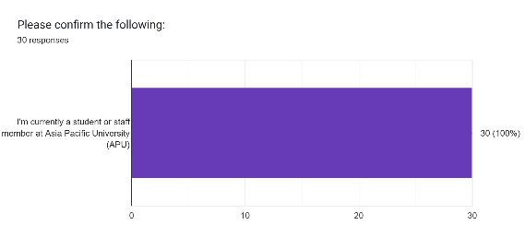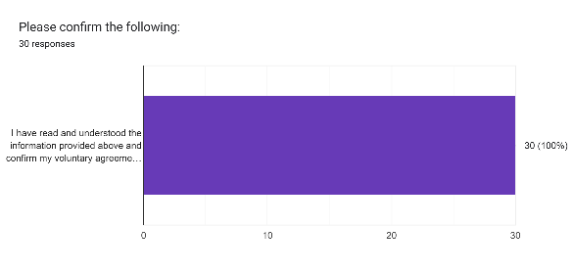
Figure 11: Participant Eligibility and Consent
The survey results confirm a 100% compliance rate regarding participant eligibility and voluntary consent. 100% of respondents identified as current students or staff members of Asia Pacific University (APU). This ensures that the data collected is highly relevant and reflects the actual experiences of the stakeholders who will interact with the proposed event coordination platform.
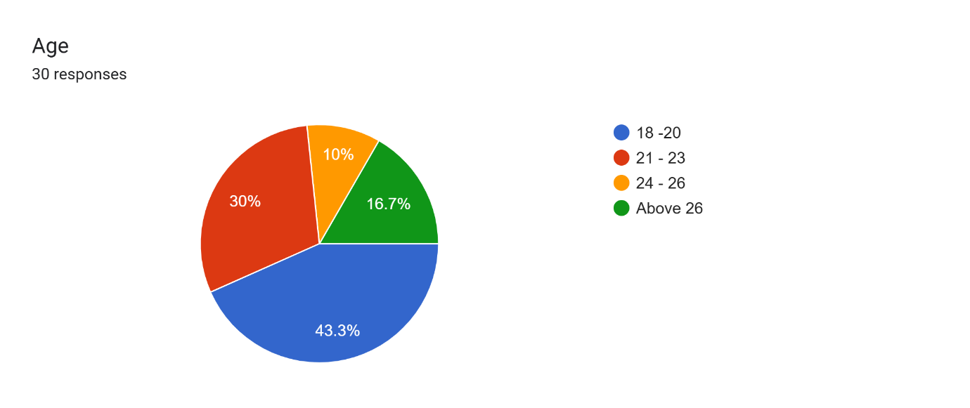
Figure 12 : Age eDistribution of Survey Participants
Most of the respondents fall within the 18–20 (43.3%) and 21–23 (30%) age brackets. This indicates that the primary user base of the platform consists of "digital natives" who are highly accustomed to mobile and web-based applications. Their familiarity with technology suggests a high potential for rapid adoption of a digital system over traditional manual method.

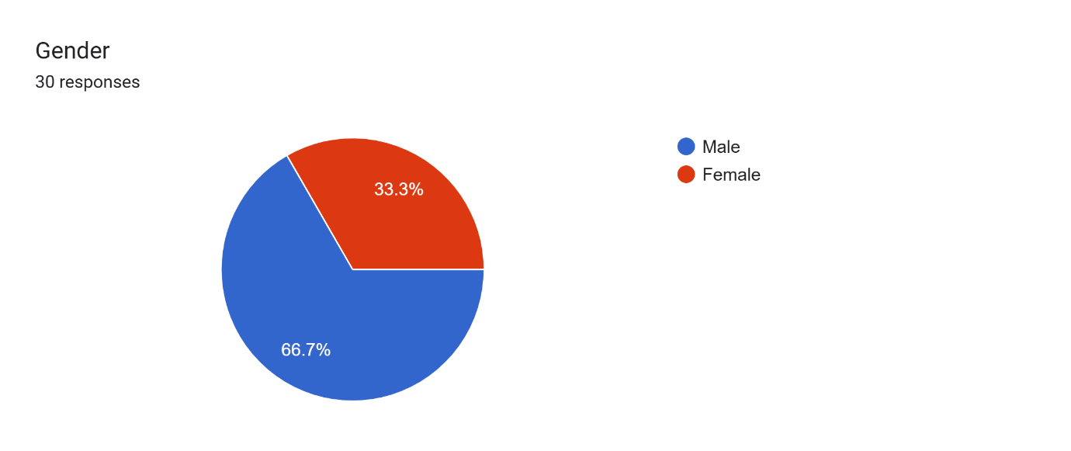
Figure 13: Gender Distribution
The participant pool consists of 66.7% males and 33.3% females. This diverse representation helps in understanding if different user groups have varying perspectives on system usability, ensuring the final event coordination system is inclusive and user-friendly for all members of the university community.
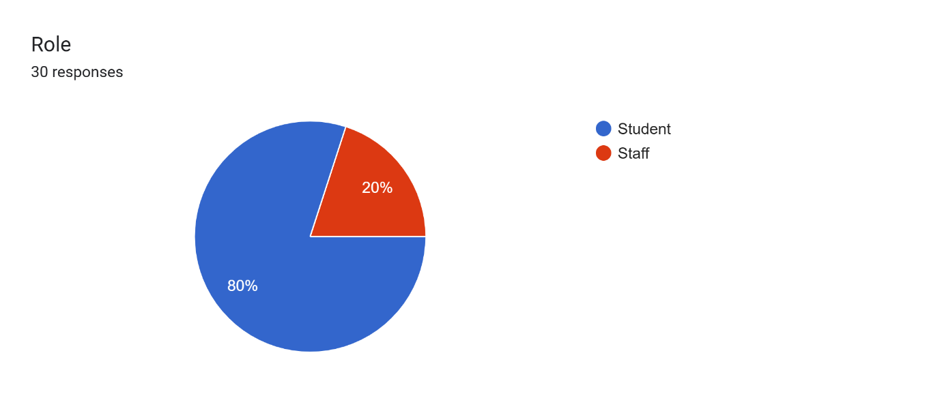
Figure 14: Roles within the University The
data shows a split between students (80%) and staff members (20%). While students represent the primary end-users who will be requesting and attending events, the inclusion of staff members is critical. Staff members often act as the "Approvers" or "Service Providers" (Logistics, AV, etc.) in the workflow, and their feedback validates the need for a centralized administrative backend.

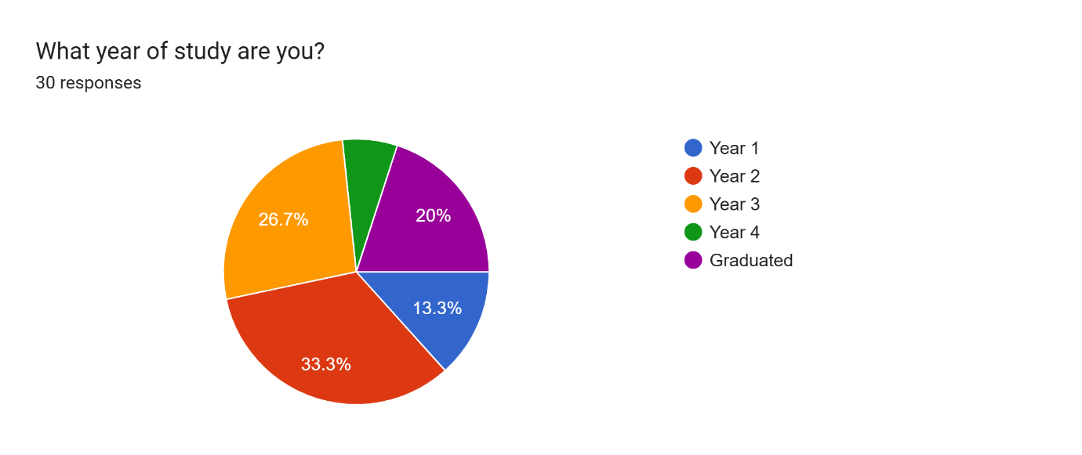
Figure 15: Academic Year Representation
Respondents are spread across all years of study, with a significant number in Year 2 (33.3%) and Year 3 (26.7%). This variety ensures the findings are not limited to one specific cohort but represent a broad academic lifecycle. Graduates (20%) also provided input, offering a retrospective view of the coordination challenges they faced during their full tenure at APU.
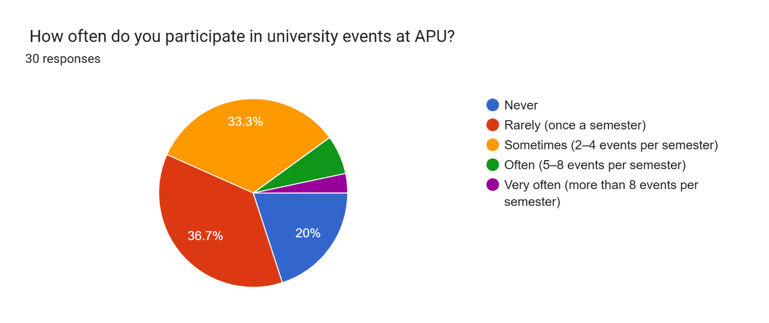
Figure 16: Frequency of Event Participation at APU
A combined 70% of participants participate in events at least once a semester or more. This high level of engagement underscores the importance of a reliable management system. Since a large portion of the community interacts with the event lifecycle regularly, any inefficiencies in coordination have a wide-reaching impact on the student experience.
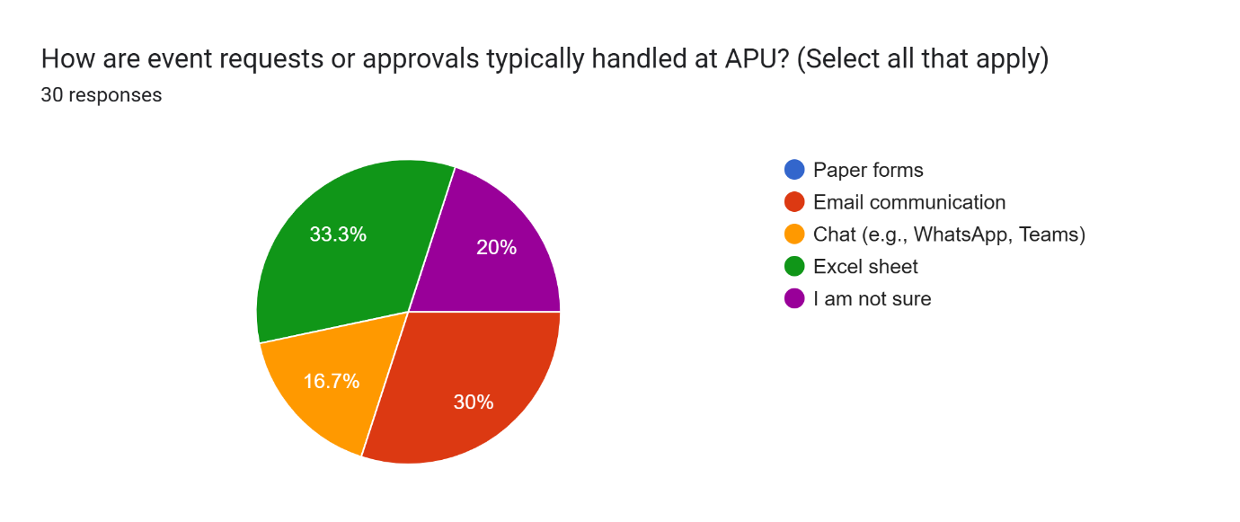
Figure 17: Current Methods for Handling Event Requests
The survey reveals a fragmented approach to event management, with 33.3% of participants using Excel sheets, 30% using Email, and 16.7% relying on chat platforms like WhatsApp or Teams. This lack of a single "source of truth" confirms the core problem: data is scattered across different platforms, leading to communication gaps and a lack of real-time visibility.
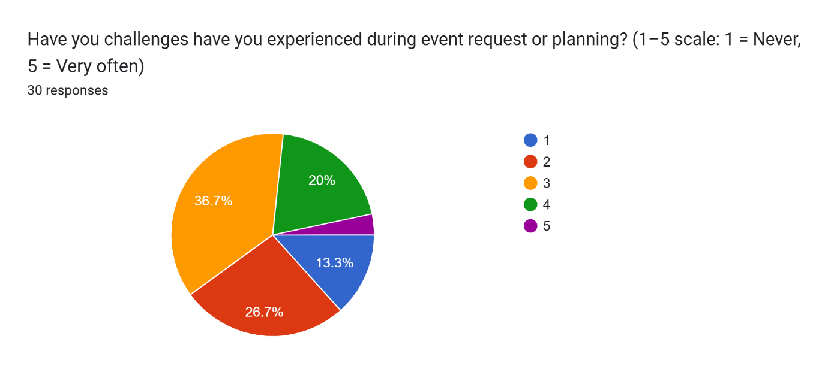
Figure 18: Perceived Challenges in Event Planning
When asked about challenges experienced during event planning (on a scale of 1 to 5), the majority of respondents chose 3 or 4. This indicates that coordination issues are a frequent occurrence rather than rare exceptions. Only a small minority (13.3%) reported never facing challenges, proving that the current manual/semi-digital workflow is consistently problematic.
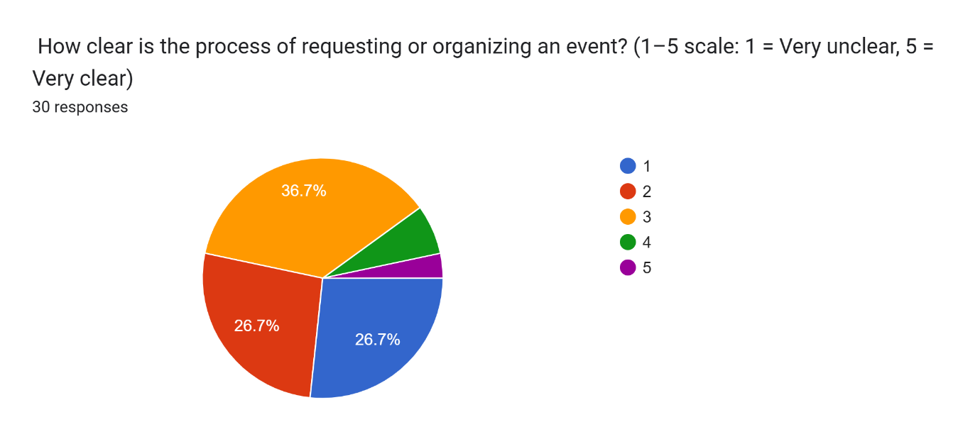
Figure 19: Clarity of the Existing Request Process
Process clarity is a major concern, with 53.3% of participants rating the current process as "Unclear" (1 or 2 on the scale). Only 3.3% of participants rated it as "Very Clear." This highlights a significant "information gap" where users are unsure of the steps required to organize an event, justifying the need for a system that provides a structured, step-by-step digital workflow.
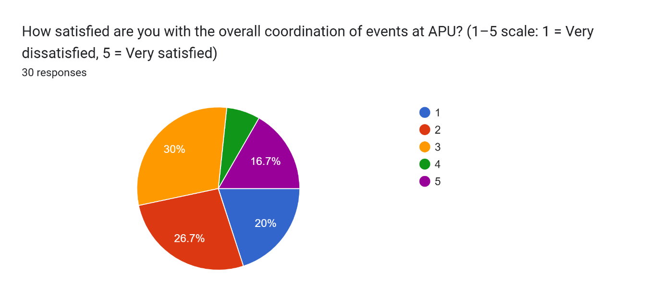
Figure 20: Overall Satisfaction with Current Coordination
Satisfaction levels are notably low, with 46.7% of respondents being "Dissatisfied" (1 or 2) and 30% being "Neutral" (3). Only 16.7% of participants expressed high satisfaction. This data serves as a strong mandate for change, showing that the current system does not meet the expectations or needs of the university population.
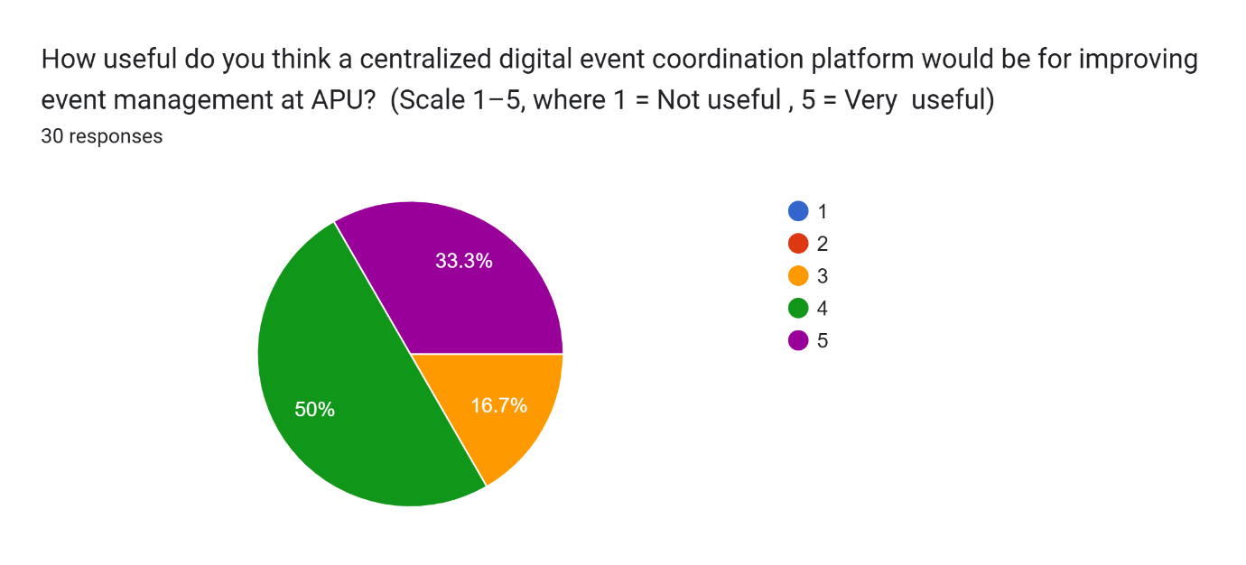
Figure 21: Perceived Usefulness of a Centralized Platform
There is overwhelming support for the proposed solution, with 83.3% of participants rating the usefulness of a centralized digital platform as 4 or 5. This high level of perceived value indicates that the university community recognizes the potential for a digital system to solve the existing coordination bottlenecks.
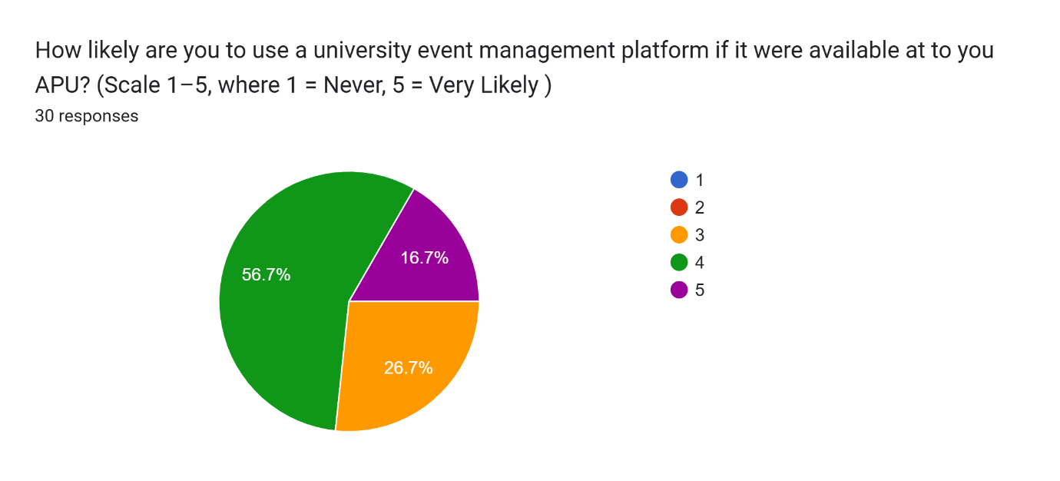
Figure 22: Likelihood of System Adoption
User intent to use the new platform is very high, with 73.3% of participants indicating they are "Likely" or "Very Likely" to adopt the system. This suggests that the platform will not face significant user resistance and will likely see high engagement once implemented.
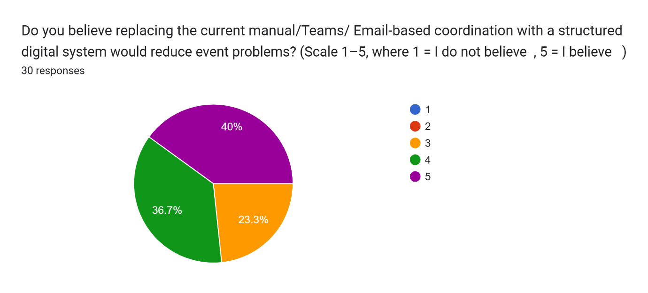
Figure 23: Belief in Problem Reduction via Digital System
A total of 76.7% of participants believe (rating 4 or 5) that replacing manual/email-based systems with a structured digital platform will reduce event-related problems. This confirms that the project's goal of "Intelligent Coordination" aligns with user expectations for error reduction and increased accountability.
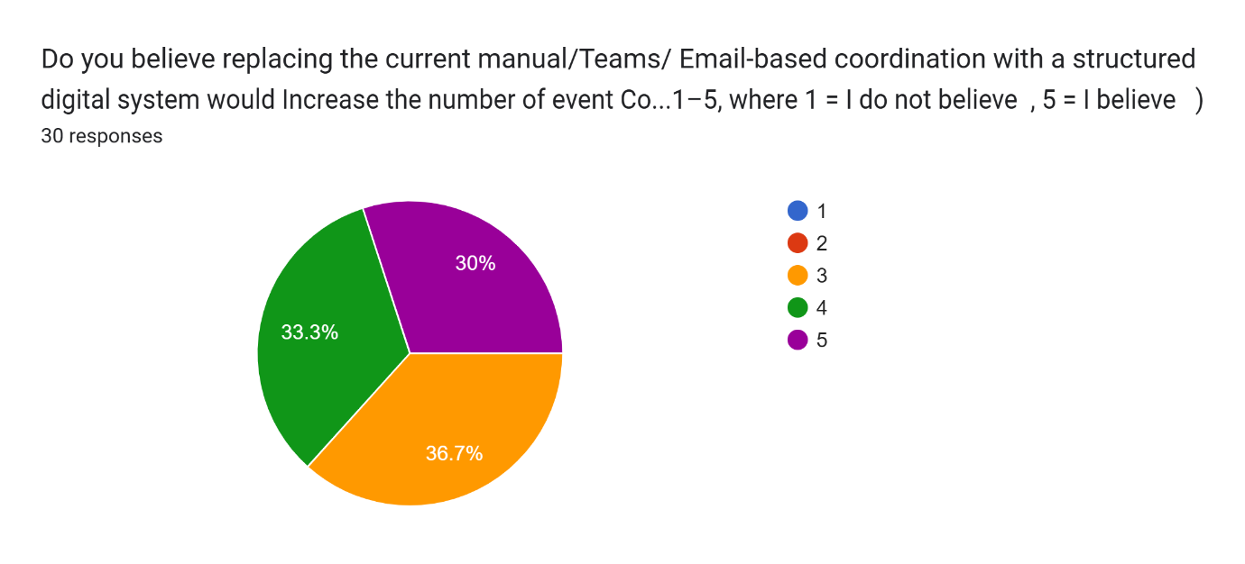
Figure 24: Potential Impact on Event Frequency
The survey suggests that a digital system could actually increase the number of events conducted at APU. 63.3% of participants believe (rating 4 or 5) that a more efficient system would encourage more frequent event activity by making the administrative process less daunting and time-consuming.
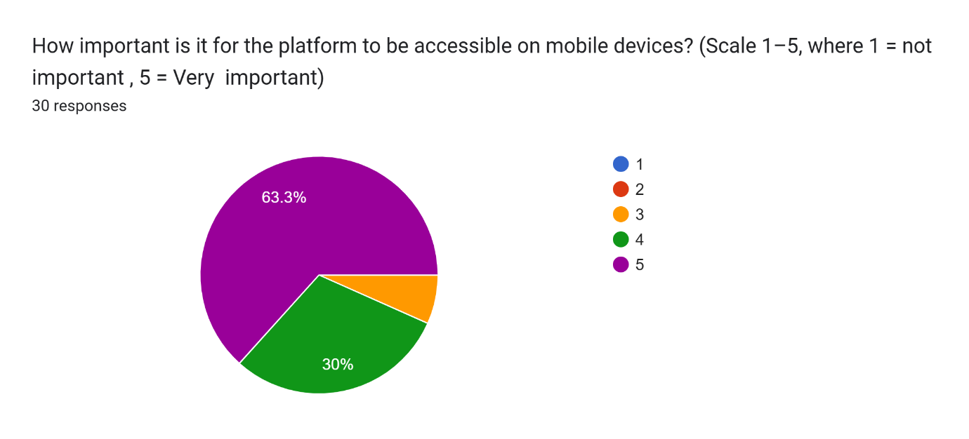
Figure 25: Importance of Mobile Accessibility

Mobile access is deemed critical, with 93.3% of participants rating it as important (4 or 5). This finding is essential for the technical design of the FYP, confirming that the solution must be a cross-platform (Web and Mobile) system to accommodate users who need to manage event tasks on the go.
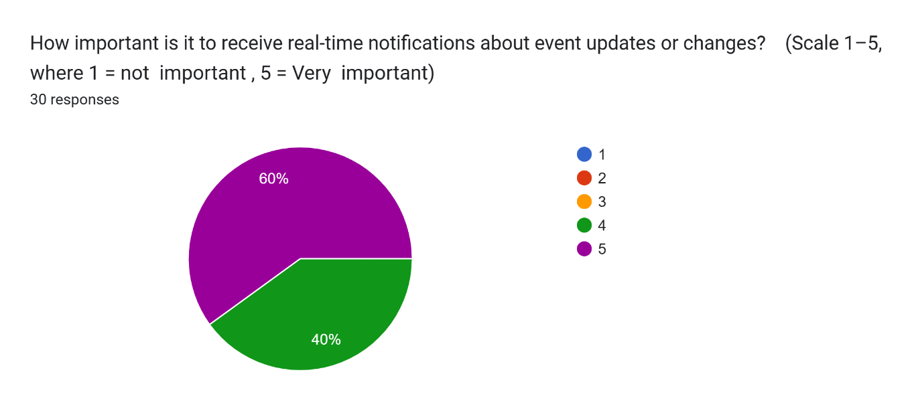
Figure 26: Importance of Real-Time Notifications
Real-time notifications received the highest "Importance" ratings in the entire survey, with 60% of participants rating them a 5 (Very Important). This emphasizes that the platform must include an automated alert system to inform users of status changes, approvals, or required revisions immediately.
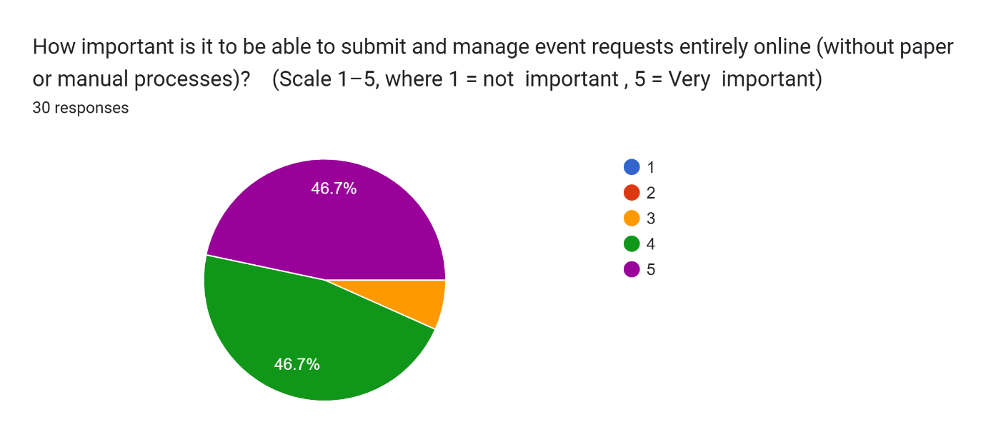
Figure 27: Preference for Fully Online Management
The move toward a paperless university is supported by the data, where 93.3% of participants expressed a strong desire to manage event requests entirely online. This confirms that the "Less Paper" initiative is a priority for the APU community, aligning the project with sustainable and modern administrative practices.

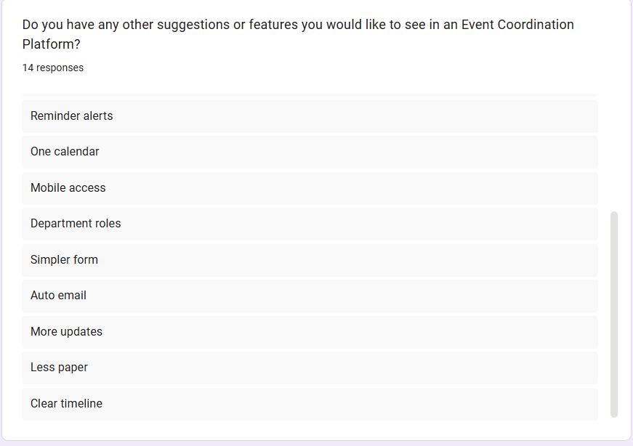
Figure 28: User-Suggested Feature Enhancements
The open-ended suggestions provide a roadmap for the platform's features. Users specifically requested high-level technical tools such as a Single Dashboard, Central Chat, Track Status, and Auto-Email alerts. These suggestions have been directly integrated into the final User Requirements List for the system, ensuring the development is truly user driven.
User suggestion:
- Central chat.
- Single dashboard.
- Track status.
- Faster approval.
- Better AV flow.
- Reminder alerts.
- One calendar.
- Mobile access.
- Department roles.
- Simpler form.
- Auto email.
- More updates.
- Less paper.
- Clear timeline.

3.8.2 Summary of Findings and Synthesis
The analysis of the quantitative data gathered from 30 stakeholders at APU highlights three critical conclusions that justify the development of the Intelligent Web and Mobile Event Management System:
- The "Information Silo" Problem: The heavy reliance on Excel (33.3%) and Email (30%) creates a fragmented environment where nearly half of the participants (46.7%) are dissatisfied with coordination. The data proves that current methods fail to provide a single "source of truth," leading to the confusion identified in Figure 20.
- Technological Readiness and Expectations: With 93.3% of users demanding mobile accessibility and 60% prioritizing real-time notifications, there is a clear expectation for a modern, responsive solution. The high potential for adoption (73.3%) suggests that the APU community is ready to move away from legacy manual processes.
- Operational Efficiency as a Catalyst: Perhaps the most significant finding is that 63.3% of participants believe a better system will lead to more events. This suggests that the current administrative burden is actually a barrier to university activity. By simplifying forms and centralizing approvals, the proposed platform will not only organize existing events but likely increase the overall vibrancy of campus life.

These findings directly inform the system design, specifically the need for Real-Time Status Tracking, and a Single Dashboard as requested by the participants.

3.9 Summary
This chapter established the methodological framework used for developing the centralized role-based event coordination platform. It began by evaluating several SDLC approaches, including Waterfall, Agile (Scrum), RAD, and hybrid models, highlighting their strengths and limitations in relation to system complexity, individual development, and evolving user requirements. The analysis showed that while traditional models offer structure and documentation, iterative approaches provide flexibility and better user alignment.
Based on this comparison and supporting literature, a Waterfall–Agile Hybrid with evolutionary prototyping was selected as the most suitable methodology. This approach combines structured planning for system architecture with iterative development and continuous feedback through prototyping tools. It ensures both stability in core system design and adaptability in user-facing features.
The chapter also outlined the overall development phases, data collection strategy, and analysis approach. Survey-based data from APU students and staff provided key insights into current event coordination challenges and validated the need for a centralized digital solution. Overall, the chosen methodology ensures a balanced, controlled, and user-driven development process aligned with both academic requirements and real-world institutional needs.

CHAPTER 4: DESIGN AND IMPLEMENTATION

4.1 Introduction
This chapter documents the design and implementation of the APU Event Management System, the centralised, role-based event coordination platform proposed in the earlier chapters of this report. Where Chapter 1 defined what the system was intended to achieve and Chapter 2 justified the technologies selected to build it, this chapter records what was actually designed and delivered. It presents the structural design of the system, the database that supports it, the interface through which users interact with it, the implemented screens themselves, and representative extracts of the source code that realise the behaviour described.
The chapter is organised to move from the abstract to the concrete. Section 4.2 presents the design of the system through a set of modelling views: the overall architecture and the layering it enforces, the identity and authorisation model on which every access decision depends, the capabilities available to each category of user expressed as use case diagrams, the behaviour of the approval and fulfilment workflow expressed as activity diagrams, and the ordering of messages between components expressed as sequence diagrams. Section 4.3 documents the physical database, presenting the entity relationship diagram of the deployed schema together with a data dictionary describing the purpose of every table. Section 4.4 addresses the interface, covering navigation structure, screen layout, the role-driven menu, the design tokens and shared components that hold the interface visually consistent, storyboards of the three principal user journeys, and the responsive strategy that allows the same pages to serve desktop and mobile users.
Section 4.5 then presents the delivered system itself. Each implemented screen is shown as captured from the running application on both a desktop and a mobile viewport, accompanied by a discussion of what the screen does, why it is designed as it is, and how it contributes to the objectives set out in Chapter 1. Section 4.6 presents annotated extracts of the source code behind the most significant behaviours in the system, and Section 4.7 summarises the chapter. Together these sections provide a complete account of how the proposed platform was translated from a documented intention into a working system.

4.2 Design

4.2.1 Design Overview and Rationale
The system is designed as a three-tier web application in which responsibility is separated strictly by layer. The presentation tier is an Angular single-page application that runs in the user's browser and is responsible only for rendering and for collecting input. The application tier is a Flask service that owns every rule in the system: it authenticates the caller, decides what that caller is permitted to do, executes the approval workflow, and is the only component permitted to reach the database. The data tier is a PostgreSQL database hosted as a managed service on Supabase. Two external services sit outside the system boundary and are reached only from the application tier: the Google Gemini model used by the assistant, and an SMTP relay used to send notification email.
The design is governed by three principles that recur throughout the chapter. The first is that the client is never the authority. The Angular application renders whatever the server returns and evaluates no permission rule of its own; the identity of the acting user is taken from the authentication token attached to each request and never from a field supplied by the browser. This principle is what allows the interface to be generated dynamically per role without weakening access control, because a page that appears in a user's menu is a page the server has already agreed that user may open.
The second principle is that state and evidence change together. Every transition in the approval workflow writes its audit record inside the same database transaction as the state change it describes, so the recorded history of a request can never disagree with the request's current status. If any part of a write fails, the whole transaction is rolled back and nothing is persisted. This directly supports the accountability objective stated in Chapter 1, because it makes the approval trail a by-product of the workflow rather than a separate record that must be maintained and can drift out of step.
The third principle is that behaviour which an administrator may reasonably need to change is stored as data rather than written into the code. The pages each role can reach, the option lists offered on the request form, the approval thresholds that decide whether a request must be seen by the CFO, and the escalation windows that decide when an approver is chased are all held in configuration tables and read at the moment they are needed. An administrator can therefore reconfigure the institution's coordination policy without a code change or a redeployment, which is a practical requirement for a system intended to survive changes in university procedure.

4.2.2 System Architecture
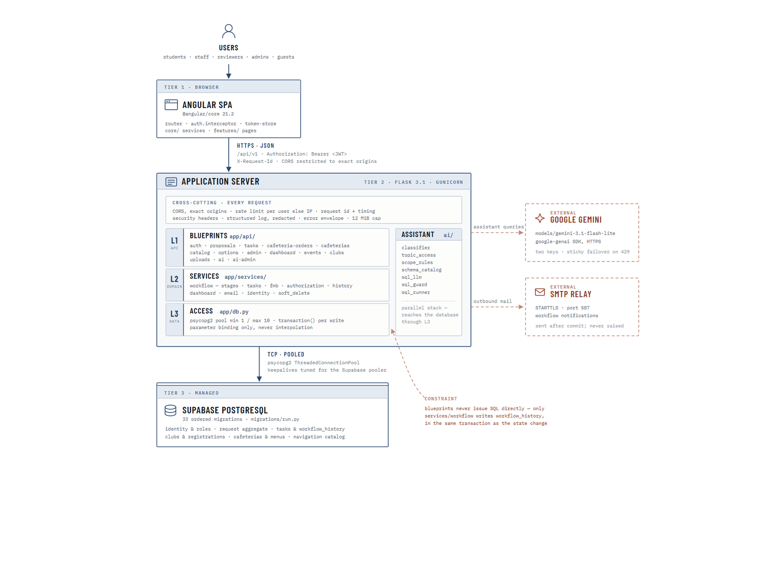
Figure 1: System architecture and deployment topology
Figure 29 presents the deployment and layering of the system. The browser tier holds the Angular application together with the routing, the authentication interceptor and the token store that manage the session on the client side. Communication with the server is exclusively over HTTPS using JSON, addressed to a single versioned API path, and every request carries the caller's access token in an Authorization header together with a correlation identifier used for log tracing. Cross-origin access is restricted to an explicit list of permitted origins rather than left open.
The application server is divided into three internal layers with a deliberate restriction on what each may do. The outermost layer holds the API blueprints, one per resource family, which parse and validate the request and format the response. Beneath it sits the domain layer, which contains the workflow state machine, the task and food-and-beverage services, the authorisation rules, the dashboard aggregations, the email templates and the soft-delete lifecycle. The innermost layer is the data access module, which owns the connection pool and the transaction helper, and which binds every value as a query parameter rather than interpolating it into a statement. The constraint annotated on the diagram is that a blueprint never issues SQL directly; a route that needs to change a request must go through the workflow service, which is where the audit record is written alongside the change.
A set of concerns is applied uniformly to every inbound request rather than being repeated per route. These include the cross-origin check, per-user rate limiting that falls back to the caller's address when no user is identified, the security headers, a structured log entry carrying the request identifier and timing, the single error envelope that returns a user-safe message while the internal detail is logged rather than disclosed, and a cap on request body size.
The assistant is shown as a parallel stack because it is not a route family in the ordinary sense. It holds its own classifier, topic access rules, scope rules, schema catalogue, generation step, guard and runner, and it reaches the database through the same data access layer as everything else, which is what prevents it from becoming a second and less careful path to the same records. The Gemini model and the SMTP relay are drawn with dashed borders to mark them as outside the system boundary; the model is reached with two credentials configured for automatic failover, and mail is dispatched only after a database transaction has committed.
The database is a managed PostgreSQL instance reached over a pooled connection. Its schema is applied by an ordered set of migration files rather than by manual changes, which means the database can be rebuilt from an empty state into a known configuration. This is the arrangement described and justified in Section 2.4.6 of this report, shown here in the detail that the design of the application depends on.

4.2.3 Security and Identity Design
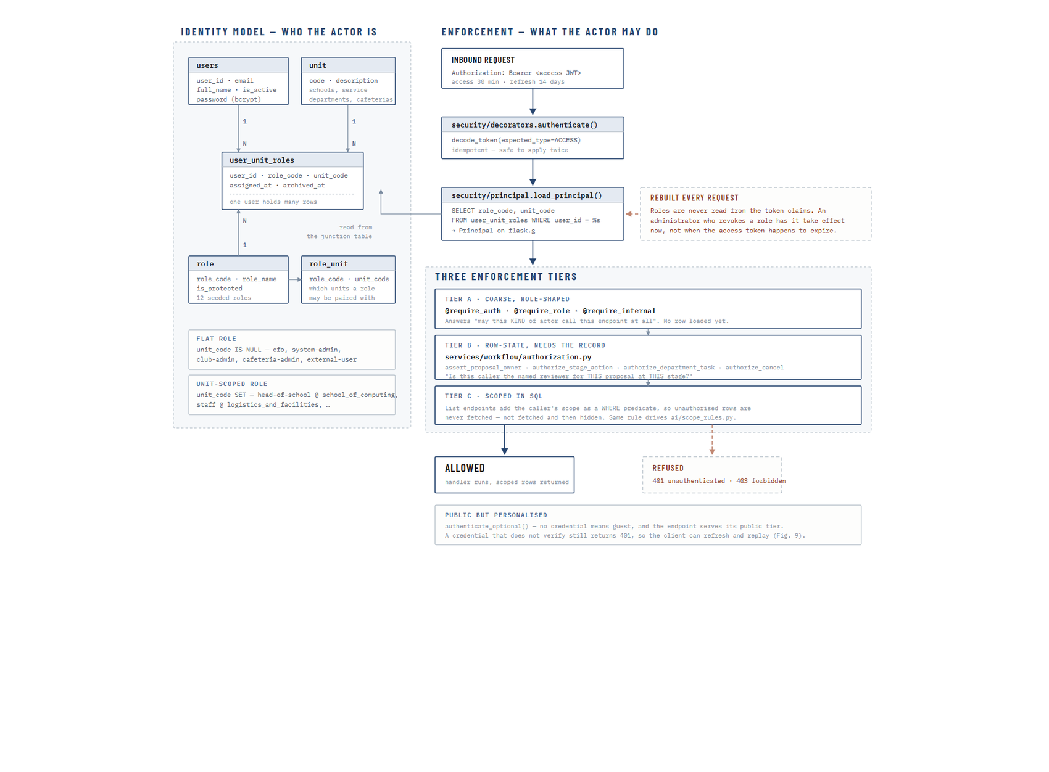
Figure 1: Identity model and the three authorisation tiers
Figure 30 presents the identity model on the left and the enforcement path on the right. The identity model is the design decision that most distinguishes this system from the systems reviewed in Chapter 2. A role is not held by a user globally; it is held by a user within an organisational unit, recorded as a row in a junction table that pairs a user, a role and a unit. The same person may therefore be a member of staff in one department and hold no standing at all in another, and a Head of Department carries authority only over the unit named on their own assignment. A small number of roles are deliberately unit-independent, such as the CFO, the System Admin, the Club Admin, the Cafeteria Admin and the external guest account, and these are stored with no unit attached. A supporting table records which roles are legal to pair with which units, so an administrator cannot create a nonsensical assignment such as a Head of School over a cafeteria.
The enforcement path shows what happens to every request that reaches the server. The access token is decoded and its type verified, so that a refresh token cannot be presented in place of an access token. The caller's roles are then loaded from the database rather than read from the claims inside the token. This is a deliberate cost: reading the roles on every request is more work than trusting the token, but it means that when an administrator revokes a role the revocation takes effect immediately rather than when the user's current token happens to expire.
Authorisation is then applied in three tiers, each answering a different question. The first tier is a coarse, role-shaped decorator on the route itself, which answers whether this kind of actor may call this endpoint at all; at this point no record has been loaded. The second tier is applied after the record is loaded and answers a question that only the record can settle, such as whether this caller is the named reviewer for this particular request at its current stage, or whether this caller owns the proposal they are trying to cancel. The third tier applies to list endpoints, where the caller's scope is added to the query as a filtering condition so that records outside their scope are never retrieved at all, rather than being retrieved and then hidden. The same scope rules are the ones applied to the assistant, which is why the assistant cannot be used to reach records the interface would refuse to show.
Two supporting behaviours complete the picture. Endpoints that serve both public and signed-in visitors use an optional authentication path, where the absence of a credential is treated as a guest and the public tier of the content is served, while a credential that is present but does not verify still returns an authentication failure so that the client can refresh its session and retry. Passwords are stored only as bcrypt hashes, and password reset is performed through a hashed, expiring token rather than by transmitting a password.

4.2.4 Use Case Design
The capabilities of the system are documented across three use case diagrams rather than one. A single diagram covering twelve roles and the full functional surface of the platform would be dense to the point of being unreadable, and the three natural groupings in the system are sufficiently distinct to be modelled separately: the capabilities available for access, discovery and community participation; the capabilities that make up the event request, approval and fulfilment cycle; and the capabilities reserved for administration, configuration and oversight. Each diagram is presented with the system boundary drawn explicitly, so that what is inside the delivered platform and what is outside it remains unambiguous.
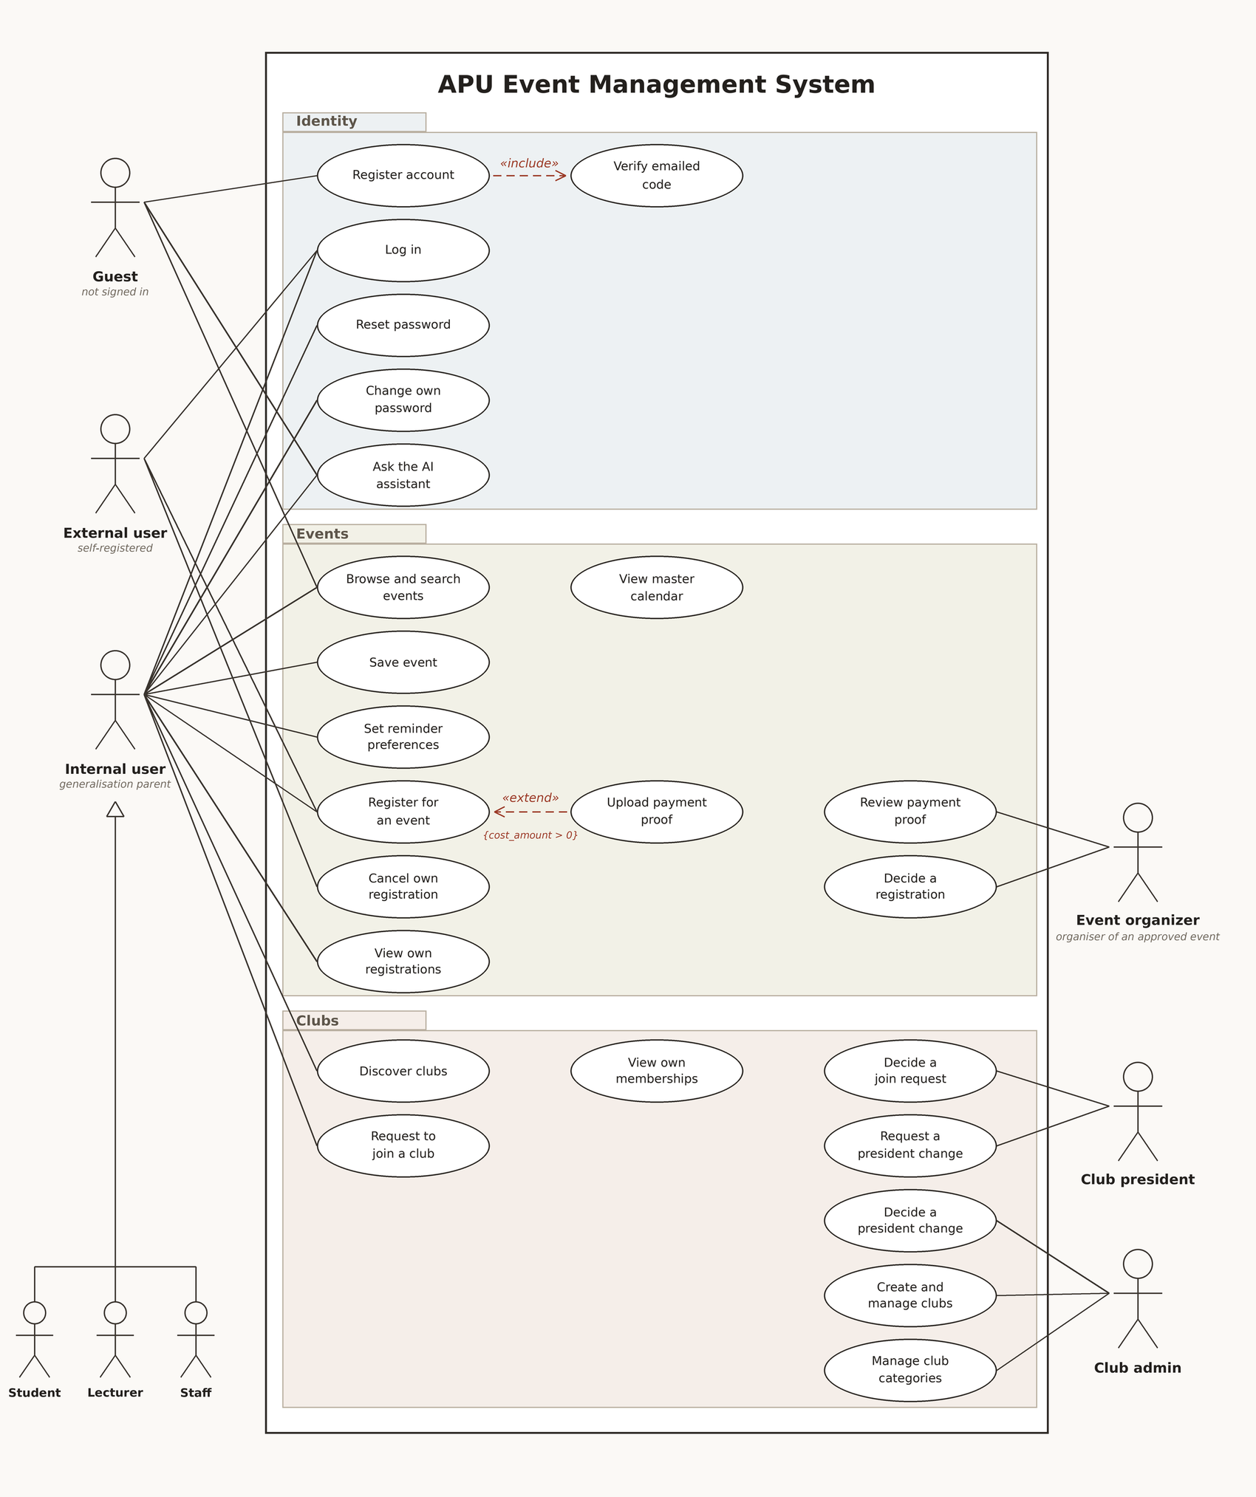
Figure 1: Use case diagram — access, events and community
Figure 31 models the capabilities available to visitors, self-registered external users, and the internal population of students, lecturers and staff. The three internal roles are drawn as specialisations of a generalisation parent because they share an identical capability set at this level; the differences between them appear later, in the request cycle and in the pages the navigation grants make available. A guest who has not signed in can browse and search published events, view the master calendar, register an account and ask the assistant, which reflects the deliberate decision recorded in Chapter 1 to give the platform a genuine public face rather than confining it entirely behind the login.
Account creation is modelled with an included verification step, because the design does not create a user record at the point the registration form is submitted. A verification code is issued and only a successfully verified attempt becomes an account, which prevents abandoned or automated registrations from accumulating as real users. Registering for an event carries an extension rather than an inclusion, because uploading payment proof applies only when the event actually carries a cost; the conditional nature of that step is what the extension notation is intended to express.
The community half of the diagram introduces two actors that are defined by circumstance rather than by an assigned role. An event organiser is the person whose approved event has been published, and it is that circumstance that gives them the ability to decide a registration and review payment proof. A club president is similarly the current president of a particular club, and it is that position that lets them decide join requests and request a change of president. Distinguishing these from the twelve assigned roles matters, because they are authorised by a relationship to a record rather than by an entry in the role table, and that is exactly the distinction the second authorisation tier described in Section 4.2.3 exists to enforce.
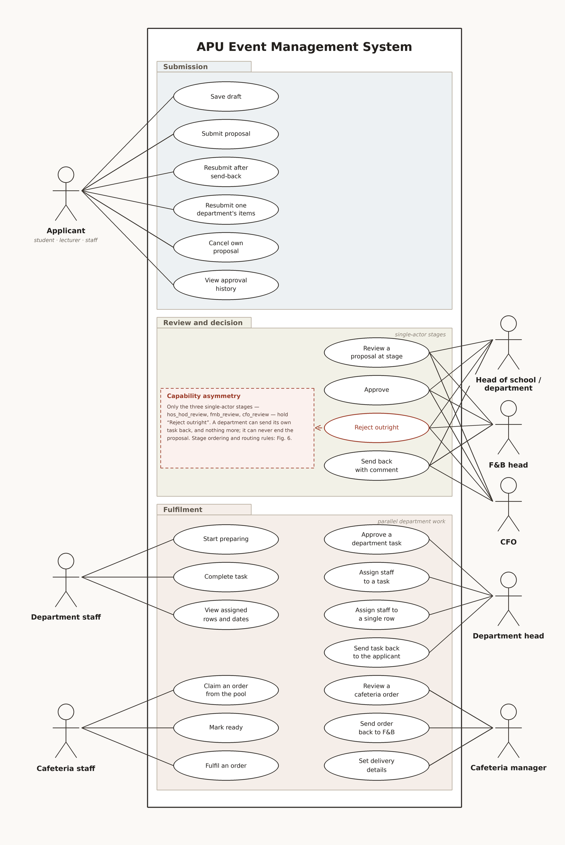
Figure 1: Use case diagram — request submission, review and fulfilment
Figure 32 models the core of the system: the creation, review and fulfilment of an event request. The applicant, who may be a student, a lecturer or a member of staff, can save a draft, submit it, cancel it, view its approval history, and resubmit it. Two distinct forms of resubmission are modelled because two genuinely different situations exist. A request sent back by one of the reviewer stages returns to the applicant as a whole; a request sent back by a single department returns only that department's section, and the other departments retain the progress they have already made.
The review group carries the most important asymmetry in the design, and it is annotated on the diagram so that it cannot be missed. Only the three single-actor reviewer stages, held by the Head of School or Head of Department, the Food and Beverage head, and the CFO, are able to reject a request outright and end it. A service department reviewing its own task can approve it or send it back for correction, and nothing more. This is a deliberate choice: a department is being asked whether it can deliver its own portion of the work, not whether the event should take place, and giving a single service department the power to cancel an event on behalf of the whole institution would misrepresent where the decision authority actually sits.
The fulfilment group divides the work between the Head of Department, who approves the department's task and decides who will carry it out, and the department staff, who perform it. Assignment is modelled at two levels because the system supports both: a task may be assigned as a whole, or, for the five requirement types that are itemised row by row, individual rows of the task may be assigned to different staff members. The cafeteria pathway is modelled separately because its shape genuinely differs; the manager reviews and approves the order and it then enters a pool visible to that outlet's staff, from which a staff member claims it, prepares it, marks it ready and records its delivery.
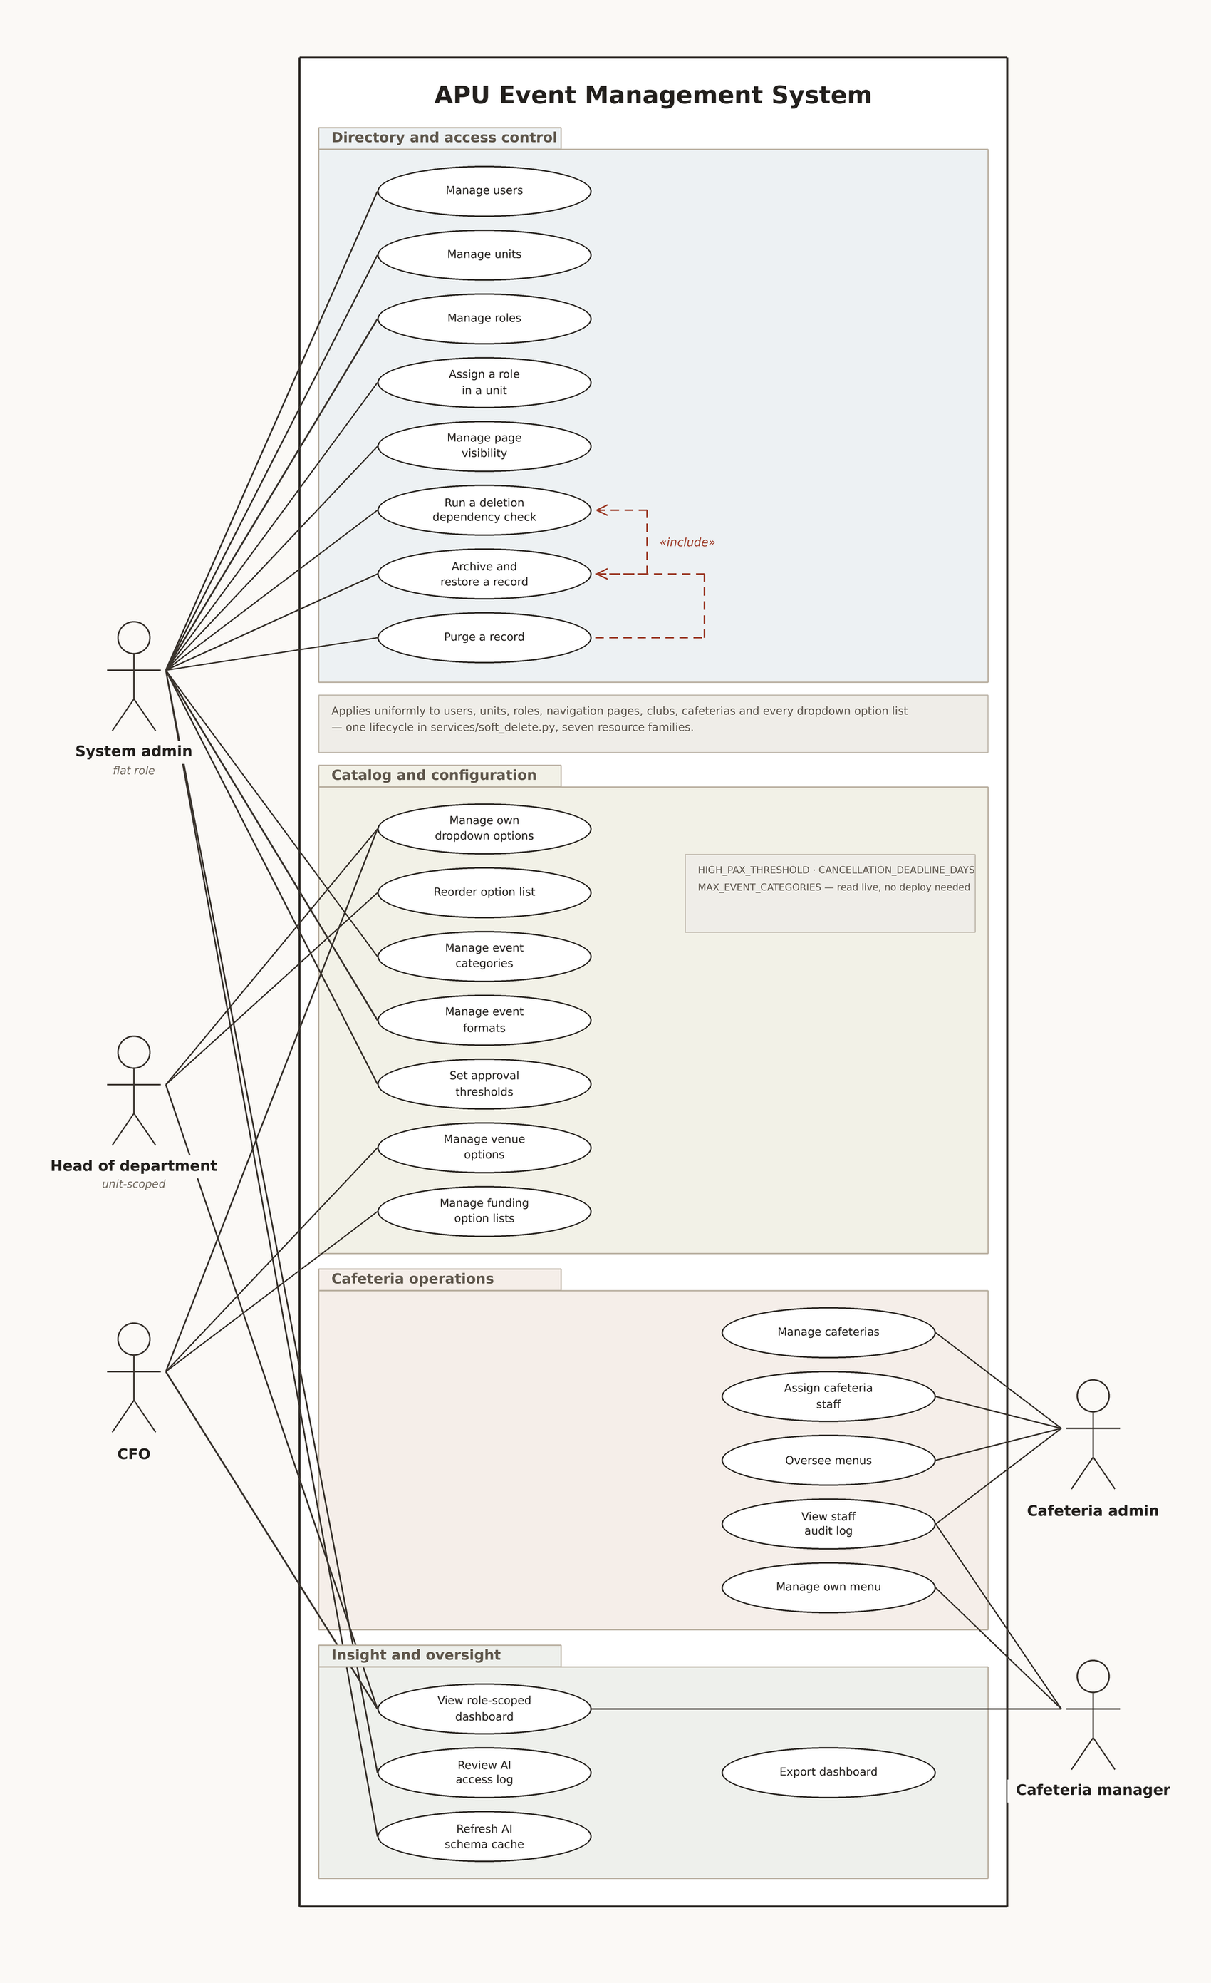
Figure 1: Use case diagram — administration, configuration and oversight
Figure 33 models administration, configuration and oversight. The System Admin holds the flat, unit-independent role that maintains the directory of users, organisational units and roles, assigns a role to a user within a unit, and controls which pages each role can reach. The deletion pathway is modelled with an included dependency check because deletion in this system is not immediate: a record is first checked for dependants, then archived and recoverable, and only later purged. The same three-step lifecycle applies uniformly across users, units, roles, navigation pages, clubs, cafeterias and every dropdown option list, which is why it appears once in the model rather than being repeated for each resource.
The configuration group shows a deliberate distribution of authority. Each Head of Department maintains the option list belonging to their own department and no other, so the Logistics head curates the logistics catalogue while the A/V head curates sound and light. The CFO owns the venue catalogue and the funding option lists, which is consistent with the CFO's role as the financial reviewer. The System Admin owns the institution-wide settings: the event categories and formats, and the numeric thresholds that govern approval routing and escalation. These thresholds are read at the moment they are used rather than compiled into the application, so a change takes effect on the next request.
The oversight group covers the role-scoped dashboards, which are available to every role that has operational responsibility and which present only the measures relevant to that role, together with the export of any panel for reporting. The AI access log and the assistant's schema refresh are reserved to the System Admin, which reflects the position taken in Section 4.2.3 that the assistant is a privileged component and its use must be reviewable.
Use case specification tables for five representative use cases are presented below.
Field | Description
Primary Actor | Applicant (Student, Lecturer or Staff)
Description | The applicant completes the six-step event request form and submits it for review.
Preconditions | The applicant is signed in and holds a role within an organisational unit.
Postconditions | The request is stored with a status of submitted, a task is created for every selected requirement, and the first reviewer is notified by email.
Main Flow | The applicant opens the request form, completes the applicant, event, requirement, request detail and detailed information steps, reviews the summary, and submits. The system validates the form, writes the request, its requirement rows and its first history entry in a single transaction, determines the first reviewer stage, and sends notification after the transaction commits.
Alternative Flow | The applicant saves the form as a draft at any step and resumes later from the Drafts page.
Exception Flow | If validation fails, the affected fields are marked and no record reaches the database.

Table 1: Use Case Specification — Submit an Event Request
Field | Description
Primary Actor | Head of School or Head of Department, Food and Beverage Head, CFO
Description | The reviewer holding the request's current stage approves it, rejects it, or sends it back to the applicant with a comment.
Preconditions | The request is at a stage the reviewer holds, and the reviewer has not already decided it.
Postconditions | The request advances to the next stage, ends as rejected, or returns to the applicant for resubmission, and the decision is recorded in the workflow history.
Main Flow | The reviewer opens the request from the inbox, reads the summary and the requirement detail, enters a comment if one is required, and selects a decision. The system verifies that this reviewer is the authorised actor for this request at this stage, applies the status change and the history record in one transaction, and notifies the parties affected.
Alternative Flow | If the request is sent back, the stage it was sent back from is recorded so that resubmission resumes at that point rather than restarting the approval sequence.
Exception Flow | A rejection submitted without a reason is refused, and the reviewer is asked to supply one.

Table 1: Use Case Specification — Review a Request at a Stage
Field | Description
Primary Actor | Head of Department
Description | The department head approves the task routed to their department and assigns staff to carry it out.
Preconditions | The request has passed the reviewer stages and a task exists for this department.
Postconditions | The task moves to preparing, and the assigned staff members see it in their own task list.
Main Flow | The head opens the incoming request, reviews the requirement rows, approves the task, and selects one or more staff members. For requirement types that are itemised, the head may assign individual rows to different staff members.
Alternative Flow | The head sends the task back to the applicant with a comment; the tasks belonging to other departments continue unaffected.
Exception Flow | A requirement type that permits only one assignee refuses a second assignment.

Table 1: Use Case Specification — Assign Staff to a Department Task
Field | Description
Primary Actor | Internal user or External user
Description | A user registers to attend an event that has been approved and published.
Preconditions | The event is published and has capacity remaining.
Postconditions | A registration record exists with a status determined by the event's approval setting and its cost.
Main Flow | The user opens the event, submits a registration with a reason for attending where required, and the system records the registration. Where the event registers attendees automatically the place is confirmed immediately; where the organiser reviews registrations the record waits for a decision.
Alternative Flow | Where the event carries a cost, the user uploads payment proof and the organiser approves or rejects it before the place is confirmed.
Exception Flow | A registration submitted for an event at capacity is refused.

Table 1: Use Case Specification — Register to Attend a Published Event
Field | Description
Primary Actor | Any signed-in user, and guests for public topics
Description | The user asks a question in ordinary language and receives an answer drawn either from the curated knowledge base or from the user's own records.
Preconditions | The assistant is available and the user's session is valid.
Postconditions | An answer is returned and the interaction is recorded in the access log.
Main Flow | The question is classified into a topic, the topic is checked against the caller's permitted topics, the caller's row-level scope is derived, only the tables that scope permits are described to the model, a query is generated and validated against the guard, and the validated query alone is executed.
Alternative Flow | A repairable fault in the generated query, such as an unknown column or a missing filter, is returned to the model with the exact reason and a further attempt is made, up to a fixed limit.
Exception Flow | If the guard reports an authorisation violation the request is refused outright, the denial is logged, and no retry is attempted.

Table 1: Use Case Specification — Ask the AI Assistant

4.2.5 Workflow Design (Activity Diagrams)
The behaviour of the system is documented across three activity diagrams, each owning one lifecycle. The first covers the request itself from creation to a terminal state, the second covers what happens inside a department once a request reaches it, and the third covers the attendance registration that follows publication. Splitting them in this way keeps each diagram legible and avoids restating the same routing rules in three places.
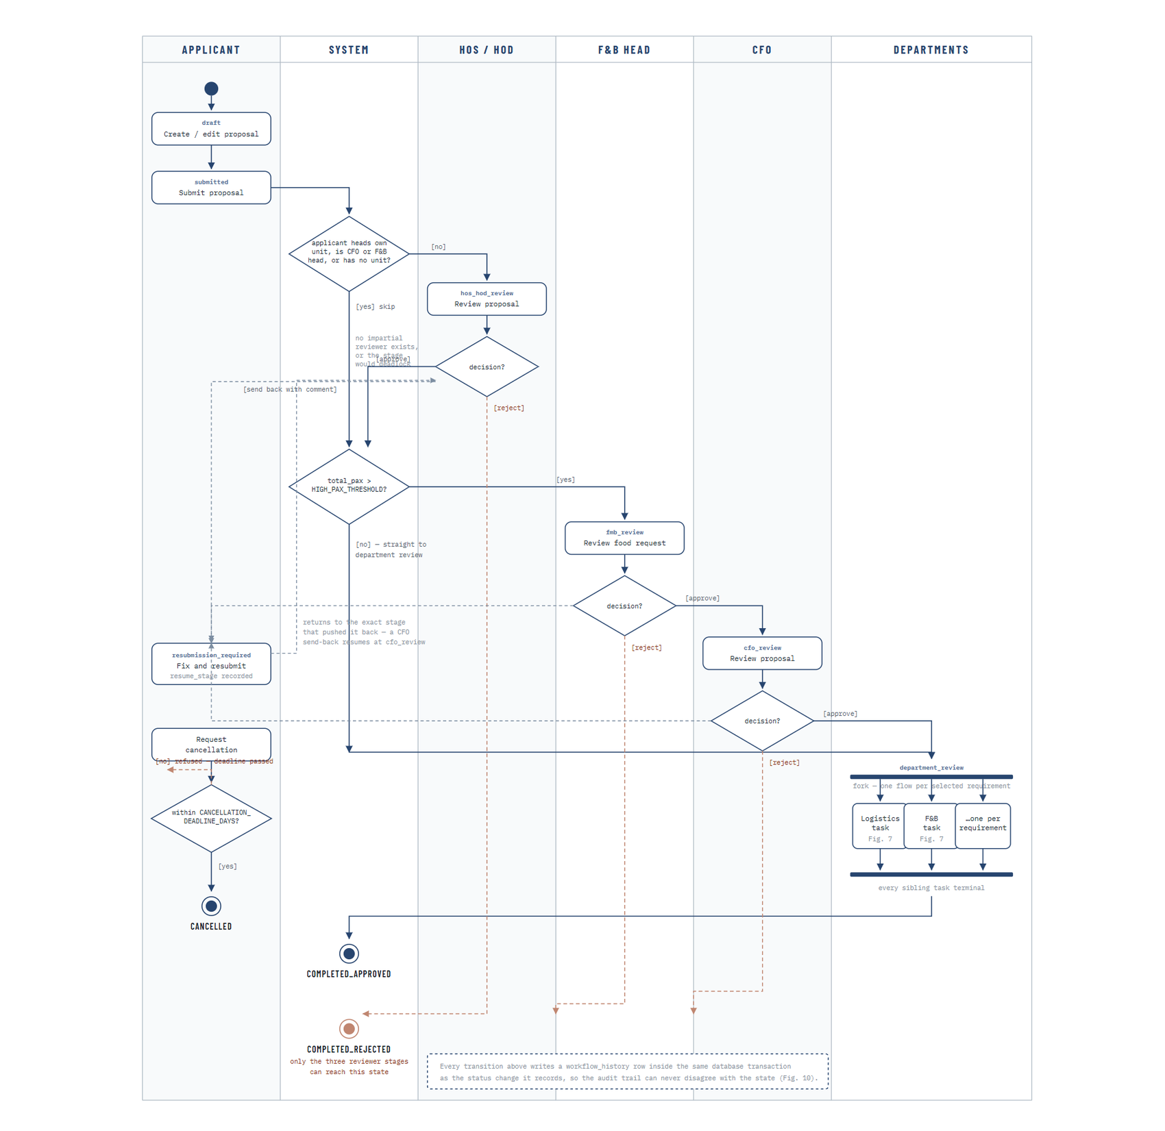
Figure 1: Activity diagram — event request lifecycle
Figure 34 models the full lifecycle of an event request across six swimlanes. A request begins as a draft owned by the applicant and enters the workflow on submission. The first decision the system makes is whether a Head of School or Head of Department review is meaningful at all: where the applicant is themselves the head of the unit the request would be routed to, or is the CFO or the Food and Beverage head, or holds no unit at all, no impartial reviewer exists and the stage is skipped rather than allowed to deadlock. This is a small piece of design that prevents a common institutional failure, in which a request waits indefinitely for an approval that can only be given by the person who raised it.
The request is then evaluated against the configured attendance threshold. Requests at or below the threshold pass directly to departmental review; requests above it are routed through the Food and Beverage head and then the CFO, which is where the financial oversight described in Chapter 1 is applied. The threshold itself is a configuration value rather than a constant, so the institution can raise or lower the point at which financial review becomes mandatory without a change to the system.
Three reviewer stages can each approve, reject or send back. A rejection is terminal and ends the request. A send-back returns the request to the applicant with a comment and records the stage it was sent back from, so that when the applicant corrects and resubmits, the request resumes at that stage rather than beginning the approval sequence again. This is the structured revision loop identified as a gap in Chapter 2, and the recorded resume point is what makes it work without discarding approvals already given.
Once the reviewer stages are satisfied, the request forks into one flow per selected requirement, and each department works its own task in parallel and independently. The join condition is that when every sibling task reaches a terminal state the parent request completes automatically; no further human action is required to close it. A separate path allows the applicant to request cancellation, which is permitted only while the event remains far enough away to satisfy the configured cancellation deadline. The annotation at the foot of the diagram records the invariant that every transition shown writes its history row inside the same transaction as the status change it represents.
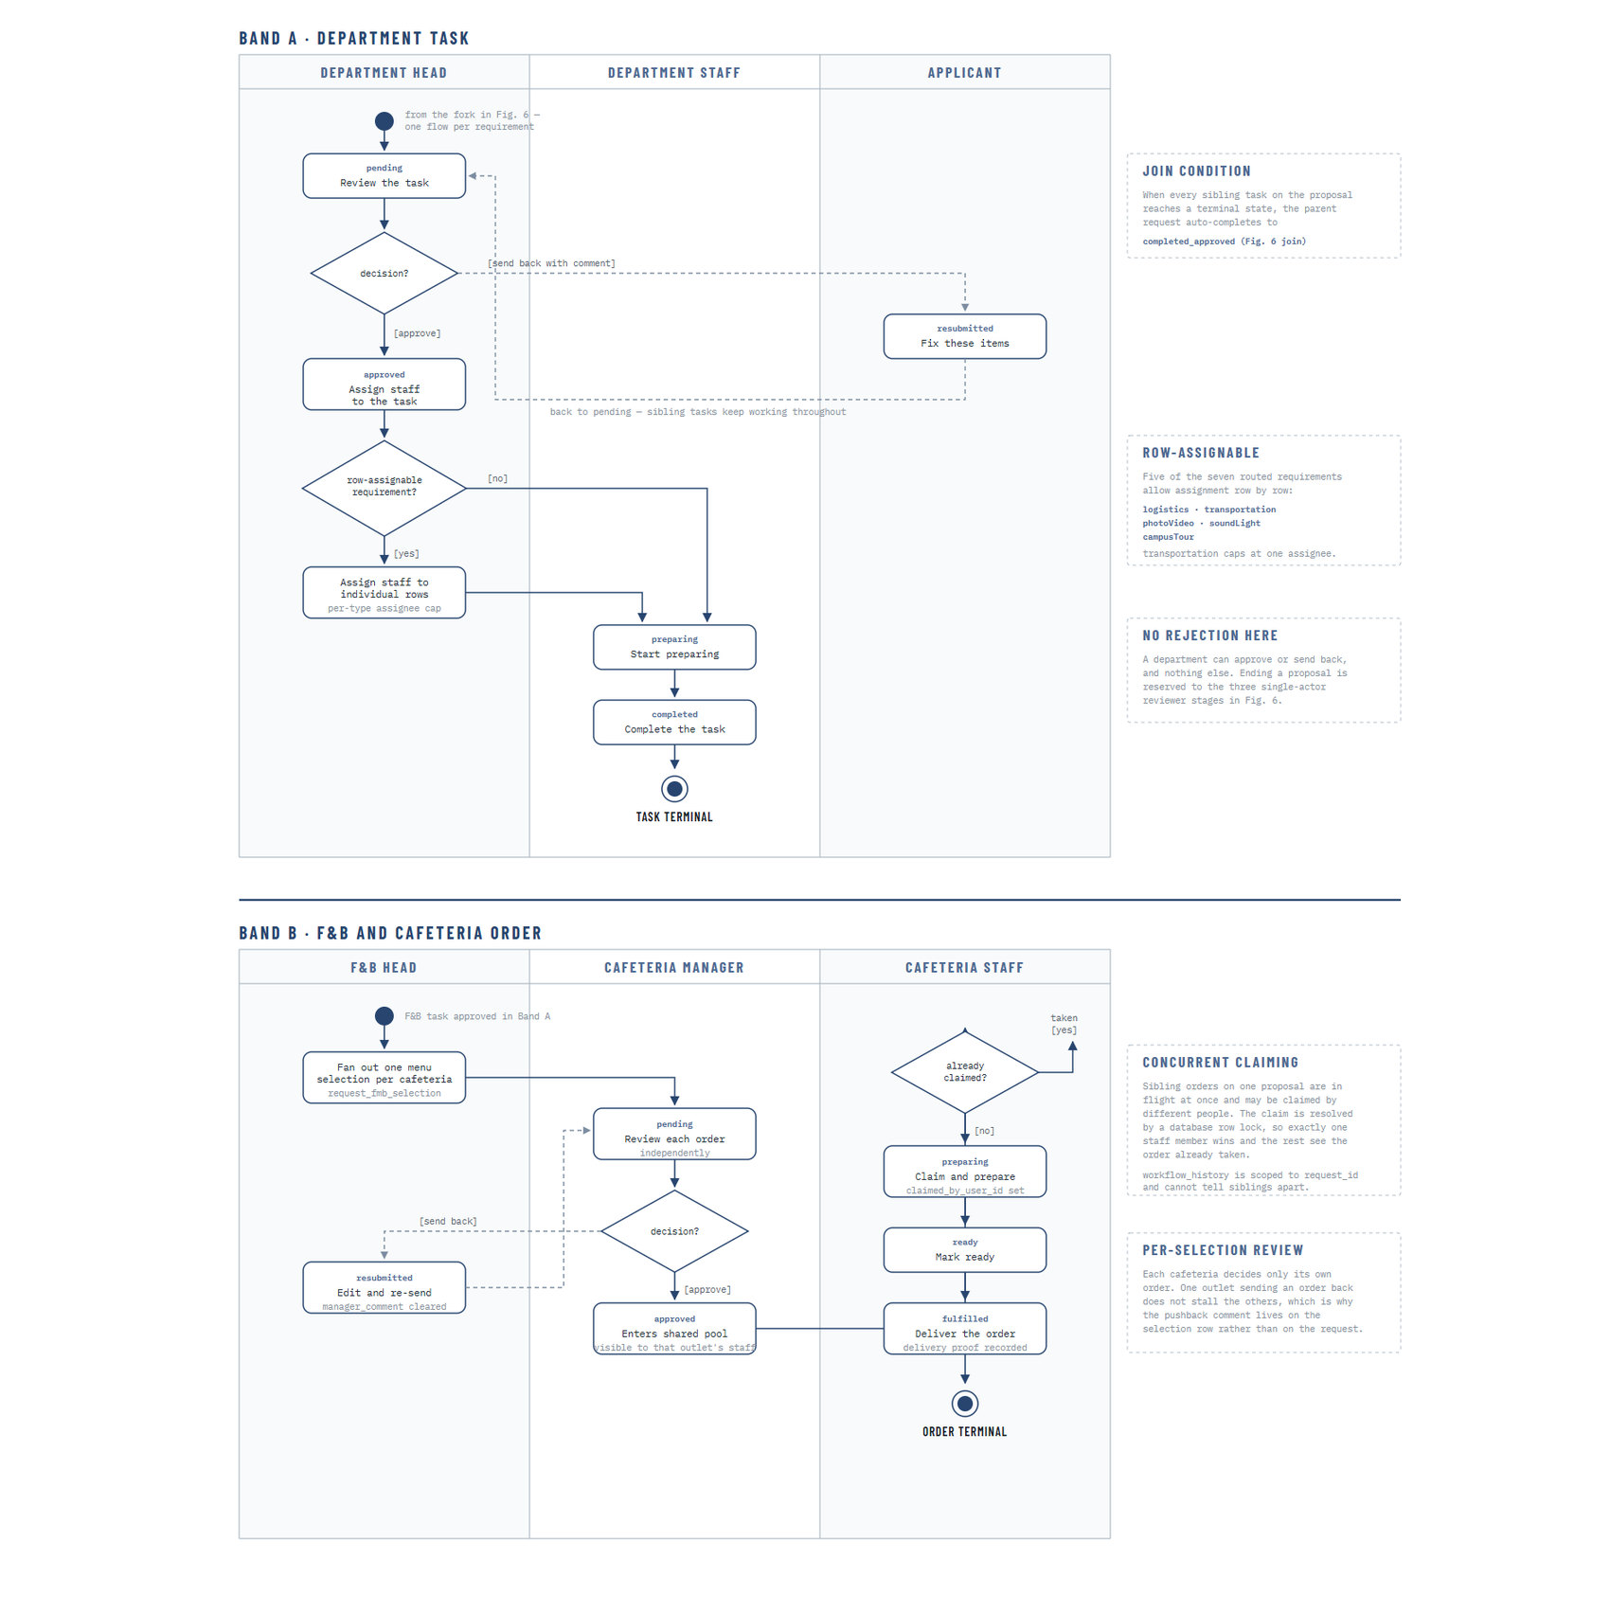
Figure 1: Activity diagram — department task and cafeteria order fulfilment
Figure 35 models what happens inside a department once a task arrives, and it is presented in two bands because the ordinary department pathway and the cafeteria pathway genuinely differ. In the upper band, a task arrives pending, the Head of Department reviews it and either approves it or sends it back to the applicant with a comment. A department cannot reject a request outright, and the annotation states this explicitly; that capability belongs only to the three reviewer stages in the preceding diagram.
Where the requirement type is itemised, the head may assign staff to individual rows rather than to the task as a whole. Five of the seven routed requirement types permit this, and transportation is capped at a single assignee because a single vehicle movement cannot sensibly be shared. The task then moves to preparing while the assigned staff carry it out, and to completed when the work is done. Sibling tasks belonging to other departments continue throughout, including while this task is sitting with the applicant for correction.
In the lower band, a food and beverage requirement fans out into one order per cafeteria named in the request, and each cafeteria decides only its own order. A manager who sends an order back does not stall the other outlets, which is why the pushback comment is stored against the individual selection rather than against the request. An approved order enters a pool visible to that outlet's staff, and the claim is resolved by a database row lock so that when several staff open the same order at once exactly one succeeds and the others are told the order has already been taken. The order then moves through ready to fulfilled, with delivery evidence recorded against it.
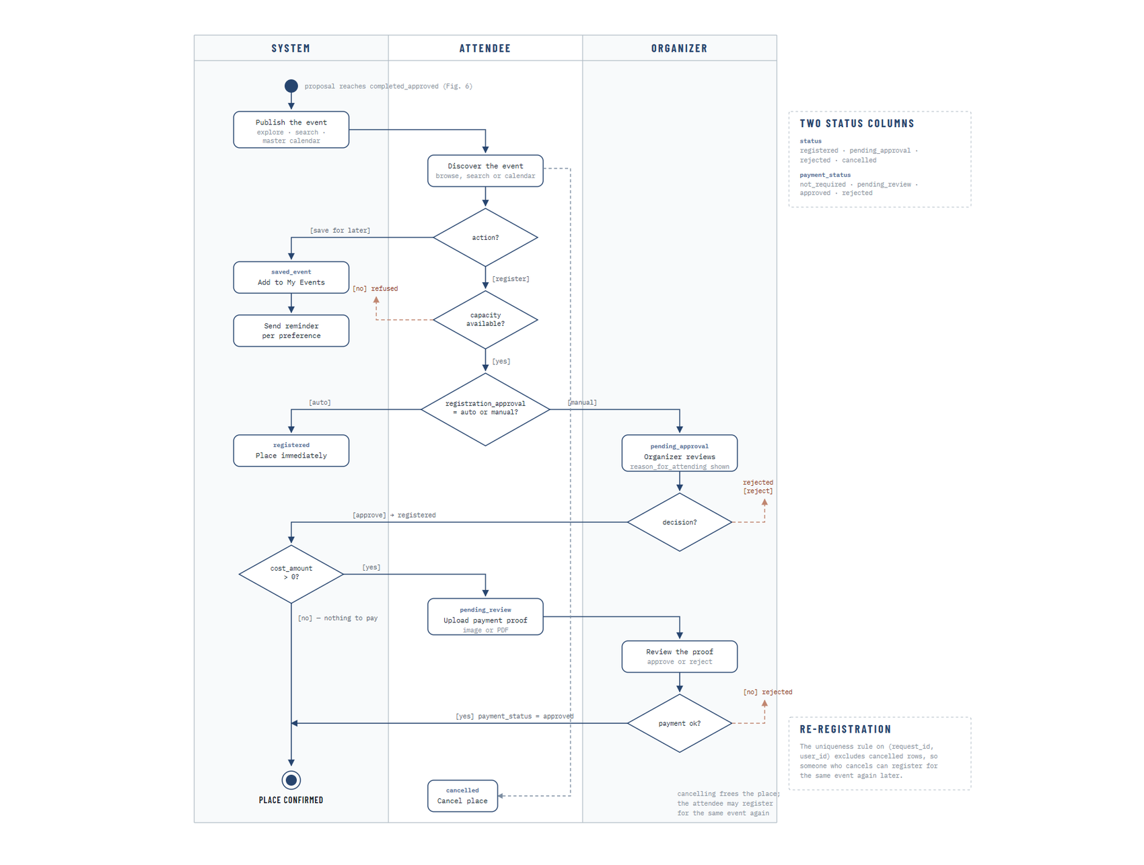
Figure 1: Activity diagram — event publication and attendance registration
Figure 36 models what happens after a request completes and its event is published. A visitor may discover the event by browsing, searching or through the calendar, and may either save it for later or register to attend. Saving an event places it in the user's own list and enrols them in the reminder schedule, subject to the preferences they control themselves.
Registration is governed by two independent status columns, and the diagram shows why both are needed. The first records whether the person holds a place, and it depends on whether the event registers attendees automatically or requires the organiser to decide each request. The second records the state of payment, and it applies only where the event carries a cost, in which case the attendee uploads proof and the organiser approves or rejects it. A place is confirmed only when both conditions are satisfied. Keeping the two columns separate avoids conflating an organiser's decision about who may attend with a finance decision about whether payment has been received.
A registration that is cancelled frees the place, and the uniqueness rule that prevents duplicate registrations deliberately excludes cancelled rows, so a person who cancels is able to register for the same event again later. This is a small behaviour, but it is the kind of detail that determines whether a system feels usable in practice.

4.2.6 Interaction Design (Sequence Diagrams)
The three sequence diagrams that follow document the ordering of messages between components for the interactions where ordering is itself part of the design. They are selected rather than exhaustive: authentication, because the session behaviour it defines applies to every other interaction in the system; the write path, because the ordering of the transaction and the notification is a deliberate design decision; and the assistant, because the order in which authorisation, generation and validation occur is what makes the feature safe.
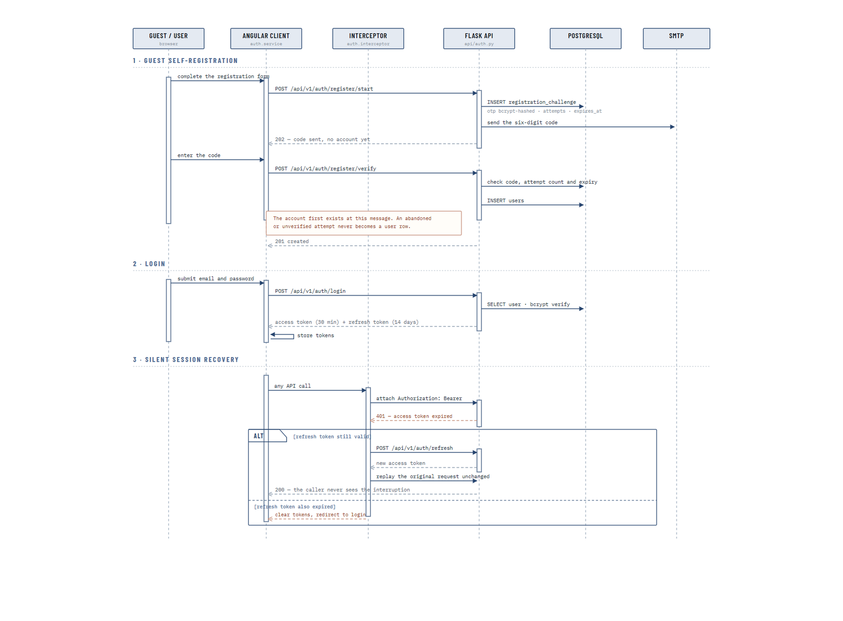
Figure 1: Sequence diagram — registration, login and silent session recovery
Figure 37 documents three related interactions. In guest self-registration, the account does not exist at the moment the form is submitted. A verification challenge is stored with the code hashed, an attempt counter and an expiry, and the code is emailed. Only when the code is verified is a user record created. The annotation marks the exact message at which the account first exists, and the consequence is that an abandoned or automated registration attempt never becomes a real user.
In login, the submitted credentials are verified against the stored bcrypt hash and the caller receives two tokens: a short-lived access token and a longer-lived refresh token. The separation exists so that the credential presented on every request has a small exposure window, while the user is not forced to sign in again every half hour.
The third interaction is silent session recovery, and it is the reason the separation is worth the additional complexity. When an access token expires, the interceptor on the client receives the authentication failure, exchanges the refresh token for a new access token and replays the original request unchanged, so the user never sees the interruption. Only when the refresh token has itself expired are the stored tokens cleared and the user returned to the login page. This behaviour is important in a workflow system, where a reviewer may leave a long request open while reading it and would otherwise lose their work to a session timeout.
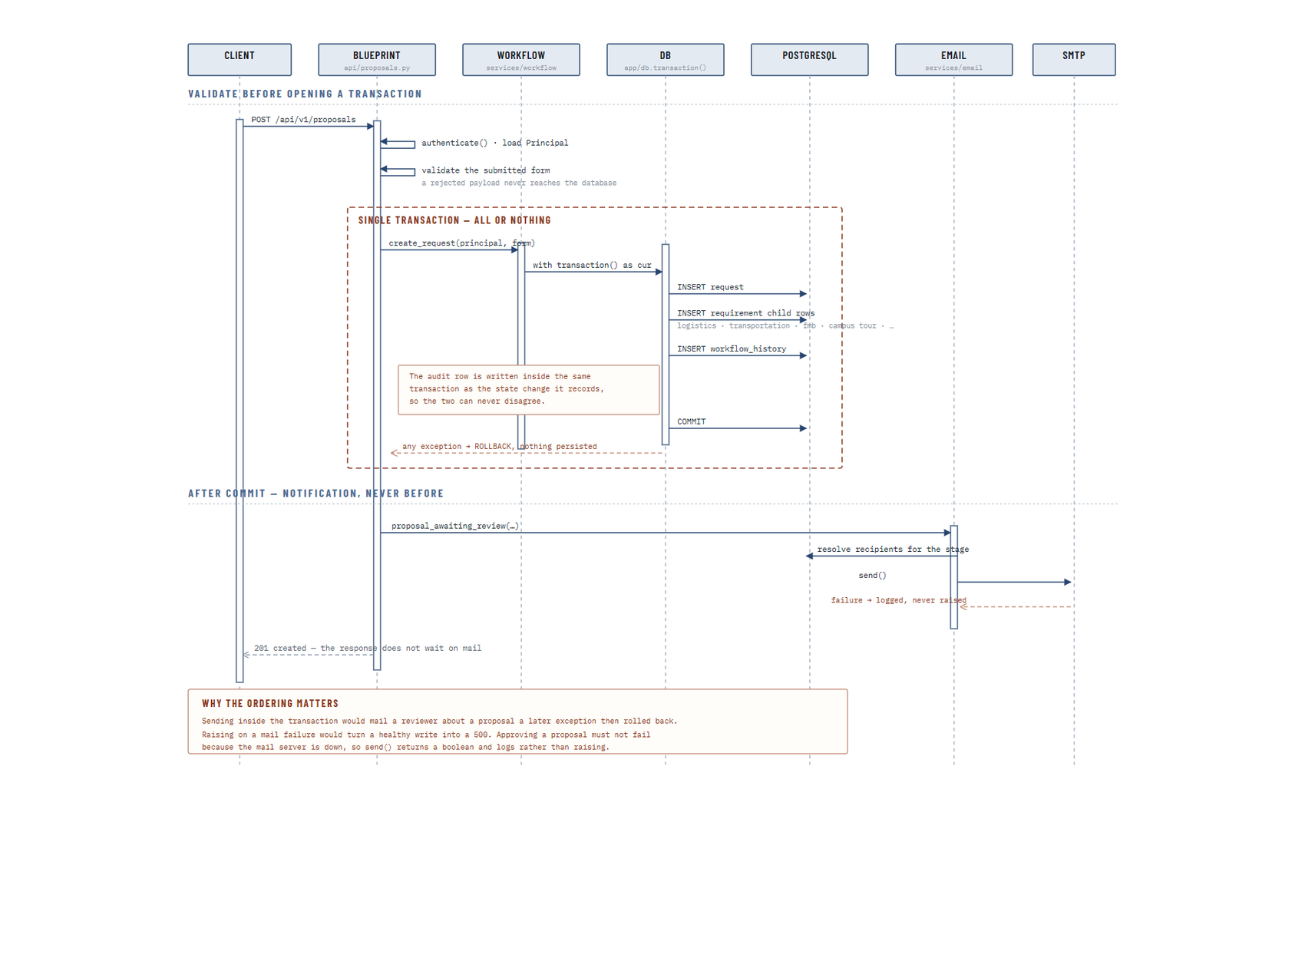
Figure 1: Sequence diagram — transactional write path and post-commit notification
Figure 38 documents the write path taken by every state-changing operation in the system, using the creation of a request as the example. The ordering shown is the design, not an implementation accident, and it has three distinct phases.
Validation happens before a transaction is opened. The caller is authenticated and their principal loaded, and the submitted form is validated; a payload that fails validation never reaches the database at all. Opening a transaction and then discovering the input was invalid would hold a connection and produce a rollback for a fault that could have been detected earlier.
The write itself takes place inside a single transaction covering the request row, the requirement child rows and the history entry. The annotation records the reason: because the audit row is written in the same transaction as the state change it describes, the two cannot disagree. Any exception at any point rolls the whole transaction back and nothing is persisted.
Notification is dispatched only after the transaction has committed, and the response to the client does not wait for the mail to be sent. The lower annotation gives the two reasons. Sending inside the transaction would email a reviewer about a request that a later exception then rolled back, so a reviewer could be notified about work that does not exist. Raising an exception on a mail failure would turn a healthy write into a server error, so an approval would appear to fail because the mail server was unavailable. The send therefore returns a result that is logged rather than raised.
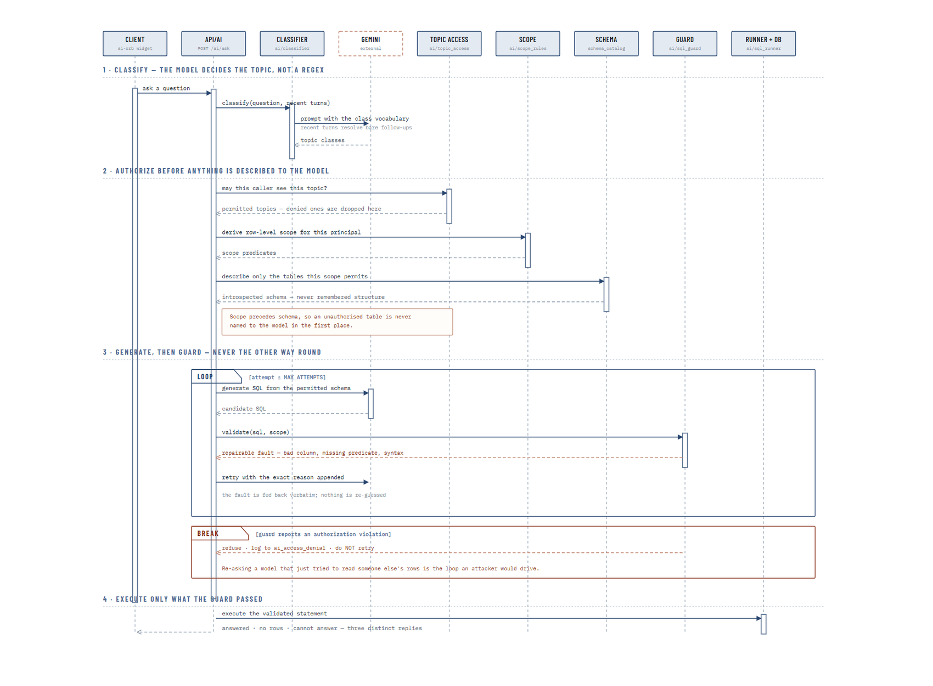
Figure 1: Sequence diagram — AI assistant question-answering pipeline
Figure 39 documents the assistant's question-answering pipeline, and the order of its four phases is the whole of its security design. In the first phase the question, together with the recent conversation, is classified into a topic by the model itself rather than by pattern matching, which is what allows a bare follow-up question to be resolved against what was asked before it.
The second phase performs authorisation before anything is described to the model. The classified topic is checked against the topics this caller is permitted to ask about, and topics they may not reach are dropped. The caller's row-level scope is derived, and only the tables that scope permits are then described to the model. The annotation states the consequence plainly: because scope precedes schema, a table the caller may not read is never named to the model in the first place, and the model cannot generate a query against a structure it was never shown.
The third phase generates a query and then validates it, never the reverse. A repairable fault, such as an unknown column, a missing filter or a syntax error, is returned to the model with the exact reason appended so that the next attempt corrects a stated problem rather than guessing again, and this loop is bounded by a fixed attempt limit. An authorisation violation is treated entirely differently: it breaks out of the loop, is refused, and is written to the denial log without a retry. The annotation gives the reason, which is that re-asking a model that has just attempted to read another user's records is precisely the loop an attacker would want to drive.
The fourth phase executes only the statement the guard has already passed, and returns one of three distinct replies: an answer, an explicit statement that no rows matched, or an acknowledgement that the question cannot be answered. Distinguishing an empty result from an inability to answer matters, because presenting the two identically would allow a user to mistake a system limitation for a factual absence of records.

4.3 Database Design
The database is the authoritative record of everything the system knows, and its design is therefore inseparable from the design of the workflow described in the previous section. The deployed schema contains sixty-eight tables joined by one hundred and eleven foreign key relationships, applied through an ordered sequence of migration files rather than by manual alteration, and hosted as a managed PostgreSQL instance. This section presents the entity relationship diagram of the schema as deployed, followed by a data dictionary describing the purpose of every table.

4.3.1 Entity Relationship Diagram
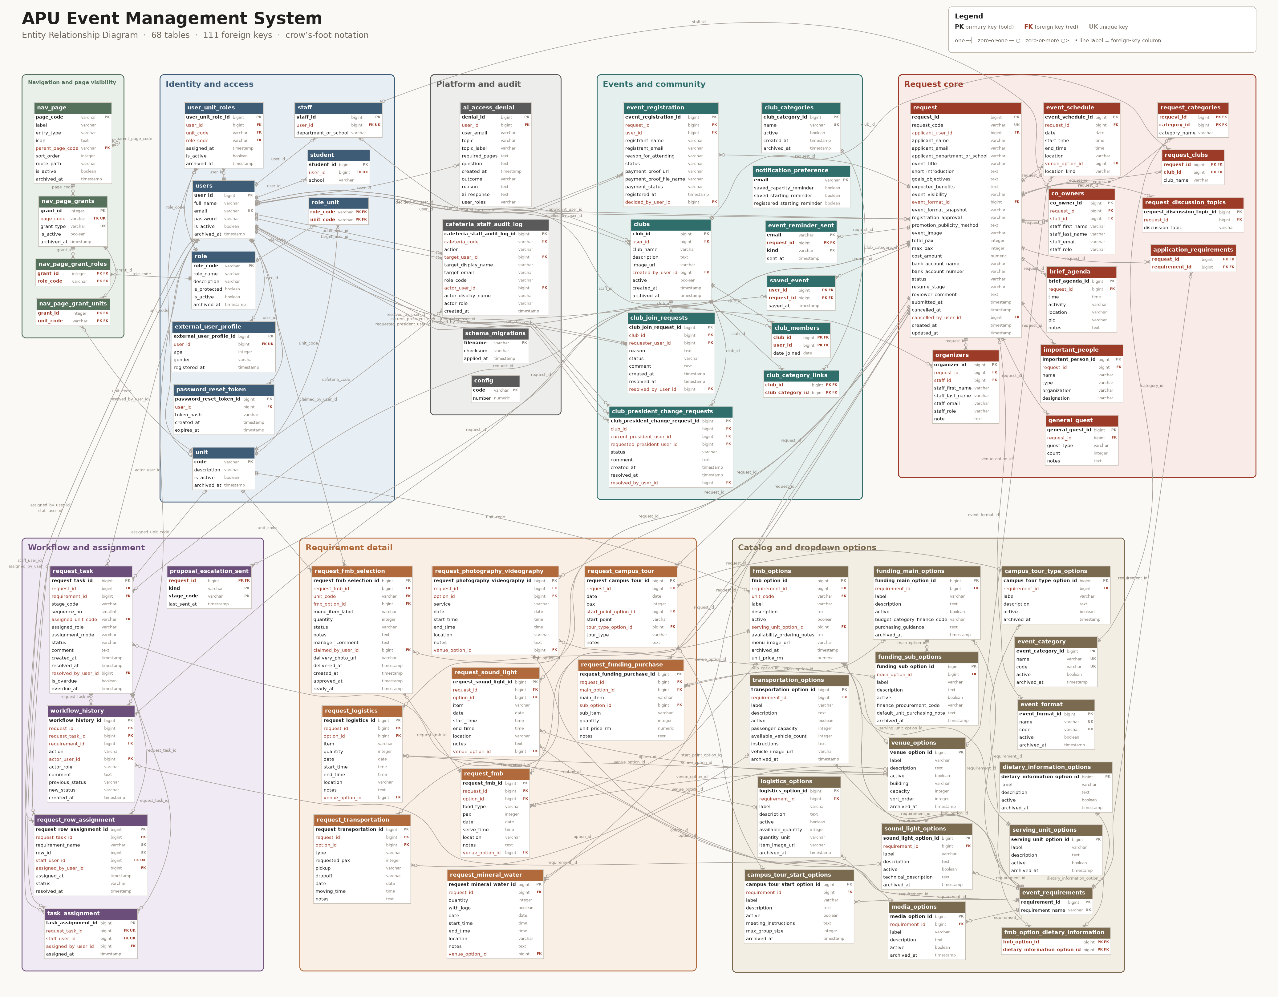
Figure 1: Entity relationship diagram of the deployed database
Figure 40 presents the entity relationship diagram of the deployed database. It is generated directly from an introspection of the live schema rather than drawn by hand, which means it cannot disagree with the database that is actually running; a table added by a later migration appears in the diagram automatically rather than being forgotten. The tables are arranged into eight clusters that correspond to the functional areas of the system, and the same eight clusters organise the data dictionary that follows. Because the schema is large, the figure is presented as an overview of structure rather than as a readable listing of columns; it is embedded at full resolution and can be magnified in the electronic copy of this report, and the detail of every table is set out in the data dictionary in Section 4.3.2.
Three characteristics of the design are visible in the diagram and are worth stating explicitly. The first is that the request is a genuine aggregate rather than a single wide table. The core request row holds the information common to every event, while each requirement type the applicant selects has its own detail table with the columns that requirement actually needs, and the participant, schedule and agenda information is held in child tables that permit any number of rows. This avoids the alternative of a single table carrying dozens of mostly empty columns, and it means adding a new service requirement later is a matter of adding a table rather than altering an existing one.
The second is that the workflow and its evidence are modelled separately from the request. The task table records what each department was asked to do and where it has reached, the assignment tables record who is carrying it out, and the history table records every transition that has ever occurred. Because history is a table in its own right rather than a set of columns on the request, the full sequence of decisions survives even after the request reaches a terminal state.
The third is that the catalogue cluster is not incidental. Sixteen tables exist purely to hold the option lists offered on the request form, and every requirement detail row references the catalogue entry it was chosen from rather than storing free text. This is what makes the analytics in Chapter 4 possible at all: a report on the most requested logistics items is only meaningful if two people asking for the same item recorded it the same way.
Soft deletion is applied consistently across the schema. Records that participate in the deletion lifecycle carry an archive timestamp, so a deleted record is withdrawn from view but remains recoverable for a configured period before it is purged. This is a deliberate trade-off in favour of recoverability, on the reasoning that an administrator removing a unit or a user in a live institutional system is more likely to want that action reversible than immediate.

4.3.2 Data Dictionary
The data dictionary below describes every table in the deployed schema, organised into the same eight clusters used in Figure 40. For each table the dictionary gives its purpose within the system and the columns that carry its identity and its principal relationships. Columns present purely for record keeping, such as creation timestamps and archive markers, are omitted from the key column list where they do not affect the meaning of the table.
The tables of the identity and access cluster are described below.
Table | Purpose | Key columns
users | Holds one row per person known to the system, internal or external, with the bcrypt password hash and an active flag. | user_id, email, full_name, password, is_active
staff | Extends a user record with the staff-specific detail of the department or school they belong to. | staff_id, user_id, department_or_school
student | Extends a user record with the student-specific detail of the school they are enrolled under. | student_id, user_id, school
external_user_profile | Extends a self-registered guest account with the demographic detail collected at registration. | external_user_profile_id, user_id, age, gender, registered_at
unit | The organisational units of the university: schools, service departments and cafeterias, each identified by a code. | code, description, is_active
role | The twelve role definitions, with a protected flag marking those the system depends on and will not allow to be deleted. | role_code, role_name, description, is_protected
role_unit | Records which roles are legally pairable with which units, preventing nonsensical role assignments. | role_code, unit_code
user_unit_roles | The junction that gives the system its role-per-unit identity model: one row per role a user holds within a unit. | user_unit_role_id, user_id, unit_code, role_code, is_active
password_reset_token | Stores hashed, expiring tokens issued for password reset so that no password is ever transmitted. | password_reset_token_id, user_id, token_hash, expires_at

Table 1: Data Dictionary — Identity and Access
The tables of the navigation and page visibility cluster are described below.
Table | Purpose | Key columns
nav_page | The catalogue of navigable pages and folders, with the parent, ordering and route from which the sidebar is built. | page_code, parent_page_code, label, entry_type, icon
nav_page_grants | One grant attached to a page, describing a condition under which that page becomes visible. | grant_id, page_code, grant_type, is_active
nav_page_grant_roles | The roles a grant applies to. | grant_id, role_code
nav_page_grant_units | The units a grant applies to, allowing a grant to be scoped to a role within a particular unit. | grant_id, unit_code

Table 1: Data Dictionary — Navigation and Page Visibility
The tables of the request core cluster are described below.
Table | Purpose | Key columns
request | The core event request: applicant details, event information, visibility, capacity, cost, current status and the stage a send-back should resume at. | request_id, request_code, applicant_user_id, event_format_id, cancelled_by_user_id, applicant_name, applicant_email, applicant_department_or_school
request_categories | The event categories selected for a request, stored with a snapshot of the category name. | request_id, category_id, category_name
application_requirements | Which service requirements the applicant selected, and therefore which departments the request will be routed to. | request_id, requirement_id
request_clubs | The clubs associated with a request, where the event is organised by or on behalf of a club. | request_id, club_id, club_name
co_owners | Staff recorded as co-owners of a request alongside the applicant. | co_owner_id, request_id, staff_id, staff_first_name, staff_last_name, staff_email
organizers | Staff recorded as organisers responsible for running the event. | organizer_id, request_id, staff_id, staff_first_name, staff_last_name, staff_email
important_people | Guests of honour, invited dignitaries and other named attendees of significance. | important_person_id, request_id, name, type, organization
general_guest | Counts of unnamed guest categories expected to attend. | general_guest_id, request_id, guest_type, count, notes
event_schedule | The dated sessions that make up the event, each with a time window and either a catalogue venue or a free location. | event_schedule_id, request_id, venue_option_id, date, start_time, end_time
brief_agenda | The running order within the event, with time, activity, location and person in charge. | brief_agenda_id, request_id, time, activity, location
request_discussion_topics | Topics the applicant wishes to raise with reviewers, attached to the request. | request_discussion_topic_id, request_id, discussion_topic

Table 1: Data Dictionary — Request Core
The tables of the requirement detail cluster are described below.
Table | Purpose | Key columns
request_logistics | Logistics items requested, each referencing a catalogue option with quantity, timing and location. | request_logistics_id, request_id, option_id, venue_option_id, item, quantity, date
request_transportation | Transport movements requested, with vehicle type, passenger count, pickup, dropoff and time. | request_transportation_id, request_id, option_id, type, requested_pax, pickup
request_photography_videography | Photography and videography services requested, with the service type, timing and location. | request_photography_videography_id, request_id, option_id, venue_option_id, service, date, start_time
request_sound_light | Sound and lighting equipment requested, with the item, timing and location. | request_sound_light_id, request_id, option_id, venue_option_id, item, date, start_time
request_fmb | Food and beverage requirements requested, with the food type, headcount, serving time and location. | request_fmb_id, request_id, option_id, venue_option_id, food_type, pax, date
request_fmb_selection | One menu selection per cafeteria derived from a food and beverage requirement, carrying its own fulfilment status, claim, manager comment and delivery evidence. | request_fmb_selection_id, request_fmb_id, unit_code, fmb_option_id, claimed_by_user_id, menu_item_label, quantity, status
request_campus_tour | Campus tour requests, with the start point, tour type, date and group size. | request_campus_tour_id, request_id, start_point_option_id, tour_type_option_id, date, pax, start_point
request_mineral_water | Mineral water requests, with quantity, branding option, timing and location. | request_mineral_water_id, request_id, venue_option_id, quantity, with_logo, date
request_funding_purchase | Funding and purchase items requested, with the main and sub category, quantity and unit price. | request_funding_purchase_id, request_id, main_option_id, sub_option_id, main_item, sub_item, quantity

Table 1: Data Dictionary — Requirement Detail
The tables of the workflow and assignment cluster are described below.
Table | Purpose | Key columns
request_task | One task per department per requirement, holding the stage, the unit and role it is assigned to, its status, and its overdue marker. | request_task_id, request_id, requirement_id, assigned_unit_code, resolved_by_user_id, stage_code, sequence_no, assigned_role
request_row_assignment | Assignment of an individual requirement row to a staff member, for the requirement types that are itemised row by row. | request_row_assignment_id, request_task_id, requirement_name, row_id, staff_user_id, assigned_by_user_id, status
task_assignment | Assignment of a whole task to a staff member, recording who assigned it and when. | task_assignment_id, request_task_id, staff_user_id, assigned_by_user_id
workflow_history | The immutable audit trail: one row per transition, recording the action, the actor, the comment and the status before and after. | workflow_history_id, request_id, request_task_id, requirement_id, actor_user_id, action, actor_role, comment
proposal_escalation_sent | Records the last time each escalation kind was sent for a request at a given stage, so a chaser is not repeated within its cadence. | request_id, kind, stage_code, last_sent_at

Table 1: Data Dictionary — Workflow and Assignment
The tables of the events and community cluster are described below.
Table | Purpose | Key columns
event_registration | One registration per person per published event, with the attendance status, the reason for attending, and the separate payment status and proof. | event_registration_id, request_id, user_id, decided_by_user_id, registrant_name, registrant_email, reason_for_attending
saved_event | Events a user has saved for later, which also enrols them in the reminder schedule. | user_id, request_id, saved_at
notification_preference | Per-address opt-in settings controlling which reminder emails a person receives. | email, saved_capacity_reminder, saved_starting_reminder, registered_starting_reminder
event_reminder_sent | Ledger of reminders already sent, so a repeated or missed run never sends the same reminder twice. | email, request_id, kind, sent_at
clubs | The club directory, with the current president, description, image and active state. | club_id, user_id, created_by_user_id, club_name, description, image_url
club_categories | The categories clubs can be classified under. | club_category_id, name, active
club_category_links | The many-to-many link allowing a club to belong to more than one category. | club_id, club_category_id
club_members | Club membership, with the date the member joined. | club_id, user_id, date_joined
club_join_requests | Requests to join a club, with the applicant's reason and the president's decision. | club_join_request_id, club_id, requester_user_id, resolved_by_user_id, reason, status, comment
club_president_change_requests | Requests to transfer a club presidency, decided by the Club Admin. | club_president_change_request_id, club_id, current_president_user_id, requested_president_user_id, resolved_by_user_id, status, comment

Table 1: Data Dictionary — Events and Community
The tables of the catalogue and dropdown options cluster are described below.
Table | Purpose | Key columns
event_category | The catalogue of event categories offered on the request form. | event_category_id, name, code, active
event_format | The catalogue of event formats, such as on-campus or online. | event_format_id, name, code, active
event_requirements | The master list of service requirement types the system can route. | requirement_id, requirement_name
logistics_options | The logistics catalogue, with available quantity, unit and item image. | logistics_option_id, requirement_id, label, description, active
transportation_options | The transport catalogue, with passenger capacity, fleet count and usage instructions. | transportation_option_id, requirement_id, label, description, active
media_options | The photography and videography service catalogue. | media_option_id, requirement_id, label, description, active
sound_light_options | The sound and lighting catalogue, with technical description. | sound_light_option_id, requirement_id, label, description, active
dietary_information_options | The dietary information catalogue used to tag menu items. | dietary_information_option_id, label, description, active
serving_unit_options | The serving unit catalogue, such as per person or per tray. | serving_unit_option_id, label, description, active
fmb_options | The menu catalogue, owned per cafeteria unit, with price, serving unit, ordering notes and image. | fmb_option_id, requirement_id, unit_code, serving_unit_option_id, label, description, active
fmb_option_dietary_information | The many-to-many link tagging a menu item with dietary information. | fmb_option_id, dietary_information_option_id
campus_tour_start_options | The campus tour start point catalogue, with meeting instructions and maximum group size. | campus_tour_start_option_id, requirement_id, label, description, active
campus_tour_type_options | The campus tour type catalogue. | campus_tour_type_option_id, requirement_id, label, description, active
funding_main_options | The main funding category catalogue, with the finance code and purchasing guidance. | funding_main_option_id, requirement_id, label, description, active
funding_sub_options | The funding sub-item catalogue, nested under a main category. | funding_sub_option_id, main_option_id, label, description, active
venue_options | The venue catalogue owned by the CFO, with building, capacity and display order. | venue_option_id, label, description, active

Table 1: Data Dictionary — Catalogue and Dropdown Options
The tables of the platform and audit cluster are described below.
Table | Purpose | Key columns
config | Numeric configuration values, including the approval threshold, cancellation deadline and escalation windows, read at the point of use. | code, number
schema_migrations | The migration ledger, recording each applied file with its checksum so an edited migration is reported rather than silently skipped. | filename, checksum, applied_at
cafeteria_staff_audit_log | Audit trail of cafeteria staff assignment and removal, recording both the target and the actor. | cafeteria_staff_audit_log_id, cafeteria_code, target_user_id, actor_user_id, action, target_display_name, target_email
ai_access_denial | Record of every assistant request that was refused, with the topic, the question, the outcome and the reason. | denial_id, user_id, user_email, topic, topic_label

Table 1: Data Dictionary — Platform and Audit

4.4 Interface Design
The interface design translates the structural decisions of the preceding sections into something a user can operate. Its central problem is stated by the role model itself: twelve roles, held per organisational unit, cannot be served by twelve separate applications, and neither can they be served by one interface that shows everybody everything. The approach taken is a single application shell whose contents are assembled per user from the access grants the server issues, supported by a shared component library and a token-based visual system that keep the result coherent no matter which combination of pages a given user sees.

4.4.1 System Navigation Site Map
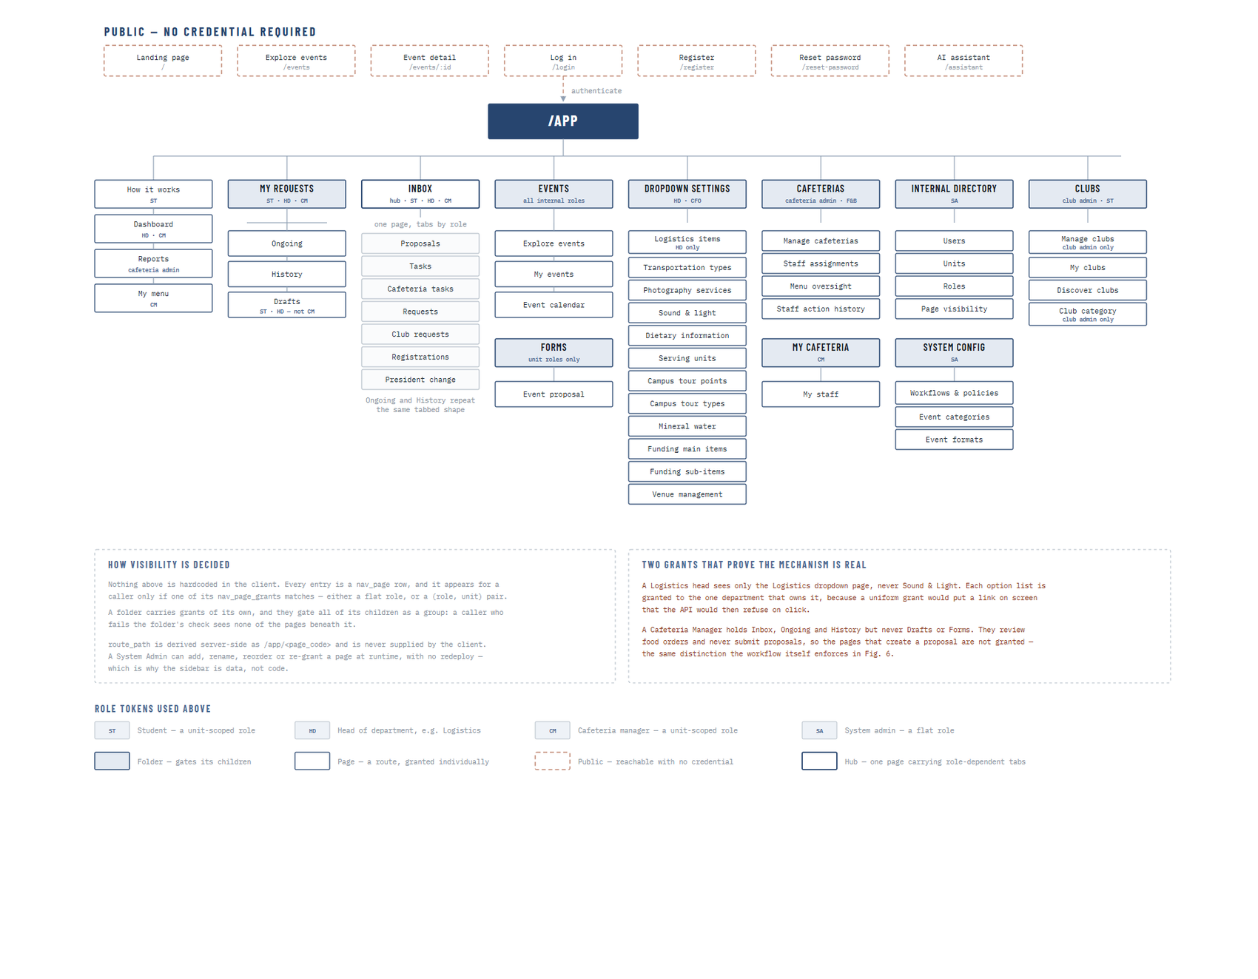
Figure 1: System navigation site map
Figure 41 presents the navigation structure of the system. The public tier, drawn with dashed borders, is reachable with no credential at all and comprises the landing page, event browsing and detail, login, registration, password reset and the assistant. Everything below the authenticated boundary is organised into eight top-level areas, each of which is either a single page or a folder that gates the pages beneath it.
The role tokens on each entry record which roles reach it, and they show the design working in practice. The Inbox is a single page carrying tabs that differ by role, so a Head of Department, a student and a cafeteria manager all open the same route and are presented with the queues that concern them, rather than each having a separate inbox page to maintain. The Ongoing and History areas repeat the same tabbed shape, which keeps the mental model consistent as a user moves between what is in progress and what is finished.
The two annotations at the foot of the figure record the mechanism and give evidence that it is genuine rather than cosmetic. Nothing in the structure is hard-coded in the client: each entry is a row in the page catalogue, and it appears for a caller only if one of its grants matches, either by role or by a role within a specific unit. A folder carries grants of its own that gate all of its children as a group. Two grants demonstrate that the mechanism is real: the Logistics head sees only the Logistics option list and not Sound and Light, because each catalogue is granted to the department that owns it, and a Cafeteria Manager holds Inbox, Ongoing and History but not Drafts or Forms, because they review food orders and never submit requests. That second distinction is the same one the workflow itself enforces, expressed here as navigation.

4.4.2 Screen Layout Anatomy
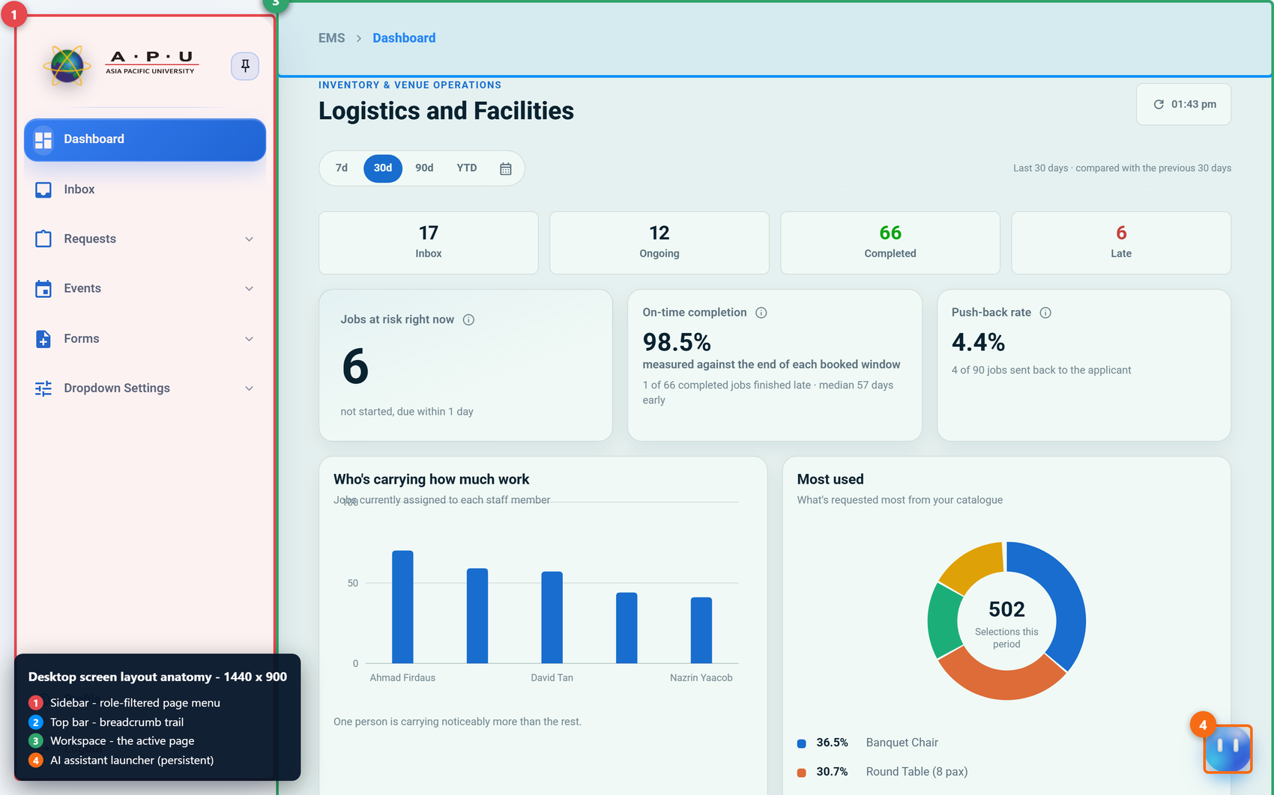 | 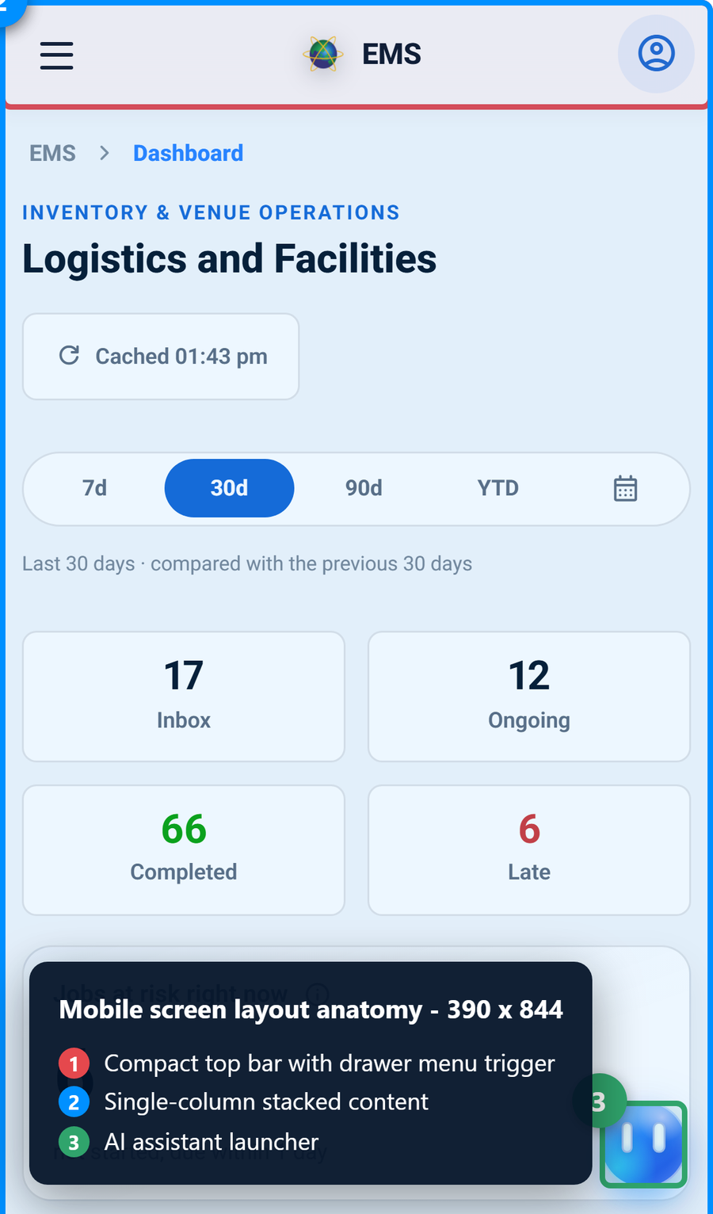
Figure 1: Screen layout anatomy on desktop and mobile
Figure 42 presents the anatomy of an internal screen at both viewports. On the desktop the layout is a persistent left sidebar carrying the role-filtered page menu, a top bar carrying the breadcrumb trail, a workspace holding the active page, and a persistent assistant launcher anchored to the lower right. The sidebar can be pinned or collapsed, which allows a user working on a wide data table to reclaim the horizontal space without losing their place in the navigation.
On the mobile viewport the same four elements are present but rearranged. The sidebar becomes a drawer opened from a compact top bar, the workspace stacks into a single column, and the assistant launcher remains anchored in the same position. Keeping the launcher in a constant position across both viewports is deliberate: it is the one control that is available on every page in the system, and a control that moves depending on the device is a control users stop looking for.
The breadcrumb trail is more than decoration in a system with this many pages. Because the sidebar contents differ per role, a user cannot rely on a shared mental map of the application learned from a colleague; the breadcrumb gives every screen an unambiguous position within the structure regardless of which subset of that structure the user can see.

4.4.3 Role-Based Menu Design
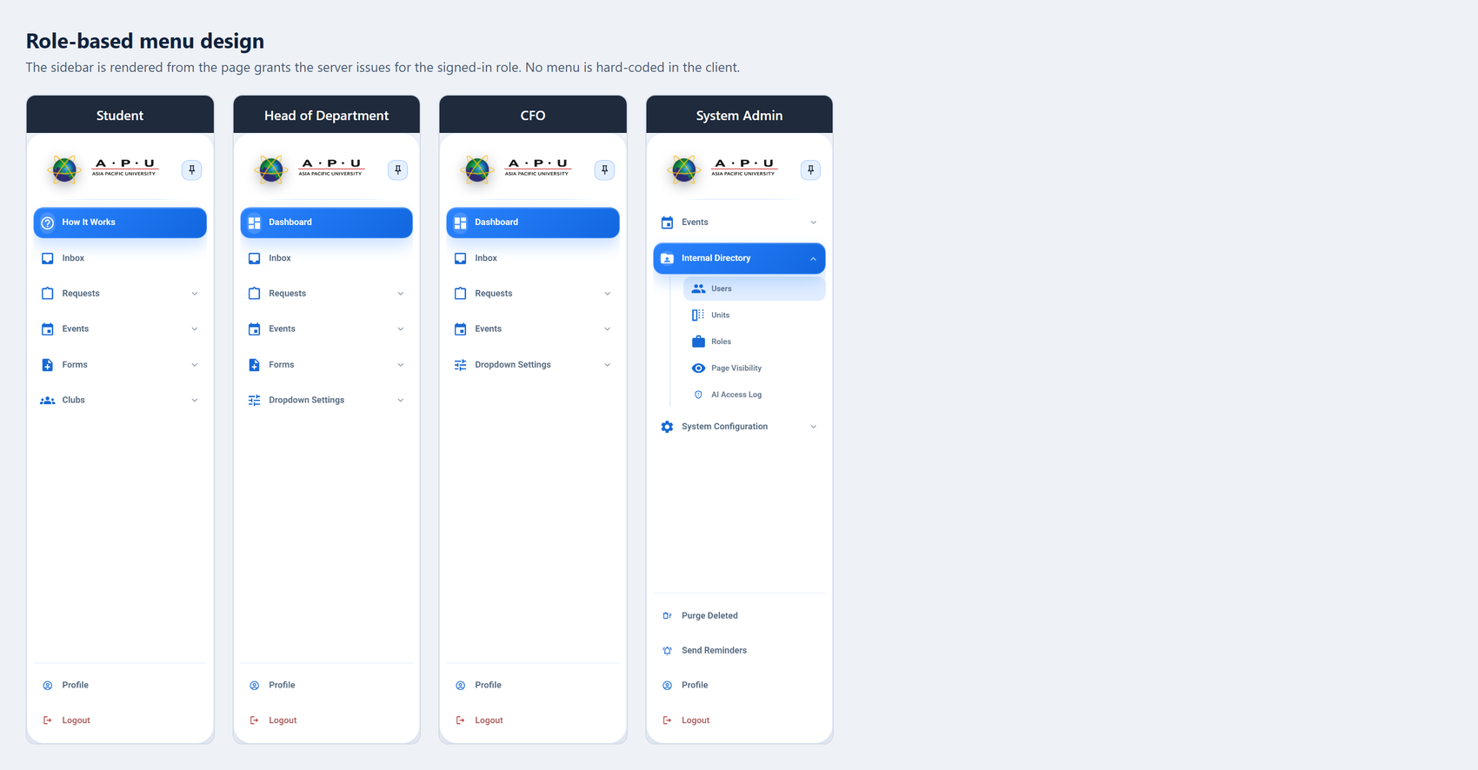
Figure 1: Role-based menu design across four roles
Figure 43 places four sidebars side by side, captured from a Student, a Head of Department, the CFO and the System Admin. The differences between them are not styling variations of one menu; they are four different menus, each assembled at run time from the grants the server issued for that signed-in role.
The comparison makes the access model visible. The Student opens on How It Works and holds Forms and Clubs but no Dashboard, because a student raises requests and joins clubs but has no operational figures to review. The Head of Department opens on the Dashboard and holds Forms and the Dropdown Settings for their own department. The CFO holds the Dashboard and Dropdown Settings but not Forms, because the CFO reviews requests and owns the venue and funding catalogues but does not submit event requests. The System Admin holds neither Dashboard nor Forms, and instead holds the Internal Directory and System Configuration together with the maintenance actions for purging deleted records and dispatching reminders.
The practical consequence of assembling the menu this way is that adding a page, renaming it, reordering it or granting it to a different role is an administrative action taken in the running system rather than a development task. The sidebar is data, not code, which is what allows the access model described in Section 4.2.3 to be adjusted as university procedure changes.

4.4.4 Design System Tokens
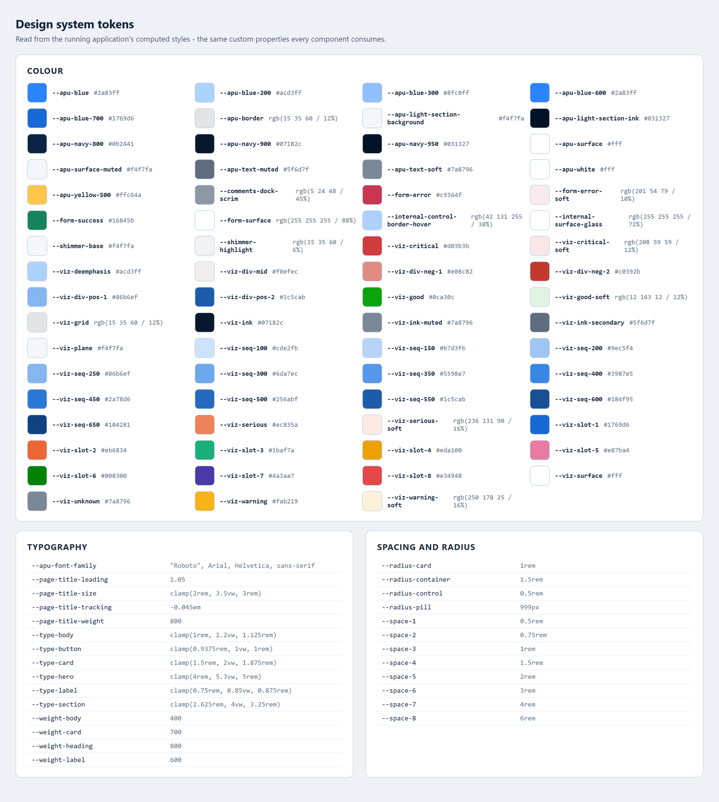
Figure 1: Design system tokens read from the running application
Figure 44 presents the design tokens read from the running application's computed styles. These are the custom properties every component consumes, and they are the mechanism by which visual consistency is maintained across an interface that is assembled differently for each user.
The colour set is organised by purpose rather than by appearance. The institutional blues and navies establish the identity, a small set of semantic colours carries meaning that must never vary by context, and a separate visualisation palette supplies sequential ramps, divergent pairs and categorical slots for the dashboard charts. Separating the visualisation palette from the interface palette prevents a common failure in which a chart series accidentally adopts the same colour the interface uses for an error, and a reader misreads a neutral data point as a warning.
Typography and spacing are expressed as scales rather than as fixed values. The type scale is defined with fluid clamping so that a heading has a minimum size, a preferred size proportional to the viewport, and a maximum size, which allows the same page to remain readable from a phone to a wide monitor without a separate set of mobile type rules. Spacing and radius are defined as a small numbered scale, so that a developer adding a new panel chooses a step on an existing scale rather than inventing a new measurement, and the result stays visually aligned with everything already built.

4.4.5 Shared Component Library
The shared component library is a private development reference route within the application itself, listing twenty-nine reusable components and global classes with their selector, purpose, available states and responsive behaviour. It is shown across six figures because the catalogue is longer than one screen. Presenting it as a live route rather than as a static specification document has a practical advantage: the catalogue renders the real components, so it cannot fall out of step with what the application actually does.
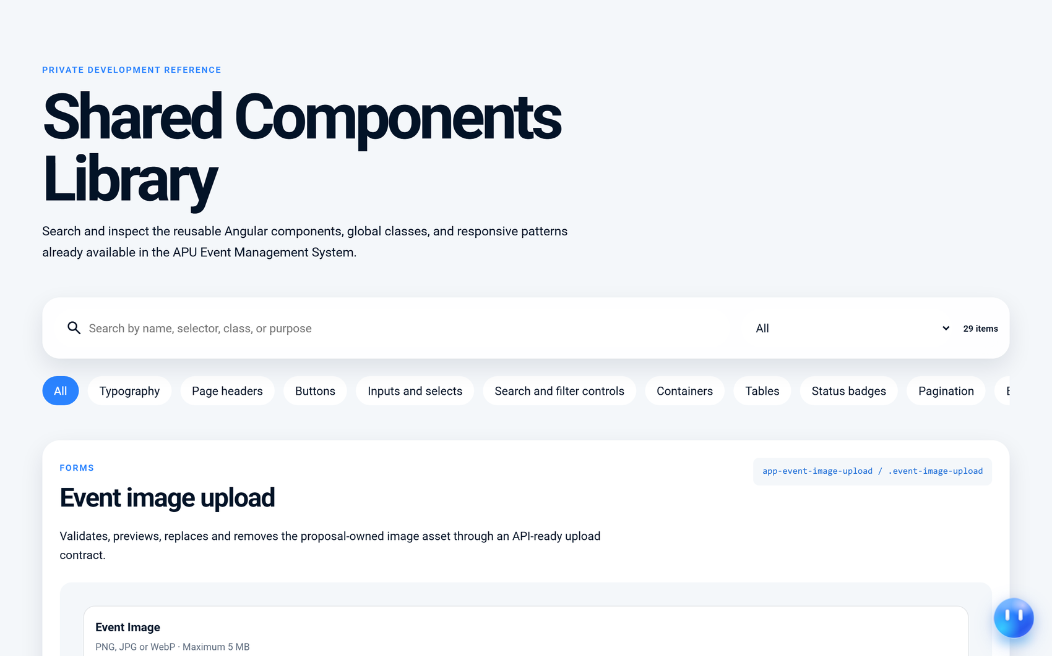
Figure 1: Shared component library (part 1 of 6)
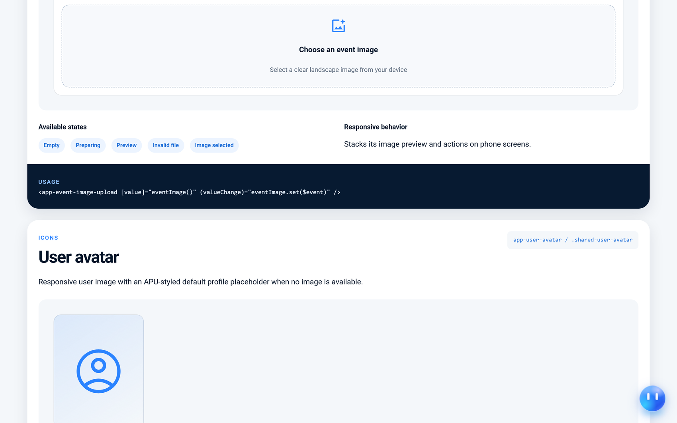
Figure 1: Shared component library (part 2 of 6)
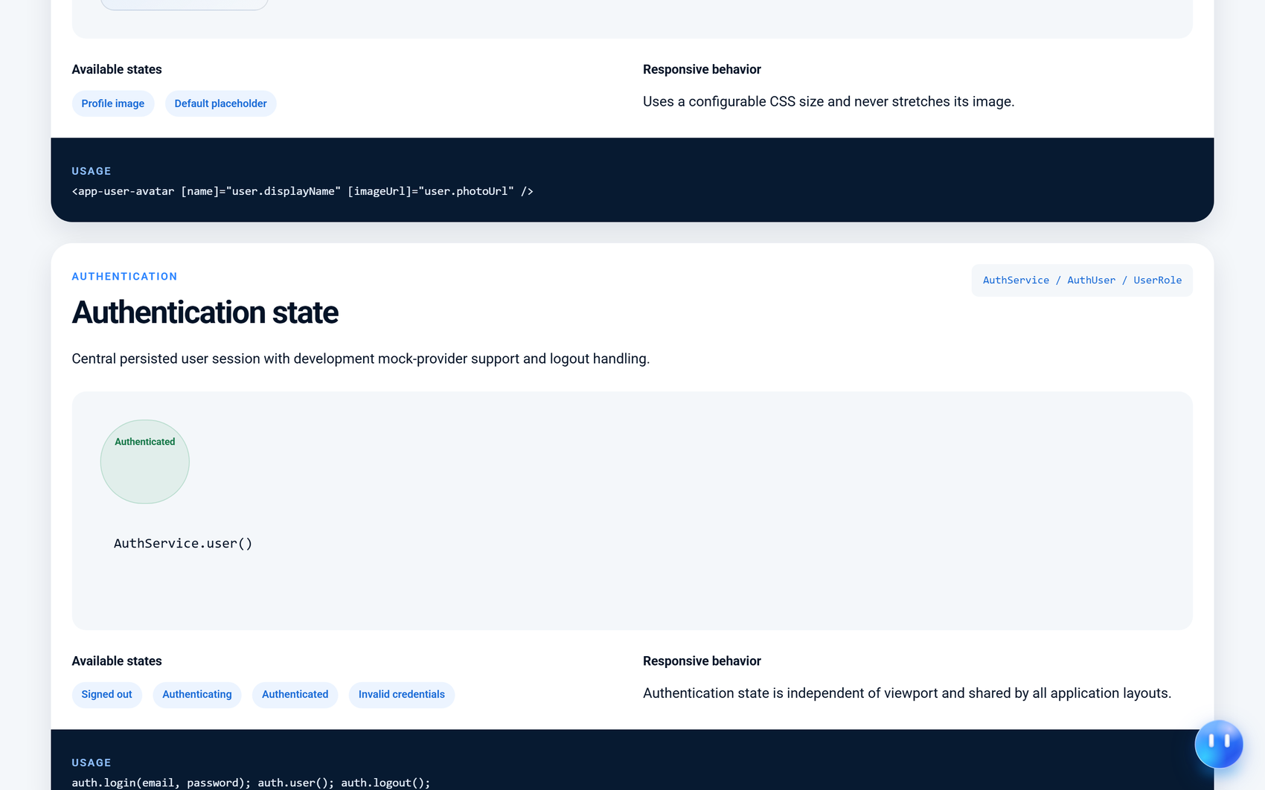
Figure 1: Shared component library (part 3 of 6)
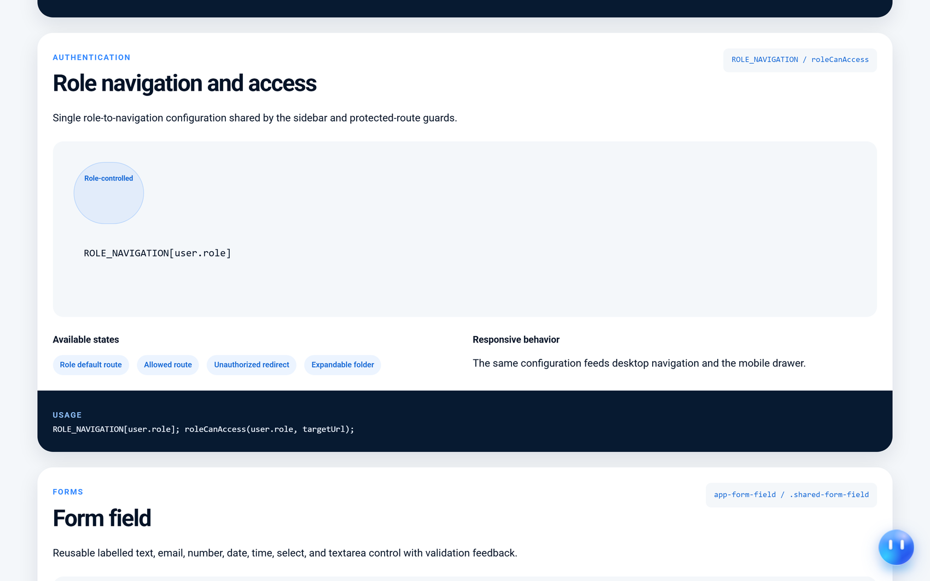
Figure 1: Shared component library (part 4 of 6)
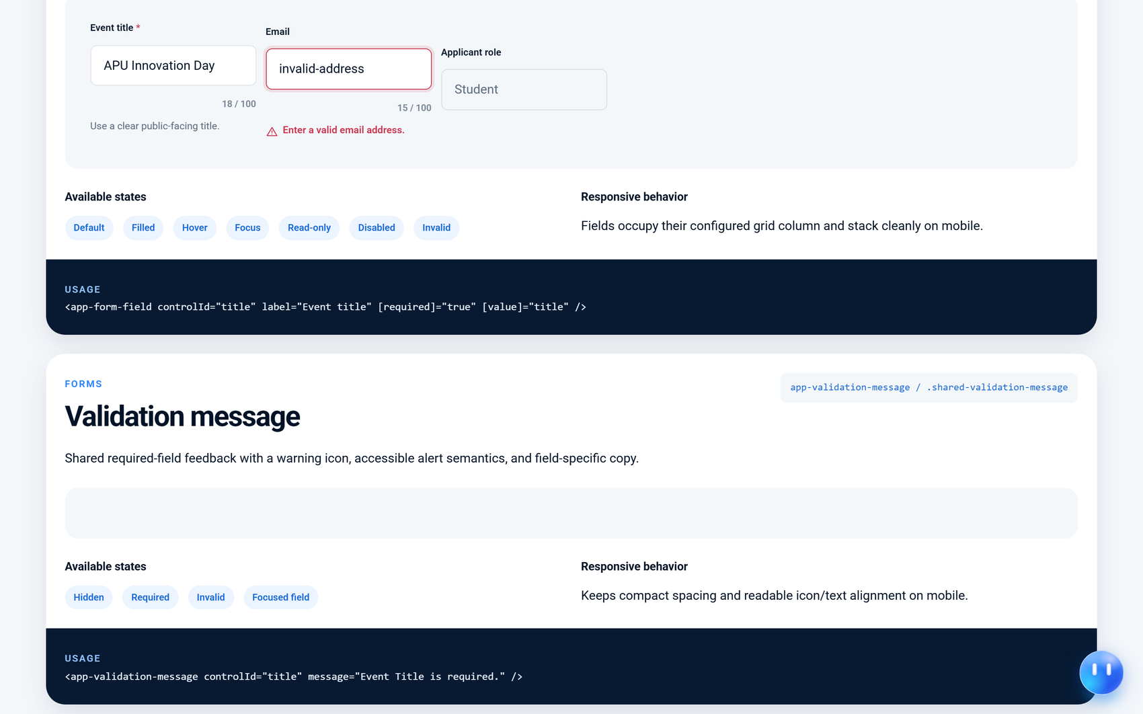
Figure 1: Shared component library (part 5 of 6)
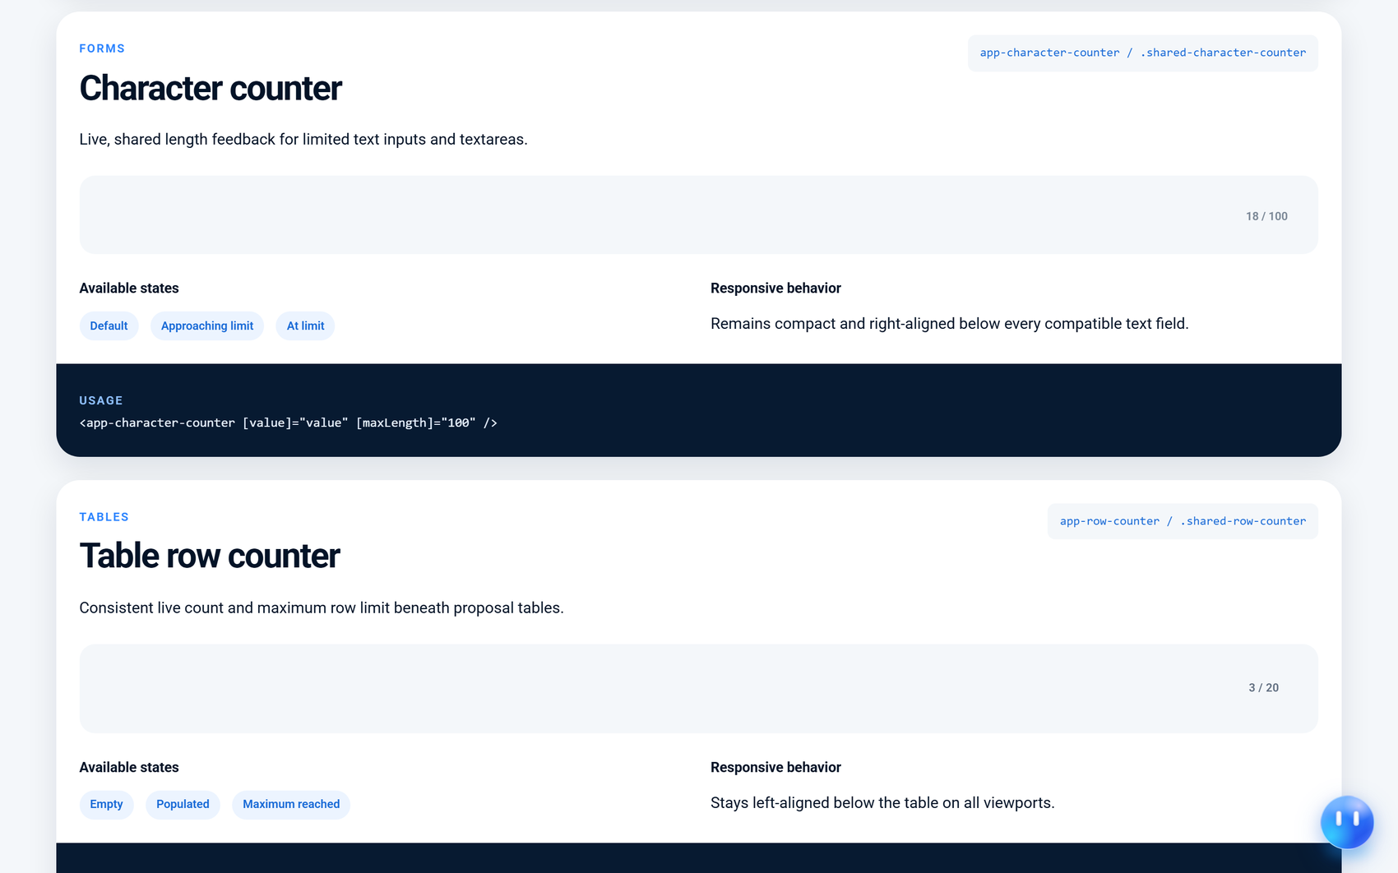
Figure 1: Shared component library (part 6 of 6)
Each entry documents four things. The selector and class name identify the component, a short description states what it is for, the state list enumerates the conditions it must handle, and a note records how it behaves on a narrow viewport. The state lists are the most valuable part of the catalogue, because they force the empty, loading, invalid and disabled conditions to be designed rather than discovered. A form field, for example, is documented with default, filled, hover, focus, read-only, disabled and invalid states, and a validation message is documented with hidden, required, invalid and focused-field states.
The catalogue also covers behaviour that is not strictly visual. The role navigation entry documents the single configuration that feeds both the desktop sidebar and the mobile drawer and is also consulted by the route guards, which is what keeps the menu a user sees and the routes they may open from ever disagreeing. The authentication state entry documents the persisted session shared by every layout in the application. Recording these alongside the visual components is deliberate, because they are shared in exactly the same way and are subject to exactly the same risk of being reimplemented inconsistently.

4.4.6 Storyboards
Three storyboards document the principal user journeys through the system as a sequence of real screens rather than as an abstract flow. They are drawn from the running application, so each panel is a screen a user actually encounters in the order they encounter it.
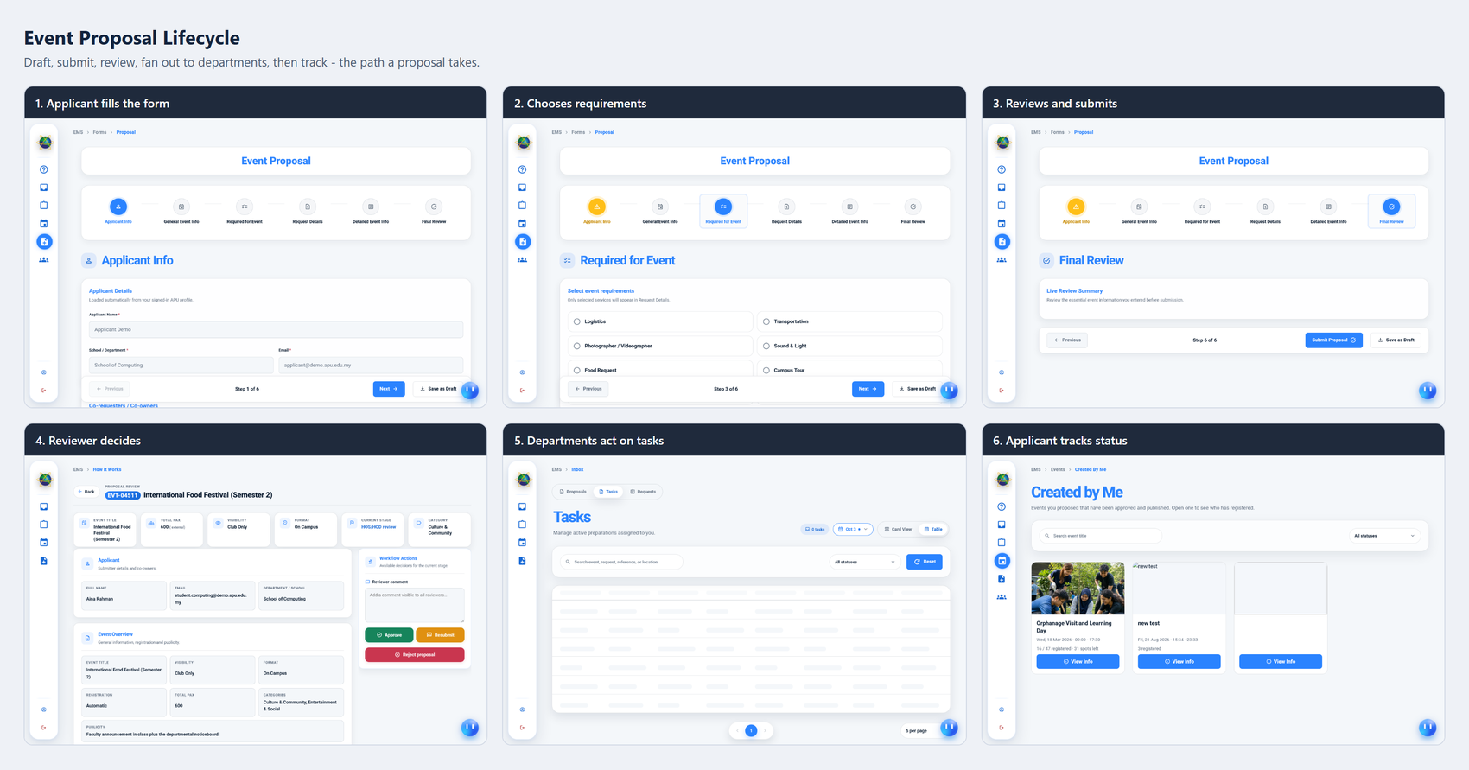
Figure 1: Storyboard — event proposal lifecycle
Figure 51 follows an event request from creation to tracking in six steps. The applicant completes the form, which is presented as a six-step wizard rather than a single long page; selects the service requirements needed, which is the step that determines which departments the request will later be routed to; and reviews a live summary before submitting. The reviewer then opens the request and is presented with the event summary alongside a workflow actions panel offering approve, resubmit and reject. Departments act on the tasks that have been created for them, and the applicant tracks the outcome from a page listing the events they have raised.
The storyboard makes one design decision particularly visible. The requirement selection step comes third, before the detailed request information, and only the requirements selected there appear in the following step. An applicant who needs only logistics is therefore never shown the transport, photography, sound and campus tour sections at all. This keeps a form that must cover seven service departments from presenting every applicant with the union of all of them.
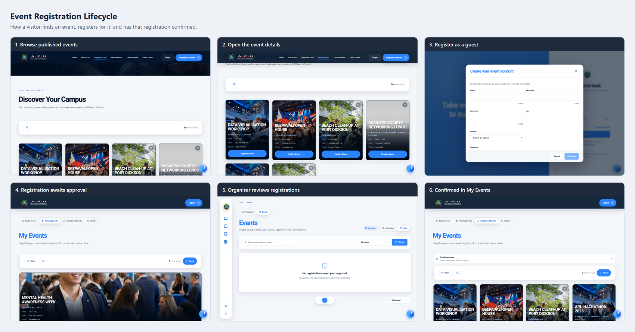
Figure 1: Storyboard — event registration lifecycle
Figure 52 follows a visitor from discovering a published event to holding a confirmed place. The visitor browses the public event listing, opens the event detail, and creates a guest account if they do not already hold one. The registration then waits in the pending queue where the event is set to manual approval, the organiser reviews it, and the confirmed registration appears in the visitor's own event list together with the reminder preferences they control.
The account creation panel shows the design decision that makes the public tier usable. A visitor is not asked to create an account in order to browse; the account is requested at the point it becomes necessary, which is when they want the system to remember something on their behalf. Deferring registration to the moment of genuine need is what allows the platform to serve as a public event portal rather than only as an internal tool with a login page.
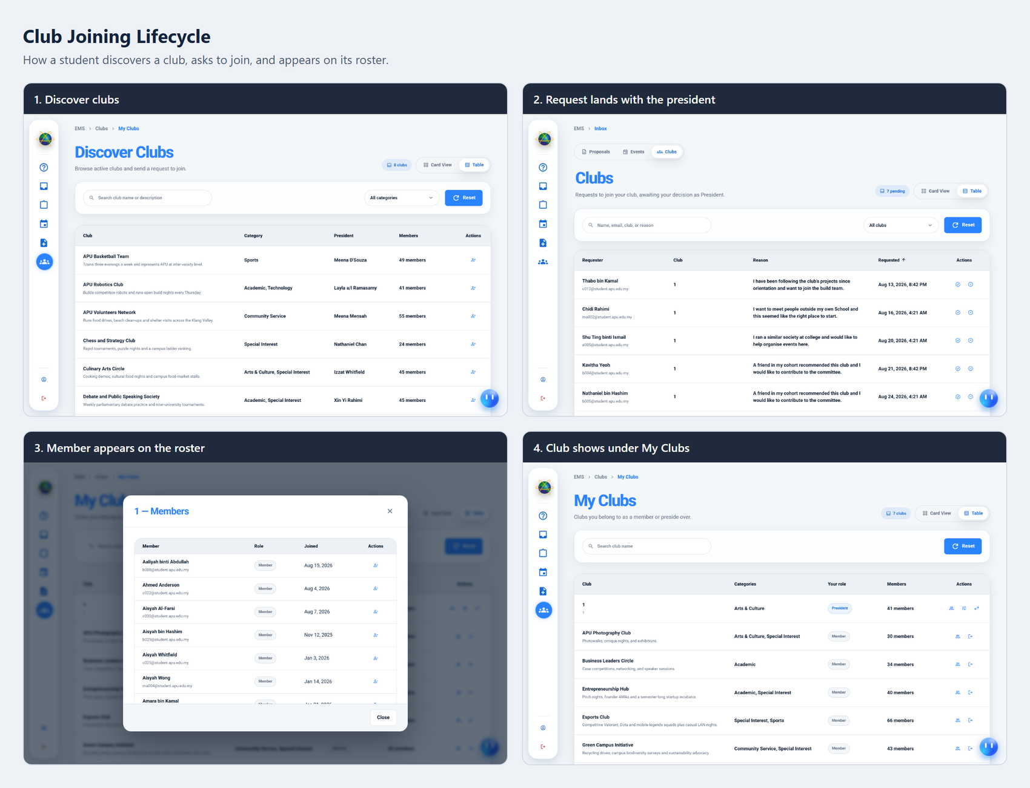
Figure 1: Storyboard — club joining lifecycle
Figure 53 follows a student from discovering a club to appearing on its roster, in four steps. The student browses the club directory, filtered by category, and sends a request to join with a stated reason. The request lands in the president's inbox alongside the reasons given by other applicants, which allows the president to decide the queue as a set rather than one message at a time. Once approved, the member appears on the club roster and the club appears under the student's own club list with their role shown.
The reason field carries more weight than its size suggests. Without it a president receives a list of names and no basis on which to decide, which in practice means every request is approved or none are. Collecting a short statement of intent at the point of request is what turns the decision into a real one, and it is the same reasoning that places a reason for attending on the event registration.

4.4.7 Responsive Breakpoint Strategy
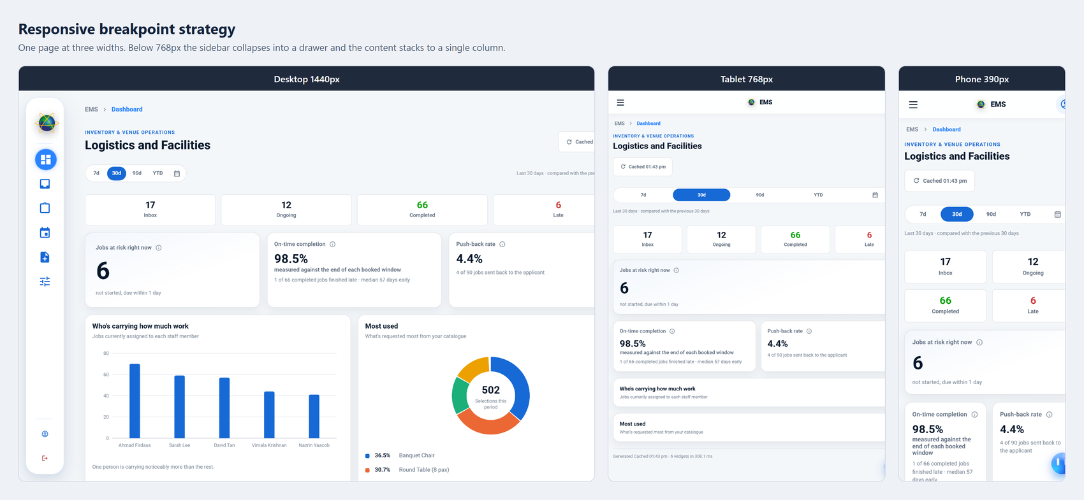
Figure 1: Responsive breakpoint strategy at three viewport widths
Figure 54 presents one page rendered at three widths: a desktop viewport, a tablet viewport at the breakpoint itself, and a phone viewport. The strategy is a single breakpoint below which the sidebar collapses into a drawer and the content reflows from a multi-column grid into a single stacked column.
Choosing one breakpoint rather than several is a deliberate simplification. A system with as many pages as this one cannot realistically be verified at four or five separate widths for every screen, and a responsive design that is only partly tested is worse than a simpler one that holds everywhere. The single-column phone layout also preserves the reading order of the desktop layout, so the summary figures appear before the detail panels at every width, and a user moving between devices encounters the same information in the same sequence.
The comparison also shows what is deliberately not changed. The page title, the period selector, the summary figures and the panels are all present at every width; nothing is hidden on the phone. This matters for the accessibility objective stated in Chapter 1, because a coordination platform whose mobile version omits functionality would fail precisely the users it is most intended to help, namely staff who are away from a desk while an event is being prepared.

REFERENCE:
Abdul Rahman, N., Mohd Zin, N. A., Ahmad Zukarnain, Z., & Putra, Y. H. (2024). User-centered UiTM e-Event using predictive software development life cycle (SDLC). Journal of Computing Research and Innovation (JCRINN), 9(2), 290–302. https://doi.org/10.24191/jcrinn.v9i2.468
Alami, A., & Krancher, O. (2022). How Scrum adds value to achieving software quality? Empirical Software Engineering, 27(7), 165. Springer. https://doi.org/10.1007/s10664-022-10208-4
Albesher, L., & Alfayez, R. (2024). An observational study on Flask web framework questions on Stack Overflow (SO). IET Software, 2024(1). https://doi.org/10.1049/sfw2/1905538
Alesandro, N., Maulana, F., Lim, L. F., Hendri, & Robet. (2025). Development of a campus project management system to enhance collaboration using the Agile method. Journal of Artificial Intelligence and Engineering Applications (JAIEA), 4(3), 2294–2304. https://doi.org/10.59934/jaiea.v4i3.1158
Arriesgado, J., Calaguian, J., Golpeo, A., Lagman, A., Pajarillo, M., Pardo, P., Solomo, M., & Vicente, H. (2023). TICaP Hub: An event management system for FEU Tech using DigitalOcean droplets and cron jobs. In Intelligent Sustainable Systems (pp. 225–232). Springer. https://doi.org/10.1007/978-981-19-7660-5_19
Ahmad, T., & Van Looy, A. (2020). Business process management and digital innovations: A systematic literature review. Sustainability, 12(17), 6827. https://doi.org/10.3390/su12176827
Anderer, S., Kempter, T., Scheuermann, B., & Mostaghim, S. (2023). Dynamic optimization of role concepts for role-based access control using evolutionary algorithms. SN Computer Science, 4, 416. https://doi.org/10.1007/s42979-023-01805-1
Benavides, L. M. C., Tamayo Arias, J. A., Arango Serna, M. D., Branch Bedoya, J. W., & Burgos, D. (2020). Digital transformation in higher education institutions: A systematic literature review. Sensors, 20(11), 3291. https://doi.org/10.3390/s20113291
Choudhary, S. R., Prasad, M. R., & Orso, A. (2012). CrossCheck: Combining crawling and differencing to better detect cross-browser incompatibilities in web applications. 2012 IEEE Fifth International Conference on Software Testing, Verification and Validation (ICST), 171–180.https://doi.org/10.1109/ICST.2012.97
Cvent. (2025). Cvent — All-in-one event management and marketing platform. Cvent Inc. Retrieved from https://www.cvent.com
Dalimunthe, S., Putra, E. H., & Ridha, M. A. F. (2023). Restful API security using JSON Web Token (JWT) with HMAC-SHA512 algorithm in session management. IT Journal Research and Development, 8(1), 81–94. https://doi.org/10.25299/itjrd.2023.12029
Essel, D. D., Techie-Menson, H., Oppong, S. O., & Alakuu, A. (2023). Digitalising the clearance processes of higher education institutions through the design and implementation of an online clearance system. International Journal of Scientific Research and Management (IJSRM), 11(7), 42–58. https://doi.org/10.18535/IJSRM/V11I07.AS01
Fernández-Portillo, A., Almodóvar-González, M., & Hernández-Mogollón, R. (2023). Digital transformation initiatives in higher education institutions: A multivocal literature review. Education and Information Technologies, 28, 12375–12406. https://doi.org/10.1007/s10639-022-11544-0
Habib, M. N., Jamal, W., & Khalil, U. (2021). Transforming universities in interactive digital platform: Case of City University of Science and Information Technology. Education and Information Technologies, 26, 517–541. https://doi.org/10.1007/s10639-020-10237-w
Hadiwiyanti, R., Suryanto, T. L. M., & Safitri, E. M. (2022). Evaluation of campus event management information system using system usability scale method. In 2022 IEEE 8th Information Technology International Seminar (ITIS) (pp. 350–353). IEEE. https://doi.org/10.1109/ITIS57155.2022.10009978
Hron, M., & Obwegeser, N. (2022). Why and how is Scrum being adapted in practice: A systematic review. Journal of Systems and Software, 183, 111110. https://doi.org/10.1016/j.jss.2021.111110
Hron, M., & Obwegeser, N. (2018). Scrum in practice: An overview of Scrum adaptations. In Proceedings of the 51st Hawaii International Conference on System Sciences (pp. 5445–5454). https://doi.org/10.24251/hicss.2018.679
Ismail, R., Safieddine, F., & Jaradat, A. (2019). E-university delivery model: Handling the evaluation process. Business Process Management Journal, 25(7), 1633–1646. https://doi.org/10.1108/BPMJ-10-2018-0281
ISGlobal. (n.d.). SDG 9: Build resilient infrastructure, promote inclusive and sustainable industrialization and foster innovation. https://www.isglobal.org/en/-/sdg-9-build-resilient-infrastructure-promote-inclusive-and-sustainable-industrialization-and-foster-innovation
Jeny, J. R. V., Sadhana, P., Kumar, B. J., Abhishek, S. L., & Chander, T. S. (2022). A web-based college event management system and notification sender. In 2022 4th International Conference on Inventive Research in Computing Applications (ICIRCA) (pp. 1434–1438). IEEE. https://doi.org/10.1109/ICIRCA54612.2022.9985774
Jiao, T., Ye, M., & Cai, Z. (2022). Role-based access control model for inter-system cross-domain in multi-domain environment. Applied Sciences, 12(24), 13036. https://doi.org/10.3390/app122413036
Kadenic, M. D., Koumaditis, K., & Junker-Jensen, L. (2023). Mastering scrum with a focus on team maturity and key components of scrum. Information and Software Technology, 153, 107079. https://doi.org/10.1016/j.infsof.2022.107079
Kaputa, V., Loučanová, E., & Tejerina-Gaite, F. A. (2022). Digital transformation in higher education institutions as a driver of social-oriented innovations. In Social Innovation in Higher Education (Vol. 61, pp. 81–85). Springer. https://doi.org/10.1007/978-3-030-84044-0_4
Khan, M., Parvaiz, G. S., Dedahanov, A. T., Abdurazzakov, O. S., & Rakhmonov, D. A. (2022). The impact of technologies of traceability and transparency in supply chains. Sustainability, 14(24), 16336. https://doi.org/10.3390/su142416336
Matheus, R., Janssen, M., & Maheshwari, D. (2020). Data science empowering the public: Data-driven dashboards for transparent and accountable decision-making in smart cities. Government Information Quarterly, 37(3), 101284. https://doi.org/10.1016/j.giq.2018.01.006
Moy, A. J., Hobensack, M., Marshall, K., Vawdrey, D. K., Kim, E. Y., Cato, K. D., & Rossetti, S. C. (2023). Understanding the perceived role of electronic health records and workflow fragmentation on clinician documentation burden in emergency departments. Journal of the American Medical Informatics Association, 30(5), 797–808. https://doi.org/10.1093/jamia/ocad038
https://doi.org/10.1007/978-3-642-12636-9_9 Mualla, W., & Mualla, K. J. (2024). Digital transformation in higher education:
Reijers, H. A. (2021). Business process management: The evolution of a discipline. Computers in Industry, 126, 103404. ScienceDirect. https://doi.org/10.1016/j.compind.2021.103404
Reijers, H. A., Vanderfeesten, I., & van der Aalst, W. M. P. (2016). The effectiveness of workflow management systems: A longitudinal study. International Journal of Information Management, 36(1), 126–141. https://doi.org/10.1016/j.ijinfomgt.2015.08.003
Salunke, S. V., & Ouda, A. (2024). A performance benchmark for the PostgreSQL and MySQL databases. Future Internet, 16(10), 382. https://doi.org/10.3390/fi16100382
Schwaber, K., & Sutherland, J. (2020). The Scrum guide: The definitive guide to Scrum — The rules of the game. Scrum.org. https://scrumguides.org/docs/scrumguide/v2020/2020-Scrum-Guide-US.pdf
Shi, L., Tang, Z., Zhang, N., Zhang, X., & Yang, Z. (2025). A survey on employing large language models for text-to-SQL tasks. ACM Computing Surveys. https://doi.org/10.1145/3737873
Srivastava, A. (2019). A comparative analysis of software development models based on various parameters. International Journal of Computer Sciences and Engineering, 7(9), 17–21. https://ijcseonline.org/index.php/j/article/view/7072
Tan, J., Chen, Y., & Jiao, S. (2023). Visual Studio Code in introductory computer science course: An experience report. ACM. https://arxiv.org/pdf/2303.10174
Thesing, T., Feldmann, C., & Burchardt, M. (2021). Agile versus Waterfall project management: Decision model for selecting the appropriate approach to a project. Procedia Computer Science, 181, 746–756. https://doi.org/10.1016/j.procs.2021.01.227
Urnikienė, J., Steponavičienė, V., & Atanasov, S. (2026). Comparative read performance analysis of PostgreSQL and MongoDB in e-commerce: An empirical study of filtering and analytical queries. Big Data and Cognitive Computing, 10(2), 66. https://doi.org/10.3390/bdcc10020066

Vashisht, V. S. (2021). Angular and Svelte Frameworks: a Comparative Analysis. 2021 16th International Conference on Engineering of Modern Electric Systems (EMES), 1–4. https://doi.org/10.1109/EMES52324.2021.9484119
Zubair, M., Sabzevari, M., Khatri, V., Tarkoma, S., & Hätönen, K. (2024). Access control for trusted data sharing. EURASIP Journal on Information Security, 2024, 30. https://doi.org/10.1186/s13635-024-00178-z

APPENDICES

Appendix A: Project Proposal Form (PPF)
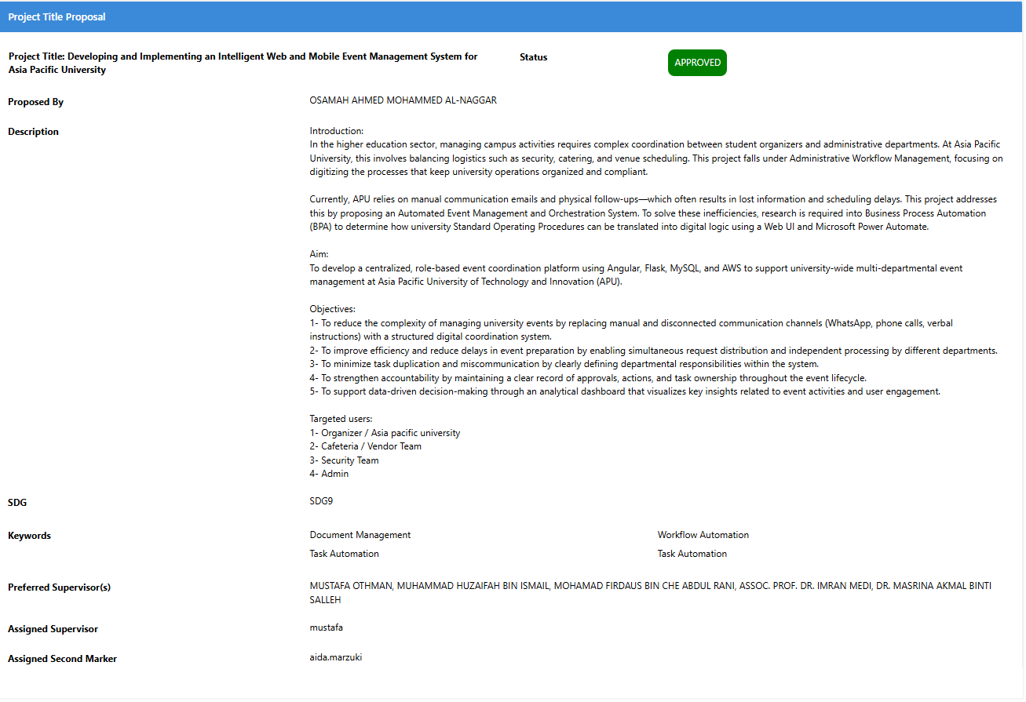
Figure 29: Proposal Form (PPF).

Appendix B: Ethics Forms
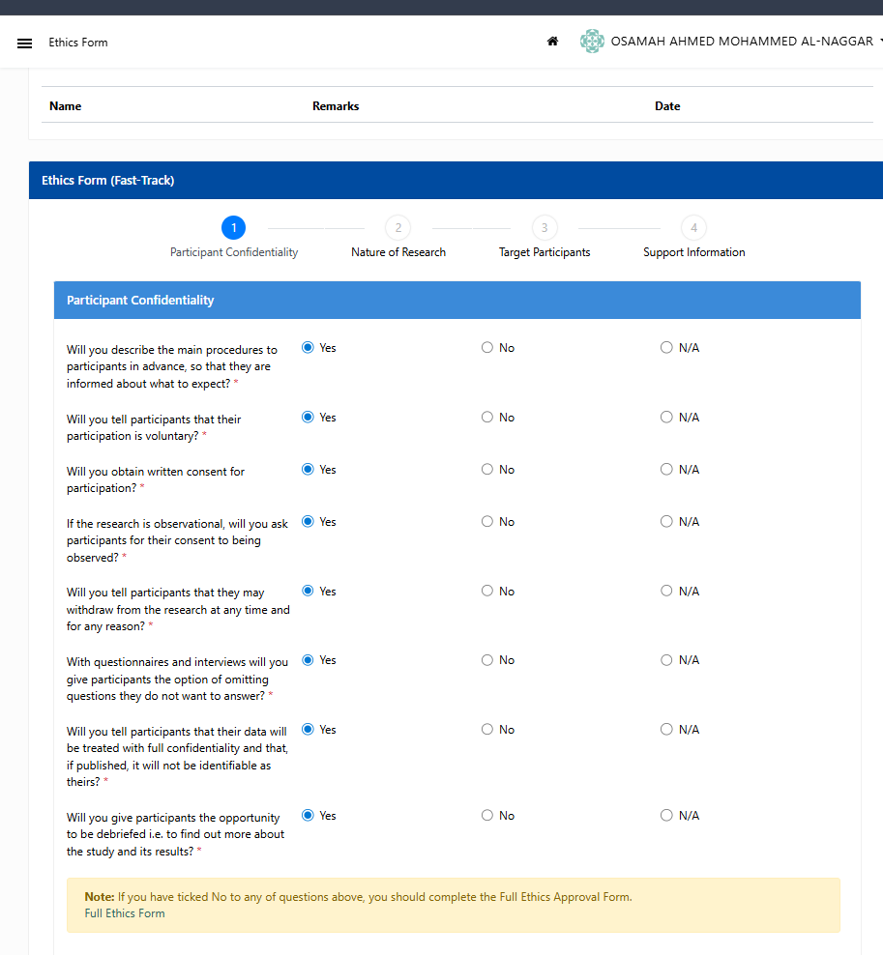
Figure 30: Proposal Form (PPF).

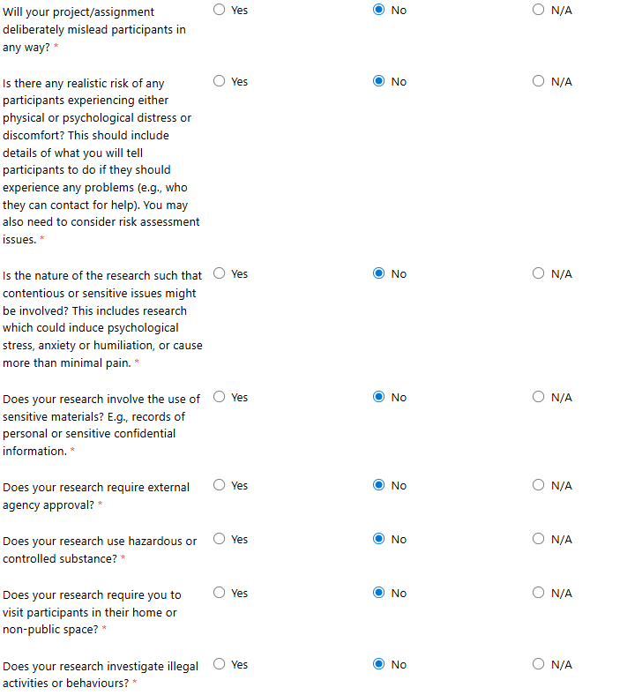
Figure 31: Ethics Forms — Nature of Research - part 1.

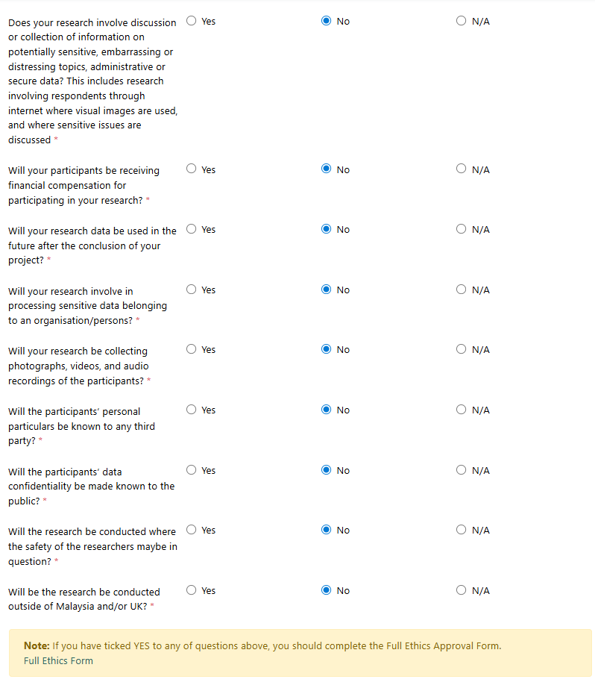
Figure 32: Ethics Forms — Nature of Research - part 2.
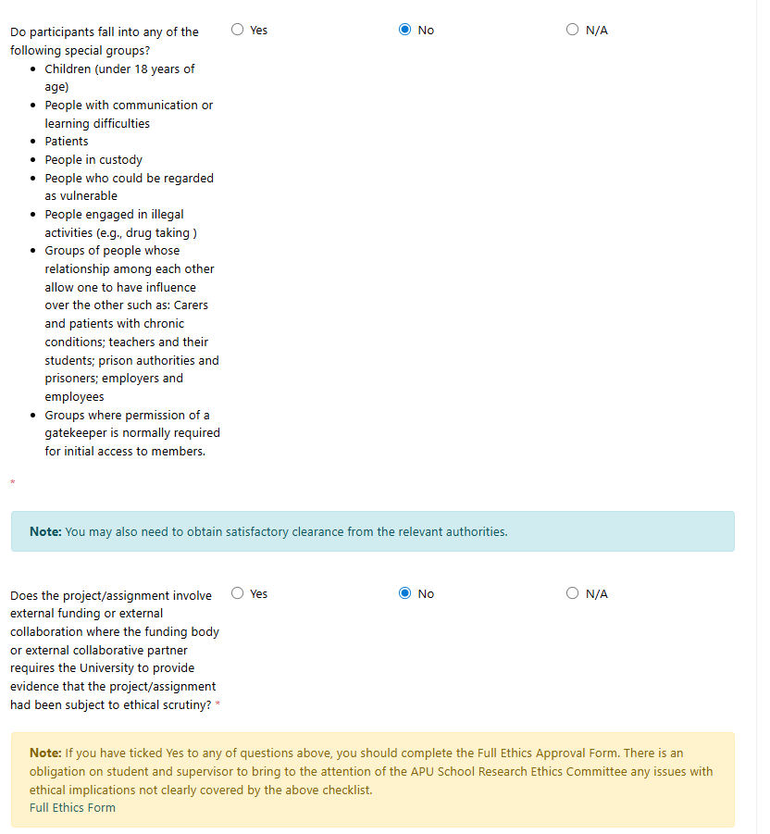
Figure 33: Ethics Forms — Target Participants.

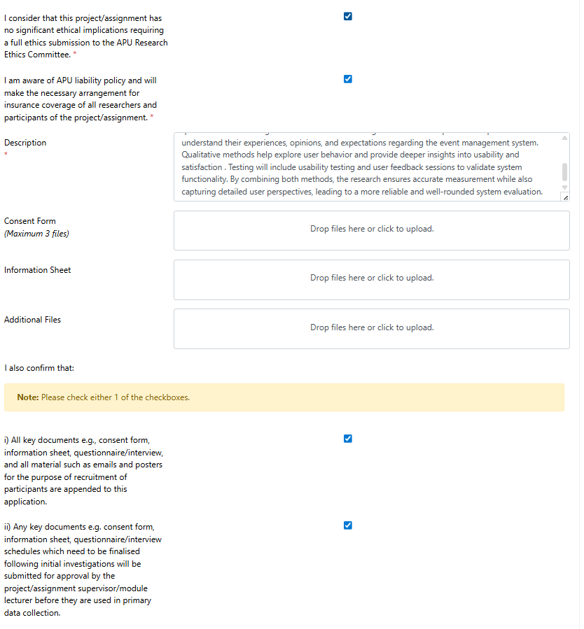
Figure 34: Ethics Forms — Target Participants.

Appendix C: Log Sheets
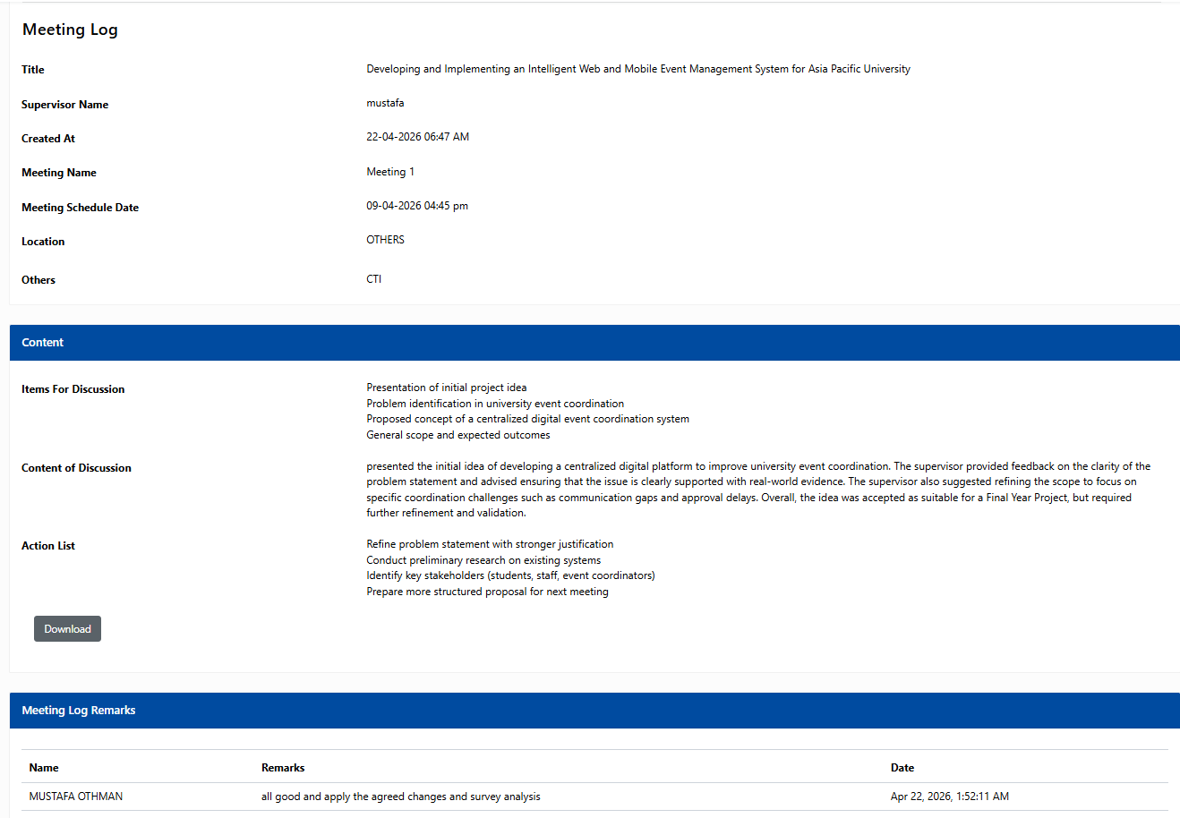
Figure 35: Log Sheets – meeting 1.

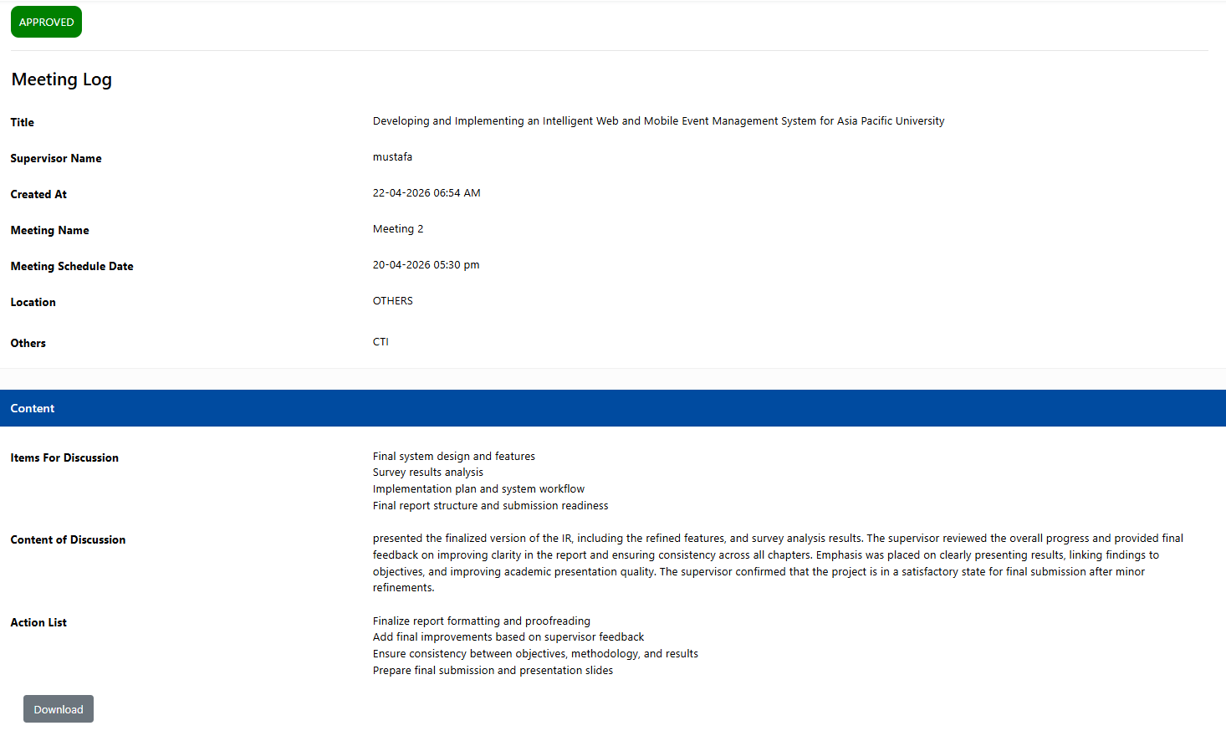
Figure 36: Log Sheets – meeting 2.

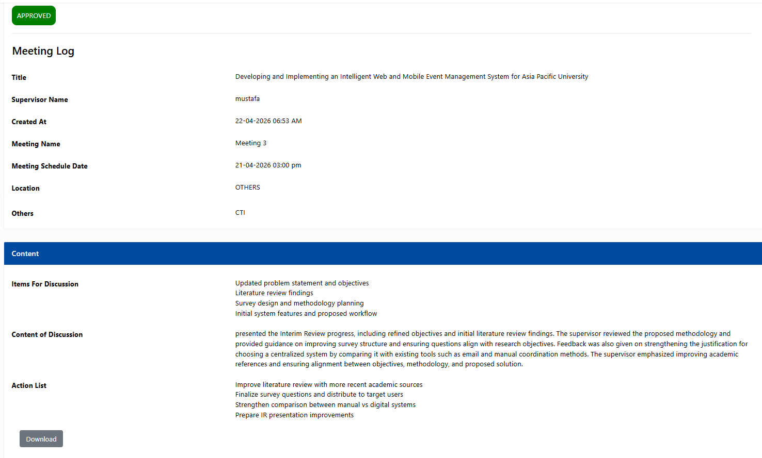
Figure 37: Log Sheets – meeting 3.

Appendix D: Gantt Chart
Centralized Role-Based Event Coordination Platform — IR Semester Timeline.
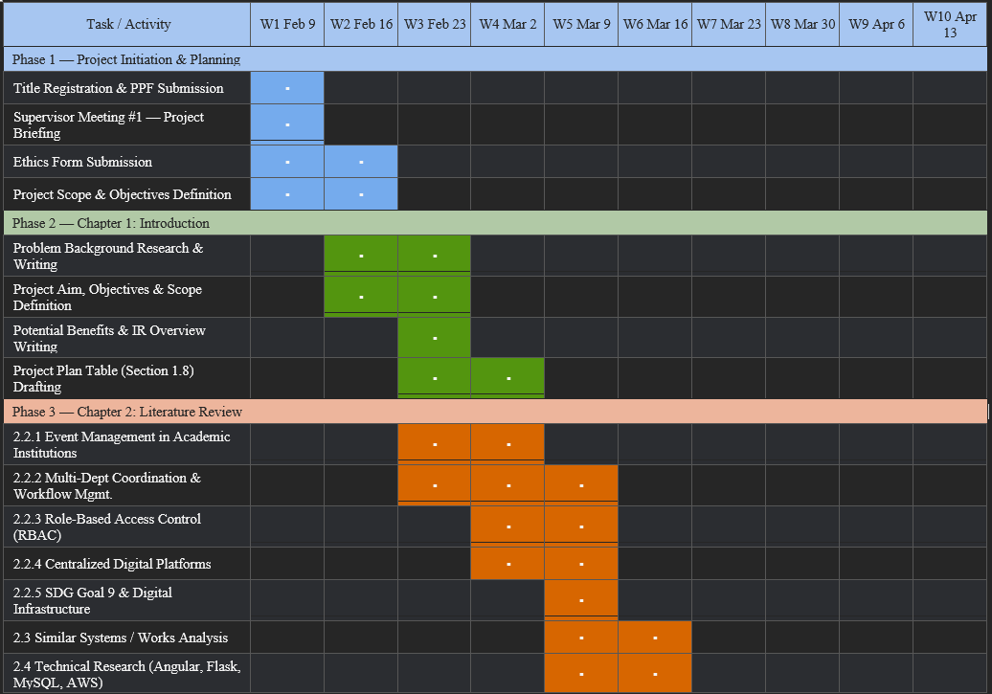
Figure 38: Gantt Chart – part 1.
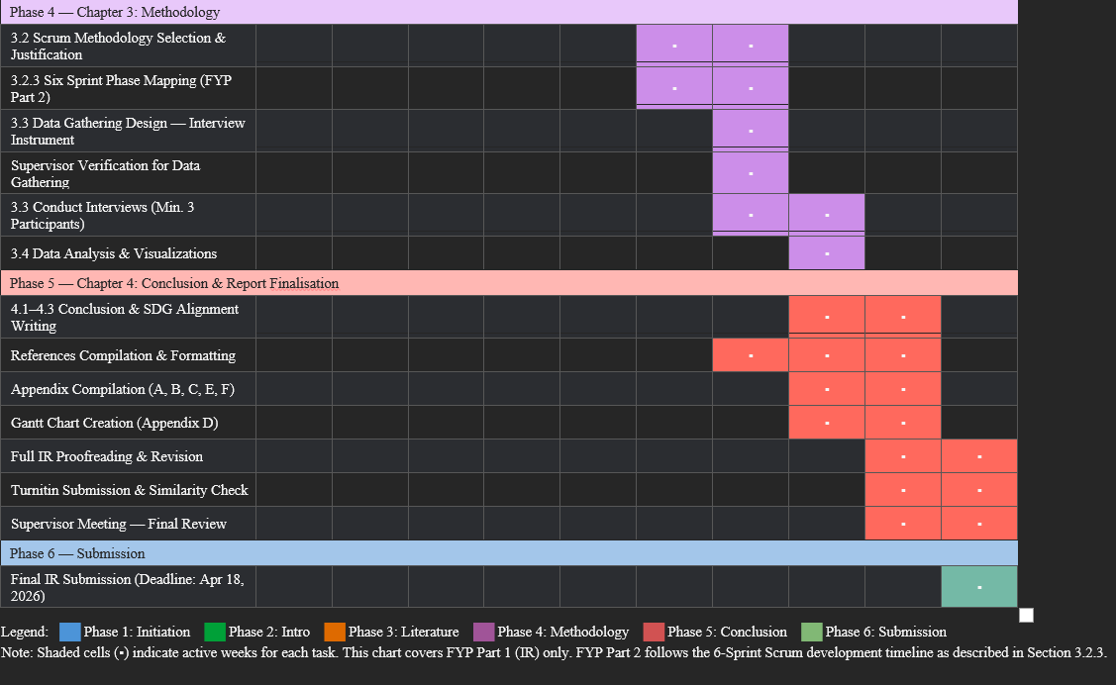
Figure 39: Gantt Chart – part 2.

Appendix E: Respondent Demographic Profile
Table 5: Respondent Demographic Profile
No | Name | Gender | Age | Role
1 | Participant 1 | Female | 24 - 26 | Student
2 | Participant 2 | Female | 21 - 23 | Student
3 | Participant 3 | Male | 18 -20 | Student
4 | Participant 4 | Female | 18 -20 | Student
5 | Participant 5 | Male | 18 -20 | Student
6 | Participant 6 | Male | 24 - 26 | Staff
7 | Participant 7 | Male | 18 -20 | Student
8 | Participant 8 | Male | 21 - 23 | Student
9 | Participant 9 | Male | Above 26 | Staff
10 | Participant 10 | Female | 18 -20 | Student
11 | Participant 11 | Male | 21 - 23 | Student
12 | Participant 12 | Male | 21 - 23 | Student
13 | Participant 13 | Male | Above 26 | Staff
14 | Participant 14 | Male | 24 - 26 | Student
15 | Participant 15 | Male | 21 - 23 | Student
16 | Participant 16 | Male | 21 - 23 | Student
17 | Participant 17 | Female | 18 -20 | Student
18 | Participant 18 | Male | 18 -20 | Student
19 | Participant 19 | Male | 21 - 23 | Student
20 | Participant 20 | Female | 21 - 23 | Student
21 | Participant 21 | Male | 18 -20 | Student
22 | Participant 22 | Male | 18 -20 | Student
23 | Participant 23 | Female | 18 -20 | Student
24 | Participant 24 | Male | 18 -20 | Student
25 | Participant 25 | Female | Above 26 | Staff
26 | Participant 26 | Male | Above 26 | Staff
27 | Participant 27 | Male | Above 26 | Staff
28 | Participant 28 | Female | 21 - 23 | Student
29 | Participant 29 | Female | 18 -20 | Student
30 | Participant 30 | Male | 18 -20 | Student
Note: Table 3 presents the demographic profile of respondents who participated in the study. It summarizes key background characteristics including gender, age group, and role (student or staff). The dataset consists of 30 respondents selected to represent different age ranges and institutional roles, allowing for a balanced overview of the sample population used in this research.

Appendix F: Turnitin Similarity Report

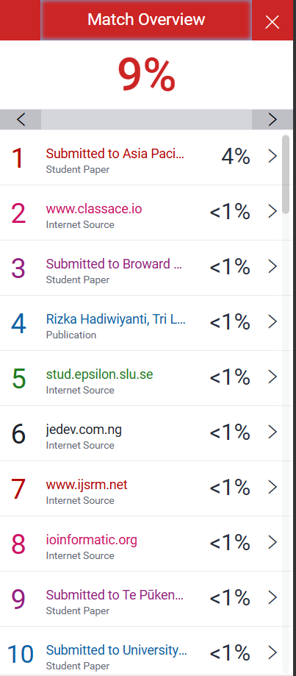
Figure 40 : Similarity Report – 1.
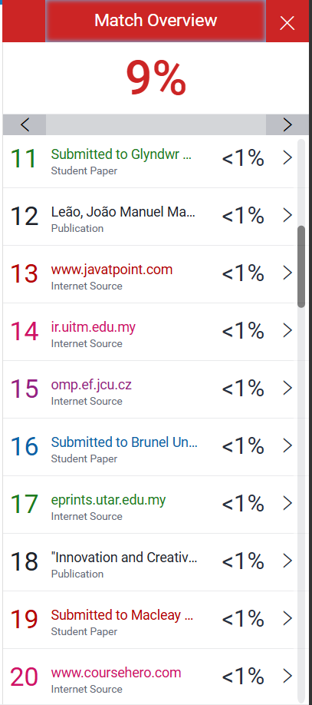
Figure 41: Similarity Report – 2.

