Product Owner Assignment - Invoice Module
Prepared for Product Owner Assessment
Invoice Module inspired by modern ERP workflows similar to Daftra.

1. Module Overview
The Invoice Module is designed to streamline billing and accounting operations for businesses.
The module enables users to create invoices, manage customers, add products/services,
apply taxes and discounts, export invoices, track payments, and maintain audit history.
The solution focuses on usability, scalability, accounting accuracy, and operational efficiency.

2. Naming Convention
Invoice Number Format:
INV-YYYY-####
Examples:
INV-2026-0001
INV-2026-0150

3. General Preconditions
- User is authenticated.
- User has invoice permissions.
- Products and clients are configured.
- Invoice module is enabled.

4. General Postconditions
- Invoice activities are logged.
- Totals are calculated automatically.
- Notifications are tracked.
- Audit logs are maintained.

5.1 Create Invoice

Epic
Create Invoice

User Story
As an accountant, I want to create invoices so that I can bill customers accurately.

Description
Create Invoice supports invoice lifecycle management and enterprise accounting workflows.

Normal Flow
1. User opens Invoice module.
2. User clicks Create Invoice.
3. System opens invoice screen.
4. User enters invoice details.
5. User saves invoice as Draft or Confirmed.

Screen Fields
Field | Type | Required
Invoice Number | Auto Generated | Mandatory
Invoice Date | Date Picker | Mandatory
Due Date | Date Picker | Optional
Currency | Dropdown | Mandatory
Notes | Textarea | Optional

Behavior
- Invoice totals update dynamically.
- Draft invoices do not affect inventory.
- Validation prevents incomplete invoices.

Acceptance Criteria
- Invoice number generated automatically.
- User cannot save invoice without client.
- Invoice saved successfully.

5.2 Select Client

Epic
Select Client

User Story
As a user, I want to select or create a client while creating an invoice.

Description
Select Client supports invoice lifecycle management and enterprise accounting workflows.

Normal Flow
1. User opens client selector.
2. System displays searchable clients.
3. User selects existing client or creates new one.
4. Client linked to invoice.

Screen Fields
Field | Type | Required
Client | Searchable Dropdown | Mandatory
Phone Number | Text | Optional
Email | Email | Optional

Behavior
- Autocomplete supported.
- Inline client creation available.

Acceptance Criteria
- Client linked successfully.
- Duplicate validation exists.

5.3 Add Products

Epic
Add Products

User Story
As a user, I want to add products to invoices so totals are calculated automatically.

Description
Add Products supports invoice lifecycle management and enterprise accounting workflows.

Normal Flow
1. User clicks Add Product.
2. System displays products list.
3. User selects products.
4. Totals update automatically.

Screen Fields
Field | Type | Required
Product | Searchable Dropdown | Mandatory
Quantity | Number | Mandatory
Unit Price | Currency | Mandatory
Discount | Number | Optional

Behavior
- Inline product creation supported.
- Inventory validated before confirmation.

Acceptance Criteria
- Product totals calculated correctly.
- Out-of-stock warning displayed.

5.4 Apply Taxes and Discounts

Epic
Apply Taxes and Discounts

User Story
As a user, I want to apply taxes and discounts so invoice totals are calculated correctly.

Description
Apply Taxes and Discounts supports invoice lifecycle management and enterprise accounting workflows.

Normal Flow
1. User selects taxes and discounts.
2. System recalculates totals instantly.

Screen Fields
Field | Type | Required
Tax Type | Dropdown | Optional
Tax Value | Percentage | Optional
Discount Type | Dropdown | Optional
Discount Value | Percentage | Optional

Behavior
- Inclusive and exclusive tax supported.
- Tax calculated after discounts.

Acceptance Criteria
- Grand total recalculated correctly.
- Discount cannot exceed total.

5.5 Inventory Validation

Epic
Inventory Validation

User Story
As a user, I want the system to validate stock availability before confirming the invoice.

Description
Inventory Validation supports invoice lifecycle management and enterprise accounting workflows.

Normal Flow
1. User confirms invoice.
2. System validates stock quantities.
3. Warning displayed if stock insufficient.

Screen Fields
Field | Type | Required
Available Quantity | Read Only Number | System Generated
Stock Warning | Alert Message | System Generated

Behavior
- Inventory updated only after confirmation.
- Low stock warning supported (Configuration Level).

Acceptance Criteria
- Invoice blocked when stock unavailable.
- Stock validation works correctly.

5.6 Draft Management

Epic
Draft Management

User Story
As a user, I want to save invoices as draft before final confirmation, so that I can complete the invoice later.

Description
Draft Management supports invoice lifecycle management and enterprise accounting workflows.

Normal Flow
1. User enters invoice details.
2. User clicks Save Draft.
3. Invoice stored without accounting impact.

Screen Fields
Field | Type | Required
Status | Dropdown | Mandatory

Behavior
- Draft invoices editable.
- Draft invoices excluded from reports.

Acceptance Criteria
- Draft saved successfully.
- Inventory not affected.

5.7 PDF Export

Epic
PDF Export

User Story
As a user, I want to export invoices as PDF for sharing and printing.

Description
PDF Export supports invoice lifecycle management and enterprise accounting workflows.

Normal Flow
1. User opens invoice.
2. User clicks Export PDF.
3. System generates PDF.

Screen Fields
Field | Type | Required
Export Format | Dropdown | Mandatory

Behavior
- Company branding included.
- Supports Arabic and English.

Acceptance Criteria
- PDF downloads successfully.
- Invoice formatting preserved.

5.8 Email Sharing-Notification

Epic
Email Sharing

User Story
As a user, I want to send invoices to client directly via email and/or WhatsApp.

Description
Email Sharing supports invoice lifecycle management and enterprise accounting workflows.

Normal Flow
1. User opens invoice.
2. User clicks Share.
3. User selects Email and/or WhatsApp.
4. Invoice shared successfully.

Screen Fields
Field | Type | Required
Recipient Email | Email | Mandatory
Message | Textarea | Optional

Behavior
- Share logs tracked.
- Localized templates supported.

Acceptance Criteria
- Invoice sent successfully.
- Sharing errors handled properly.

5.9 Payment Tracking

Epic
Payment Tracking

User Story
As a finance manager, I want to track paid, unpaid, and overdue invoices.

Description
Payment Tracking supports invoice lifecycle management and enterprise accounting workflows.

Normal Flow
1. User opens invoice list.
2. System displays statuses.
3. User filters invoices.

Screen Fields
Field | Type | Required
Payment Status | Status Badge | System Generated
Paid Amount | Currency | System Generated

Behavior
- Statuses update automatically.
- Partial payments supported.

Acceptance Criteria
- Overdue invoices identified.
- Payment tracking accurate.

5.10 Recurring Invoices

Epic
Recurring Invoices

User Story
As a business owner, I want recurring invoices for subscription-based clients.

Description
Recurring Invoices supports invoice lifecycle management and enterprise accounting workflows.

Normal Flow
1. User enables recurring option.
2. User configures schedule.
3. Invoices generated automatically.

Screen Fields
Field | Type | Required
Recurrence Type | Dropdown | Mandatory
Start Date | Date Picker | Mandatory

Behavior
- Automatic invoice generation supported.
- Notifications triggered before creation.

Acceptance Criteria
- Recurring invoices generated correctly.
- Schedule configuration validated.

5.11 Audit Logs

Epic
Audit Logs

User Story
As an admin, I want to track invoice modifications for auditing purposes.

Description
Audit Logs supports invoice lifecycle management and enterprise accounting workflows.

Normal Flow
1. User modifies invoice.
2. System stores activity logs.
3. Admin reviews history.

Screen Fields
Field | Type | Required
Activity Type | Text | System Generated
Modified By | Text | System Generated
Timestamp | Datetime | System Generated

Behavior
- All activities logged automatically.
- Historical data preserved.

Acceptance Criteria
- Audit logs visible to admins.
- Modification history accurate.

6. Invoice Module Wireframe
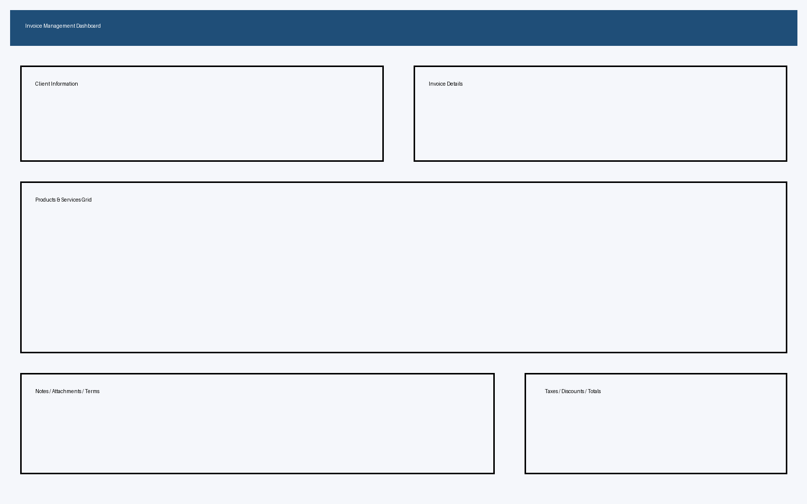

7. Future Enhancements
- AI product recommendations
- Payment gateway integrations
- Approval workflows
- Revenue analytics dashboard
- OCR invoice import
- WhatsApp integration

