**Final Report**

**Name of Project:** “FYP Management System named as **Bahria FYP Management System**”.

**Main Objectives:** Following are some of the main objectives of this project:

* To develop a Management System that can process Final Year Project operations and procedures.
* A single Unit that can provide further three Interfaces for Project Administrator, Supervisor, Student and Evaluator.
* A system that can act as a single interface FYP management systems
* A system that can handle filing module as storage options

**Step By Step Explanation**– what is this project and how it works.

1. It is a Final Year Project Management System.
2. It can handle all the process related to FYP’s
3. It has 5 Portals.
4. **1st Portal - Project Administrator portal.**
5. In this portal, administrator has the option to register and add Groups with 2 people in each group for FYP.
6. Administrator will register the students with default information already present in University’s Database.
7. Students and Supervisors can change it Later.
8. **2nd Portal - Student Portal.**
9. In 2nd portal, students have different options
10. Students can see their supervisor information just by entering their Group No.
11. Students can Edit their profiles that are already stored just by entering their Group No
12. Students can also submit their Final Projects just by Selecting their Group No.
13. If the submission date is greater than deadline, the system will not accept the submission displaying a late massage
14. **3rd Portal – Supervisor Portal**
15. A wide variety of different options are available for supervisors in Supervisor’s Portal
16. Supervisors can Edit Project Status and Deadline just By Entering respective Group No.
17. Supervisors can view the Total No of Groups assigned to them just by Entering their Full Official Name.
18. Supervisors can view student/project profile just by Entering their Group No.
19. Supervisors can view The Total Submitted Projects
20. Supervisors can create and show their own Topics List
21. **4th Portal – Marking Portal**
22. Marking Portal is the most important Portal as it deals with results
23. It allows Supervisors and Evaluators to Mark the projects separately and calculate Total Result/Marks
24. **The 5th and Last Portal** display Final Marks Sheet of Submitted and Marked Projects on Board.

**Program Design**

* This program has been written in C++.
* I have used Random Access Files in this particular program as they are more efficient and secure
* I have also used Inheritance and designed through technique of separate compilation

**Total Functions Used**

* **Projectccordinator:: void getdata()** – Is used to get data from user for project coordinator class
* Same **getdata()** functions are used in all classes to get data from user.
* **void getevalmarks()** is used to get Evaluator Marks
* v**oid writetopic()** - function by which supervisor can create its topic list in another file
* **void displaytoplist()** - function by which supervisor can display its own Topic list so students can see
* **void writefile();** - function for registering a student for FYP and creating a Full object in Main Storage file with The Default information present in University’s Database
* **friend ostream& operator**<<(ostream& output, projectmanagement PO) – Is used to overload output operator to be used with userdefined class object
* **void display();** - function for displaying All the Group Information stored in Main Storage File when the student got registered
* **void sviewsuper();** - function by which student can view it's supervisor's information jus by entering its Group No.
* **void studentedit();** - function by which students can edit their Profile.
* **void supervisoredits();** - function by which supervisor can edit project profile which includes project status and project deadline
* **void supervisortotalgroups();** - function by which a supervisor can view Total no of Groups assigned to him/her just by Entering their Full Official Name
* **void supdstupro();** - function by which supervisor can view Student Profile and Project Profile just by entering their Respective Group No
* **void studentsubmits(); -** function by which student can submit their Final Year Project when it is done. If the submission date is greater than deadline the system won’t accept the submission. It will display a late massege
* **void displaysubmittedprojects**(); - function which displays all the submitted projects that were stored in a separate file.
* **void calculateresultsuper();** - function which is used by supervisor for entering the marks of a submitted assignment by entering Group No
* **void calculateresulteval**(); function which is used by evaluator for entering the marks of a submitted assignment by entering Group No. This function also calculates the total marks by adding ”supervisor marks + evaluator marks”

**Files Usage**

* All the Group Data which includes group number, student name, enrollment, class, project profile and supervisor’s profile is stored in a main file named as “TestData.dat”
* All the submitted projects are stored in a separate file with submission Date. The file name is “SubmittedProjects.dat”.

**Main Architecture**

* Main is designed using a primary Switch statement.
* The main is totally menu driven.
* It has 5 Portals
* Project Administrator Portal, Student Portal, Supervisor Portal, Marking Portal and Result Sheet Portal

*Thank You*

*--------------------------------------------------------------------*

**UML Class Diagram:**

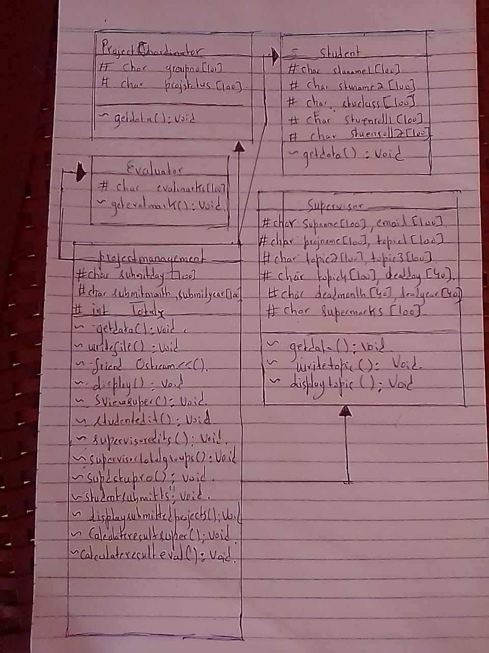

**Sample Outputs:**

1 – Displaying Main at The Start – Displaying First Look Interface

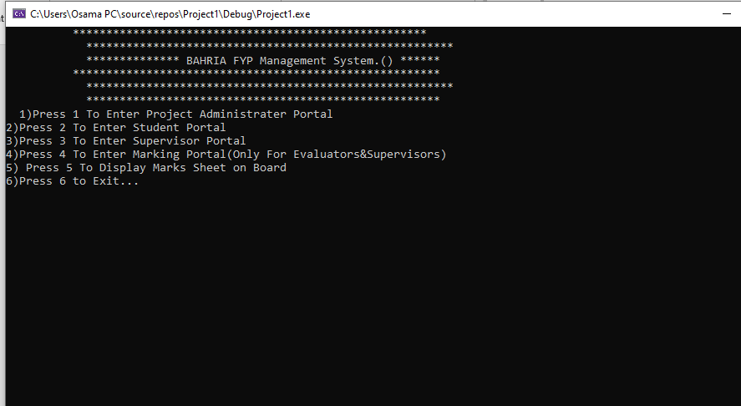

2 – Pressing 1 – It Goes to Project Administrator Portal:

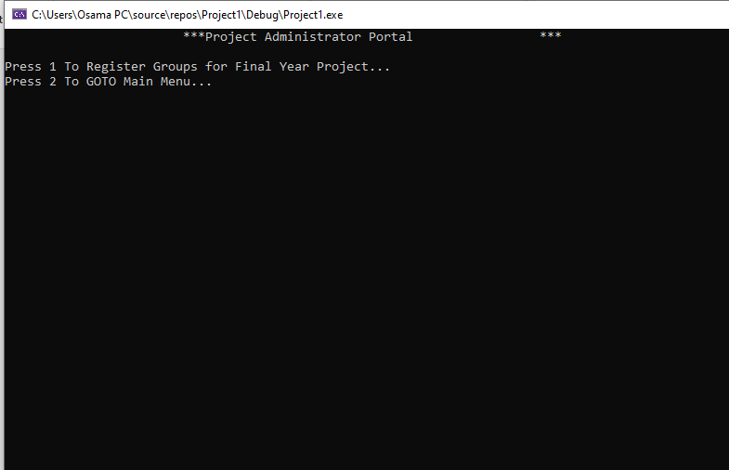

3 – Pressing 1 in Administrator Portal registers Students Group wise, 2 students in 1 group and saves the object in file.

Getting the default info for the group from user and storing it into file

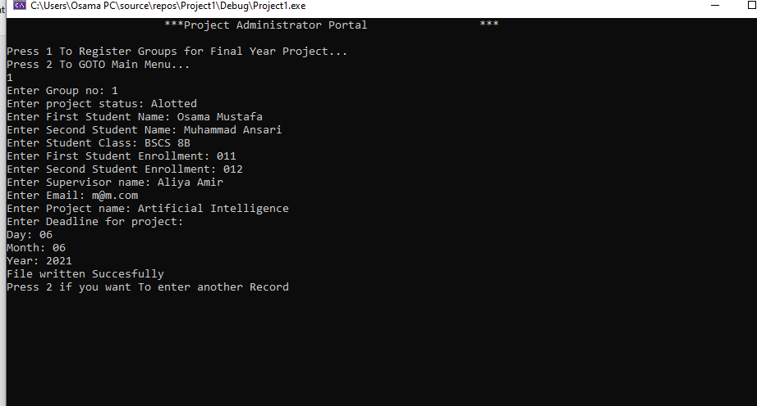

Also Displays Group Profile After writing in File To Confirm Successful writing:

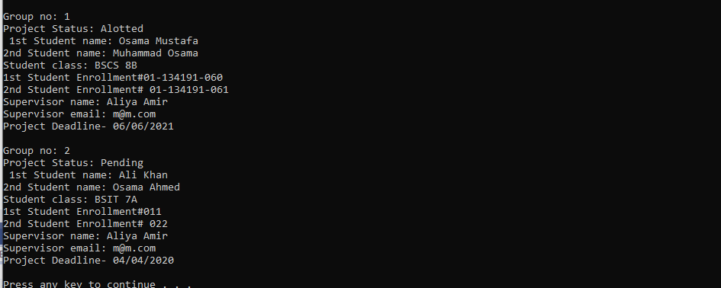

4 – Pressing 2 – It goes into Student Portal and Displays Menu

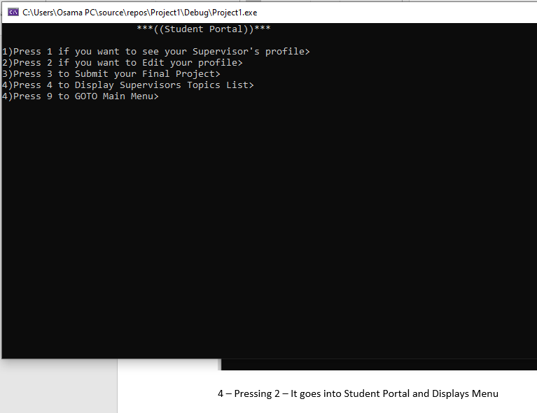

**Pressing 1** in Student’s Portal Displays student’s supervisor Info After taking Student Group No.

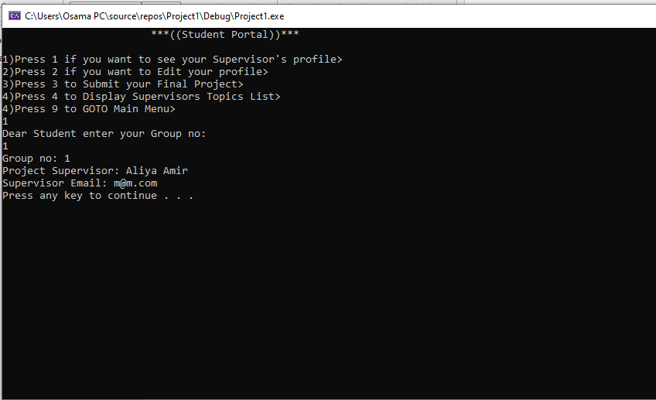

**Pressing 2** in Student’s Portal Allows Them to Edit their profile by Taking Their Group No. They can change both students name and enrolment No.

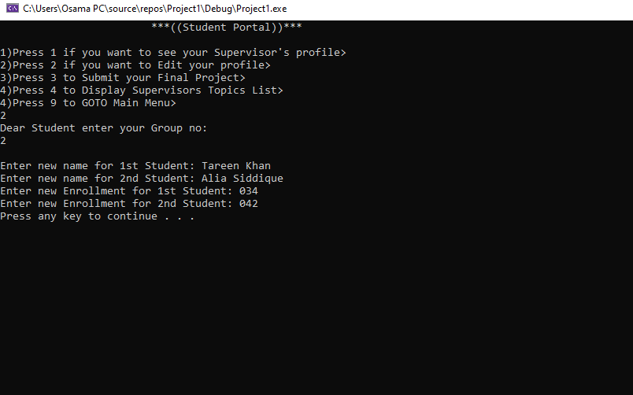

**Pressing 3 Takes you To Project Submission Portal.** It asks you group no and then asks you to type submitted for confirmation. It also asks you for the submission date and then checks it with the deadline if its ok or not. Also Store the submitted projects in a separate file.

When a project is submitted by a Group, the Project Status is Automatically changed to “Submitted”.

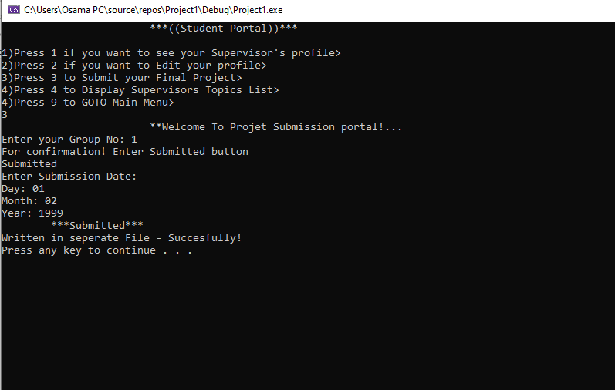

**If Submission date>Deadline,** means if it exceeds deadline it rejects submission and displays a massage that deadline has passed Already.

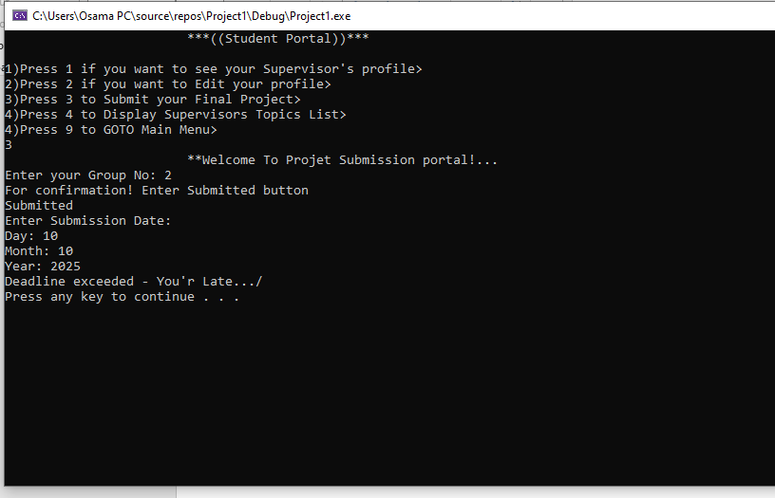

**Pressing 9 in Student’s Portal** Takes back to Main Menu

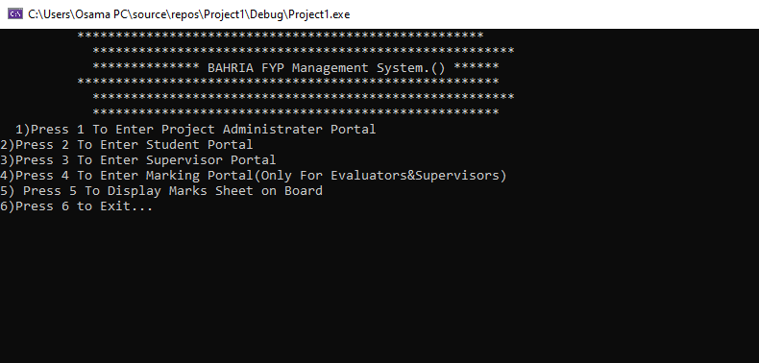

**Pressing 3 In Main Menu** Takes You To Supervisor’s Portal and Displays Menu

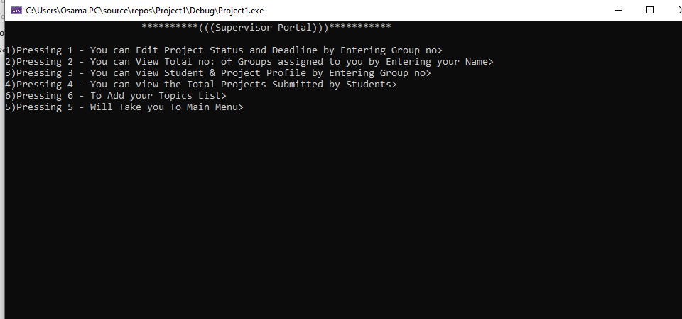

**Pressing 1 in Supervisor’s Portal** allows Supervisor To Change Project Status and Deadline for A Group By Entering Their Respective Group No.

After editing, it also displays the Group Profile for Confirmation of Changes..

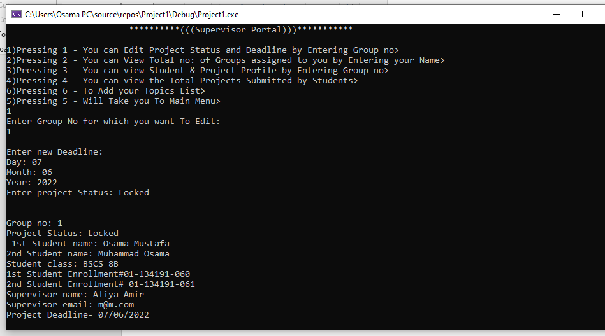

**By Pressing 2 in Supervisor’s Portal**:

It asks for the Supervisor Full Name and Then Displays the Total Number of Groups Assigned To That particular Supervisor Respectively

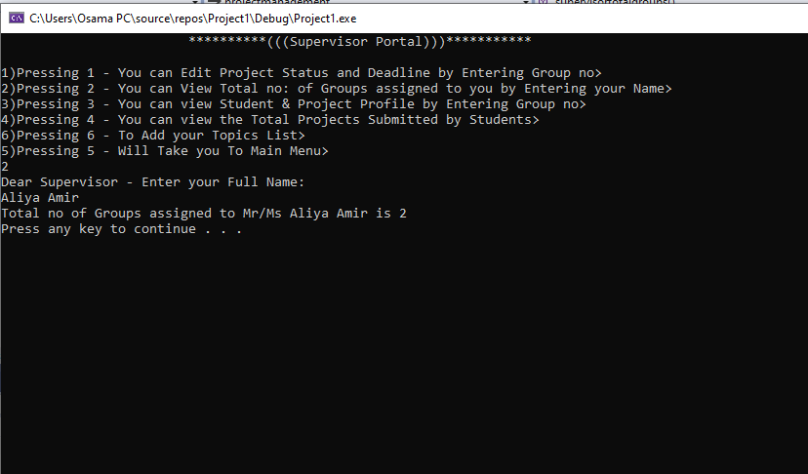

**Pressing 3 in Supervisor’s Portal:**

It asks you To Enter A Group No. Than it searches and displays complete Student’s Profile and Complete Project info/Profile of That Particular Group.

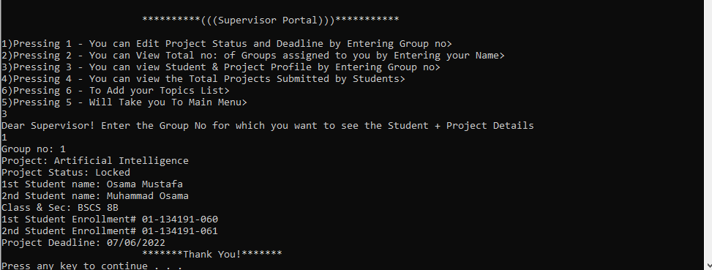

**Pressing 4 in Supervisor’s Portal:**

It displays all the submitted Projects. If Marks are 0 or NIL it means it hasn’t been checked yet by the evaluators and supervisors

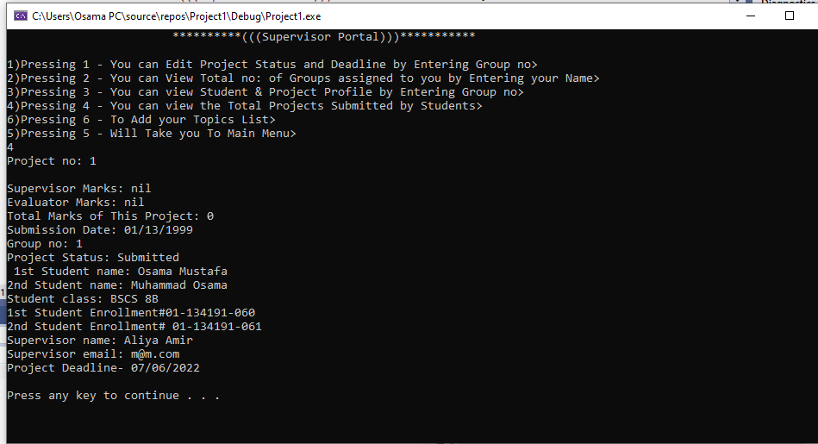

**Pressing 4 in Main Menu:** Takes you To Marking Portal. Here the Supervisor and Evaluator Can Mark a Project separately.

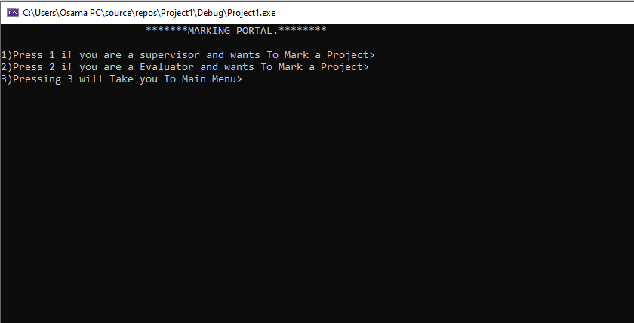

**Pressing 1 in Marking Portal:**

Takes you To “Supervisor’s Marking Portal where supervisor can enter Group no and Mark the Project. After marking it displays so it is confirmed that supervisor marks are added in supervisor marks portion

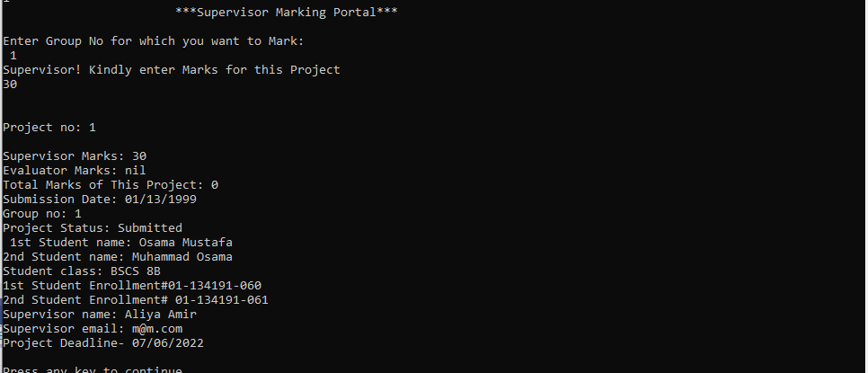

**Pressing 2 in Marking Portal:**

Takes you To “Evaluator Marking Portal where Evaluator can enter Group no and Mark the Project. After marking it displays so it is confirmed that Evaluator marks are added in Evaluator marks portion.

This option also sums the previously added Supervisor Marks + Evaluator Marks that were just added. Than It shows the Total Result as well

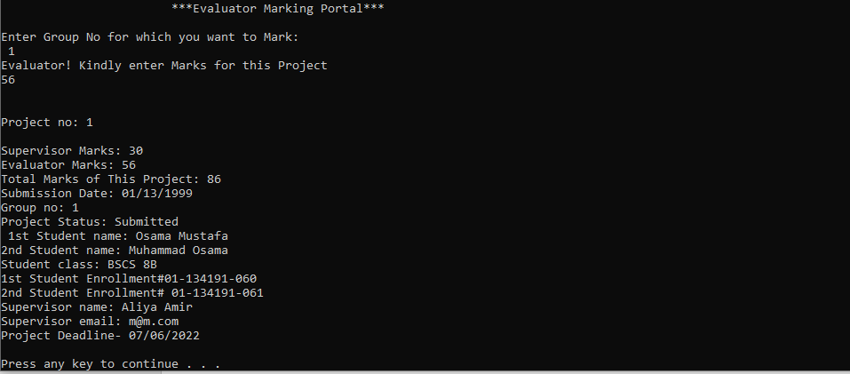

**Pressing 6 in The Main Menu:**

Takes you To Result Display Board and Displays the Result along with Group’s Complete Profile

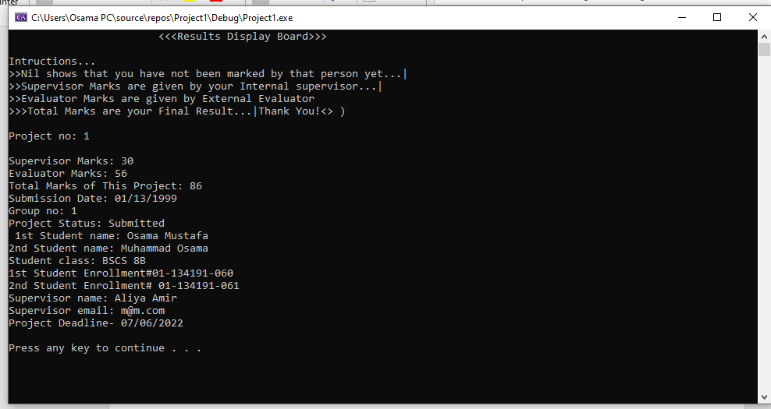

**Thank You!**

*------------------------------------------------------------------*

**Code:**

**Main.cpp:**

#pragma once

#include<iostream>//header file for input/output streams

#include<conio.h>

#include<string>//header file for string operations

#include<sstream>//header file for converting string - int

#include<fstream>//header file for using files

#include<stdlib.h>

#include"projectCoordinator.h"

#include"student.h"

#include"supervisor.h"

#include"evaluator.h"

#include"projectmanagement.h"

using namespace std;

int main()

{

g: system("cls");

int choice1, choice2, choice3, choice4, choice5, choice6, choice7, choice8;

cout << " *****************************************************\n ";

cout << " *******************************************************\n ";

cout << " ************** BAHRIA FYP Management System.() ******\n";

cout << " *******************************************************\n ";

cout << " *******************************************************\n ";

cout << " *****************************************************\n ";

cout << "1)Press 1 To Enter Project Administrater Portal\n";

cout << "2)Press 2 To Enter Student Portal\n";

cout << "3)Press 3 To Enter Supervisor Portal\n";

cout << "4)Press 4 To Enter Marking Portal(Only For Evaluators&Supervisors)\n";

cout << "5) Press 5 To Display Marks Sheet on Board\n";

cout << "6)Press 6 to Exit...\n";

cin >> choice1;

switch (choice1)

{

case 1:

{

system("cls");

cout << "\t\t\t***Project Administrator Portal\t\t\t***\n\n";

cout << "Press 1 To Register Groups for Final Year Project...\n";

cout << "Press 2 To GOTO Main Menu...\n";

cin >> choice2;

if (choice2 == 1)

{

projectmanagement PM;

PM.writefile();

cout << "\n\n";

PM.display();

system("pause");

goto g;

}

if(choice2==2)

{

goto g;

}

}

case 2:

{

h: system("cls");

cout << "\t\t\t***((Student Portal))***\t\t\t\n\n";

cout << "1)Press 1 if you want to see your Supervisor's profile>\n";

cout << "2)Press 2 if you want to Edit your profile>\n";

cout << "3)Press 3 to Submit your Final Project>\n";

cout << "4)Press 4 to Display Supervisors Topics List>\n";

cout << "4)Press 9 to GOTO Main Menu>\n";

cin >> choice3;

if (choice3 == 1)

{

projectmanagement PM;

PM.sviewsuper();

system("pause");

cout << "\n\n";

goto h;

}

if (choice3 == 2)

{

projectmanagement PM;

PM.studentedit();

system("pause");

cout << "\n\n";

goto h;

}

if (choice3 == 3)

{

projectmanagement PM;

PM.studentsubmits();

system("pause");

cout << endl<<endl;

goto h;

}

if (choice3 == 4)

{

supervisor SO;

SO.displaytoplist();

system("pause");

cout << endl << endl;

goto h;

}

if (choice3 == 9)

{

goto g;

}

}

case 3:

{

system("cls");

i: cout << "\t\t\t**********(((Supervisor Portal)))***********\t\t\t\n\n";

cout << "1)Pressing 1 - You can Edit Project Status and Deadline by Entering Group no>\n";

cout << "2)Pressing 2 - You can View Total no: of Groups assigned to you by Entering your Name>\n";

cout << "3)Pressing 3 - You can view Student & Project Profile by Entering Group no>\n";

cout << "4)Pressing 4 - You can view the Total Projects Submitted by Students>\n";

cout << "6)Pressing 6 - To Add your Topics List>\n";

cout << "5)Pressing 5 - Will Take you To Main Menu>\n";

cin >> choice4;

if (choice4 == 1)

{

projectmanagement PM;

PM.supervisoredits();

cout << endl << endl;

PM.display();

system("pause");

cout << endl;

goto i;

}

if (choice4 == 2)

{

projectmanagement PM;

PM.supervisortotalgroups();

system("pause");

cout << endl << endl;

goto i;

}

if (choice4 == 3)

{

projectmanagement PM;

PM.supdstupro();

system("pause");

cout << endl << endl;

goto i;

}

if (choice4 == 4)

{

projectmanagement PM;

PM.displaysubmittedprojects();

system("pause");

cout << "\n\n";

goto i;

}

if (choice4 == 6)

{

supervisor SM;

SM.writetopic();

system("pause");

cout << "\n\n";

goto i;

}

if(choice4==5)

{

goto g;

}

}

case 4:

{

j: system("cls");

cout << "\t\t\t*******MARKING PORTAL.********\t\t\t\n\n";

cout << "1)Press 1 if you are a supervisor and wants To Mark a Project>\n";

cout << "2)Press 2 if you are a Evaluator and wants To Mark a Project>\n";

cout << "3)Pressing 3 will Take you To Main Menu>\n";

cin >> choice5;

if (choice5 == 1)

{

projectmanagement PLD;

PLD.calculateresultsuper();

cout << "\n\n";

PLD.displaysubmittedprojects();

system("pause");

cout << "\n";

goto j;

}

if (choice5 == 2)

{

projectmanagement PLD;

PLD.calculateresulteval();

cout << "\n\n";

PLD.displaysubmittedprojects();

system("pause");

cout << "\n";

goto j;

}

if (choice5 == 3)

{

goto g;

}

}

case 5:

{

system("cls");

projectmanagement resultlist;

cout << "\t\t\t<<<Results Display Board>>>\t\t\t\n\n";

cout << "Intructions...\n";

cout << ">>Nil shows that you have not been marked by that person yet...|\n";

cout << ">>Supervisor Marks are given by your Internal supervisor...|\n";

cout << ">>Evaluator Marks are given by External Evaluator\n";

cout << ">>>Total Marks are your Final Result...|Thank You!<> ) \n";

cout << endl;

resultlist.displaysubmittedprojects();

system("pause");

cout << "\n\n";

goto g;

}

case 6:

cout << "Thank You Bye! Bye!\n\n\n";

system("pause");

exit(0);

default:

cout << "Invalid Selection Made...|\n";

goto g;

}

system("pause");

return 0;

}

**Implementation.cpp:**

#pragma once

#pragma once

#include<iostream>//header file for input/output streams

#include<conio.h>

#include<string>//header file for string operations

#include<sstream>//header file for converting string - int

#include<fstream>//header file for using files

#include<stdlib.h>

#include"projectCoordinator.h"

#include"student.h"

#include"supervisor.h"

#include"evaluator.h"

#include"projectmanagement.h"

using namespace std;

void projectCoordinator::getdata()

{

cout << "Enter Group no: ";

cin.getline(groupno, 40);

cout << "Enter project status: ";

cin.getline(projstatus, 40);

}

void student::getdata()

{

cout << "Enter First Student Name: ";

cin.getline(stuname1, 100);

cout << "Enter Second Student Name: ";

cin.getline(stuname2, 100);

cout << "Enter Student Class: ";

cin.getline(stuclass, 100);

cout << "Enter First Student Enrollment: ";

cin.getline(stuenroll1, 100);

cout << "Enter Second Student Enrollment: ";

cin.getline(stuenroll2, 100);

}

void supervisor::getdata()

{

cout << "Enter Supervisor name: ";

cin.getline(supname, 100);

cout << "Enter Email: ";

cin.getline(email, 100);

cout << "Enter Project name: ";

cin.getline(projname, 100);

cout << "Enter Deadline for project: \n";

cout << "Day: "; cin.getline(deadday, 40);

cout << "Month: "; cin.getline(deadmonth, 40);

cout << "Year: "; cin.getline(deadyear, 40);

}

void supervisor::writetopic()

{

supervisor SO;

ofstream wr("superlist.dat,ios::app|ios::out");

if (!wr)

{

cout << "Error opening File!\n";

}

else

{

cin.ignore();

cout << "Enter supervior name: ";

cin.getline(SO.supname, 100);

cout << "Enter First Topic: ";

cin.getline(SO.topic1, 100);

cout << "Enter Second Topic: ";

cin.getline(SO.topic2, 100);

cout << "Enter Third Topic: ";

cin.getline(SO.topic3, 100);

cout << "Enter Fourth Topic: ";

cin.getline(SO.topic4, 100);

wr.write((char*)&SO, sizeof(SO));

cout << "Topic List File written succefully\n";

wr.close();

}

}

void supervisor::displaytoplist()

{

char usname[100];

cout << "Following Supervisors are available: \n";

cout << "Aliya Amir - Sikandar Hayat\n";

cin.getline(usname, 100);

supervisor SM;

ifstream ir;

ir.open("suoerlist.dat");

if (!ir)

{

cout << "Error opening requested File!\n";

}

else

{

while (ir.read((char*)&SM, sizeof(SM)))

{

if (strcmp(usname, SM.supname) == 0)

{

cout << "Topic 1: " << SM.topic1 << endl;

cout << "Topic 2: " << SM.topic2 << endl;

cout << "Topic 3: " << SM.topic3 << endl;

cout << "Topic 4: " << SM.topic4 << endl;

}

}

ir.close();

}

}

void evaluator::getevalmarks()

{

cout << "Evaluator! Kindly enter Marks for this Project\n";

cin.getline(evalmarks, 100);

}

void projectmanagement::getdata()//get function which involves getter of all three base classes involved

{

projectCoordinator::getdata();

student::getdata();

supervisor::getdata();

}

void projectmanagement::writefile()//function for creating a major Group object and writing it into Main File

{

int n = 2;

projectmanagement PM;

ofstream wr("TestData.dat", ios::app | ios::out);

if (!wr)

{

cout << "Error! Requested File could not be opened\n";

}

else

{

while (n == 2)

{

cin.ignore();

PM.getdata();

wr.write((char*)&PM, sizeof(PM));

cout << "File written Succesfully \n";

cout << "Press 2 if you want To enter another Record\n";

cin >> n;

}

wr.close();

}

}

void projectmanagement::display()//function for displaying the main group object present in the Main File

{

projectmanagement PO;

ifstream ir;

ir.open("TestData.dat");

if (!ir)

{

cout << "Error Opening File!\n";

}

else

{

while (ir.read((char*)&PO, sizeof(PO)))

{

cout << PO;

cout << endl;

}

ir.close();

}

}

void projectmanagement::sviewsuper()//function by which student can view it'ssupervisor's information

{

projectmanagement PI;

char usenroll[100];

cin.ignore();

cout << "Dear Student enter your Group no: \n";

cin >> usenroll;

ifstream ir;

ir.open("TestData.dat");

while (ir.read((char*)&PI, sizeof(PI)))

{

if (strcmp(usenroll, PI.groupno) == 0)

{

cout << "Group no: " << PI.groupno << endl;

cout << "Project Supervisor: " << PI.supname << endl;

cout << "Supervisor Email: " << PI.email << endl;

}

}

ir.close();

}

void projectmanagement::studentedit()//function by which students can edit teir Profile

{

projectmanagement PI;

char usgrouupno[100];

cin.ignore();

cout << "Dear Student enter your Group no: \n";

cin.getline(usgrouupno, 100);

fstream wr("TestData.dat", ios::in | ios::out);

wr.seekg(0);

while (wr.read((char*)&PI, sizeof(PI)))

{

if (strcmp(usgrouupno, PI.groupno) == 0)

{

cin.ignore();

cout << "Enter new name for 1st Student: ";

cin.getline(PI.stuname1, 100);

cout << "Enter new name for 2nd Student: ";

cin.getline(PI.stuname2, 100);

cout << "Enter new Enrollment for 1st Student: ";

cin.getline(PI.stuenroll1, 100);

cout << "Enter new Enrollment for 2nd Student: ";

cin.getline(PI.stuenroll2, 100);

wr.seekp(-(long int)sizeof(PI), ios::cur);

wr.write((char*)&PI, sizeof(PI));

break;

}

}

wr.close();

}

void projectmanagement::supervisoredits()//function by which supervisor can edit project profile

{

projectmanagement PI;

char usgroupno[100];

cin.ignore();

cout << "Enter Group No for which you want To Edit: \n";

cin.getline(usgroupno, 100);

fstream wr("TestData.dat", ios::in | ios::out);

wr.seekg(0);

while (wr.read((char*)&PI, sizeof(PI)))

{

if (strcmp(usgroupno, PI.groupno) == 0)

{

cin.ignore();

cout << "Enter new Deadline: \n";

cout << "Day: "; cin.getline(PI.deadday, 40);

cout << "Month: "; cin.getline(PI.deadmonth, 40);

cout << "Year: "; cin.getline(PI.deadyear, 40);

cout << "Enter project Status: ";

cin.getline(PI.projstatus, 100);

wr.seekp(-(long int)sizeof(PI), ios::cur);

wr.write((char*)&PI, sizeof(PI));

break;

}

}

wr.close();

}

void projectmanagement::supervisortotalgroups()//function by which a supervisor can view Total no of Groups assigned to him/her

{

projectmanagement PI;

int total = 0;

char ussupnamee[100];

cin.ignore();

cout << "Dear Supervisor - Enter your Full Name: \n";

cin.getline(ussupnamee, 100);

ifstream ir;

ir.open("TestData.dat");

while (ir.read((char*)&PI, sizeof(PI)))

{

if (strcmp(ussupnamee, PI.supname) == 0)

{

total++;

}

}

ir.close();

cout << "Total no of Groups assigned to Mr/Ms " << ussupnamee << " is " << total << endl;

}

void projectmanagement::supdstupro()//function by which supervisor can view student&project profile

{

projectmanagement PI;

char usgroupNo[100];

cin.ignore();

cout << "Dear Supervisor! Enter the Group No for which you want to see the Student + Project Details\n";

cin.getline(usgroupNo, 100);

ifstream ir;

ir.open("TestData.dat");

if (!ir)

{

cout << "Error opening requested File\n";

}

else

{

while (ir.read((char*)&PI, sizeof(PI)))

{

if (strcmp(usgroupNo, PI.groupno) == 0)

{

cout << "Group no: " << PI.groupno << endl;

cout << "Project: " << PI.projname << endl;

cout << "Project Status: " << PI.projstatus << endl;

cout << "1st Student name: " << PI.stuname1 << endl;

cout << "2nd Student name: " << PI.stuname2 << endl;

cout << "Class & Sec: " << PI.stuclass << endl;

cout << "1st Student Enrollment# " << PI.stuenroll1 << endl;

cout << "2nd Student Enrollment# " << PI.stuenroll2 << endl;

cout << "Project Deadline: " << PI.deadday << "/" << PI.deadmonth << "/" << PI.deadyear << endl;

cout << "\t\t\t*******Thank You!*******\t\t\t\n";

}

}

ir.close();

}

}

void projectmanagement::studentsubmits()//function by which student can submit their Final Year Project

{

projectmanagement PI;

char usGroupno[100];

cout << "\t\t\t**Welcome To Projet Submission portal!...\n";

cin.ignore();

cout << "Enter your Group No: ";

cin.getline(usGroupno, 100);

ofstream wr("SubmittedProjects.dat");

ifstream ir;

ir.open("TestData.dat");

if (!ir)

{

cout << "Error Opening Requested File!\n";

}

else

{

while (ir.read((char*)&PI, sizeof(PI)))

{

if (strcmp(usGroupno, PI.groupno) == 0)

{

int endline = (atoi(PI.deadyear) * 10000) + (atoi(PI.deadmonth) * 100) + (atoi(PI.deadday));

cout << "For confirmation! Enter Submitted button\n";

cin.getline(PI.projstatus, 100);

cout << "Enter Submission Date: \n";

cout << "Day: "; cin.getline(PI.submitday, 100);

cout << "Month: "; cin.getline(PI.submitmonth, 100);

cout << "Year: "; cin.getline(PI.submityear, 100);

strcpy_s(PI.supermarks, "nil");

strcpy_s(PI.evalmarks, "nil");

PI.Totalx = 0;

int submitdate = (atoi(PI.submityear) * 10000) + (atoi(PI.submitmonth) * 100) + (atoi(PI.submitday));

if (submitdate <= endline)

{

cout << "\t***Submitted***\t\t\n";

wr.write((char*)&PI, sizeof(PI));

cout << "Written in seperate File - Succesfully!\n";

}

else

{

cout << "Deadline exceeded - You'r Late.../\n";

}

}

}

}

ir.close();

wr.close();

}

void projectmanagement::displaysubmittedprojects()//function which displays all the submitted projects info

{

projectmanagement PI;

int i = 1;

ifstream ir;

ir.open("SubmittedProjects.dat");

while (ir.read((char*)&PI, sizeof(PI)))

{

cout << "Project no: " << i++ << endl << endl;

cout << "Supervisor Marks: " << PI.supermarks << endl;

cout << "Evaluator Marks: " << PI.evalmarks << endl;

cout << "Total Marks of This Project: " << PI.Totalx << endl;

cout << "Submission Date: " << PI.submitday << "/" << PI.submitmonth << "/" << PI.submityear << endl;

cout << PI << endl;

}

ir.close();

}

void projectmanagement::calculateresultsuper()//function which is used by supervisor for marking

{

projectmanagement PI;

char sugroupno[100];

cin.ignore();

cout << "\t\t\t***Supervisor Marking Portal***\t\t\t\n\n";

fstream obj;

obj.open("SubmittedProjects.dat", ios::in | ios::out);

cout << "Enter Group No for which you want to Mark:\n ";

cin.getline(sugroupno, 100);

while (obj.read((char*)&PI, sizeof(PI)))

{

if (strcmp(sugroupno, PI.groupno) == 0)

{

cout << "Supervisor! Kindly enter Marks for this Project\n";

cin.getline(PI.supermarks, 100);

obj.seekp(-(long int)sizeof(PI), ios::cur);

obj.write((char*)&PI, sizeof(PI));

break;

}

else

{

cout << "Group No Not Found!!\n";

}

}

obj.close();

}

void projectmanagement::calculateresulteval()//function which is used by evaluator for marking & It also calculates total

{

projectmanagement PI;

char sugroupno[100];

cin.ignore();

cout << "\t\t\t***Evaluator Marking Portal***\t\t\t\n\n";

fstream obj;

obj.open("SubmittedProjects.dat", ios::in | ios::out);

cout << "Enter Group No for which you want to Mark:\n ";

cin.getline(sugroupno, 100);

while (obj.read((char*)&PI, sizeof(PI)))

{

if (strcmp(sugroupno, PI.groupno) == 0)

{

PI.getevalmarks();

PI.Totalx = (atoi(PI.supermarks) + atoi(PI.evalmarks));

obj.seekp(-(long int)sizeof(PI), ios::cur);

obj.write((char*)&PI, sizeof(PI));

break;

}

else

{

cout << "Group No Not Found!!\n";

}

}

obj.close();

}

**projectCoordinator.h:**

#pragma once

#pragma once

#include<iostream>//header file for input/output streams

#include<conio.h>

#include<string>//header file for string operations

#include<sstream>//header file for converting string - int

#include<fstream>//header file for using files

#include<stdlib.h>

using namespace std;

class projectCoordinator {

protected:

char groupno[40];//initializing projectCoordinator class data

char projstatus[40];

public:

void getdata();//function for getiing Data from user

};

**Student.h:**

#pragma once

#pragma once

#include<iostream>//header file for input/output streams

#include<conio.h>

#include<string>//header file for string operations

#include<sstream>//header file for converting string - int

#include<fstream>//header file for using files

#include<stdlib.h>

using namespace std;

class student {

protected:

char stuname1[100];//intializing student class data

char stuname2[100];

char stuclass[100];

char stuenroll1[100];

char stuenroll2[100];

char sstuprojname[100];

public:

void getdata();//function for getting Data from user

};

**Supervisor.h:**

#pragma once

#pragma once

#include<iostream>//header file for input/output streams

#include<conio.h>

#include<string>//header file for string operations

#include<sstream>//header file for converting string - int

#include<fstream>//header file for using files

#include<stdlib.h>

using namespace std;

class supervisor {

protected://initializing supervisor class Data

char supname[100];

char email[100];

char projname[100];

char topic1[100];

char topic2[100];

char topic3[100];

char topic4[100];

char deadday[40];

char deadmonth[40];

char deadyear[40];

char supermarks[100];

public:

void getdata();//function for getting data from user

void writetopic();//function by which supervisor can create its topic list in another file

void displaytoplist();//function by which supervisor can display its own Topic list so students can see

};

**evaluator.h:**

#pragma once

#pragma once

#include<iostream>//header file for input/output streams

#include<conio.h>

#include<string>//header file for string operations

#include<sstream>//header file for converting string - int

#include<fstream>//header file for using files

#include<stdlib.h>

using namespace std;

class evaluator {

protected://initialzing evaluator class data

char evalmarks[100];

public:

void getevalmarks();//function for getting evaluatir marks on a project

};

**projectmanagement.h:**

#pragma once

#pragma once

#include<iostream>//header file for input/output streams

#include<conio.h>

#include<string>//header file for string operations

#include<sstream>//header file for converting string - int

#include<fstream>//header file for using files

#include<stdlib.h>

#include"projectCoordinator.h"

#include"student.h"

#include"supervisor.h"

#include"evaluator.h"

using namespace std;

class projectmanagement :public student, supervisor, projectCoordinator, evaluator {

public://initiazlizing class Data

char submitday[100];

char submitmonth[100];

char submityear[100];

int Totalx;

public:

void getdata();//get function which involves getter of all three base classes involved

void writefile();//function for creating a major Group object and writing it into Main File

friend ostream& operator<<(ostream& output, projectmanagement PO)//overloading output operator

{

output << "Group no: " << PO.groupno << endl << "Project Status: " << PO.projstatus << endl << " 1st Student name: " << PO.stuname1 << endl << "2nd Student name: " << PO.stuname2 << endl << "Student class: " << PO.stuclass << endl << "1st Student Enrollment#" << PO.stuenroll1 << endl << "2nd Student Enrollment# " << PO.stuenroll2 << endl << "Supervisor name: " << PO.supervisor::supname << endl << "Supervisor email: " << PO.email << endl << "Project Deadline- " << PO.deadday << "/" << PO.deadmonth << "/" << PO.deadyear << endl;

return output;

}

void display();//function for displaying the main group object present in the Main File

void sviewsuper();//function by which student can view it'ssupervisor's information

void studentedit();//function by which students can edit teir Profile

void supervisoredits();//function by which supervisor can edit project profile

void supervisortotalgroups();//function by which a supervisor can view Total no of Groups assigned to him/her

void supdstupro();//function by which supervisor can view student&project profile

void studentsubmits();//function by which student can submit their Final Year Project

void displaysubmittedprojects();//function which displays all the submitted projects info

void calculateresultsuper();//function which is used by supervisor for marking

void calculateresulteval();//function which is used by evaluator for marking & It also calculates total

};

Ending Line

*----------------------------------------------------------------------------------------*