7. Explore the functionalities of Cloud Watch

- Type Cloud watch in the Search bar.
- Select All alarms under Alarms option
- Click the Option “Create alarm”
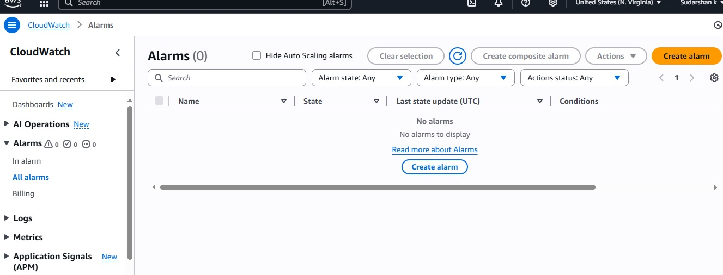
- Select EC2 option under select metric option

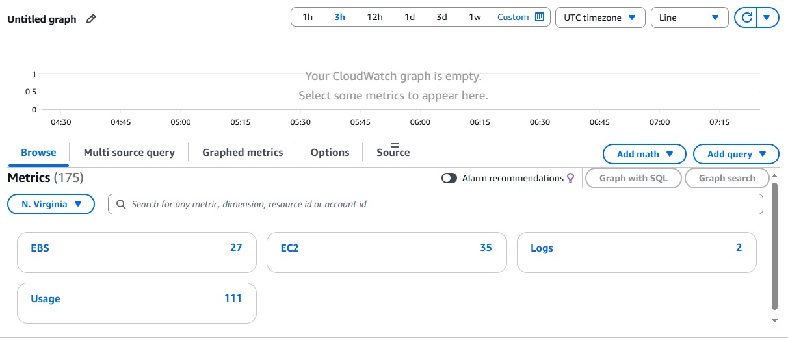
- Select CPUUtilization under Per-instance Metrics
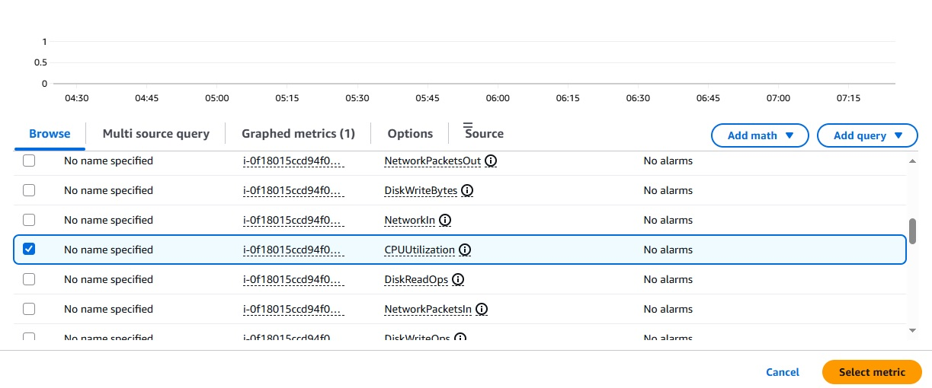
- In the next step, set the periods and threshold value for CPUutilization

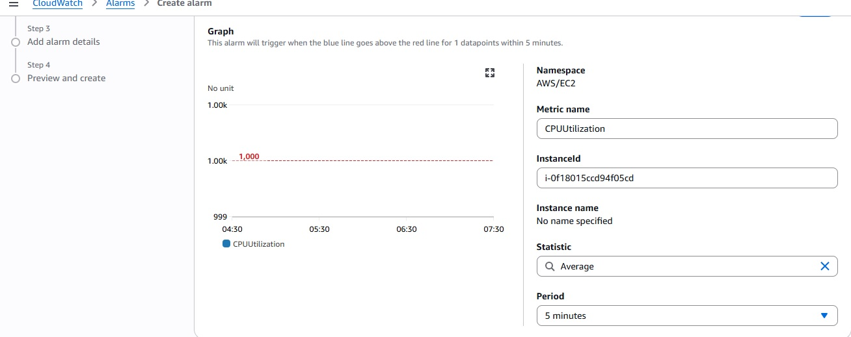
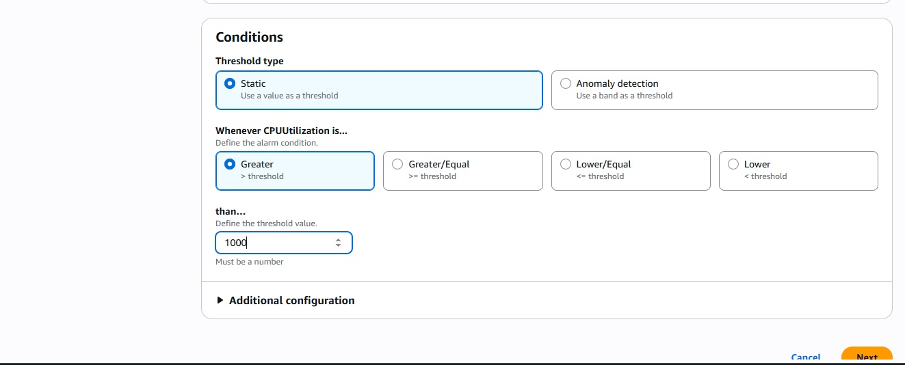

- Next Create the new topic or select the already existing SNS topic

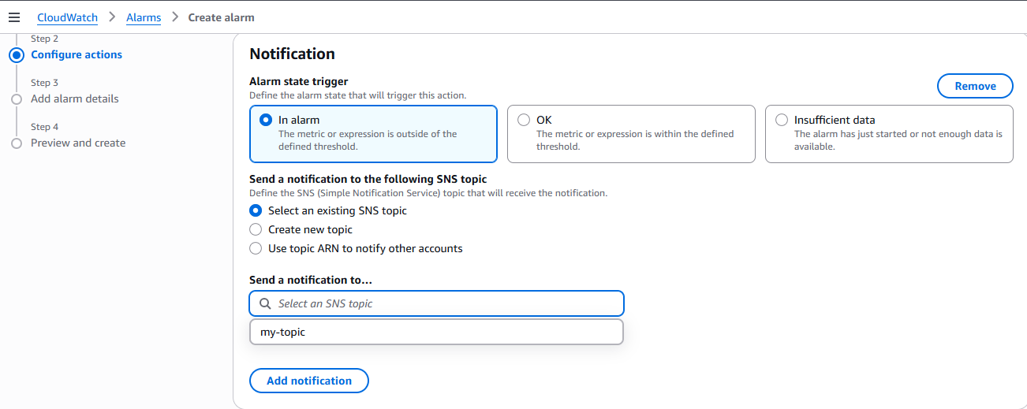
- Type the alarm name in the next screen
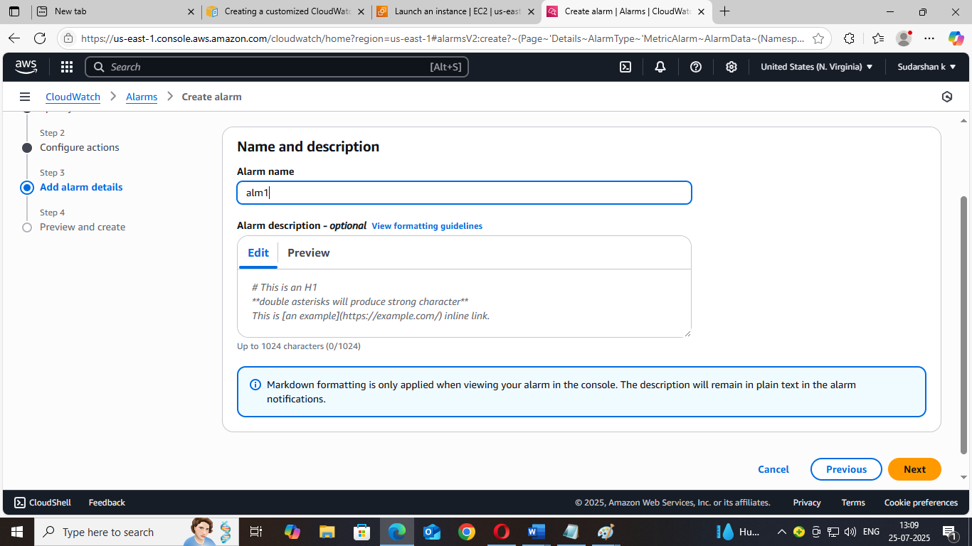

- Click Next button and select the create alarm button. Then Alarm will be created.
