**Report about performance and structure of K-Means project**

**By / Osama Alaa**

* Structure of K-means algorithm: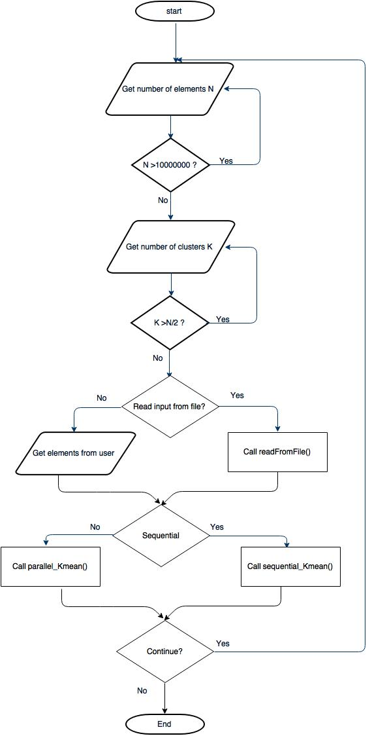

Performance:

|  |  |  |
| --- | --- | --- |
| Input | Sequential | Parallel |
| N=10  K=3 | Time= .015s | Time= 0 s |
| N=100  K=30 | Time= .031s | Time= .016s |
| N=1000  K=300 | Time=.328s | Time= .11s |
| N=10000  K=300 | Time=3.334s | Time=0.188s |
| N=100000  K=300 | Time=30.217s | Time=1.125s |
| N= 1000000  K=40 | Time=41.602s | Time=1.25s |