

KATI KATI 11.00

House made chapatti chopped, cooked with vegetables served with beef/chicken.

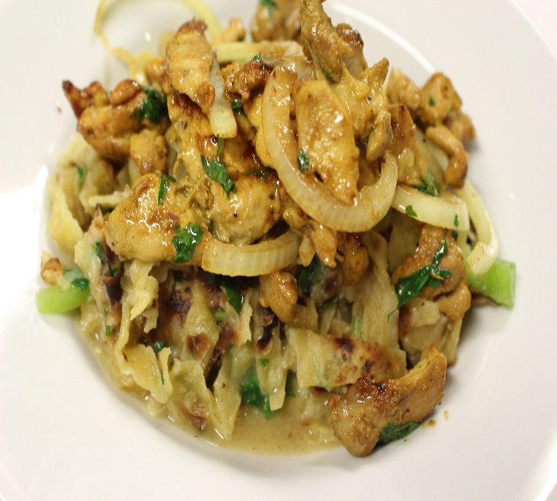

PASTA/BEEF 11.99

Pasta tossed in house made marinara sauce served beef and aside of salad.

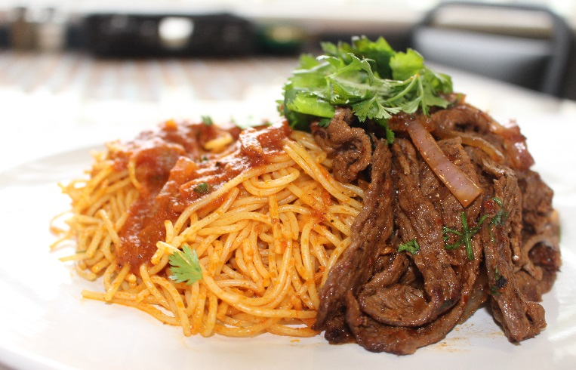

SLOW ROASTED LAMB SHANK /AROMATIC RICE 14.00

Slow roasted lamb shank in oregano, paprika, garlic served with basmati rice and a side of salad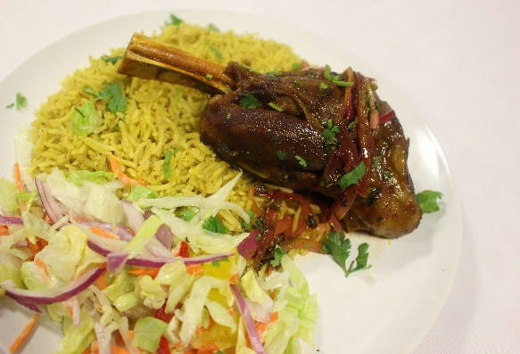

PHILLY CHEESE STEAK SANDWICH 9.00

Beef steak topped with caramelized onions, green pepper and melted cheddar cheese served on a French baguette with fries

BEEF OR CHICKEN SANDWICH / FRIES 8.00

Grilled chicken/ beef topped with onions, bell peppers, lettuce, tomato served on a French baguette. Complemented with fries.

SALMON / MASHED SWEET POTATO 12.00

Seared salmon served with black beans salsa and mashed sweet potato.

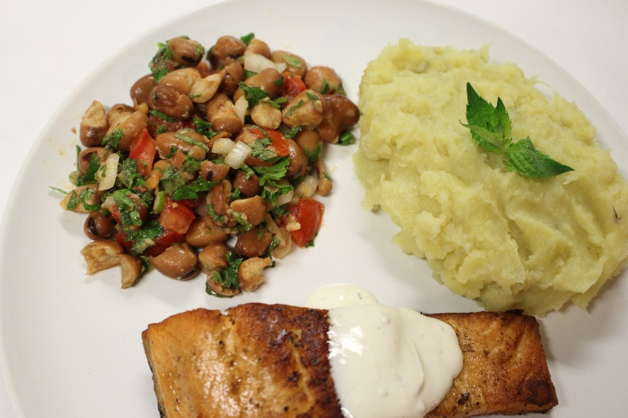

GOAT MEAT / AROMATIC RICE 14.00

Braised goat meat sautéed in Somali spice xawaash served with stir fried vegetables, basmati rice and a side of salad.

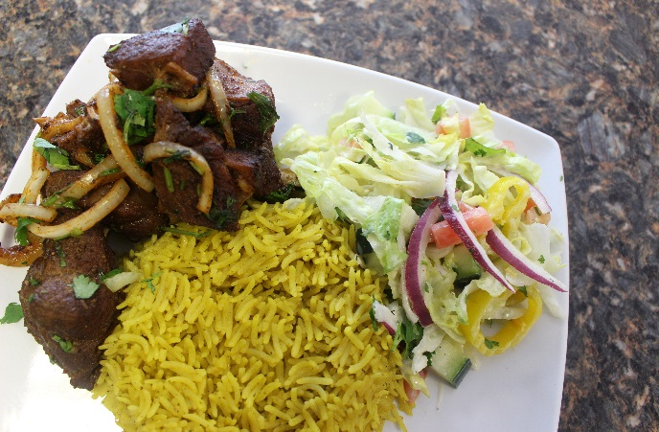

ROASTED CHICKEN / AROMATIC RICE 11.00

Marinated slow roasted chicken served with aromatic basmati rice and a side of salad.

CHAPATTI / LENTIS 6.0

Lentils cooked in coconut milk and curry served with house made chapatti. 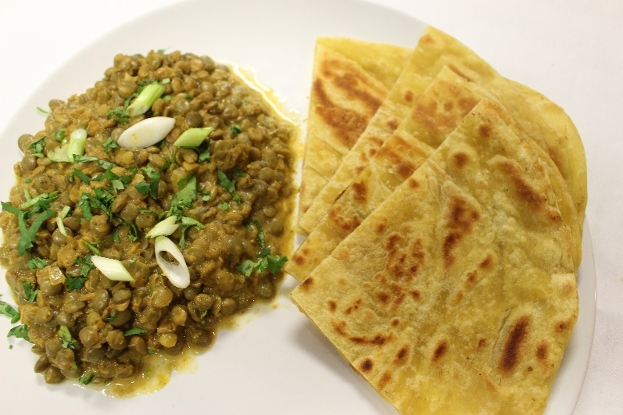

CHICKEN SUQAAR 11.99

Marinated chicken served with sautéed bell peppers, onions, garlic, cilantro and aromatic basmati rice.

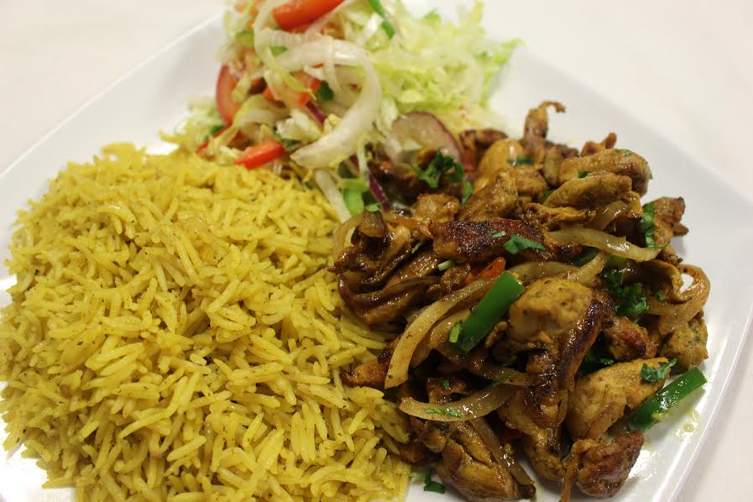

CHAPATTI/BEEF SUQAAR 11.00

Beef stew served with chapatti

HOT MUUFO / SUQAR 9.00

Flat bread served with beef/chicken stew.

FRIED TILAPIA / UGALI 14.00

Slow cooked ugali served with fried tilapia, glazed with lemon pepper seasoning, sautéed greens and curry sauce.

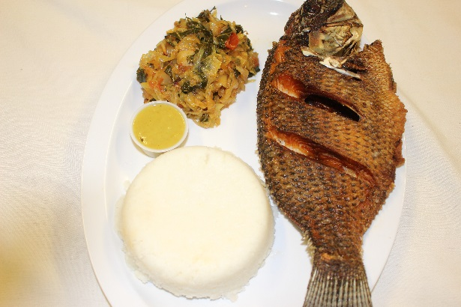

DINI BURGER 8.00

Special seasoned beef patties, cheddar cheese, lettuce, tomatoes topped with Dini’s hot sauce and fries.

PHILLY CHEESE STEAK SANDWICH 9.00

Beef steak topped with caramelized onions, green pepper and melted cheddar cheese served on a French baguette with fries

BEEF OR CHICKEN SANDWICH / FRIES 8.00

Grilled chicken/ beef topped with onions, bell peppers, lettuce, tomato served on a French baguette. Complemented with fries.

CHAPATTI WRAP 7.00

Chapatti wrapped in beef/chicken topped with tomato and lettuce.

MASALA FRIES 3.00

Spicy French fries coated in a house made marinara sauce.

SAMOSAS 1.00 EA

Samosa filled with beef/fish/veggie

SOMALI TEA 1.50

(CARDAMON, CLOVES, GINGER, CINNAMON)

Open hours: 9AM-9PM

We also provide catering services.

DINI KITCHEN

206-723-6721

5901 RAINER AVE S.

SEATTLE WA 98118